Problem Solving and
Decision Making
(BMSW4004_LON)
Lecturer name: Syed Jaffrey

Student name: Ioana Irina Dinu
Student id:1914863

Table of contents

Introduction.............................................................................3
Problems in the workplace ....................................................4
Identified and analyse the problem .......................................5
Solutions to solve the issues ................................................6
Decision-making technique ...................................................6
Solutions plan.........................................................................9
Offer the plan to the stakeholders .......................................10
Monitoring and Review techniques to ensure successful implementation of the solution ...........................................11
Conclusion ...........................................................................14
References ...........................................................................15

Introduction
The intention of this paper is to analyse the communication dispute in the corporation of Matalan, fashion retailer of the UK. Additionally, the suitable using decidedness procedures is almost notice in the paper. The communication rivalry is gathering by using nominal group technique to recognise the employees to engage and offer their reactions. Effective use of decision-making and problem-solving techniques to allow the corporation to fit the problems and recover the faith of the traders and consumers as too.

Most of the issues in the work are frequently confusing and resistant to keep up euphony in the employment. The composite issues are yonder the capacity of a business to appreciate and solve. When the difficulty is straightforward, the compound can be simply put in the work but when the issues are multiplex such as xenophobia, prejudice or poor communication among guidance and employees, they need some decidedness and well organised techniques to answer the issues and support the workplace position. In this report, a problem regarding conversation, poor salaries and differentiation in the workplace of Matalan Retail Limited, is to analyse and present the appropriate solutions using decision-making techniques is closely remarked.

Matalan is a British fashion and homeware retailer based in Knowsley, Merseyside. It was founded by John Hargreaves in 1985 ,and is still owned by the Hargreaves family. In 2020, the company employed over 13,000 and had 230 stores in the United Kingdom, together with 32 franchise stores in Europe, and the Middle East. (dailymail.co.uk)

Problems in the workplace
In the corporation of Matalan Retail Limited, the major problem was the poor workplace relationships, and this occur a crucial complex issue for the organisation. The conflict among regulation and employees caused a major wallop action and, in the meantime, affected the consumers service with the company. Striking Matalan warehouse workers share personal concerns as strike over low pay at Matalan reaches at least six weeks. (www.business-humanrights.org). This strike has been amplified by the managers with poor leadership skills because they didn't know how to interact with them, and in the meantime they postponed to offer promotions, avoid to increase the wages for the employees who are working hard and they wanted to progress in their careers.
Scope: The issue expands with the distinction within the staff. Psychological aggressiveness in the organisation causes from the persecution due to distinction. In a 1996 study title “Emotional Abuse in the Workplace “, Loraleigh Keashly (professor of communication at University Wayne State who studies conflict resolution) and her colleagues defined it as “hostile verbal and nonverbal behaviours that are not explicitly tied to sexual or racial content yet are directed at gaining compliance from others”: a definition that included yelling and screaming, but also things as gossip, interrupting, ignoring someone and withholding information. (www.thecut.com). The competitive identification between the labourers is one of the aspects for the discussion conflicts with the administration. The planer model of communication that describes the hierarchical model of leadership can be carried out to this issue of communication in the workplace. The transaction model of communication also plays a crucial position during the management feedback process.

Identified and analyse the problem
The disputes led to a poor communication and disconnect the decision-making process of the hierarchical structure of leadership in Matalan Retail Limited. The management analysed the situation and proposed an effective problem-solving strategy to overcome the conflicts. The workers from Matalan refused the offer from the manager because is described as an “insulting pay offer": 25% of employees who work on weekends receive a pay rise 1,5%. (www.business-humanrights.org)
Problem-solving and decision-making are important skills for business and life. Problem-solving often involves decision-making and is essentially important for management and leadership. There are process and techniques to improve decision-making and the quality of decisions. (Williams, pp.181-183). A spokesman for Matalan decided to increase the offer to 4,7% and this offer was the largest promotion from this company. In October 2019 the strike has been suspended after Matalan and the GMB brokered a new deal which has been accepted by 87% of employees. (www.bussiness-humanrights.org). After identifying the cause of the issue and its factors that affect the business in the meantime the management evolves alternatives solutions to gadget in this case. Between different procedures, the manager has the ability to control the situation and makes the best alternative to judge the decision-making process.

Solutions to solve the issues
In order to achieve the successful of problem-solving the management must identify the summons and the effect of poor relationships, conflictual communication between employees in Matalan Retail Limited. There were several solutions to investigate this problem before making an effective decision.
According to Shapiro and Stefkovich (2016), positive psychology it is the best solution because are encourages the employees to feel important in the workplace. If the workplace started to be positively and the communication are present, the employees become more attractive and competitive with the rest of the colleagues and the company will achieve the goals.

Decision-making technique
The management tries to pick out a diversity of decision-making techniques and applies the appropriate procedure to resolve the problem.
Brainstorming: is a method design teams use to generate ideas to solve clearly defined design issues. In controlled conditions and a free-thinking environment, teams approach a problem by such means as “How might we" questions. According with Rao (2007) the article describes the effects of training in brainstorming strategy on learner’s performance and how they receive in writing. In this case the first 2 classes has been prepared with brainstorming strategy in Chinese university but the third class has been completed the same exercises without any knowledge’s in brainstorming. This article demonstrate how important are the instructions of brainstorming to achieve the performance in writing. All the participants who have been involved in this survey indicate attitudes positively about brainstorming strategy. In conclusion the teachers from university or colleges should focus in teaching writing in order to activate students skills thinking and to understand about writing ideas.

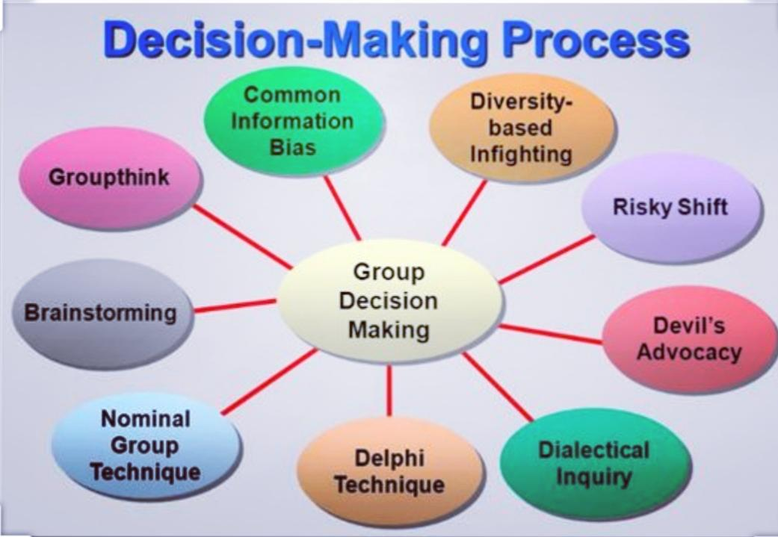
Figure 1: (Source: iedunote.com)
Delphi Technique: is a method used to arrive at a group opinion by surveying a panel of experts. In this technique managers do not have to meet each other but the leader uses a range of questionnaires to make the decision. According with Goodman (1987) the characteristics of this method is anonymity and is using by experts to control the feedback. This technique is useful in structuring group communication and is as an aid for policy makers.
Nominal group technique: The method is an alternative of a team conference to reach the crave aim in order to achieve effective decision-making. With the aid of the procedure, the administration collects all the facts connected with the conflict by request each employee a range of questions and making effective decisions to resolve the issue. The process of a group method minimises the chances of control for each sole and motivates the group to take part in the decision-making process to suggest effective strategies to the issue.
Brainstorming and Delphi method have some restrictions, as it requires specialists trading with a good head to determine the management to extract the effective decision. In this practice the group leader takes the action by writing questionnaires and the participants never meet. Brainstorming is the most common procedure to make alternative solutions but most of the time is creating errors between participants. In order to avoid the communication conflicts between workers it is important to use nominal group technique. It is the best method to achieve group harmony and inspiring the employees to participate and to improve the service. In each organisation it is important to take part everyone (staff, stakeholders and community leaders) in order to identified the root of the issue and the management needs to involve all the participants to ensure they are clearly understood their priorities.
The edge of using the technique in communication and discrimination conflict in the workplace are discussed below:
The method causes a diversity of schemes that can be more effective for the issue than the traditional method of group discussion.
It brings down the chance of control of an independent person's idea to the group by split up the power of decision-making between traders and it reduces the competition, pressures in the workplace. In the meantime, the technique allows the group of labourers to range the objectives for all participants democratically.

Solution plan
The action to control and execution the solution includes four phases. The first phase is to create projects. The controllers prepare some interrogations or problem forms to the employees to be answered. The management organise the meeting and straight everyone to give their comments in brief and also work in partnership. All individual creates suggestions and offer them to resolve the issues.
According with Sorooshian (2018), the mediator accumulates the point from the team and asks some query and profits to the following activity of idea caused and divide. In this case the repetition of ideas is unacceptable.
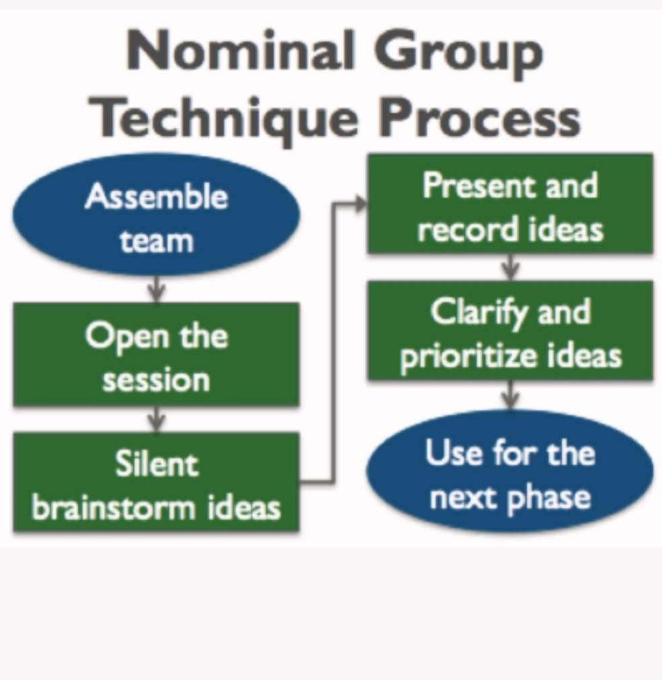
Figure 2: Nominal Group Technique Process (Source: extensionaus.au)
Everyone is presenting ideas but in the end of discussion they will choose the best and appropriate solution. The moderator must to encourage all participants to take part in order to get the feedback from them. Each creator provides their point of view and discusses them freely without any influence of any individual.
In the last stage, each votes are counted in order to get the highest voted idea by the moderator and manager to apply the idea for an effective and decision-making process. After selecting, the highest idea by the favorited group responded the questions asked by the management.

Offer the plan to the stakeholders

A stakeholder is a party that has an interest in each organisation and can either affect or be affected by the business. The primary stakeholders in a corporation are: investors, employees, customers and suppliers. (investopedia.com) According with Heo (2018) it is necessary for stakeholders to use techniques to communicate with them in problem-solving and decision-making process.
The nominal group method is promoted and encouraged the stakeholders during the decision-making process. The monitoring meeting it is very helpful for the stakeholders in discussions because are reducing the summons and time frontiers. Real-time problems can be interpreted by this method and imply stakeholders affected by the solution results. Participation rates are satisfactory among the stakeholders.

Monitoring and Review techniques to ensure successful implementation of the solution
The communication conflict is solved by using the nominal group technique to authorise the traders to take part and offer their reactions. It is preventing the rivalry pressure among employees and it encourages them to take part in discussions. There are some types of devices to observe and analysis the technique such as: Grantt charts, Kotter's 8 step model, PDSA and others that include each duty and reliance’s of the duties.
A Grantt chart is a project management tool who helps in planning or scheduling of projects of all sizes and are useful for simplifying complex projects.

Figure 3: Grantt chart (Source: interest.co.uk)
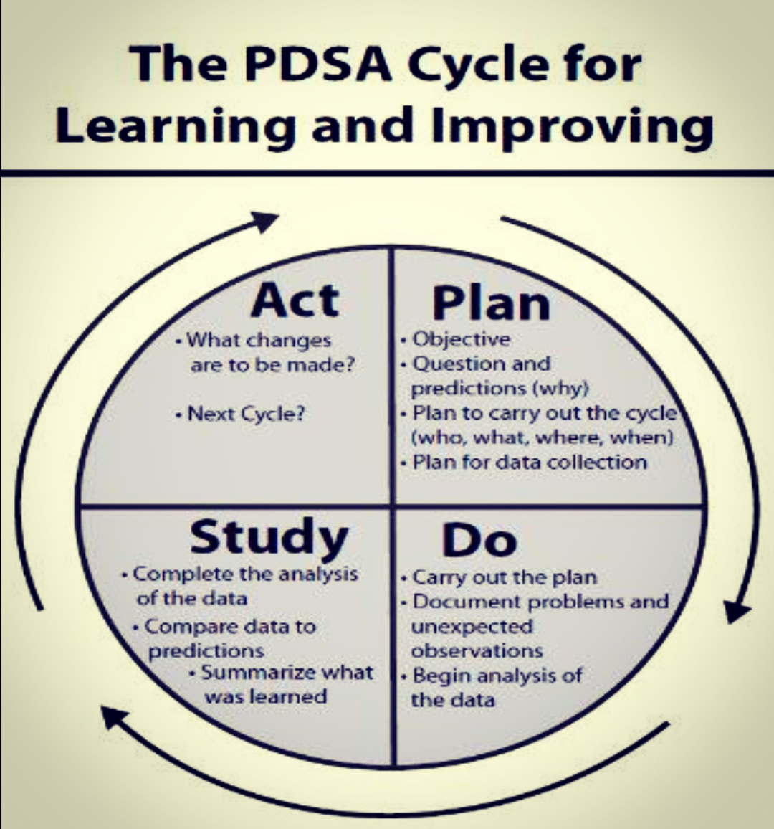
Figure 4: (Source: astho.org)

The PDSA cycle is shorthand for testing a change by planning it, trying it, observing the results and acting on what is learned. This is the scientific technique used for action-oriented learning. (ihi.org)

The purpose of this step in Kotter’s 8 model is to create a sensitive vision and the 8 steps are: increase urgency, build building team, develop the vision, communicate for buy-in, empower action, create short terms WINS, don't let up, make change stick. (managementstudyguide.com)
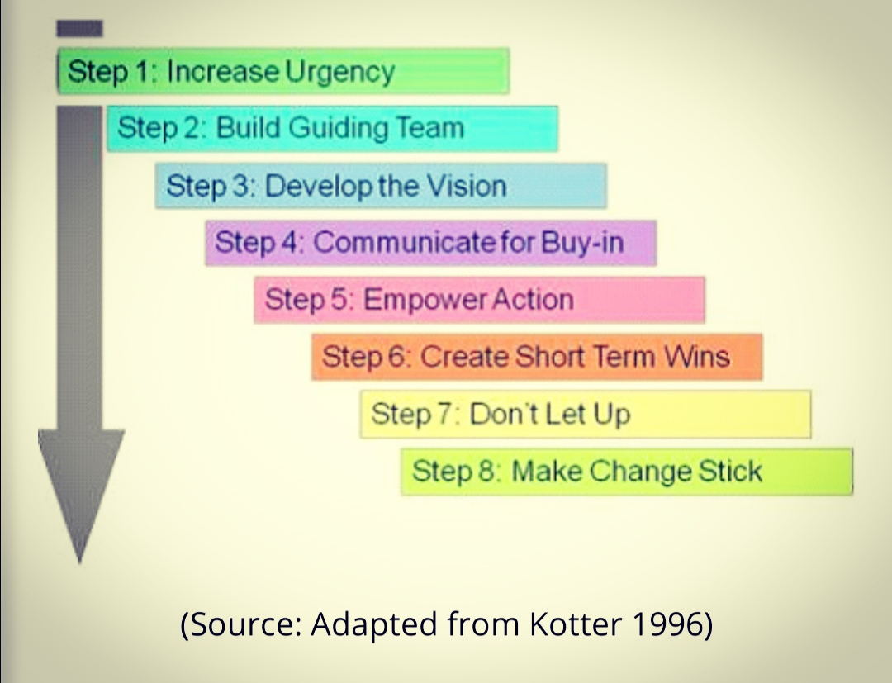
Figure 5: Kotter's 8 model (Source: managementstudyguide.com)

Conclusion
In conclusion of this assignment, communication morals increase the possibility support euphony within the work if yonder is lack of contact morals there must be conflicts to keep the correlations among regulation along with employees in organizations. The workplace conflict in Matalan Retail Limited high-flown the working operation and the capacity of the firm. Effective use of decision-making and problem-solving techniques allow the firm to recover the confidence of the labourers and consumers too. By applying the nominal group technique, the organisation admitted the traders to offer their judgement without any restrictions and the conductor accepted to come after the reaction and encouraged the people to support the polyphony at work in order to achieve the goals.

References
Williams, A (2016). The Scouse Docker's son who left school at 14 to set up a market stall and become a billionaire Monaco tax exile: Meet John Hargreaves, the man who built Matalan. [Online], Available at: https://dailymail-co-UK.cdn.ampproject.org/v/s/www.dailymail.co.uk/news/article, Accessed at: 25 November 2020.
UK: Striking Matalan warehouse workers share personal concerns as strike over low pay at Matalan warehouse reaches sixth week, (2019). [Online], Available at: https://www.business-humanrights.org/en/latest-news/uk-striking-matalan-warehouse-workers, Accessed at: 29 November 2020.
Romm, C (2018). The Insidious Effects of Verbal Abuse in the Workplace. [Online], Available at: https://www.thecut.com /2018/05/the-insidous-effects-of-verbal-abuse-in-the-workplace.html, Accessed at: 29 November 2020.
Shapiro, J.P and Stefkovich, J.A,2016, Ethical leadership and decision making in education: Applying theoretical perspectives to complex, Routledge.
Rao, Z (2007). Training in brainstorming and developing writing skills, ELT journal 61 (2) ,100-106, [Online], Available at: https://doi.org/10.1093/elt/ccm002, Accessed at :2 December 2020.
Technique for Forecasting of Human Resources, [Online], Available at: https://iedunote.com/forecasting-human-resources, Accessed at: 2 December 2020.
Goodman, M.C, (1987). The Delphi technique: a critique. Journal of advanced nursing 12(6), 729-734, [Online], Available at: https://doi.org/10.1111/j.1365-2648.1987.tb01376.x, Accessed at :2 December 2020.
Sorooshian, S., 2018 June. Group Decision Making with Unbalanced-Expertise. In Journal of Physics: Conference Series (Vol.1028, No.1, p.012003).IOP Publishing.
Nominal group technique, [Online], Available at: https://extensionaus.com.au/extension-practice/nominal group-technique/, Accessed at: 4 December 2020.
Chen, J., (2020), Stakeholder definition, (Online], Available at: https://www.investopedia.com/terms/s/stakeholder.asp, Accessed at: 12 December 2020.
Heo, W., Park, N., Henager, R.and Grable, J.E., 2018.What do financial planning organizations communicate to stakeholders and consumers? An empirical narrative analysis. Financial Services Review, 27(2).
Grantt chart figure, [Online], Available at: https://www.pinterest.co.uk/pin, Accessed at: 12 December 2020.
PDSA cycles figure, [Online], Available at: https://www.ihi.org/resources/Pages/Howtoimprove/ScienceofimprovementTestingChanges.aspx, Accessed at: 12 December 2020.
Kotter's 8 step model of change, [Online], Available at: https://www.managementstudyguide.com/kotters-8-step-model-of-change.htm, Accessed at: 16 December 2020.
Certificate in Higher Education: Skills for the workplace student yearbook, Maund, A., Schriek, M., Tinkler, P.K, Sage Publications, Williams, S.,Decision-making difficulty,(pp.181-183).

