APPENDICES:
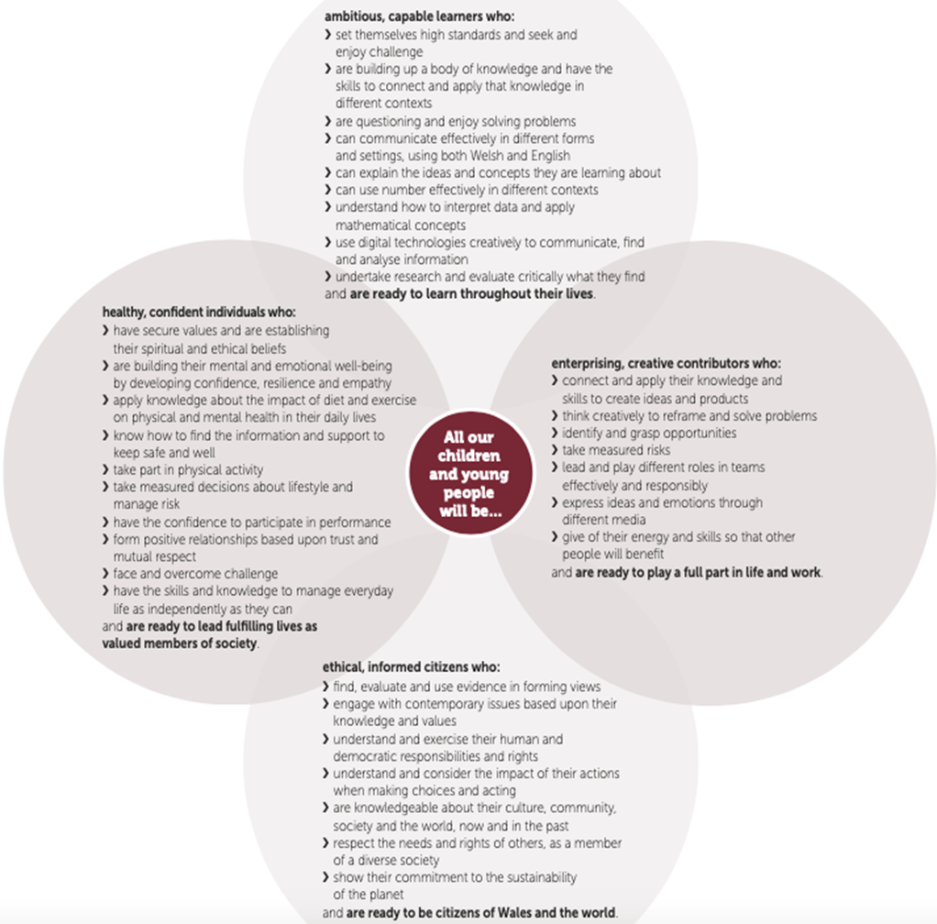
Appendix 1: The Four Core Purposes of the Welsh curriculum

Donaldson, G. (2015). Successful Futures: Independent Review of Curriculum and Assessment Arrangements in Wales. Welsh Government.

Appendix 2: Driscoll’s ‘What?’ model of reflection
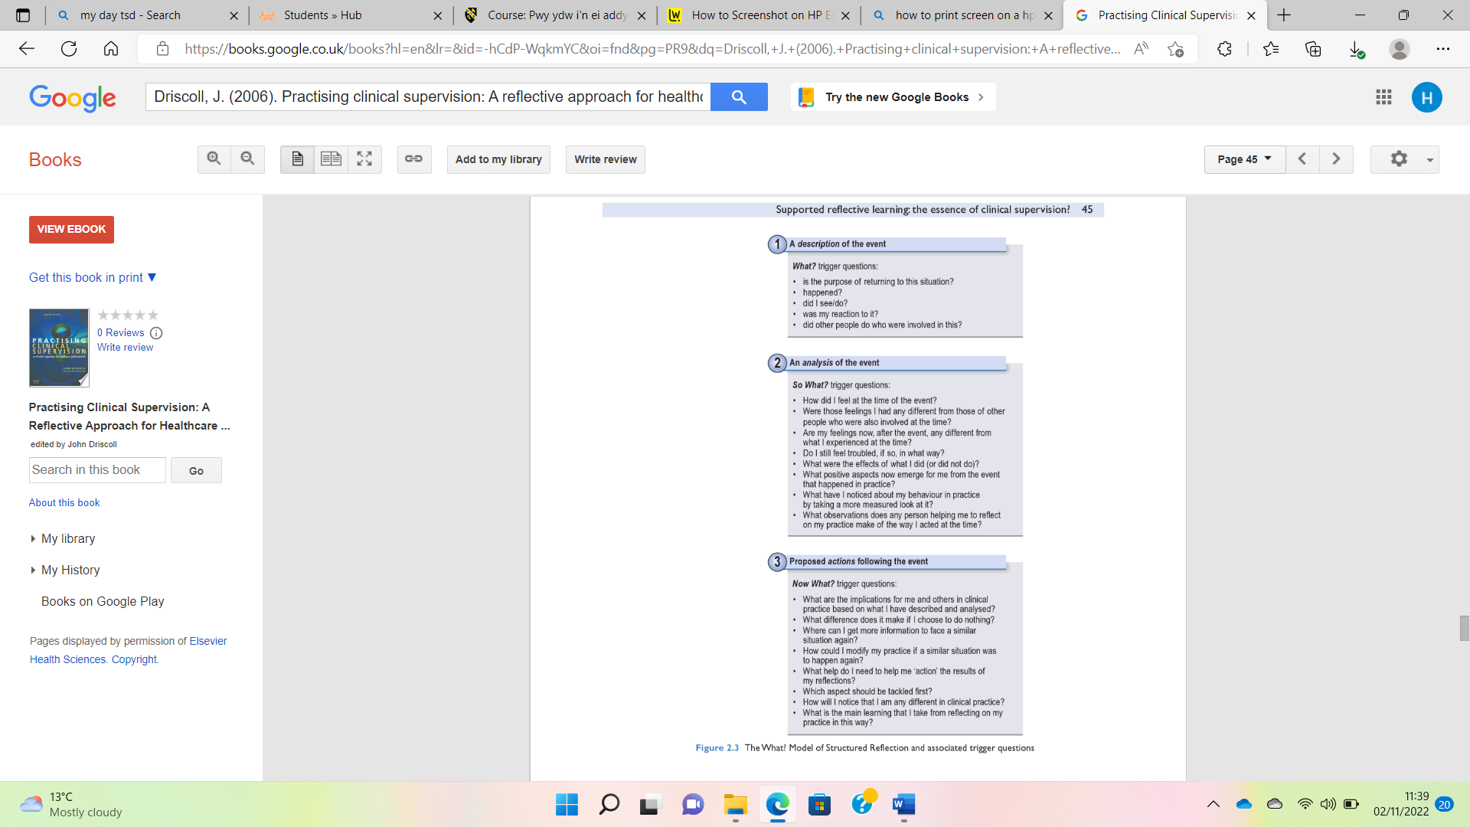

Driscoll, J. (2006). Practising clinical supervision: A reflective approach for healthcare professionals. Philadelphia: Elsevier Health Sciences.

Appendix 3: Gibbs’ Reflective cycle
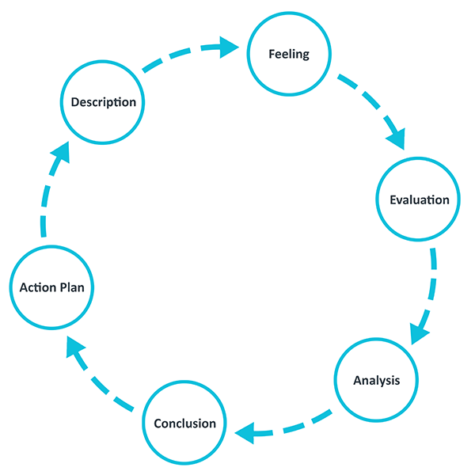

The University of Edinburgh. (2020). Gibbs' Reflective Cycle. Available at: https://www.ed.ac.uk/reflection/reflectors-toolkit/reflecting-on-experience/gibbs-reflective-cycle (Accessed 4 October 2022).

Appendix 4: Maslow’s Hierarchy of Needs

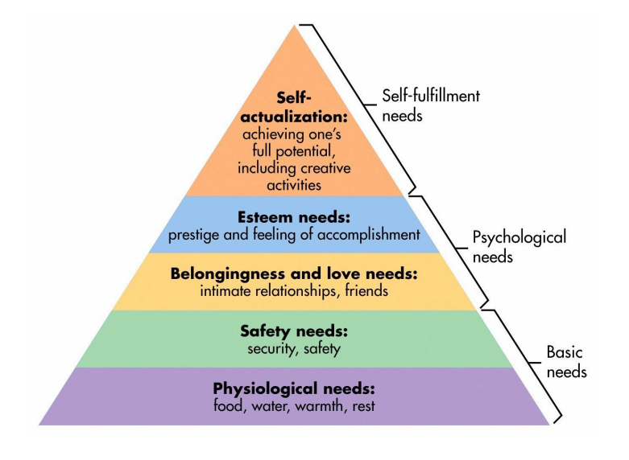

McLeod, S.A. (2018, May 21). Maslow’s hierarchy of needs. Available at: https://canadacollege.edu/dreamers/docs/Maslows-Hierarchy-of-Needs.pdf (Accessed 4 October 2022).

Appendix 5: Critical Incident observations

Record 1
Date and time, year group: 26/9/22 at 9.30am, year 4.

Where and When: Context of the observation – subject/AOLE, general classroom context

Upon entering the classroom the children were sat on the carpet facing the interactive whiteboard, which displayed the lesson focus. The subject/ AOLE was mathematics, centring around partitioning numbers. After a period of time on the carpet, the children moved to tables.

What happened: a detailed description of the critical incident(the more detail the better to refer to in your later work)

Following a brief recap, the mathematics work was divided into 3 “Chilly Challenges”, including “medium”, “hot” and “spicy” (each challenge increasing in difficulty). The students were given the choice to pick which challenge they felt they were able to do and go sit on a corresponding table to complete their worksheets. Teacher 1 sat with the “medium” challenge table throughout the session. Here the teacher utilised sentence and question prompts to test the children’s knowledge and understanding and aid them in completing the “medium challenge worksheet” (e.g., “Remind me, what’s the first thing we have to do here?”). On occasion, the teacher was working closer with the students struggling on the table. While this occurred, the remaining students aided each other. For example, student A said to student B “What’s 3 add 4?”, to which student B replied “7!”, leading student A to say “oh so we add 7 to 110?”, with student B replying “yeah!”, subsequently leading student A to reply with “so the answer is 117?” and student B responding "I think so!”. Teacher 1 then praised the students “Bendegedig student A and student B!” upon hearing their collaboration in answering the sum.

Sum was as follows:

53 + 64

50 + 60 = 110 3 + 4 = 7

Areas of possible exploration: what you think could be” under the hood” in these incidents? What avenues of research could you consider?

- Child- centred learning through being given the choice to pick which level they wanted to work at.
- Assessment for Learning – throughout the whole lesson the teacher was utilising AfL strategies. Formative assessment techniques to constantly regulate learning – e.g. quality of questions and talk and use/ quality of feedback.
- 16 Habits of Mind – Evident one being “thinking interdependently” here for the pupils were working together.
- Constructivist school of learning. – Scaffolding, ZPD and MKO. Here both the teacher poses as a MKO and scaffolder, as well as student B. Both aid in bridging the gap between what students (student B) can and cannot do.
- Maslow’s Hierarchy of Needs – Esteem needs (feelings of accomplishment).

Notes: any details you can note (is it a busy environment, is it after lunch, are there lots of distractions, are directions made explicit - the more you can refer to the better here)

- Busy/ lively classroom, but controlled.
- First lesson after assembly – students are engaged and ready to start day.
- Classroom is colourful and displays are inciteful, but not cluttered.
- All directions made by teacher are clearly communicated.
- If class does get too loud for optimal learning, teacher rings bells to which all children immediately quieten down (classical conditioning – Pavlov).
- Children sat in groups based on a level they think is suitable.
- 30 children in class.

Record 2
Date and time, year group: 26/9/22 at 1.15pm, year 1

Where and When: Context of the observation – subject/AOLE, general classroom context

Upon entering the classroom after lunch, children were sat on rug with teacher 1 sat in front of them and teacher 2 sat beside them. Following a “speed sounds pack” starter activity, the children were separated into their groups (these were Welsh colours). 1 group went into the foyer with teacher 1 to read, another went outside, another in the “Independent Area” to do dragon egg designing and the final having “free choice” inside the classroom. This worked in a carousel fashion, enabling each group time for every activity.

What happened: a detailed description of the critical incident(the more detail the better to refer to in your later work)

Group X were outside engaging in imaginative play. Student A was playing on a digger and when asked by teacher 2 what colour the digger was, they replied “yellow”, to which teacher 2 replied “Cymraeg?” resulting in the child saying “melyn!” and the teacher giving praise; “Da Iawn!”. Following this interaction, Student A turned to a group of peers and said, “I know all of my Welsh colours” and started singing the “colours of the rainbow” in Welsh. When student B replied saying they couldn’t remember all the colours, Student A repeated the song in a slower manner, ensuring student B was able to follow along. Subsequently, they both sang the song once more together.

Areas of possible exploration: what you think could be” under the hood” in these incidents? What avenues of research could you consider?

- Learning through play (Piaget and Vygotsky)
- Habits of Mind – learning interdependently (Student B learning Welsh colours from student A).
- Welsh language development. – Curriculum links.
- Social constructivism (Vygotsky) - ZPD and MKO.
- Dan Siegel’s “The Healthy Mind Platter” – Physical time, play time and connecting time all needed to “educate the mind”.
- Links to new curriculum and the four purposes (ambitious, confident learners etc...)
- Outdoor engagement.

Notes: any details you can note (is it a busy environment, is it after lunch, are there lots of distractions, are directions made explicit - the more you can refer to the better here)

- Busy, positive environment – all children are content.
- Controlled environment.
- Bright and colourful room.
- Displays in alignment with the current class topic.
- Class divided into small groups (collaborative learning).
- Directions are clear and easy to follow.
- 28 children in class.

Record 3
Date and time, year group: 27/9/22 at 9.55am, year 6.

Where and When: Context of the observation – subject/AOLE, general classroom context

Children were sat on their pre-set tables after arriving back from assembly and were engaging in discussion about single-use plastic in preparation for a video as part of their literacy and communication lesson. However, it is apparent that this lesson drew on additional learning areas, like that of health and wellbeing and humanities. Before the video was played, 3 pupils were called to a keyboard lesson and left quietly. Teacher 1 played the video and the children made notes in preparation to answer set questions.

What happened: a detailed description of the critical incident(the more detail the better to refer to in your later work)

Teacher 1 was about to start the informative video, however an additional member of staff came to collect 3 pupils for a keyboard lesson. The children left quietly with teacher 1 saying “enjoy guys!” and then playing the video. The children were told to make notes during the video in preparation to answer their set questions. Following the video, the children were made to write down 4 questions and answer them in around 50 words each. At 10.20am, the three keyboard pupils returned and sat quietly in their seats. This return was acknowledged by teacher 1 at 10.25am. Subsequently, teacher 1 told the 3 students to start answering the questions using their peers’ video notes. At 10.35am the children were dismissed for morning break, returning at 11am. At 11am, teacher 1 told the three keyboard students to write in the corner of their page “(keyboard)” to account for their lack of question answers. Following this, the class proceeded with their next lesson. The researcher is unaware if the keyboard pupils were given opportunity to finish their question answers later in the day.

Areas of possible exploration: what you think could be” under the hood” in these incidents? What avenues of research could you consider?

- Child-centred learning – allowing children the opportunity to explore interests through musical lessons etc.
- Social learning – scaffolding from others and their notes (Vygotsky, ZPD and MKO).
- Curriculum for Wales links – the four purposes. For example, the class focus is encouraging children to become ethical, informed citizens through developing understanding of sustainability. Furthermore, confident individuals and creative contributors for those who engaged in additional musical lessons.
- Curriculum for Wales links – the 6 AoLEs. For example, literacy, language and communication evident within the classroom and expressive arts apparent in terms of those taken for musical instrument lessons.
- Teaching and leadership standards – effective pedagogy and leadership through recognising the needs and interests of all learners – those going to music lessons were enthusiastically told to enjoy themselves for example. Here the positive relationship with class members is evident (good leadership).
- Maslow’s Hierarchy of Needs – self-fulfilment needs through pupil engagement in musical lessons.

Notes: any details you can note (is it a busy environment, is it after lunch, are there lots of distractions, are directions made explicit - the more you can refer to the better here)

- Calm, positive and controlled environment.
- All children are content and engaged – clear positive peer-teacher and peer-peer relationships.
- Bright, colourful and organised displays.
- 5 tables of students – students given choice over where they sit.
- All directions clearly articulated and repeated if needed.
- Enthusiastic environment where all children are included in discussions.
- 22 pupils.

