

Name :- Nishit Jitendrabhai Adesara
Student ID :- 2315269
Subject :- Banking and Financial Economics
Subject Code :- LCMB7032
Submission Date :- 29th April, 2024

Table of Contents

Introduction 2
Overview 2
Key Reason for going public 3
Key Risks 4
Quantitatively review 5
Annual Growth Rate 8
Sharpe and Treynor ratios 10
Exchange traded options 11
Call Option 11
Put Option 12
Straddle Strategy 13
Performance Analysis 14
Performance of 10Y note 14
Impact of changes in the yield of this note upon consumer debt 16
References 18

Introduction

Overview
Uber Technologies is a well-known corporation that operates in the transportation and ride-hailing industries and has been in business since 2009 (Rangel et al., 2021). Because of the company's smartphone application, which enables users to call a ride service, the company earned a significant amount of popularity, which led to a change in the modes of transportation that people use to commute. Uber has set a goal to acquire 75% of the millennials and members of Generation Z in the United States market. Due to the fact that members of Generation Z are always prepared to try new things and are innovative, we believe them to be an important generation for our company. Users of the Uber app are also extremely devoted, spending an average of thirty minutes on the app each day. As a result, the Uber app offers as a perfect platform for businesses that want to target customers who are actively engaged in their activities.
Within the context of the current market scenario, ride sharing is the primary source of revenue for Uber (Ming et al., 2019). The fact that Uber offers a variety of services, such as UberX, UberPool, and UberEats, contributes to the company's widespread popularity. Both for commuting and for the delivery of meals, these services are utilized by a significant number of people. Therefore, the services provide the businesses with the ideal environment in which to place lucrative advertising endeavors on the enormous user base of the Uber app.
Uber has, on the one hand, been the recipient of a great deal of praise and recognition globally. On the other hand, it has been facing a great deal of difficulty over the course of the past few years. During the year 23, the company made 4.6 billion dollars in revenue and made every effort to guarantee that it would not fall behind the initial investments by 1.3 billion dollars. Additionally, in March of 2022, Uber debuted a new service that was dubbed Uber+. However, only seven million people enrolled to this service. Uber is still the reigning king in the transportation territory, and it continues to show foresight when the environment changes for the better or for the worse for both riders and ad sponsors. Therefore, businesses choose Uber as a marketing platform, which enhances their communications to a large number of people from a variety of backgrounds and among the other users. Despite the fact that it has experienced certain difficulties, the company never ceases investing in the advancement of new ideas and the satisfaction of its customers. As a result, this is an indication that it will continue to be a force to be reckoned with in the market.

Key Reason for going public
Publication has an effect on growth, market place, and relationships with investors. Uber's public launch was filled with hopes, rumors, and worries about the company's future. Uber's IPO was one of the most anticipated in recent years. It was driven by investors' financial commitments, market forces, industry trends, and their feelings. Uber's path to the public market involves strategy and changes in the market. Delays in the company's IPO led to more debt and financial trouble. Uber sped up its IPO to lower its debt and take advantage of the way the market was doing.
Uber's path to public ownership is shaped by how well it has done with private funds. Investors have put a lot of money into Uber because they think it will grow globally and branch out into other areas, like food delivery and self-driving cars. Market and economic changes happen at the same time as Uber's IPO. The company decides to go public because prices are high and the economy looks good. This way, it can raise money without having to deal with the problems that come with a slump. The initial public offering (IPO) of Uber shows how corporate finance and business are changing. Uber wants to go public to get more money, improve its image, win back the trust of stakeholders, and set itself up for long-term success in a field that is already very competitive.
The public offering of Uber has this one coming for years now and the company is now getting ready to roll out into the public arena (Cordina et al., 2020). Uber had partnered with Goldman Sachs in the year 2015 in which it promised to a make public in a time of four years, but it didn't; as a result, the company has been on a track to pay a higher fee and have a spanned debt. It's been quite some time that the deadline had passed so; it's likely now the reason why now Uber is
Furthermore, Uber has been successful in soliciting substantial private capital over the years, with investors channeling billions of dollars into its services to allow its expansion onto the global markets and diversification into the emerging business lines like delivery of food and autonomous vehicles. Nonetheless, these investors have been willing to wait for the appropriate time and going public enables them to cash out their shares in exchange for a profit.
Similar to Uber, it seems they are also aiming at this and wants to go public to avoid a possible economic recession. Market watchers attribute IPO of Uber and Lyft to fueled optimism caused by the pricing boom and positive economic news, which may result in difficulties with the capital raise process in case of the economic slowdown (Hawkins, 2019).
Moreover, Uber’s IPO is another move in a larger somewhat pattern where late-stage, venture-backed startups reaching for the public ownership (heinonline.org, 2024). In line with this, the rise of different forms of private capital, especially working in partnership with Uber, the company has been enabled for many startups to stay private for much longer than before. However, it seems now the starting point of public markets to fund their next phase of growth has shaped the horizon.
Finally, conducting an initial public offer also serves as marketing instrument for Uber because it takes the other party and the public by persuasion to believe that Uber has gone over the highest peaks and is ready for greater transparency and scrutiny of a public company. This could prove a paramount way of reviving Uber's image that was adversely affected by various scandals during Travis Kalanick's own reign (www.acquired.fm, 2024).

Key Risks
When you look at the information in Uber's SEC Form S-1 file, three major risks become clear:
- Regulatory Risks: Uber has a lot of problems with the law in many markets because its business plan hurts traditional transportation services (Smith and McCormick, 2018). Some examples of these regulatory risks are legal disputes over whether drivers are employees or independent contractors, safety problems, and following regional transportation rules. Due to the constant legal and regulatory scrutiny Uber sees around the world, these risks are likely to happen in a moderate to high percentage of cases (Corporate Finance Institute, 2024).
- Competition Risks: Other ride-sharing services, like Lyft and regional rivals, as well as standard taxi services, can hurt Uber's business in this very competitive field. Uber's market share, ability to set prices, and ability to get and keep drivers and customers are all at danger because of how competitive the market is. It's likely that competition dangers will happen because the ride-sharing market is still growing quickly.
- Risks to Data Privacy and Cybersecurity: Because Uber uses a lot of personal information and is always improving its technology, it faces cybercrime and privacy risks. A data breach or invasion of privacy can cost us money, get us in trouble with the law, and hurt image. There are likely to be threats to data privacy and safety, especially since cyberattacks on companies like Uber are getting smarter and happening more often.
Given these risks, Uber's suggested value must take into account how they might affect the company's overall health, its ability to grow, and its ability to stay in business. To make smart investment choices, people looking at Uber's valuation should carefully look at the company's plans to lower these risks, its ability to handle pressure from rivals and government rules, and its strength against cyber threats (PwC, 2017).

Quantitatively review
Financials
Based on what the image depicts, Uber is experiencing significant increase in a number of financial metrics, including operating income, net income, gross margin, and net margin, year over year (YoY). The meanings of each point are listed below:
1. Operating Margin: An organization's operating margin indicates how well it manages its operations by comparing its operating income to sales. Uber's operational income has more than doubled since last year, as evidenced by the company's operating margin growth of 161% year over year. This suggests that Uber has improved its ability to generate revenue from its core business operations.
2. Net Income: Net income is the entire profit following the deductibility of all expenses, such as interest and fees. Uber's net income increased by 121% in the previous year, making it more than twice as profitable as it was in the previous year. Furthermore, a 79% increase from the prior quarter indicates that profits have been increasing consistently over a shorter time frame.
3. Gross margin: A company's gross margin, which indicates how successful its primary business operations are, is calculated by dividing its gross profit by its income (Dos, Oliveira and Silva, 2024). Uber's gross profit has more than doubled from the previous year, based on a 153% increase in gross margin year over year. This demonstrates how Uber has improved its ability to turn a profit while controlling its direct expenses.
4. Net margin: This indicates the overall profitability of a corporation by comparing net income to sales. Uber's net income increased by 118% year over year after deducting all costs and taxes, indicating that the business is now more than twice as profitable as it was the previous year. Given that the gain was 76% over the prior quarter, overall profits should climb over a shorter time frame.
Uber is obviously profitable per all of its main performance metrics, based on the facts in the image. Greater increases in operating income, net income, gross margin, and net margin indicate that the business is operating more profitably, more efficiently, and with improved financial standing. Uber appears to be utilizing its business plan and market prospects well in order to achieve long-term development and profitability, based on this increasing trend.
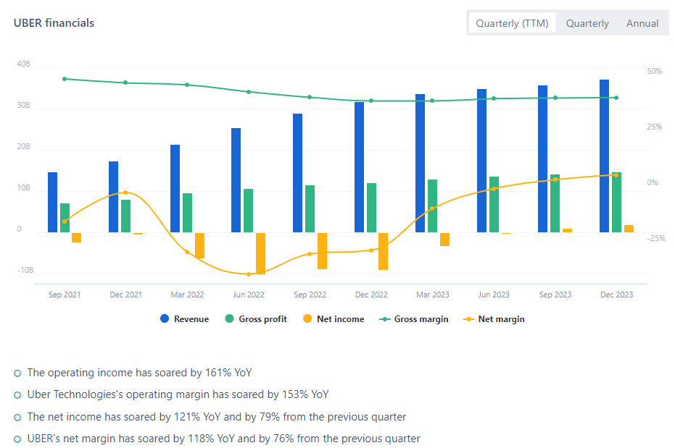
Figure 1(fullratio.com, 2024)
Efficiency
The return on equity (ROE) performance of Uber over time is shown in this interesting graph. There is a clear upward trend in this important financial measure. Return on equity (ROE) is a key measure of how well and financially stable a business is. It shows how profitable the business can be with the money its owners have put into it.
The first part of the line shows the percentage ROE, which ranges from -150% to 50%. However, the ROE over the time period shown has always been above 0%, which means that Uber has made money from its stock investment. This shows that one of Uber's main strengths is its ability to make good use of shareholder capital.
On the other hand, the time in quarters from 2019 to Q1 2023(TTM )is shown on the x-axis. For Each quarter we step down on the vertical grid line and a year is shown by a bigger line that follows it. Through this a clear timeline means that the viewers typically have simple time to keep up with Uber's ROE success during the beginning given time period as it shows the company's financial direction they are headed.
Discussing Uber's ROE history (2019), one may notice a constant increasing trend of it. The graph shows clearly that the company creates a long-term return on shareholder equity higher and higher, which means that the speed of the development of the company accelerates, too.
This sentence goes on to point out that Uber achieved very high ROE both on year-over-year (YoY) and on quarterly basis (QoQ) basis. During such early years, the ROE has grown by 116% year on year and by 60% as compared to the end of the last quarter. With these developments we can appreciate that virtually Uber has made tremendous strides in making its financial operations more dynamic and therefore, more money goes into the owners’ pockets.
Uber tp be considered an excellent ROE performer, the attached text and graph offer a lot of such proof. Uber's given positive trend in the return on equity over the shown period, points to the fact that it is increasingly generating real profit with the investor's fund raised through share ownings. It may says for Uber provider of money and well doing its business very well. The proposal foresees the starting point of the business that has a strong potential for success in a challenging market environment.
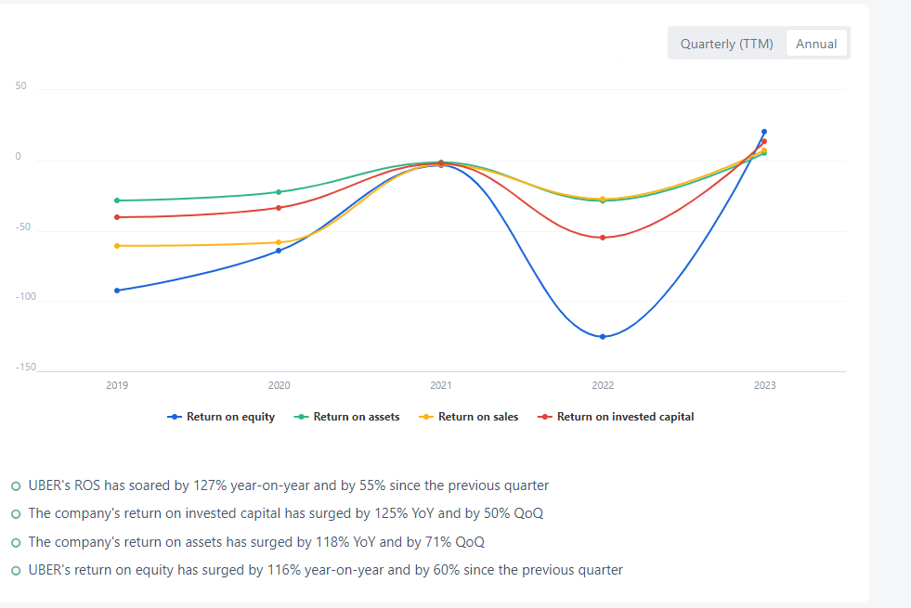
Figure 2 (fullratio.com, 2024)

Annual Growth Rate
The data numbers given show us the price movement of Uber shares that have been taken in the last five years. It presents the closing price of the stock at year end, the average stock price, the annual percent of change, as well as mentioned ratios: risk-free rate and S&P index. Compound Annual Growth Rate of Uber stocks is indeed a remarkable figure with as much as 43% annual growth packed.
A good way to analyze the Uber stock's performance is by examining its performance over a certain period of time against an index, for instance, the S&P 500 which is known to track the US stock market as a whole. In actual fact the data shows that past five years witnessed a fluctuation in value of Uber shares. Notably, the company's stock price rocketed by a staggering 71.49% in 2020 during which the index of the S&P gained 16.26% almost. Uber's stock price has grown for multiple reasons, for example, because of the good sentiments the investors have about the company's innovative structure and the wide room for its expansion
Uber's stock, nonetheless, twitched so strongly in the proceeding years, with the annual percent swings recorded. Such as we have Uber that in the past two years, that is 2021 and 2022 the shares have outperformed the S&P index, with negative returns -17.78% and -41.02%. Such changes could have been as a result of challenges with regulation, stiff competition and investor related factors. To cite an example, the stock of was the best performing one in 2023. It outperformed even the best stock indices. Numerous aspects comprised a sound financial performance, strategic initiatives, and widespread enthusiasm towards the prosperity of the organization for that positive change.
Uber's stock experienced a 12.15% increase in 2024, surpassing the S&P average once again. In other words, this indicates that investors still hold strong expectations for Uber's expansion and ability to generate money. The company's experiences clearly reflect the variations in Uber's stock price over the past five years. Nevertheless, the business demonstrated endurance and perseverance despite significant uncertainty and occasional disappointing performance, particularly in the years 2023 and 2024. Prospective Uber investors should consider the company's historical achievements, as well as broader market trends and distinctive company attributes, to make well-informed investment choices.
Year | Average Stock Price | Year Close | Annual % Change | S & P | Risk Free Rate
2024 | 72.154 | 69.05 | 12.15% | 6.92% | 4.65%
2023 | 41.7801 | 61.57 | 148.97% | 24.23% | 4.65%
2022 | 29.352 | 24.73 | -41.02% | -19.44% | 4.65%
2021 | 48.61 | 41.93 | -17.78% | 26.89% | 4.65%
2020 | 35.5117 | 51 | 71.49% | 16.26% | 4.65%
CAGR |  |  | 43%

Sharpe and Treynor ratios
The data shows how Uber is doing in the market by comparing its financial factors to the S&P index. The S&P had a 6.32% average excess return, while Uber had a 30.11% average excess return. On average, Uber has done better than the market, which means that buyers in Uber stock should make more money.
Uber's standard deviation is 0.6842, which is higher than the S&P's 0.1672. Standard deviation is a way to measure how volatile or risky an investment is. Uber's stock is riskier than the S&P average because its standard deviation is higher, which means that price changes are bigger. The Sharpe ratio for Uber is 0.4401, while the Sharpe ratio for the S&P is 0.3780. Uber's Sharpe ratio suggests a better risk-adjusted return than the S&P index, even though it is more volatile. This means that investors in Uber get a better return on their money than investors in the market.
The S&P index and Uber both have a beta of 1.36. The market sensitivity of stock profits is measured by beta. This means that Uber's stock price changes 36% more than the market as a whole. In other words, Uber's stock makes market changes stronger. Uber's Treynor ratio of 22.14% is a lot higher than the S&P's 4.65%. Uber has high returns per unit of market risk because it uses its cash well and gets higher returns per unit of risk.
Uber looks like an investment with a high risk and a high gain compared to the S&P index. Uber's stock is more risky than the market as a whole, but it has historically given investors more money for their risk. Before buying Uber stock, investors should think about how much risk they are willing to take and what their financial goals are.
 | Uber | S& P
Average excess return | 30.11% | 6.32%
Standard Deviation | 0.684217097 | 0.1672381
Sharpe ratio | 0.440072531 | 0.378024
Beta | 1.36 | 1.36
Treynor Ratio | 22.14% | 4.65%

Exchange traded options

Call Option
The given graph indicates Call options are in profit only if the stock price is above the strike price, this point also shows the effect of various stock prices on the payoff of the call option. When the stock price reaches a strike price of $125 that is an end of the call option and the payoff is $0. An increasing stock price that is above the strike price would correspond with a decreasing payout of the call option which would continue until the cap is achieved at a market value of $150 at maximum loss (Umar et al., 2021).
In drawing, the payoff from an at-the-money call option will be a line that slopes downward and starts from a point $125 on the strike price axis and continues infinitely to the right side of the graph. At X=0 and below, the line will intersect the y-axis at $0 or shake his hand to show his appreciation. As the underly stock price continues to rises above the strike price, the line drawn would sway downwards indicating that the payout has less value to the call option.
The determinant of the profitability of an impot put option that is at-the-money, the stock price rises beyond the strike price. Ordinarily, if the stock fails to rise above the strike level, the call option would be worthless, making the premium the expiry cost to its purchaser. For this reason, these investors who opt for at-the-money call options will strategically chase a bullish market and aim to see the stock price dramatically rise above the strike price to have their profits increase (MarketWatch, 2023)

Put Option
This stated information shows the pay off an at-the-money put option produces for different stock prices. And now the stock price is either at or above the strike price $125 thus, the put option will expire worthless gaining $0. Therefore, as the stock price is less than the strike price, the put option’s payoff also increases linearly, which leads to a maximum profit of $50 at the time of maturity when the stock price is $100 (Zhan et al., 2021).
Graphically the pay-off of a put option with the strike price of $125 could be represented with the rising line that comes from the strike price and ends up at the left side of x-axis, showing all options of stock price at expiration. The line will appear in between the strike price and above it at the point it will intersect the y-axis at $0, meaning either profit or loss. With the decline in stock price below the strike price, the curve of the future would rise, symbolizing the larger gain of the put option.
The shape of this picture in fact means that an at the money put option will be profitable only if the stock price will be lower than the strike price (CARR and WU, 2020). The option finishes “in the money.” However, in this case, the contract expires worthless, and the investor is paid the premium, resulting in a maximum loss equal to the premium paid for the option contract. As a result, buyers of at-the-money puts are typically those who expect a bearish market outlook and hope that stock price will fall substantially below the strike price to benefit from the options contract.
Uber will also be abiding by these principles as well as all of the other obligations imposed upon it. Strikingly buying at the money calls from Uber would be from the investors who would have the expectation of the stock price to decline below the strike price so that they can benefit from the option contract. However, if Uber's stock price continues trading at or above the agreed-upon strike price the day the option contract expires, the put option will be worthless, thus leading to the maximum loss equal to the cost of the put option premium (Nasdaq.com, 2021).

Straddle Strategy
Regarding the strangle options strategy for Apple (AAPL) stock, we shall discuss the search results that follow. A strangle in the realm of options trading occurs when an investor purchases an out-of-the-money call option and an out-of-the-money put option on the same underlying asset. These options have distinct strike prices and expiration dates. The strike prices of call and put options in a straddle are identical, whereas they are dissimilar in a strangle. The principal differentiation between a straddle and a strangle is as follows (Businessperspectives.org, 2023).
Prior to constructing a strangle on Apple shares, an investor would ascertain the stock's prevailing market price, which, according to the information provided, is approximately $182.50. They would then select, for the same expiration date, a call option with a strike price higher than the current stock price and a put option with a strike price lower than the current stock price.
As an illustration, the investor might acquire a $190 strike price call option and a $175 strike price put option on AAPL, both of which would mature on the identical day. Cost of this strangle would equal the sum of the premiums paid for the call and put options.[4] The primary advantage of a strangle is that it enables the investor to profit regardless of the direction of a significant price movement in the underlying stock. The investor may benefit from exercising the applicable option in the event that the stock price surpasses the call strike price or falls below the put strike price.[4] A strangle approach, as opposed to a straddle strategy, requires a more substantial fluctuation in the stock price to generate a positive return. The investor is also exposed to the risk that the stock price will remain in the "strangle" zone, rendering both options meaningless at expiration.[4]
To capitalize on a substantial increase in the underlying stock price, establishing a strangle on Apple stock typically requires judicious selection of call and put options featuring unique strike prices but an identical expiration date (Using Straddles and Strangles to Help Manage Stock Events Webinar Presentation Trading Strategy Desk, 2024).

Performance Analysis

Performance of 10Y note
The performance of 10-year Treasury note yields in the volatile world of financial markets provides insight on the state of the market and the economy. The trends seen in 2023 provide valuable insights about the evolution of investor confidence and economic conditions.
With a return of 3.529% in January, the year began rather steadily. Investors were cautiously optimistic because they thought the economy would grow and inflation would stay low. In February, returns hit 3.916%, which broke the silence. This jump showed that the market had changed because of inflation or tighter money policy.
It went down to 3.494% in March after going down in February. During this shift, economic measures were carefully set to the right levels. Investors were worried about jobs, inflation, and monetary policy. The yield dropped to 3.452% in April, which shows that the market is unclear and people are worried about the world economy.
Once more, returns went up by 3.637% in May. This rise showed cautious hope among investors. This could be because people are optimistic about the economy or the banking system. In June and July, yields hit 3.819% and 3.959%, putting an end to this happiness. Bond markets were affected by stories in the macroeconomy and the world's politics.
August's rate increase to 4.093% marked a significant turning point. This sharp increase indicated that concerns about growing trade tensions, threats to the world economy, or the likelihood that central banks would tighten monetary policy were causing the market to get increasingly agitated. With a significant increase to 4.573% in September, this trend persisted. This indicates that concerns about potential negative consequences and the strains on the world economy are growing (CNBC, 2023).
This increasing trend persisted in October, with a return of 4.875%. This increase demonstrated the erratic and erratic nature of the financial markets as investors attempted to make sense of shifting economic and global conditions. In November, there was a brief pause in the rising rates as yields dropped to 4.352%. When conditions stabilized, it indicated that investors were carefully reevaluating their expectations as they sought additional details regarding the primary economic drivers and potential policy directions.
Returns decreased to 3.866% in December, the last month of the year. This slight decline suggested that market volatility might be lessening as investors attempted to make sense of a convoluted web of geopolitical and economic uncertainties. Overall, 2023 demonstrated the unpredictability and volatility of the bond market. For instance, shifts in the yields on 10-year Treasury notes demonstrated the complex interplay between external shocks, market sentiment, and economic fundamentals (Trading Economics, 2019)

Date | Close
01-01-2023 | 3.529
01-02-2023 | 3.916
01-03-2023 | 3.494
01-04-2023 | 3.452
01-05-2023 | 3.637
01-06-2023 | 3.819
01-07-2023 | 3.959
01-08-2023 | 4.093
01-09-2023 | 4.573
01-10-2023 | 4.875
01-11-2023 | 4.352
01-12-2023 | 3.866

Impact of changes in the yield of this note upon consumer debt
Any changes in the yield on the 10-year US Treasury note have a big effect on consumer debt in a lot of different areas of the economy.
The rate on the 10-year Treasury note has gone up a lot in 2023—it hit 5% in October—because of this. This has directly affected the cost of getting money for consumers. The 10-year Treasury rate is used as a standard for many types of consumer loans, such as mortgages, car loans, and student loans.
The jump in the 10-year yield has caused mortgage rates to go up by a large amount. Freddie Mac says that the average rate for a 30-year fixed mortgage is now 8%. This is a big jump from the recent low interest rate environment. This means that people who want to buy a home will have a harder time getting financing because their ability to spend will go down as their mortgage payments go up. Mortgage rates going up is likely to have a domino effect on the housing market, lowering demand and slowing down the sales rate.
In the same way, the higher return on the 10-year Treasury has caused interest rates on new car loans to go up. The weekly payments for people who are getting new auto loans will go up, but payments for people who already have fixed-rate auto loans will stay the same. Some people would stop looking for new cars because of this, which could hurt auto sales and the economy as a whole.
It also has an effect on the market for government student loans, where interest rates are directly linked to the yield on the 10-year Treasury note. If a college student wants to borrow new direct federal student loans for the 2023–24 school year, they will now have to pay 5.50%, up from 4.99% the previous year. If the 10-year yield stays high, federal student loan rates could go up even more when they restart in the spring. This would add to the debt that students and their families already have.
Mortgages, auto loans, student loans, credit cards, small business loans, and home equity lines of credit are all affected by the higher return on the 10-year Treasury note. A lot of these debt products rely on the federal funds rate, which is set by the Federal Reserve. As the Fed continues to raise interest rates to fight inflation, these fees will make it more expensive for consumers to borrow money. The family will have less money. Costs of borrowing may be going up more across all consumer credit markets, which could hurt the economy more. Less spending on things that aren't necessary could slow down economic growth. People may have trouble making ends meet because the costs of paying off debt are going up, which can lead to fails and late payments.
The yield on 10-year U.S. Treasury notes went up a lot in 2023, which made it more expensive to get car loans, mortgages, school loans, and other types of credit. Family income, spending, and economic growth may all get worse.

References
Businessperspectives.org. 2023. Available at: https://www.businessperspectives.org/images/pdf/applications/publishing/templates/article/assets/16401/IMFI_2022_02_Shivaprasad.pdf.
CARR, P. and WU, L. 2020. Option Profit and Loss Attribution and Pricing: A New Framework. The Journal of Finance, 75(4), pp.2271–2316.
CNBC 2023. Check out US TREASURY-CURRENT 10 YEAR’s stock price (US10Y) in real time. [online] CNBC. Available at: https://www.cnbc.com/quotes/US10Y.
Cordina, R., Feng, J., Hannah, G. and Power, D.M. 2020. The IPO of Uber - a classroom case. International Journal of Teaching and Case Studies, 11(3), p.191. doi:https://doi.org/10.1504/ijtcs.2020.111137.
Corporate Finance Institute. 2024. SEC Form S-1. [online] Available at: https://corporatefinanceinstitute.com/resources/wealth-management/sec-form-s-1/ [Accessed 27 Apr. 2024].
Dos, J., Oliveira, S. and Silva, R. 2024. UBER’S PROFITABILITY: THE ELEPHANT IN THE ROOM Work project carried out under the supervision of. [online] Available at: https://run.unl.pt/bitstream/10362/158109/1/2022_23_Fall_49165.pdf.
fullratio.com. 2024. NYSE: UBER - Uber Technologies stock analysis and financials. [online] Available at: https://fullratio.com/stocks/nyse-uber/uber-technologies.
Hawkins, A.J. 2019. Uber goes public: everything you need to know about the biggest tech IPO in years. [online] The Verge. Available at: https://www.theverge.com/2019/5/10/18564197/uber-ipo-stock-valuation-pricing-fares-drivers-public-market.
heinonline.org. 2024. Redirecting... [online] Available at: https://heinonline.org/hol-cgi-bin/get_pdf.cgi?handle=hein.journals/hbusrew10§ion=5 [Accessed 27 Apr. 2024].
MarketWatch. 2023. AAPL | Apple Inc. Options. [online] Available at: https://www.marketwatch.com/investing/stock/aapl/options.
Ming, L., Tunca, T.I., Xu, Y. and Zhu, W. 2019. An Empirical Analysis of Market Formation, Pricing, and Revenue Sharing in Ride-Hailing Services. SSRN Electronic Journal.
Nasdaq.com. 2021. Apple Inc. Common Stock (AAPL) Option Chain. [online] Available at: https://www.nasdaq.com/market-activity/stocks/aapl/option-chain.
PwC (2017). Roadmap for an IPO A guide to going public. [online] Available at: https://www.pwc.com/hu/hu/szolgaltatasok/konyvvizsgalat/szamviteli-tanacsadas/kiadvanyok/roadmap_for_an_ipo.pdf.
Rangel, T., Gonzalez, J.N., Gomez, J., Romero, F. and Vassallo, J.M. 2021. Exploring ride-hailing fares: an empirical analysis of the case of Madrid. Transportation, 49(2), pp.373–393.
Smith, N.C. and McCormick, E. (2018). Uber and the Ethics of Sharing: Exploring the Societal Promises and Responsibilities of the Sharing Economy. Managing Sustainable Business, pp.575–607.
Trading Economics 2019. United States Government Bond 10Y | 2019 | Data | Chart | Calendar. [online] Tradingeconomics.com. Available at: https://tradingeconomics.com/united-states/government-bond-yield.
Umar, Z., Gubareva, M., Yousaf, I. and Ali, S. 2021. A tale of company fundamentals vs sentiment driven pricing: The case of GameStop. Journal of Behavioral and Experimental Finance, 30(30), p.100501.
Using Straddles and Strangles to Help Manage Stock Events Webinar Presentation Trading Strategy Desk. 2024. Available at: https://www.fidelity.com/bin-public/060_www_fidelity_com/documents/StraddlesStrangles_Webinar.pdf [Accessed 27 Apr. 2024].
www.acquired.fm. 2024. The Uber IPO | Acquired Podcast. [online] Available at: https://www.acquired.fm/episodes/the-uber-ipo.
Zhan, X. (Eunice), Han, B., Cao, J. and Tong, Q. 2021. Option Return Predictability. The Review of Financial Studies, 35(3), pp.1394–1442.

