Experimental portfolio

Intro
The purpose of this portfolio is to demonstrate the understanding of physiological testing methods that are used to assess performance and health. Throughout our module, there were three mini experiments conducted in a group setting to understand and explore key physiological measures that the reliantly to exercise. While data collection was completed together as a group, this portfolio will present an individual analysis, and critical evaluation of the findings.

Physiological testing plays a significant role in athlete development and performance evaluation across various sports. (Söderström, et al., 2024) Laboratory and on filed based assessments are used to monitor training, optimise people's performances and identify the strengths and weaknesses within the specific physiological systems. (Schupfner, et al.2021). Also, Physiological testing can be clinical and health settings, similar tests and assessments can be used to help cardiovascular, identify any health risks and guide exercise prescriptions according to Delextrat, & Cohen., (2008). Therefore, the use of objective physiological testing and measures allows to make evidence based decisions that help both performance outcomes and overall wellbeing.

The three mini experiments are looking to three different options and what we could gain from them using data, one mini experiment is to examine whether Keiser peak power predicts the Wingate performance. The Keiser measures the peak power during explosive exercise, while the whgate test is more anaerobic power and during high intensity cycling. This experiment is to aim to determine of whether the peak power measured using kesierpeak power is associated with performance outcomes in the Wingate test. The other experiment is to examine where're there is a difference in countermovent jump (CMJ), for this experiment i will divide the participants into males and females' groups and work out the mean between both groups by using SPSS. The aim for this experiment is to find out whether is there meaningful difference in jump hight existed between sexes. The third experiment is to explore whether there is a relationship between vo2 max score and Wingate peak power.

Does Keiser peak power predict Wingate performance?
Participants
Participants that took part in the in this experiment were all undergraduate students between 19-30 on the same module volunteered to take part in the particle experiment. All 16 precipitants were fit and injury free while the testing was taking place and included both male and females.

Protocol
Adenoidally, to examine whether there was a significant relationship exists between the two measures, participants completed two different assessments of peak power. The participants asseed their peak power by using the Keiser a300 Leg press (Keiser Corporation, Fresno, CA, USA.) Therefore, by using this equipment participants performed explosives leg press with it being vital their legs were in a 90 degrees angle, with instructions to push as hardest and as quickly as possible to get the best power output. The highest peak power value that was record were used for analysis.

Participants also completed a 30 second Wingate test by using the Monark Bike. ( Monark Exercise AB, Vansbro, Sweden). Following a standard 5 minute warm up on wattbike pro (Wattbike Ltd, Nottingham, UK) participants were instructed to cycle at maximal effort for the full duration for the full 30 seconds of the test. The Peak power output that was recorded was used for comparison.

Results

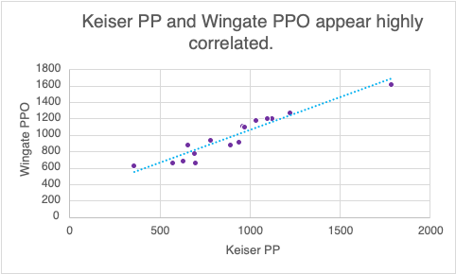

Model Summary
Model | R | R² | Adjusted R² | Std. Error of the Estimate
1 | 0.955 | 0.912 | 0.906 | 84.81

Interpretation
The results show that there is a very strong positive liner relationship between Keiser peak power and Wingate peak power output as shown in the graph with an upwards line. Additionally, research agress with this and says how important keiser peak power and a wingate performer are important for anaerobic power which averages power and fatigue index (Zupan, et al. 2009). As we can see the Correlation coefficient R-0.955 indicates a very strong assosction between both variables. Furthermore, the coefficient of determintation which was R2(squared) 0.912 shows that around 91% of the Wingate performance can be explained by Kesier peak power. This suggests that keiser peak power is a highly effective predictor anaerobic peak power that is measured during the Wingate test. As Takizawa, et al. (2021) states. Therefore, this shows that despite the two being a different movement in machines with the Keiser being a leg press movement and the Wingate being a cycling movement they help each other and has a strong positive relationship.

Reflections
As the Wingate and Keiser power are both well known for assessing anaerobic power (Klasnja et al., 2010). While doing this experiment one important situation was important which was the Participants that took the experiment on, all 16 that took part were under graduated students in university so results can be not reliable as there was a lot of people taking it on with a small amount of time and did all make sure they had a recovery inbetweener the both, recovery was important as both are working on the legs which will need to have a adequate recovery between the tests. Also, as the two are a different movement, as with the Keiser being more of a powerful leg movement and the Wingate being more of a cycling sprits and pays more attention to the sport cycling the students maybe haven’t takin’s part in cycling sprits before or not play a sport that concentrate on different muscles and health fitness, therefore legs could be the weakest muscles for some students.

Is there a difference in CMJ performance between males and females?
Participants
Participants that took part in the in this experiment were all undergraduate students between 19-30 on the same module volunteered to take part in the particle experiment. All 15 precipitants were fit and injury free while the testing was taking place. Therefore, as I wanted to find if there is a difference between male and females, splitting them between both was needed. In this experiment there was 8 females and 6 males. With the aim to determine whether there is a difference in a countermovement jump between male and females

Protocol
The countermovement jump (CMJ) was assessed with the participants using the force platform (HUR Oy, Kokkola, Finland) By the participants using this equipment they stood in upright position, performed a fast jump and then immediately land on both feet with the intention of jumping as high as they can with hands on their hips while they were doing this. Each participant performed this jump and peak power output was measured for analysis.

Results
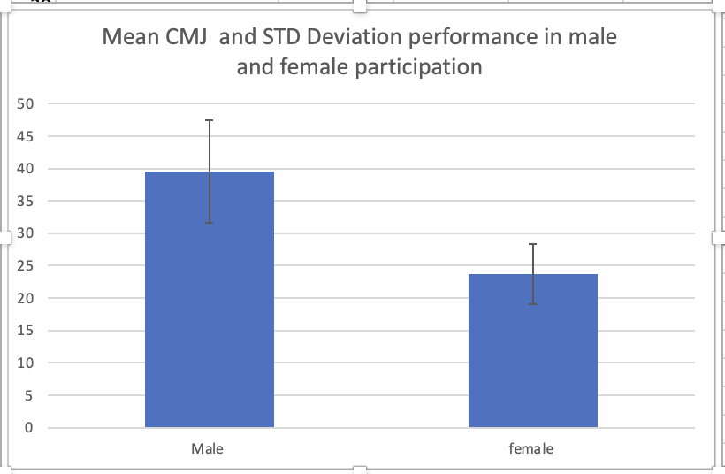

Interpretation
The results from this experiment and what it shows in the graph desmotstes that male participants had much higher mean countermovent jump (CMJ) performance with the results being 39.5 mean score with a 7.9 std Deviation compared to the female participants that had 23.7 mean with a 4.7 Std Deviation. This suggests a clear difference in both sexes with the males having lot better explosive sexes.
With these results research does agree with it, for example McMahon, Rej & comfort., (2007) states that ‘’males generally demonstrate better countermovment jump performance than females across various populations and sport disciplines, these differences apllty to men having a larger concerictic impulse and achieving greater velocity during the phase of the jump’ ’with this research it explains from a physiological perspective that there is a large different in muscle mass between the both sexes. Research suggest that males generally have a greater absolute skeletal muscles mass compered to females (Abe, et al. 2019). This explains and gives a understanding why males in this experiment do have a larger higher mean countermovent jump. Overall, the findings that were found are match with the physiological principles that sex differences in muscle and with power, which supports that males would demonstrate a greater CMJ performance then females.

Reflections
While the countermovement jump (CMJ) test is widely used to assess lower body power. (Altaibi, et al. 2023). There are many factors that can affect the accuracy of the result, for example, jumping techniques because some participants may not be familiar with the right jumping you need to do the CMJ, therefore the effort level is not as high with some who hasn’t experienced this movement before. Also, with having only 15 participants doing the tests it’s a small size which my limit how well the results are with other wider populations, For this experiment foot wear is important with how comfortable you need to be to land and jump from a sand point, therefore some participants may not have had the right footwear on the day.

Is there a relationship between vo2 max score and Wingate peak power.
Participants
Participants were undergraduate students between 19-30 on the same module. All 6 were healthy and free from injury time of the testing and was conducted in a controlled laboratory environment. With the aim was to find out if whether a relationship exists between VO2 max score and Wingate peak power.

Protocol
Peak power was assesses using a 30 second max cycling test with using the Monark Bike. (Monark Exercise AB, Vansbro, Sweden). Participants performed an all out sprint with peak power(W) achieved during this test was needed for analysis.

Vo2max was assessed using a graded exercise performance by using the Wateebike Pro (wattbike LTD., Nottingham, UK.) as we took a 30 second of expired air by using the Douglas bag. (Hans Rudolph Inc., Shawnee, KS, USA) and measured it to get there Vo2 max.

Results

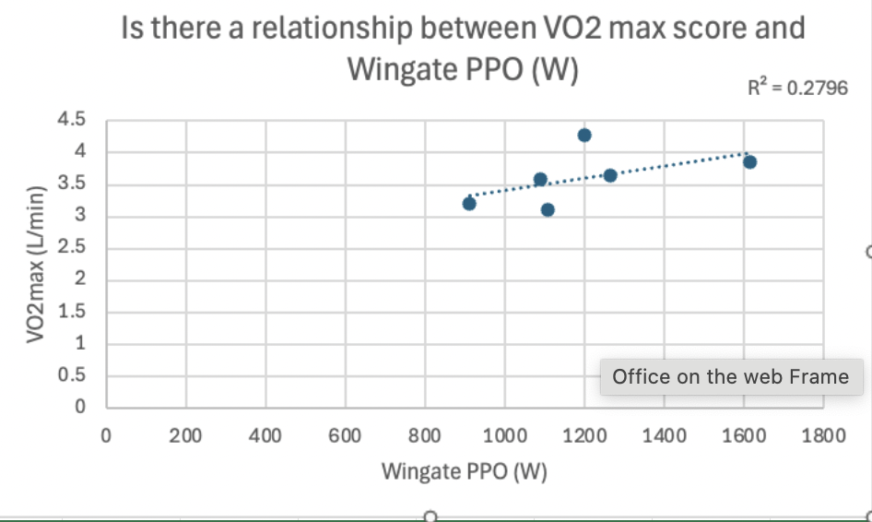

Interpretation
The scatter plot shows a positive relationship between vo2 max and the wingate peak power, as the graph shows the Wingate Peak power (PPO) does increase, also the vo2 max values also does increase a bit more slightly, that being said the graph also that the relationship appears to be weak. As shown by the R squared the value is 0.2789, that indicates that only 28% of the variation in the vo2 max can be assessed and explained by difference in peak power. From a physiological perspective, the relationship can be explained with that the Wingate and VO2 max measures different energy systems. According to Price. et al. (2014) the wingate test primarily evaluates anaerobic power, while the Vo2 max test assesses aerobic capacity. This explains that the participants who perform well in a anaerobic power tests, in this experiment is the wingate test they may not have high aerobic capacity. This might explain why the correlation between the two is not particularly strong.

Reflections
Therefore, while the both vo2 man and Wingate tests are used to assess physiological performance, There could be factors that may affect the influence the results. For example, with the wingate it relies on heavily maximal effort, and if the participants didn’t give their maximum effort the peak power may not have been as accentuate on their anaerobic capacity. Also, with the vo2 max testing it can be affected by factors such as fatigue and with it only testing 6 participants if some are unfamiliar with the testing equipment it can have an impact.
Despite these, the findings can still be used in a real word setting and sport performances. As they can use these two testing in different aspects of athlete’s fitness that includes aerobic capacity and anaerobic power.

In conclusion, the results from these three mini experiments have provided an insight on different aspects of physiological performances. The CMJ results showed that the male participants produced a higher jump performance then female and agreed with research of it likely being due to different in muscle mass and power. The tdate from vo2 max and wingate peak power output showed only a weak relationship, suggesting that aerobic capacity and anaerobic power do rely on different physiological systems, also the kiser peak power and Wingate power shows a very strong positive liner relationship and again research agrees and states how important both are for anaerobic power. Overall, these tests have demonstrated how different some measures can be used to assesess performances and fitness levels, and show how important of using these kinds of tests to have a better understanding n physical performance.

Reference list

Abe, T. et al. (2019) “Differences in 100-m sprint performance and skeletal muscle mass between elite male and female sprinters,” Journal of sports medicine and physical fitness, 59(2), p. 304. Available at: https://doi.org/10.23736/S0022-4707.18.08267-1.

Alotaibi, M.M. et al. (2023) “30-Second Chair Stand Test Predicts Countermovement Jump Performance in Young Adults,” Sports health, 15(3), pp. 452–458. Available at: https://doi.org/10.1177/19417381221105040.

Delextrat, A. and Cohen, D. (2008) “Physiological Testing of Basketball Players: Toward a Standard Evaluation of Anaerobic Fitness,” Journal of strength and conditioning research, 22(4), pp. 1066–1072. Available at: https://doi.org/10.1519/JSC.0b013e3181739d9b.

Douglas bag’’ Hans Rudolph Inc., Shawnee, KS, USA. ‘’ Available at https://www.rudolphkc.com

Forceplatfrom ‘’HUR Oy, Kokkola, Finland ‘’. Available at: https://hur.fi

Keiser A300 Leg Press’’ Keiser Corporation, Fresno, CA, USA’’ Available at: https://www.keiser.com

Klasnja, A. et al. (2010) “Comparative analysis of two different methods of anaerobic capacity assessment in sedentary young men,” Vojnosanitetski pregled, 67(3), pp. 220–224. Available at: https://doi.org/10.2298/VSP1003220K.

McMahon, J., Rej, S. and Comfort, P. (2017) “Sex Differences in Countermovement Jump Phase Characteristics,” Sports (Basel), 5(1), p. 8. Available at: https://doi.org/10.3390/sports5010008.

Monark Ergomedic 894E ‘’ Monark Exercise AB, Vansbro, Sweden’’ Available at: https://monarkexercise.se

Price, M. et al. (2014) “Oxygen uptake during upper body and lower body Wingate anaerobic tests,” Applied physiology, nutrition, and metabolism, 39(12), pp. 1345–1351. Available at: https://doi.org/10.1139/apnm-2013-0405.

Schupfner, R. et al. (2021) “Physiological factors which influence the performance potential of athletes: analysis of sports medicine performance testing in Nordic combined,” The Physician and sportsmedicine, 49(1), pp. 106–115. Available at: https://doi.org/10.1080/00913847.2020.1796181.

Söderström, T. et al. (2024) “The role of physiological testing for athlete development in sport: The elite athlete perspective,” International review for the sociology of sport, 59(8), pp. 1244–1265. Available at: https://doi.org/10.1177/10126902241258677.

Takizawa, K. et al. (2021) “Effects of work-matched high-intensity intermittent cycling training with different loads and cadences on Wingate anaerobic test performance in university athletes,” The Journal of Physical Fitness and Sports Medicine, 10(4), pp. 191–198. Available at: https://doi.org/10.7600/jpfsm.10.191.

Wattbike Pro’’ Wattbike Ltd, Nottingham, UK’’. Available at: https://www.wattbike.com

Zupan, M.F. et al. (2009) “Wingate Anaerobic Test Peak Power and Anaerobic Capacity Classifications for Men and Women Intercollegiate Athletes,” Journal of strength and conditioning research, 23(9), pp. 2598–2604. Available at: https://doi.org/10.1519/JSC.0b013e3181b1b21b.

