Student: | Charles Gill | Student ID No: | 0250767
Programme: | BSc/HND Computing (All Streams) | Module: | Academic and Employability Skills (May2019 PT intake)
Lecturer: | Gareth Jones | Module code: | ACCA4016
Assignment Title: | Reflection on Academic and Employability Skills | Submission: | 26th July 2019

Reflection on Academic and Employability Skills

Declaration

The work of this report completed under the supervision of (G Jones). I declare that this report is the product of my own work and is not being submitted for any other degree etc.
Signed: Charles Gill

Abstract

This report contains a reflection and discussion around the topics covered during the course of the Academic and Employment Skills module. It covers areas such as delivering presentations, and a reflection on the presentation given as part of the course.
The presentation also included a personal review of the personality type of the author, using the Jungian, Myers-Brigg format, and how that is best utilised within the workplace. Other personality type tests were performed and the results of these are compared to give a more complete picture.
The goals of the author are discussed and the SMART system is used to determine steps towards achieving those goals. These take the form of both short-term goals and long-term goals.
A methodology is provided for keeping data safe, including the ‘in three places’ rule. This leads on to disaster recovery and how recovery would be achieved in light of several disaster scenarios, including a ransomware attack.
A roundup completes the document including how to improve time-management and increase productivity.

Contents
Declaration 2
Abstract 3
Section 1. About myself. 5
Section 2. Research into Skills Evaluation 10
Section 3. Action Plans 14
Section 4. Application 20
Section 5. Conclusion and Evaluation 26
Bibliography 27
Section 6. Appendices 29
Appendix A – Personality Tests 30
Appendix B: Ransomware class exercise 35

About myself.
The presentation revealed aspects of the life of the author, from physical attributes to how time is spent, hobbies and personality traits.
Apart from physical attributes, the author is a hard-working, conscientious (debatable – see later section about skills evaluation), dynamic individual that enjoys the pressure of an immediate task. Never happier when working on the fly.
Over the years, his role has included technical support for a local computer firm (long gone after the advent of 16bit computing).
IT manager (read computer/electronic device fixer) for a chain of local retail pharmacies, including help develop an EPOS system in-house for the chain. A national chain of pharmacies took that business over and the role changed to include helping with UAT testing of an EPOS system for a national chain of pharmacies. The national chain of pharmacies also implemented his skills when converting branches from other businesses over to their portfolio. This meant training staff and setting up the EPOS system in each branch, sometimes within one weekend.
The above tasks were nearly always immediate response, type of tasks. In the nine years of working for the local pharmacies, no branch was without their computer system for more than 3-4 hours. This was run with one spare system and the area covered was from Pembroke Dock to Monmouth.
Dealing with situations quickly and diagnosing what needs to be done is probably a speciality of the author. However, this type of demand is often at the detriment of long-term projects.
Although, this was not covered within the scope of the presentation, the author initially felt that the presentation was more pf a personal presentation than an employment history.
From that perspective the following slides were created:

Physical attributes:
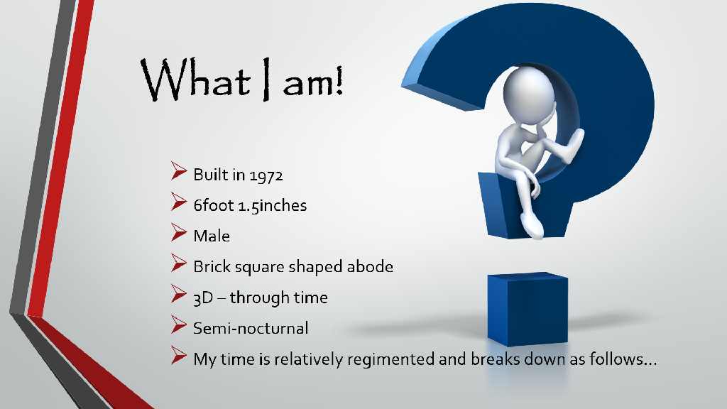
This was included as a humourus introduction to the basic nature of the author, a couple of comments from these lines linked in to later aspects of the slides.
What he does:
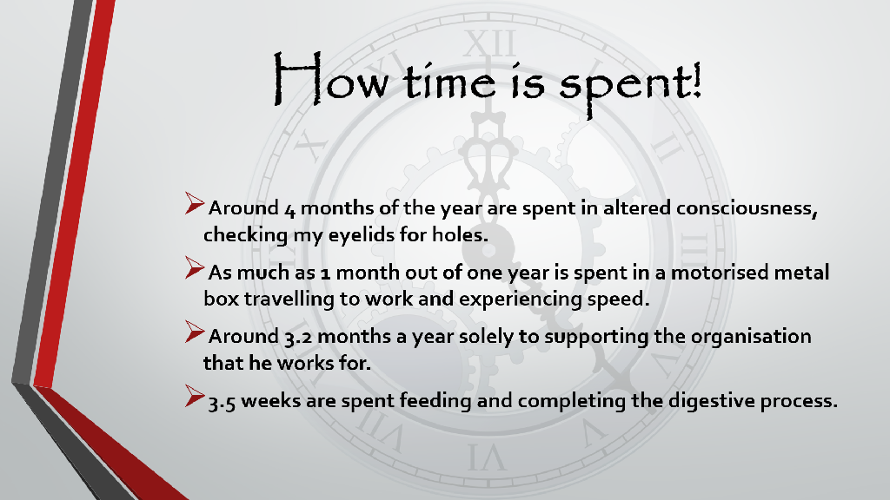
This divided up an average year, but displaying that more time is spent at work than enjoying personal hobbies, such as:
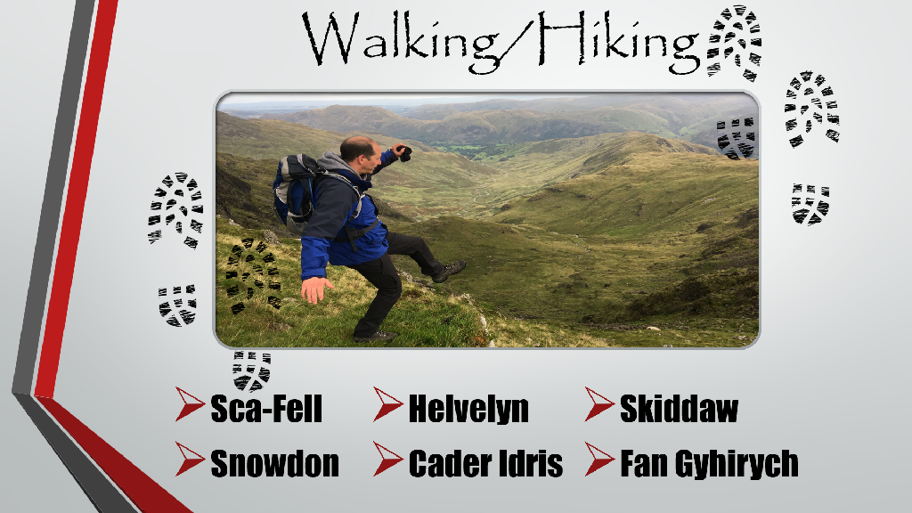
and

There were further slides that showed the personality traits from personality tests, however, the screenshots of these are included in the appendix of this document and there is no need for replication.
The key points that were personally realised by the design and implementation of the presentation are as follows:
- 5 minutes is not that long to talk for, prose must be quite short.
- Copyright is sometimes an issue for making a presentation with certain effects.
- Practice the presentation out loud and time it.
- Use material that you know well (or know your subject well), if something does go slightly awry during the presentation its much easier to get back on track.
- Make each slide themed, and do not cram too much into it.
- Use the bullet points on the screen for reminders, rather than type everything onto the slide.
- Use a clear design with minimal information on the slide.
- Use a template background and stick to it. If it can be themed to the subject, great otherwise simple and striking is best.
- Deliver the presentation with the slides as a background.
- Arrive prepared, check presentation hardware works.
- Deliver confidently and believe that the audience are genuinely interested and speak to them as if they were friends or colleagues.

The above matches well with the advice given on Microsoft’s website for producing and delivering an effective presentation. [1]
- Minimize the number of slides.
- Choose a font style that your audience can read from a distance.
- Keep your text simple by using bullet points or short sentences.
- Use art to help convey your message.
- Make slide backgrounds subtle and keep them consistent.
- Use high contrast between background color and text color.
- Check the spelling and grammar.

The above cover the slide content and the below cover the delivery: [1]
- Show up early and verify that your equipment works properly.
- Don't assume that your presentation will work fine on another computer.
- Verify that the projector's resolution is the same as the computer on which you created your presentation.
- Turn your screen saver off.
- Check all colors on a projection screen before giving the actual presentation.
- Ask your audience to hold questions until the end.
- Avoid moving the pointer unconsciously.
- Do not read the presentation.
- Stay on time.
- Monitor your audience's behavior.

Improvements for future presentations:
There was a section missed from the brief and therefore the first improvement would be to always carefully read the outline of the presentation first.
One of the slides was rather too busy, as it had content from multiple sources. The sources colours and shapes did not match well. Maybe a couple of slides would have been ideal.
There was an amount of humour placed into the presentation, that maybe could have been lessened and further facts put forward. This worked well with the audience, but the use of humour should be lessened.
Try to remain on focus to the material that is directly relevant and do not ‘go off on a tangent’ when speaking, unless a question arises that warrants it. If the question is too far off topic, offer a ‘We can speak about this after the presentation’ reply.

Research into Skills Evaluation
The key skills required for successful learning in higher education are considered by the author to be dedication, a willingness to learn, time management, an interest in the subject and teaching materials being available to the student.
The above are correlated by Catherine Dawson as she lists the following [2]:
- The skills to be learned are relevant to you and your needs.
- You are interested in your learning.
- You are motivated to learn.
- You can learn to use these skills in different contexts and activities.
- You are actively involved in the learning process.
- You are able to think, develop and work at your own pace.
- You feel comfortable in your learning environment.
- You are comfortable with the instructor, teaching methods and/or teaching materials.
The above are to some degree interlinked, for example being interested in your learning increases motivation that leads to being actively involved in the learning. And the interest is likely to stem from the skills being relevant to your needs. Being comfortable in the learning environment includes the lecturers, methods and materials in some ways. So, to break the above down, interest and a good learning environment are very important.

The key skills that employers generally look for in potential employees are according to prospects.ac.uk [3]:
Resilience | The ability to deal with setbacks, it is understood that there will be an effect but are you able to react positively.
Good communication | How clearly you can put across ideas and listen to others. How you can build rapport, persuade and negotiate with others.
Effective leadership | Demonstrate that you have the potential to motivate and lead others to achieve common objectives.
Planning and research skills | Be able to arrive at a suitable strategy and plan of action.
Self Management | Prioritising duties, working under pressure, managing time effectively demonstrate that you are able to be flexible and can be trusted.
Teamwork and inter-personal skills | Not only the ability to lead a team successfully, but being a team member also, where following instruction and direction from someone else is important.

All of the above are important to employers as they provide the security for the employer to know that the employment of that person will be advantageous to the organisation. Depending on the job role, it may be that certain aspects of the above are more or less important. But a demonstration of these attributes will always give a positive response to an individual.
As well as the above attributes there are a well-known set of personality types and it is considered good practice to include different personality types within a given team.
To this end, the author has taken part in a number of online personality tests.
The first of which is the ‘IPIP Big 5 Factor markers’, the results of the test were as follows:
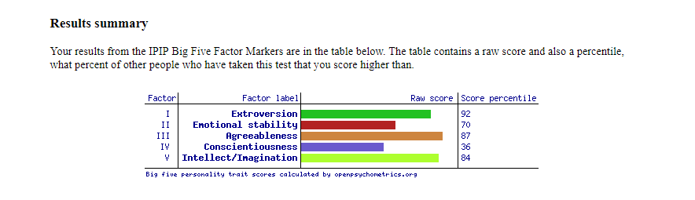
This was surprising in that the author has always considered himself conscientious, in that he has always wanted to do his work well and not let anyone down. However, the ‘in the moment’ nature of this individual means there is a high dispensation toward being impulsive and disorganised, which was obviously picked up during the questions.

Another well-known test is the Jung based, Myers-Briggs test which categorises personalities into 16 different types.
After answering the questions, the Myers-Briggs test gave a personality type of ESTP as follows:
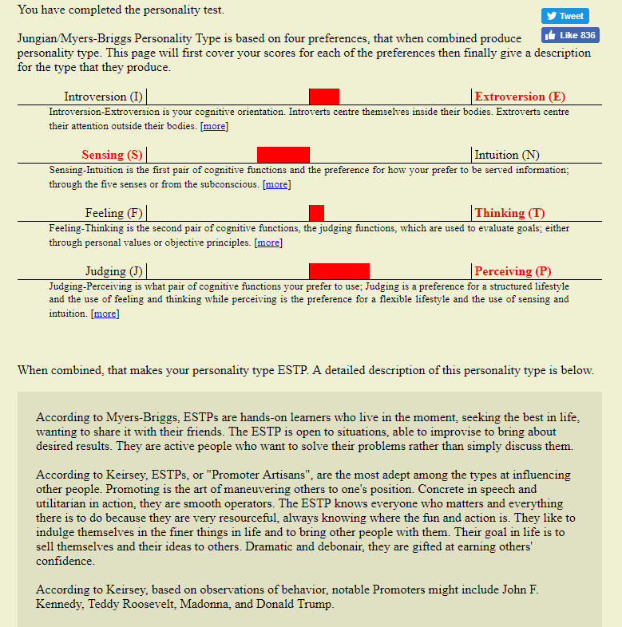
The four preference areas are probably fairly accurate for the author;
- who considers himself quite social in that he likes to be around other people and often considers how others see him.
- Certainly, making sense of the world is done through the senses for this individual rather than the subconscious.
- Prefers to think through issues rather than be laboured with subjective feelings.
- Enjoys the dynamism of a flexible lifestyle and to experience new situations and not be tied to a structured lifestyle.
The first paragraph is correct in that the author
‘is a hands on learner, seeking the best in life, wanting to share it with friends. The ESTP is open to situations, able to improvise to bring about results. They are active people who want to solve their problems rather than simply discuss them.’
However, there are aspects of the synopsis that do not tally with the author, he has always reserved the right to respect other people’s positions and does not actively attempt to manoeuvre them to his position. There is always the aspect that the other person has their timeline of events that makes them think in a certain way, without having access to that information it is unfair for him to try and change another. The author is not someone who structures their life around who ‘matters’, and also does not try to sell themselves, in fact that seems an alien concept to him. Again, dramatic and debonair are not words that describe the author well, although he will accept that he is good at earning other’s confidence.
Another website – www.123test.com/jung-personality-test/ provided another set of questions that provide a Jung based Myers-Brigg result.
This time the result was as follows:
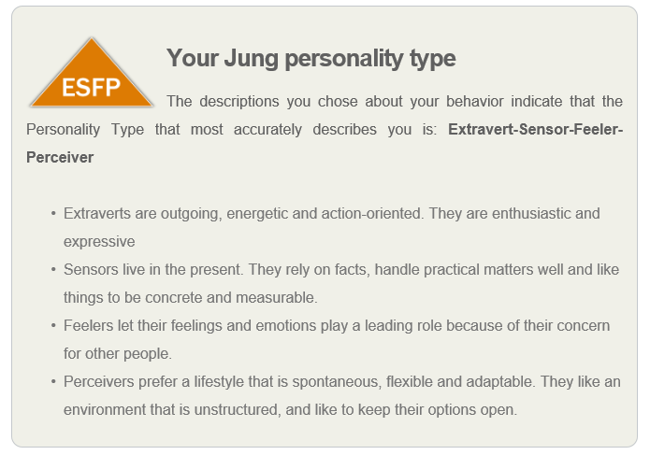
The ESFP is probably more accurate with the above descriptions, however, although it is apparent that the questions asked around the Feeling/Thinking area have nuances that means that the author may have answered some of these questions slightly differently. It is true that this preference area was the closest to the middle on the first chart. Indicating that he sits around the middle of this area and circumstances will push the author either way.
The results of the tests mainly confirmed the authors description of himself, although would not have scored the extrovert nature so highly.
The author relishes a dynamic environment and enjoys the thrill of urgent work, long term projects are less appealing but can be broken down into small steps that are achievable meaning that the sense of gratification is still achievable within such a project.

Action Plans
The below is a list of some of the goals that I currently am aiming for:
Short term goals | Complete ISO17025 Validation and current maintenance within work by October.  Complete first ‘term’ of university degree.  Complete house renovation by October. (All downstairs rooms including re-wiring, plastering and decorating)
Long-term goals | Attain accreditation for all areas within ISO17025 for work.  Complete degree course and change role to include an element of programming.  Setup a business utilising my programming skills.  Enjoy hobbies again.

Applying SMART to the above provides the following:
Complete ISO17025 Validation and maintenance
Specific | - Complete 24,000 word write-up of validation process by end of July.  - Upload 18 months of work into validation library by beginning of August.  - Visit Quality Assurance checks and check all work against the criteria by 3rd week August.  - Collate any issues, raise and correct them by early September.  - Audit all SOPs by first week of September  - Produce training days and make sure staff are aware of their responsibilities for ISO17025 by end of September.
Measurable | The validation report will be emailed to the quality manager by the end of July, with the validation library being available on the server shortly afterwards.  The Quality assurance documents will be completed and saved as records with issues detailed thereon toward the end of August.  Routine Auditing of documents provides the framework against which to complete the checking of SOPs by the beginning of September. The framework includes documentation of the above taking place.  The above two tasks will detail any content of training days required in preparation for October.
Achievable | Each of the tasks above is achievable within the timescales detailed. The validation leads to the SOP changes and QA checking provides the details of any training.  All content and SOPs exist and so the content of any training is already known, they will not be new subjects.
Realistic | Without too many extraneous distractions and support from staff members, the timetable as it is set out is achievable.
Time-Bound | The accreditors are visiting in mid-October. We will be ready by this time.

Complete first ‘term’ of university degree
Specific | Complete 3,500 word write-up of AES assignment by 3pm July 26th.
Measurable | The AES assignment will be completed and then submitted through Turnitin on Friday 26th July.
Achievable | The amount of work left on the assignment is achievable as the groundwork for the document has been laid over the last couple of weeks and time in lectures.
Realistic | 3,500 words is achievable within the timescale left.
Time-Bound | The assignment has to be submitted by 3pm on Friday 26th July.

Complete house renovation by October
Specific | - Drill holes and re-route electric cabling by end of July  - Measure sliding door arrangement and mark walls by end of July  - Fit studding and false walls to cover pipework by first week of August  - Arrange plasterers for quote and timescales by mid August.  - Plaster living room and front room by end of August/beginning of September  - Fit sliding door mechanism and standard doors by mid September.  - Complete fitments by end of September and decorate by October.
Measurable | Within the next week, the cabling will be in place and walls marked with the sliding door dimensions.  Contractors will have the studding completed by the first week of August at which point the pipework etc will be hidden by the false walls.  Plasterers will visit shortly after that to provide costs and timescales by mid August.  Fit sliding doors and other fitments once the walls are dry and decorate by October.
Achievable | Each of the steps above can be completed within a day to a maximum of a week, there is at least a week between each step and so this is achievable.
Realistic | The timescales are reasonable, and the only aspect that is unknown is whether the contractors can arrive on time.
Time-Bound | I have invited friends and family over to watch the rugby autumn internationals. Although they start on the 23rd of September, Fiji on the 9th October would be good.

Long Term goals
Attain accreditation for all areas within ISO17025 for work.
Specific | - Complete submission of extension of scope as validated with recent work by end of July.  - Be audited by the governing body in light of the new extension to scope, likely to be November-December depending on their availability.  - Cover the three months of actions that will be produced by the audit by February / March 2020.  - Confirm accreditation 1 month later.
Measurable | The large validation document just completed starts this process and will see the email of an AC4 document to the auditing body.  The auditors will arrive in November/December to audit the work performed. Actions will be raised at this point.  Completion of the actions means a submission of evidence that the actions have been addressed. If completed to their satisfaction, accreditation will be granted with a certificate a month later.
Achievable | All of the validation documents are complete and all SOPs have been amended or will have been amended according to internal auditing procedures. The quality management system is in place and it is a question of awaiting the auditors results to determine the following three months of work.
Realistic | The timescales are reasonable, and the only aspect that is unknown is how many actions the auditors will find.
Time-Bound | The organisation would like to be accredited as soon as possible, but April 2020 is likely.

Complete degree course and change role
Specific | - Complete each assignment on time and progress my abilities within the scope of the degree course  - Learn about my interests and abilities and utilise my strengths to perform well.  - Organise my life around furthering my education, rather than fitting it in.
Measurable | The assignments will be submitted on time and reflection on this activity will display my strengths.  As submissions become earlier and of better quality I can measure my success of the above.
Achievable | I have a good background knowledge of the degree subject and enjoy reading on the subject matter. These two factors make the above achievable.
Realistic | The timescales are reasonable, as the degree is part time, and over 4 years. This should provide time to complete the course satisfactorily.
Time-Bound | By 2023 I will have a degree in software engineering.

Setup a business utilising software engineering skills
Specific | - Early projects will be work orientated and will build my confidence in writing applications within the next 2 years.  - Think of certain programming projects that could be marketable in three – four years. (The degree project will be work oriented)  - Set in motion, research into what could be provided and look into the technologies behind those projects by 2022.  - Start writing software in spare time in 2023 to produce a marketable application in 2024.
Measurable | The assignments within the degree course will form the start of writing applications.  I already have ideas for what products to supply, research online and with other businesses to determine which would be profitable. Produce a product plan in 2022 naming the technologies to be used.  Learn those technologies and realise that I can utilise them to write apps, produce first app 2023.
Achievable | I have a good background knowledge of programming and need to get up to speed with current techniques. By staging this career advancement in the manner above this will be achievable.
Realistic | The timescales are reasonable, as the degree ties in almost integrally to furthering my ability in this area.
Time-Bound | By 2024 I will have a project that will possibly become a business.

Application
The most suitable backup solution that applies to a general student or home user utilises the ‘in three different places’ rule. To take this one step further, there is the addition of the 3, 2, 1 rule [4] as put forward by Ryan Harnedy on the Carbonite website. Carbonite are a supplier of storage solutions.
The 3, 2, 1 rule extends the ‘three different places’ rule to include media types. Therefore, have your data in three different places, on two different media types and one offsite storage media.
The first place that personal data is created will be on a personal device. This could be a camera, phone or other device initially. It is common for the author to already backup those devices to one of his desktop or laptop computers. The Apple iPhone will backup to the Apple MacBook regularly, and also, it copies the photos, movies and contacts to iCloud. This procedure is automatic and already covers the 3 different places rule. There is no concern for these files.
The author already uses an external hard drive that is formatted for use between; Apple MacOSx, Windows 10 and Linux. This device is used sporadically up to this time but will become part of the overall strategy to be described below.
Emails are accessible remotely and also, can be viewed on either device and so for the usage of that service, there is cover.
The important aspect of backing up, is for files such as photos from cameras, and university work which, over time may become quite substantial.
Timescales –
Minutes and hours, when files are being worked on, there is a danger that the computer may crash or some other fault occurs that means the last amount of work is lost. Therefore, work files should be routinely saved whilst work is on-going. This helps make sure that the latest work is safe.
Days to Weeks – a cloud based service will be utilised to synchronise files between computer devices and the cloud account. An encrypted USB pen drive usage creates further backups as work is carried around.
Months – An external hard drive creates a disconnected backup.
The initial devices that will contain the data will be the Windows desktop or Apple laptop that get used regularly. The Linux machine is only used for research, data rescue for friends and to become familiar with other OSs. Therefore, an online cloud storage solution will then be utilised to synchronise data between the two devices providing an easy way to share data and not have to transfer constantly with USB pen drives.
The cloud storage drive will only synchronise certain document folders and will include further folders that are updated manually. This is to avoid, the possibility that if a ransomware attack were to occur, the cloud service would not automatically copy (or synchronise) the encrypted data to all files.
A further manual backup of data will be performed by utilising the existing external hard drive to copy all data once a month. There will be a calendar reminder on the Apple Mac to remind the author to perform this task.
There is no need currently with the amount of data that a NAS would be required, as the online storage solution will cover that aspect.
It is also true that since starting the university degree course that a 64Gb USB stick has been encrypted with Bitlocker and is carried with the author, almost at all times. Currently, this contains all university work, as well as the laptop, and the regularly used computers at the university (which is akin to another off-site location). It is understood that the university computers are not a permanent or controlled place to keep data. However, the author’s university data is currently on 5 different devices in three different locations, so the university computers are only mentioned for completion here, not as part of the strategy.
Possible disaster scenarios include the following:
Accidental deletion | Result - Files go missing
Strategy: The cloud may not help if it replicates the deletion. Detached storage resolves unless file recently created. If cloud synchronises folders between computers, the computer that has not been switched on, should be powered on offline. USB pen drive may contain data that has been used at home and at university.

Power surges | Result - Possible file corruption
Strategy: This is likely to affect files that are open. In this instance, there may not be a way to recover the latest changes, therefore a routine of regularly saving will help circumvent this issue. A particularly bad power surge could permanently damage a storage medium or the computer itself, in this case the cloud storage, external backup or other computer can be utilise to recover files.
Malware attack eg: Ransomware | Result – Inaccessible files/computer
Strategy: This could affect all stored files on local devices, such as the laptop and desktop (in a worst case scenario) is linked across a network. Files may be encrypted or deleted, and this could replicate onto the cloud and across to other synchronised devices. The external hard drive may be the only rescue option, but also it is wise to minimise the times where both computers are connected simultaneously. With an attack of this nature, it is also advisable to switch the computer off directly, to minimise the number of encrypted files. Be aware, the author has seen a malware attack encrypt 18,500 files in 30 minutes, switch off immediately. Files that have not yet been encrypted can be recovered from that drive if accessed via a USB bridge. However, be very careful that the malware isn’t copied across when rescuing that data. Safer to rely on other backups, but be aware of cloud service replicating the encryption.
Hacking online account | Result – Lost files online
Strategy: Do not use both computers online simultaneously unless required. If this occurs, change passwords, utilise 2 factor authentication. Use external backup drive, second computer or USB pen-drive to recover files.

Fire | Result – Lose local equipment and data
Strategy: In a worst-case scenario this could lose both computers, USB pen drive and the external hard drive. Use Cloud service to regain files.
Media damage (water, age) | Result – Lose data on that device only
Strategy: Use other computer, or cloud services to regain files. Or USB pen drive or external hard drive. It is of note here that NAS units that use multiple hard drives from the same batch will often have two hard drives fail relatively close to each other, as the production of that batch may replicate slight defects. The author has seen this on more than one occasion with various NAS units.
Theft | Result – Lose local equipment and data
Strategy: Similar to fire, this may mean all devices being taken at worst, cloud storage would be the only option to recover data.
Generally in all of the above scenarios, data is copied back to the devices quite easily.
It has to be noted that in some instances if the media or equipment is replaced that it is not just the data that has to be replaced but that the OS may have to be re-installed also and applications re-installed. There are software applications that can make complete system backups for this eventuality. However, the author has already created clean system install images of the devices used in the past. Current installs of OSs can be performed quite quickly over the internet now and will include all current updates, which is sometimes much more efficient than going back to a system that needs to be updated from a number of years ago. Rolling system images could be implemented here. However, (especially with Windows), there is the danger of copying a mass of installed DLLs or other files that over the years of installing and uninstalling applications leave a system clogged with un-necessary files. In this case several computers are available to the author, so time is not so critical here.

Time management and self-organisation
Through reading the course material and understanding that the author is an ESFP/TP, he has realised that the constant demands of working in a very busy, dynamic environment is not conducive to the success and timely delivery of long-term projects. It has become apparent that the ESTP persona is needed to be a little at the forefront to persuade managers and others that place pressure on projects that unless certain aspects are addressed in the manner that the author requires then the project will not get delivered on-time.
The author is too eager to please and keep everyone happy around him and this places a huge burden on his work life. His work life is currently excessive due to the demands for various projects to be completed.
This has led to self-doubt, worry, stress, lack of sleep and an inability to focus on certain matters.
Unfortunately, a long history (20 years) of working as a quick responding, problem solver and the satisfaction that is derived from that has re-iterated this behaviour. It is now time for that to stop, for the author to take stock, put plans in place to allow others to share the workload and delegate some tasks. This has been difficult in the past as the pressures on the surrounding staff have made this almost impossible. But now, the plan will be to sell this strategy to the management by being a little more ESTP, saying that it is the only way that the large projects will succeed.
Once the amount of work is reduced or shared, schedules and plans will be implemented around the major projects that will be adhered to.
The following article from Forbes [5] describes a similar situation:
‘Do you ever finish your workday feeling like you weren’t able to accomplish everything on your list? You start with a plan, a list, a goal… but by the end of the day, you find your to-do list is even longer.’
The 5 tips to helping enhance productivity [5] are:
- Stop multitasking – citing Earl K. Miller, “multitasking is not humanly possible.”. Focus on one task at a time.
- Take breaks - Studies show taking regular breaks helps concentration and boosts your mood
- Set small goals - Seeing a handful of big projects on our calendar can be stressful… but if you break it up into smaller tasks, you’ll feel more in control and will be much more productive.
- Take care of the biggest tasks when you’re most alert - Understanding when and how you work best is key to getting those big projects done on time.
- Implement the “two-minute rule” - if it takes less than two minutes, do it now. Including starting a goal within that time.
Actively realising the above will help become more productive.

Conclusion and Evaluation
A brief round-up of the above sections reveals the following attributes of the author.
Within presentations, there is a requirement to be slightly more thorough in planning and this will help with the relevancy of the content. This links in with other findings as detailed below. Delivering the presentation was not a particular concern, as it was felt that it went quite well.
Researching the key skills required for education and employment was an excellent module for realising the personality type of the author and how that affects his working model. The realisation of years of working in a similar way and why that is appealing helps with understanding part of what needs to change.
While living in the moment can be a good thing, it is sometimes good to set aside time to write down some goals and how they can be achieved. The SMART system is quite good in breaking these goals down, and although the author internally does this regularly, writing it down and finalising it helps to make it more ‘concrete’.
The author has spent much of his adult life rescuing data for various people. However, again it was a good exercise to formulise a strategy to keep data safe. The experience of seeing a ransomware attack on a customer’s computer is quite chilling.
The time-management section is of the most use to the author as he has worked in an ‘immediate response’ style for many years. With the advent of larger projects being his responsibility this style now needs to change toward a managed, planned execution of work.
Areas such as time-management, influencing your work environment, changing responses and understanding how these fit in with personality types will form a large part of the authors next reading list.

Bibliography

[1] | Microsoft, “Tips for creating and delivering an effective presentation,” MS, 2019. [Online]. Available: https://support.office.com/en-us/article/Tips-for-creating-and-delivering-an-effective-presentation-F43156B0-20D2-4C51-8345-0C337CEFB88B. [Accessed 20 07 2019].
[2] | C. Dawson, The Mature Student's Study Guide, Oxford: How to Content, 2007.
[3] | R. Swain, “What skills do employers want?,” MAy 2019. [Online]. Available: https://www.prospects.ac.uk/careers-advice/applying-for-jobs/what-skills-do-employers-want. [Accessed 20 07 2019].
[4] | R. Harnedy, “What is 3-2-1 backup?,” Carbonite, 29 January 2016. [Online]. Available: https://www.carbonite.com/blog/article/2016/01/what-is-3-2-1-backup/. [Accessed 25 07 2019].
[5] | A. Stahl, “5 Ways To Increase Your Productivity At Work,” Forbes, 28 June 2018. [Online]. Available: https://www.forbes.com/sites/ashleystahl/2018/06/28/5-ways-to-increase-your-productivity-at-work/#a8eb16721388. [Accessed 25 07 2019].
[6] | P. C. H. L. K Savage, “The Evolution of Ransomware,” Symantec, 6 August 2015. [Online]. Available: https://www.symantec.com/content/en/us/enterprise/media/security_response/whitepapers/the-evolution-of-ransomware.pdf. [Accessed 17 June 2019].
[7] | J. Petters, “The State of Cryptowall in 2018,” Varonis, 1 June 2018. [Online]. Available: https://www.varonis.com/blog/cryptowall/. [Accessed 11 June 2019].
[8] | L. Abrams, “CryptoWall and HELP_DECRYPT Ransomware Information Guide and FAQ,” 10 July 2014. [Online]. Available: https://www.bleepingcomputer.com/virus-removal/cryptowall-ransomware-information. [Accessed 11 June 2019].
[9] | L. Mathews, “Why you should never Pay a Ransomware Ransom,” 9 March 2018. [Online]. Available: https://www.forbes.com/sites/leemathews/2018/03/09/why-you-should-never-pay-a-ransomware-ransom/#78d8412a1753. [Accessed 17 June 2019].
[10] | Symantec, “The difference Between a Virus, Worm and Trojan Horse,” DigiCert Inc, 2019. [Online]. Available: https://www.websecurity.symantec.com/security-topics/difference-between-virus-worm-and-trojan-horse. [Accessed 17 6 2019].
[11] | Wikipedia, “Code Injection,” 17 April 2019. [Online]. Available: https://en.wikipedia.org/wiki/Code_Injection. [Accessed 17 June 2019].

Appendices
Appendix A – Personality type tests
Appendix B – Ransomware/virus class exercise

Appendix A: Personality Tests
IPIP Big 5 personality test 1 (http://personality-testing.info/):
Big 5 personality test 2 (https://www.123test.com/jung-personality-test/):
The Big Five Factors | Describing a low range scoring person... | Percentile | Range | Describing a high range scoring person...
Openness to experience | Traditionalist • down-to-earth • practical • conservative • prefers traditional outlooks and technical problem-solving | 75 | High | Imaginative • open-minded • experimental • prefers creative conceptual problem-solving
Conscientiousness (Work Ethic) | Spontaneous • disorganised • prefers flexible plans • dislikes precise details | 24 | Low | Conscientious • disciplined • efficient • well organised • likes precise detail • strong sense of duty • (Very High scorers could be described as workaholics)
Extraversion | Reserved • formal • serious • quiet • prefers working alone • avoids direct leadership roles | 91 | High | Outgoing • friendly • assertive • likes working with others • enjoys direct leadership roles
Agreeableness | Hard-headed • sceptical • competitive • proud • prefers competition over co-operation | 92 | High | Compassionate • eager to please • good natured • prefers co-operation over competition and conflict
Natural reactions | Not easily upset in stressful situations • relaxed • resilient • calm | 30 | Low | Experiences negative emotional reactions and feelings of anxiety • prone to worry • easily upset

Jungian, Myers-Briggs test (https://openpsychometrics.org/tests/OEJTS/):
Extended Jungian test (https://www.123test.com/jung-personality-test/):

Career test 1 (https://www.123test.com/career-test/):
Your jobs
Here is a list of jobs that fit your Holland code IRASCE. The list is only part of all jobs that fit your personality. You should use this list of occupations as prototypical examples. A total of 20 occupations are suggested based on your score.
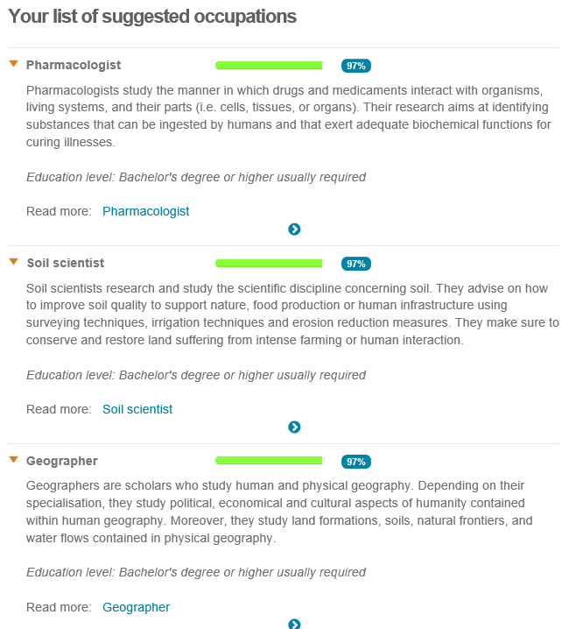
Career test 2 (https://www.theguardian.com/lifeandstyle/2014/nov/11/-sp-questionnaire-what-job-would-make-you-happiest):
Your scores:
- Hands-on: 15
Your ideal work is mainly about engaging with the physical world, for example building, cooking, craft, DIY, working with animals, plants and machines, sports and hands-on therapy. Example jobs include: sports coach, physiotherapist, engineer, LGV driver, builder, mechanic, veterinary nurse.
- Information and research, processes and systems: 14
Your ideal work is mainly about researching or managing information. This will include analysis, cataloguing and database management, but may include investigating topics in depth, IT, science, maths, quality control, systems and regulations. Example jobs include: accountant, scientific researcher, investigative journalist, legal assistant, book-keeper, health and safety officer, purchasing professional.
- Influencing, negotiating, communicating: 13
Your ideal work is mainly about persuading other people to do something, buy something or believe in your cause. This includes driving others, influencing, persuading, lobbying, motivating, selling. Example jobs include: sales person, recruiter, fundraiser, event manager, estate agent, public speaker.
- Creative use of ideas, materials or situations: 15
Your ideal work is mainly about working imaginatively with ideas or designs. This includes jobs in the arts, performing, creative writing, and also visual design, lateral thinking, business creativity, adapting or coming up with new ideas, working in situations where no rulebook exists. Example jobs include: graphic designer, training consultant, wedding planner, public relations.
- Supporting people: 6
Your ideal work is mainly about working with people, with their wellbeing and development as the main focus of your work. Example jobs include: teacher, life coach, therapist, nurse, learning and development, career coach.
- Making new things happen: 7
Your ideal work is mainly about achieving things with and through other people. This may involve organisational change, planning, managing projects, leadership, creating a new business, shaping teams, getting results. Example jobs include: project manager, team leader, operations manager, sales manager, business developer.

Appendix B: Ransomware class exercise

A Report
on
Cryptowall
Ransomware
[Document subtitle]
HTCI1
[Date]

Abstract.

This report has been produced to explain the nature of Ransomware, how it works and and what steps can be taken to minimise the effects and reduce the chance of an attack. This report will then focus in on one particular version of ransomware, namely Cryptowall.
Ransomware is a type of malware that can infect a user’s computer through various methods including phishing emails, exploit kits, trojans and other methods.
Once infected, the code will encrypt the user’s files targeting files that are likely to be of most value. The only way to decrypt these files is with the encryption key.
To obtain the encryption key the malware usually instructs the user to pay a ransom. This is usually in the form of a Bitcoin (or part thereof) or other online crypto-currencies. This method is sometimes referred to as cryptoviral extortion.
However, there is no guarantee that after payment that the decryption key will be provided.

Contents
1 Abstract. 2
1 Introduction 4
2 Trojans and Viruses 4
2.1 Trojans and viruses overview 4
2.2 How they infect your computer 5
3 Ransomware 5
3.1 Ransomware Overview 5
3.2 What to do if infected with Ransomware 5
4 The Cryptowall Trojan 6
4.1 Specifics about the CrytpoWall threat 6
4.1.1 Where it communicates 6
4.1.2 What it encrypts 6
4.2 Should we pay 6
5 Examples of good practice 7
5.1 Protection from infection 7
5.2 Backup procedures 7

- Introduction

Ransomware, in its current form started in 2005 with Trojan.GPcoder [1, p. 5] and there are essentially two main types of ransomware [1, p. 5] in circulation today; Locker Ransomware (computer locker) and Crypto-ransomware(data locker). Locker Ransomware denies a user access to their computer or device whereas Crypto ransomware prevents the user access to their files or data (usually by encrypting the contents). This report is ultimately going to focus on Cryptowall, which is a type of Crypto-ransomware.
Ransomware incidents now make up about 40% of all reported malware incidents according to the 2018 Verizon Data Breach Investigation report, cited by J. Petters [2].
Cryptowall was first released (into the wild) around the end of April 2014 [3] and since then there have been many variations of this method as the criminals who propagate this type of code find it, as quoted by Jeff Peters [2]:
“… cheap, easy to use and people continue to pay the ransom hoping to get their files back. (Tl;dr: Don’t)”
Only 19% of users get their data back! [4]
- Trojans and Viruses

Trojans and viruses are the main methods with which the ransomware payload is delivered. These mechanisms plant the malicious code that, when run, encrypts the contents of the user’s files.
2.1 Trojans and viruses overview
Although both of the above are types of malware or malicious code, the main difference is that Trojan horses do not replicate themselves as such, whereas viruses can self-replicate. Viruses also have the ability to attach themselves to other programs to propagate and can leave infections as they move from system to system. [4]
Trojan horse malicious code does not work like a virus, it is commonly a destructive program that appears to be a genuine application. Trojans also open a backdoor entry to a user’s system giving the hackers access to that computer enabling theft of confidential and personal data. [4]
2.2 How they infect your computer
The most common ways that malicious code is propagated is via one of the following:
- Phishing Emails – These are emails that appear to be genuine, often supposedly from a trusted company; eg. banks, online retailers etc. However, following the links on these emails downloads the malicious code onto the user’s system.
- Exploit Kits – These take advantage of security vulnerabilities, often within the operating systems or installed applications to deploy the malicious code. For example, Microsoft release Windows Updates on the second Tuesday of each month. This is known as ‘Patch Tuesday’, unfortunately the hackers reverse engineer the patches, to determine the vulnerabilities and then release their exploitative code. This is known as ‘Exploit Wednesday’, such is the speed that they work.
- Malicious ads – Cybercriminals use hacked internet adverts to propagate their malicious code. Often they implement javascript to run the code in the background.
- Code injection – involves the exploitation of a computer bug that is caused by processing invalid data. Injection is used by an attacker to introduce code into a vulnerable computer program and change the course of execution [5]. For example if a website prompts a user for a username and the background database is SQL, instead of typing a username, the hacker types the equivalent of a ‘delete users’ command in SQL and the command is executed, damaging the user table.

- Ransomware
3.1 Ransomware Overview
Ransomware, as described above, essentially is preventing a user from accessing their data but promises to release their data/system back to them if the user pays a ransom. Enough people pay the ransom to make this a viable method of crime. The criminals use dynamic pricing, so that varying ransoms are dictated by the origin of the IP address of the victim. Ie, someone in the USA would have a higher ransom than a victim from India. [1]
3.2 What to do if infected with Ransomware
There are a number of variants of ransomware and so the success of advice here, is in part down to the variant. However, common advice is to
- ‘immediately scan your computer with an anti-virus or anti-malware program.’ [3]
- Turn system off (to halt further files being encrypted), restart in safe mode with networking [2] to run any anti-virus/malware scan that can be performed.
- Once system is off, remove drive and attempt rescue of any unencrypted data with another protected system.
- Download and install a malware removal application – make sure it is from a reputable provider.
- Once the malware has been removed, use a clean restore point to regain your original files. If this is not possible, utilise any backups that may have been made of required files.
- Re-scan drive with an up-to-date anti-virus/malware application. [2]
- Use a tool named ListCwall that automates the finding of encrypted files and produces a list from an infected computer. Available from Bleepingcomputer.com [3]

- The Cryptowall Trojan
The CryptoWall Trojan is a specific type of ransomware that has been evolving over the years since 2014, it is now on v5.1 and utilises a different AES-256 encryption algorithm to previous versions.
4.1 Specifics about the CrytpoWall threat
CryptoWall injects new code into Explorer.exe and restarts it. This amended version of explorer then installs malware, deletes volume shadow copies, disables windows services and starts a new process with further injected modules. [2]
It installs itself into the Windows registry and start-up folder meaning that restarting will not clear or halt the infection. If the infection isn’t cleared out whilst in safe mode it will continue once the system is restarted.
4.1.1 Where it communicates
CryptoWall then communicates with a Command and Control (C&C)server, this is where possible rates are set, to continue the attack. The C&C sends CryptoWall the encryption key that it will use to encrypt all of the files.
4.1.2 What it encrypts
Many file-types are targeted by the CryptoWall Trojan. These include
- JPG, BMP, PNG, GIF for common image filetypes,
- AVI and MPG for movies,
- DOC, XLS, PDF for documents
- Plus many others. [2]
4.2 Should we pay
As stated above, only 19% of people who pay the ransom actually get their files back. Paying the ransom keeps the industry going. Therefore, the best advice is to not pay.
- Examples of good practice
5.1 Protection from infection
- Keep PC patched, both OS and Applications [2]
- Use a trusted, up-to-date, paid Anti virus/malware suite.
- Use a firewall [2]
- Don’t click random unsolicited links to webpages, be aware of poorly worded emails. [2]
- Get used to safe browsing habits –
  - Turn off ads – use an adblocker
  - Turn off Javascript
  - Be selective with accepted ads. [2]
5.2 Backup procedures
- Have three separate copies of any data – Physically separate (USB), cloud and system backup copies. [2]
- Restrict access to files, for a company, this may mean setting user rights and privileges. [2]
- Use a 3rd party monitoring software package. [2]

- References

[1] | P. C. H. L. K Savage, “The Evolution of Ransomware,” Symantec, 6 August 2015. [Online]. Available: https://www.symantec.com/content/en/us/enterprise/media/security_response/whitepapers/the-evolution-of-ransomware.pdf. [Accessed 17 June 2019].
[2] | J. Petters, “The State of Cryptowall in 2018,” Varonis, 1 June 2018. [Online]. Available: https://www.varonis.com/blog/cryptowall/. [Accessed 11 June 2019].
[3] | L. Abrams, “CryptoWall and HELP_DECRYPT Ransomware Information Guide and FAQ,” 10 July 2014. [Online]. Available: https://www.bleepingcomputer.com/virus-removal/cryptowall-ransomware-information. [Accessed 11 June 2019].
[4] | L. Mathews, “Why you should never Pay a Ransomware Ransom,” 9 March 2018. [Online]. Available: https://www.forbes.com/sites/leemathews/2018/03/09/why-you-should-never-pay-a-ransomware-ransom/#78d8412a1753. [Accessed 17 June 2019].
[5] | Symantec, “The difference Between a Virus, Worm and Trojan Horse,” DigiCert Inc, 2019. [Online]. Available: https://www.websecurity.symantec.com/security-topics/difference-between-virus-worm-and-trojan-horse. [Accessed 17 6 2019].
[6] | Wikipedia, “Code Injection,” 17 April 2019. [Online]. Available: https://en.wikipedia.org/wiki/Code_Injection. [Accessed 17 June 2019].

