Please delete the box below and replace it with an “appropriate” passport style photograph that clearly shows your face. Your photo should be roughly the same size as the box:

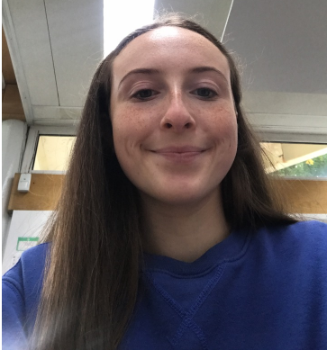

Name:
Taya Gibbons

Student number:
1803025

Student email address:
1803025@student.uwtsd.ac.uk

Contact number:
07428514681

Please use the remaining space to give a brief outline of why you have chosen your course of study and any relevant special interests or experiences:

Sports Therapy interests me because of the sports I have played. I have always played some form of contact sport where the chance of injury occurring is rather high and it has always been interesting to me to see how those injuries are “fixed”. I take a big interest in how a Sports Therapist/Medic/Physiotherapist runs onto the field and takes control of the situation to prevent an injury from occurring further or to actually help and preserve life. I have received so much physiotherapy on my own self that it interests me as to how someone is able to help someone else get back to their optimal fitness levels without the injury occurring again.

