Small Business Project Management Analysis

Name: Xun Cheng
Student Number: 2206582
Contents

1 Introduction 1
2 Fundamental principles of project management 2
3 Project analysis 4
3.1 PEST analysis 4
3.2 SWOT analysis 5
4 Organizational structure and management 9
Figure 1- Departments of company 9
4.1 Leadership and Management 10
4.2 Communication and change management 11
5 Work breakdown structure 13
6 Conclusion 15
References 16

1 Introduction
As the current owner's home is used to produce the fruit smoothies, which will hinder the company's future development, they are now contemplating relocating to a new industrial estate location. By doing so, they will be able to expand their product line and are also preparing to introduce new products to better meet their customers' needs.

As a consultant, this report will evaluate the project's viability and the project management considerations pertinent to this case study. In addition, the case study will be analysed using SWOT/PESTLE and related to organisational structure, leadership, management, communication, and change management. Finally, a high-level work division structure will be presented for industrial unit conversions.

2 Fundamental principles of project management
The Manhattan Project, which created the atomic weapon during World War II in the United States, is the origin of project management (Wideman, 1995). According to Parker and Skitmore (2005), a scientific approach to project management may be essential for adapting to changes in the global market. In addition to the great importance accorded to scientific project management, he argues that project management should be accorded important consideration. Utilizing cooperation and judicious resource allocation, project management is a cutting-edge, scientific method for organising and regulating the schedule (Armenia et al., 2018).

As project sizes and quality deadlines increase, the significance of scientific project management grows. In the late 1970s, the American Project Management Institute developed the Project Management Body of Knowledge (PMBOK), a contemporary corpus of project management knowledge organised into nine knowledge categories (Guide, 2001). There are three fundamental elements of a project: quality, time (schedule), and cost (Heerkens, 2002). Here are 9 basic principles.

1) Scope management: Planning, definition, work breakdown structure (WBS), validation, and control are the five phases. Fundamentally, it is functional management. The primary objective is to ensure that everyone on the project crew understands what the project entails. A precise project scope is essential for the subsequent accuracy of project execution, and scope management is the initial step of project management.
2) Progress (time) management: It is a crucial tool for guaranteeing the delivery of competent results within the parameters of demand side acceptance. This phase contains six sub-sections: planning, schedule management, activity decomposition, prioritisation, schedule estimation, definitive schedule, and schedule control.
3) Cost management: It is a crucial tool for preserving the company's profitability through cost reduction and resource optimisation. It includes planning, computation, management, and performance evaluation.
4) Quality Management: Establishing quality standards for the project and comparing project outputs against the necessary requirements on a regular basis to ensure that they are met. Bear in mind the client's quality expectations and ensure that the project meets them.
5) Communication Management: It is regulated with the intent of fully comprehending demand side requirements, such that the variance in information transmission is suitably low to maximise the probability that the output will satisfy demand side requirements.
6) Human Resource Management: In essence, it involves maximising the potential of the individuals who comprise a project team or group of individuals. Through effective training, deployment, and encouragement, the entire project team becomes a diligent team. identifying participant roles and responsibilities and assigning duties. Manage the execution of duties efficiently. Enhance the skills of each team member individually and the project team collectively as the project progresses.
7) Risk management: Create a risk management strategy and list risk management duties. Develop systems that will enable the project team to identify potential risks early on. Analyze the likelihood of risks occurring and their impact on the project using qualitative or quantitative techniques. Prioritize risks based on risk data, monitor them closely, and develop viable solutions.
8) Purchasing Management: The three primary duties are supply chain management, information management, and supply assurance. Inventory management, accounts payable management, and general ledger management are frequently combined to facilitate efficient monitoring and tracking of purchased production supplies and cash flow throughout.
9) Integrated Management: Coordinating the objectives of project stakeholders and project resources in order to meet the expectations of each stakeholder as efficiently as feasible. To make the best decisions, evaluate and compare each project component.

3 Project analysis
This paper will use the SWOT and PEST models to help businesses better comprehend macroenvironmental shifts in order to respond to market and industry shifts, to understand their strengths and weaknesses, to identify market opportunities and challenges, and to formulate strategies accordingly.

3.1 PEST analysis
Ho (2014) mentions PEST analysis, which examines four categories of environmental influences that are beyond one's control: Political factors include lobbying efforts and other forms of government involvement in the economy (P). Economic elements (E) refer primarily to the external macroeconomic environment, but can also include seasonal and meteorological factors. Social elements (S): These include the social, cultural, and demographic aspects of the external environment. Technical factors include technology-related activities, technological infrastructure, technological incentives, and technological changes that have an effect on the outside world (T). Peng and Nunes (2007) state that PEST analysis has two applications. The first objective is to assess the standing or circumstance of a particular business or industry, and the second objective is to assess the viability of general management solutions in a business context.

1) Political: A company's expansion goals may be affected by the government's oversight of the food industry, tax laws, and prospective subsidies. Before entering an industrial zone, you must comply with all applicable rules and be aware of any tax breaks or subsidy programmes. Tariffs and other trade restrictions may also affect the prices of raw materials, finished products, and supply chains. Government grants or subsidies are provided to modest businesses.
2) Economic: The economic climate, including employment rates and income levels, may influence individuals' consumption decisions. Moreover, the cost and availability of basic materials may affect production costs and profitability. The operations of a business may be affected by global economic conditions, inflation rates, interest rates, and consumer purchasing power. To ensure sustained sales growth, companies must assess the economic climate in their respective markets. Organic and health-related consumer product trends. The economic downturn influences consumer expenditure.
3) Social: The increasing demand for healthy foods and beverages is a consequence of the modern cultural trend towards health and wellness consciousness. Sustainability and environmentally favourable products are gaining importance among consumers. trends in environmentally friendly packaging and production techniques, as well as changing consumer preferences and interests. Age, socioeconomic status, and the need to focus on the needs of target markets can all influence how well a product is received. social media's impact on brand perception and product promotion.
4) Technological: Changes in food production technology, distribution, supply chain management strategies, etc., can have an effect on a company's operational efficacy and expenses. Studying about and implementing new technology can increase productivity, reduce expenses, and improve a company's competitiveness. IT systems for managing inventory and sales, social media and digital marketing trends, and technological advancements in production and packaging. E-commerce and digital marketing to expand sales channels and increase brand awareness; innovative packaging technologies to help reduce costs and enhance product appeal.

3.2 SWOT analysis
According to Jetoo and Krantzberg (2014), the SWOT analysis is one of the most common methodologies for analysing a company's strategy . McKinsey & Company was the first organisation to implement this method for assessing a company's strengths, weaknesses, opportunities, and threats. The four elements identify either internal or external factors. When referring to an organization's internal components, strengths are those that assist it in achieving its goals, whereas weaknesses are those that prevent it from doing so. Opportunities—external factors that aid an organisation in attaining its goals—include not only favourable environmental factors, but also opportunities to fill gaps and launch new initiatives. Threats, on the other hand, are elements of an organization's external environment that pose actual or potential obstacles to attaining its goals(Aldehayyat and Anchor,2008; Shrestha et al., 2004).

1) Strengths: A distinctive product line emphasises natural and healthful ingredients. Strong sales indicate the market's approval of the product. founded by three entrepreneurs who collaborated well. Using its existing supply chain and distribution network, the company can expand its product offering rapidly. The company's products reflect market trends and consumer health consciousness. The entrepreneurs may add coconut water, kid-friendly juices, nutritious stews, and yoghurt beverages to the product line.
2) Weaknesses: To meet customer demand, the business must expand its product line. To effectively manage the increasing production volume, the company must expand its manufacturing facilities and personnel. In the extremely competitive food and beverage industry, the business encounters stiff competition. In the absence of a solid sales and marketing plan, a business may lack the resources (financial, human, and technical) required for growth and may lack the management expertise required for a large organisation.
3) Opportunities: By adding more healthful food and beverages to its product line, the company can capitalise on the consumer demand for such items. By developing innovative products and marketing strategies, businesses can increase their market share and profitability. To increase productivity and reduce expenses, businesses must adopt new technologies and production equipment. The market for fruit beverages has significant growth potential, particularly among health-conscious consumers. Expand marketing through online sales, social media, and sales channels such as specialty stores, online sales, etc. Moving to larger facilities in the industrial area would help increase production capacity and product variety; the market for healthy beverages is expanding; there may be place for additional products (such as coconut water, kid-friendly juices, nutritious soups, and yoghurt drinks);
4) Threats: A market for food and drink that is fiercely competitive and where brands must compete with one another Market changes and political movements may affect the price and availability of raw materials. Government regulations and laws may have an adverse effect on the corporation's production and sales. Changing customer preferences.

These techniques can make it crystal apparent how strengths and weaknesses can be matched with opportunities and threats. Based on internal and external factors, managers can develop four strategies: SO (weaknesses- opportunities), ST (weaknesses- threats), WO (weaknesses- opportunities), and WT (weaknesses- threats) (weakness -threats) ((David et al., 2019). The SWOT matrix is shown below.
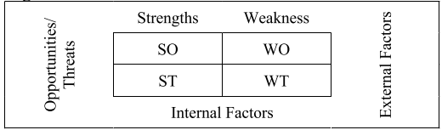
Figure 1-The SWOT Matrix(Benzaghta et al., 2021)

1) SO strategies (growth-oriented strategies)
It is crucial to highlight the company's strengths and use growth-oriented strategies to promote it and enhance its overall competitiveness, while also maximising external opportunities in the portfolio of strengths and opportunities, where opportunities are the focal point of the entire SO portfolio. The company should expand its selection of keycon products, promote them online and through social media, and purchase new equipment to increase production efficiency.

2) ST strategies (diverse strategies)
The key to this strategy is determining how to utilise Shuangliu Airport's strengths within a diversified business strategy. In the combination of strengths and problems, the company capitalises on its own strengths to address external challenges. It is essential to utilise a variety of government initiatives to support the expansion of the business and to monitor those with the opposite affect. The best course of action for the business can be determined through market research, which may involve relocating to less competitive locations.

3) WO strategies (turnaround strategies)
In the context of disadvantages and opportunities, this strategic decision focuses on opportunities rather than disadvantages, and it is crucial to maximise external opportunities and resolve flaws in the development process. To increase production efficiency, the company must generate more new products, expand its facilities, and employ more workers. Diverse policies will be implemented to resolve the required resources for expansion, develop corporate management capabilities, and enhance human resource management systems. Employ qualified managers to oversee the business administration. Enhance corporate culture and brand recognition.

4) WT strategies (defensive strategies)
In other words, a mixture of disadvantages and problems. The success of this strategy depends on your ability to respond positively and effectively to external challenges, as well as on your ability to identify methods to modify and adapt your organisation to minimise risks and eliminate disadvantages. Companies should avoid competing with competitors and devote fewer resources to industries with intense competition. Take advice from the most successful companies to enhance your strengths. Create new products and frequently update existing ones to satisfy consumers. Continue establishing more rational development strategies, standardising management processes, and enhancing existing businesses.

4 Organizational structure and management
Flat management is a novel management strategy that streamlines personnel, reduces organisational layers between decision-making and operational levels, and reduces management levels to increase the efficiency of business operations. This enables the organisation to swiftly implement decisions in the production and sales lines. According to Rakowski and Mongan (2014), a typical flat organisational structure is characterised by a small number of intermediate management levels. Due to the elimination of multiple layers, top management will have direct access to highly skilled workers, front-line employees will be more involved in decision-making, and they will be better able to respond quickly to changes in the internal environment, customer preferences, and external environment.

The review of pertinent literature reveals that the team now consists of three individuals and is a small business, which is better suited to a lean and efficient flat structure; therefore, this report divides the company into the six sections listed below.
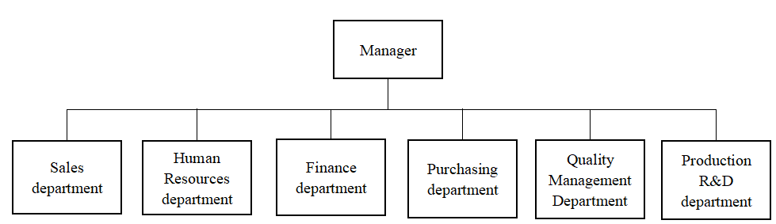

Figure 1- Departments of company

1) Sales department: The sales division is responsible for promoting the purchase of the organization's products or services. They communicate with clients to determine their requirements and recommend the most effective solutions to help them achieve their sales objectives.
2) Human Resources department: HR plays a crucial role in ensuring that the company is able to hire, manage, develop, train, and retain the finest personnel, as well as manage employee performance and relationships.
3) Finance department: The finance department is responsible for administering finances and making financial decisions. Its responsibilities include financial planning, accounting, budgetary control, fund administration, and risk management. They are responsible for facilitating the financial management and decision-making of the company.
4) Purchasing department: The department of an organisation responsible for supply chain management and purchasing is known as the purchasing department. Its responsibilities include locating and selecting suppliers, purchasing supplies and equipment, managing supplier relationships, lowering costs, and increasing productivity. They are responsible for supplying the company with the supplies and equipment necessary for its proper, dependable, efficient, and cost-effective operation and production.
5) Quality Management Department: The quality management department is responsible for monitoring the organization's products and services. Its responsibilities include the creation and implementation of quality management systems, the testing and inspection of products, the administration of supplier audits, and the resolution of customer complaints.
6) Production R&D department: R&D divisions of production companies are in charge of developing and manufacturing novel products. Their responsibilities include product design, the acquisition of basic materials, production planning, and production control. Their efforts ensure that the company is innovative and competitive, and that it continues to expand into new markets and industries.

4.1 Leadership and Management
Leadership is an essential managerial characteristic and a crucial criterion for evaluating managers. According to Peter (1967), managers should possess certain leadership qualities, especially "in the absence of authority, they must learn to lead, as they are neither controlled nor governed." Dynamism and continuity are largely attributable to a company's leadership, which influences the process of achieving objectives and provides the primary impetus for keeping a business alive. Principal examples of leadership include commanding the team, adhering to shared ideas and ideals, taking risks, leading effectively, managing effectively, treating people with sincerity, and planning.

According to Clinton (1992), leaders should be born with the following 16 traits, sometimes referred to as leadership qualities or leadership personality theory: conscientious, dependable, courageous, responsible, inventive, direct, self-disciplined, idealistic, good interpersonal skills, graceful, competent and pleasant, physically fit, academically gifted, organised, and judgmental.

Leadership guides the team forward, and management ensures that the team advances accurately and successfully. Managers provide the means and capacity to execute plans, whereas leaders provide the organisation with direction and inspiration. Good management and control are required for good management, and good management requires excellent leadership. A successful organisation requires both management and leadership from a practical standpoint. Managers and leaders must be competent of both management and leadership in order to maximise the potential of their workforce and contribute to the organization's success.

4.2 Communication and change management
Communication is one of the most essential aspects of implementing change management. Communication aids organisational leaders in the process of change management by enabling them to convey the change's message and objectives to employees, assist employees in understanding how the change will affect their employment, and increase employee support for the change. Through open, transparent, timely, and efficient communication, employee fears and apprehension can be allayed, resulting in a more efficient and successful change process. In conclusion, there is a close relationship between communication and change management. Communication is one of the most essential components of change management, and change management can also serve to improve communication. By integrating communication and change management, organisations can respond to opportunities and challenges more effectively and successfully manage change and development.

5 Work breakdown structure
Work breakdown structure is the process of dividing a project's total work into a number of more manageable, hierarchically-organized tasks (WBS). While keeping tasks realistic, the level of detail should reflect the overall scope of the undertaking(Norman et al,. 2008).

The procedure for WBS decomposition adheres to the following guidelines: (1) The operability principle pertains to the final product of the WBS decomposition, which is a collection of work packages containing a number of activities each. Typically, when decomposing a task, the operability principle is adhered to, and the task is broken down to the point where a group or a single individual can operate and complete it based on the nature of the task. (2) The 100 percent norm. In other words, work that does not fall within a range does not constitute project labour. Therefore, the subsequent sub-layer of a decomposition element must represent 100 percent of the element of the previous parent layer, and the sum of all the work in the sub-element must equal 100 percent of the work represented by the parent element. (3) The principle of sufficiency of necessity. The breakdown of labour on a construction project must meet the "sufficiently necessary" criterion. No work that contributes to the building project's output may be less than one, and no work that does not contribute to its output may have more than one.

This project's final deliverables included the creation and marketing of fruit smoothies as well as the creation of a brand-new health beverage, as outlined in the table below.
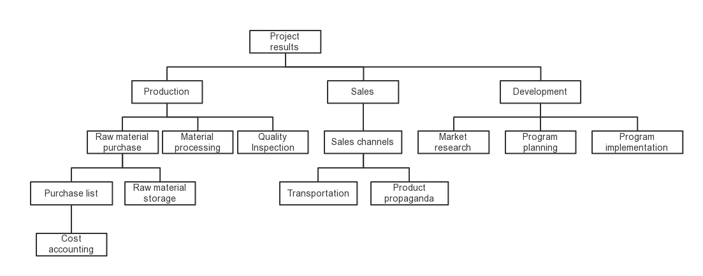
Figure 1- Fundamental works of organization

6 Conclusion
This report analyses the company's internal and external environments, as well as its strengths and weaknesses, using PSET and SWOT analyses. In addition, the report defines the nine fundamental project management principles, concludes that the organisation is suitable for a flat organisational structure based on a literature review, and breaks down the company's work using a WBS.

References
Armenia, S., Pompei, A., Pupillo, V. and Nonino, F., 2018. Marketing competition on a new product introduction–a structural analysis using systems thinking. International Journal of Markets and Business Systems, 3(2), pp.141-162.

Aldehayyat, J.S. and Anchor, J.R., 2008. Strategic planning tools and techniques in Jordan: awareness and use. Strategic change, 17(7‐8), pp.281-293.

Benzaghta, M.A., Elwalda, A., Mousa, M.M., Erkan, I. and Rahman, M., 2021. SWOT analysis applications: An integrative literature review. Journal of Global Business Insights, 6(1), pp.55-73.

Clinton, J.R., 1992. A short history of modern leadership theory. Barnabas Publishers.

David, F.R., Creek, S.A. and David, F.R., 2019. What is the key to effective SWOT analysis, including AQCD factors. SAM Advanced Management Journal, 84(1), pp.25-3.

Guide, A., 2001. Project management body of knowledge (pmbok® guide). In Project Management Institute (Vol. 11, pp. 7-8).

Ho, J.K.K., 2014. Formulation of a systemic PEST analysis for strategic analysis. European academic research, 2(5), pp.6478-6492.

Heerkens, G.R., 2002. Project management. McGraw Hill Professional.

Jetoo, S. and Krantzberg, G., 2014. A SWOT analysis of the Great Lakes Water Quality Protocol 2012: The good, the bad and the opportunity. Electronic Green Journal, 1(37).

Norman, E.S., Brotherton, S.A. and Fried, R.T., 2008. Work breakdown structures: the foundation for project management excellence. John Wiley & Sons.

Peng, G.C.A. and Nunes, M.B., 2007, July. Using PEST analysis as a tool for refining and focusing contexts for information systems research. In 6th European conference on research methodology for business and management studies, Lisbon, Portugal (pp. 229-236).

Peter, F.D., 1967. The effective executive. New York, Harper&Row.

Parker, S.K. and Skitmore, M., 2005. Project management turnover: causes and effects on project performance. International Journal of Project Management, 23(3), pp.205-214.
Rakowski, J. and Mongan, M., 2014. Optimizing leadership and business performance: organizational development themes seen through the lens of classical viennese music. International Journal of Arts & Sciences, 7(4), p.477.

Shrestha, R.K., Alavalapati, J.R. and Kalmbacher, R.S., 2004. Exploring the potential for silvopasture adoption in south-central Florida: an application of SWOT–AHP method. Agricultural systems, 81(3), pp.185-199.

Wideman, R.M., 1995. Criteria for a project-management body of knowledge. International Journal of Project Management, 13(2), pp.71-75.

