  Component One: Student Journal (learning log) 750 words +/- 10%  Contribution to Overall Module Assessment: 25% | Student No: | 2232252
 | Module Title: | OPERATING HOTEL FACILITIES
 | Module Code: | BMIH 4006
 | Lecturer: | DAN PAYNE
Housekeeping is an essential function in various settings, ensuring cleanliness, hygiene and order. Effective teamwork within a housekeeping unit demands a range of critical skills. In this essay, I will explore these skills using Graham Gibbs reflective model, reflecting on personal experiences, and linking them to theoretical principles. (Lee & Ok, 2013)
Graham Gibbs reflective model comprises six stages: description, feelings, evaluation, analysis, conclusion, and action plan. This framework aids in self-reflection and deeper understanding.

Key skills within a Housekeeping Team:
- Communication skills: effective communication is essential for team coordination and understanding tasks. Initially, I felt confident in my communication abilities but later realised the need for improved clarity and active listening. Effective communication fosters a positive environment and reduce errors. Theoretical principles, emphasize the role of effective communication in the forming and norming stages of a team’s evolution. Improving communication skills is essential for a harmonious housekeeping team. (Maguire & Pitceathly, 2002)

- Attention to detail: attention to detail is vital for cleanliness and order. I often felt overwhelmed by the details, but I also appreciated its importance. Attention to details ensures that no area is overlooked, maintaining high standards. The concept of “Total Quality Management” underlines the importance of precision and consistency in delivering quality service. Attention to detail aligns with the quality principles essential in housekeeping. (Dotchin & Oakland, 1992)

- Time management: effective time management is crucial for completing tasks efficiently. Initially, I struggled with time management but grew more adept over time. Time management minimizes delays and ensures rooms or areas are ready for use. Mastering time management is integral to housekeeping efficiency.

- Adaptability: is necessary to handle unforeseen challenges. I experienced anxiety when faced with sudden changes but grew more flexible. Adaptability allows the team to respond to unexpected issues without compromising quality. Adaptability aligns with principles of change management in housekeeping and the importance of flexibility in adjusting to new situations.

- Teamwork and cooperation: collaborative teamwork is at the core of housekeeping success. I initially had concerns about fitting into a team, but I learned the value of cooperation. Teamwork fosters a positive atmosphere and maximizes productivity. Effective teamwork is consistent with the theories of team dynamics and role specialization, and those theories highlight how different team members bring unique strengths and contributions to the group, which is crucial for housekeeping success.

Reflecting on personal skills and experience:
In the description stage, I recall my experiences working at Hilton London Paddington as a member of the housekeeping team. Initially, I was anxious about my communication abilities and time management. However, my attention to detail and adaptability proved to be strengths. The initial feelings ranged from apprehension to self-assurance.
The evaluation stage involves assessing my strengths and weaknesses. Through self-reflection, I’ve recognised that I have improved my communication skills over time. However, I still need to work on time management. My adaptability and attention to detail have been valuable assets.
In the analysis stage, I link my experiences at Hilton London Paddington to theoretical principles. For instance, my improvement in communication skills can be linked to the “forming” stage in Tuckman’s model, where team members establish initial connections through effective communication. (Jones, 2019)
In the conclusion stage, I emphasise the importance of personal growth in these skills. The growth in these skills directly impacts the effectiveness of a housekeeping team. It’s evident that theoretical principles are not abstract concepts but directly applicable to real-world situations.
In the action plan stage, I outline my future goals. I plan to attend time management workshops and courses and seek mentorship to enhance my time management skills. I also aim to further develop my communication abilities by actively participating in team meetings. This approach will contribute not only to personal development but also to the overall efficiency and success of the housekeeping team.
In conclusion, this reflective essay has explored the key skills required in a housekeeping team, reflected on personal experiences from when I was working at Hilton London Paddington, and linked them to theoretical principles. My journey in housekeeping has revealed the direct applicability of theory to practice. With continuous self-improvement, I am to contribute effectively to housekeeping teamwork. Effective housekeeping depends on individuals who not only posses these skills but also strive to enhance them continually. This reflective analysis provides a roadmap for continual improvement and success within the housekeeping domain.

References
1. Lee, J., & Ok, C. (2013). Examination of factors affecting hotel employees’ service orientation. Journal of Hospitality & Tourism Research, 39(4), 437–468. https://doi.org/10.1177/1096348013491593
2. Maguire, P., & Pitceathly, C. (2002). Key communication skills and how to acquire them. BMJ, 325(7366), 697–700. https://doi.org/10.1136/bmj.325.7366.697
3. Dotchin, J. A., & Oakland, J. S. (1992). Theories and concepts in total quality management. Total Quality Management, 3(2), 133–146. https://doi.org/10.1080/09544129200000015
4. Jones, A. (2019). THE TUCKMAN’S MODEL IMPLEMENTATION, EFFECT, AND ANALYSIS & THE NEW DEVELOPMENT OF JONES LSI MODEL ON A SMALL GROUP. Journal of Management, 6(4). https://doi.org/10.34218/jom.6.4.2019.005
5. Bonebright, D. A. (2010). 40 years of storming: a historical review of Tuckman’s model of small group development. Human Resource Development International, 13(1), 111–120. https://doi.org/10.1080/13678861003589099

Component Two: Housekeeping cleaning checklist
Contribution to Overall Module Assessment: 25%

Room cleaning checklist to follow up:

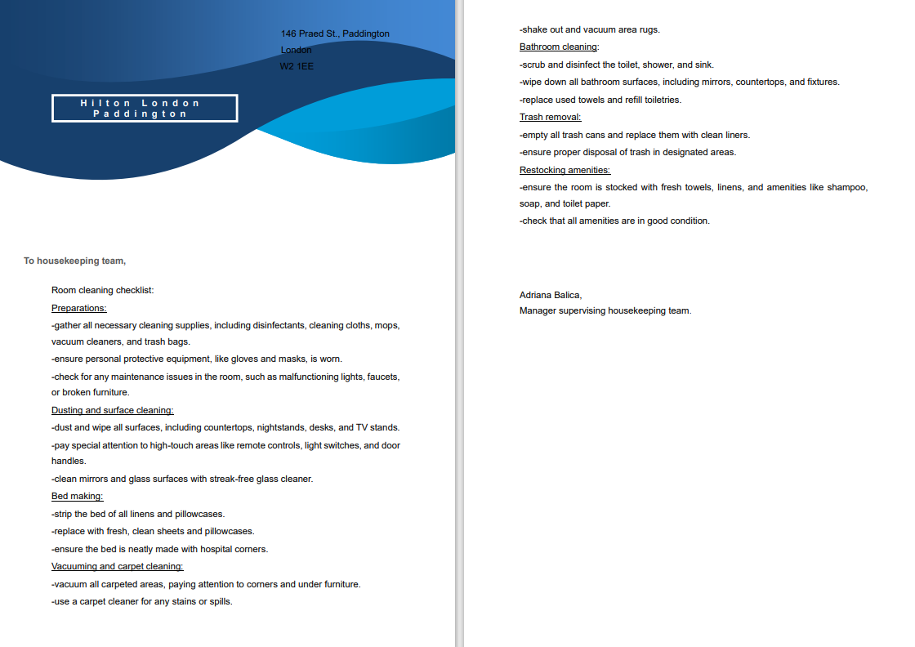
Housekeeping, the backbone of any successful hotel, plays a crucial role in ensuring guest satisfaction. To achieve this, an efficient and comprehensive housekeeping checklist is essential. This essay explores the significance of housekeeping checklist, the measures to assure the effectiveness, and why they are a key tool in maintaining brand standards. (Torres & Kline, 2006)
My housekeeping checklist is a structured document that outlines the tasks and responsibilities for cleaning and maintaining guest rooms. It serves as a crucial tool to uphold brand standards for several reasons:
- Consistency ensures that each room is cleaned consistently, following the same set of standards every time. This consistency is fundamental to maintaining brand identity.
- Efficiency, housekeepers are often tasked with multiple rooms daily. A well-organised checklist helps them manage their time and resources efficiently, contributing to overall productivity.
- Accountability, with a checklist in place, there’s a clear record of the tasks completed in each room. This promotes accountability among housekeeping staff and allows for easy tracking of performance.
- Quality control, checklist can include inspection points for quality control. This step ensures that rooms meet or exceed brand standards before they are made available to guests.
- Training tools, housekeeping checklist serve as invaluable training tools for new staff. They provide a structured roadmap for employees to learn and understand the brand's expectations.

To maximise the regularly review and revise the checklist to ensure effectiveness of my housekeeping checklist, I consider the following measures:
- Regularly review and revise the checklist to ensure that is detailed and up to date, reflecting the latest brand standards and cleaning protocols.
- Train housekeeping staff thoroughly on the checklist’s content and its importance in maintaining brand standards. New staff should be familiarised that with the cleaning checklist during their onboarding process.
- Implement quality control system where designated individuals inspect a sample of cleaning rooms to ensure compliance with the checklist. Provide feedback and support for improvement.
- Consider integrating technology like mobile apps or software that can help housekeepers access and complete checklists electronically, improving accuracy and tracking.
- Encourage staff to report any issues or suggestions related to the checklist for continuous improvement.
- Implement a reward and recognition system for staff who consistently meet or exceed brand standards, which can boost motivation.

Reasons to believe my checklist will be effective:
Checklist standardise cleaning process, ensuring each room receives the same level of care and attention.
With clear expectations outlined, accountability is enhanced, staff know what is expected of them.
Quality control serve as a safeguard against inferior cleaning, this assurance being a direct reflection of brand standards.
Checklists streamline the cleaning process, making it more efficient and productive.
By regularly reviewing and updating the checklist, the hotel can adapt to changing customer expectations and industry trends, ensuring its brand standards remain relevant.
In conclusion, my checklist is an indispensable tool that ensures rooms are cleaned to brand standards. It promotes consistency, efficiency, accountability, and quality assurance. By implementing the measures above mentioned we can assure effectiveness, hotel can maintain a reputation for cleanliness, guest satisfaction, and adherence to brand standards. My checklist its not just a document but the realisation of a commitment to excellence.

References
- Deckop, J. R., Konrad, A. M., Perlmutter, F. D., & Freely, J. (2006). The effect of human resource management practices on the job retention of former welfare clients. Human Resource Management, 45(4), 539–559. https://doi.org/10.1002/hrm.20131
- Ryan, M. (2011). Improving reflective writing in higher education: a social semiotic perspective. Teaching in Higher Education, 16(1), 99–111. https://doi.org/10.1080/13562517.2010.507311
- Torres, E. N., & Kline, S. F. (2006). From satisfaction to delight: a model for the hotel industry. International Journal of Contemporary Hospitality Management, 18(4), 290–301. https://doi.org/10.1108/09596110610665302
- Rutherford, D. G. (2006). Hotel Management and Operations. http://ci.nii.ac.jp/ncid/BA65898168
- Cottrell, S. (2013). The Study Skills Handbook. https://doi.org/10.1007/978-1-137-28926-1

Based on your completed checklist you will need to write 500 words in essay format discussing the following:
- How will you ensure that the rooms are cleaned to brand standards?
- What measures would you introduce to improve team effectiveness?
- Why would you consider your check list to be the most effective?

References

