DIGITAL SKILLS AND RESEARCH METHODS

Ion Alexandru Gosea - ID (2012683)
Module Code - BMSW4003
Assessment 2

Table of Contents
Introduction 3
Research aim 3
Research question 3
Research objective 4
Discussion 4
Virtual learning environments (VLEs) 4
Positive impacts of VLEs 5
Research methods 6
Ethical considerations 6
Analysis 7
Use of Moodle has a positive impact on your achievement 7
Use of Moodle can encourage Independent Learning 8
VLE gives you motivation and satisfies your learning experience 8
Experience with the VLE 9
VLE is beneficial and enriching for students 10
Conclusion 10
Reference list 12
Appendices 14

Introduction
With the development of technology and ICT, there is a rising interest in the use of computers and other internet tools. These internet tools can be helpful in improving the educational process and incorporate the use of technology in classrooms. VLEs are the virtual areas that are used by students and teachers for presenting and sharing resources and communicate with each other. These platforms such as Moodle can be employed for teaching an online course or also as supporting aspect for face to face lessons. VLEs act as a way for managing the learning experience, interact about the learning experience and also facilitate teachers' and students’ experiences in the process (Rienties et al. 2016). The main goal of VLEs such as Moodle is to motivate, make it easier and offer learning experiences that are beyond the classroom. VLEs such as Moodle have proved to give a secure learning setting over the teaching experiences. Most of the teachers and the students who are surveyed for this research have successfully used the platform and provided their positive experience based on pedagogical benefits, technological progress and practicality. Despite the several benefits that VLEs provide, to students and teachers, there are certain people who do not prefer these in the educational setting and consider these as a waste of time (Mosquera, 2017). The research highlights the impacts of VLEs in the learning experience of students at the University of Wales Trinity Saint David London Campus. The researcher has conducted online surveys and has not engaged in any face to face conversation due to the restrictions in the ongoing pandemic. The researcher had conducted both qualitative and quantitative research for getting responses from the participants.

Research aim
The research aims to find out the benefits and impacts that VLEs have on the learning experience of students at the University of Wales Trinity Saint David London Campus. The research also aims to find out the competency level of students in using the technology In their learning process and any difficulties that they might face.

Research question
- Does the employ of a VLE have a positive effect on student learning?
- Does the use of a VLE in learning help expand student independent knowledge?
- Does the exercise of a VLE for learning augments students’ inspiration to learn?

Research objective
- To find out the impact of VLEs on the learning experience of students
- To evaluate the effect of VLE in expanding student independent knowledge
- To assess the benefits of incorporating VLE in improving students’ inspiration to learn

Discussion

Virtual learning environments (VLEs)
A VLE is an online process that consists of a variety of tools for supporting and managing to learn. VLEs play their part in providing instructions or also an entire course through a web-based setting. With the help of VLEs, teachers can choose and employ different applications and resources for reviewing the content of a course. Teachers can use chat for communicating with learners directly or also send a message. In order to encourage and advance teaching and learning in higher schooling, higher education institutions have approved learning administration platforms that are referred to as Virtual Learning Environments (VLEs) (Cassidy, 2016). These settings have been utilised both by organizations heading for distance learning and by foundations fundamentally aimed at onsite learning. This digital platform is particularly important in the current pandemic, where colleges and educational institutions are closed down and learning takes place through online medium. Virtual learning environments allow learning to occur based on the basics currently there in the learning setting, based on a nonstop scale starting from the fundamentals specific to the surroundings to the essentials rising from use (Janßen et al. 2016).
A well-preserved VLE must facilitate students of all education styles to obtain the finest probable teaching, in a manner that they might not get in a completely lecture-based setting which is inclined to be concentrated on auditory apprentices simply. A student’s understanding in the classroom or talk theatre relies on how to fit the teaching approach is with their personal learning method. The same subjects are present with virtual methods and an assortment of possessions is wanted in order to offer sufficiently for all education styles (de Boer et al. 2017). Empirical confirmation proposes that the employ of a Virtual Learning Environment (VLE) has an effect on student accomplishment, supports autonomous education and boosts students’ inspiration to learn. The statistically noteworthy findings account that the exercise of Moodle brings improvement in education and enthusiasm to learn as described by the student participants.

Positive impacts of VLEs
There are several studies that portray the positive effects on student learning by using VLEs. It is seen that after using the software tool which helps teachers and students to interact online for developing their knowledge in analytical skills, students significantly performed better on reading tests, vocabulary and language and were independent than the learners who did not use the tool. It was recognized that admission to broadband internet from a learner’s home and staff training and the time for development were main features in the usefulness of VLEs. VLEs must be used to improve learning and must not be employed as only storage or message facilities. It is also recommended that VLE detailed quality assurance plans and self-assessment must be dignified in institutions for assessing the impact and progressing effectiveness (Hettiarachchi and Wickramasinghe, 2016). It is seen that classes having an online learning factor attained better learning results than face-to-face classes. There are also several benefits seen in the utilization of VLEs in institutions. These are; enhanced management of data and communication throughout the institution, superior parental association, during being improved informed, and improved sustaining of learning at the house; and augmented student chances for autonomous and personalised education. In synopsis, VLEs have a series of research which showed optimistic effects from a variety of contexts (Chen, 2016). They can help in encouraging reflection, containing the wants of scholars, boosting enthusiasm and assurance, better eagerness to learn, and generally accounted above better course appraisal performance.
VLE also can be motivating for students to learn and help in improving their learning process. The factors are:
- Students can have control over the activities and tasks that they prefer to be engaged in and they have a responsibility for their learning.
- There is enhanced access to technology which can inspire better participation. The chance to learn through an informal source at a place, time and pace are motivating for students (Tsay et al. 2018).
- VLEs provide better chances of formative feedback and assessments which leads to advantages based on achievement and retention.
- Communication and integrated learning like the use of chats, emails and forums for conversation and feedback show that the learning process is motivating for students.
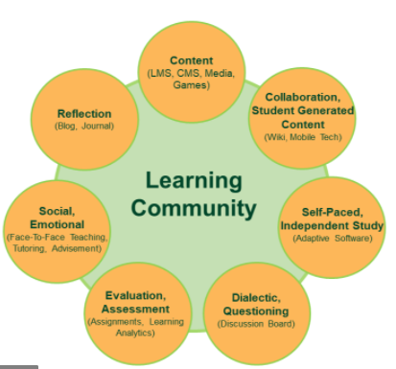
Fig 1: positive impacts of VLEs
(Source: aitsl.edu.au, 2020)

Research methods
The quantitative research was conducted in the shape of an e-questionnaire permitting analysis with Excel. All the 100 students of class at the University of Wales Trinity Saint David London Campus were invited to finish the survey. The survey was conducted online and the questions were sent to the students through the mail. With the help of primary research conducted, raw data can be gathered and the true experience of the students can be provided. The survey followed a Likert type structure and was provided to the participants after every VLE class they attended. The survey asked the students about the experiences in attending the class, their inspiration or motivation or any challenges that they faced (Holmes, 2018).
The research also uses secondary data by using published materials from books, articles and journals that are present on the internet stating the effects of VLE in student learning. Journals and books from the previous 5 years will only be judged in the research to offer fresh information about the subject (Holmes, 2018).

Ethical considerations
Students provided their consent to involve themselves in the study and were educated regarding all the particulars of the process. It was apparent to both the educators and the scholars that no personal data would be exposed nor any sort of injury would be caused to any of the members. The educators were also informed that the study was not planned to centre on reviewing their teaching activities and methods, but fairly on how learners responded to the use of technology and the circumstances neighbouring the execution of a VLE in their learning courses (Salvador et al. 2017). Despite the information that some research supporters were there in the class conducting some clarification, their attendance did not seem to source any disruption to the educators nor pressure of learners.

Analysis

Use of Moodle has a positive impact on your achievement
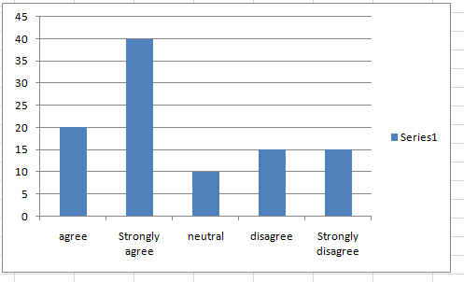
Fig 2: Use of Moodle has a positive impact on your achievement
(Source: excel)
Most of the students agree and strongly agree that the chance to learn through Moodle at a place and time encourages them to learn independently. Most of the students agree that the resources provided on Moodle are primarily for information uses. However, there are some students who agree on the fact that events on Moodle enhance communication among students. The response from students states that they prefer the use of Moodle for their learning purposes (Mai and Muruges, 2018).

Use of Moodle can encourage Independent Learning
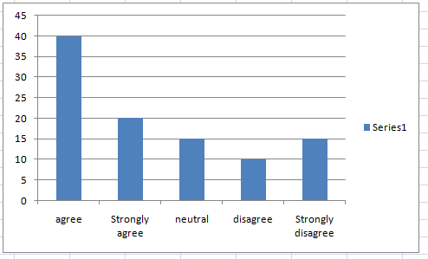

Fig 3: Use of Moodle can encourage Independent Learning
(Source: excel)
Most of the students agree with the statement that with the use of moodle they are in control of their learning which helps them in increasing their motivation to learn further. Most of the students also agree and strongly agree that the wide range of course tools that are provided in Moodle help in increasing the motivation of students to learn (Mai and Muruges, 2018). They responded positively to the statement that the range of formats present in the university moodle boosts their motivation to learn.

VLE gives you motivation and satisfies your learning experience

Fig 4: motivation and satisfaction in learning experience
(Source: excel)

When asked about the experience of using VLE in their classes, Very few students uttered feelings of demotivation and dissatisfaction. Most students described an emotion of approval, with class surveillance comments written by a research assistant to sustain it. Based on the comments, Students turn into more enthusiastic when functioning with the software platform (Nguyen et al. 2017).

Experience with the VLE
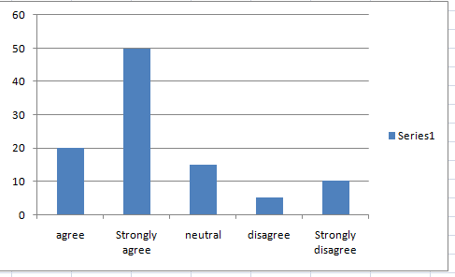

Fig 5: students’ Experience with the VLE
(Source: excel)
Despite the truth that a large number of apprentices had an acceptable familiarity with the VLE, a major minority of learners expressed some displeasure because of technical troubles when using the VLE, like slow connection, inadequate possessions, no association to some websites, and so on. The comment recorded by the assistant researcher confirms this claim: link to the Internet is slow, that results in a waste of time in the progress of class actions (Nguyen et al. 2017).

VLE is beneficial and enriching for students
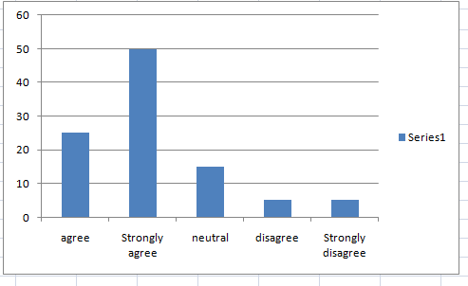
Fig 6: teachers’ experience of VLE
(Source: excel)
Educators stated that the employ of the online platform was helpful, inspiring and sensible for learners. however, there was an educator who considered this skill as unsatisfactory due to the way the online platform was carried out, which was referred to as too behaviourist (Chen, 2016).

Conclusion
Empirical research in the literature highlights the research questions and results in the development of the hypotheses. This data verifies that VLE supports autonomous learning with the chance to learn casually at a time, position and speed to go well with the student offering suppleness for learners to fit their courses in their lives. The literature review also gives confirmation that a VLE augments students’ inspiration to learn, encourages message and mutual knowledge, through the use of forums, email for conversation and that the straight feedback is extremely inspiring. Use of a VLE has an optimistic effect on student learning. It is Suggested that VLE helps the growth of independent learning. Data from student responses propose that using VLE for learning augments students’ inspiration to study. From the learning viewpoint, a VLE can offer chances for performance and remind and contain a variety of learning resources and layouts such as multimedia. Empirical research located proposes that the using VLEs consequences in enhancement in learning and education which result in enhanced fulfilment, preservation and attainment for a better and more assorted student. This study proposes that activities on a VLE and the chance to learn at an individually definite place, occasion and speed support learners to take a stage of possession for their knowledge which augments their autonomy and inspiration to learn.

Reference list
Cassidy, S., 2016. Virtual Learning Environments as Mediating Factors in Student Satisfaction with Teaching and Learning in Higher Education. Journal of Curriculum and Teaching, 5(1), pp.113-123.
Chen, Y.L., 2016. The effects of virtual reality learning environment on student cognitive and linguistic development. The Asia-Pacific Education Researcher, 25(4), pp.637-646.
de Boer, I.R., Lagerweij, M.D., de Vries, M.W., Wesselink, P.R. and Vervoorn, J.M., 2017. The effect of force feedback in a virtual learning environment on the performance and satisfaction of dental students. Simulation in Healthcare, 12(2), pp.83-90.
Hettiarachchi, S. and Wickramasinghe, S., 2016, July. Impact of virtual learning for improving quality of learning in higher education. In 2 nd International Conference on Education and Distance Learning–1 st July.
Holmes, N., 2018. Engaging with assessment: Increasing student engagement through continuous assessment. Active Learning in Higher Education, 19(1), pp.23-34.
Janßen, D., Tummel, C., Richert, A. and Isenhardt, I., 2016, June. Towards measuring user experience, activation and task performance in immersive virtual learning environments for students. In International Conference on Immersive Learning (pp. 45-58). Springer, Cham.
Mai, M.Y. and Muruges, G.R., 2018. Primary school science teachers’ attitude towards using virtual learning environment (VLE) in teaching science. European Journal of Education, 1(3), pp.155-162.
Mosquera, L.H., 2017. IMPACT OF IMPLEMENTING A VIRTUAL LEARNING ENVIRONMENT (VLE) IN THE EFL CLASSROOM. Íkala: Revista de Lenguaje y Cultura, 22(3).
Nguyen, Q., Rienties, B., Toetenel, L., Ferguson, R. and Whitelock, D., 2017. Examining the designs of computer-based assessment and its impact on student engagement, satisfaction, and pass rates. Computers in Human Behavior, 76, pp.703-714.
Rienties, B., Giesbers, B., Lygo-Baker, S., Ma, H.W.S. and Rees, R., 2016. Why some teachers easily learn to use a new virtual learning environment: A technology acceptance perspective. Interactive Learning Environments, 24(3), pp.539-552.
Salvador, P.T.C.D.O., Bezerril, M.D.S., Mariz, C.M.S., Fernandes, M.I.D., Martins, J.C.A. and Santos, V.E.P., 2017. Virtual learning object and environment: a concept analysis. Revista brasileira de enfermagem, 70(3), pp.572-579.
Tsay, C.H.H., Kofinas, A. and Luo, J., 2018. Enhancing student learning experience with technology-mediated gamification: An empirical study. Computers & Education, 121, pp.1-17.

Appendices
Appendix 1: Questionnaire
- Do you agree or disagree that use of Moodle has a positive impact on your achievement?
Agree | Strongly agree | Neutral | Disagree | Strongly disagree
5 | 10 | 0 | 5 | 0

- Do you agree or disagree that the use of Moodle can encourage Independent Learning?
Agree | Strongly agree | Neutral | Disagree | Strongly disagree
3 | 17 | 0 | 0 | 0

- Do you agree that VLE gives you motivation and satisfies your learning experience?
Agree | Strongly agree | Neutral | Disagree | Strongly disagree
5 | 15 | 0 | 5 | 0

- Are you happy with your experience with the VLE?
Agree | Strongly agree | Neutral | Disagree | Strongly disagree
1 | 19 | 0 | 0 | 0

- Wen do you start courses did you find hard VLE?
Yes | No | Sometimes
2 | 17 | 1

- How do you rate the usability of VLE?
Good | Excellent | Poor | Verry poor
5 | 15 | 0 | 0

- Have you checked about features about VLE?
Yes | No | Not really
17 | 3 | 0

- When you use VLE what are you using for?
Studies | Materials | Lecture | Videos
13 | 2 | 5 | 0

- Are you encouraged to use VLE as part of learning?
Yes | No | Occasionally
18 | 2 | 1

- Do you think will be much easier to learn using VLE?
Yes | No | Maybe | Do not know yet
15 | 2 | 0 | 3

