Julia Lockheart

Motors of glory
Since the dawn of the automobiles, the motors which have powered them have become a prime part of the culture of those fortunate enough to own them. Both motorcycles and cars, even in the early days of automobiles, had gained massive affection from their owners. Their manufacture brought rapid innovations especially by Henry Ford who revolutionised the car industry with the production line. Henry Ford’s passion for what he made can be seen when he said: “A business that makes nothing but money is a poor business.”
In this exhibition you will see the best examples of the best motors spread throughout history. All motors are connected to testing platforms and therefore you can explore first-hand the sounds, sights and smells. In some cases you will even feel their roar in your bones.

Location
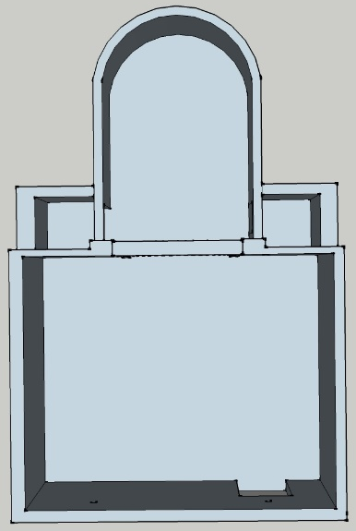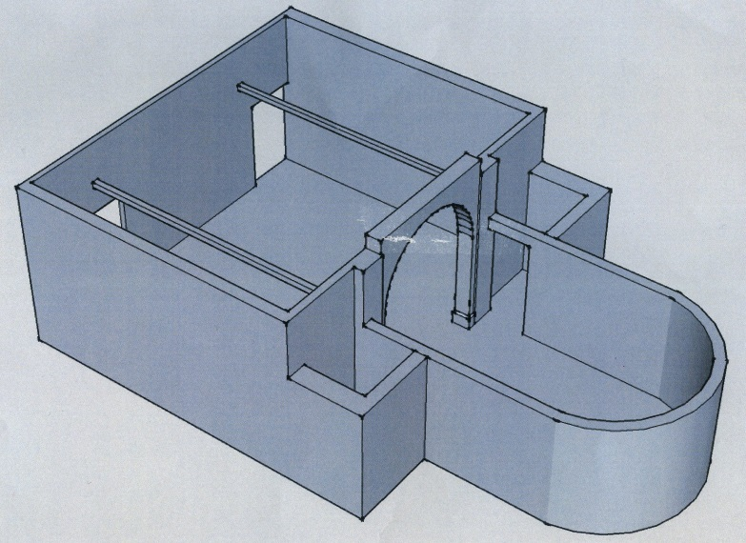
Fig.1, Fig.2
The exhibition is held in the mission gallery and all motors are fuelled ready to start by pushing the button beside each motor. Fume extractors have been placed throughout the gallery for your safety.
We do recommend anyone easily startled or with sensitive hearing wear the ear protectors provided.

V Twin
The V Twin is a two-cylinder engine with the cylinders sat opposed to one another. This set up is most commonly used in motorcycles especially Cruisers and American motorcycles as this is a particularly torquey motor, which is good for large Tourers as allows for steady and smooth cruising. The reason the V Twin has become such an icon is because of men like William Harley, “ Life offers few guaranties but generally the harder and longer you work, the more likely you will succeed.” William Harley continued to work and develop the V Twin until his dying days.
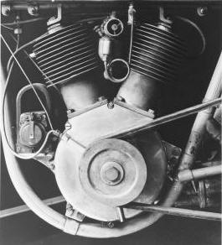
Fig.3 (1909 Harley Davison V Twin designed by William Harley).
The V Twin was first invented in 1909 by Harley Davidson. It produced 7 horse power with a displacement of 49.5 cubic inches. Developed by William S. Harley it was far superior to any single cylinder engine of the time as it allowed for twice the rotation per minute without putting extra stress on the piston or rings and this allowed for faster and more reliable motors.
By this point in time it is highly believed that Harley Davidson is king of the V Twins however there are also V Twins made by other companies such as Indian, Morgan and Buel. Shown here are multiple v twins seen as the highest in quality or popularity.
Included in the collection is the original V Twin made by Harley Davidson mentioned above. Next to that is, arguably, Harley Davidsons most famous V Twin being the Knuckle Head motor. It was developed in 1936 with a displacement of 60.33 ci and produced a whole 40 horse power.
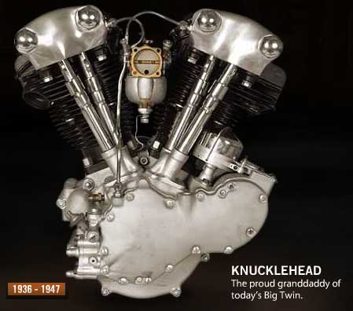
Fig.4 Harley Davidson’s 1936 knuckle head engine designed by William Harley.

V 8
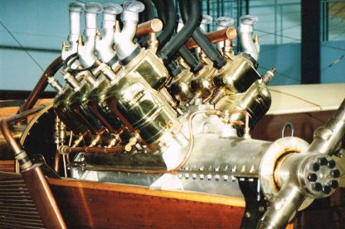
Fig.5 1902 V8 designed by Leon Levavasseur
The V8 was first designed by Leon Levavasseur in 1902 with its original purpose being a light motor for competition speed boats and aircraft. In 1904 a V8 was first placed into a car and used for racing in France. These motors allowed for twice the amount of cylinders without being incredibly long, provided easy maintenance and access to most of the motors major components. It also allowed easier cooling due to all the cylinders being half the length of having all 8 cylinders in a row. The V8 has become an icon due to these traits and is now held by many to be the superior motor design (especially by Americans).
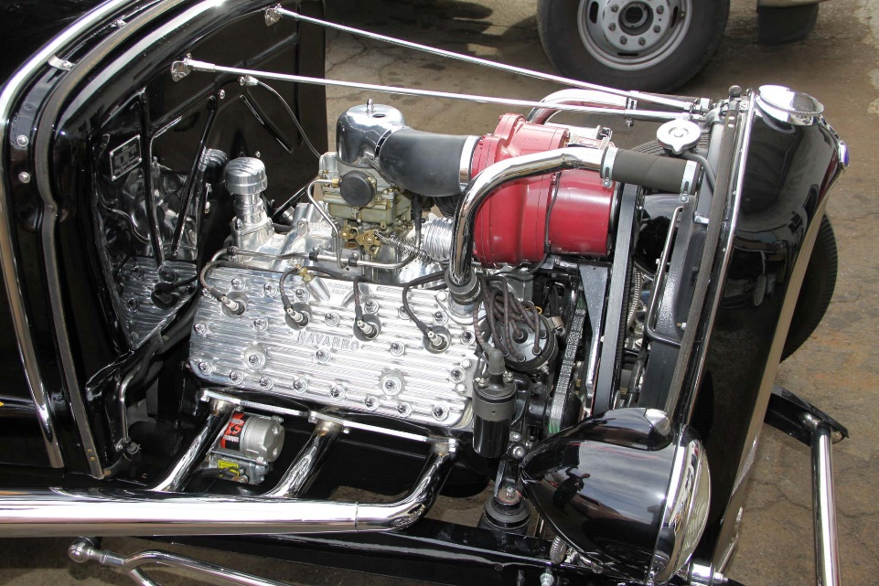
Fig.6 1926 ford Flathead motor designed by Edsol Ford.
The Ford Flathead was arguably Fords most famous V8 motor being 221 ci in displacement and producing 65 horse power. It is still used today by modern Hotrodders. It was first put into production in 1926 in the Ford Model A and was an immediate success as it provided far more power than the previous Ford options. It was quickly supported by the aftermarket and ‘speed parts’ so was therefore quickly adopted by drag racers. Soon after this it became the motor of choice for Moonshiners who would modify their cars to outrun the police during the prohibition period. This activity would become the beginnings of Nascar which is now the world’s most watched motorsport.
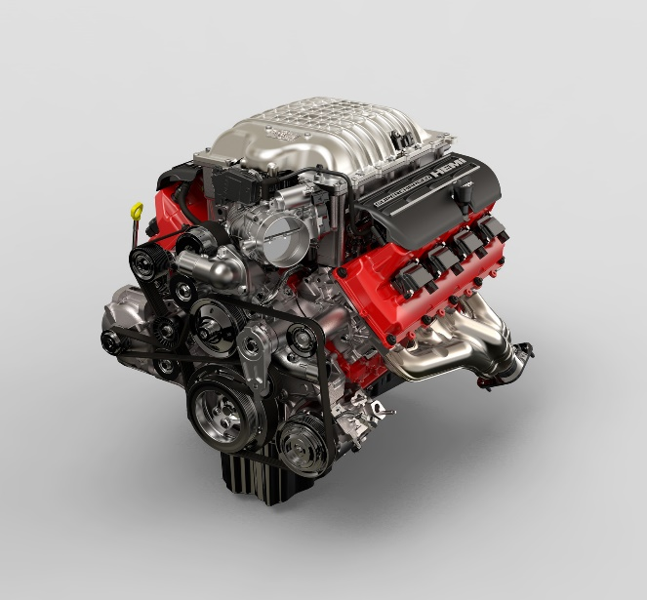
Fig.7 Dodge’s 2018 Demon Hemi V8 designed by Michael Castiglione.
The Hemi V8 was first designed in the early 1900s but not commercialised until the 1950s by Chrysler. They called it the Firepower which amazingly, for that era, produced 180 horsepower from a 331 ci motor. This was achieved by using hemispherical cylinder heads and pistons (hence the name ‘Hemi’) which created a larger surface area. The potential of these motors was quickly realised and it soon became a status symbol to have the word ‘Hemi’ on the side of your vehicle. They also quickly gained popularity with truck owners due to high torque numbers being able to move their very heavy trucks through mud and rough terrain. The Hemi displayed here is the 6200cc hemi V8 from the Dodge Hellcat Demon. This motor produces 840 horse power which is far beyond the power of any other motor that has been displayed so far.

V 12
The V12 was first designed in 1904 by the Putney Motor Company originally designed for a ship called the Craig-Dorwald named after its company’s founders. The V12 weighed 430kg and produced 150 horse power. One of these original engines was found still powering a Hong Kong junk (boat) in the late 1960s. The first instance of a V12 being put into a car was in 1913 when it was put into the Sunbeam Toodles V, a specially designed race car for the Brooklands circuit.
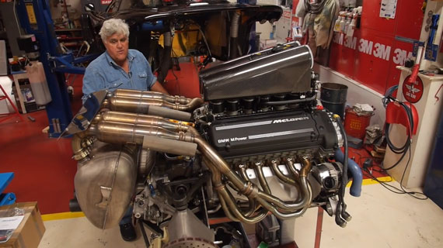
Fig.8 McLaren’s 1998 F1 V8 designed by Gordon Murray and Peter Stevens
The McLaren F1 made good use of such a powerful motor and in 1998 released their new car which quickly became the world’s fastest production car with a top speed of 231 mph. The impressive engine that powered this car was a 6100 cc V12 which produces an amazing 618 horse power and due to this relatively huge amount of horse power it held the record of world’s fastest production car for 7 years.
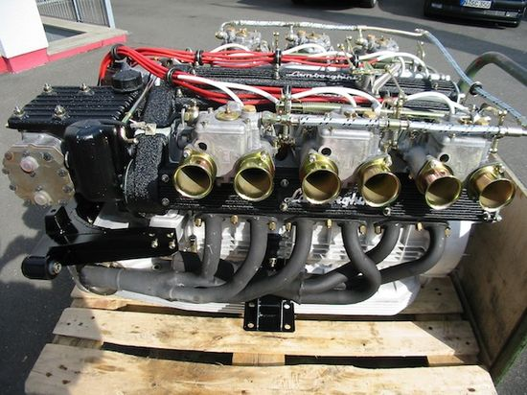
Fig.9 Lamborghini’s 1974 V12 motor designed by Marcello Gandini and Paolo Stanzani.
The next motor is a 1974 Lamborghini Countach V12 this engine rapidly gained popularity due to the exotic styling of the Italian super car itself but was also helped by the high speeds achieved by the Countach. As Ferruccio Lamborghini himself said, “ Lamborghini is refinement, luxury and perfection.” Unsurprisingly, because of its looks this car made it onto bedroom wall posters. It was a car that had dreamers drooling over the idea of having the huge V12 sat behind there heads powering them down the road. The engine itself was a 3900 cc V12 producing 374 horse power and, I’m sure you will agree, has one of the best engine notes ever heard.

Triple
The first triple motor to be created was by Moto Guzzi in 1932 and it was a 500cc motor designed for their luxury tourer. These motors became very popular as a motorcycle engine due to the great compromise between top-end and low-end power giving a much more practical but still a fun bike.
There is only one Triple engine on display as that is all it takes to fall in love with its very distinctive characteristics.
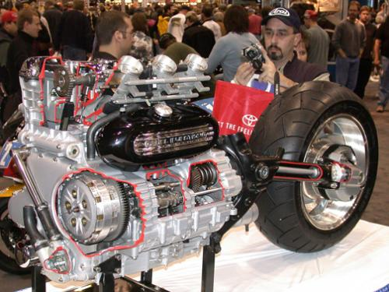
Fig.10 Triumph’s 2017 Rocket iii Triple motor designed by John Mockett
The engine on show is the 2294cc motor, straight out of a Triumph Rocket iii. This motor is currently the largest displacement production motorcycle engine in the world. It produces 127.1 horsepower and has more torque then a lot of small family cars have. This engine is mighty and is loved by many motorcyclists for its perfect compromise of power.

V5
The V5 is the rarest and most unusual motor in this exhibition almost exclusively used for high specification cars and motorbikes. The V5 package is so effective as it is a very compact way to position the cylinders and allows for a very powerful motor. It also has a recognizable engine note due to its odd number of cylinders in a V configuration.
The first V5 was developed by Oldsmobile in 1983 but was never put into production. A few years later in 1997 Volkswagen put it into production as a top specification engine option for some of their car ranges. But it was not longstanding option.
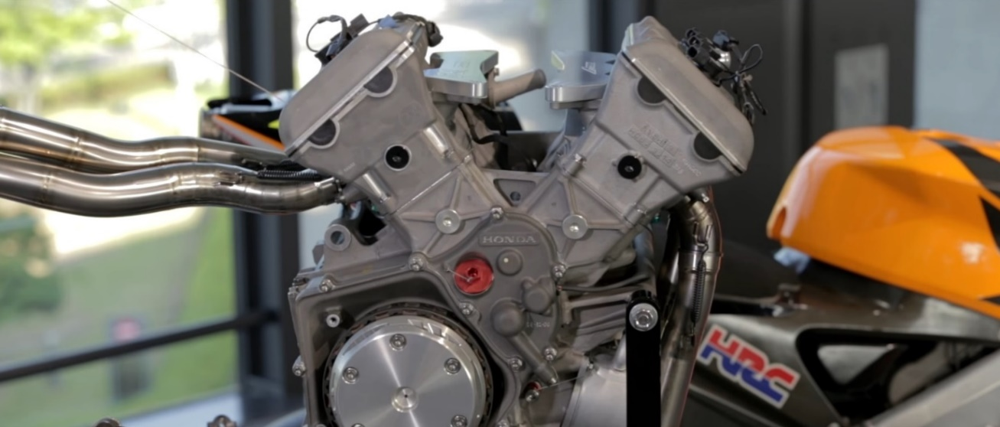
Fig.11 Honda’s 2002 V5 designed by Nobuhiko Shiozaki.
However, Honda made good use of the V5 motor for their MotoGP bike, the RC211V. This was continually used from 2002 until 2006 leading to the Honda winning 48 out of 82 races, in 5 seasons of MotoGP. It also won 3 Rider World Championships (Rossi 2002, 2003 and Hayden 2006) and 4 Constructor titles (2002, 2003, 2004, and 2006). The 990cc motor produced 207 horse power and had no driver aids such as traction control or ABS: it is therefore a “Real Man’s Bike”.

Conclusion
As you can see the engine has evolved massively since first invented and the cultures around them have exploded into a thousand different realms and have even separated into there own groups within the culture from bikes to cars and even within those groups there is separation. They are deeply embedded in our DNA through the sounds, looks and power and now we can not be separated from our vehicles.

Bibliography
www.adrianflux.com
www.autoevoloution.com
www.autoguide.com
www.boxrepsol.com
www.britishgas.co.uk
www.cjponyparts.com
www.hotrod.com
www.motorcycleclassics.com
www.motorcyclenews.com
www.motorsportretro.com
www.rideapart.com
www.scribd.com
www.triumphrat.net

Quotes
Ferruccio Lamborghini, (20/02/1975), (https://medium.com/@entrepreneursway0007/23-amazing-quotes-by-ferruccio-lamborghini-1f75d33fff9c), (04/05/2019)
Henry Ford, (23/10/1917), (https://addicted2success.com/quotes/38-memorable-henry-ford-quotes/), (04/05/2019)
William Harley, (18/09/1935), (https://www.aitak-solutions.com/quote-william-harley/), (04/05/2019)

Images
Fig.1 uwtsd Moodle (Ways of perceiving)
Fig.2 uwtsd Moodle (ways of perceiving)
Fig.3 https://www.factoryfat.com/hdmotorhistory.html
Fig.4 https://freedomcyclesource.wordpress.com/2014/10/25/harley-davidson-knucklehead-engine/
Fig.5 https://www.razaoautomovel.com/2017/05/porque-nao-existem-motores-v7-ou-v9/leon-levavasseur-v8
Fig.6 https://www.hotrod.com/articles/topping-off-fords-flathead-v8/
Fig.7 https://www.autoguide.com/auto-news/2017/06/dodge-reveals-more-details-on-the-challenger-srt-demon-s-engine.html
Fig.8 http://www.motorsportretro.com/2013/07/taking-the-engine-out-of-a-mclaren-f1/
Fig.9 http://ricambi-toro.de/en/products/engine/
Fig.10 http://www.triumphrat.net/photogallery/v/events/album187/aaf.jpg.html
Fig.11 https://www.boxrepsol.com/en/motogp-en/the-honda-rc211v-the-dawn-of-new/

