
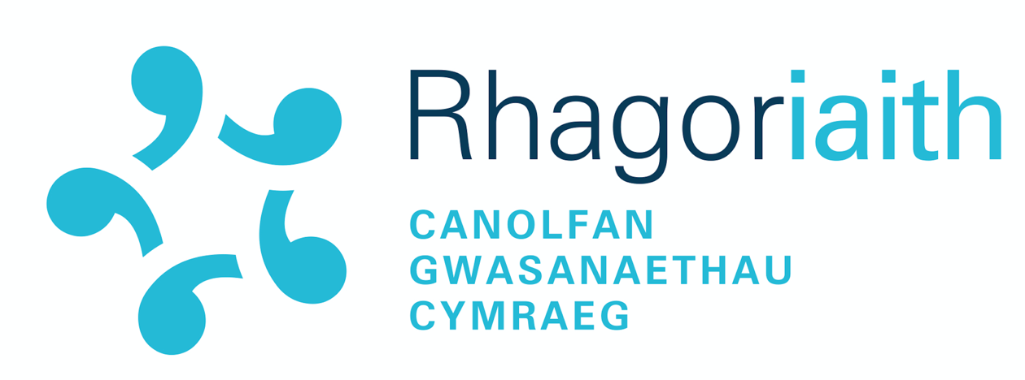

Welsh Language Competency Framework for Teachers Portfolio

Student number: ________________________________

Primary PGCE |  | Secondary PGCE |  | BA Education
Programme (tick the relevant box):

 | Type of evidence | Reasons for submitting the evidence
SPEAKING
LISTENING
READING
WRITING
Teaching and Learning

Advice whilst planning your portfolio
- RELEVANT evidence- the evidence submitted must be relevant to the level descriptions.
- ENOUGH evidence of the 4 skills and your ability in regard to the teaching and learning, but don’t overload it. You shouldn’t submit more than 5 resources for any individual skill. Think about WHY you have included each piece.
- Listening – if you submit listening tasks as evidence, you must submit the audio file along with your answers to the questions, or the evidence will not prove your listening ability.
- Writing – make sure you have sufficient evidence of your written work
- Teaching and Learning: At the highest levels, you must show ‘a range of progressive language teaching and learning strategies’ – choose your evidence carefully.
- If you submit evidence which is relevant to more than one skill, please note this in the table above. You will only need to upload the file to the PLP once.
- Showcase yourself at your best in the portfolio – choose your evidence wisely!

