DS 1 Template

My Screenshots/Photos
- Please add 4–6 screenshots or photos of your digital life.
- You can use your phone or laptop.
- For each screenshot, write one or two sentences explaining what it shows.

Screenshot/Photo 1
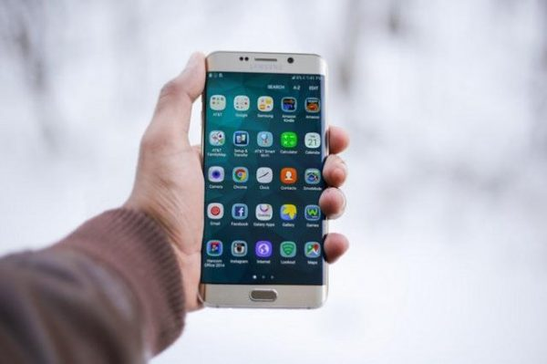
Smartphone is very useful item, as it is needed for everyday use and helps us carry out our daily tasks, I will provide a few examples of how I use my mobile phone throughout the day.
- Navigating using a satellite navigation for transporting.
- Using social media for friends/family, promoting our business & buying and selling goods.
- Receiving phone calls and text messages.
- Checking time & day to keep track of my tasks.
- Using calendar as an reminder for important events/appointments.
- Using online banking checking balance & payments managing money throughout the day.
- Internet access for researching online for information.
(Mobile Direct Online, n.d.)

Screenshot/Photo 2
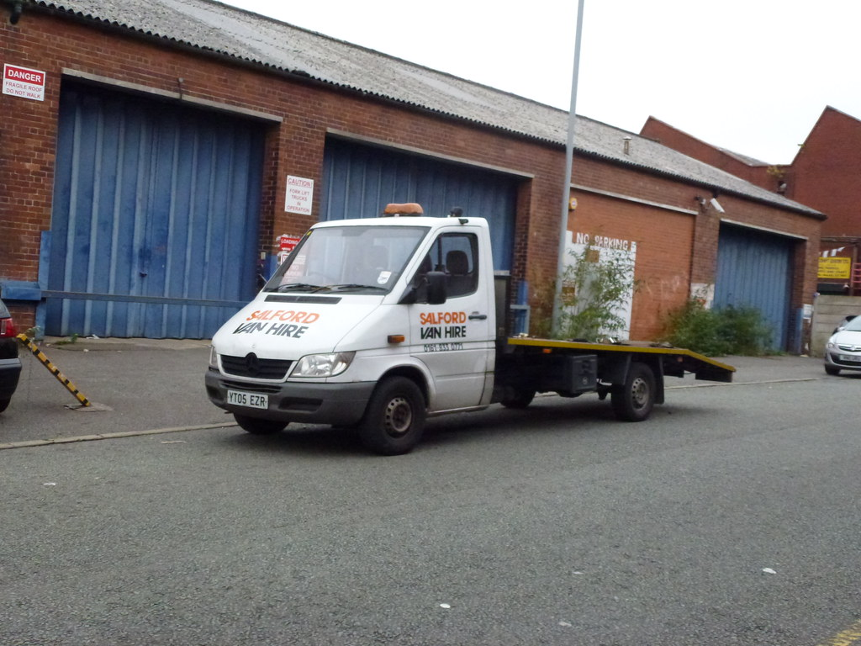
This photo of a recovery trucks shows how digital technology is used in my daily life. Recovery trucks use gps and satellite navigation to find locations and reach customers who need assistance. Mobile phones are used to receive calls, send text messages and communicate with customers. Digital technology also helps drivers find quickest route, check traffic conditions and manage their work effciently. This shows how important digital technology is for communication, navigation and carrying out everyday tasks. (Duggan Recovery, 2023)

Screenshot/Photo 3
[Insert Photo/Screenshot below]
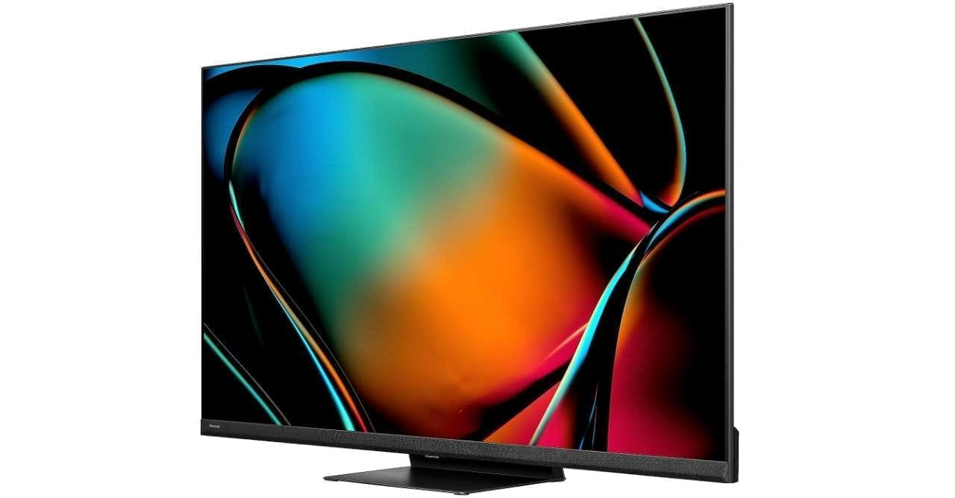
A television is an important part of modern life because it allows me to enjoy my free time at home. I can choose what I want to watch depending on my my interests, whether it is a football match, a film or a documentary. It also allows me to access different apps and online platforms, giving me more control over my viewing choices. This shows how technology has changed the way people spend their time leisure and access entertainment. (Mai Hien, n.d.)

Screenshot/Photo 4
[Insert Photo/Screenshot below]
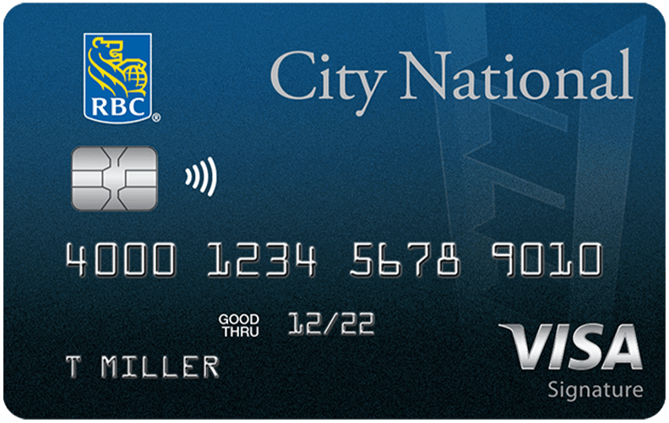
Having a bank card makes it easier for me to pay for things in my daily life. Instead of carrying cash, I can simply tap my card when shopping or buying something to eat. I can also it to order products from websites. This shows how digital technology has changed the way people handle money and make payments in modern society.
(Berns, 2026)

Screenshot/Photo 5
[Insert Photo/Screenshot below]
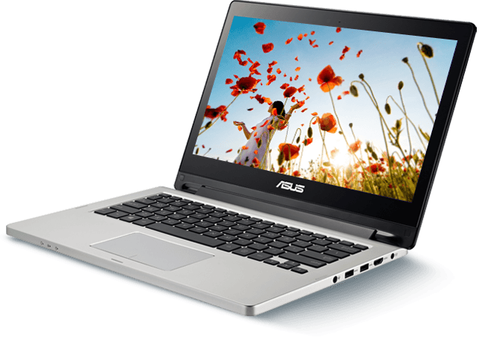
A laptop gives me the opportunity to access a wide range of information from home. I can use it to research different topics, watch videos and complete my university work. It allows me learn new skills and access online services without having to leave the house. This shows how technology has made learning and accessing information much easier. (Education Forum, 2023)

Screenshot/Photo 6
[Insert Photo/Screenshot below]
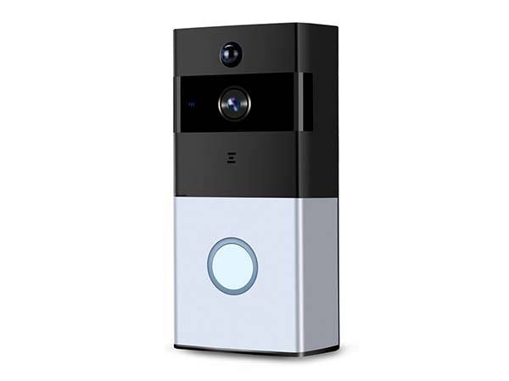
A smart doorbell is an example of how digital technology can be used to improve home security. It allows people to see who is at their front door and, in some cases speaking to visitors through their mobile phone. This technology can be useful when I am away from home because it helps me know when someone is visiting. (Meridian Security, 2024)

My Short Reflection
- Write 5–8 simple sentences about your digital life.
- You can use the sentence starters below if helpful.
I use digital tools every day to help me with my daily tasks, university work and communication. I feel confident when using when using my mobile phone, laptop and other digital devices. I want to improve my computer skills and learn how to use different online services. I often use digital tools to find information, make payment and stay connected with other people. I sometimes feel nervous about using new technology, but I am willing to learn. I hope this module will help me become more confident and independent when using digital tools. Digital skills are important to me because they make everyday life easier and help me with my education and future opportunities.

Sentence starters
- I use digital tools to …
- I feel confident when I …
- I want to improve …
- I often use these tools: …
- I sometimes feel nervous about …
- I hope this module will help me …
- Digital skills are important for me because …
You can write more if you want.

Submission Checklist
Before you submit, please check:
​​​ ☐ I added 4–6 screenshots
☐ I wrote short sentences for each screenshot
☐ I wrote my short reflection
☐ My work is my own
☐ My file opens correctly
​​☒ My file opens correctly
Referencing:
Mobile Direct Online (n.d.) 20 Advantages of Having Mobile Phone. Available at: https://mobiledirectonline.co.uk/blogs/mobile/20-advantages-of-having-mobile-phone (Accessed: 18 October 2026)
Duggan Recovery (2023) How technology is changing the breakdown industry. 6 February. Available at: https://www.dugganrecovery.co.uk/how-technology-is-changing-the-breakdown-industry/ (Accessed: 18 October 2026)
Mai Hien (n.d.) B1 Essay: The Advantages of Watching TV in Modern Life. Studocu. Available at: https://www.studocu.vn/vn/document/truong-dai-hoc-kinh-te-dai-hoc-da-nang/vstep/b1-essay-the-advantages-of-watching-tv-in-modern-life/161903092 (Accessed: 18 October 2026).
John Berns (2026) What the future holds for consumer payments: Credit cards and digital wallets. The Payments Association, 8 May. Available at: https://thepaymentsassociation.org/article/what-the-future-holds-for-consumer-payments-credit-cards-and-digital-wallets/ (Accessed: 18 October 2026).
Education Forum (2023) Digital Dawn: How tablets and laptops can boost educational outcomes. 24 July. Available at: https://education-forum.co.uk/briefing/digital-dawn-how-tablets-and-laptops-can-boost-educational-outcomes/ (Accessed: 18 October 2026).

Meridian Security (2024) The Role of Smart Home Devices in Enhancing Security. 25 June. Available at: https://meridiansecurityleeds.co.uk/the-role-of-smart-home-devices-in-enhancing-security/ (Accessed: 18 October 2026).

