Richard Jones - 1809132
rojones@gmail.com
Database Design (The book Store)
ACCB4013 – Bev Holland

Abstract
Create and document a database system to computerise existing paper-based systems for Dylan’s Book store. The new computerised system will need to have the ability to allow for the staff and customers via staff to place orders with suppliers. The Database will also need to be able to capture the catalogue of the stores stock of books while also being able to generate reports from this information, such as being able to identify all the First Edition books that the store hold. The author will also need to make sure all Customer information is captured while also being able to identify if the customer would like to be on the stores mailing list. They key attribute around all of the previously mentioned elements will be that the database needs to be user friendly and efficient to use for the staff to allow for a prompt and friendly service.

Table of Contents
Abstract 1
Table of Contents 2
Introduction 3
1. Task 1 1
1.1. Normal form of data capture. 1
1.2. ERD Entity Diagram 2
1.3 Entity Relationships (Further Evidence from MS Access Database) 3
Task 2 4
2.1 Evidence of SQL utilised in MS Access Table Creation. 4
2.2 Database Input Masks and data types expanded. 5
2.3 Output from Macro Query driven Reports 8
• AuthorID_Input (Author ID book Search) 8
• Customer ID Input (Customer ID Orders Search) 10
• StaffID Input (Staff ID Orders Report) 12
• First Editions Books (Retrieves all books that are First Editions) 14
• Customer Newsletter Subscribers 15
2.4 Examples of all forms utilised in the Dylans Book Store Database. 16
2.5 Brief User Guide 20
• Main Menu 20
• Forms Menu 21
• Specific Forms Data Editing 22
• Reports Menu 23
• Specific Reports examples. 23
2.6 Conclusion. 25
Appendix 26

Introduction
The new computerised system will need to have the ability to allow for the staff and customers via the staff to place orders with suppliers. The Database will also need to be able to capture the catalogue of the stores stock of books, while also being able to generate reports from this information, such as being able to identify all the First Edition books that the store hold. The author will also need to make sure all Customer information is captured, while also being able to identify if the customer would like to be on the stores mailing list. They key attribute around all the previously mentioned elements will be that the database needs to be user friendly and efficient to use for the staff to allow for a prompt and friendly service.

Task 1

Normal form of data capture.
The Types of data being captured for Dylan’s Book Store has been captured in a First Normal Form process and then Processed through from 1NF 2NF 3NF to show the kind of tables required to start looking at the ERD Layout. Normal Form (Database Normalization) is a process that is carried out on test data to organise a database into tables and columns[1].The idea being that the outcome from this process would then lead to tables only being about the specific topic/content that is required in the aforementioned table. The process consists of 3 phases. 1NF which mainly consists of all the data being formalised into one table making it easier to search and sort the information[2]. This then leads on to the second phase known as 2NF, in second normal form we now look to focus in on any duplication in the data and how this can now be reduced to singular columns and eliminate further anomalies[3]. Lastly we than have the third phase which is 3NF, third normal form then expands further on 2NF by making sure each column is dependant on a primary and serves a single purpose, while again making sure any duplication in second normal form has been cleared out[4].

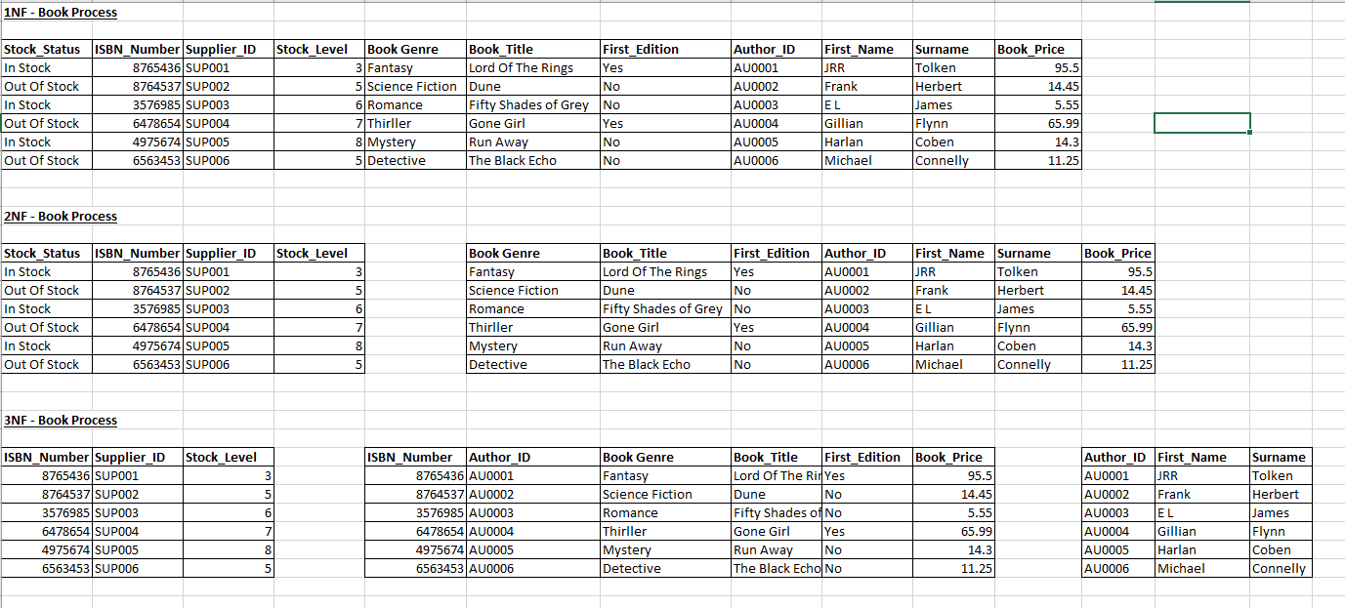
- Above is a screenshot from the Normal Form process for the Books aspect of the proposed database. The file is embedded in the Appendix

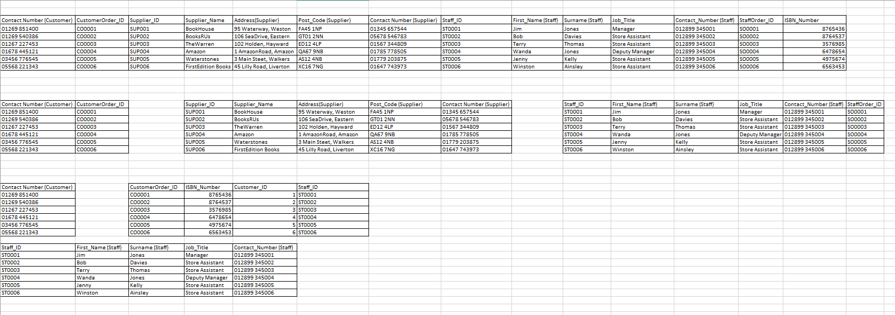
- Above is a screenshot from the Normal Form process for the remaining data required in tables for the proposed database. The file is embedded in the Appendix

ERD Entity Diagram
Below is the ERD that was created after carrying out the Normal Form process on the proposed data to be captured in the database, it details the relationship between the proposed tables and the Primary, Foreign[5] & Composite keys where required.
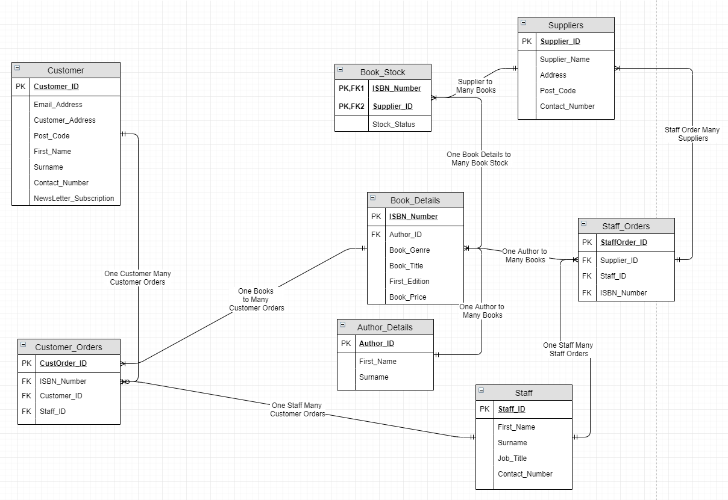
On the Diagram above the relationships between the proposed tables are shown. Further detailed below.
- 1 Customer to Many Customer_Orders
- 1 Book to Many Customer_Orders
- 1 Staff to Many Customer_Orders
- 1 Staff to Many Staff_Orders
- 1 Staff_Orders to Many Suppliers
- 1 Book_Details to Many Book_Stock
- 1 Author to Many Books
- 1 Supplier to Many Book_Stock

1.3 Entity Relationships (Further Evidence from MS Access Database)
Further to the ERD Diagram in 1.2, The diagram below is the relational diagram generated within MS Access to display and show the relationships between the data and tables. Including the Primary Keys, Foreign Keys & Composite Keys where needed.

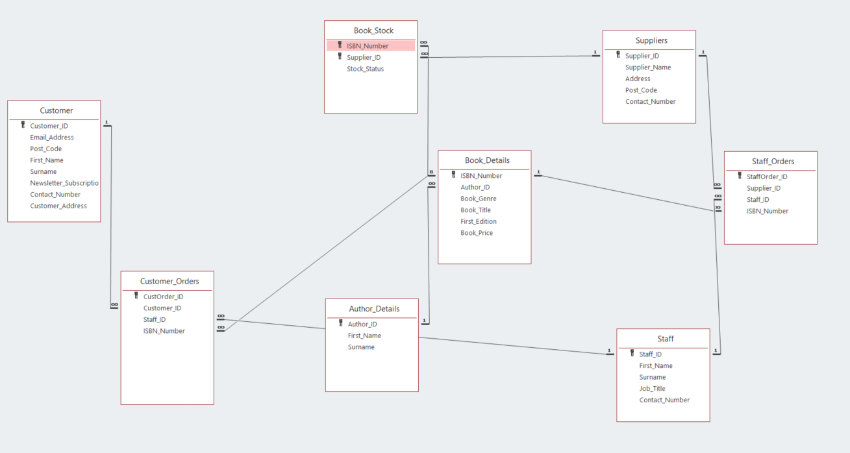

Task 2

2.1 Evidence of SQL utilised in MS Access Table Creation.
The Author has detailed below the evidence of SQL being utilised to create the tables for the database implementation. As park of the table creation Primary Keys are designated in each table as well as any required foreign keys and their relating tables. There is also an example of a composite key being utilised in one table “Book_Stock”.
- Create Author Details Table
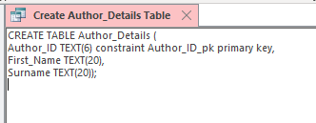

- Create Book Details Table
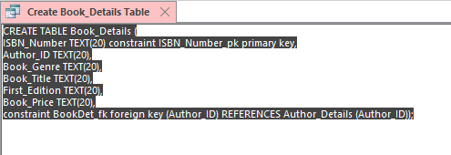

- Create Book Stock Status Table
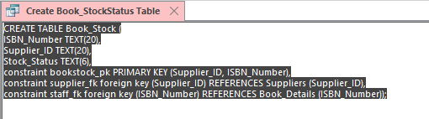

- Create Customer Table
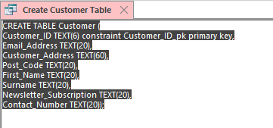

- Create Customer Order Table
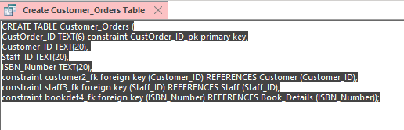

- Create Staff Table
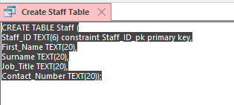

- Create Staff Order Table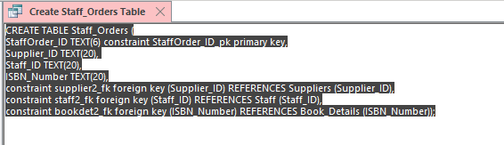

- Create Suppliers Table
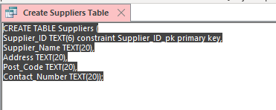
- Insert Data in to a Table (Suppliers Example)
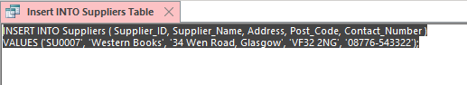

2.2 Database Input Masks and data types expanded.
Below are the tables once created via the SQL statements. Any altered data types, input mask and lookup controls required are also detailed below. Details of input mask character are referenced[6]

- Author Details Table
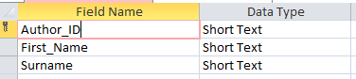
Author_ID Field: Input Mask LL0000

- Book Details Table
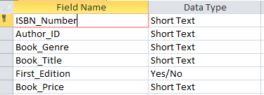
ISBN_Number Field: Input Mask 000\-0\-0000\-0000\-0
Author_ID Field: Input Mask LL0000 (Lookup Author_Details Table)
First_Edition Field: Format Yes/No
Book_Price Field: Input Mask "£"00.00

- Book Stock Table
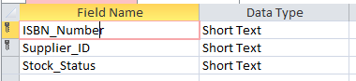
ISBN_Number Field: Input Mask 000\-0\-0000\-0000\-0 (Lookup Book_Details Table)
Supplier_ID Field: Input Mask LL0000 (Lookup Suppliers Table)
Stock_Status Field: Input Mask 000

- Customer Table
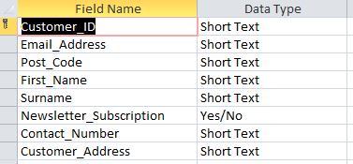
Customer_ID Field: Input Mask LL0000
Post_code Field: Input Mask >LL09\ 0LL
Newsletter_Subscription Field: Format Yes/No
Contact_Number Field: Input Mask 00000\-000000

- Customer Orders Table
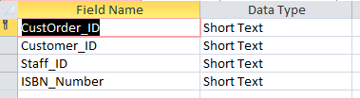
CustOrder_ID Field: Input Mask LL0000
Customer_ID Field: Input Mask LL0000 (Lookup Customer Table)
Staff_ID Field: Input Mask LL0000 (Lookup Staff Table)
ISBN_Number Field: Input Mask 000\-0\-0000\-0000\-0 (Lookup Book_Details Table)

- Staff Table
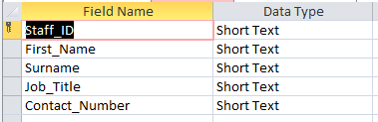
Staff_ID Field: Input Mask LL0000
Contact_Number Field: Input Mask 00000\-000000

- Staff Orders Table
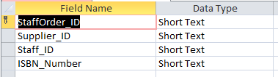
StaffOrder_ID Field: Input Mask LL0000
Supplier_ID Field: Input Mask LL0000 (Lookup Suppliers Table)
Staff_ID Field: Input Mask LL0000 (Lookup Staff Table)
ISBN_Number Field: Input Mask 000\-0\-0000\-0000\-0 (Lookup Book_Details Table)

- Suppliers Table
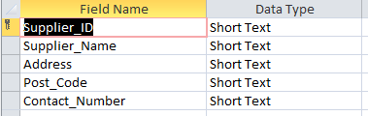
Supplier_ID Field: Input Mask LL0000
Post_code Field: Input Mask >LL09\ 0LL
Contact_Number Field: Input Mask 00000\-000000

2.3 Output from Macro Query driven Reports
The Author has created and documented three macro query driven reports that were identified by the owners of the Dylans Book Store. Below are the documented screenshots and evidence of the Macros & Queries used.

AuthorID_Input (Author ID book Search)
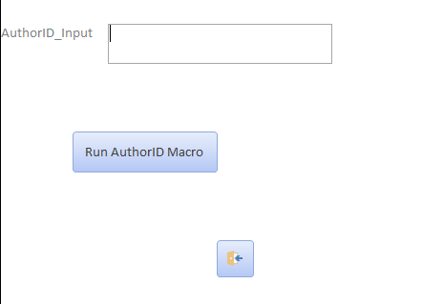
Above is the Authorid_Input form, the user enters a relevant Author_ID and clicks the “Run AuthorID Macro” Button.

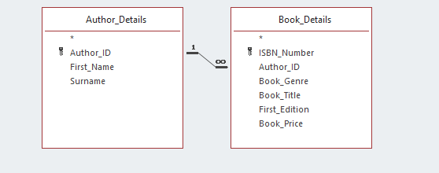
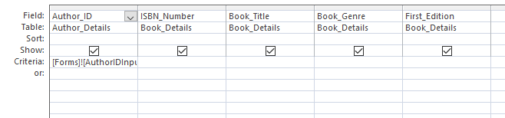
Above is the Query used to pull relevant information from multiple tables.

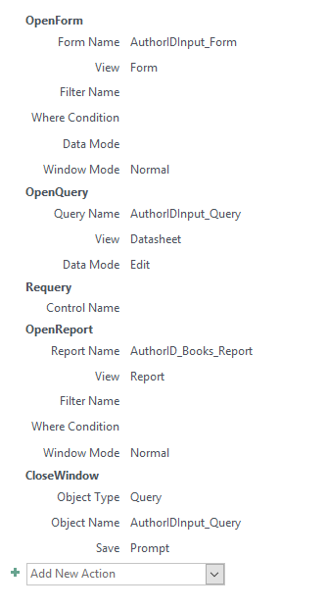
Above is the Macro utilised to run the AuthorID_Input Report.

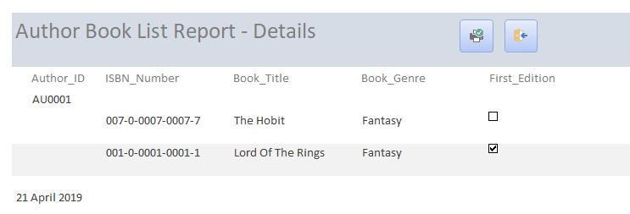
Above is an example report querying the Author_ID (AU0001), which returns the two current book titles associated with the author.

Customer ID Input (Customer ID Orders Search)
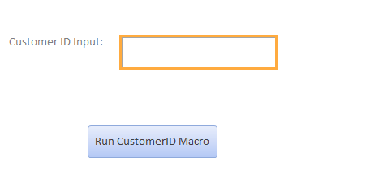
Above is the Customer ID Input form, the user enters a relevant Customer_ID and clicks the “Run CustomerID Macro” Button.

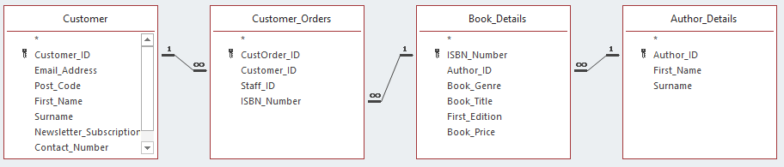
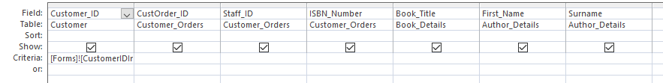

Above is the Query used to pull relevant information from multiple tables.

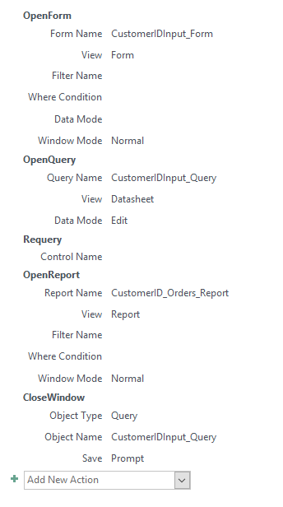
Above is the Macro utilised to run the Customer ID Input Report.

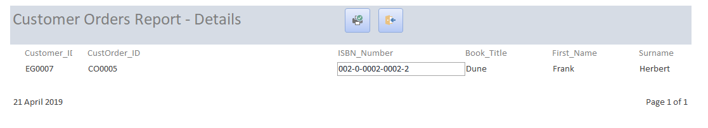
Above is an example report querying the Customer_ID (EG0007), which returns the order(s) placed for the specific customer.

StaffID Input (Staff ID Orders Report)
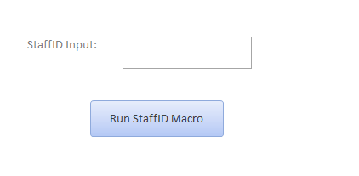
Above is the StaffID Input form, the user enters a relevant Staff_ID and clicks the “Run StaffID Macro” Button.

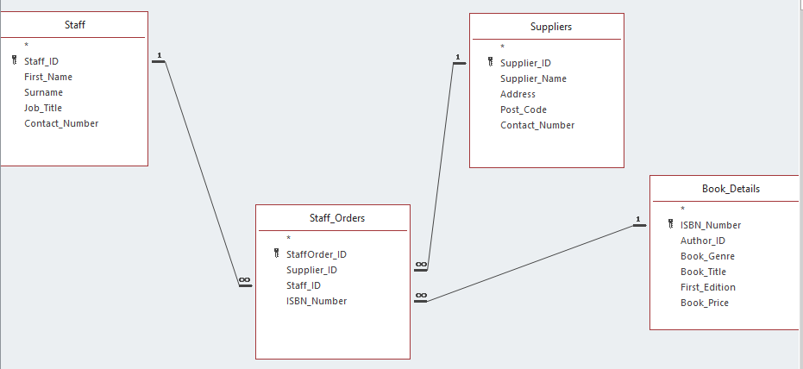
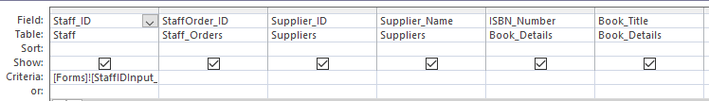

Above is the Query used to pull relevant information from multiple tables.

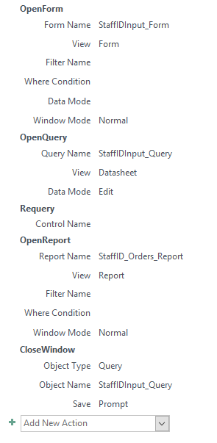
Above is the Macro utilised to run the StaffID Input Report.

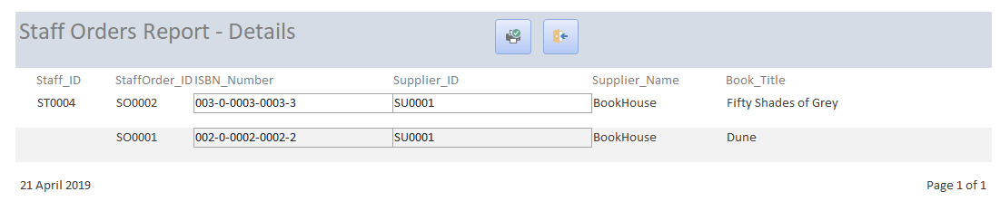

Above is an example report querying the Staff_ID (ST0004), which returns the order(s) placed for the specific staff member.

First Editions Books (Retrieves all books that are First Editions)
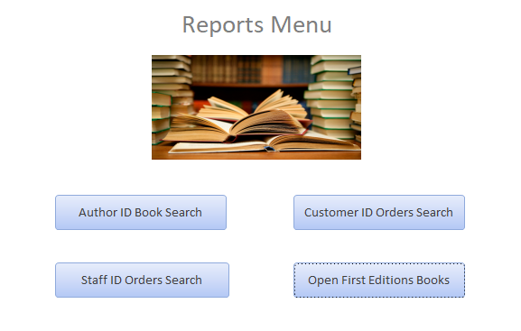
Above is the Reports Menu, from which the user can click on the “Open First Editions Books” button which will retrieve all First edition books.

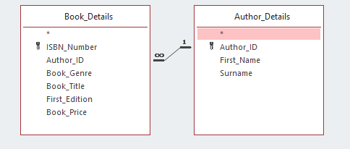
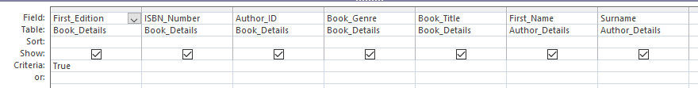
Above is the Query used to pull relevant information from multiple tables.

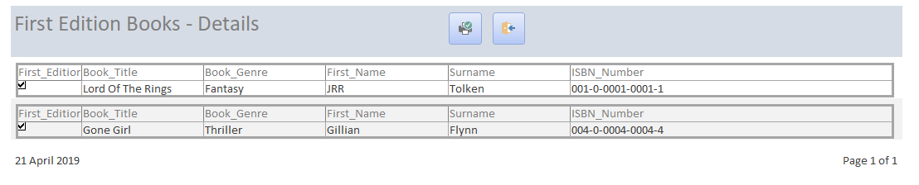
Above is an example report outputting all First Edition books.

Customer Newsletter Subscribers
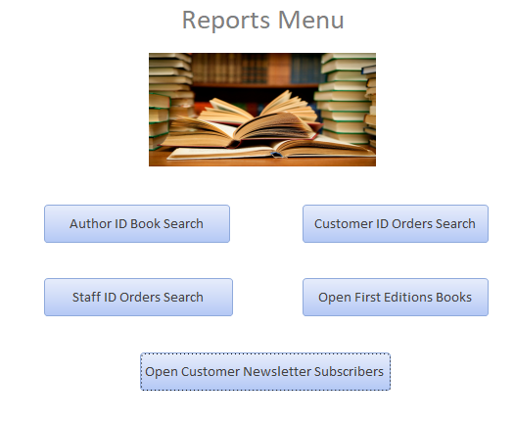
Above is the Reports Menu, from which the user can click on the “Open Customer Newsletter Subscribers” button which will retrieve all customers who have subscribed to a newsletter
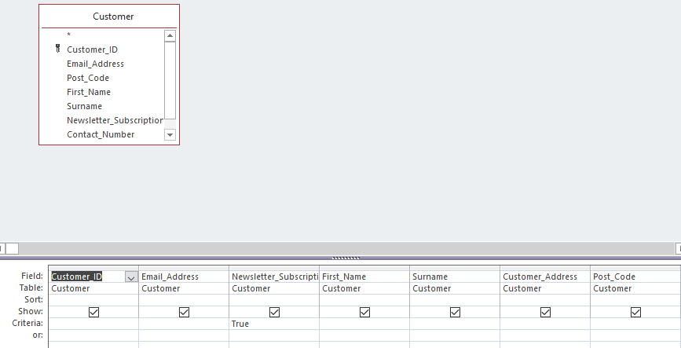.
Above is the Query used to pull relevant information from a single table.
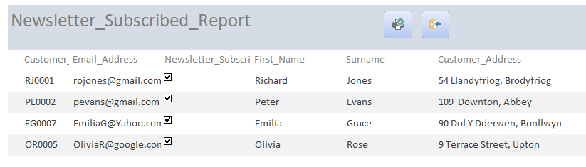
Above is an example report outputting all customers with newsletter subscriptions.

2.4 Examples of all forms utilised in the Dylans Book Store Database.
The following screenshots demonstrate the Author has evidenced all examples of forms used in the Dylans book Store Database.
- Main_Menu
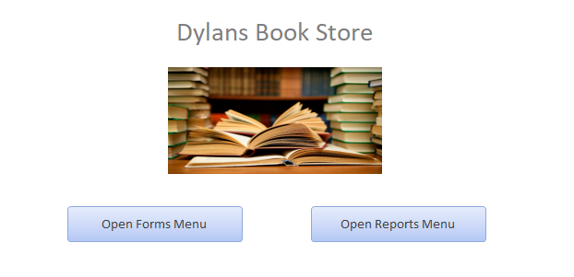
- Forms_Menu
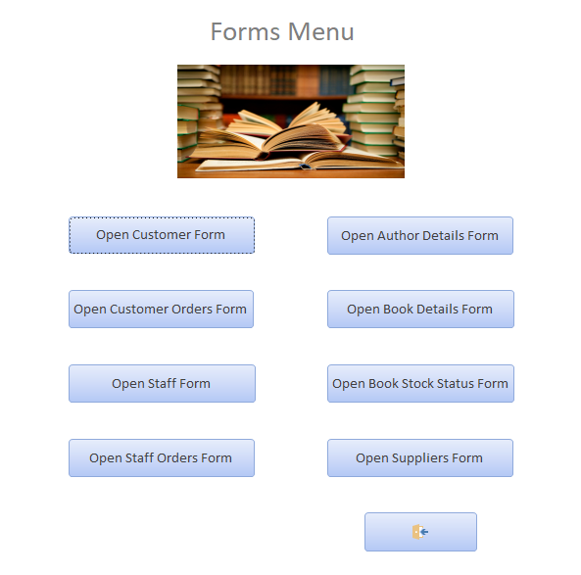
- Reports_Menu
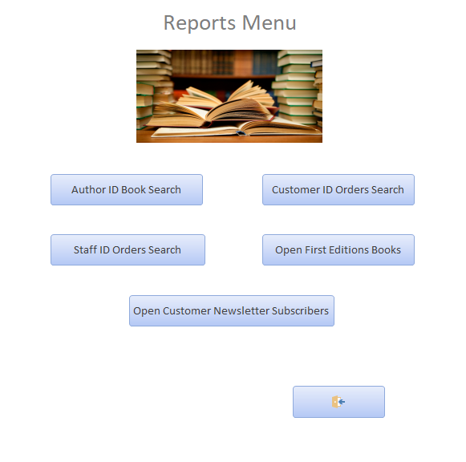

- Customer_Form
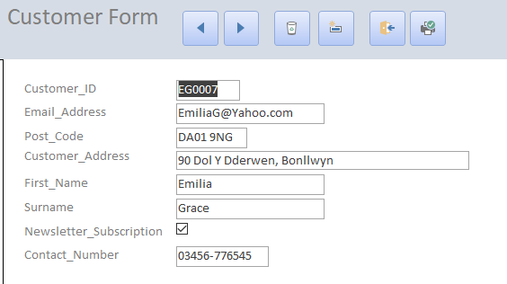

- CustomerOrders_Form
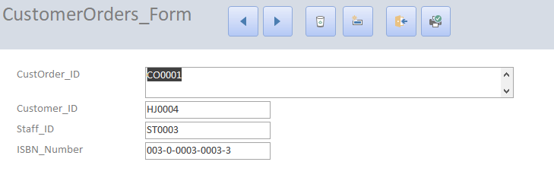

- Staff_Form
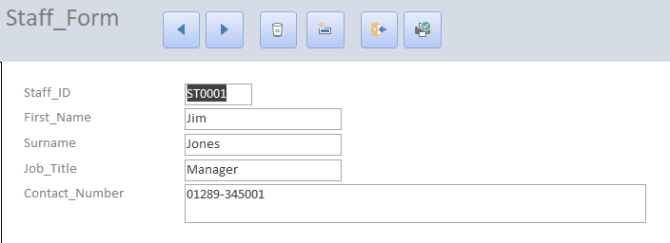

- StaffOrders_Form
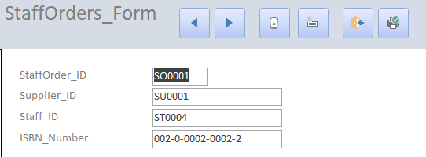

- AuthorDetails_Form
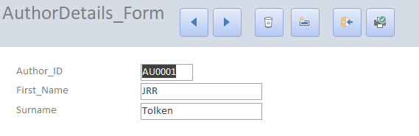

- BookDetails_Form
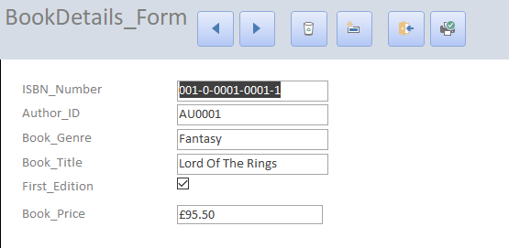
- BookStock_Form
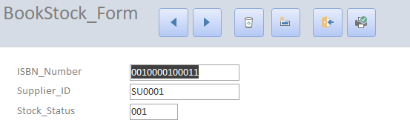
- Suppliers_Form
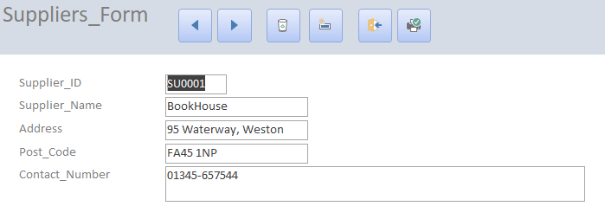

2.5 Brief User Guide
The Author has detailed a brief user guide below with screenshots to show the navigation of the menu system that is the front end for the database.

Main Menu

From the “Main Menu” the user can drill down in to two specific areas. The “Open Forms Menu” which will navigate to the forms for editing data in to the specific tables. Or the user can click on the “Open Reports Menu” which will navigate to the listed array of reports available.

Forms Menu
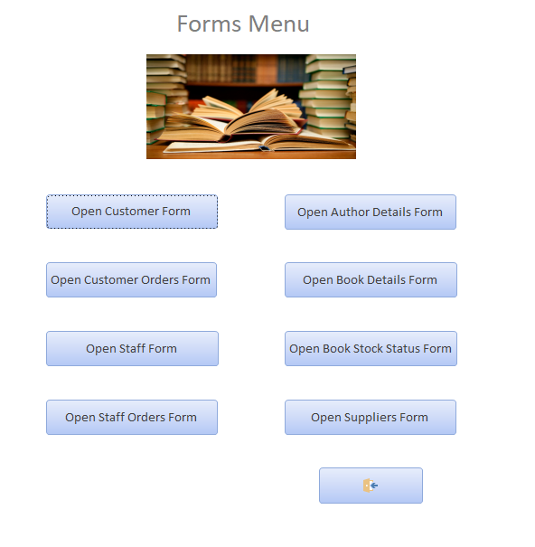
From the “Forms Menu” the user can navigate to the required form for data input. For example, the user could click on the “Open Customer Form” to enter new customers, or perhaps edit, delete existing ones. If the user wished to return to the “Main Menu” there is a “Return” icon on the bottom right of the form

Specific Forms Data Editing
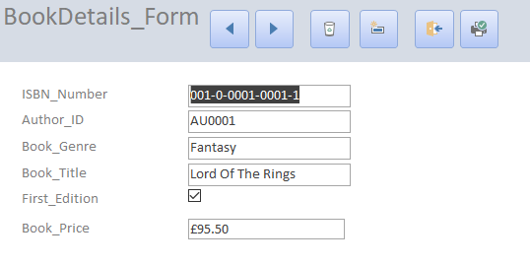
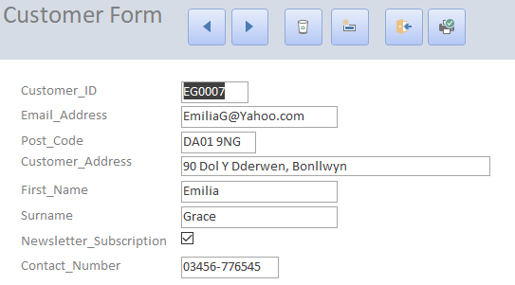
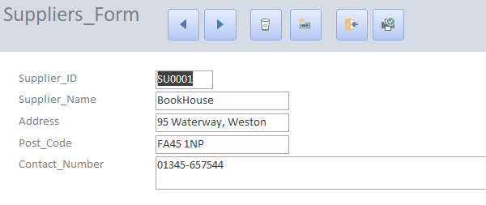
Above are several examples from the “Forms Menu”. Each form while specific to its individual table has the same layout for ease of use for the end user. At the top of the form is the navigation and editing ribbon, from left to right you have the following features: Previous Record, Next Record, Delete Record, Add/Save Record, Exit Form & Print Page. Below the Ribbon the end user is then presented with the relevant fields for each table and they are simply able to highlight and add/amend.

Reports Menu
From the “Reports Menu” the end user is able to navigate to three “Macro Query Driven reports” which require end user data input for the report to output. There are also 2 predetermined reports that will produce (1) output for all “First Edition Book” (2) Customer who has subscribed to a newsletter. If the user wished to return to the “Main Menu” there is a “Return” icon on the bottom right of the form.

Specific Reports examples.
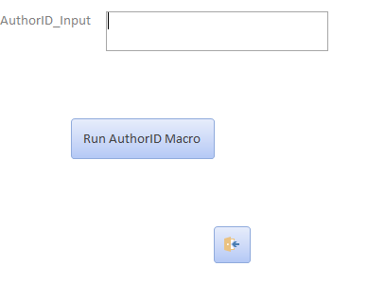

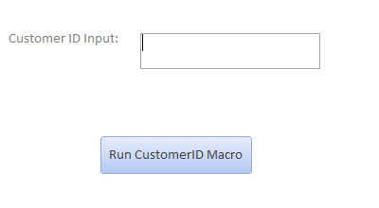
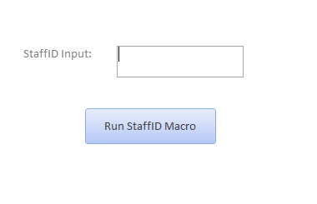
Above are the three examples of the user driven reports, these three reports require data input by the end user for the output report to be generated, on each form on the bottom there is an “exit” button which will return the end user to the Reports Menu. For example, in the case of the “Author_ID Input” form, When the user enters an Author_ID the report will then be generated and display the list of books by that Author, Example below:

The “Customer ID” and “Staff_ID” both work in a similar manner, and again once a valid ID is entered a report will be generated to display the orders for the specifically requested Customer or Staff member.

2.6 Conclusion.
The author has concluded that the database that has been created meets the original criteria set out by Dylans Book store requirements. The Database has all the required tables created and have been created utilising the SQL command line demonstrating the understanding required to complete this aspect of the database creation. The author also created a suitable Menu’s interaction format for the end user to utilise rather than having to modify data on the tables themselves, this was also achieved using the forms approach within the menus.
Appropriate reports were created as required by Dylans Book store. Two pre-defined reports were created.
- A report which retrieved customers who were subscribed to the stores mailing list, this report outputted the necessary information required including Customer name and all relevant contact methods.
- A report which outputted all first edition books that were currently detailed in the books stores database, outputting all the necessary information on the book from author to title.
The author also created three further query driven reports based on the book stores requirements.
- A report which allowed the staff to input an author ID, which in turn returned all the books associated with that author and the relevant information on those books.
- A report which detailed the current customer placed orders, returning the details of the books and relevant information associated with those books.
- A report which detailed the current staff placed orders, returning the details of the books and relevant information associated with those books.
The Database as mentioned previously is also fronted by a menu GUI based interface for the staff to administer. This initiates immediately on the opening of the database. This allows for staff to easily administer the system and utilise inbuilt forms.
For future improvements the author would look to:
- Improve the graphical layout of the menu driven system for the end user. To improve the ease of use and be a more pleasant user experience.
- Expand upon the reports that have already been created, whilst also create new reports to allow for further information to be generated from the database tables.
- Look to expand the database by adding additional tables for improved tacking and reporting on customer and staff purchases, for example an ability to allow for invoicing.
- Add additional functionality with the newsletter. Look to integrate a mail merge functionality to allow for newsletters to be automatically created and printed from the database information.

[1] K. Wenzel, “Database Normalization Explained in Simple English - Essential SQL,” essentialSQL.com. [Online]. Available: https://www.essentialsql.com/get-ready-to-learn-sql-database-normalization-explained-in-simple-english/. [Accessed: 21-Apr-2019].
[2] K. Wenzel, “Learn about the First Normal Form and Database Design - Essential SQL,” essentialSQLcom. [Online]. Available: https://www.essentialsql.com/get-ready-to-learn-sql-8-database-first-normal-form-explained-in-simple-english/. [Accessed: 21-Apr-2019].
[3] K. Wenzel, “Database Second Normal Form Explained in Simple English - Essential SQL,” essentialSQL.com. [Online]. Available: https://www.essentialsql.com/get-ready-to-learn-sql-10-database-second-normal-form-explained-in-simple-english/. [Accessed: 21-Apr-2019].
[4] K. Wenzel, “Database Third Normal Form Explained in Simple English - Essential SQL,” essentialSQL.com. [Online]. Available: https://www.essentialsql.com/get-ready-to-learn-sql-11-database-third-normal-form-explained-in-simple-english/. [Accessed: 21-Apr-2019].
[5] S. Chauhan, “Difference between Primary Key and Foreign Key,” dotnettricks.com, 2012. [Online]. Available: https://www.dotnettricks.com/learn/sqlserver/difference-between-primary-key-and-foreign-key. [Accessed: 21-Apr-2019].
[6] J. L. Viescas, Running Microsoft Access. Microsoft Press, 1993.

Appendix

