

Name: Greg Thompson
Number: 1705753
University of Wales Trinity Saint David
Date: 21/1/22

Course: Built Environment Programmes – Level 6 Construction Management
Module: Construction Management
Module Code: ACB6000

Index

- Site report

  - Costs review ………………. Pg 3
  - Resource review ………… Pg 5

- Productivity and Incentivisation
  - Concept on productivity and Incentivisation …. Pg 6
  - Issues that affect Productivity …. Pg 7
    - Weather
    - Skilled workers
    - Detail drawings from Architect
    - Material shortage
  - Incentivisation schemes …… Pg 8
    - Pain / Gain
    - Earned Value Management (EVM)
    - Co-operative Incentive budget Negotiation (COIN)

- Situation that will affect the programme on Swansea Student Accommodation
  - COVID-19 ……... Pg 10
  - Potential issues with new designs …… Pg 10
  - Potential cost implications ……. Pg 11
  - Force Majeure ……. Pg 11

Appendix
- Detail Drawing of Bauder flat roof drawing …... Pg 12

References …… Pg 13

Student Accommodation Site report – specific to roofing

The roofing element of the new Student Accommodation have multiple factors that all have to align to achieve the budgets and timescales set out by the client and contractor pre-construction. As shown below in figure 1, the breakdown costs of the roofing across all roof levels. These costs are for the supply and installation of a Buader Built up felt flat roofing system. Potential cost savings could be achieved by looking at alternative manufacturers and suppliers. Bauder who is on the specification for this project have a tremendous reputation within the roofing industry having been established since 1857. (Bauder , n.d.) Due to them being the market leaders; it allows them to control prices and charge higher rates. Therefore, there are other opportunities to explore alternative options which produce similar products (All BBA approved systems) and guarantees are:
- Alumasc
- Danosa
- IKO
- Icopal

COST DISTRIBUTION

Figure 1: Cost Distribution

Figure 1 identifies the distribution in costs between Materials, Labour and ‘cost’ being scaffolding costs. This is clear that materials have the largest costs for the project, and it should be there that the client & contractor should work together to attain potential savings. The labour is something that can be negotiated. However, you do not want to choose the cheapest contractor as that is where potential quality issues will arise from.

Cost status for work resources.
COST STATUS

Figure 2: Costs of resources

Having the correct number of resources available to carry out specific tasks is crucial to ensure the work is kept on track and is progressing as per programme of works especially tasks are within the critical path. There are areas within the programme that more resources are required than available to carry out that task. When installing flat roofs, the middle section of the process – PU Adhesive, Insulation and underlay is all completed within one day as the underlay is used to ensure the insulation is kept watertight. Therefore, it is difficult to pinpoint the exact number of resources required for this area. The client or Main contractor should not worry that the programme is under-resourced in this area.

The time scale is heavily reliant on materials and other trades managing to complete their works to enable the roofing to progress. For example, there are an increasing number of delays and materials shortage due to COVID-19 and Brexit making it difficult to get the influx of oversea materials into the UK. This could create a threat to the budget and timeline; some contingency should be included within the tender documents for this. This is shown in an Article by Brabners, it mentions that wood and steel in particular have become a sought-after product with supplies declining rapidly which in turn increases the material costs. Steel has risen by 17.6%. (Jones, 2021)
Fortunately, the main roofing materials have been specified by Bauder which have a number of factories and are the leading manufacturer in Europe for bitumen roofing products. (Bauder , n.d.) Another benefit of using Bauder is that they produce their own insulation which gives the client and contractor a level of certainty that prices will not rise from tender stage to the start of the project.

To complete the flat roofs on time and within budget it will require Skilled fitters that will need a Bauder approved ticket otherwise a guarantee will not be given for the roofing works. There will also need to be skilled labourers who have worked on construction sites of this size before and have all the required certification. Carpenters will need to work in front of the roofers to build all upstands to enable them to install the built-up system and finish with the GRP trim as per Appendix 1. It is crucial that the carpenters are able to read drawings to ensure all heights and levels are correct otherwise the built up roof will not be able to continue.

Resource Status
Remaining work for all work resources.
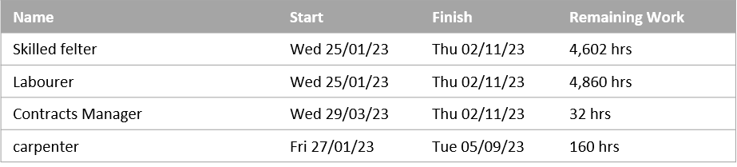

Figure 3: Hours remaining for each resource
Resource Stats
Work status for all work resources.

Figure 4: Graph of the works status for all resources

Figure 3 is the remaining hours of each resource as shown in the table, this will be extremely useful for the client and Main contractor to track how the works are progressing and give them a good understanding of potential completion dates, alongside this they can track labour costs against what has been budgeted for. Figure 3 & 4 should be run as reports every week to compare planned vs actual work on site, it will enable a review process to be undertaken on a weekly basis.

Performance and productivity on site

Concept of Productivity and Incentivisation
Incentivisation is used to try and motivate the contractor to achieve pre-set targets and a high quality of work. (Deborah Hughes, 2012) Incentives are either financial payments for the achievement of the set goals or psychological. (Bolutife Oyemomi, 2016)
‘Productivity is a measure of total efficiency of a production process.’ (K. Almazyed*, 2015)
As a nation it is in the employees and employers’ best intention to work with a higher level of efficiency and productivity, it is economies of scale; Higher productivity = more work completed = higher pay = more money to spend on the economy.

Figure 5: Theoretical Framework (K. Almazyed*, 2015)

The studies by K. Almazyed are that the three sections of the Theoretical framework that influence the productivity of the job at hand. These headings are heavily reliant on the conditions that the employer sets alongside recognition for the work that is being undertaken. If the employee feels they are acknowledged for working hard and the hours required, they are more likely to want to work at the highest of their ability in future projects.

As a client it is crucial that the construction of your building is built to the time frame and the budget set out. To do this it will require productivity of the highest order from all trades, communication from top to bottom and logistically organised for deliveries etc. According to UK Construction online 69% of construction projects exceed their budget for a number of reasons such as: (UKConstructionOnline, 2018)
- Wrong Forecasts
- Labour Costs
- Poor communication
- Sub-contractor issues
- British weather
- Disputes
- Inefficient payment process

Issues that may affect productivity
The flat roofing aspects of this project are crucial to be run on time and within budget; if the roofs are not watertight then the internal works cannot continue. To ensure the roof is watertight the vapour control layer (VCL) will need to be installed, this is the crucial checkpoint that the build is trying to get to.

Weather
The performance issues on site can be down to a multitude of things that are outside the control of the operatives. When dealing with roofing in general the weather has a huge impact on productivity and performance. No work can be carried out in the rain which is an issue for the UK and especially Swansea, Wales as it has been labelled as the wettest city in Wales by a study carried out by Wales online in 2013. (WalesOnline, 2004)

Skilled workers
Other productivity issues arise from the lack of skilled construction workers within the UK, we are currently at an all-time low for skilled workers within the industry, especially roofing. The CITB recently closed Birmingham training centre in 2021 leaving all trainee torch on flat roofers having to travel to Glasgow, Scotland to train and achieve their certificates. (CITB, 2021) An article written by the Construction news shows that it is the second highest number of vacancies within the construction industry for 20 years and are significantly higher than at the start of the Pandemic in 2019. (Clark, 2021)

Detail drawings from architect
Design and build projects are a great concept for working around issues and restricting the amount of failures on projects. However, they do create time issues when drawings are not up to date or need revising to what is being built on site. A study carried out with J Randall Roofing Ltd showed that this area is the most frustrating aspect of new builds and architects need more site knowledge on how buildings are built. The lead times can be upwards of 2-4 weeks before a drawing have been revised or a new method has been confirmed and signed off. This can create major setbacks when trying to achieve water tightness for the rest of the trades to continue works.

Material Shortage
The mixture of Brexit and COVID-19 has brought extremely challenging times to the construction industry, the flat roofing industry has suffered significantly with Insulation price being increased monthly in 2021 and another 6% in March 2022 by Kingspan a leading manufacturer. (Insulation online, 2021) Timber has risen approx. 200% since the beginning of the pandemic and Brexit in 2020 this was reported in an article by the construction index. (ConstructionIndex, 2021) With these increases also comes with long lead in times and some materials even becoming discontinued. Cladding companies are giving 24hr quotations until they expire and lead times looking into 4th quarter 2022. Fortunately, Bauder flat roofing supplier are extremely well developed and have multiple depots with some factories in the UK.

Incentive schemes
As the client there are options through incentivisation to increase productivity and to work alongside the contractor instead of against.

Pain and Gain
Pain / Gain method is a way of partnering, this is where the client and contractor would have a set target that is the project was completed within the budget then it would be shared between client and contractor. The split percentage is decided pre-construction between the client and contractor. Within the study conducted by Hughes it highlights that Pain / Gain is most effective when the client and the contractor have trust, having targets set early which also falls in line with Egan’s thoughts.
To achieve pain / gain method of partnering it will require a high level of collaboration and organisation, this is something that often breaks down throughout a project. This is shown in Hughes’ findings, her conclusion reads ‘the level that the gain/pain share is set at is significant for achieving a successful project, was not substantiated.’ (Deborah Hughes, 2012)

Earned Value Management (EVM)
EVM is a project management is a methodology that identifies actual costs Vs planned costs, according to Fleming and Koppleman once a project is 20% complete you can predict when completion will be along with the costs. (Hexagon, n.d.)This system is a huge advantage when to the project manager from the client to determine how well the project is running against what was planned. If the project is falling behind then incentivisation schemes can be introduced for example bonuses, shorter days if certain tasks are completed and increased labour to help assist with the job. EVM will help identify a profit or loss before the project is complete which in turn will aid the use of the pain / gain scheme. (David James Bryde, 2007)

Co-operative incentive negotiation budget (COIN)
The COIN budget is designed that the rates are a variable rate so that the contractor can earn a cost-plus margin. This is often used alongside EVM; EVM is the measuring tool to enable COIN to be a powerful tool in creating a greater level of productivity from the contractor. The budget needs to be set out with clear objectives and costs related to specific tasks, once this has been agreed then the contractor is able to achieve higher rates than priced if they are ahead of schedule or workmanship is at the highest level. (David James Bryde, 2007)
As shown in Figure 6, a contractor and client can work together to achieve a below cost project. The graph shows the actual costs lower than the budgeted costs by just over 126k they have managed this by being co-operative, honest, both working together to achieve the same result and many other factors. This 126k will then be shared between contractor and client which is a similar approach to the pain/gain scheme. (David James Bryde, 2007)

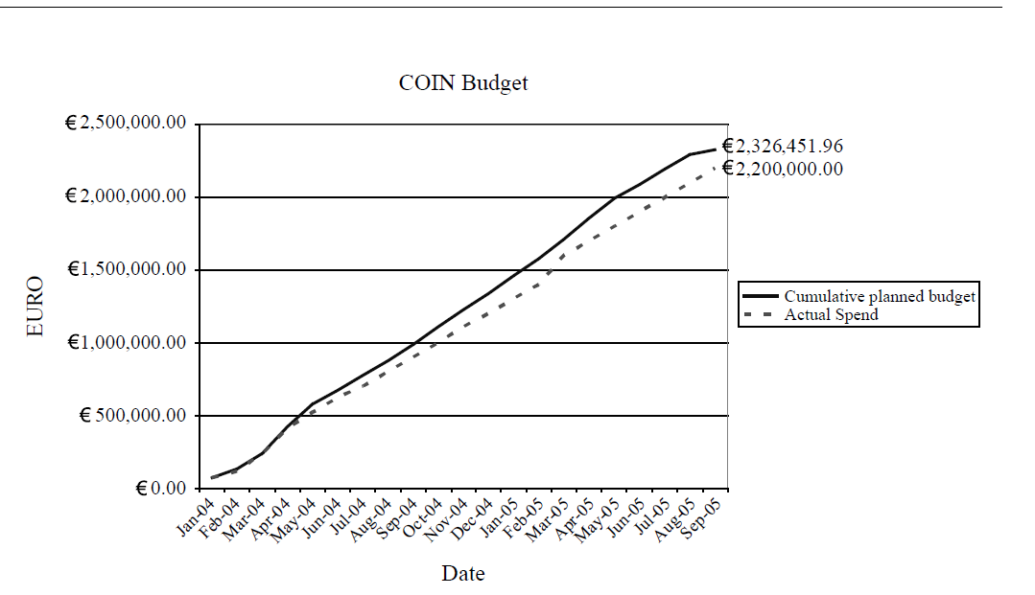

Figure 6: COIN Budget report on Incentivisation (David James Bryde, 2007)

In conclusion, incentivisation is not the answer for every project as Hughes identifies in her survey, with 44% of people thought using incentivisation would work on every project. 66% of people do not think that incentivisation will provide a higher level of productivity on projects. That percentage shows just how specific clients have to be when introducing incentivisation into a project. However, when used within the correct project and used with a high level of trust and co-operation between all parties. (Deborah Hughes, 2012)
If a project has early targets set which all parties are aware of and costs and progress are tracked throughout with the aid of EVM or other project managing tools such as Microsoft project, then incentivisation schemes such as pain/gain and COIN can be extremely useful tool to the client and contractor. The most important aspect of creating an incentivisation scheme is trust, without this none of the schemes will work.

Situation given that will impact the programme of the student accommodation

‘The M and E has had to be redesigned just as the work is about to begin due to new information received about Covid transmission. This is predicted to take 4 weeks.’

Covid-19
During these uncertain times Covid is at the forefront of every contractor and clients’ thoughts. Ventilation is a widely spoken about tool to combat the spread of COVID-19 and is crucial for student accommodation and helping stop the spread for the deadly virus. The importance of ventilation is shown in the Chartered Institute of Building Service Engineers and their latest report on Ventilation Guidance. (The Chartered Institution of Building Services Engineers London, 2020)

Potential Issues with new designs
Unfortunately, from a client’s point of view this is a far from ideal situation as the extra 4 weeks mean an extension of the onsite project period by a minimum of 4 weeks, costing up to £10,000 per month for the running overheads of the site. Once the new drawings and specifications have been confirmed the contractor will then have to re-price any differences from the original details, this could also create financial increases for the client. Alongside this, there a number of issues that can occur with the new details such as:
- Never installed before. Therefore, can come across issues
- Training on the job to instal
- Guarantees
- Sourcing the new equipment
- Long time period to install
- No approved contractor to install
All of these points could be hugely impactful on the running of the project, the M & E being a final item of the build and yet it could create the biggest problem for the client and contractor. These will not only have increases in the time but also the costings.
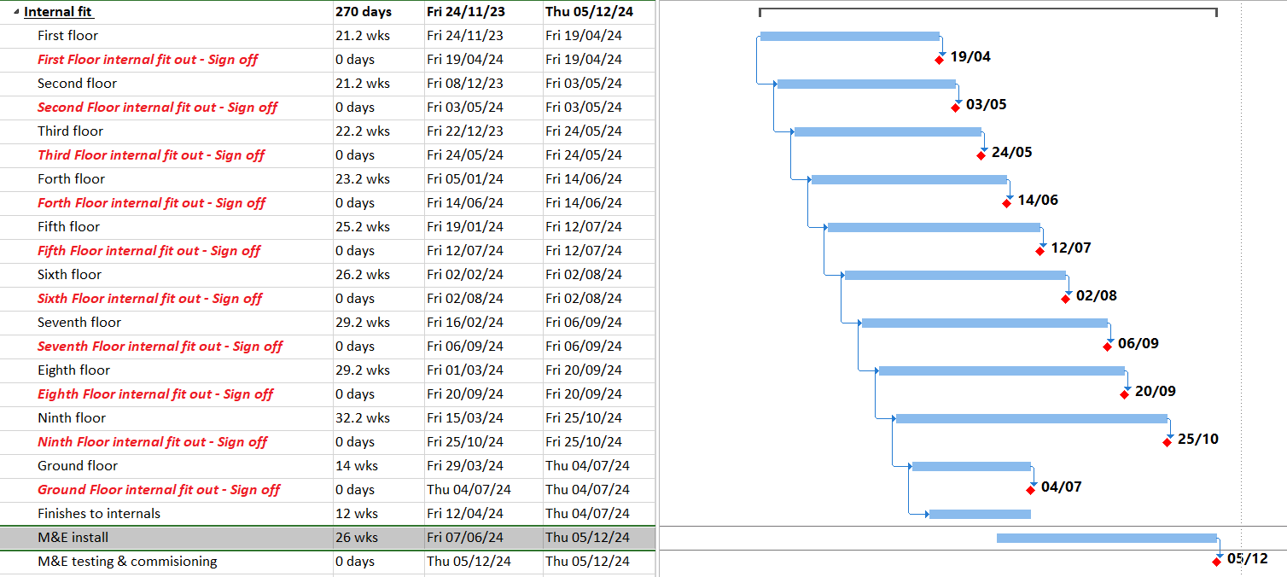

Figure 7: Updated Programme for the student accommodation build

Potential costs implications
The M & E installation has been postponed by 4 weeks and has left major impacts on the rest of the floors being completed. With the average time scale for one floor to be competed going from 20 weeks to 25 weeks. Financially it will have the largest impact to the client, having potential extra costs from:
- M & E contractor
- Internal decorators
- Electricians
- If the M & E is to be penetrated to the roof, then roofing works will need to be considered to protect the roofing materials.
- Floorers
- Plumbers
- All other internal fit out trades
- Site overheads

Force Majeure
From a contractual point of view this issue would be classed as a Force Majeure. “Force majeure events are usually defined as certain acts, events or circumstances beyond the control of the parties, for example, natural disasters or the outbreak of hostilities” (THOMSON REUTERS, 2022)
This is evident from the current situation in the country with record cases of COVID-19 on a daily basis with over 200,000 on the 4^{th of} January 2022. The adaptations of the M & E are crucial for the supressing of COVID-19 in the coming years amongst the youths that will take accrommodation in this building.

If this new system has extra costs involve then the contractor is to issue a force majeure to the client as they are in breach of the contract as they will be unable to fulfil the contract unless extra monies are agreed. As this is an unforeseen issue then the client will have to pay the outstanding balance for the new designed M & E work.

In conclusion, if the new design issues have cost implications on the contractor, then the client will be forced to pay the extra costs as it is an unforeseen and something that cannot be avoided. However, the contractor would have to be seen to have done everything possible to avoid the extra costs.

Appendix 1: Site drawings of the flat roofing detail showing GRP trim and built up system

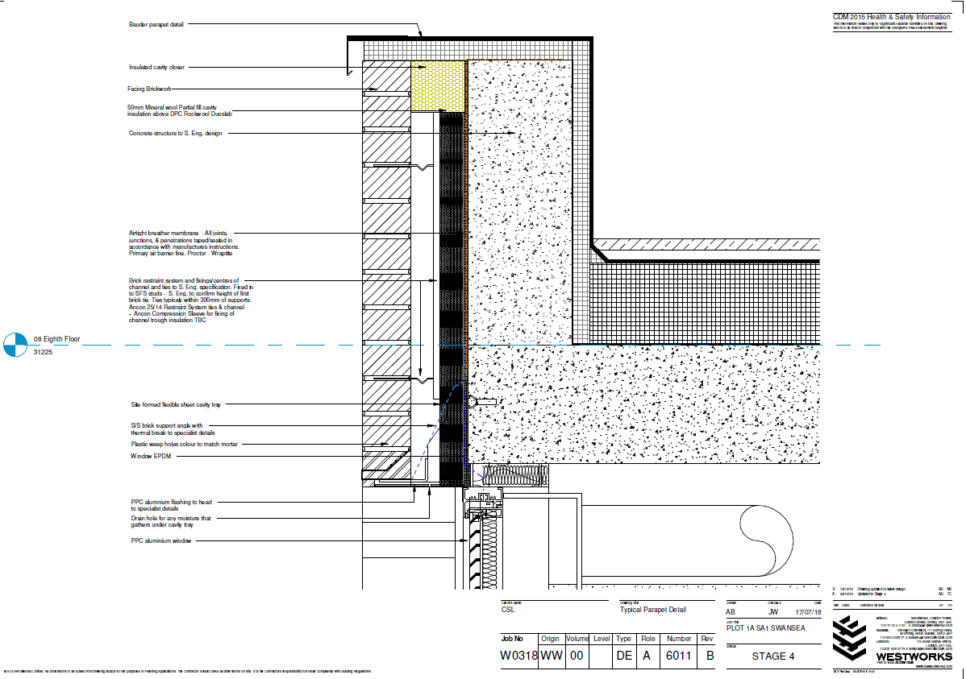

References
Bauder , n.d. Home : Bauder. [Online]
Available at: https://www.bauder.co.uk/about-us
[Accessed 14 01 2022].
Bolutife Oyemomi, B. H. a. M. T., 2016. EXPLORING HUMAN RESOURCE INCENTIVISATION FOR PUBLIC SECTOR CONSTRUCTION PROJECT DELIVERY IN SCOTLAND, Glasgow: Department of Construction and Surveying, School of Engineering and Built Environment, Glasgow.
CITB, 2021. Built-up felt roofing apprenticeship course. [Online]
Available at: https://www.citb.co.uk/national-construction-college/apprenticeship-courses/built-up-felt-roofing-apprenticeship-course/
[Accessed 18 12 2021].
Clark, T., 2021. Demand for construction workers close to 20-year high. [Online]
Available at: https://www.constructionnews.co.uk/supply-chain/demand-for-construction-workers-nears-20-year-high-16-07-2021/
[Accessed 10 01 2022].
ConstructionIndex, 2021. ‘Highly likely’ that timber shortages are over. [Online]
Available at: https://www.theconstructionindex.co.uk/news/view/highly-likely-that-timber-shortages-are-over
[Accessed 25 11 2021].
David James Bryde, R. J., 2007. Incentivising project performance in the construction of new facilities Utilising the earned value-based method, Liverpool : Emerald publishing .
Deborah Hughes, T. W. Z. R., 2012. Is incentivisation significant in ensuring successful?, Swansea: Emerald publication,.
Hexagon, n.d. Earned Value Management: The Basics. [Online]
Available at: https://www.ecosys.net/knowledge/earned-value-management-basics/
[Accessed 05 01 2022].
Insulation online, 2021. Supply Challenges. [Online]
Available at: https://www.insulation-online.com/notifications.html
[Accessed 02 01 2022].
Jones, J., 2021. How have Brexit and COVID-19 affected the supply of materials in the UK construction industry?. [Online]
Available at: https://www.brabners.com/blogs/how-have-brexit-and-covid-19-affected-supply-materials-uk-construction-industry
[Accessed 08 01 2022].
K. Almazyed*, 1. A. A. a. A., 2015. Study on the Key Factor Parameters to Increase Productivity in Construction and Manufacturing Industries., Paisley: School of Engineering and Computing, University of the West of Scotland, Paisley, PA1 2BE, UK,.
The Chartered Institution of Building Services Engineers London, 2020. CIBSE COVID-19 VENTILATION GUIDANCE, London: CIBSE.
THOMSON REUTERS, 2022. Force majeure. [Online]
Available at: https://uk.practicallaw.thomsonreuters.com/3-107-5776?transitionType=Default&contextData=(sc.Default)&firstPage=true
[Accessed 17 01 2022].
UKConstructionOnline, 2018. Seven reasons why 69% of construction projects exceed their budgets. [Online]
Available at: https://www.ukconstructionmedia.co.uk/press-releases/seven-reasons-why-69-of-construction-projects-exceed-their-budgets-progressclaim-com/
[Accessed 20 12 2021].
WalesOnline, 2004. Swansea named UK's wettest city. [Online]
Available at: https://www.walesonline.co.uk/news/wales-news/swansea-named-uks-wettest-city-2440540
[Accessed 19 12 2021].

