Katie Thomas 2307138
ECEY4009 The professional practitioner: Part one (PDP) 5/10/23
This table provides the skills, knowledge and behaviors that will change and develop to help achieve my vision and goals in my future. I like to think I have really good time management as always try to arrive early for everything. I have a good knowledge of working with children and what their needs are. I have a good understanding of children with additional needs as I am a senco in my nursery. I would like to think I am a good listener and people can talk to me and if people need help, I will always do my best to help.
No. | Improvement and development goals | How will I know when I made changes? | The actions I will take to achieve these goals: | What will help me to achieve my goals? | Target date to complete
1. | More reading | I will have more information on the subject at hand and know where to find the information needed and be able to us in day-to-day life. | Allocate more designated time to read if on breaks in work after work while watching tv or just before bed. | Stick to my allocated time slot for reading if complete it do another space for some more. | By January 2024 if not beforehand
2. | Confidence | I will feel less worried about public speaking and be able to ask questions in class without feeling nervous. | To slowly push myself into situations where and when I must overcome this, I will also try recording myself speaking or talking | Give myself little tasks each time to try boost my confidence. | By January 2024 if not beforehand
3. | Multitasking | I will not feel so overwhelmed when I have one or more things happening at once | Work at a slow but steady pace and if struggling tell people write a plan of any activities to work along with. | Following the plan made and stick to it and if anything jumps up can add it alongside it. | By January 2024 if not beforehand
4. | Technical skills | I will feel more at ease doing things on my laptop for university and more confident in what I am doing. | Watch videos use different resources to increase my knowledge | Keep challenging myself and get to know my laptop properly doing little tasks or practice activities. | By January 2024 if not beforehand
5. | Complete my BA Honor in early years education and care degree | I will have lots more knowledge of early years foundation and be able to apply for wider variety of jobs | I will take every opportunity I get to study and read and put effort in to all my modules. | Attend any study groups and extra sessions ask for help from lectures if and when needed. | July2025
Page one
What is reflection and reflective practise?  Reflective practise is the process of thinking about and analysing your practise with the aim of challenging,modifying,changing,delveloping and helping us work. Reflective practise is the we you will learn from experiences and ways we can improve next time (finlay 2008) says refelective practice is learning through and from experiences gaining new insights of self and practice. This will help everyone make links from one experience to the next | Why is reflective practise important to EY practise?  Reflection of practice is very important part of working with children it allows you to identify and appreciate positive experiences and better identify in ways you can improve your practice, helps gain new experience, can also help if you have any challenging experiences, it will help you learn and process from them for future incidents. It allows you to recognize your own strengths and weaknesses this can be from knowledge what we know or do not know skills knowing ways of doing certain things and practice the way we do certain things in an around the nursey setting. By reflection you will develop your skills by self-learning, improve anything you are unsure of and improve the quality of care we provide as childcare practitioners. This will help support you to maintain and continually improve. This process will also benefit the parents/carers as they will see the constant improvement in yourself and the practice as we will be providing the best care possible for their children. Reflective practice in a early years setting also helps you as a practitioner develop a critical understanding of their practice, increases confidence, helps be more proactive, improves skills, knowledge and understanding and improves the quality of care and education offered to children. An example of reflection of practice in my nursery setting we do daily planning and evaluations of the activities so maybe we did a activity and didn’t go to well we would write down what happened and what we would change next time to see if it improved we would also note what went well with the activity then in future planning we can go back and check if has improved or needs changing more. Although there is lots of good about reflective practice there like everything in the world there is pros and cons some pros are they offer a structure to be followed, provide help for those unsure where to begin in a situation, allow us as practitioners to assess all levels of any situation we will know when the process is completed, can build our confidence in knowing we did something well, personal growth, better communication and enhanced relationships. Some cons of reflective practice are that it implies all steps must be followed in a certain way, in the real world it may not be as easy to start at the beginning of situations, some of the models may not even apply to our situation and we can not adjust them to fit our problem, reflective practice is a repetitive process and may become bored of what is going on, it may knock confidence rather than building it to think you have done something wrong or gone the wrong way around something and when reflecting yourself see that you could have done better or something different to the way you did it, not all practitioners may understand the reflective process, could be time consuming, may feel uncomfortable challenging and evaluating their own practice, may not be adequate to be able to resolve their problems.
The theory of reflective practise:
(Dewey1933 page118 believed that active, persistent and careful consideration of any belief or supposed form of knowledge in the light of the grounds that support it, and further conclusions to which it leads. While (Schon 1991) said that reflection in action/reflection on action provides an additional element by making a distinction between reflection during the event. Reading both theories and analyzing them I prefer Dewey’s theory because I can relate to this more.

Gibbs’ model  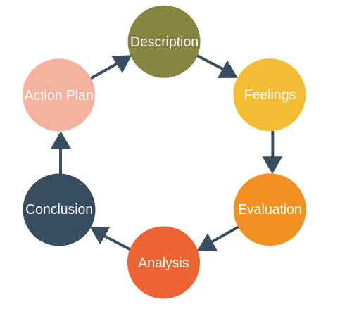  This picture attached was found on expert programme management | 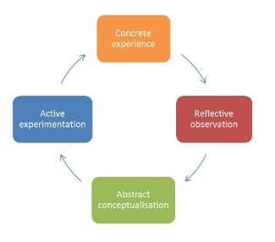  Kolb’s model  The pic attached was found on Nicole brown
Analysis of models – compare/contrast/pros/cons:
Gibbs model of reflection which is description-feeling-evaluation-analysis-conclusion-action plan which I think is the best way to describe the best way to reflective practice and breaks it down to a easier step by step plan to stick to. Gibbs model of reflection was developed in 1988 and helps us as learners to have a plan in place to follow whilst reflects our practice and motivates a self-learning from all our experience of what has happened. Gibbs is an ideal cycle going through the reflective steps in depth. This will allow us to see all our professional practice in action and helps it develop and shows we are progressing from what we are experiencing and self-reflecting. Kolb’s model of reflection is slightly different, it comes in four stages rather than 6 like Gibbs. This model of reflection was developed in 1984. The four stages are concrete experience, reflective observations, abstract conceptualization and active experimentation we are encouraged to have the experience describing what went on and how it happened then creating a review of it then if anything we would change from the situation and then trying what we have learnt and putting all together we are still able to reflect on situations but not as in depth as Gibbs model of reflection. We as childcare practitioners may find different model of reflection that works better for us some may want simplicity the simplicity of Kolb and some may want the in-depth model of Gibbs I personally prefer Gibbs model of reflection to make sure everything is covered. There are many models of reflective practice, but it is just finding the one that works for you.

Conclusion
In my opinion, reflective practice really does help and reading some of the theorists and the way they do certain things helps us as practitioners and as learners as we put all the theorists in to practical and we use it more in a day than we think. I think I use a mix of theories when I am reflecting on myself or any activities that I do. I find that looking back at something I have done helps a lot and can plan better for next time or change something slightly if doesn’t go well and if something goes well, I can see that and apply the same for next time.

page three
Part three
The term professional practice can be seen as practice which shows professional knowledge, have the relevant skills and qualities, competencies values and beliefs, within a framework of certain agreed standards it shows we can meet the needs of every child excluding no one with opportunities to constantly improve our skills and knowledge and having training to keep on top of everything or any new materials that have been added in. the professional practice will be able to meet any needs of children in their care and know the right people to contact if need any advice and the main aim from professional practice is to make sure every child gets treated as an individual and the parents will feel happy and comfortable leaving their children in that setting.
A professional practitioner, someone who cares about the children and the job, they are going to be there to guide and support the children and parents in day-to-day life. You will feel like you can approach them and speak about anything and will feel like you have a bond with not just the child but parent or carer as well. They will have a real passion for the job and when they come to work/ training it will feel more like a hobby rather than a job. They will be good listeners and never judge what the other person is saying to them. People will feel like they can confine in the practitioner and will not go back to anyone unless they think it’s serious or there are worries but then they will always know who to go to so won’t be just anyone. They will be able to share information with parents and pass information to any multi-agency involved. They will be fun and not too serious and always try to make every child smile no matter what it takes or however silly we have to act if it be dancing putting on funny voices while reading stories. Will be aware of all cultures and how to approach them if not allowed certain food due to their cultural backgrounds. The values that are important to us as professionals are being patient although this seems like everyone would have this some practitioners some people do not and when children call them or want them to do something they might sound offish with the child this is why it is important to wait to for to finish what they are asking then help them the best way that we can accordingly to what they want. Another massive value is respect for the children, parents, carers and staff. You should be treating everyone the way you want to be treated, being polite and happy so someone could make their day without you even realizing that. Being curious is always good, it means you are always looking to learn and further yourself in your caring for children. Another important value is compassion, which shows you have care if a child has hurt themselves or in need, it teaches the children at a young age to be kind and care for others. Integrity is another important value to a childcare professional It means doing what is right even if you know the outcome is not going to be good, the children will learn the difference between right and wrong and they will learn to be honest. Values are important to a practice because it’s what keeps the nursery running and from word of mouth from people that attend there, they will always recommend the setting due to how professional they are it also means they should pass inspections because they will have all the correct training.
Values in a practice should include welfare of the child meaning the safety of the child is critical so this means any multiagency that needs to be involved is involved for example speech and language, social services and everyone is communicating and passing any messages on so the practice can work as a team and everyone knows. Making sure the environment is as safe as can be for the children and young people, meaning daily garden checks for any hazards and making sure toys are not broken or damaged or have little parts and making sure cleaning products are locked away safely. Another value is forming good relationships with parents and families and the children making sure they feel welcome and happy that they are leaving their prize possession in your hands and building these relationships they will feel comfortable to talk to you if they need help or advice. Maintaining confidentiality is another massive value in a professional practice anything you are told unless it’s a concern you must keep to yourself and not talking about children out of work. Valuing diversity and equal opportunities which means everyone gets treated as an individual and activities adapted to any needs you face and not including a child/staff member/child’s family due to their cultural backgrounds or disabilities and giving everyone equal rights and choices. Children’s learning and development is another important part of professional practice which is basically making sure we meet the developmental needs of the child and making sure the time they are with you making the most of it and helping them grow as much as possible. Communication is so important in a nursery setting because if no messages are passed on and something happens the other staff would worry or panic but if informed, they will know what to do for example if a child has a medical condition and it is not told when child starts everyone would worry but if child has medication to stop anything worsening or to prevent they will act professionally and carry on as normal or if a child has come in with a bruise or injury and staff not informed how happened the child could make a story what happened and could cause trouble for their families that’s why communication is so very important so there is nothing missed and everyone is on the same page.
Building the best relationships with everyone involved in the setting is important due to the parents/carers need to feel happy and comfortable leaving their child in your care that first impression is critical and will make all the difference if everyone is friendly and welcoming, they will want to talk to you and feel like they confide in you and the child will feel happy going from the person that drops them of to yourself. There is also the chance of the children doing better at home and nursery if the parents and teacher have built a bond as they will communicate better and you will be able to inform them if you feel there is a problem. Positive family relationships will help family members solve problems and work as a team. The child will also benefit from this due to the fact the child will want to come into nursery/school and if upset they know that you will be there to comfort and reassure the child that everything is ok and their parents will be back soon. (Duncan et al 2006) had believed the value of conversation is not to share but also to increase the resilience of parents so that the supportive relationship with practitioners gives them more strength to manage their situation. I like that quote because it’s true some parents might find being a parent hard sometimes and we are there to support them through anything they may be going through or facing.
Meeting the needs of the children is important to settings because not every child is the same what may work for one child may not work for all and we obviously will have children that may have additional needs and its important us as the practitioners take the time to get to know the children as a individual and that way we will find out if they are struggling in certain areas and flourishing in other areas and then will know if anyone from multi agency need to be informed to work together to help the child reach its full potential. This is the same for children with disabilities as some may need a nurse along side them while they are at nursery or setting and we learn to adapt to the children so if we are playing a game we make it accessible for everyone and everyone feels they can join in or if doing activities and for example you have a child that’s a wheelchair user you would bring to their height this all helps build for their future. I think Maslow hierarchy of needs is a very good way of explaining this.

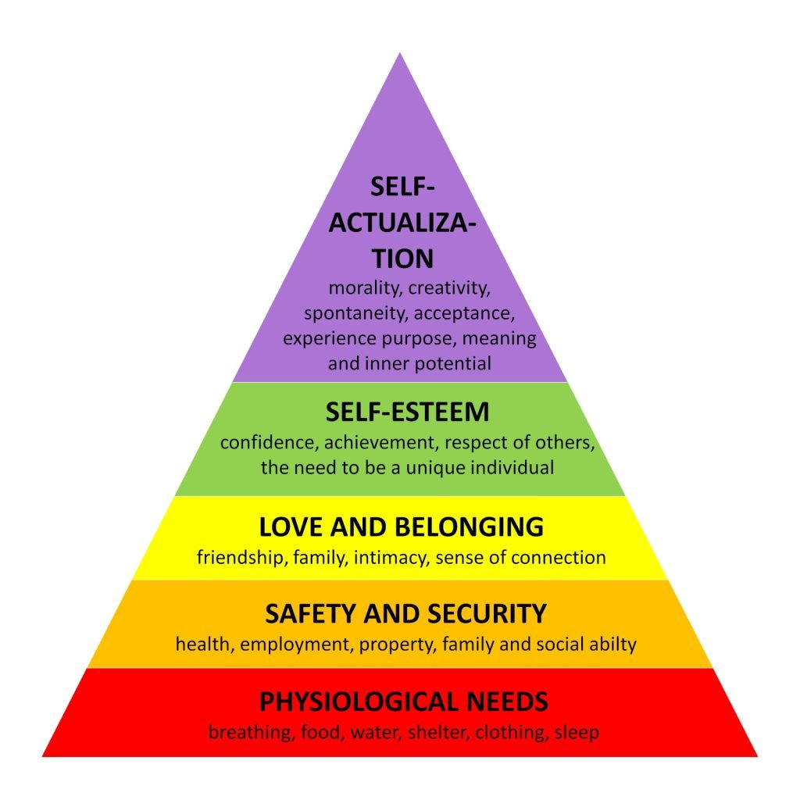picture of Maslow’s hierarchy of needs pyramid.

Page 5

Reference list
Dewey,J,(1910,1933) how we think New York NY:D.C. Heath & company
Finlay,L,(2008) reflecting on reflective practice paper 52, The open university
Gibbs model of theory picture https://expertprogrammanagement.com/2019/05/gibbs-reflective-cycle/ accessed on the 25th October 2023
Kolb’s model of practice picture was found on https://www.nicole-brown.co.uk/reflective-model-according-to-kolb/ website accessed on 25th October 2023
Maslow hierarchy pyramid picture https://www.simplypsychology.org/maslow.html website accessed 26th October 2023
Schön, D. (2016) The reflective practitioner : how professionals think in action. England: Routledge
Teresa Wilson (2016) Working with Parents, Carers and Families in the Early Years : The Essential Guide. London: Routledge. Available at: https://search-ebscohost-com.ezproxy.uwtsd.ac.uk/login.aspx?direct=true&db=nlebk&AN=1036396&site=ehost-live (Accessed: 21 October 2023). Page 88 Duncan et al

