DS 1 Template

My Screenshots/Photos
- Please add 4–6 screenshots or photos of your digital life.
- You can use your phone or laptop.
- For each screenshot, write one or two sentences explaining what it shows.

Screenshot/Photo 1
[Insert Photo/Screenshot below]
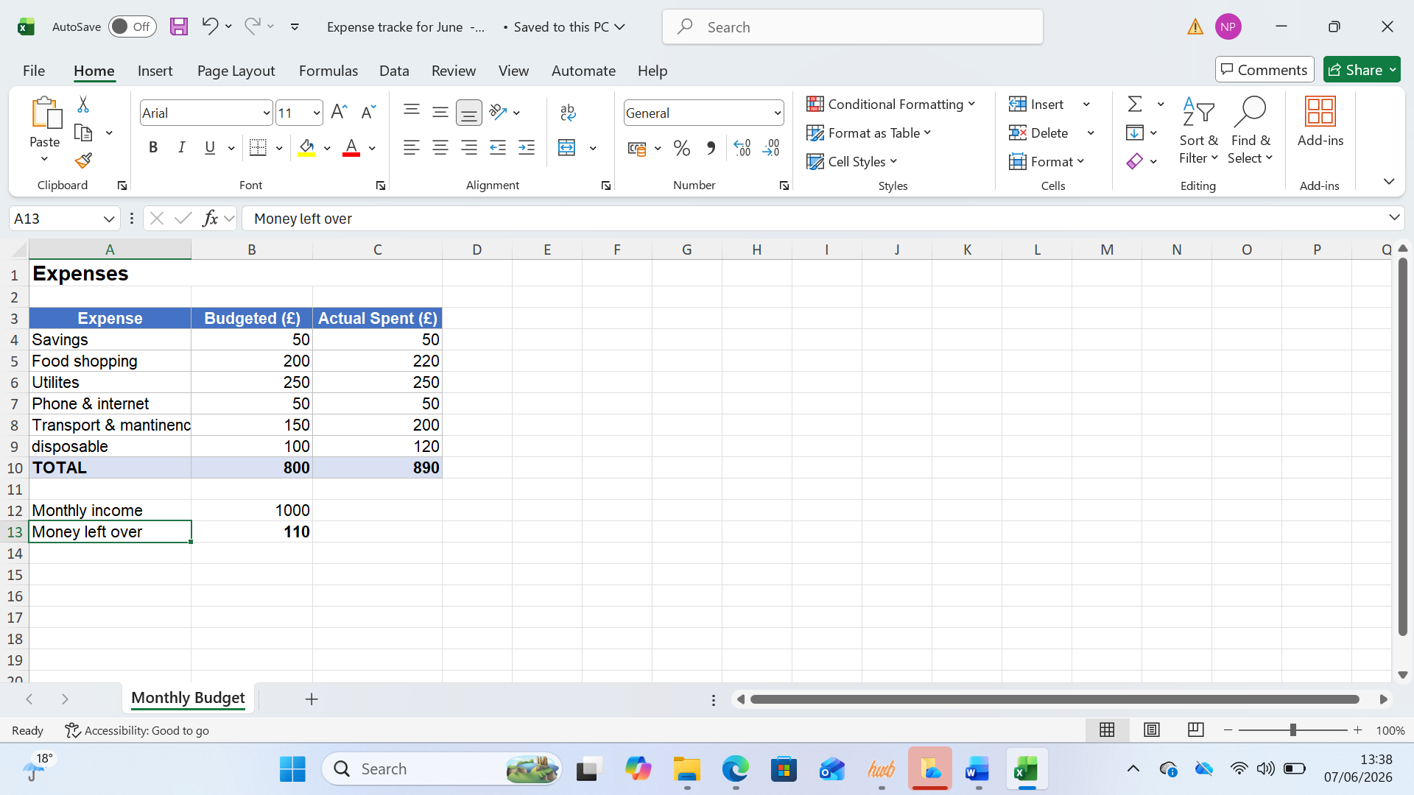
[Write what this shows of your digital life]
I’ve created a excel spreadsheet budget and track my expenses.

Screenshot/Photo 2
[Insert Photo/Screenshot below]
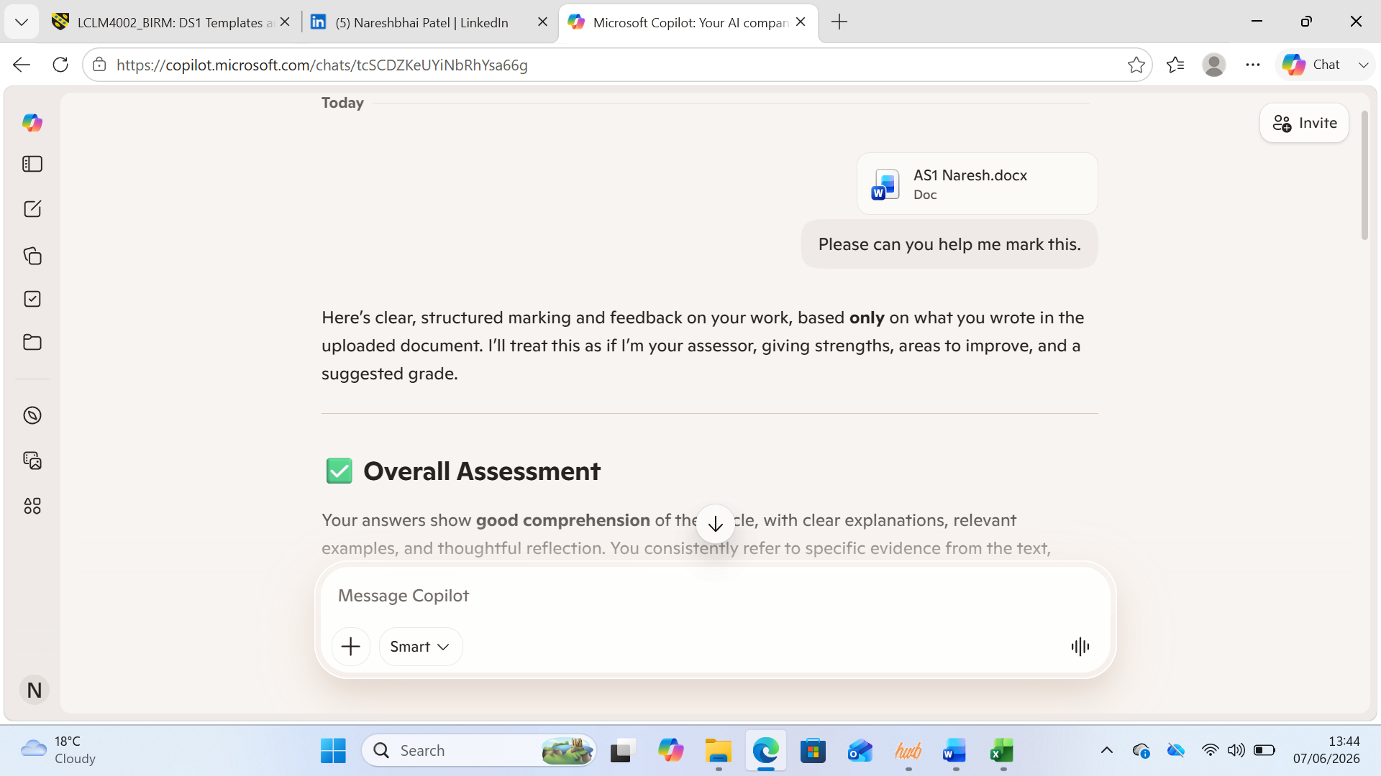
Using the AI Copilot to help me in my other modules.

Screenshot/Photo 3
[Insert Photo/Screenshot below]
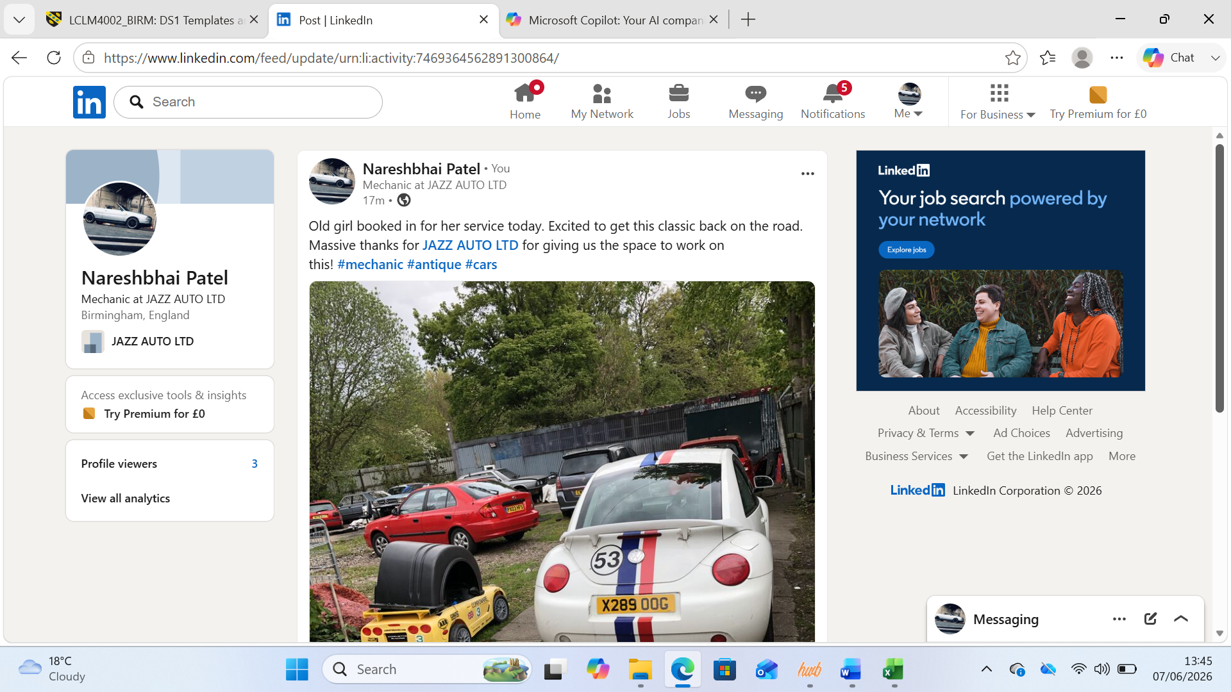
I’ve created a LinkedIn profile, and have posted my recent work on a car bought in to the shop.

Screenshot/Photo 4
[Insert Photo/Screenshot below]

Using Google Scholar to find articles for my other modules.

My Short Reflection
- Write 5–8 simple sentences about your digital life.
- You can use the sentence starters below if helpful.
Digital skills are important because I still feel very new to this. I become nervous using technology like AI as I don’t wont to give away information it sometimes asks for. I’ve started to use apps like excel to help me budget and manage my finances. As for AI, my computer has a built in AI which has allowed me to ask for help, as I’m writing. The other app LinkedIn, feels like Facebook, and ive started to use it to post about my actual job as a mechanic. Overall this module is helping me to learn about technology that others around me are using, making me feel confident.

Sentence starters
- I use digital tools to …
- I feel confident when I …
- I want to improve …
- I often use these tools: …
- I sometimes feel nervous about …
- I hope this module will help me …
- Digital skills are important for me because …
You can write more if you want.

Submission Checklist
Before you submit, please check:
​​​ ☒ I added 4–6 screenshots
☒ I wrote short sentences for each screenshot
☒ I wrote my short reflection
☒ My work is my own
☒ My file opens correctly
​​☒ My file opens correctly

