

Network Operating Systems and Services

Harry Elsey

03/05/24

—

Configure, and manage a Type 2 Hypervisor platform based Virtualised network

—

Adrian Hone

Introduction
In this assignment I will be configuring the type 2 hypervisor.

I will be managing and maintaining the network resources and applying appropriate network policies, routing and packet filtering within core TCP/IP services, File sharing, Issuing Certificates, drafting security practices, critical failover/redundancy practices





TASK 1

Routing

Routing is the process of deciding what path the traffic in a network will process and this can be between multiple networks, so routing process helps find the best route for the traffic to go through. [1]

In computer networking, the routers are devices that facilitate this process. They receive data packets from a network and then figure out what the best and most efficient way for those packets to reach their intended destination, routers make decisions based on various factors such as network congestion, the link quality, and routing protocols.

Routing protocols are sets of rules used by the routers in order to communicate with each other, share the information about the network topology. The information they then receive will help the router to a build a map of the network and make more precise decisions about how to forward traffic.

There are two types of routing protocols:

- Static Routing
Normally static routing is manually configured by a network administrator.

- Dynamic Routing
In dynamic Routing they are automatically determined by routers based on information exchanged between them using the protocols such as OSPF or BGP. [2]

The key differences between static routing and dynamic routing is fist the configuration, as in static routing it involves manual configuration by a network administrator. They are specifically entered by the administrator.

Another key difference between static routing and dynamic routing is the security aspect is that static routing can be secure in most scenarios as it does not rely on a dynamic protocol where as dynamic routing May produce security risks as routing protocol messages traverse the network. [3]

Routing plays a crucial role in ensuring that data packets are delivered efficiently and reliably across the networks.

Case Study

Routing protocols play an important role when it comes to how data is transmitted across networks efficiently. Depending on the scenario, the routing protocols are different based on factors like the topology, application requirements and the network size.

- OSPF – Enterprise Network

- Benefits

Scalability: The OSPF scales well for a large enterprise network that has multiple routers and areas.

Fast Convergence: OSPF uses a link-state algorithm, which enables fast and efficient convergence in case of network topology changes.

Design: OSPF supports hierarchical network design with areas, reducing routing overhead and improving the speed overall.

- Negatives

Complexity: The configuration and maintenance of OSPF can be quite complex, especially in large networks.

Resource Consumption: OSPF requires a significant amount of CPU and memory resources, which impacts the router performance in resource-constrained environments.

[4]

- BGP - ISP

  - Benefits

Interdomain Routing: BPG is designed for interdomain routing, making it suitable for ISP networks that connect to many autonomous systems.

Policy-Based Routing: BPG will allow ISPs to implement complex routing policies based on the factors such as path preference, network security and traffic engineering.

  - Negatives

Scalability: BPG tables can grow large in ISP networks, leading to scalability challenges for routers.

Configuration: BPG configuration can be complex, requiring expertise to prevent routing anomalies and ensure stable operation throughout.

[5]

- OLSR – Wireless Mesh Network

  - Benefits

Dynamic Routing: OLSR dynamically discovers and maintains routes in wireless mesh networks, adapting to topology changes.

Reduced Overhead: OLSR will minimize the routing overhead by maintaining only essential routing information, which making it suitable for resource-constrained wireless devices.

  - Negatives

Limited Scalability: OLSR may face many scalability limitations when encountering large mesh networks which control thousands of nodes due to the flooding of control messages.

Single point of failure: OLSR relies on a centralized topology control mechanism, leading to a single point of failure in the network.

[6]

Implementation of Task 1

4.1 - Install Routing and Remote access Service and modify firewall rules to allow ICMP Traffic.

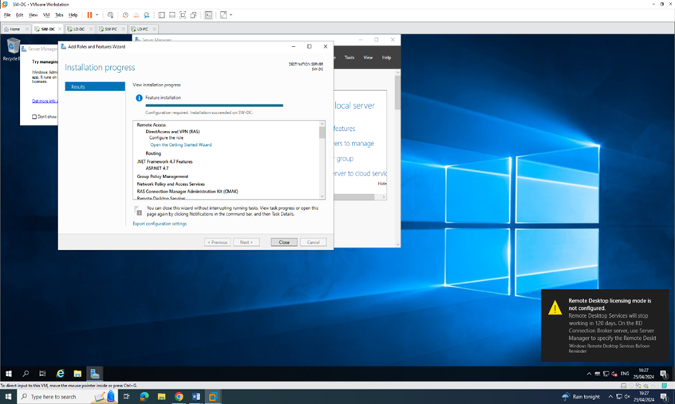





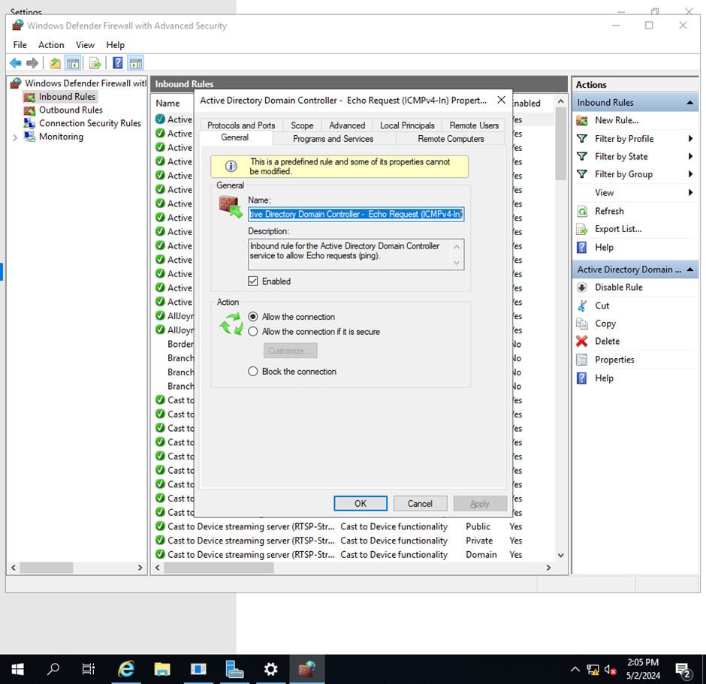

4.2 - Configure Site-to-Site VPN to London Network. Set the connection type to “persistent connection”.



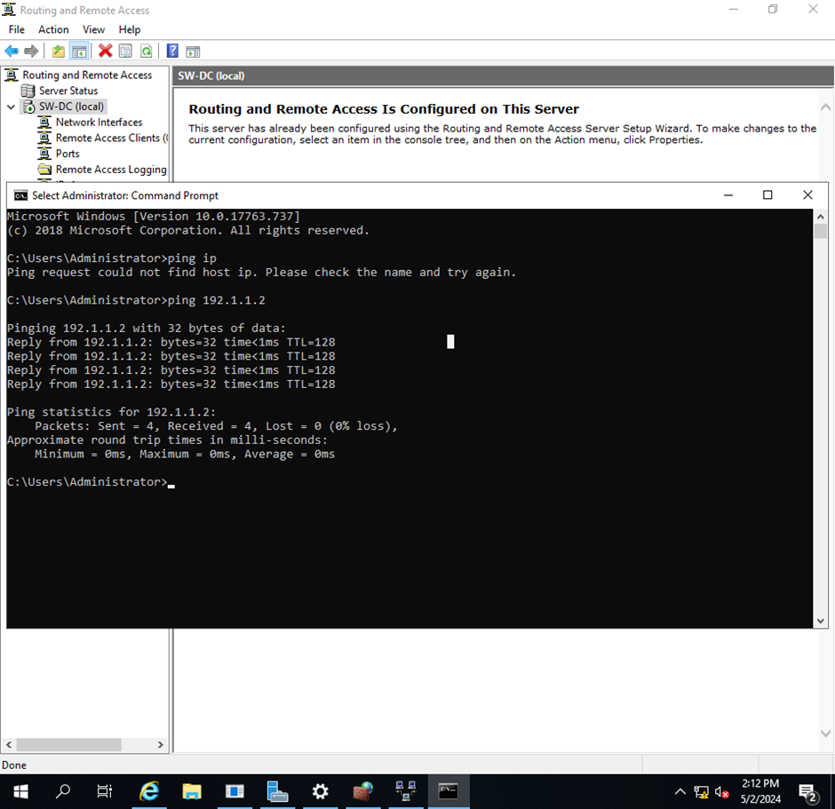

4.3 - Create a forest named acca5023.noss

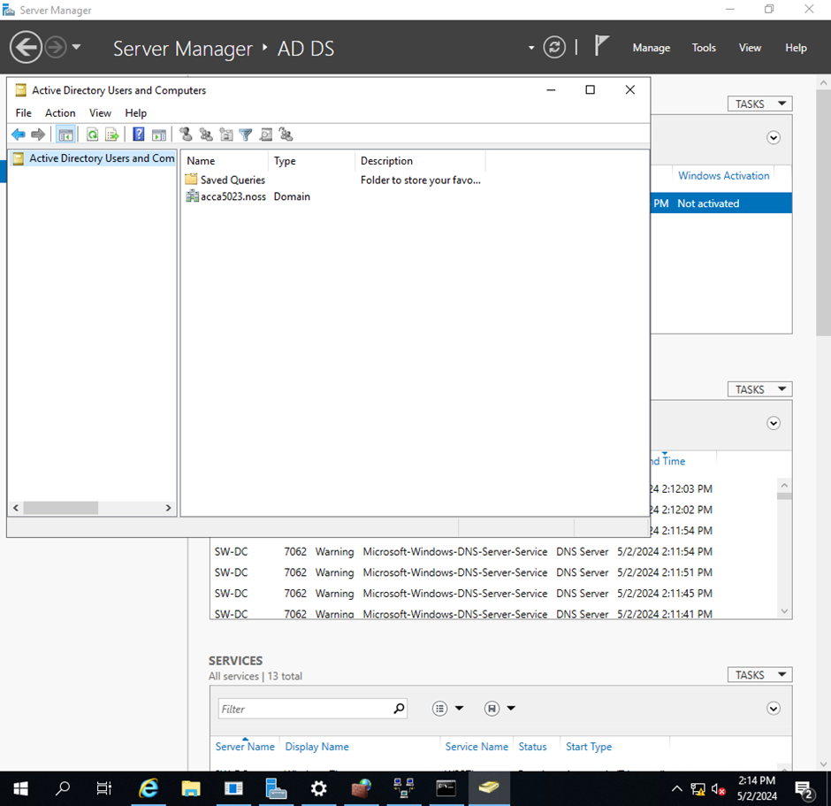

4.4 - Create all appropriate A records for all servers on 10.1.0.0/24 and 10.2.0.1/24.

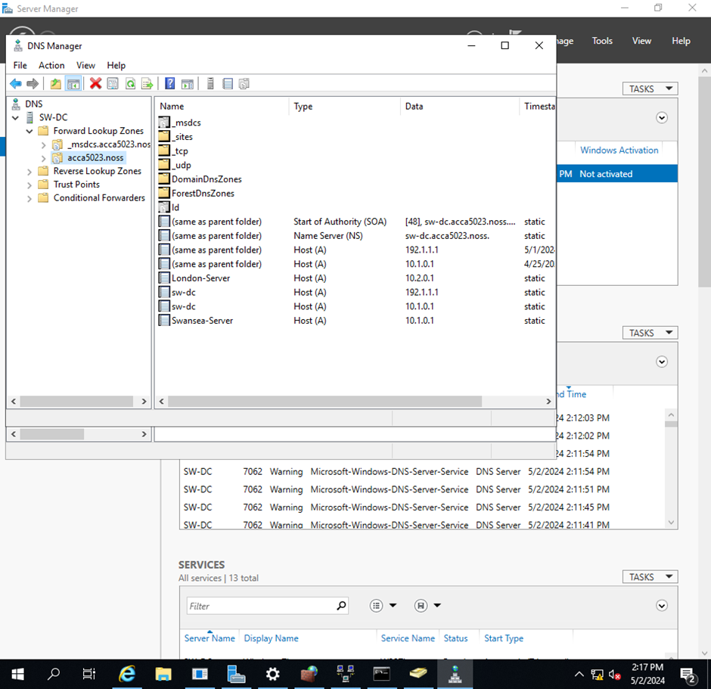

4.5 - Create a reverse lookup zone creating PTR records for all servers.

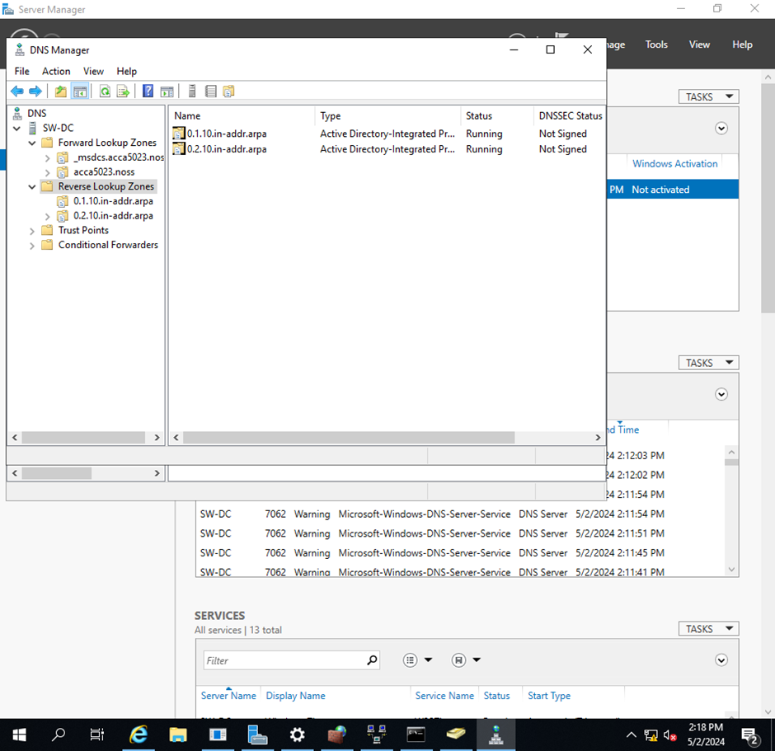

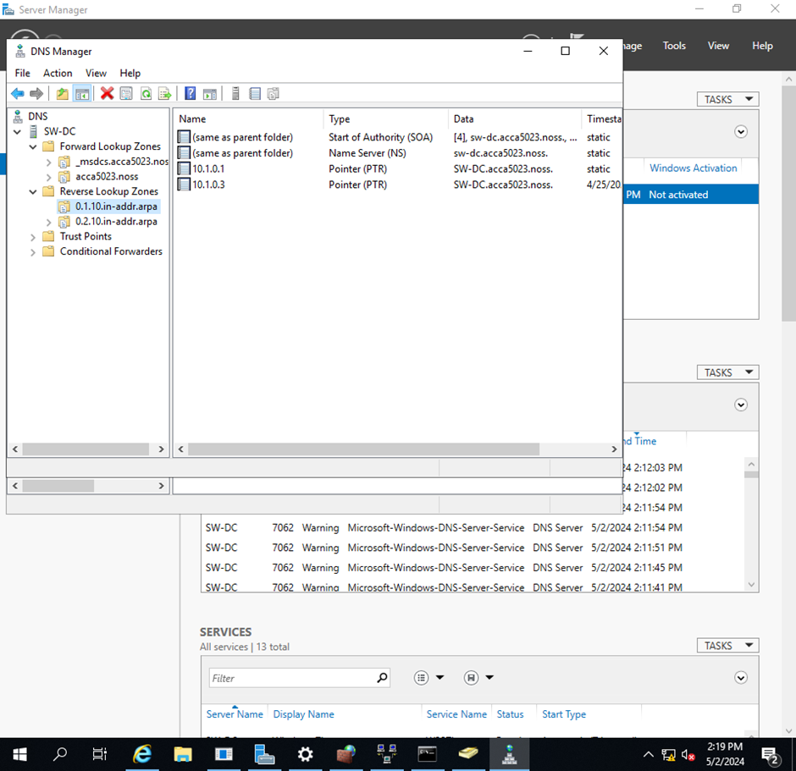

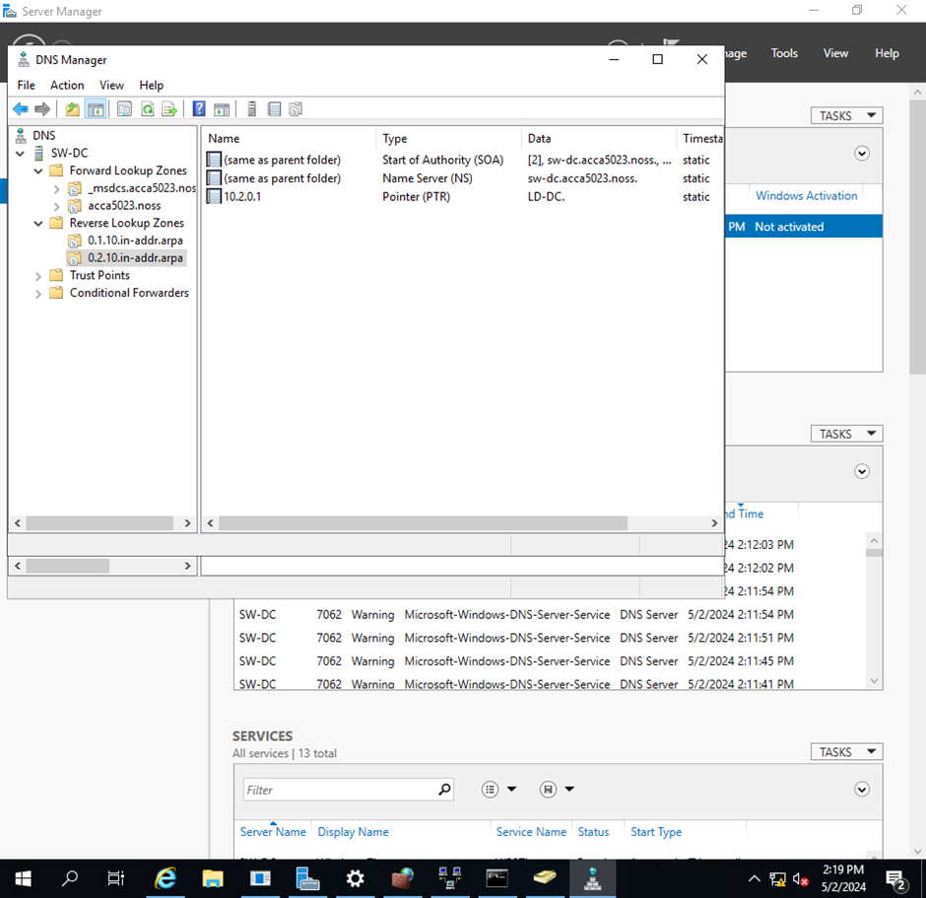

5.1 - Install Routing and Remote access Service and modify firewall rules to allow ICMP Traffic.

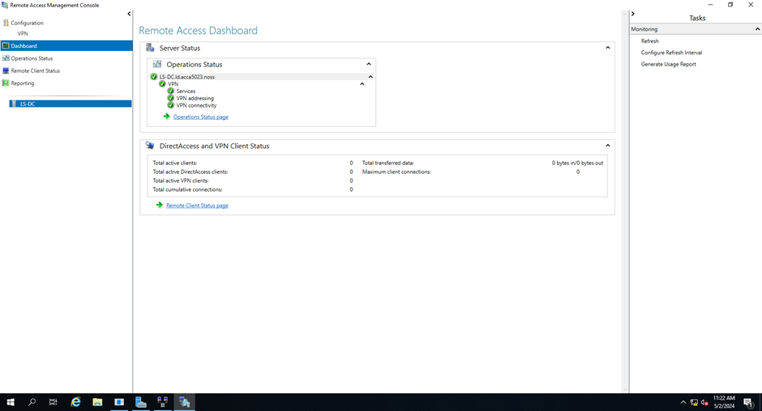

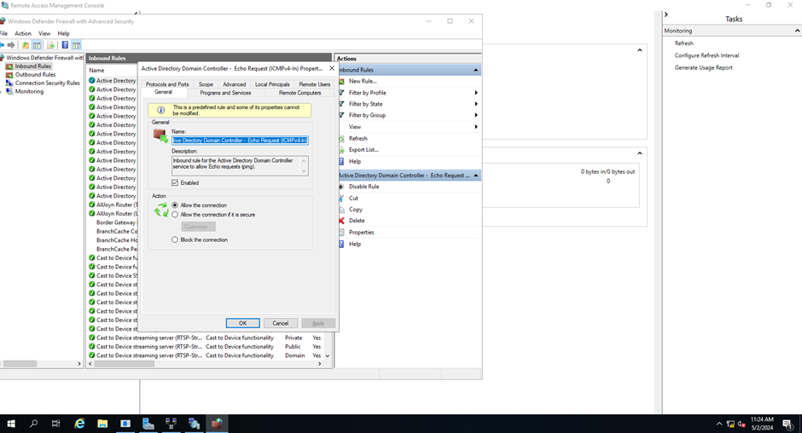

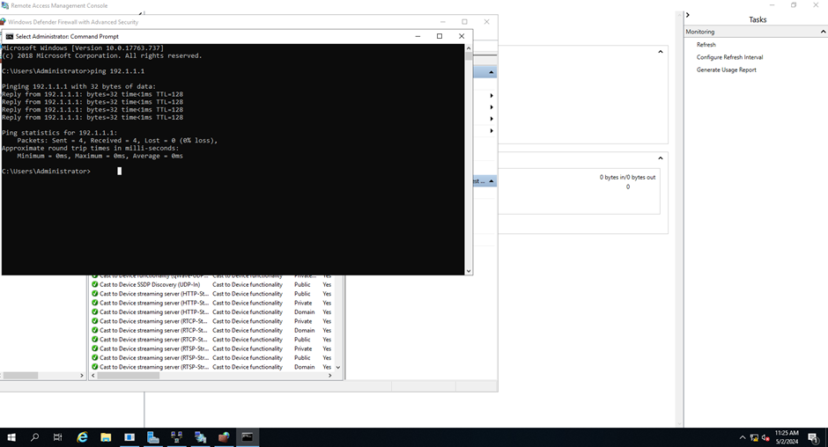

5.2 - Configure Site-to-Site VPN to Swansea Network. Set the connection type to “persistent connection”.

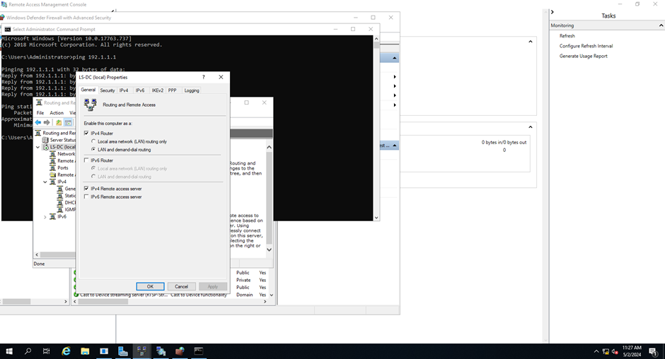

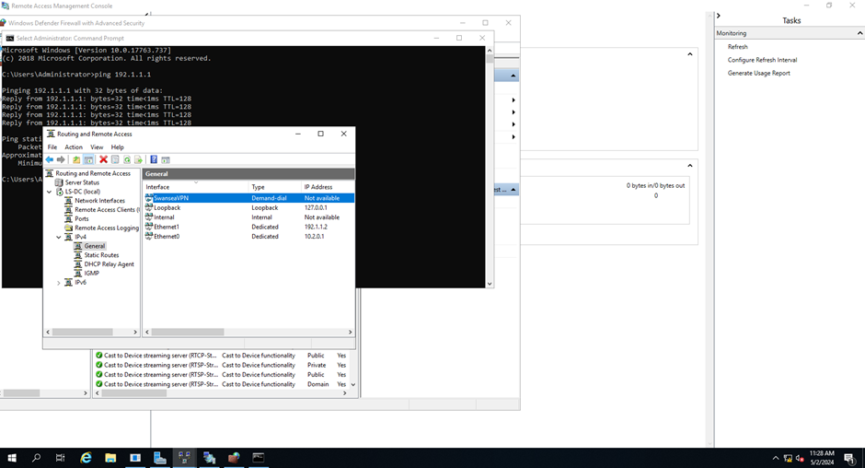



5.3 - Create a child domain named ld.acca5023.noss in acca5023.noss tree

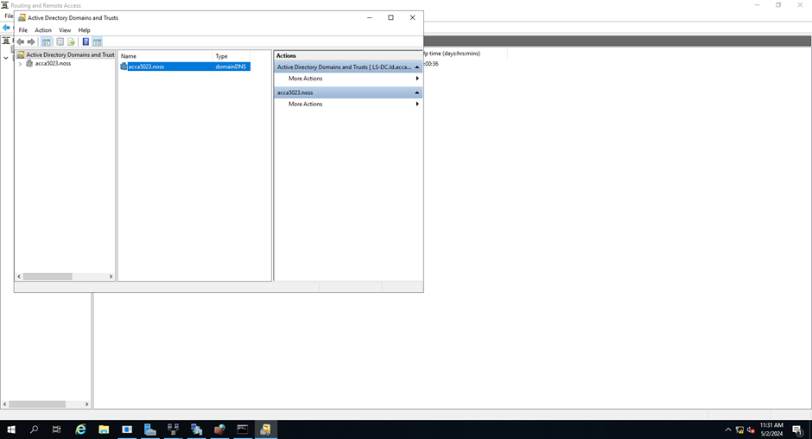

5.4 - Create user accounts for ld.acca5023.noss domain with all the parameters defined in the users_list.xlsx document.



5.5 - Mount second disk drive to C:\LondonFiles.

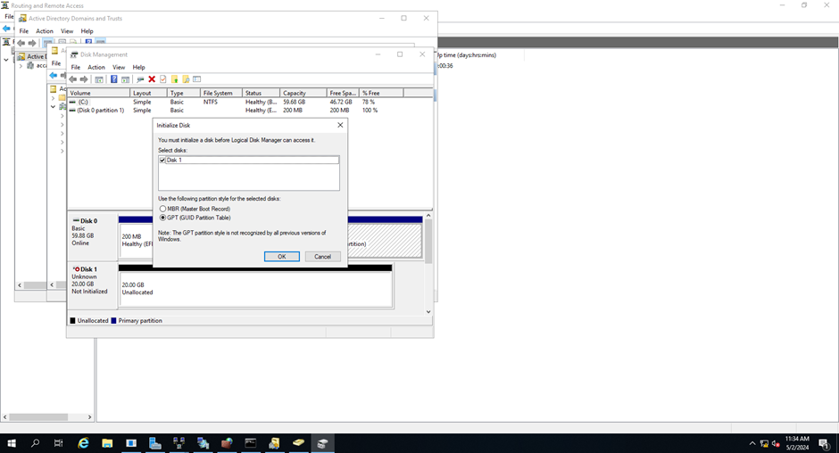



5.6 - Configure DHCP Services.




6 - Test the network for Connectivity.

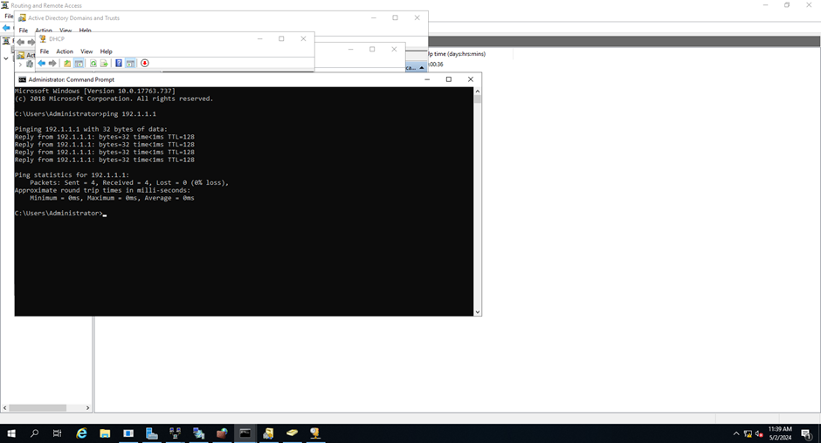

PART 2 – Task 2

7 - Sharing Disk Drive

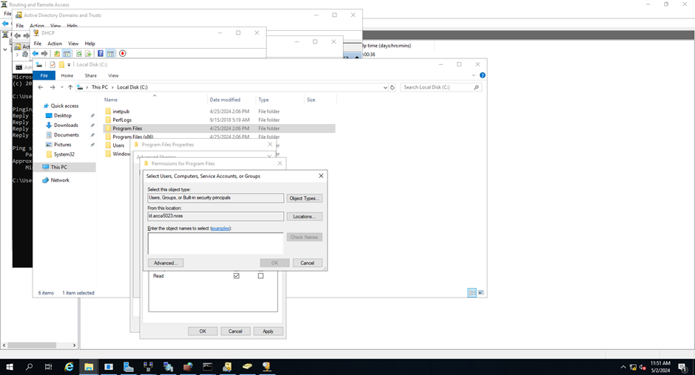

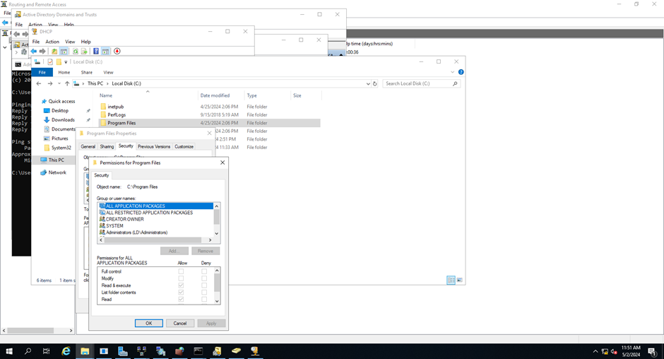

8 - Configure IIS Server

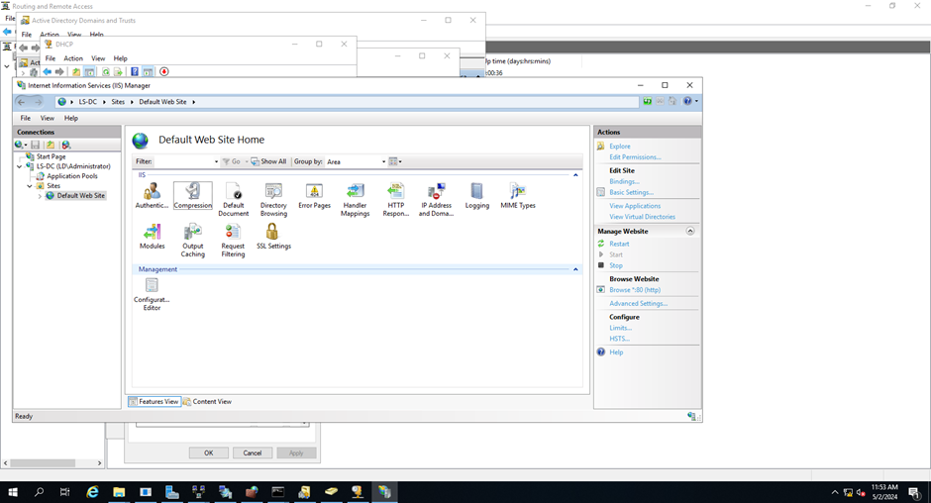

Network Policies and Security Practices

DHCP and DNS services

DHCP stands for Dynamic Host Configuration Protocol. It is a protocol that automatically assigns IP addresses and other physical characteristics to devices connected to a network. DHCP allows network administrators to manage IP address assignments and other settings without manually configuring each device. DHCP is used on almost all network devices such as computers, mobile phones, switches and game consoles.

  - Intermediate TCP/IP configuration.

  - Ability to define TCP/IP configuration from the centre.

  - Ability to view full list of TCP/IP addresses using DHCP options.

  - It is easily implemented and automatically assigns IP addresses based on customer requests.

  - Avoid copying or unauthorized use of IP addresses.

[7]

Active Directory Domain Services and Certificate Authorities

The directory is used by companies to facilitate user management, data control, and compliance with company security policies.

AD DS is a database service that plays an important role in Windows networking.

In summary, AD DS provides security, control, and policy-based management for network users and administrators, making it an essential part of Windows networking.

- Integrated management

- Strong authentication and authorization mechanisms

- Security and compliance features

- Group policy settings allow system administrators to enforce administrative standards on all computers in the

- Security environment.

In the simplest possible sense, a certificate authority is a digital certificate authority. These digital certificates are used to enforce the latest PKI (public infrastructure) security standards. Certificate Authority (CA) is an important factor in online communication and identity.

- Issues certificates

- Certifies the identity of the certificate owner

- Proves the validity of the certificate

These tasks are very important as they help validate the identities within the company.

[8]

High Availability and Redundancy

High availability clusters are servers grouped together to function as a single integrated system. These clusters, also called fail clusters, share the same storage but use different networks. They share the same mission in that they can perform the same functions as the core systems they support.

If a server in the cluster fails, another server or node can automatically take over to ensure that the application or service supported by the cluster continues to work. Using a high-availability cluster ensures there is no single point of failure for critical IT and reduces or eliminates downtime. The most suitable groups are tested regularly so that the groups are always ready. IT administrators often use open heart rate monitoring software to monitor the health of clusters. The software sends data packets to each machine in the cluster to ensure it operates as intended.

Redundancy

Network redundancy is the process of providing multiple traffic paths so that data can continue to flow even in the event of an outage. Simply put extremity equals confidence. It also helps manage distributed governance. The idea is that if one device fails, the other can take over immediately. By adding a little more complexity, we reduce the likelihood that an outage will shut down the channel.

But it is difficult and the enemy of reliability. The more complex things are, the more difficult they are to understand, the greater the likelihood of human error and the greater the likelihood that software will create new paths to failure. Therefore, it is important to balance density and complexity when designing a network.

[9]

Troubleshooting and Problem-Solving

Problem solving is a powerful skill and approach used in many fields, from information technologies to customer service. In general, Problem Solving is about diagnosing and solving problems, understanding why they occur, and implementing solutions to prevent future problems. This introductory blog aims to present the concept of 'What is Problem Solving' not only as a necessary technique but also as a fundamental method for solving problems in our daily lives and work environments by exploring what problem-solving entails, its value and application in different situations.

The process begins with identifying and defining the problem, followed by a comprehensive analysis of its causes. This is where critical thinking and experience come into play, allowing problem solvers to identify potential errors based on known evidence. The next step is to test these ideas using an experiment or logical inference and then implement a practical solution. But “What's the Problem” isn't just about solving the problem, also learns from the problem.

Effective troubleshooting involves documenting the problem and its solution and providing important information to prevent future incidents. By understanding problem solving as a structured yet simple process, individuals and organizations can develop a more efficient mindset, save time, and increase productivity.

[10]

VPN

VPN hides your IP address and allows you to route it through a special remote server controlled by the VPN host. This means that when you access the Internet with a VPN, the VPN server becomes the source of your data.

For example, a VPN can be used to access different streaming/gaming platforms that are only available in certain countries, so if you wanted to watch a film that isn’t out in your country, a VPN can allow you to watch that film. [11]

Features of a VPN

  - Encryption: VPNs encrypt your internet activity and keep your identity private while browsing the internet.

  - Privacy: VPNs offer a special level of privacy.

  - Access to Foreign Websites: VPNs allow you to access foreign websites.

  - Secure Connection: VPNs can provide a secure network for the transfer of private data.

  - Line Split: A popular VPN feature that lets you choose between security apps and VPNs.

[12]

Conclusion

As a result, routing is necessary to connect computers and direct traffic between networks through routers and protocols such as OSPF, BGP, and OLSR, each of which is appropriate to a particular system with different benefits and challenges. OSPF provides scalability and fast connectivity but can be complex; BGP, on the other hand, simplifies routing between domains but still requires expert configuration. OLSR integrates well with wireless mesh networks but suffers from measurement issues. Implementing administrative tasks includes configuring services, configuring VPNs, and configuring domains. Network policies and security practices, DHCP, DNS, Directory Services and certificate management, resource management and authentication. High availability and scalability reduce errors, troubleshooting allows for faster resolution of issues, and VPNs provide privacy and access. The process is critical and enables the exchange of information while maintaining security and regulatory standards. Understand protocols and best practices for creating stable networks that support required operations.

References

All Reference links are in the red numbered boxes (IEEE FORMAT) which is where you will find the URL link to the directed pages. There are a total of [12] references in this report.

