Student Name: Shahreen Akhtar

Student number: 2440149

Module: Introduction to Public Health
Module Code: LCHS4008

Assignment Title: Assessment 2 – Report on a Health Issue (Heart Disease)

Lectures Name: Olufemi Oluranti

Contents

Introduction 3
Main body 4
Causes and Risk Factors of CHD 4
Consequences of Coronary Heart Disease on the NHS and Community 5
Health Inequalities in Cardiovascular Disease 6
Prevention and Control of Coronary Heart Disease 6
Impact on Patients, Families and Carers 8
Conclusion 9
References 10

Introduction
Coronary heart disease (CHD) is a common cardiovascular condition and occurs when the heart’s blood vessels cannot deliver sufficient oxygen to the heart muscle. It develops as a fatty substance, known as atheroma, gradually accumulate within the walls of the coronary arteries. This build up causes the arteries to narrow, reducing the amount of oxygen rich blood that reaches the heart muscle (myocardium).
When the heart receives reduced blood flow, several symptoms can occur. The most common is angina, sensation of chest tightness or pressure that can spread to the arms, neck, jaw, back or stomach. Other signs may include breathlessness, tiredness, light headedness and sensation of nausea. In severe cases, a complete blockage of coronary artery can trigger a heart attack (myocardial infarction) a serious medical emergency that requires immediate treatment (British Heart Foundation, 2024).
Globally, cardiovascular diseases remain leading cause of death, accounting for 19.8 million deaths in 2022 (32% of all global deaths), with 85% from heart attacks and strokes (World Health Organization, 2025). In the UK, roughly 7.6 million people are living with heart or circulatory conditions, of which about 2.3 million are diagnosed with coronary heart disease (British Heart Foundation, 2024). This report explores the impact of CHD on individuals, and the NHS, and outlines key prevention and management strategies.

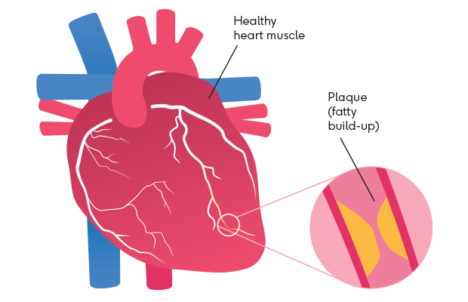
(British Heart Foundation, 2024)

Main body

Causes and Risk Factors of CHD
Coronary heart disease develops when atheroma narrows the coronary arteries, reducing blood flow and oxygen supply to the heart. Risk factors include lifestyle, medical, non-modifiable, and social environmental factors.

Lifestyle Factors
Smoking: Damages artery walls, narrows blood vessels and promote blood clots. Nicotine and carbon monoxide increases hearts workload and accelerate arterial damage, significantly raising the risk of developing heart disease (NHS, 2024).
Hypertension: Elevated blood pressure can increase the chance of heart attacks and strokes by straining the heart and blood vessels. Risk factors include age, family history, ethnicity (Black African, Black Caribbean, and South Asian), a high salt intake, obesity, smoking, excessive alcohol consumption, and prolonged stress. Lifestyle changes and medication can help control blood pressure and lower the risk of heart problems. (NHS, 2024)
Physical inactivity: Lack of regular exercise raises the risk of CHD by allowing fatty deposits to build up in the arteries. Regular physical activity improves blood flow, prevents plaque buildup, and reduces the risk of heart disease and stroke. (NHS, 2024).
Diabetes: High blood sugar thickens blood vessels walls, restricting blood flow and doubling the risk of CHD (NHS, 2024).
Thrombosis: Blood clots in a coronary artery can block oxygenated blood flow, often causing heart attacks (NHS, 2024).
High Cholesterol: Excess cholesterol forms fatty deposits in arteries, narrowing vessels and increasing the risk of CHD (NHS, 2024).
Excessive alcohol: Heavy drinking raises the risk of abnormal heart rhythms, heart muscle damage, heart attacks, and stroke. (British Heart Foundation, 2018).

Non Modifiable
Age: likelihood of developing CHD grows as people get older.
Gender: Men tend to develop CHD more often than women
Family history: Genetics influence
Ethnicity: people from south Asian or African Caribbean backgrounds face an increased risk.

Consequences of Coronary Heart Disease on the NHS and Community

More than 7.6 million people in the UK are currently affected by CVD, and this figure is projected to rise as the population ages and more people survive cardiac events (British Heart Foundation, 2025). CVD can lead to premature death, reduced life expectancy and decline in overall wellbeing.
Many CVD are long term conditions that cause significant disabilities. Heart failure and other forms of heart disease may result in symptoms such as breathlessness and chest pain, which can make daily activities, including work, difficult or impossible. These conditions often lead to repeated hospital visit and long term management, highlighting the impact of CHD on both quality of life and independence (Raleigh, Jefferies and Wellings, 2022).
CHD also creates a considerable economic strain on the National Health Services (NHS). Annual healthcare expenditure related to CHD is estimated at approximately £12 billion, while the total economic cost including premature mortality, long term care, disability and informal care giving is projected to reach £30 billion each year (UK Cardiovascular Disease Factsheet, 2025). Heart failure alone accounts for approximately one million hospital bed days year, representing 2% of total NHS bed use and 5% of emergency admissions.
The high demand for cardiac services affects hospitals, primary care and community health teams. High patient volumes can lead to longer waiting times for appointments, diagnostic tests and interventions such as angioplasty or bypass surgery. The prevalence of CHD increases the pressure on ambulance services, intensive care units and outpatient’s clinics.
The HEE/NHS reports highlight the need for improved workforce planning, training and the development of new roles to ensure a service ready cardiovascular workforce capable of meeting current and future demands, improving care quality and reducing health inequalities across the NHS and communities (Health Education England, 2023).

Health Inequalities in Cardiovascular Disease

Cardiovascular disease contributes substantially to unequal health outcomes in England. Individuals living in the most socioeconomically disadvantaged communities are nearly four times as likely to experience premature death from CVD compared with those in more affluent areas. Certain population groups face particularly high risk including men, older people, individuals with severe illness, and those from South Asian or African Caribbean backgrounds. Hypertension, the leading modifiable risk factor, is around 30% more prevalent in deprived populations. Approximately 40% preventable CVD deaths occur within the three most deprived population groups (Public Health England, 2019).
Social determinants such as poor housing, unemployment, limited access to health care and lifestyle factors such as smoking, poor diet, and lack of physical activity contribute to these inequalities. Addressing these issues requires a multi approach, combining public health interventions, community engagement and improved access to early screening and treatment services. Targeted prevention strategies, community engagement, and early screening programmes are essential to reducing disparities and improving cardiovascular outcomes in high risk communities (Public Health England, 2019).

Prevention and Control of Coronary Heart Disease

CVD remains a leading cause of death in the UK, and differences in access to care across socioeconomic and cultural groups highlight the importance of targeted prevention strategies and community support (British Heart Foundation, 2024; 2025). Coronary heart disease (CHD)the most common type of CVD is influenced by both population level and individual level risk factors making a multi level approach essential.
Primordial prevention
Primordial prevention focuses on reducing population level risk factors that contribute to the development of CHD, including smoking, poor nutrition, excess weight, lack of physical activity, and high alcohol consumption as well as exposure to air population. Public health Strategies at this level include smoking bans, sugar taxes and reducing salt intake (World heart federation, 2023) (NHS, 2020). By addressing these determinants early, primordial prevention aims to lower the overall incidence of CHD across the population.

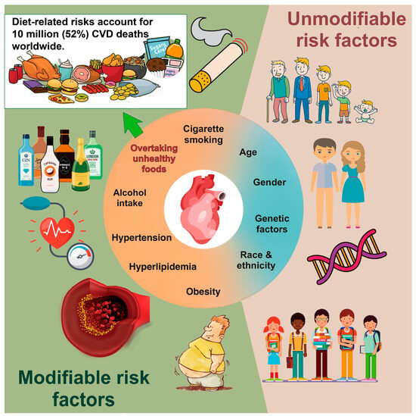
Factors contributing to the development of CVD (Chen et al., 2023)

Primary prevention
primary prevention targets individuals at high risk who have not experienced cardiovascular events. Key strategies include maintaining healthy weight, exercising regularly, quit smoking, limited alcohol intake and following a balanced diet (World Heart Federation, 2023).
The NHS Health Check screens adults for blood pressure, cholesterol, and pulse rhythm, offering personalised advice and referrals to support lifestyle changes. By detecting risk early, it helps improve CHD outcomes and reduce health inequalities (Public Health England, 2019).

Secondary Prevention
Secondary prevention supports individuals with existing CHD to prevent further events This includes lifestyle modification, medication strategies to decrease the risk of recurrent cardiovascular events such as medication (statins, antiplatelets, beta blockers), regular monitoring, and where appropriate surgical interventions such as angioplasty or coronary artery bypass grafting (NHS, 2020, World heart federation, 2023). Early risk factors identification enhances the effectiveness of secondary prevention strategies.

Tertiary prevention
Prevention focuses on improving outcomes for people with coronary heart disease, through treatments like angioplasty, stent, bypass surgery, pacemakers and defibrillators (World heart federation, 2023). Combined with ongoing specialist care and monitoring, tertiary prevention helps patients maintain independence and reduces the risk of severe complications.

Cardiac Rehabilitation and Support Groups
Cardiac rehabilitation and support groups provide patients and carers with guidance on exercise, lifestyle education and psychological support. These programmes help patients and carers manage emotional and practical challenges, improve recovery and reduce hospital readmissions. Research demonstrates patients who complete cardiac rehabilitation are less likely to be readmitted to hospital and often report improved quality of life. (NHS,2020).

Impact on Patients, Families and Carers

CHD affects physical, psychological and social wellbeing. Anxiety and depression are common after cardiac events. Early intervention through counselling and participation in rehabilitation programmes improves recovery and wellbeing (Better Health Channel, 2022). Participation in cardiac rehabilitation programs can improve both mental and physical wellbeing, helping individuals remain active and engaged within their families and communities.
Family history and inherited conditions can increase CHD risk, and families may share lifestyle habits that influence disease development. Encouraging healthy behaviours across generations can help reduce risk.
Carers often experience emotional, physical, and financial strain, and advanced CHD may require palliative support at home, in hospices, or hospitals. Holist care approaches help maintain wellbeing for both patients and carers (British Heart Foundation, 2021; NHS, 2017).

Conclusion
Cardiovascular disease remains a leading cause of morbidity and mortality in the UK, placing significant burden on individuals, families, carers and the NHS. It also poses a major economic challenge, costing billions each year in healthcare services and lost productivity. Continued research, early detection, and healthier lifestyles are essential to reducing its impact. Effective management requires a combination of prevention, medical intervention, cardiac rehabilitation, and community support, alongside targeted strategies to reduce health inequalities. Charities such as the British Heart Foundation play a vital role in funding research, supporting patients, and raising awareness. By prioritising early detection, healthier lifestyles, and comprehension care, the impact of CHD can be reduced, improving both patient outcomes and the sustainability of health care services.

References

Better Health Channel (2022) Heart disease and mental health. [online] Vic.gov.au. Available at: https://www.betterhealth.vic.gov.au/health/HealthyLiving/heart-disease-and-mental-health
British Heart Foundation (2018) Effects of alcohol on your heart. [online] British Heart Foundation. Available at: https://www.bhf.org.uk/informationsupport/heart-matters-magazine/medical/effects-of-alcohol-on-your-heart
British Heart Foundation (2021) Family history. [online] Bhf.org.uk. Available at: https://www.bhf.org.uk/informationsupport/risk-factors/family-history
British Heart Foundation (2024) Coronary heart disease. [online] Bhf.org.uk. Available at: https://www.bhf.org.uk/informationsupport/conditions/coronary-heart-disease [Accessed 15 October 2025].
British Heart Foundation (2025) UK Factsheet. [online] British Heart Foundation. Available at: https://www.bhf.org.uk/-/media/files/for-professionals/research/heart-statistics/bhf-cvd-statistics-uk-factsheet.pdf
Chen, W., Zhang, S., Hu, X., Chen, F. and Li, D. (2023) ‘A review of healthy dietary choices for cardiovascular disease: From individual nutrients and foods to dietary patterns’, Nutrients, 15(23), p.4898. Available at: https://doi.org/10.3390/nu15234898
Figure 1 Heart Disease: understanding the future service and workforce need Heart Disease Workshop - Evaluation Report (n.d.) [online] Available at: https://www.hee.nhs.uk/sites/default/files/documents/Heart%20Disease%20Report%20-%20Feb%202023.pdf
National Health Service (2017) Heart failure - Living with. [online] nhs.uk. Available at: https://www.nhs.uk/conditions/heart-failure/living-with/
National Health Service (2024) Prevention - Coronary heart disease. [online] NHS. Available at: https://www.nhs.uk/conditions/coronary-heart-disease/prevention/
NHS (2020) Recovery - Coronary heart disease. [online] NHS. Available at: https://www.nhs.uk/conditions/coronary-heart-disease/recovery/
NHS (2020) Treatment - Coronary heart disease. [online] NHS. Available at: https://www.nhs.uk/conditions/coronary-heart-disease/treatment/
NHS (2024) Causes - Coronary heart disease. [online] NHS. Available at: https://www.nhs.uk/conditions/coronary-heart-disease/causes/
NHS (2024) High blood pressure. [online] NHS. Available at: https://www.nhs.uk/conditions/high-blood-pressure/
Our vision is a world where everyone has a healthier heart for longer. UK Cardiovascular Disease Factsheet (2025) [online] Available at: https://www.bhf.org.uk/-/media/files/for-professionals/research/heart-statistics/bhf-cvd-statistics-uk-factsheet.pdf?rev=0759fdcb1d3248f9b9331c4039e6075c&hash=B0C8BEA1A48B306E4D2FC73C4265FBFA
Public Health England (2019) Health matters: preventing cardiovascular disease. [online] GOV.UK. Available at: https://www.gov.uk/government/publications/health-matters-preventing-cardiovascular-disease/health-matters-preventing-cardiovascular-disease
Raleigh, V., Jefferies, D. and Wellings, D. (2022) Cardiovascular disease in England. [online] Available at: https://assets.kingsfund.org.uk/f/256914/x/ad22aeaeff/cardiovascular_disease_in_england_2022.pdf
World Heart Federation (2023) CVD prevention. [online] World Heart Federation. Available at: https://world-heart-federation.org/what-we-do/prevention/ [Accessed 11 November 2025].
World Health Organization (2025) Cardiovascular diseases (CVDs). [online] World Health Organization. Available at: https://www.who.int/news-room/fact-sheets/detail/cardiovascular-diseases-(cvds)

