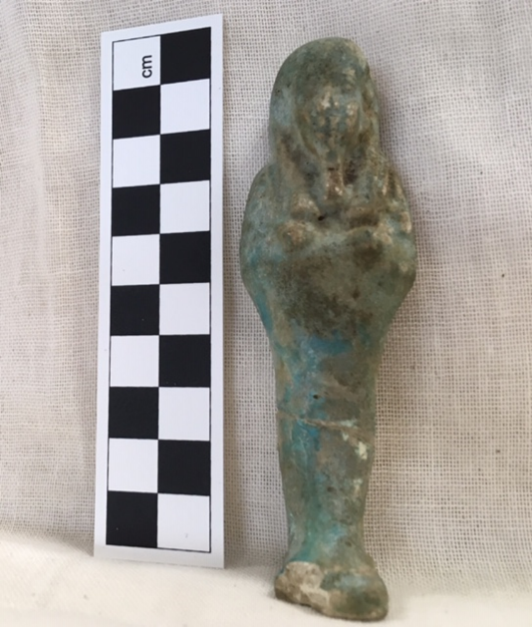
Ushabti embodied 3-D solid
Cyfarthfa Castle, Merthyr Tydfil
CCM. No. 1693.004.3
Object type: Funerary figurine
Material: Faience
Period: Possibly within Intermediate and Ptolemaic
Provenance: Unknown (Possibly from Cairo or surrounding area – Egypt)
Dimensions: Height = 9.5cm, width = 2.9cm (shoulder); length = 1.7 cm (Inc. pedestal base)
Fig.1, Funerary figurine (Stevens, 2019)

Object analysis by Flavia Stevens

It is difficult to know where this specific modest Ushabti was made and for whom.
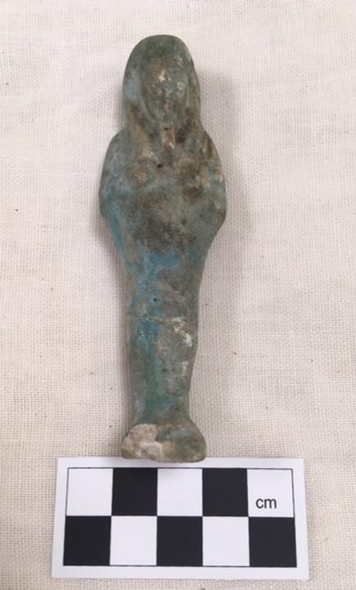
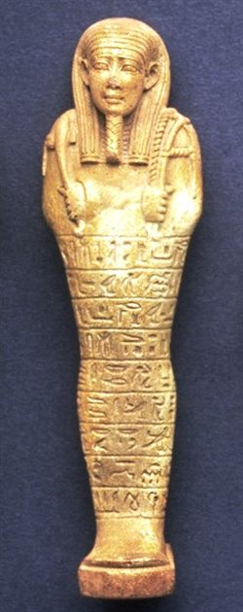
It is a based figurine intended to be placed near to the coffin on a flat surface or perhaps inside a tomb. The base is a square pedestal, approximately 2cm x 2 cm, and is of the same material as the figure. The Ushabti appears to have been mass produced; it does not have a visible inscription and is lacking in the detail which would be expected had it been carved individually. It is made of faience, a sand material typical of the area. It is a male figurine with a beard and a wig (nemes), which reaches down to the shoulders. The facial features are not clear, although it is still possible to see the nose and lips. The arms are held in a crossed position; although they are no longer visible, they can be felt. The hands reach to just below the shoulders. It is common for tools to be held in the hands of Ushabti, as they are intended to be servants in the after-life, but only a slight outline can be felt on this example, with insufficient detail to know what the tools of this Ushabti might have been . It does seem that the left shoulder might have carried a bag, which was symbolically used for grains (Taylor:2001:114), as there are small lines which can be felt in the area of the left shoulder. There is no indication of any inscriptions. However, it was customary for Ushabti to have an inscription which stated the duties of the Ushabti ‘servant’ to the deceased. (Fig.3)
Fig.2 Funerary figurine, (Stevens,.2019)

This faience shabti is very similar to that shown in figs.1and 2. However, one can clearly see the face, wig, beard, collar and implements. The figure carries a pick, hoe, and has a string basket over its back. Hieroglyphs are inscribed in low relief around the lower body.

Fig.3 Faience shabti (Liverpool Museum).

Although the names of these figurines changed over the course of their production, 1693.004.3 is from the Later Period, and is properly called a Ushabti. To be precise, the term shabti refers to early models interred in burials outside Thebes and the West Bank at the end of the First Intermediate Period and the Middle Kingdom and New Kingdom. The term shawabti refers to those items from the Seventeenth Dynasty and Eighteenth Dynasty from Deir el Medina, the West Bank and Thebes. Ushabti , which is the object I am describing here, comes from the Twenty-first Dynasty or later (Hill.2010). The word is ancient Egyptian and may derive from the Egyptian term Swb, meaning ‘stick’ (UCL.2011).It is also possible that is derived from the Egyptian word wSb, meaning to ‘answer’ or ‘respond’. Archaeologists at University at College, London suggest that the variations of spelling indicate changes in manufacturing methods, the meaning of the items and also cross-cultural influences . They suggest that the inscription of spell 6 on ushabtis or shawabtis shows that they are answering or responding to Amun in the moment they left this life and were being judged by the Gods of the first millennium BC (UCL.2011). A ushabti is a small human figure representing a person who would perform a given task for the deceased in the afterlife. Ushabti were made from various materials including faience, wax, clay, wood, stone, terracotta and, occasionally, glass and bronze (Taylor:2001:112).
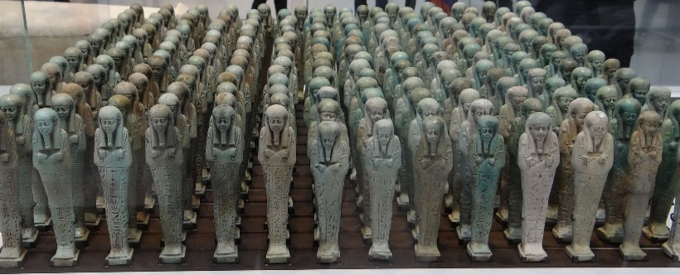
Evidence suggests that faience was made by the distinctive silica, quartz rock, natron, alum, salt, sea salt and niter, responsible for the efflorescent shiny colour, that was from surrounding area of Egypt. Also, some scholars suggest that by accident the Egyptians used a mixture of sand that was found on ground after they had cut limestone and rock with a copper drill. This would add in the mixture the different tones of green, blue efflorescent (Metropolitan Museum of Art. 2017). In fact, there is no archaeological evidence for how they made faience, the evidence is based on current experimentation (Metropolitan Museum of Art. 2017). However, we can be sure that they used moulds and also modelled clay figurines with a mixture of the faience which utilized high temperatures, for example 1000°C, to achieve the opulence of the glaze and colour of faience (Metropolitan Museum of Art. 2017).

Fig.4 500BC- Menphis troops of funerary servants ushabtis in the name of Neferibreheb (Louvre-Lens).

The earliest figurines were made mainly for the Pharaoh and his family in the period towards the end of the old Kingdom and the beginning of the New Kingdom. The figurines were used during this period as an alternative to the earlier custom of burying the actual servants with their Pharaoh (Taylor 2001:115). Later, the practice of being buried with figurines spread to all the important and wealthy people of Egypt, for example the governor, Viziers and accountants. For the servants it would be an honour to be a ushabti, possibly because they would rather be a volunteer worker in their own afterlife than be gone for all eternity.
Taylor (2010) describes the magic used by the Egyptians in the ceremonial burial, part of which was the use of spell 6 for causing a shabti to work for a man in the realm of the dead (2001:115). According to Taylor, there would be a Ushabti for every day of the year, ensuring that all the needs of the deceased were taken care of. In addition to the 365 servants there would be 36 overseers to ensure that the servants worked properly (2001:116).

In Fig. 3 a shabti, in a coffin, has a spell carved into the lower half of the body. The inscriptions were based on spell 6 from the Book of the Dead, which is a promise to fulfil any tasks demanded of the Ushabti.

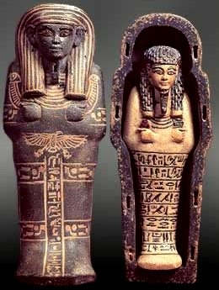

Fig.5 Shabti and mini coffin (Grosvenor)

“ O shabti, allotted to me, if I be summoned or if I be detailed to do any work which has to be done in the realm of the dead; If indeed obstacles are implanted for you therewith as man at his duties, you shall detail yourself for me on every occasion of making arable the fields, of flooding the banks or of conveying sand from east to west; ‘Here I am’, you shall say (spell 6)” (Taylor.2010:43).

Reference List

Hill, J. (2010). Shabti, Shawabti and Ushabti.
Available from: https://ancientegyptonline.co.uk/
[Accessed at: 19/03/2019]

Metropolitan Museum of Art(2017). Egyptian Faience. Technology and Production.
Available from: (http://www.metmuseum.org/collections)
[Accessed at: 19/03/2019]

Taylor, John H.(2001). Death and the Afterlife in Ancient Egypt. London: The Trustees of the British Museum.

Taylor, John H., and British Museum, eds (2010). Ancient Egyptian Book of the Dead: Journey through the Afterlife ; [Published to Accompany the Exhibition at the British Museum from 4 November 2010 to 6 March 2011]. London: The British Museum Press

University College London.(2001). Shabtis
Available from :
https://www.ucl.ac.uk/museums-static/digitalegypt/burialcustoms/shabtis.html
[Accessed at: 18/03/2019]
Figs.1 and 2 ,Stevens, F. 25/03/2019
Fig. 3 Faience shabti, Liverpool Museum , 1995, p.77, pl.121
Available from: http://www.globalegyptianmuseum.org/detail.aspx?id=4435
[Accessed at:09/04/2019]

Fig.4 Memphis, 500B. Troop of Funerary Servant figurines ushabtis in the name of Neferibreheb , Ottaviani,S. 24/03/2013.
Available from:
https://upload.wikimedia.org/wikipedia/commons/thumb/f/fa/Menphis
[Accessed at: 18/03/2019]

Fig.5 Shabti in a coffin. Grosvenor, J. The History of Shabti. Ancient Luxor
Available from: http://www.ancientluxor.com/gods-shabti.html [Accessed:06/04/2019]

