MADE L7

Capital Project Appraisal Presentation

MSc Financial Management & Planning

Module Code: ACPA7002
Supervisor: Gareth Frost
29th April 2023
Student- Lee Price
Email:Pricey_lee@yahoo.co.uk / Lee.Price@safran group.com
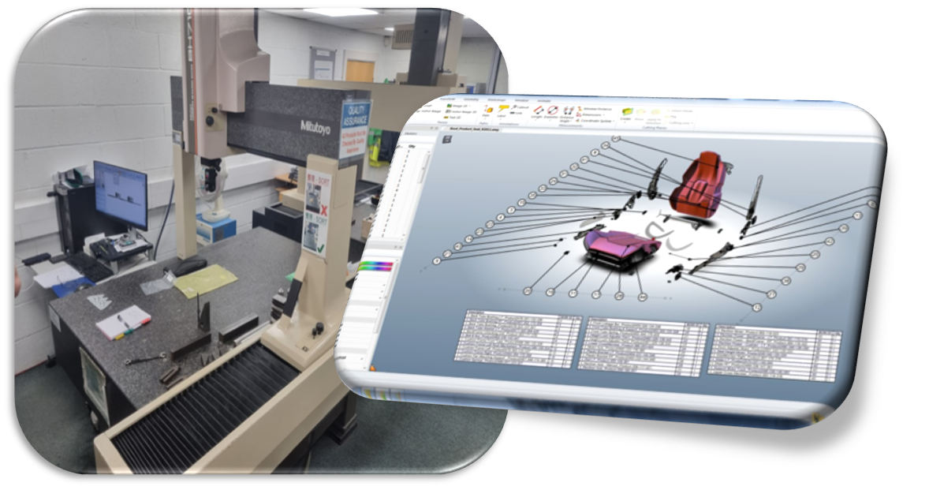



Content

- Summary
- Detailed Review around Capital Expenditure
  - Payback
  - NPV (net present value)
  - IRR (internal rate of return)
  - PI (profitability index)
  - BCR (benefit-cost ratio)
  - ARR (accounting rate of return)
- Implementation issues
- Options for funding
- Conclusions & recommendations
- References
- Full capital expenditure approval

Summary
This project is to provide an efficient method of completing first article inspections as part of our AS91002 regulations.
During a continuous improvement campaign within engineering it was found that there was a bottleneck with releasing bubbled drawings for manufacturing parts. This led to the removal of common practice and moved to defining drawings against model data.
The CMM has now become the bottleneck, this is due to each drawing not having bubbled data but now requests that all dimensions can be obtained on the model.
The model is loaded separately from the CMM and has no auto population function, in addition hand metrology cannot be achieved without a drawing in the model sense.
This project is provide the justification to purchase five catia licence’s that have the ability to combine model software with other metrology hardware. This will also support the current hardware (CMM) but will be utilised across other factories. Being a licence and software based against the web the additional advantage is that this can be used remotely by multiple individuals.
The initial out-going for this software is £64,000, the below capital expenditure reviews the payback period for the project, net present value, internal rate of return, PI, BCR and ARR.
Other alternative projects have already been put forward in the way of adding to the current CMM’s however they are at a cost of £110,000 each (min of x2 required) or utilising a 3rd party organisation to carry out the work, both cases have been rejected by the CFO.

Detailed review

Payback
The payback for this project is 2.2 years, this has been calculated by dividing the investment over the new yearly profit per year. The new profit per year is calculated against the increased amount of parts that are now available. This calculation described by (KAGAN, 2023) quickly provides the time required to return the initial investment and breakeven. When investing the quicker a project can payback the initial investment the more attractive it become to an investor, there is however still a risk with the payback formula as it does not identify the value of money within the period.

NPV
The NPV for this project is £47,426, (excel formula £47,449) this has been calculated by having the initial investment as a minus and then adding the investment payback added which has been subjected to the denominator driven from the WACC discount rate. The NPV provides the difference between the present cash flow coming in vs the present cash flow going out. (FERNANDO, 2023) highlights that an NPV with a negative value is not worth pursuing as it will be losing investment every month and will therefore never provide a return. The WACC or discount rate associated can change and the initial formula does not account for that, it will need to be adjusted, the higher the WACC the more original investment is used within a month.

IRR
The IRR rough calculation for this project is 39.19%, (excel formula 36%) this has been calculated by finding the negative value against the WACC rate. In the below calculation we have found that 40% takes the original NPV close to zero, from this movement we can understand what a single moment cost is. In this case 1% movement is equal to £5,162 and the total to breakeven is 39.19%, (FERNANDO, 2023) explains that the IRR is the expected growth of the project for that year, again the higher the more desirable the project. In this project we can take this IRR and compare it against another project where different equipment maybe purchased.

PI
The PI is calculated as 1.74 for this project, this index is devised by the NPV and initial investment being added and then divided by the investment. Essentially this formula is looking at the ratios between the future value amounts combining the initial investment. (Team, 2023) defines the three outcomes when calculating this index,
- When the PI is greater than 1, the project creates positive value and the company can proceed with the project.
- When the PI is less than 1, the project creates negative value and the company can halt the project for further evaluation or information.
- When the PI is equal to 1, the project breaks even and the company is neither of the above and is effectively even, no losses or gains.
This project falls into the grater than 1, once again this is adding to the confidence that this project will be beneficial to the business and will not create a loss.

BCR
The BCR is calculated as 0.74 for this project, this calculation is the same as PI however does not combine the NPV and investment, it is simply the NPV divided by the initial investment. As PI BCR is an index figure, over 1 being favorable, this defines the cost of the benefits relative to the initial investment. Even though our BCR is less than 1 this does not mean that the project is a failure, (HAYES, 2022) provides clarity that BCR is a simple calculation and does not take into account the required data to suggest failure straight away. BCR must be used in tandem with other calculations as on its own it can be misleading, it does not take into account changes in the business that are unforeseen.

ARR
The ARR in this instance is calculated as a percentage, for this project it is 49.7%. The ARR uses a residual figure to calculate a depreciation figure, from this we can create a net income profit. In addition we can create an average investment and average net, by adding the initial investment and average investment then divided by the total net and by 2 we will get our ARR percentage. This percentage is the rate on return from the asset, in this project the purchase from the initial investment is the asset. Through this project the lifetime of the asset will provide nearly 50%, this calculation also takes into account any other expenses for the asset. (MURPHY, 2022) highlights that ARR can show the depreciation of the asset, when they will require maintenance or replacement, this will provide the business time to plan in extra capital and the most effective was to integrate the change to not disrupt efficacy or profitability.

Implementation issues
This project is based on expanding the current model within the first article room, therefore there is no reason to disrupt the current workflow or output being achieved. Issues we will see are the sign off for other daily requirements desks, laptops, interface connections i.e HDMI leads, seat and possible safety equipment to support the project. These will either have to be placed on a separate order request or built into a business case with this appraisal, these maybe a given as daily requirements, however that is not the case for our business. This is where we have found that the time to complete that process is very long in time, in addition the above items can only be purchased from approved HSE suppliers, this would mean a desk at £100 in Ikea now becomes £850 from the approved suppliers. When these are added to the initial improvement reason the cost spirals, as in the initial summary this is where the improvement will be rejected by the CFO.
Outside of this we also have the health of the employees to consider, change is often seen as negative. With poor communications team member fear of redundancies, technology taking over or the expectation of working harder when the reality is to work smarter.
To move away from that (Mellssa A.Schilling, 2019) describes how a company can create buy in with adding in champions to the process. This is where we can utilize current staff in the area to create a positive approach. As well as providing a clear single thread message feedback is essential as often it can provide additional options either cost savings or efficiency improvements that support the initial project.

Options for funding
The natural process for funding is to raise an internal capex form, this reviews technical summary, solution & schemes, project impacts, low carbon, HSE, cost of the project, benefits of the project, financial summary, detailed financials and investment details. This would be review by the finance team and essentially be accepted or rejected based on the direction provided by the CFO.
In addition we have reviewed the potential sale of machines that have high value but low effect to the business. One item within our business is a Mazak CNC machine, this is currently worth in the region of £500k. The Mazak was purchase with the intension to reduce first off failures that were nearly 50%, however this has not been achieved. With still a consistent failure rate of 40% the tradeoff is not beneficial but the asset still holds worth. The bottleneck is still maintained and double handling still occurs, selling this asset would provide the capital to pursue this project creating positive efficiency and a positive financial impact back into the company.
Funding externally has also been explored, in the global company being held in France we have had success with the EIB (European investment bank). (EIB, 2021) provides details of how a loan has been agreed of 500 million euros to support research of future steps within the business. This is for the global company however benefits may be seen at the subsidiary levels or actions providing a positive effect downstream.

Conclusions & recommendations
The project financial data provides a clear benefit to the company and also provides some alternative options that can be pursued to support it further. The fundamentals are clear, the payback is just over two years, as we have a positive NPV this will support that payback period. We also have a gap of 36-39% before the breakeven point which can be measured, this is around £5,100 per percent change. The project also hold just under a 50% mark of the depreciation of the asset over the 5 year and at which point can support new replacements.
The recommendation would be to run through this project with the CFO and in addition do it in the location where the products are. Seeing where the project is and how this project will support the business and the team will give further insight into the impact not only financially but also the additional benefits.
This project appraisal also does not provide the full range of what the catia composer can support within the business. Within this project we have only covered the FAI’s in the lower level area, however this can be applied to our sub assy process and to the final assy line where top level seats and suites are created. As we have a fluctuating workload within the business another advantage is that this is movable software under a license that can be used on any PC. This would mean that we would no longer be confined to measuring in one area or moving multiple parts to one area.
There are other key fundamental advantages where this software connects to our digital models and ERP system (Baan). As it can utilize these systems for model data & BOM (bill of material data) there is no longer requirements for multiple systems or movement of digital data, this can reduce risks and create functional space.
Overall the project will benefit the company in many ways and is unlikely to provide a loss to the business without unforeseen external factors. As above this project can evolve as it has may other features that can support the business elsewhere as it can attach to multiple software and business systems.

Full Capital Expenditure Approval

References
EIB, 2021. France: Safran signs €500 million loan agreement with EIB to finance research on future aircraft propulsion systems. [Online]
Available at: https://www.eib.org/en/press/all/2021-082-safran-signs-eur500-million-loan-agreement-with-european-investment-bank-to-finance-research-on-future-aircraft-propulsion-systems
[Accessed 22 4 2023].
FERNANDO, J., 2023. Internal Rate of Return (IRR) Rule: Definition and Example. [Online]
Available at: https://www.investopedia.com/terms/i/irr.asp
[Accessed 20 4 2023].
FERNANDO, J., 2023. Net Present Value (NPV): What It Means and Steps to Calculate It. [Online]
Available at: https://www.investopedia.com/terms/n/npv.asp
[Accessed 20 4 2023].
HAYES, A., 2022. Benefit-Cost Ratio (BCR): Definition, Formula, and Example. [Online]
Available at: https://www.investopedia.com/terms/b/bcr.asp
[Accessed 20 4 2023].
KAGAN, J., 2023. Payback Period Explained, With the Formula and How to Calculate It. [Online]
Available at: https://www.investopedia.com/terms/p/paybackperiod.asp
[Accessed 20 4 2023].
Mellssa A.Schilling, P., 2019. Strategic Managment of Technological Innovation. s.l.:McGraw Hill.
MURPHY, C. B., 2022. Accounting Rate of Return (ARR): Definition, How to Calculate, and Example. [Online]
Available at: https://www.investopedia.com/terms/a/arr.asp
[Accessed 20 4 2023].
Team, C., 2023. Profitability Index. [Online]
Available at: https://corporatefinanceinstitute.com/resources/accounting/profitability-index/
[Accessed 20 4 2023].

