Improvement of a HR Priority Area
Organisational culture change and development-Twitter



Human Resource Management
BMMB7007

Samantha Gronow
1905869

Executive Summary
Twitter is a social media and networking service, which was taken under new management in 2022. Elon Musk, who already owned a significant number of shares in the organisation, bought out the other shareholders and changed it back to a private trading company. During the first few days as CEO, Elon Musk terminated the contracts of many of the core employees and gave a short window of choice to those who remained, on if they would like to remain employed at Twitter with a new working regime or take voluntary severance. In order to significantly cut expenses, many of the employee benefits were discontinued and all remote working employees were expected back into the office permanently , to work towards the new Twitter 2.0. (Ding, 2022).
This created an enormous culture change at the organisation. The significant decrease in employees resulted in under a third of the original employees remaining (Ding, 2022). The effect that such a sudden culture change can have on staff may be low morale, motivation and staff engagement (Herrity, 2022), which can lead to an overall lack of productivity and innovation (Johnson et al, 2012). The cultural web model (Johnson & Scholes, 1992) was used to describe the difference between the past and present cultures. This was followed with an explanation of Maslow’s Hierarchy of needs model (1943), to assess the needs of the employees through the sudden culture change, with an added examination using Herzberg’s two factor theory, which can be used to assess factors of motivation (Nickerson, 2023).
Following through these models highlighted several issues, which included lack of morale, motivation, and employee engagement. As a recommendation, it was suggested that employees were given the opportunity to voice their opinions, without repercussions, at an appropriate time and place, with their department managers. This information could then be fed up or down the chain of command, but overall giving everyone at the organisation a voice.
The second recommendation was to provide training for the managers of each department. The training would involve learning exactly what the values of the new culture are and what is expected from them, as well as how the management can effectively support their staff teams to be the best that they can be through the transition. This has the potential to build trust and form relationships, which would also benefit the openness to communication from recommendation one.

Table of Contents

Executive Summary……………………………………………………………………………………………………………………………2
Table of Contents………………………………………………………………………………………………………………………………3
1. Introduction………………………………………………………………………………………………………………………………….4
2. Organisational overview……………………………………………………………………………………………………………….5
3. Main Discussion……………………………………………………………………………………………………………………………6
4. Conclusions…………………………………………………………………………………………………………………………………11
5. Recommendations………………………………………………………………………………………………………………………12
6. Refence List…………………………………………………………………………………………………………………………………13

1. Introduction
Alteration to a core aspect of an organisation’s operation can be defined as an organisational change (Helms-Mills et al, 2008). There can be many factors that result in organisational change ranging from new technologies, relocations to new management structures. Organisational change can be seen as a journey, with effective management being in place to handle any complications that may arise along the way (Paton & McCalman, 2008). Human Resource Departments can play an important role in the effective management of an organisational change. Corporate culture is seen as a core element of an organisation. It relates to the way people in the organisation think, feel, and behave, which is guided by ideas, beliefs, and values of a similar minded cultural nature (Alvesson, 2013). Schein and Schein (2017) described organisational culture as a slow process developing over time, with new employees adjusting to the culture already in place when they join. With this in mind, it is clear to see that an established organisation may have cultures that are reluctant to change.
In 2022, Elon Musk purchased the public trading company Twitter. He previously owned a 9.2% stakeholder share before purchasing the entire company, firing the board of directors, and appointing himself the new CEO. Within the first few days, Elon Musk fired over 3750 Twitter employees, with many more taking forced redundancy after disagreeing with the new working expectations in place (Milmo, 2023). There was an email sent out to all staff, explaining that he expected them to ‘work long hours at high intensity’ and that the work would be ‘extremely hardcore’ in the build-up of the new Twitter 2.0. If this was not something that they could commit to, then they had the option to receive three months’ severance pay. There was a time limit on the email, and those who did not respond to sign up in little over a day were automatically issued the severance pay (Mann, 2022). This completely changed the organisational culture of Twitter, at a very fast pace, which will be discussed throughout this report.

2. Organisational Overview
Twitter is an online social media and networking service, which has over 300 million active users (Iqbal, 2023). Based in California, the multi-billion-dollar industry had over 7500 employees before Elon Musk appointed himself CEO and cut the staff teams down to little over 2000 employees, several of whom he brought into the company with him (Ding, 2022). Twitter still has a strong human resources team, who play a key role in the operations at Twitter headquarters. On the first day that Musk took over the company, he was sent a guidance of leadership from the HR team, who he publicly mocked posting screenshots on Twitter. Elon Musk has earned a reputation in the media from previous business ventures as a leader, disapproving of others who do not share his viewpoint. This point was validated on his arrival at Twitter, where he fired twelve individuals who had slated his leadership style on the employee social network (Ding, 2022). Twitter was once an open area for ideas, where employees were allowed to criticise company policy to a degree and publicly pushback against some aspects that they didn’t agree with, however Musk highlighted immediately that similar actions under his leadership would result in termination (Ding, 2022).

3. Main Discussion
The priority area that was highlighted was the organisational culture change and how it was carried out. Twitter was once an organisation which allowed a significant amount of freedom, offering many employee benefits which encouraged a relaxed work environment. It was believed that the relaxed atmosphere would be beneficial in inspiring new ideas. Whilst many staff embraced working from home following the pandemic, and others taking advantage of the childcare facilities in place on site, it greatly affected most staff when Musk announced the new working conditions, as well as the majority of employee benefits that would be scrapped (Das, 2022). The new working conditions meant that all staff were expected into the workplace, with the possibility of working long, gruelling hours until the task at hand was achieved. The new business model diminished the previous environment which contained little restrictions and brought in harsh leadership with the aim to improve the organisation in every way, effectively a Twitter 2.0.
The culture of an organisation can define an organisation on an internal basis for employees and on an external basis as the organisation’s public image (Tran, 2023). The perception of an organisations public image can be the factor that attracts customers, investors, and employees, especially those of particular talent, so it is a crucial aspect to maintain a culture that represents the core principles and values that the organisation aims for. Whilst it is easy for an organisation to put in place policies and procedures to achieve organisational values, it is difficult to put a culture fully in place as it is based on the interaction of people and relationships formed.
The Human Resources team can define the tone of the culture that they wish to achieve, going between higher management and employees to achieve a status quo area of working that is acceptable and achievable to all parties. This can be done by using engagement and feedback tools, to open a clear line of communication, giving employees a chance to express opinions and concerns, whilst giving an opportunity to reiterate the organisations mission and value statements to employees that management have put in place (Armstrong, 2020). The HRM responsibilities need to be spread out amongst department managers, to be able to achieve the best from everyone as policies and procedures can only achieve a certain amount and can not force people to feel in a particular way (Torrington et al, 2020).
One tool used to assess an organisations culture is the Cultural Web (Johnson & Scholes, 1992). It consists of six elements which make up the paradigm, identifying the culture of the workplace. The cultural web can then be used to map out the current culture, the culture that is wished to achieve and what changes need to be made to achieve the desired culture, addressing the best route possible.
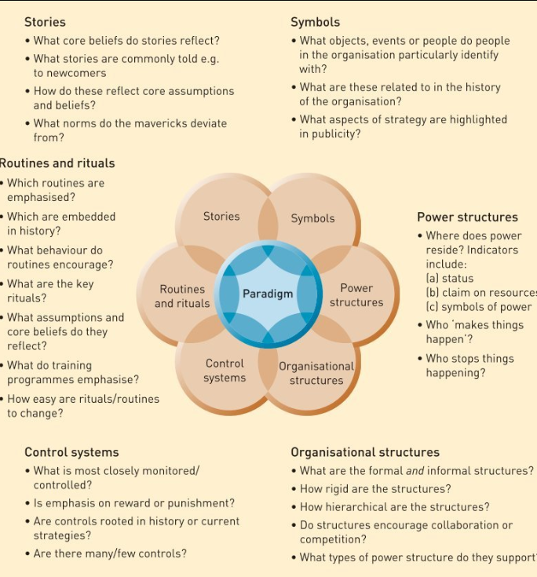

(Johnson et al, 2012)
Considering the model above, when Elon Musk purchased Twitter and began making drastic changes, he changed all of the core fundamentals that make up the culture paradigm. The power structure had always been one of hierarchy, however he took this one step further into an authoritarian style of leadership. Where as before, the organisational options were discussed through levels and agreed upon through a board of directors, now Elon Musk was solely responsible as the owner and CEO. The formal and informal structures were dissolved, with many of the core management personnel being terminated shortly after his acquisition of Twitter. The routines and rituals were all shaken up, with many people having to return into the workplace from remote working, as well as many employees facing childcare issues when employee perks were discontinued to save costs (Das, 2022). The new working hours could be difficult for some to accommodate at short notice, leading to stress and excessive pressure. Excessive pressure and long hours can lead to an employee becoming stressed, which can increase the likelihood of conditions such as depression and anxiety (CIPD, 2012). A company that once encouraged expression and critique to status quo, which is suggested to feed innovation (Johnson et al, 2012), was now firing the employees who voiced opinions that did not agree with the new CEO (Milmo, 2023). These factors caused an effect on most that were employed at the company, as even some of those who declared support for Musk’s new Twitter 2.0, were still terminated (Mann, 2022). For the employees that remained, their work environments may have changed drastically, with new roles, expectations, and the lack of familiarity.
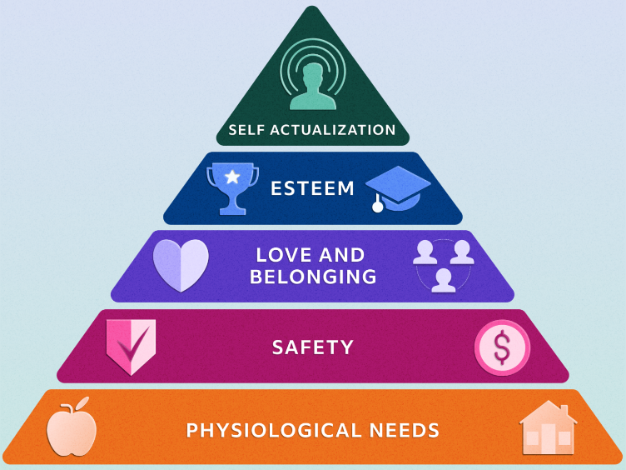

(Herrity, 2022)

To successfully change a culture, there needs to be a high involvement of staff engagement. This may be difficult to achieve if the employees are fearful of job security, the new way of working with no room for error, all while learning the new expectations. With all these factors in place, the individual needs of the employees may not be met. When these needs are not met, it can have a damaging effect on morale, productivity, and success (Schwartz & Porath, 2014).
Maslow’s (1943) Hierarchy of needs model suggests that in all aspects of life, individuals have five areas of need that need to be achieved for an individual to feel fulfilled and satisfied. This model has been adapted by many organisations in order to achieve the best from their employees. The bottom tier of needs is the most basic psychological needs, which in the workplace it would be a comfortable work environment, with access to toilets and break room facilities, and ultimately the work provides income so that the individual can support themselves outside of work (Herrity, 2022). The next tier up regards safety, which the employer has a duty to provide a physically safe work environment. In regards to emotional safety, the fear of losing the employment or unsteady futures can result in difficulty progressing to the next tier. This would be a great concern to Twitter, as not progressing past this tier could result in poor staff morale and lack of motivation (Herrity, 2022). Progressing further up the tier is a sense of love and belonging. The lack of staff morale and distrust in the culture change at Twitter could make it extremely hard to progress to or past this point. Especially as many may be grieving the lost relationships that they have built amongst work colleagues who were now laid off. The final tiers of self-esteem and self-actualisation, from a workplace perspective focus on encouraging the employee to achieve the best they can be in their job role, providing support when obstacles arrive and helping the employee have enough self-esteem to succeed (Herrity, 2022). In relation to Twitter, it would be extremely difficult for individuals to progress to this tier due to the lack of staff morale. The lack of trust in their work due to the sudden overhaul of staff, and fear of suggesting the wrong ideas may inhibit the creativity needed in such a workplace.
Maslow’s (1942) hierarchy of needs model is hard to achieve in a collectivist culture, which is common in organisations as big as Twitter. The employee’s may work together as a team or in separate departments, where all their individual work combined would be the success for the group. In this case, the organisation may have an overall culture, with subcultures running throughout the different departments, and the needs would differ from the original model. The basic needs would be a sense of belonging, self-esteem would be taken from the equation and self-actualisation would be achieved through meeting societal developmental needs (Gambrel, 2003).
The lack of staff morale and uncertainty of the future can lead to poor employee engagement (Basu, 2023). From a HR perspective, employee engagement is a crucial factor to success. Without it, there is limited communication and decreased motivation (Ristiawansyah, 2023), which in turn can lead to decreased productivity, less innovation, and less retention of staff (CIPD, 2021).

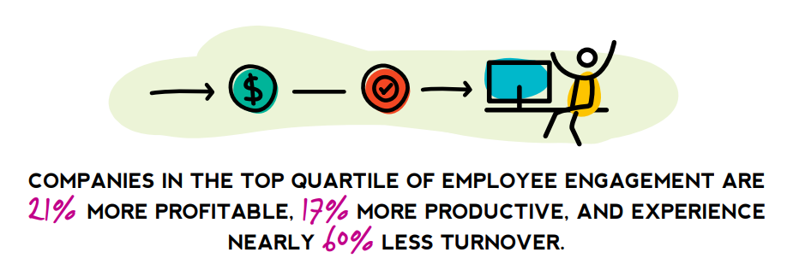

(EagleHillConsulting, 2018)

Overall, a business usually aims to be profitable and successful, so having high employee engagement is important. Employee engagement is encouraged by leadership containing strong strategic narratives, by line managers who continue to support and encourage their employees, and by employees having a voice in the organisation (CIPD, 2021). Overall, the organisational culture needs to reflect the values the company publishes, showing integrity for who they are (MacLeod, 2009).
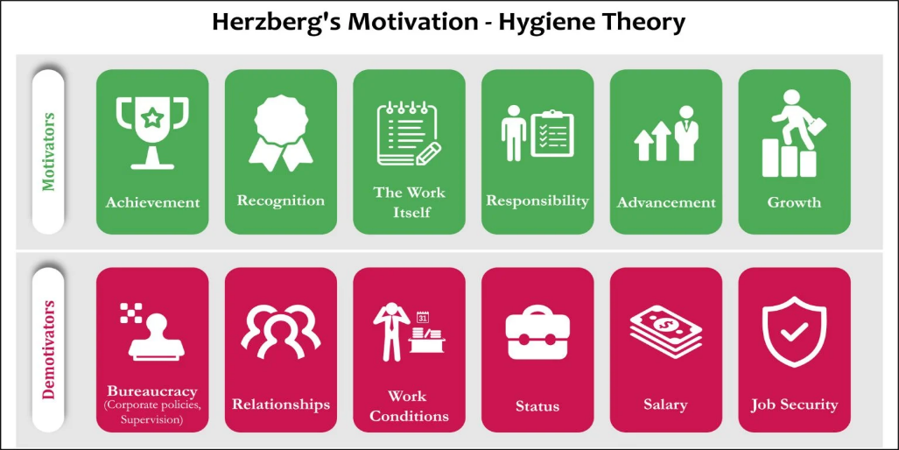
According to Herzberg’s two factor theory, there are many factors that can affect an employee’s motivation levels. There are positive aspects that can reinforce motivation and other factors that can diminish motivation (Nickerson, 2023), which are displayed below. Many of these factors were included in the culture change of Twitter, which according to the theory could significantly diminish the motivation of the employees. Lack of support and encouragement can lead to employees feeling undervalued (Waters, 2023), which combined with new working conditions, limited relationships and decreased job security, could lead to the individual seeking new employment.
(Nickerson, 2023)

4. Conclusions
When Elon Musk took over Twitter in 2022, the actions that proceeded shortly after significantly changed the culture at the organisation. The changes happened almost instantly, in order for his new agenda to take place, which left little room for transition and periods of adjustment. This could have a significant impact on employee engagement, morale and motivation. An organisation like Twitter thrives on innovation and new ideas, however if employees are worried about keeping their jobs, they may lack the confidence to voice new ideas or criticisms, overall decreasing possible creativity. For Twitter, this may result in missed ideas that may have generated a significant profit and/or put the organisation on top for innovative technology. Employee engagement especially is crucial, working together to create the best form of Twitter possible.

5.Recommendations
1. Improving lines of communication- As many of the staff may now feel uneasy since the recent overhaul of employees, and the examples that were made of those employees who expressed criticism, it is important to reassure the staff who remained that they are still able to voice their opinions, however unlike before, it may be preferred to express in an area not viewable by the general public. It is important that the employees feel safe enough to have their views heard, regardless of how big or how small the viewpoint is. As Twitter appears to be a collectivist organisation, it may be easier for staff to speak to their head of department regarding how they feel. Employee engagement surveys are helpful; however, it can only measure sentiment annually (Tsang, 2019). It is recommended that employees gather on a weekly basis in each department, and express views to their department managers in a ‘safe space’. In this set time and space, employees can voice freely to their department managers, how they feel about all company aspects, without repercussion. The department managers can then share these views, on an anonymous basis to higher management if requested. This could benefit the higher management as it opens pathways of communication amongst all levels. Higher management could gain clearer insight into what is working or not working, as well as creating a safe environment for innovation. As per Maslow’s model (1943), the psychological needs of the employee need to be met to endure the best from each employee.
2. Management Training-
As the organisation has been through a complete culture change, it would be beneficial to all department managers to undertake training and development in the best way possible to support their teams. They would need to understand the new values of the organisation, which sets out the tone of the new culture. It may be reassuring to lower-level employees if their management has a clear knowledge of the new vision, as well as learning the best way to support employees through the transition. The support and acknowledgement could be very beneficial to staff motivation levels, as per Herzberg’s two factor theory. The department managers could then assist all employee behaviour to align with the values and culture expected, whilst diminishing the lack of engagement and morale through positivity and support (Mogea, 2023). With new repour established, employees may also feel more comfortable communicating with management, which may reinforce the first recommendation.

6. Reference List
Alvesson, M. (2013) Understanding Organizational Culture. Los Angeles: SAGE Publications Ltd. Available at: https://search-ebscohost-com.ezproxy.uwtsd.ac.uk/login.aspx?direct=true&db=nlebk&AN=1099442&site=ehost-live (Accessed: 23rd March 2023).
Armstrong, M. (2020) Armstrong's Handbook of Human Resource Management Practice. 15th Ed. London: Konan Page
Basu, S. (2023) Motivation and Its Impact on Employee Performance. American Journal of Social Development and Entrepreneurship, 2(1), pp.22-25.
CIPD (2012) Managing for sustainable employee engagement. Available at: https://www.cipd.co.uk/Images/managing-for-sustainable-employee-engagement-guidance-for-employers-and-managers_2012_tcm18-10753.pdf (Accessed: 22nd March 2023).
CIPD (2021) Employee engagement and motivation. Available at: https://www.cipd.co.uk/knowledge/fundamentals/relations/engagement/factsheet (Accessed: 24th March 2023)
Das, M.R. (2022) ELON MUSK SLASHES EMPLOYEE BENEFITS AT TWITTER, GETS RID OF SEVERAL PERKS IN A BID TO INCREASE PROFITS. Available at: https://www.firstpost.com/tech/news-analysis/elon-musk-slashes-employee-benefits-at-twitter-gets-rid-of-several-perks-in-a-bid-to-increase-profits-11681401.html (Accessed: 23rd March 2023).
Ding, J. (2022) Elon Musk attempts ‘hardcore’ culture reset at Twitter. Will employees buy in? Available at: https://www.latimes.com/business/story/2022-11-16/elon-musk-is-laying-down-the-law-at-twitter (Accessed: 21st March 2023)
Eagle Hill Consulting (2018) The Business Case for Culture. Available at: https://www.eaglehillconsulting.com/wp-content/uploads/Eagle-Hill-Consulting-Business-Case-For-Culture.pdf (Accessed: 25th March 2023).
Helms-Mills, J., Dye, K. and Mills, A.J. (2008) Understanding organizational change. London: Routledge
Herrity, J. (2022) Maslow’s Hierarchy of Needs: Applying It in the Workplace. Available at: https://www.indeed.com/career-advice/career-development/maslows-hierarchy-of-needs (Accessed: 24th March 2023).
Iqbal, M (2023) Twitter Revenue and Usage Statistics (2023) Available at: https://www.businessofapps.com/data/twitter-statistics/ (Accessed on: 20th March 2023)
MacLeod, D. & Clarke, N. (2009). Engaging for success: enhancing performance through employee engagement. Available at: https://www.researchgate.net/publication/242468702_Engaging_for_success_enhancing_performance_through_employee_engagement/citation/download (Accessed:22nd March 2023).
Mann, J (2022) Read the midnight email Elon Musk sent Twitter staff telling them to work 'long hours at high intensity' – or quit. Available at: https://www.businessinsider.com/read-musks-midnight-email-telling-twitter-staff-work-long-hours-2022-11?r=US&IR=T (Accessed: 22nd March 2022).
Maslow, A.H. (1943) ‘A theory of human motivation’, Psychological review, 50(4), pp. 370–396. Available at: https://doi.org/10.1037/h0054346.
Milmo, D. (2023) Elon Musk fires additional 200 people at Twitter. Available at: https://www.theguardian.com/technology/2023/feb/27/elon-musk-fires-additional-200-people-at-twitter-report-says (Accessed: 21st March 2023).
Mogea, T. (2023) “The Importance Of Human Resources Training To Improve Organizational Performance”, CENDEKIA: Jurnal Ilmu Sosial, Bahasa dan Pendidikan, 3(2), pp. 58–72. doi: 10.55606/cendikia.v3i2.954
Nickerson, C. (2023) Herzberg’s Two-Factor Theory Of Motivation-Hygiene. Available at: https://simplypsychology.org/herzbergs-two-factor-theory.html (Accessed:19th March 2023).
Paton, R. and McCalman, J. (2008) Change management a guide to effective implementation. 3rd ed. Los Angeles ;: SAGE
Ristiawansyah, M. (2023) Literature Review: The Influence of Work Appraisal on Employee Performance in a Company. West Science Business and Management, 1(01), pp.17-30.
Schein, E.H. and Schein, P. (2017) Organizational culture and leadership. Fifth edition. Hoboken, New Jersey: John Wiley & Sons, Inc.
Schwartz, T. & Porath, C. (2014) The Power of Meeting Your Employees’ Needs. Available at: https://hbr.org/2014/06/the-power-of-meeting-your-employees-needs (Accessed: 23rd March 2023).
Torrington, D. et al. (2020) Human resource management. 11th edition. Harlow: Pearson Education Limited.
Tran, Q.H.N., 2023. The role of leadership skills in organisational citizenship behaviour at Vietnamese libraries: organisational culture as a mediator. Global Knowledge, Memory and Communication. Available at: https://www.emerald.com/insight/content/doi/10.1108/GKMC-10-2022-0249/full/html (Accessed on: 23rd March 2023).
Waters, A. (2023) How Companies Can Create A Culture That Prioritizes Mental Health. Available at: https://www.forbes.com/sites/forbesbusinesscouncil/2023/03/24/how-companies-can-create-a-culture-that-prioritizes-mental-health/?sh=4c179b9b5fa3 (Accessed:25th March 2023).

