
HTML & CSS Web development
ACCA4023

23 July 2026
BERNARD UNUIGBOJE ILEOGBEN (2512918)
LECTURER: Sadhana Jha

Contents
Introduction 2
Requirements 3
Purpose: 3
Subject matter 3
Intended audience 3
Implementation 4
Screenshots of the Webpages 4
Validation 6
HTML Validation 6
CSS Validation 7
Evaluation 9
Part A 9
Website usability- 9
Website accessibility: 9
Search engine optimisation 9
Part B 10
Usefulness (Usability and Utility) 10
Search Engine Optimisation (SEO) 10
Accessibility: 10
Part C 12
References: 13
Appendix 15

Introduction
This report documents the design, development and evaluation of a responsive site that was created for Burrow and Bone Pet Care, a fictitious neighbourhood pet care company. The idea behind the site is to enable potential customers to have a clear idea of the services that the company offers, introduce the business and team that run the business and even provide potential customers with an opportunity to contact the organisation by filling in an enquiry form. The site has been made with HTML5 and CSS3 and does not use any third-party frameworks or content management systems. This design is constructed following the recommendations of modern web development technologies in the form of semantic HTML, navigation regularities, flexible designs and layout, the presence of colour combinations and reusable Cascading Style Sheets elements. The site consists of four pages that are all interconnected: the Home, Services, About and Contact pages that provide the user with an easy browsing experience. Special emphasis was given to user experience within the site, e.g. the site is user-friendly, the content is well organised, and the layout will change depending on the size of the screen. Accessibility was also factored in to include such features of the webpage as descriptive headings, image replacement by alternate text and keyboard navigation, as well as the provision of a skip-to-content link that will ensure all users can use the webpage well. In this report, the way the planning will occur, how it will be implemented, how the validation testing should operate and how the final version of the site should be measured is identified. It also notes the strengths and weaknesses of the project and compares this project with the existing pet care websites with the aim of monitoring where they can improve their other websites in future.

Requirements

Purpose:
The purpose of this site was to create a virtual presence of a fictitious pet care company, Burrow and Bone Pet Care, that is a neighbourhood-based business. The site aimed to popularise services offered by the company, provide the business information needed, and make it easy for pet owners to get to know the business and book a service [1]. It also serves as an advertising strategy to highlight the experience of the company, the customer-centricity, and the commitment to providing safe and reliable treatment of pets. The site should endeavour to gain trust not only in the minds of the potential customers but also convince the potential customers to contact the business or have a free offer of a meet-and-greet.

Subject matter
The site is dedicated to services offered in Burrow and Bone Pet Care, which include walking dogs, grooming, daycare and boarding services. It boasts a catchy home page, detailed descriptions and prices of services, the story of the business and values on the About page and allows customers to contact the business with an address and a contact form, which reflects the caring side of the business [2]. There are even customer testimonials to add credibility in this area, and the photo and apt colour scheme give the impression of a friendly and professional entryway.

Intended audience
The intended audience of this site is pet owners who are looking for professional, high-quality care [3]. This would include working adults, families, the elderly and pet owners who require temporary pet care while they are at work or travelling. The site is also handy to novices within the area and those who need to find good pet care providers [4]. The simple navigation, clear presentation and convenient design of the site make it attractive to visitors of various ages and backgrounds of technical experience, who will be able to navigate the services and approach the business.

Implementation
3. Design and Implementation
Burrow and Bone Pet Care site was created using HTML5 and CSS3 to create a modern, responsive and accessible site. The site consists of four pages that are interrelated, and which are: Home, Services, About and Contact. Each page also has a uniform navigation bar allowing a user to navigate to the various parts of the site [5]. The Home page is the first page, which gives the visitor an introduction to the business. It comprises an enticing hero section, including a big banner image, a brief overview of the business, call-to-action buttons, highlights of services, customer reviews, and a footer that includes links to the navigation and business information. This design was meant to capture the visitor upon their first visit to the site in order to be encouraged to look at the site. The Services page provides a breakdown of the pet care services offered, such as day care, boarding, grooming and dog walking. All services are displayed on individual content cards with images, data and cost to enable the information to be readable and pleasing to the eye [6].
The About page provides a description of the background of the business, Burrow and Bone Pet Care, how the business was started, its mission, values and promise to give the best to their pets. To improve the visual appeal, a photograph of the team was added to the story section of the page.
The Contact page has a contact form which allows visitors to make enquiries [7]. The business contact details and opening time. Labels and placeholders are provided to make the form easier to use.
The external CSS stylesheet was used to be consistent in the styling of all pages [8]. It was designed on the principles of a natural colour palette, including green, cream and gold colours, which depict friendliness and openness of a pet care business. It has been implemented using Google Fonts to supplement typography, as well as flexbox and grid, to make the websites responsive and compatible with all desktop, tablet, and smartphone devices. The project also considered accessibility throughout the project using semantic HTML elements, descriptive page titles, hierarchy in the use of headings, alternative text to the images, keyboard-based navigation, as well as sufficient colour contrast [8]. The site also has a skip-to-content link to make it more accessible to keyboard and screen-reader users.

Screenshots of the Webpages

1. Home Page
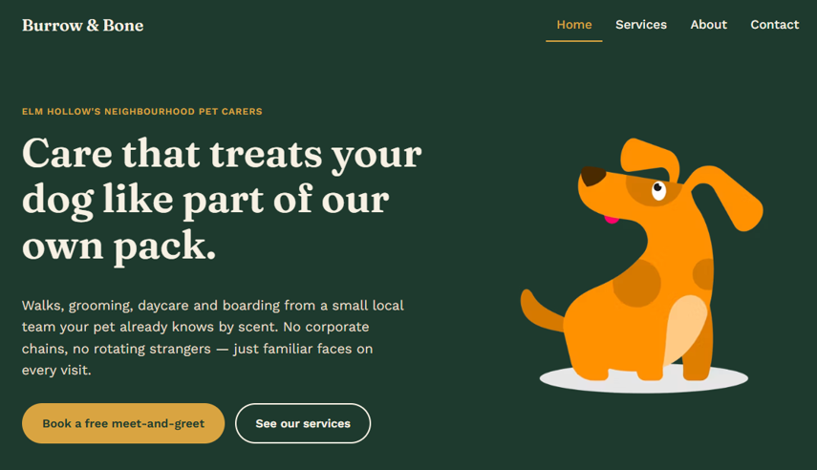
Figure 1 Home Page
2. Service Page
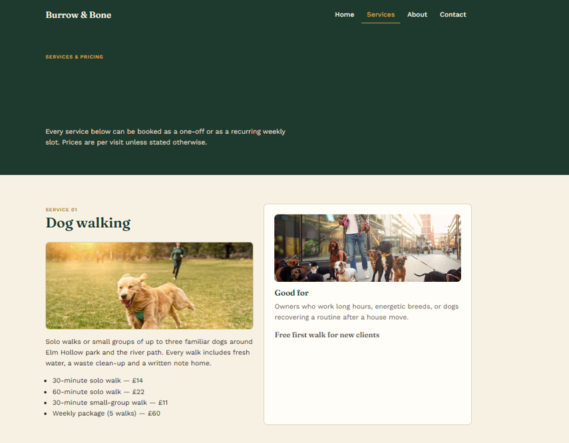
Figure 2 Service page

3. About Page
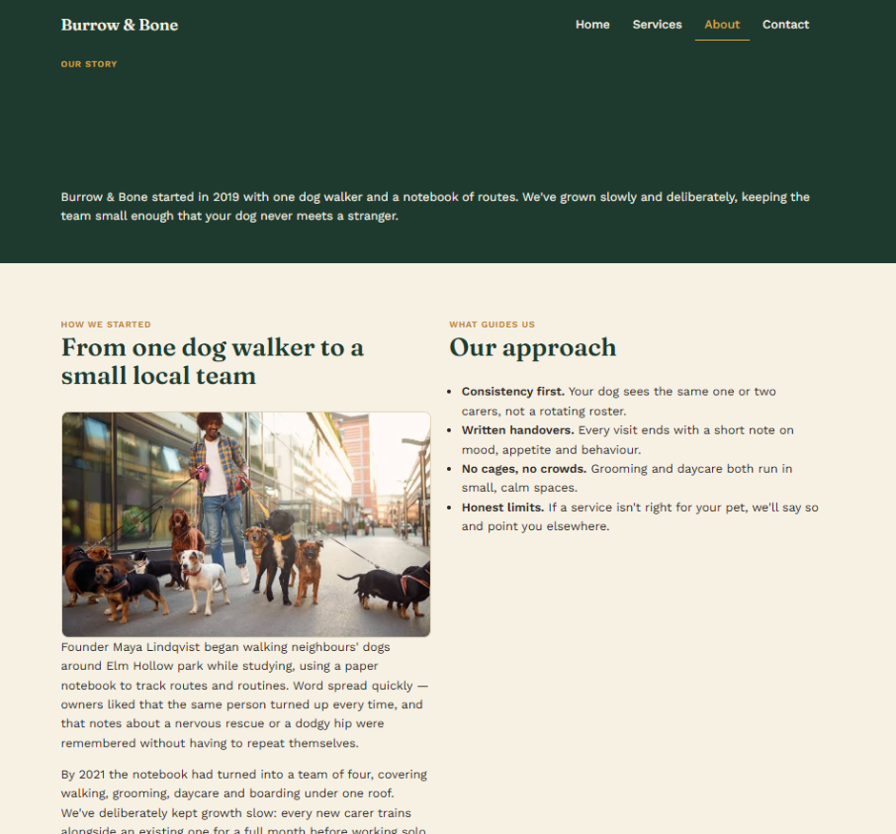
Figure 3 About page

4. Contact Page
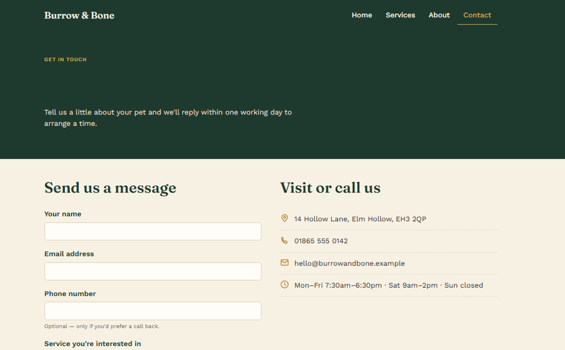
Figure 4 Contact Page

Validation

HTML Validation
The finished Home page (index.html) was tested in the W3C Markup Validation Service to check whether the HTML code complied with the latest web standards [9]. During the first validation, there were a few simple issues, like closing HTML tags and unnecessary attributes. These mistakes were rectified through proper closing of the affected tags, the elimination of unnecessary codes and making sure that all the elements of the HTML were used in the correct syntax. The corrected Home page was then revalidated, and the second test confirmed that there were no errors and that the page conforms to HTML5 standards.
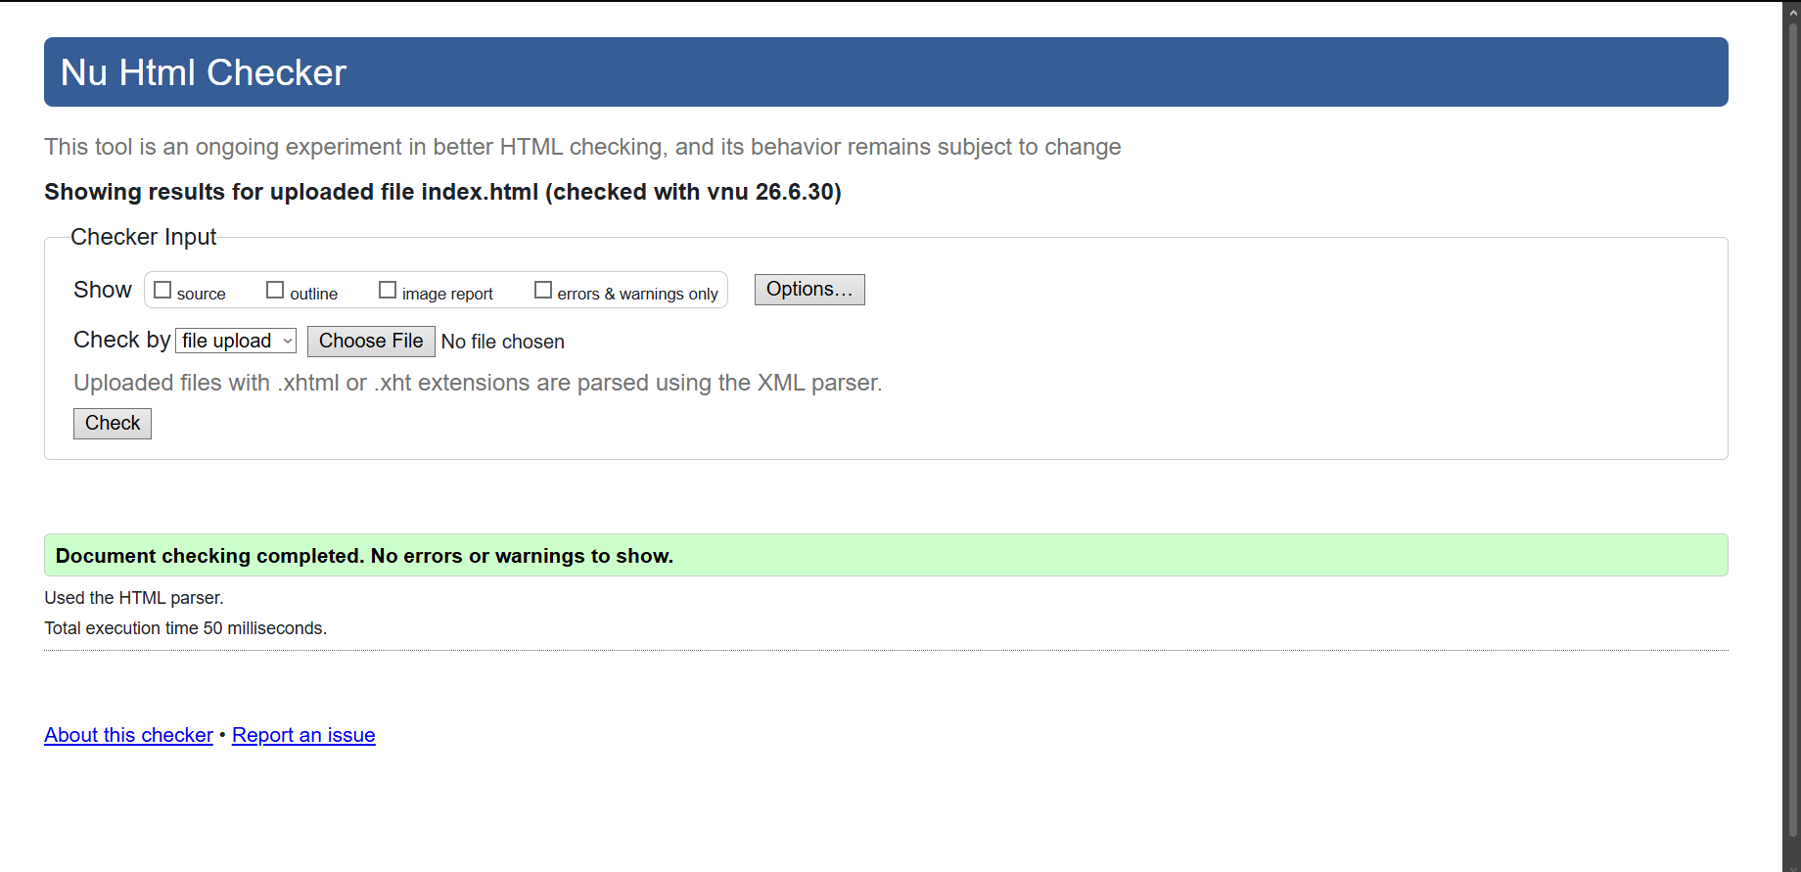
Figure 5 HTML Validation

CSS Validation
The stylesheet of the site (style.css) was checked via the W3C CSS Validation Service. The initial checkup detected a few syntax problems, such as improperly placed comments and redundant CSS statements [10]. These issues were addressed by fixing the comment structure, removing unnecessary code and verifying that all the CSS properties and values use the correct syntax. These mistakes were corrected, and the style sheet was again verified to be valid. The final test confirmed that the CSS file conforms to CSS standards with no validation errors.

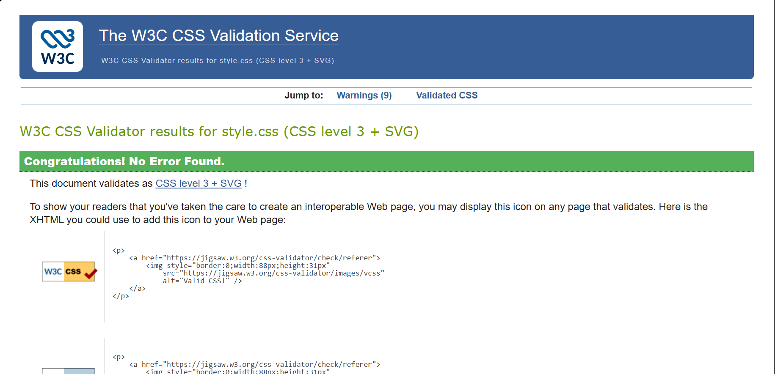
Figure 6 CSS Validation

Evaluation
Part A

Website usability-
The ease and effectiveness with which a website can be used is a term that has been applied to denote the usability of the website. With a good site, users are able to find information quickly, move between pages smoothly, and always know where they are rather than feeling lost. Clear navigation, consistent page layout, readability, high-performing response speed and responsiveness are other essential principles of usability. Good usability will enhance user satisfaction, persuade visitors to spend more time and boost the chances of someone going back to the site. Qing et al. [6] studied how visual design impacts the usability of a site. The researchers realised that with well-structured visual displays and showing the users' layout, they can comfortably navigate through them; this heightens their attention and exploration process through the eye-tracking medium.

Website accessibility:
The term "web accessibility" refers to the practice of making websites available to everyone, including persons with disabilities. Alternative text of images, use of keyboard, distinct colour contrast, convincing headings and well-marked form fields are some of the features available on sites. Ordoñez-Briceño et al. [8] studied approaches for developing easily accessible web pages. The study discovered that taking accessibility into account in the development of websites tends to create websites that are more in line with the WCAG guidelines. Guidelines such as the Web Content Accessibility Guidelines (WCAG) are used to make websites accessible, providing all users with equal opportunities to access websites with or without their differentiating abilities.

Search engine optimisation
The process of making the site more favourable in such a manner that it can be ranked higher in the list of results after searching the search engines is the process known as Search Engine Optimisation (SEO). The significant use of informative page titles, meta-descriptions, descriptive headings, semantical HTML, pertinent keywords, and speedy page loads, as well as mobile-based designs, is a significant element of functional SEO. Good SEO presupposes a high level of exposure for a website. Good SEO increases the likelihood that potential users will find a website through search engines such as Google. Roumeliotis et al. [5] researched the optimisation of websites using SEO techniques. The authors discovered that appropriate use of their page titles, keywords and metadata could enhance the ranking of websites and improve traffic.

Part B

Usefulness (Usability and Utility)
The Burrow and Bone site was designed with usability in mind. It uses the same navigation bar across all pages, giving users easy access to every page: Home, Services, About, and Contact [7]. The information is further grouped in blocks with the labels easily defined, making it easy for visitors to get information on the services, business and contact information. The responsive design ensures that the site is responsive to desktop computers, tablets and smartphones, providing an excellent user experience across all screen sizes. The second aspect that can be enhanced is putting a Google Map on the Contact page, and the inclusion of additional photos of the dogs so that the web page can be more attractive to view, and they have a favicon on the page so that it can be identified and branded in the browser.

Search Engine Optimisation (SEO)
Simple techniques of SEO were applied to the site. Each webpage has a title and meta description which are unique and descriptive. Semantic HTML tags, such as <header>, <main>, <section>, <nav> and <footer>, regulate the organisation of the site and help the search engines to understand the content [8]. All images are described with alternative text, and the headings follow a logical structure that is easy for search engines to index.

Accessibility:
Perceivable
The site was evaluated against the four main principles of WCAG 2.1: Perceivable, Operable, Understandable and Robust. Perceivable content is achieved by using descriptive alternative texts to pictures, distinct headings and enough contrast between colours to decipher the perceptions of the website. All these ensure that the material can be easily read and imagined even by a user with a screen reader or who is visually impaired.
Operable
The site also enhances the use of keyboard navigation by ensuring that there is both a skip-to-content link and an equivalent menu of navigation. This will make low-tech individuals, unable to use a mouse, use the site more efficiently.
Understandable
The page is easy to write in a language and often includes page designs and marked fields. These features will help users grasp the content with minimal effort and make operations like completing the contact form as painless as possible.

Robust
The site is coded in semantic HTML5 elements and will suit the new generation of web browsers and assistive technologies. This improves the reliability of the site, compatibility of user experience across different devices and various platforms.
Part C
Area | Website 1 | Website 2
Website | Rover (https://www.rover.com) | PetBacker (https://www.petbacker.com)
Usability | Simple navigation with clear service categories and online booking. | Easy to browse services but contains more information, making navigation slightly busier.
Accessibility | WAVE identified 1 error, 2 alerts, and 0 contrast errors on the Rover website. The results indicate that the website generally complies with WCAG 2.1 guidelines, although minor accessibility issues remain. | WAVE identified 4 errors, 60 alerts, and 9 contrast errors. The results indicate several WCAG 2.1 accessibility issues, including missing alternative text, missing form labels, broken ARIA references and low colour contrast, suggesting that accessibility improvements are needed.
SEO | Optimised page titles, meta descriptions, structured headings, and strong keyword usage. | Uses descriptive page titles, service keywords, and location-based SEO techniques.
Mobile Friendliness | Fully responsive and works well on smartphones and tablets. | Responsive layout with mobile-friendly navigation and booking features.
Conclusion | Provides a cleaner and more user-friendly experience with excellent usability and SEO implementation. | Offers a wide range of services but has a more content-heavy interface compared to Rover.

References:

- B.-C. Su, H. Lin, and Y.-M. Wang, "The Business Model of Digital Platforms for the Sharing Economy: Intensive Case Study Methodology for Rover.com Pet Boarding Platform," Sustainability, vol. 14, no. 23, p. 16256, Dec. 2022. https://doi.org/10.3390/su142316256
- E. M. N. Almutairi, A. A. Abubakar, and Y. H. Al-Mamary, "Integrating Brand Equity and Expectation-Confirmation Theory to Explain Sustainable Online Repurchase Intention and Digital Business Sustainability in Saudi Arabia's E-Commerce Market," Sustainability, vol. 18, no. 6, p. 3142, Mar. 2026. https://doi.org/10.3390/su18063142
- Y. Liang, C. Meng, R. Chen, Y. Yang, and Y. Zeng, "Pet Ownership and Its Influence on Animal Welfare Attitudes and Consumption Intentions Among Chinese University Students," Animals, vol. 14, no. 22, p. 3242, Nov. 2024. https://doi.org/10.3390/ani14223242
- C. A. Kuhl, R. G. Lea, C. Quarmby, and R. Dean, "Scoping review to assess online information available to new dog owners," Vet. Rec., vol. 190, no. 10, e1487, May 2022. https://doi.org/10.1002/vetr.1487
- K. I. Roumeliotis, N. D. Tselikas, and C. Tryfonopoulos, "Greek Hotels' Web Traffic: A Comparative Study Based on Search Engine Optimisation Techniques and Technologies," Digital, vol. 2, no. 3, pp. 379–400, July 2022. https://doi.org/10.3390/digital2030021
- H. Qing, R. Ibrahim, and H. W. Nies, "Analysis of web design visual element attention based on user educational background," Scientific Reports, vol. 14, no. 1, Feb. 2024. https://doi.org/10.1038/s41598-024-54444-8
- N. Toraman, A. Pekpazar, and C. A. Gumussoy, "Conceptualization and Survey Instrument Development for Website Usability," Informatics, vol. 10, no. 3, p. 75, Sept. 2023. https://doi.org/10.3390/informatics10030075
- K. Ordoñez-Briceño, J. R. Hilera, L. De-Marcos, and R. Saraguro-Bravo, "Generating Accessible Webpages from Models," Computers, vol. 14, no. 6, p. 213, May 2025. https://doi.org/10.3390/computers14060213
- M. Ghattas, A. M. Mora, and S. Odeh, "A Novel Approach for Evaluating Web Page Performance Based on Machine Learning Algorithms and Optimisation Algorithms," AI, vol. 6, no. 2, p. 19, Jan. 2025. https://doi.org/10.3390/ai6020019
- I. Prazina, D. Pozderac, and V. Okanović, "Beyond DOM: Unlocking Web Page Structure from Source Code with Neural Networks," AI, vol. 6, no. 9, p. 228, Sept. 2025. https://doi.org/10.3390/ai6090228

Appendix


