
By John Gallacher

Analysis of Electromagnetic wave propagation
OME Degree ACDC5009
Electromagnetic Radiation Module
25/04/2025

Declaration

The work of this report completed under the supervision of Stalin Jacob. I declare this that this report is the product of my own work and is not being submitted for any other degree etc.

Signature:
J.Gallacher (Signed electronically)

Acknowledgement

I would like to thank Stalin Jacob at the University of Wales Trinity Saint David for providing the Electromagnetic Radiation module. I was provided extensive knowledge and tutorials into electromagnetic theory and principles, in which were used for simulations and compared to relevant environments within industry.

Contents

1.Introduction 1
2.Antennas 5
3.Method 6
4.Results 7
5.Discussion 26
6.Conclusion 27
9.Appendix 28
10.References 29

Abstract

In this assignment the models simulated have been generated using the Ansys High Frequency Structure Simulator (HFFS) software to determine the waveguide behaviours through different propagation mediums in this example vacuum and Teflon. For task one the design of a rectangular waveguide model with Perfect Electric Conductor (PEC) filled with vacuum was created. The results on both the simulated values, and theoretical calculations will be analysed to determine the validity of the simulated model and its accuracy.
Furthermore, task b was completed requiring an additional model. This was created to analyse the characteristics of a halfwave dipole antenna. This radiation spread was provided in pictorial form and compared with its theoretical values.
All results obtained from the application of the specific electromagnetic modelling techniques mentioned have been compared with physical characteristics.

- Introduction

Electromagnetic Radiation:
Electromagnetic radiation is the transformation of energy through the movement and oscillation of electric and magnetic fields travelling at the speed of light or 3x10^8 m/s. It can be described as waves or particles called photons; these photons come in various frequencies from AM radio waves to gamma rays which make up the electromagnetic spectrum. The electromagnetic spectrum is the distribution of electromagnetic radiation according to the photon frequency and wavelength [1].

Electromagnetic Waves:
If we consider electricity and magnetism as both singular concepts, they generally are static. However, when combined we create what is known as electromagnetic waves. As the two variables change and move together this generates waves in which a perpendicular relationship between electricity and magnetism is formed. Therefore, a changing electric field induces a magnetic field and vice versa which creates a self-propagating wave (See Figure 1).
The relationship between electricity and magnetism can be explained via four key Laws:
- Gauss’s Law for Electricity- “Gauss's law states that the electric flux through any closed surface is equal to the charge enclosed by the permittivity. It applies to any charge distribution and any closed surface” [2]

- Gauss’s Law for Magnetism- “Gauss’s law states that the magnetic field has divergence equal to zero” [3]

- Faraday’s Law of Induction- “Faraday's Law of Induction states that a changing magnetic field can induce an electromotive force in a conductor, meaning it can create an electric potential and cause current to flow.”

- Ampère-Maxwell Law- “Ampère-Maxwell Law states that magnetic fields produced electric current and electric fields” [4]
All these laws make up Maxwell’s equations which are key for understanding how light works, how electricity and magnetism are interlinked and the concept of energy moving through space.

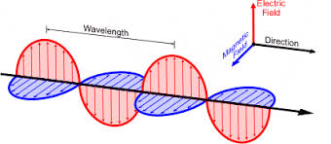
Figure 1- Magnetic Field (Blue), Electric Field (Red), self-propagating

Waveguides:
As described earlier, an electric field can induce a magnetic field and vice versa, resulting in the formation of electromagnetic waves. These waves travel in a specific direction, as illustrated in Figure 1. The direction of wave propagation depends on several factors, including how the waves are used, as well as the wavelength and frequency of the electromagnetic radiation.
For instance, in radio communication, a naturally occurring "waveguide" effect can occur due to the Earth's ionosphere, which reflects certain radio waves back toward the surface. This allows radio signals to travel long distances around the Earth. This reflection is especially effective in the high-frequency (HF) or shortwave range, where free electrons in the ionosphere, energised by solar radiation to form a plasma layer that bends radio waves back toward Earth. [5]

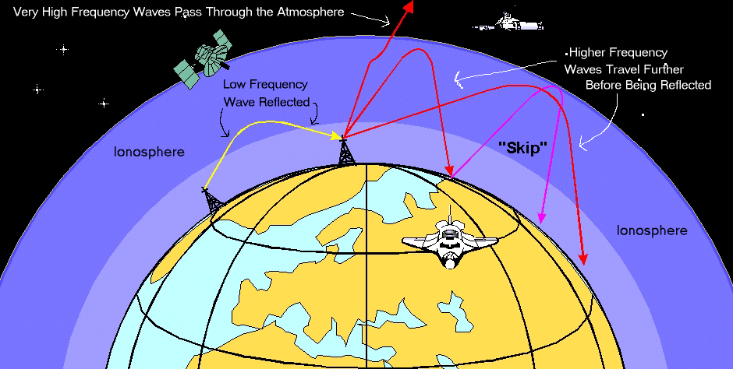
Figure 2- Ionosphere

Not all wave transmission can rely on the natural spread of electromagnetic radiation or reflection off the ionosphere. This natural reflection only works for certain frequencies, like those used in radio communication. Higher-frequency waves, such as microwaves, pass through the ionosphere and are not reflected, making natural propagation unreliable or impossible for those signals.
Additionally, relying on natural propagation causes the waves to spread out, weakening the signal and potentially diverting it from its intended destination. This is where waveguides become essential. Waveguides are designed to control and direct electromagnetic waves precisely, minimising signal loss and avoiding unwanted dispersion. They also offer improved efficiency by preventing the wave from freely traveling through air or cables, where it could be absorbed or scattered. Moreover, waveguides provide protection from outside interference, whether accidental (such as overlapping signals) or intentional (like a threat actor attempting to intercept or disrupt the communication).
Types of Waveguides:
There are three main types of waveguides, each suited to different applications. Rectangular waveguides are the most used, especially in radar systems, due to their ability to support a wide range of frequencies with their rectangular tube structure. Circular waveguides, which have a cylindrical shape and circular cross-section, are ideal for systems requiring rotational symmetry, such as those using circularly polarised antennas. The third type, dielectric waveguides, are made from insulating materials that can be polarised by an electric field. These are most found in optical Fiber systems, where they guide light rather than radio or microwave signals.
Rectangular Waveguide:
As the rectangular waveguide will be the simulated model in this assignment it must be understood how it operates. This is generally a hollow metallic rectangular shaped case or box type structure made of copper or aluminium due to their conductivity. The wave or energy enters the structure and reflects at the angle of incidence in which the wave can continue to constructively interfere and move the wave to its destination (Figure 3).
Electromagnetic waves in waveguides follow different modes, which are unique patterns of electric and magnetic field distributions. The Transverse Electric (TE) mode has the electric field entirely perpendicular to the direction of wave travel, with only the magnetic field extending along the wave’s path.
This mode is sometimes called the H-mode because the magnetic field dominates in the propagation direction. The Transverse Magnetic TM mode is the opposite, where the magnetic field is perpendicular, and only the electric field extends along the propagation direction.
Furthermore, the Transverse Electromagnetic (TEM) mode has both the electric and magnetic fields completely perpendicular to the direction of wave travel. This mode doesn’t typically exist in hollow waveguides but is seen in transmission lines like coaxial cables. Each mode has its own characteristics, so it's crucial to choose the correct one for efficient operation and to suppress other modes that might interfere with the intended signal. [6]

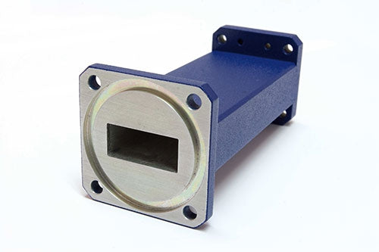
Figure 3- Rectangular Wave Guide
Cut-off Frequency:
The cut-off frequency of a rectangular waveguide is a crucial specification, as it determines the minimum frequency at which the waveguide can effectively transmit signals. This is commonly known as TE10, which is the dominant mode as it’s the lowest threshold for wave propagation. If the signal's frequency is below this threshold, the waveguide will cause significant attenuation, and the signal will not propagate properly. To ensure proper signal transmission, the frequency of the signal must be higher than the waveguide’s cut-off frequency. Each waveguide has a different cut-off frequency for each propagation mode, and the mode with the lowest cut-off frequency is called the dominant mode. For successful wave propagation, the operating frequency must be higher than the dominant mode's cut-off frequency, as this ensures the signal experiences minimal degradation in the dominant mode.
The cut off frequency can be determined by the following equation:

$$fc=\frac{c}{2}\sqrt{(\frac{m}{a})^{2}+{(\frac{n}{b})}^{2}}$$
In which:
- $fc$= cut off Frequency (Hz)
- $c=$speed of light in vacuum (3x10^8 m/s)

- m= mode number in the x-direction

- a= width of the waveguide (m)

- n= mode number in the y-direction

- b= height of the waveguide (m)

2. Antennas
For task 2 of this report a model of a halfwave dipole antenna was created and simulated using the Ansys software, in obtaining these results there must be an understanding into the applications of antennas and what this data will tell us.
An antenna is a specialised device that acts as a transducer, converting electrical signals into electromagnetic waves and vice versa. It is essential for both transmitting and receiving non-ionising electromagnetic radiation such as radio waves, microwaves, infrared, and visible light. Antennas operating in the radio and microwave ranges are widely used across various sectors, including radio and television broadcasting, wireless communication networks, and military systems. In military applications, antennas are vital for secure communications, radar operations, electronic warfare, and surveillance, where dependable signal transmission and reception are crucial.
Although antennas are often categorised as either transmitting or receiving, many are designed to perform both roles using a transceiver system. A receiving antenna captures electromagnetic waves from the surrounding environment and converts them into small electrical currents. These signals are then passed to a receiver, where they are processed for specific uses, ranging from civilian communications to critical military intelligence gathering.
There are many types of antennas, each designed for frequency bands, operational conditions, and application requirements, ensuring reliable performance in both civilian and defence technologies. [7]
Halfwave Dipole Antennas:
A half-wave dipole antenna is a simple and widely used type of aerial that consists of two metal rods, each one-quarter of a wavelength long, making the total length equal to half the wavelength of the signal it is designed to transmit or receive. It is typically centre-fed and produces an apple shaped radiation pattern, with the strongest signal radiated out to the sides. This type of aerial works best when mounted horizontally and elevated above the ground.
One of the main advantages of a half-wave dipole is its simplicity and cost-effectiveness. It is easy to build and install, making it ideal for both amateur and professional use. It also offers good performance at its resonant frequency and is often used as a reference for measuring other antennas. However, it does have some limitations. The bandwidth is relatively narrow, meaning it is most effective over a limited range of frequencies, and performance can be reduced if not properly positioned or matched to the correct impedance.
In military applications, half-wave dipole antennas are often used for field communications, particularly in HF radio systems. For example, during tactical operations, a portable half-wave dipole can be quickly deployed between trees or masts to establish reliable communication between units over long distances. Its straightforward design and efficiency make it a practical choice in rugged environments where more complex antennas may not be feasible. [8] [9]

- Method
Task 1:
For task one of the assignments, it was to create a rectangular waveguide filled with vacuum and another with Teflon. The rectangular model was created with the following dimensions:
- Length of 50mm
- Width of 21mm (based on first 2 digits of student number)
- Height of 14mm (based on 3rd and 4th digits of student number)

A simulation was carried out using Ansys HFSS to examine how electromagnetic waves behave inside a rectangular box. Two different materials, vacuum and Teflon, were tested with the same setup used for both to allow a fair comparison.
The project began with the creation of a new HFSS design. The units were set to millimetres, and the solution type was changed to Modal, which is ideal for studying wave-based problems.
A rectangular box was modelled with dimensions of 50 mm in length, 21 mm in width and 14 mm in height. In Task 1A, the box material was set to vacuum. For Task 1B, the material was changed to Teflon to observe how each material affects wave propagation.
To improve visibility inside the model during the simulation, the transparency was adjusted to 0.8. The four largest sides of the box were assigned as Perfect Electric Conductors, or PEC, simulating perfectly reflective metal walls.
Wave ports were then placed on two opposite faces of the box. These ports allow electromagnetic waves to enter and exit the structure. Each port was set to support three wave modes and had a characteristic impedance of 50 ohms.
An advanced solution setup was created for the analysis. The maximum number of passes was set to 99 to ensure accurate results. Although the exact operating frequency was not specified, it was chosen to be near the expected working range.
A frequency sweep was also added, starting at 2 GHz and ending at 30 GHz, to analyse how the structure behaves across a broad range of frequencies.
With the full setup complete, the simulation was run, and the results were checked to ensure everything functioned as intended.

Task 2:
A simulation was carried out in Ansys HFSS to model and analyse a basic antenna structure. The process began by creating a new project using the HFSS design type. The units were set to millimetres, and the solution type was changed to Modal, which is suitable for high-frequency electromagnetic analysis. A cylinder was created to act as the main antenna body. Its properties were set with a radius of 1 mm, a height of 50 mm, and it was centred at (0, 0, -25) on the coordinate system. The material of the cylinder was changed to Perfect Electric Conductor (PEC), and the transparency was set to 0.8 to help visualise the model.
To simulate a gap in the centre of the cylinder, the original cylinder was copied and modified. The copied version kept the 1 mm radius but had its height changed to 1 mm and was positioned at the centre (0, 0, -0.5). This small cylinder was set to vacuum and made semi-transparent (0.8 transparency).
Using the Boolean subtraction tool, the small vacuum cylinder was subtracted from the larger PEC cylinder. This created a split cylinder structure with a 1 mm vacuum gap in the middle.
A lumped port was then added in the gap. The section tool was used to select the YZ plane of the gap, and this plane was assigned as a modal lumped port. A full port impedance of 50 ohms was entered. An integration line was drawn from the bottom to the top of the YZ plane to properly define the port.
Next, an open region was created to provide space for the antenna to radiate into, allowing for the study of radiation patterns. An advanced solution setup was created with the frequency set close to the expected operating frequency and the number of passes set to 99 to ensure accuracy. A frequency sweep was defined to run from 1 GHz to 7.5 GHz.
The project was validated and then analysed. After simulation, the S-parameters were plotted to examine how well the antenna transmits signals. Finally, the 3D polar plot tool was used to display and record the antenna's radiation pattern.

- Results
Task 1: Vacuum
This design was created using Ansys software and represents a rectangular waveguide with PEC (Perfect Electric Conductor) walls, filled with vacuum. The two wave ports at either end of the waveguide were analysed across three different modes.
The electric and magnetic field magnitudes and vectors were computed, and the cutoff frequency was plotted on a gamma plot. The following screenshots illustrate the results of this analysis:
2 ports were created for this design and were an exact replica of each side, so port one will be highlighted as it covers both ports:

Port Fields:

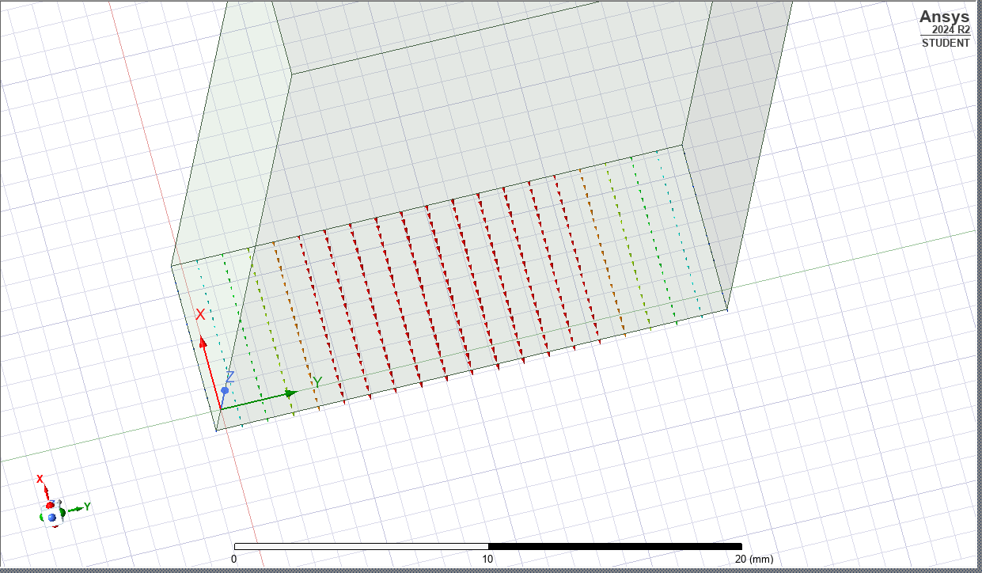
Figure 4- Port 1 Mode 1
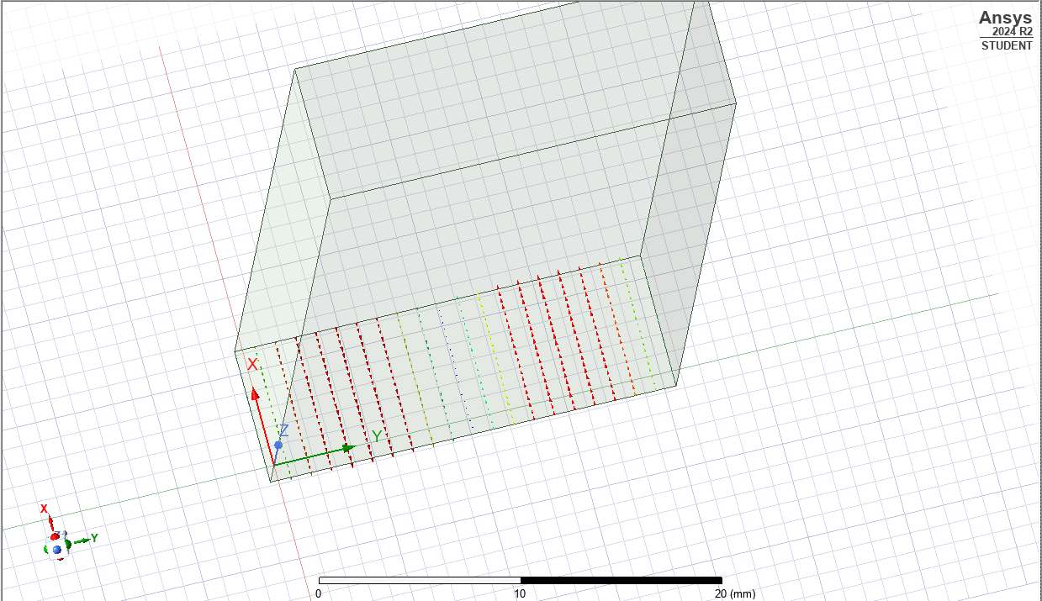
Figure 5- Port 1 Mode 2

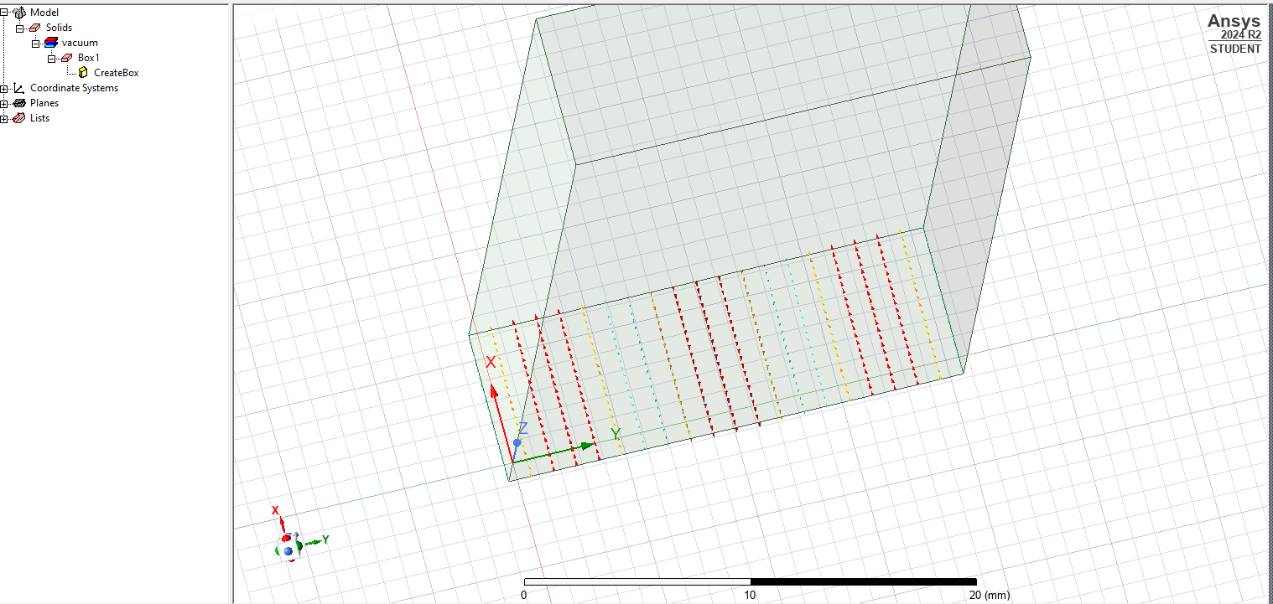
Figure 6- Port 1 Mode 3

Gamma Plot Display:

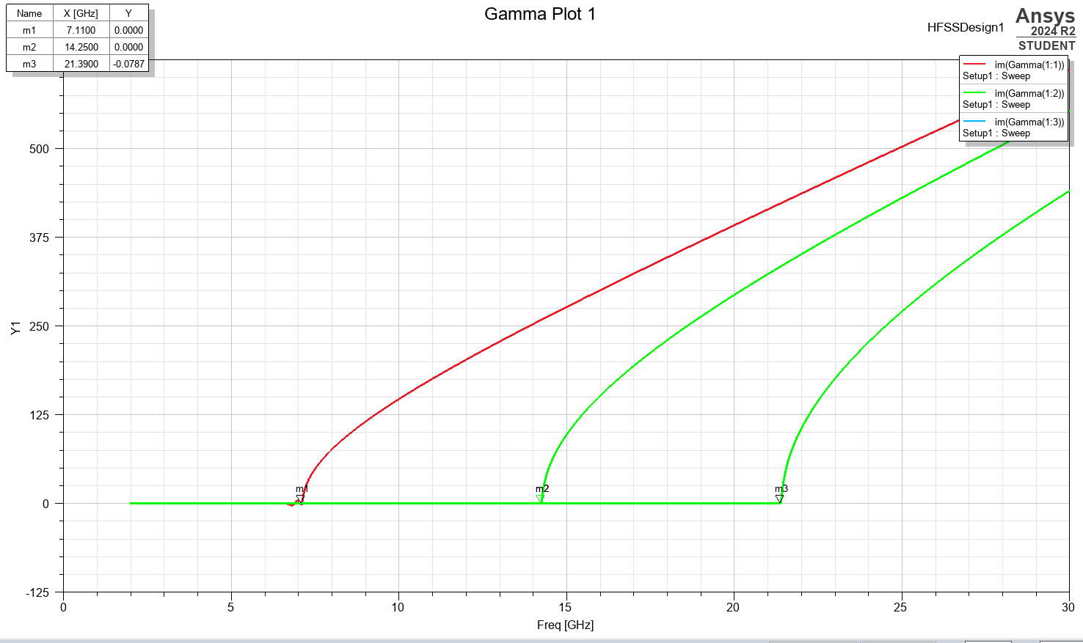
Figure 7- Gamma Plot
Electric and Magnetic Field Vector Displays:

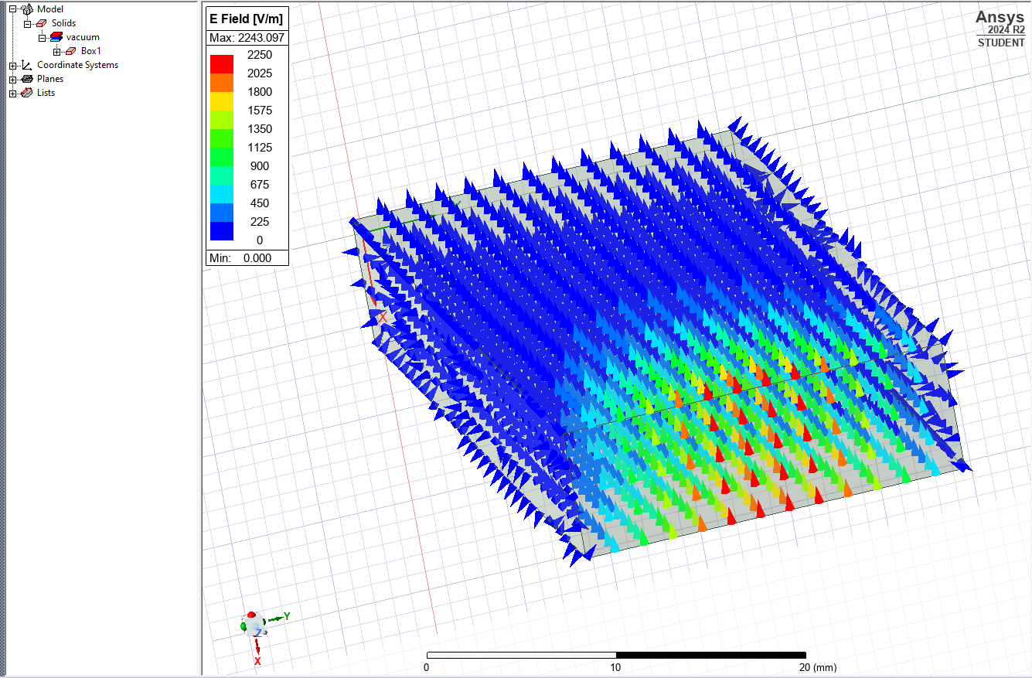
Figure 8- Port 1 Mode 1 Magnetic Field

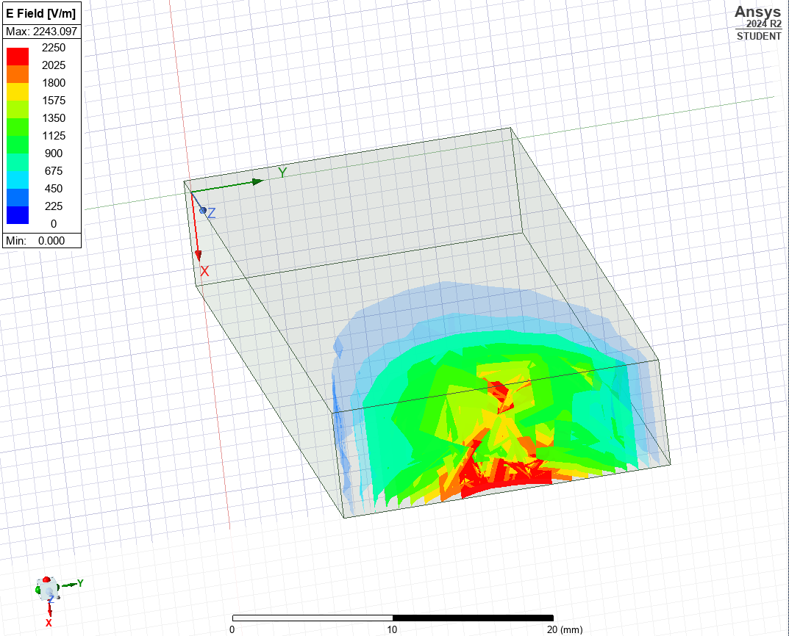
Figure 9- Port 1 Mode 2 Vector Electric Field

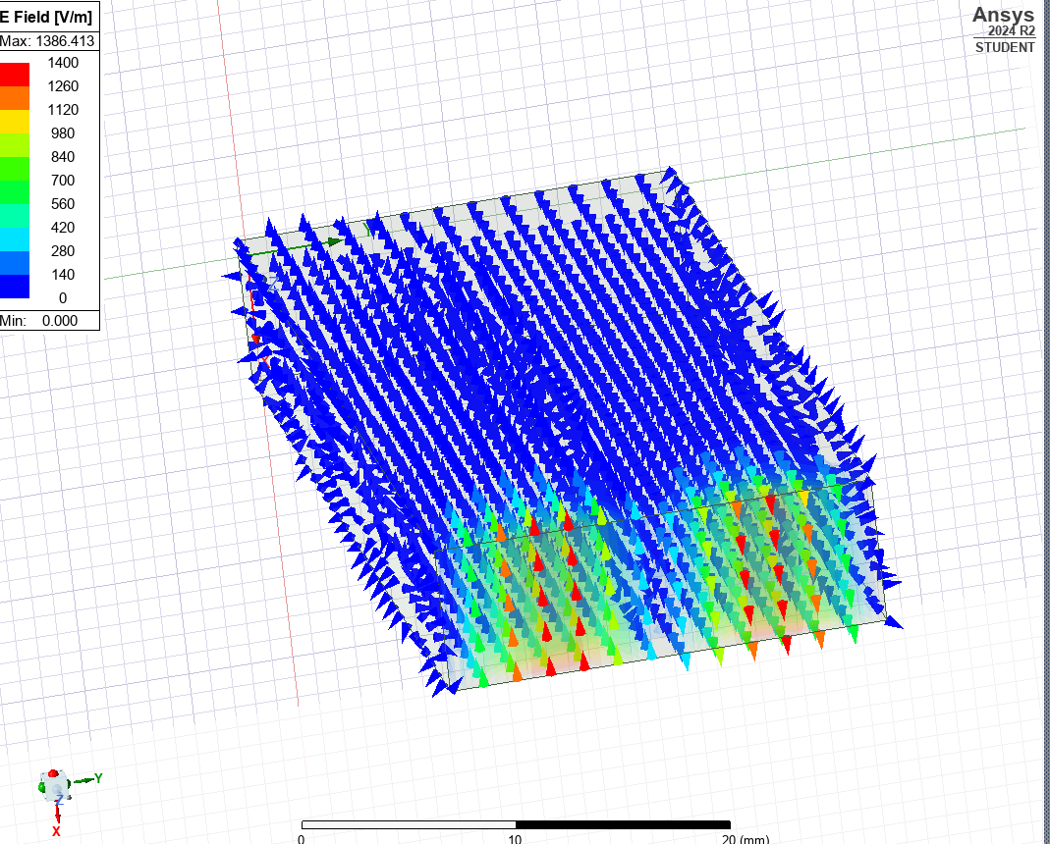
Figure 10- Port 1 Mode 2 Magnetic Field

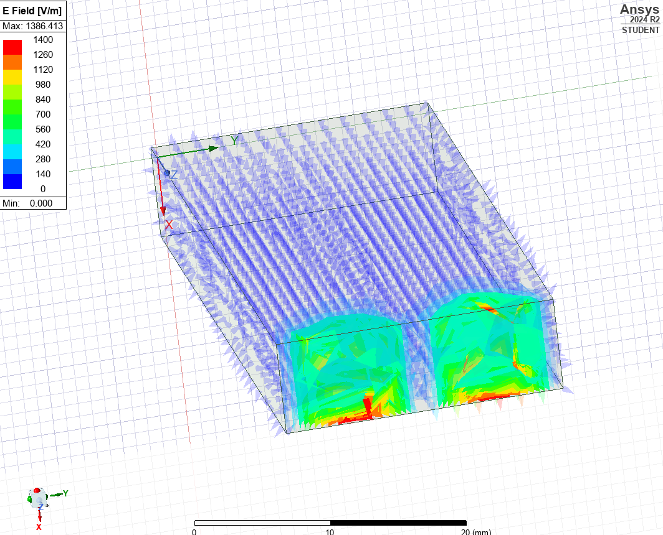
Figure 11- Port 1 Mode 2 Vector Electric Field

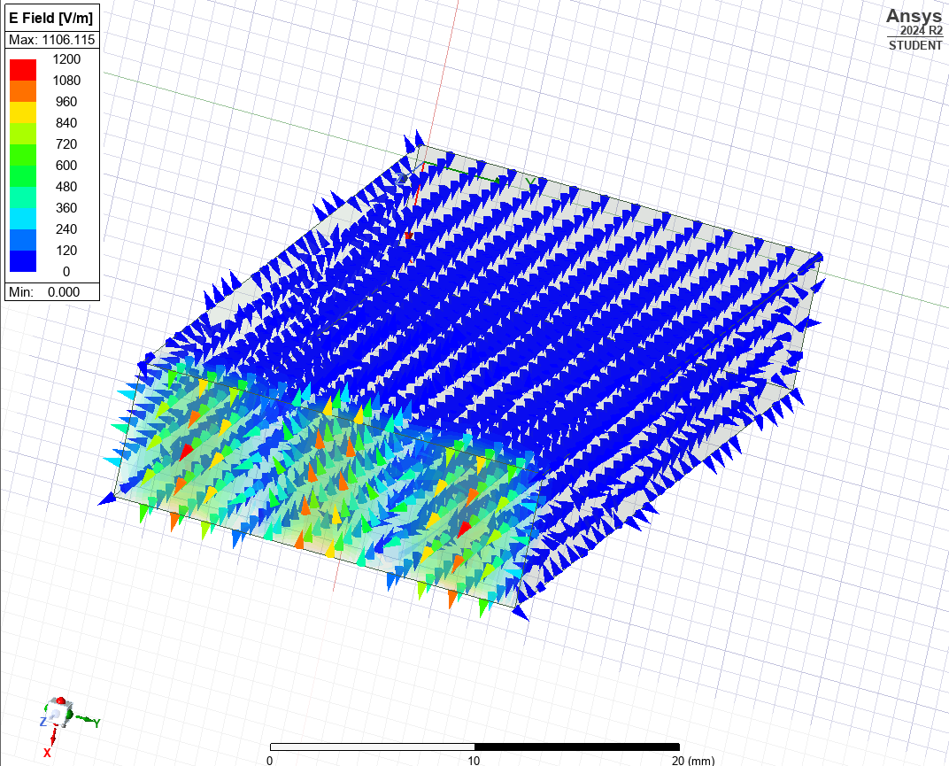
Figure 12- Port 1 Mode 3 Magnetic Field

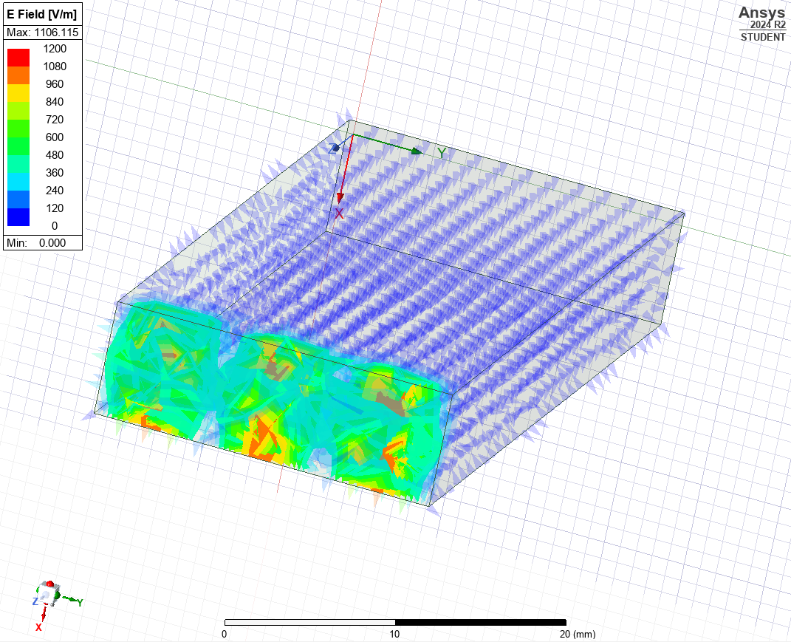
Figure 13- Port 1 Mode 3 Vector Field
Task 1: Calculations (Vacuum)
For Port 1 Mode 1 we can identify the theoretical cut off frequency using the formula explained previously, to be as follows:
$$fc=\frac{c}{2}\sqrt{(\frac{m}{a})^{2}+{(\frac{n}{b})}^{2}}$$

$$fc=\frac{{3x10}^{8}}{2}\sqrt{(\frac{1}{0.021})^{2}+{(\frac{0}{0.007})}^{2}}$$

Therefore:
$$fc=7.14Ghz$$
Mode | 1 | 2 | 3
Cut off Frequency $(fc)$ | $$7.14Ghz$$ | $$14.29GHz$$ | $$21.14GHz$$
- Calculations for additional modes can be found in appendix 1 & 2.

Task 1: Teflon
This design was created using the same Ansys software and represents a rectangular waveguide with PEC walls, however this model replaces vacuum with Teflon for simulation.

Port Fields:
The port fields for both vacuum and Teflon would not change direction or move as there is no disrupting factors.
Gamma Plot Display:
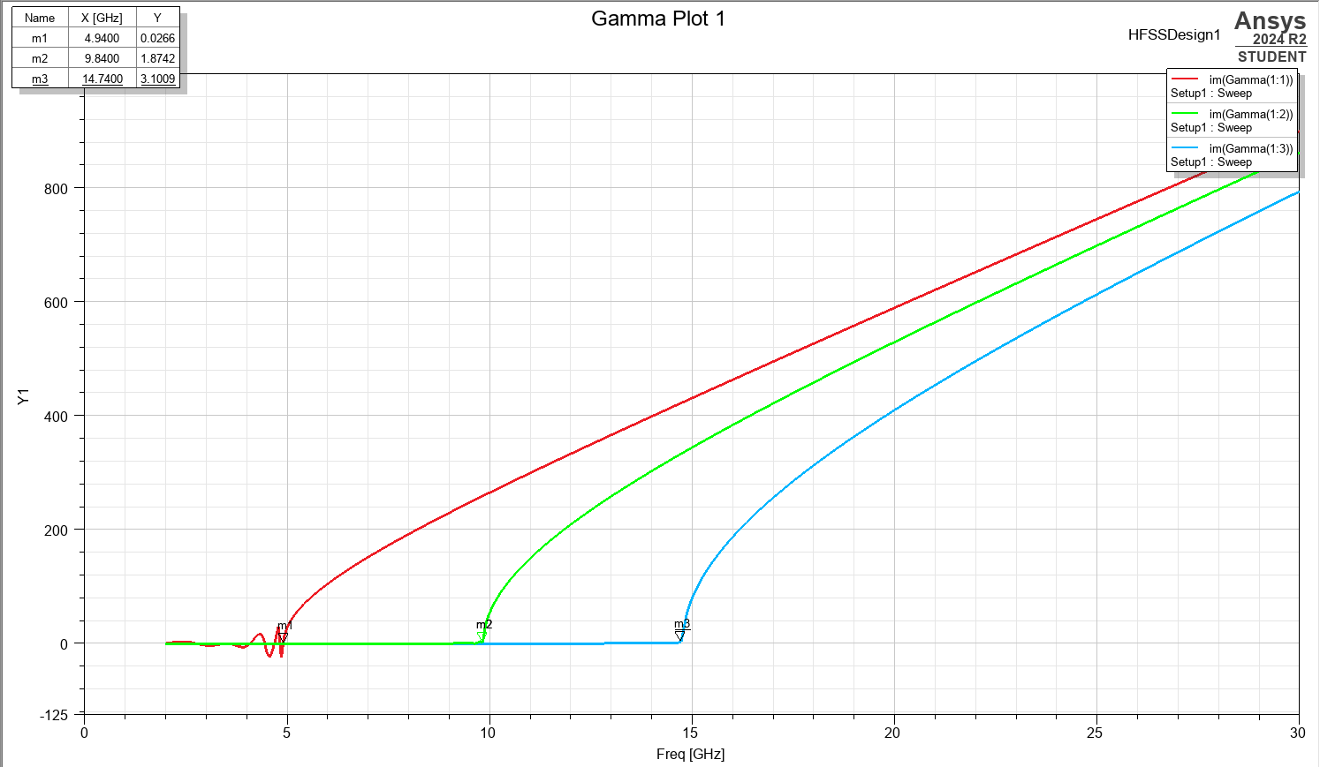
Figure 14- Gamma Plot Display (TEFLON)
Electric and Magnetic Field Vector Displays:
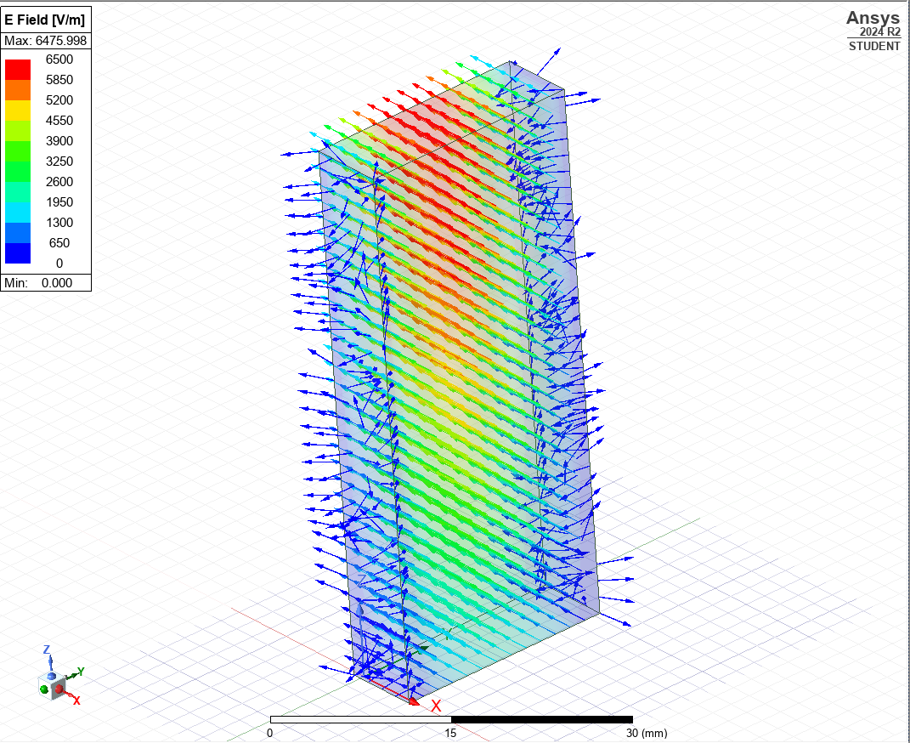
Figure 15- Port 1 Mode 1 Magnetic Field (TEFLON)

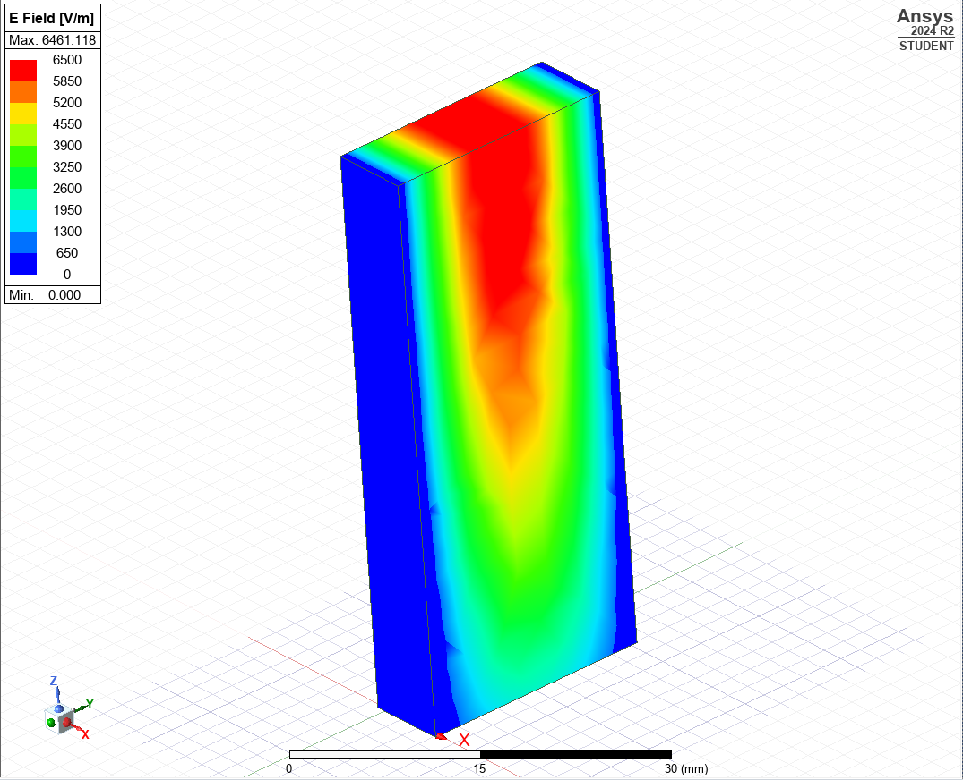
Figure 16- Port 1 Mode 1 Vector Electric Field (TEFLON)

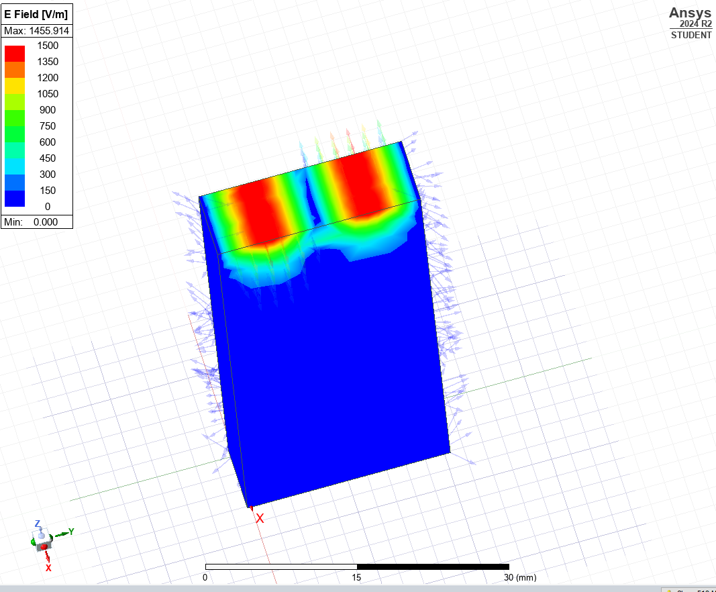
Figure 17- Port 1 Mode 2 Magnetic Field

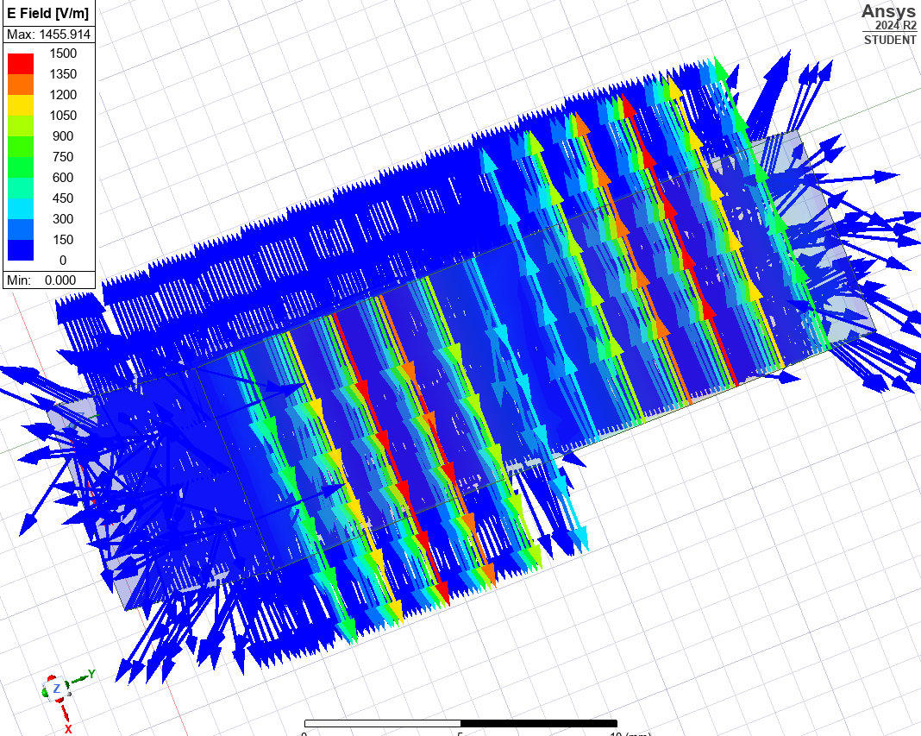
Figure 18- Port 1 Mode 2 Electric Field

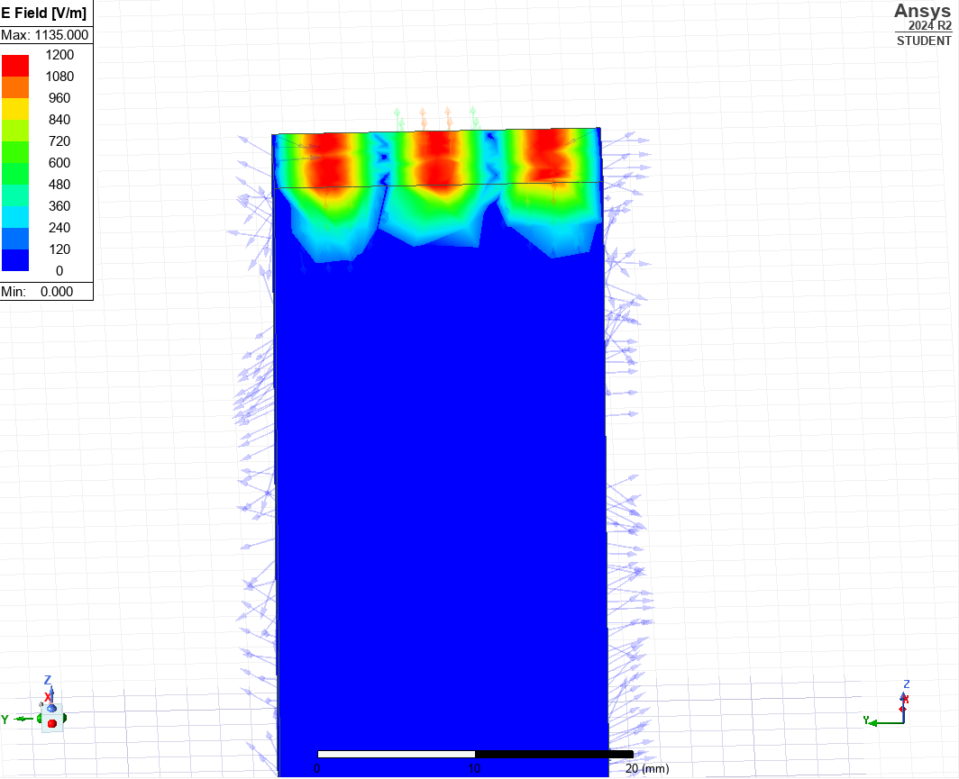
Figure 19- Port 1 Mode 3 Magnetic Field

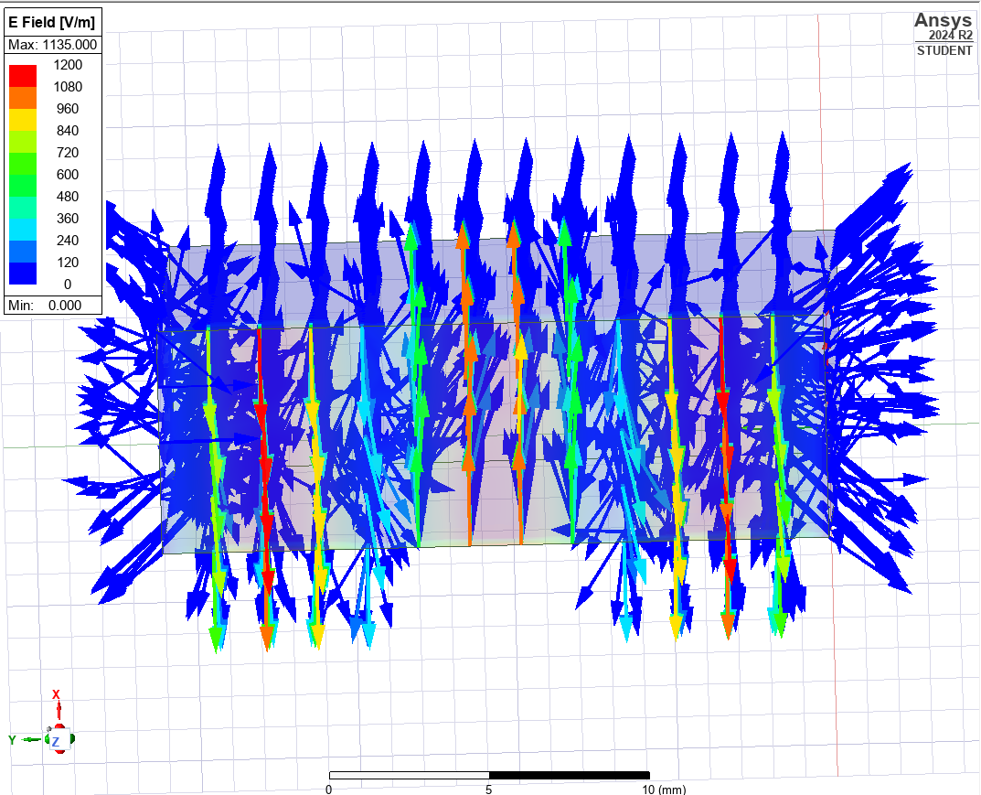
Figure 20- Port 1 Mode 3 Electric Field (TEFLON)

Task 1: Calculations (Teflon)
The cut-off frequency for the rectangular waveguide with a Teflon centre was then calculated. Similarly, to vacuum the same cut off frequency calculation will be used as before however the value of c will change as the light is moving through a different medium, this can be found by:
$$c= \frac{1}{\sqrt{εμ}}$$
Where:
c – velocity of light (multiplied by velocity of light in air)
ε – permittivity of the medium
µ - permeability of the medium
The permittivity of Teflon is 2.1 and the permeability is 1, so the velocity of light in Teflon can be calculated as:
$$c= \frac{1}{\sqrt{εμ}}$$
$$c= \frac{1}{\sqrt{2.1(1)}}$$
$$c=0.69 x {3x10}^{8}$$
$c= {2.07x10}^{8}$ m/s
So, the cut-off frequency for the waveguide in mode 1 can be calculated as:
$$f_{c}=\frac{c}{2}\sqrt{{(\frac{m}{a})}^{2}+({\frac{n}{b})}^{2}}$$

$$f_{c}=\frac{{2.07x10}^{8}}{2}\sqrt{{(\frac{1}{0.021})}^{2}+({\frac{0}{0.007})}^{2}}$$

Therefore:
$$f_{c}=4.93GHz$$

Mode | 1 | 2 | 3
Cut off Frequency $(fc)$ | $$4.93Ghz$$ | $$9.86GHz$$ | $$14.8GHz$$

- Calculations for additional modes can be found in appendix 3 & 4.

Task 2:
The model consists of a half-wavelength dipole antenna constructed using a Perfect Electric Conductor (PEC) material. Excitation is applied via a lumped port with a characteristic impedance of 50 Ω. The simulation is conducted in ANSYS HFSS, where the antenna's radiation characteristics are evaluated through far-field radiation pattern analysis. Additionally, the S-parameter (S11) plot is generated to identify the resonant frequency and assess impedance matching performance.

Dipole Antenna:
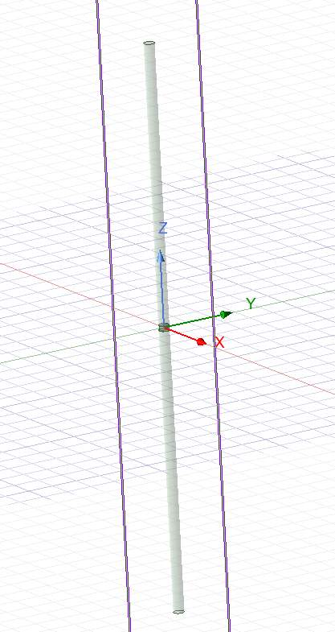
Figure 21- Dipole Antenna Model
S-Parameter Plot:
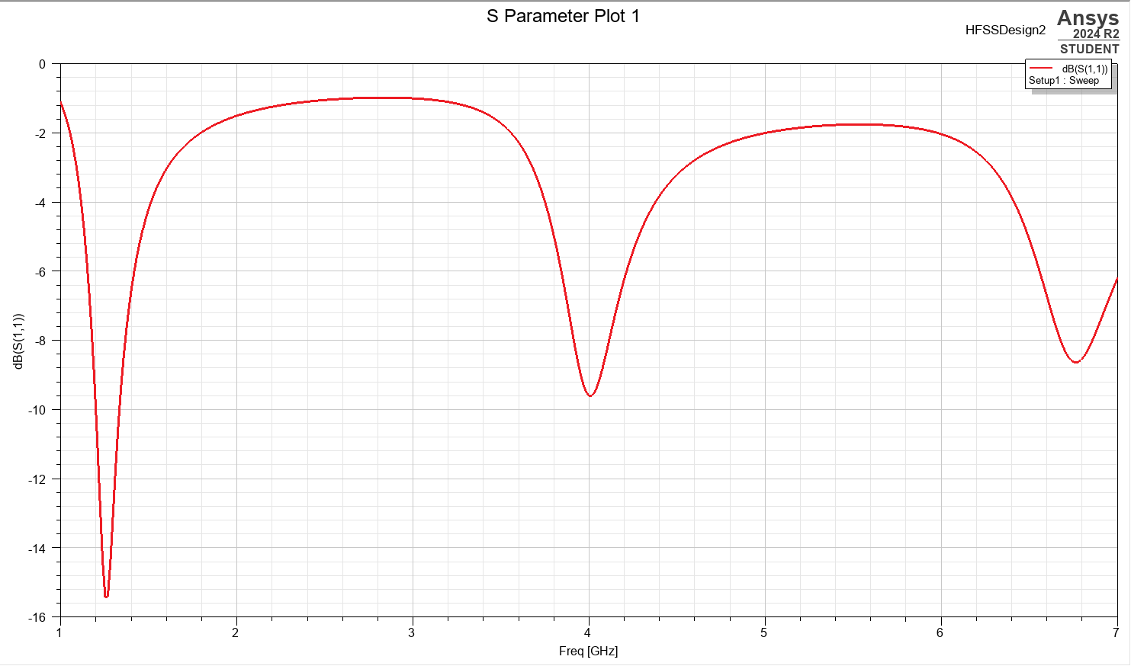
Figure 22- S-Parameter Plot

Omnidirectional Radiation Pattern:

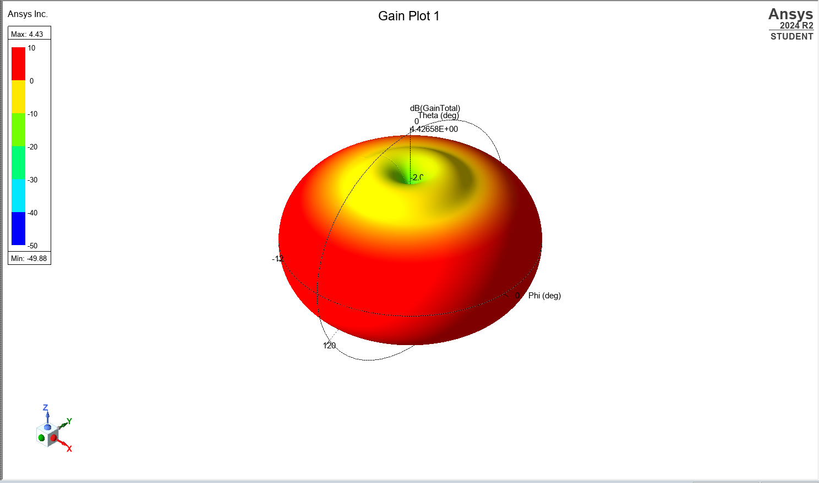
Figure 23- Omnidirectional Radiation Pattern
Task 2: Calculations
We can determine the antennas optimum operating length by the following calculation:
$$L=\frac{λ}{2}$$
Where:
L= Length (m)
$λ$= Wavelength (m)
Based on the wavelength of the dipole antenna being 211mm based on the university identification number we can determine the Length to be:
$$L=\frac{0.211}{2}$$

Therefore:
$$L=0.1055m$$

Furthermore, the operating frequency can also be calculated using the following formula:

$$f=\frac{c}{λ}$$

Where:
f = frequency (Hz)
c = velocity of light in medium (m/s)
λ = wavelength (m)
$$f=\frac{{3x10}^{8}}{0.211}$$

Therefore:
$$f=1.42GHz$$

- Discussion
Task 1: Vacuum
Theoretical Results
Mode | 1 | 2 | 3
Cut off Frequency $(fc)$ | $$7.14Ghz$$ | $$14.29GHz$$ | $$fc=21.39GHz$$

Practical Results
Mode | 1 | 2 | 3
Cut off Frequency $(fc)$ | $$7.11Ghz$$ | $$14.25GHz$$ | $$21.39GHz$$
Based on both the theoretical and practical results achieved it is clear to identify that the simulation has been successful, and the theoretical calculations have been submitted correctly. There is a slight difference in values however this can be down to the Ansys point selection tool as it can provide slight inaccuracies. However, these values would be considered appropriate and acceptable for design use in practice.
Task 1: Teflon

Theoretical Results
Mode | 1 | 2 | 3
Cut off Frequency $(fc)$ | $$4.93Ghz$$ | $$9.86GHz$$ | $$14.8GHz$$

Practical Results
Mode | 1 | 2 | 3
Cut off Frequency $(fc)$ | $$4.94Ghz$$ | $$9.84GHz$$ | $$14.74GHz$$

As previously described in the vacuum model the simulations in comparison to the theoretical results have similar values. In comparison to the vacuum, we see smaller values due to various factors such as the wavelength and difference in relative permittivity as explained previously.
Task 2:
Task two identified the dipole antenna and created the radiation pattern, almost apple shaped as explained previously. This is an omnidirectional wave patter and gives a good depiction into how the radiation would operate.
It was further identified that the optimum length for the dipole antenna was approximately $0.1055m$.
In comparing both the simulated s-parameter plot and circled in figure 22, compared to the theoretical value. They both result in the range of around 1.42GHz, again providing a valid simulation as it corresponds and is compatible with the values in theory.

6. Conclusion
For task one, there was enough data and analysis to determine what the dominant mode was in the simulation. TE10 values were identified for both vacuum and Teflon resulting in the lowest values found in the respective tables as this would be the lowest frequency required for wave guide propagation.
A successful dipole antenna was generated allowing for the identification and visualisation of the radiation patter shown in the for of an apple-shape in Ansys. There was enough data to calculate the optimum length of the dipole antenna and determine the operating frequency through calculation and software manipulation.

7.Appendices
Appendix 1:
Mode 2:

$$fc=\frac{{3x10}^{8}}{2}\sqrt{(\frac{2}{0.021})^{2}+{(\frac{0}{0.007})}^{2}}$$

$$fc=14.29GHz$$
Appendix 2:
Mode 3:
$$fc=\frac{{3x10}^{8}}{2}\sqrt{(\frac{3}{0.021})^{2}+{(\frac{0}{0.007})}^{2}}$$

$$fc=21.14GHz$$
Appendix 3:
Mode 2 (Teflon):
$$f_{c}=\frac{{2.07x10}^{8}}{2}\sqrt{{(\frac{2}{0.021})}^{2}+({\frac{0}{0.007})}^{2}}$$
$$f_{c}=9.86GHz$$

Appendix 4:
Mode 3 (Teflon):
$$f_{c}=\frac{{2.07x10}^{8}}{2}\sqrt{{(\frac{3}{0.021})}^{2}+({\frac{0}{0.007})}^{2}}$$
$$f_{c}=14.8GHz$$

8.References

[1] | J. Webb, “electromagnetic spectrum,” Britannica, 28 Mar 2025. [Online]. Available: https://www.britannica.com/science/light.
[2] | C. Singh, “Student understanding of symmetry and Gauss’s law of electricity,” American Journal of Physics, vol. 74, no. 10, pp. 923-936, 2006.
[3] | G. Poole, “Gauss’s Law for Magnetism & Law of Universal Magnetism: Calculate the Charge of a Monopole,” Journal of High Energy Physics, Gravitation and Cosmology, vol. 4, pp. 581-587, 2018.
[4] | S. E. Hill, “Reanalyzing the Ampere-Maxwell Law,” The Physics Teacher, University of Redlands, CA , 2011.
[5] | NASA, “The Effects of Earth's Upper Atmosphere on Radio Signals,” NASA, [Online]. Available: https://radiojove.gsfc.nasa.gov/education/activities/iono.html.
[6] | A. W. S. a. W. R. Young, “Modes of optical waveguides,” Journal of the Optical Society of America, vol. 68, no. 3, pp. 285-309, 1978.
[7] | M. Schwartz, “Lecture 18: Antennas and interference,” Harvard university, 2025.
[8] | Types of Antennas at the RF and Microwave Frequency, “Types of Antennas at the RF and Microwave Frequency,” Military + Aerospace Electronics, 15 Jan 2019. [Online]. Available: https://www.militaryaerospace.com/directory/blog/14059668/types-of-antennas-at-the-rf-and-microwave-frequency.
[9] | J. A. H. a. M. E. M. C. Barnes, “A FIELD GUIDE TO SIMPLE HF DIPOLES,” STANFORD RESEARCH INSTITUTE , 1969.

