Prifysgol Cymru
Y Drindod Dewi Sant
University of Wales
Trinity Saint David

Module Name: PROFESSIONAL CAREER DEVELOPMENT
Module Code: BMSW4005

Submitted By:
Student Name: ISATA MANSARAY
Student ID: 1816883

Date of Submission: 07/01/20

Professional Career Development

Table of Contents
Introduction: 4
Necessity of professional development 4
Process of career development plan in health and social care 4
Knowledge and skills to develop professionally 5
Strength and improvement area for professional development 6
Strategy for professional development: 7
Conclusion: 8
References 9

Introduction:
The professional development plan is the design and framework to develop the individual for performing in the specified sector with the best alternative way to achieve the organizational goals and success. Implementing the educational knowledge and training for increasing the skill as well as practising for gaining experience is also included in the professional development plan. An organization or person can take the initiative to develop the professional experience with following the training, matching the experience with monitoring and observation for covering the performance gap. In this report, I will describe the professional development of various strategy and process for individual and organization.

The necessity of professional development
The necessity of a professional development plan is needed to describe first and for that reason, I want to share an experience. As a social and health care employee, my mentor assigned me to a hospital where different patients are admitted with the different disease for treatment. The supervisor advised me to treat a patient who is involved with the drug and I have gone to the patient and talked with him. At a time I have understood that the case of this patient is serious due to his addiction and I was thinking about the treatment. At this moment another patient was getting senseless with the emergency condition and the supporting people of that patient was requesting me to help them. I was in a dilemma to decide due to the assigned time by my supervisors was declining. Finally, I have covered that situation with the assistance of my mentor's supporters and supervisors. After this situation, I have realized the importance of professional development and its interrelation to the profession and career. Knowledge, skill, experience as well as other personal skill like leadership and problem-solving skills are crucial to present me as a fit employee to health and social care sector (Livingston, 2012).

Process of the career development plan in health and social care
Developing professional experience is the first step to make an individual fit for performing a specific task like social and health care activities (Pease, 2009). Understanding the patient is the starting thing to assess the problem and way of solution, I think. From the above study, I have realized that communication and leadership skills are highly required to manage the people who are engaged with this sector and most of the people are patient comes from different culture and nature. For understanding them it is required to realize their psychology and communicate with active listening to their feeling and thinking about their-selves regarding their problem and provided service (Barto, et al., 2015). Convincing different people from a different culture with the different problem have to ensure with proper leadership and communication skills.
So, for developing professional career development it has to maintain some strategy and process to get a better outcome in this sector. I think education is the first step of this dev elopement process and with proper educational knowledge, it has to ensure the proper training and practice regarding social and health care. After that, understanding the situation is most essential to identify the actual problem to determine the solving factor. Listening to the patient and participants feedback and opinion to determine further service and activities is the nest task for making this process smoother. Communicating with expertise people to get effective direction and supervision to solve any problem have to ensure to provide better service to get professional success (Davis, et al., 2008). Then providing the required service to the people can ensure the effectiveness and can provide a better outcome. So, conducting the professional development process includes some personal qualification and skill like educational knowledge, leadership and communication skills as well as understanding, realizing and convincing skills are also highly related to professional career development plan and process regarding social and health care sector.

Knowledge and skills to develop professionally
In my opinion, some knowledge and skills are required to present me as a suitable employee for the social and health care sector. Communication, leadership, reading, writing, active listening and speaking skills, as well as critical problem solving and psychology understanding skills, can play a key role to make and build suitable employee (Supiano, 2013). From my experience, I can say convincing people is a prime skill to show the knowledge and to serve them for a particular requirement that comes from communication skill. Understanding the people's requirement, meeting their demands and getting their feedback is included in the communication skill where engagement between the service provider and receiver need ensure. Learning comes from communication and practice regarding any task like social and health care activities that can implement for further service. Then I want to say, professional career development is the combination of other educational skills like reading and writing with listening and speaking. To understand the feelings and feedback as well as opinion and advice, it is required to practice the active listening habit before speaking. Similarly, for expressing the quality and knowledge as well as experience, it is required to speaking clearly to understand easily. Then in health and social care sector, different ways are usually using for communication and operation where reading and writing skill are essential to transfer the relevant message and information and to understand that. Interpersonal skills are conducive to achieve professional development and to obtain career success (Shaw, et al., 2004).
Experience provided in the first part of this report, I want to say that decision making skill is the most required task to solve any problem promptly and effectively. For ensuring a good decision making skill, it is necessary to gather experience and for gathering experience, it is required to achieve relevant knowledge and practice the knowledge and qualification to build me as a good decision maker during any problem to get a better outcome. Then confusion in the career time or professional activities can hamper the attention and confidence to perform better. So for eliminating any confusion from the personal activities and performance, it has to ensure enough collection of knowledge and experience as well as qualification comparing with the duties and responsibilities.

Strength and improvement area for professional development
I have justified my strength and weakness for professional development and I have found some existing strength like gregariousness, perseverance and tolerance as well as adaptability capacity. I think that quality will assist me to cover the personal lacking regarding health and social care. With using the gregarious quality I can make good relationship with colleagues, subordinates, supervisors and experts to gain knowledge and advice to fit me to perform better to get a better outcome in this social and health care sector (Suresh, 2010). Then active working quality and interest in knowing quality also will provide me with assistance to identify the performance gap and suitable solution like skills and knowledge to fill up the gap. I think active working mind and capacity is conducive to provide better output and to present me as a perfect employee in the social and health care sector. After that, tolerating others is a vital quality of an individual to adapt with the relevant people of a sector and in have this quality. With using this quality, I can make a supporting relationship with the relevant people that can provide good assistance regarding performance and modification advice, personal skill gap and improvement as well as a communication strategy and process development (Redmond, 2010). And finally, that strong side will assist me to show as a perfect individual in the health and social care sector considering the skill, knowledge, quality and experience.
Some areas need to develop and from my experience, I want to say, as a newcomer in this social and health care sector I have to improve the people's management capacity as well as convincing quality. Because this sector is full of different people from different sector and they consist of different character and for this reason, their opinion, feelings, feedback and communication way are different from one another (Hartley, 2010). With combining such various characters people, it has to provide better service to get better feedback and outcome that can assist me to achieve the professional success and by this way organization also will be benefitted that will make the organization path towards success.

Strategy for professional development:
Though an individual like me can develop the professional skill and knowledge with maintaining the personal capability and job interest I think, every organization can play a vital role to develop the professional development plan where they can find out the performance gap of the employee and can take effective measurement for fulfilling the gap to get better outcome. The organization can maintain a good recruitment process where maintaining gob description and personal qualification will exist on the focus point. An employee who is interested to enter to the health and social care sector they have to obtain the required knowledge and skill before entering the job and it can ensure with getting proper training regarding the job description (Eraut, 2010). Organization need to clear the job duties and responsibilities to the employee to make them informed about the requirements of a particular job.
However, maintaining different employment rules and regulation, as well as policies of the organization, also included in the professional development plan which can ensure the proper rights and responsibilities regarding a job like social and health care programs. Different employment, equality and discrimination act can assist the individuals to concern about the employee code of conduct and consequence of several behaviours (Kadushin, 2014). In my opinion, the professional development plan needs to include awareness activities regarding employee rights and facilities that can motivate the employee to perform better with maintaining job security.
Hence, for professional career development, I have realized to develop some personal skills to build a career in the social and health care sector. Those skills include good communication with relevant people, tolerating subordinates and supervisors in the workplace, understanding the service receiver with listening to their feeling, opinions and feedback, expressing myself for delivering the knowledge, skill and quality belongs to me (Landsbergis, et al., 2014). After that developing and maintaining a good leadership skill to manage the people and convince them. Besides that skill, good reading and writing skills are also essential to this social and health care sector for communicating effectively that can assist to perform better to get good output.

Conclusion:
Considering the individual and organizational benefit, it is necessary to conduct the professional development plan that will include the skill and experience development of the individual to perform better to provide a good outcome. An individual who has different skills and good knowledge regarding the sector can easily achieve professional success with better performance. I think prover guidance, training, observation and monitoring as well as providing good professional advice is assistance for developing professional or career knowledge and experience. So, strengthening of the existing skills and improvement of the lacking skills are a good way of making an individual like me as a suitable person for the health and social care sector.

References
Barto, H., Lambert, S. and Brott, P., 2015. Career adaptability, resiliency and perceived obstacles to the career development of adolescent mothers. The Professional Counselor, 5(1), p.53.
Davis, R., Turner, E., Hicks, D. and Tipson, M., 2008. Developing an integrated career and competency framework for diabetes nursing. Journal of Clinical Nursing, 17(2), pp.168-174.
Eraut, M., 2010. Knowledge, working practices, and learning. Learning through practice (pp. 37-58). Springer, Dordrecht.
Hartley, J. and Benington, J., 2010. Leadership for healthcare. Policy Press.
Kadushin, A. and Harkness, D., 2014. Supervision in social work. Columbia University Press.
Landsbergis, P.A., Grzywacz, J.G. and LaMontagne, A.D., 2014. Work organization, job insecurity, and occupational health disparities. American journal of industrial medicine, 57(5), pp.495-515.
Livingston, K., 2012. Approaches to the professional development of teachers in Scotland: pedagogical innovation or financial necessity?. Educational Research, 54(2), pp.161-172.
Pease, N., 2009. Using action research to implement a career development framework in facilities. Journal of facilities management, 7(1), pp.24-35.
Redmond, C., Larkin, M. and Harrop, C., 2010. The personal meaning of romantic relationships for young people with psychosis. Clinical child psychology and psychiatry, 15(2), pp.151-170.
Shaw, J.R., Adams, C.L. and Bonnett, B.N., 2004. What can veterinarians learn from studies of physician-patient communication about veterinarian-client-patient communication? Journal of the American Veterinary Medical Association, 224(5), pp.676-684.
Supiano, K.P. and Berry, P.H., 2013. Developing interdisciplinary skills and professional confidence in palliative care social work students. Journal of Social Work Education, 49(3), pp.387-396.
Suresh, K.E., 2010. Communication Skills and Soft Skills: An Integrated Approach (With Cd). Pearson Education India.

Appendix
In class Activities
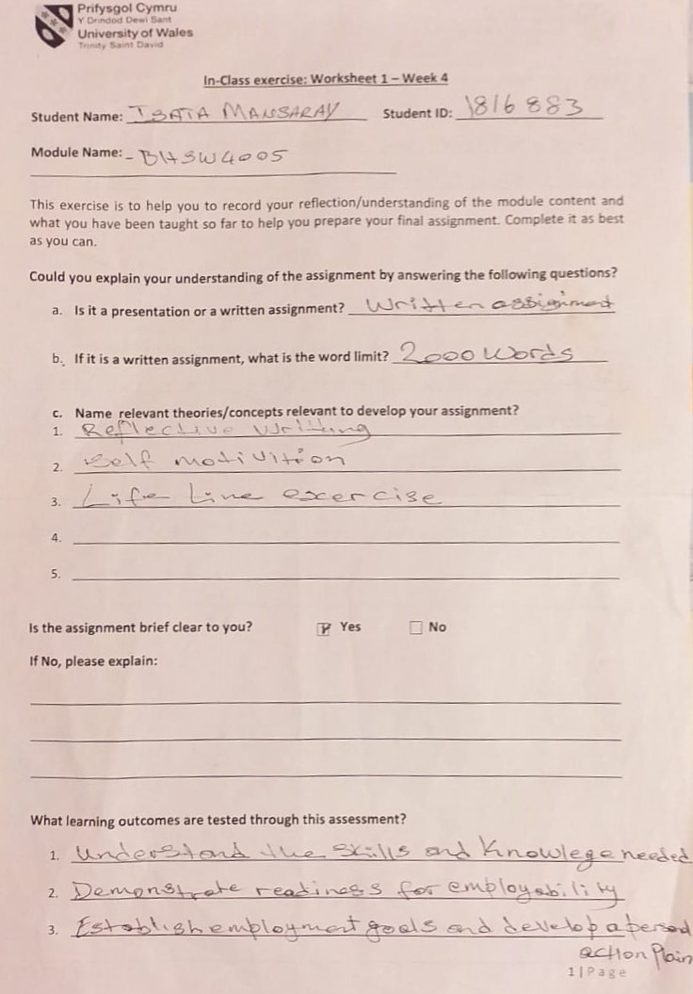
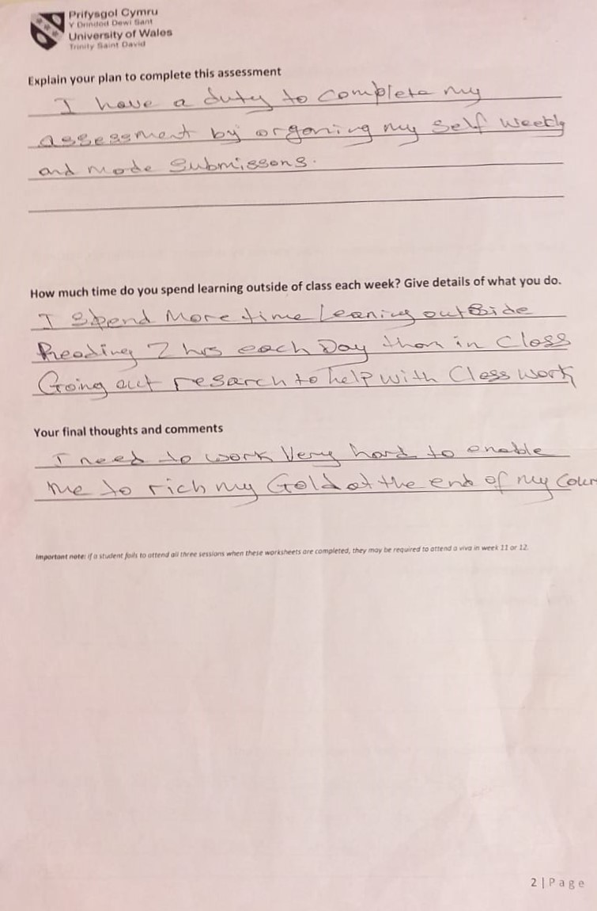

Role Play Slides


