Report
Student: Rhys Carter
Date: 26/04/2023
Project Title: Independent Project (SOAC)



SOAC Independent Project
By Rhys Carter

Supervisor: Philip Organ

Project submitted as a requirement for Bachelor of Arts Programme Computer Animation

26/04/2023

Declaration
The work on this report is under the supervision of Philip Organ and Nabeel Masih. I declare that this report is the product of my own work and is not being submitted to any other degree etc.

Signed Rhys Carter

Acknowledgment
I would like to thank the teaching staff of University of Wales Trinity Saint David for assistance during the duration of this production.

Abstract
This report is written for my animation project and will feature the progress used from the beginning of the project all the way to the end of the project with all the parts that I have done between that. This project started with identifying what my story should be based on, so I researched and took ideas from other media to come up with a basic story then refined with re writes to make a story that makes sense. This report will also discuss the research and the reviews of my works and others during the early part of the progress and also review my previous animation projects to see what I can take form it of my final animation project and how I can improve it along with gaining more knowledge and methods for the programs I used to make the best animation that I can.
This report will also go over the creation progress when the plan is set in stone and the report will go over what I was doing during that time, and it will also include the issues I ran into and what I did about them and what this meant to the final project. I will also be going over my early designs and how they evolved into the final project with the final character, ship and set designs and I will also discuss the changes that happened with these and how they have evolved through the project progress. I will also be discussing the software packages that I will be using in my animation project and the features that they have that allows me to make this animation as my vision imagined. These programs are MAYA for the creation of the models and sets itself and also the animation progress itself along with the rendering of the animation sequence and then the other program that I have used is Adobe Premiere Pro of connecting all the rendered images from MAYA into a sequence that’s in order to make a sequence of images into an animation. This program will also allow me to add the needed sound to complete the animation with the sound effects to complement the story. I also used the effects provided by Adobe Premiere Pro to complete the vision and smooth out the sequence with screens to connect the different scenes and the addition of a title and also and end card to complete the animation video. In addition to this the effects can be used to enhance the scenes like, for example, smoke for the ship and the addition of sparks to push the condition of the ship with effects. I will also discuss help I had through out the progress of this project and any changes that I made throughout this project and why I decided to do this because I believed that it would improve the final project.
This report will end with discussion on evaluation of the full project and what I believe was accomplished throughout this entire animation project and what I think went well and what I would like to improve on in future work.

Contents
Introduction 7
Research 9
Methodology/ Project Work 10
Results 14
Conclusion/ Evaluation 15
Further Work 16
Bibliography 17
Appendices 18

Introduction
The animation where this report is based on is my sci-fi comedy chase. This animation is based on a robot pirate on the run from the authorities and while on the run he ends up at a ship salvage site with old ships ready to be broken up. With the ability of escape in front of him he enters the site and goes into an open ship that has not been broken up yet and uses it to escape the authorities but taking off and going through a vortex to leave the area. However, the ship is not exactly in good condition and it starts ripping apart along the journey through the vortex it the escape trip get more difficult and unpredictable through the journey until he only just reaches the other side of the vortex that the ship finally breaks apart and crashes back down to the ground where after a nasty crash he thinks that he has escaped until the authorities present them self to him to show he failed his escape.
Some work that I looked at for reference is the work of Roger Aller’s in the form of his re production concepts for the movie Tron (1982) which I took some inspiration from. (R
Another piece of work that I look at that has relevance to my project is the work of Joe Johnston, primary for his work on the designs or the first Star Wars film for inspiration for my ship design.
I decided to look into other media that is related to the story and/ or the themes that I am going for with the story that I want to do. For this I decided to investigate into the animation industry to see what has been done in this style of storytelling and style before and draw inspiration from that and bring new ideas into my animation that follows previous work done in animation. The theme that my animation is in is based on the Cyber punk them with bright colours in the futuristic setting which I thought best fit the story that I am attempting to tell and allows me the style the backgrounds, characters, and ships within the theme.
In my previous work in animation my main methods that I used was basic models and sets to tell the story that was needed which was mostly just displays of basics movements of the models to simulate movement and therefore animation. This time I have to make lots of detailed models in the form of bespoke characters that the story is based upon, sets where the story is based and effects to make the animation feel like there is more going on in the story while also giving it a new flare that I have not done before.
In my previous works I’ve had many different things that I wanted to include in the animation. One example is effects. I have not yet in a piece of animation work done effects in the animation, not in the animation project itself or the editing software after it so that is something that I am adding to the animation to give it more sceptical and to add to the story itself.
Another addition that I have not done in an animation yet is to do a multiple camera set up to get different viewpoints on the animation in action and that is something I plan to add to the animation project to make it more interesting to look at and will allow me to more easily show important parts of the animation at a given time like a close up to and important scene in the cockpit or the character itself or a wide view to show the whole set.
I also plan to learn how to use a dolly camera so I can follow the ship during the animation which I have not yet used in a precious piece of animation work, and I plan to use it in this one to not only give a scene of speed but also movement.

There are many different methods I could use on improving the results of my previous productions and the works in them. One method I could use to figure out a previous issue is to look up official documents provided by the software company itself on methods to do certain parts that I need to of the animation. An example of this that I did was looking into how to apply textures to certain parts of a objects which I needed to make a windscreen for my spaceship, so I only wanted the front panel to be transparent and sideshow be the same as the rest of the ship. Another example of myself using this method in my animation was to create the damaged panels that appear on the ship throughout the animation, and this allows certain parts of the ship to be connected to the ship but not sharing the same textures.
Another method that I use to improve on issues that I have had in my previous animations is tutorial videos on the official site for the software that I am using and other users of the programs on video sites such as YouTube. An example of this improving the outcome of a part of the animation that in previous pieces of animated and modelling work is learning techniques on creating ships and other models for the animation like backgrounds, sets and all the objects inside them. One method that I learnt from videos is how to make lights from any objects. This allowed me to add lights to the sets and the objects like the spaceship which not only lights up the scenes, but it adds to the objects like headlights for the ship and flashing red and blue lights for the authorities which is used within the animation for the story.
These methods that I learnt was mostly for helping me understand the programs I was using more the best methods to get my thoughts and ideas of what should be in the animation and getting it into a 3D object that I can use. This is important because before this my previous animation works used mostly basic objects or pre done models by other people downloaded from an internet site for sets and objects and also models and rigged models that could be posed to then use in my animations but now after watching and reading about using MAYA and other programs I felt more confident to create my models for my animation myself as a fully bespoke project.
While doing this project I have come upon different theories that relate to the theme of my animation and some of them has piqued my interest. For example, the theories of robots becoming more human like and also mimicking what humans do is used in my animation project, so I used the theory of Artificial intelligence in the form of a pirate robot on the run as the main character this animation focuses on. Another popular theory I used in this animation was how the use of space debris could affect the future in the form of issues in space and also on earth. Because of the debris it causes collisions with other pieces of debris like satellites and also spaceships and stations and the more we send up to more chance of it happening, so I used this this in my animation project as the method that is used to rip apart the ship in the travel sequence, so it breaks apart.

Research
To research this I looked at media that has something in common with what I plan to do for this project and my main inspirations was the movie Tron (1982) for its bight futuristic designs, Star Wars, Star Trek and Red Dwarf for it ship designs and also there worlds and also some real life inspirations like real world space ships and robots along with places that fit in to my story like construction zones and equipment along.
I also researched into MAYA (King, 2019) and look into learning materials. (Watkins, 2012) and looked into ways that I’m going to edit this video (Kolb, 2004) and how best to use the features in them. (Jordan, 2012)

Methodology/ Project Work

When I started this project, I began by experimenting.
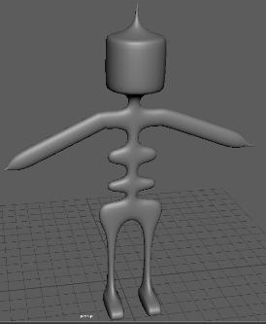
When I started development on this animation project, I started by making a basic character model as a test. As I have decided to make a robot pirate as my main character in my story, I made a basic 3D model by making experimental shapes and using new methods while creating it. This allowed me to try out some styles and also allowed me to work out good sizes and scales for the characters whining a world.
Using this time try out the programs that I will be using for this I plan to use the knowledge gained to create the models and sets for my animation project.

However, during the times when I am creating the animation, I ran into some problems in my production stage of my animation production. (O'Hailey, 2018)
The first issue I ran into was the programs that I was using not working correctly and crashing while I was working on the project, and this caused many issues as I kept losing work that has taken hours and it was slowing down my production pipeline. Originally my plan fix to it was to have autosave on my files to not lose progress when the program crashes but having to boot up the program every few new objects created. Because of this I decided to make new program files as a sub file for the main one where the animation is done, and the sub files had all the objects in the files. I order these by what the part of the animation it was. So, for example, I had one file for the spaceship, one for the objects in the file and one of my robot pirate characters and this allowed me not to fill up one project file with the history of all these parts of it in it. This reduced the crashes while I am working and had less history on the main project, and it also allowed me to have organisation like, for example, keeping all the components of the ship in the same place.
Another issue that came up in my animation project was when was attempting to rig my robot character. Before this I have not rigged myself my own bespoke model as I have always download a already rigged model from an internet model site so I was new the world of rigging so I made a robot pirate test design and decided to give it a go.
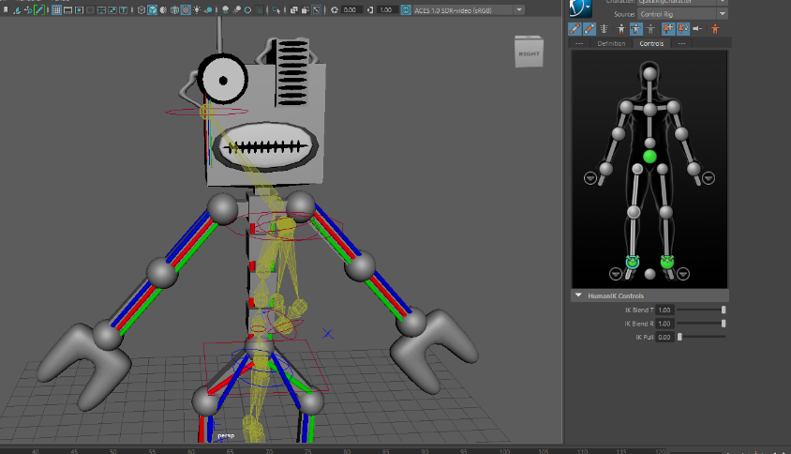
At first, I tried the auto rig feature that is provided by MAYA but ran into some issues because it would not do the correct joints and it didn’t correlate with the robot itself. I tried this method a few times, but the results didn’t change.
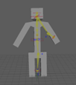
I also tried with a very basic model, but the program couldn’t figure out where the joints and the connection should be.
After this I decided to attempt to rig the model itself, but I still ran into problems. The big problem I had was I could successfully set the joints and connections for the legs but when I click off it and move onto the upper body the program would lock the model and when I tried to reopen it would crash the program. I tried this multiple times and would get the same results. After a while I realized that I was wasting time try to do this and reluctantly decided to not have a rigged model in the animation and changed the plans of the animation and how it was shot to hide this issue from the viewer.
In this animation project I used many different programs to create the final project for the different parts of the project. From the beginning to the end, I used many programs that allowed me to plan, create and edit the animation project.
The main software package that I used MAYA (Anon., 2018) and I used that to create models for my character and the sets around him. MAYA is a software package that has the ability to not only model but also animate them to create animations. It also has the capability to have sets created in them with lighting and set dressing which allows most of what I needed for an animation to be done in this program which reduces the chance of issues transferring files into MAYA from other programs as it has many capabilities to complete the whole sequence. This program also allows a more technical side to the animation progress with the ability to set up scenes with different lighting methods that allows more complex shots with brightness of the scenes and also reflections and also the ARNOLD attachment to have more lighting options along with render options. I also had great use of the camera in MAYA and the many ways to use it from the classic still and the dolly cameras and the follow cameras. Another good feature of the cameras in MAYA is that it allows multiple cameras to be used at the same time and they can have all the shots rendered which allows the use of different camera angles to be used in the editing of the sequence into the final animation.
Another program that I used in my animation project Adobe Premiere Pro as my editing software to connected up my rendered images and also add the sound to the project and additional effects to complete the animation. A very useful feature in this software package is the ability to drag an file full of images into the program and it will automatically put it in the sequence and if the files are numbered they will be put in that order in the sequence which save time and risk of messing up the order of the sequence as it is already done. This program also has many features to add additional effects to the video through the use of sequences to connect sections of the videos and effects to put on top of the video to add additional, effects. The program also allows many different methods to export the video which is useful to make sure it can work on many different video formats.
A technique I used in this animation project was how I used audio in the animation and also additional techniques in the form of additional visual features that was done in the editing section.
Throughout the progress I made many changes and to start off I will start with the changes to the story.
The first draft of the story included a story about a rescue mission of a lost traveller in the world of the internet with a test ship that throws up some issues for the journey and I started this project with that story in mind but the more that I worked on it the more issues I came up with it and new ideas that felt better in not only the narrative but a different mood being pushed through the story because the first drafts story played out more like an serios drama but throughout I started to want a more comedic animation so the story started to change to accomplish this. The second draft was similar to the first draft, but it was turned into a comedy animation with the trip being more comedic with things going wrong on the trip. The final draft started when I was begun to make the models for the animation as the robot design, I started only had one eye while the other side was a panel and when I was looking at him, I began to see him a pirate which made me think of a reason to have him have this characterization in the story. To get this aspect of the character to make sense in the story I did some re-writes to the project as a whole. To start off with I changed the story of the animation to a convict, the robot pirate, escaping from the law though the use of an old crane ship from a scrapyard. This change completely changed the tone to a comedy with calamities through the animation, from start to end.
Additional parts of the animation that has changed was the ship itself. In the first draft of the story the ship was a clean and sleek ship and then because of the previously mentioned story changes and its changes, the ship changed as well into more of a junkier, utility ship to fix the context it was now in a scrap yard. This changed also allowed more interesting destruction of the ship scenes in the travel aspect as the crane claw allowed more methods of ripping the ship apart.
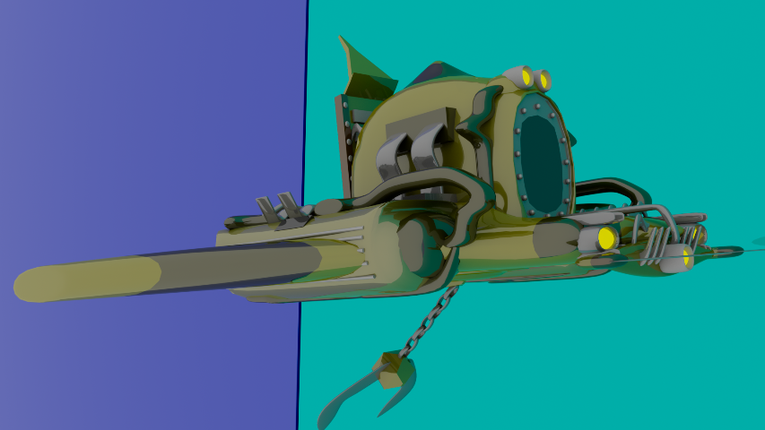
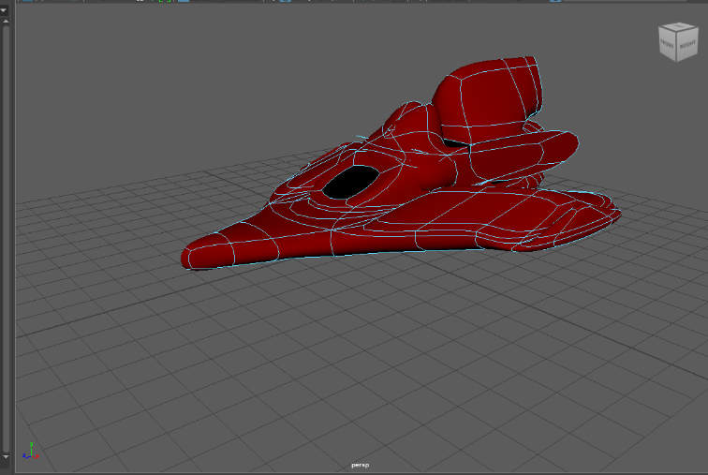

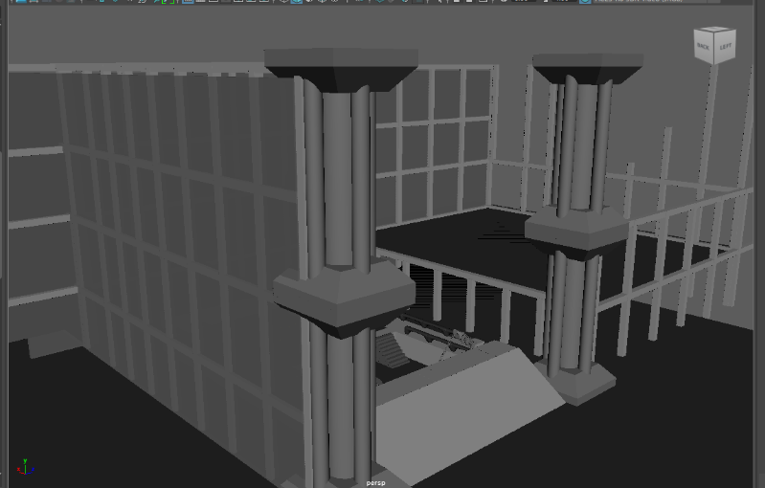
Another change caused by the previous changes was the setting. In the original draft it was a squeaky-clean laboratory that the vortex went through but because of prior changes it is setting was changed to a scrap yard and that’s where the ship launch from and where the vortex is.
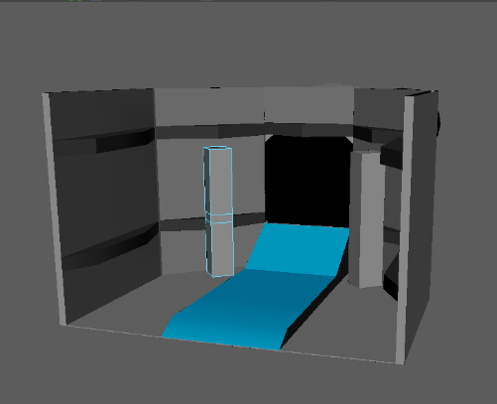
A big turning point in this production of this animation project was produced by some internal support in the form of my lecturer when we talked about the plot and how messy is was becoming and how much work would need to go into it and his suggestions and guidance help the animation become a more smaller scale and attainable project with a more simpler story that lead to the more examples of animation techniques.
I have many methods on generating ideas to use in my work but my main one is the media that I have watched and read about spurring my own ideas which leads to the realisation of usable ideas like themes, set design and story beats which I then evaluate through test them out and then see if it works by self-evaluation and getting peers to give me feedback on it to see if I should carry on work on it for the final project.
Another way I generate ideas is just messing around in, for example, MAYA by just placing things around which gives me ideas as I go along to add to it and what it should be and how I can incorporate it into the project.

Results
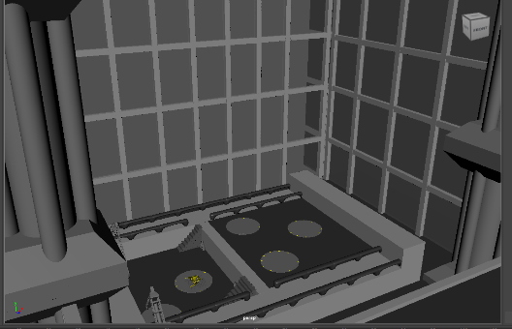
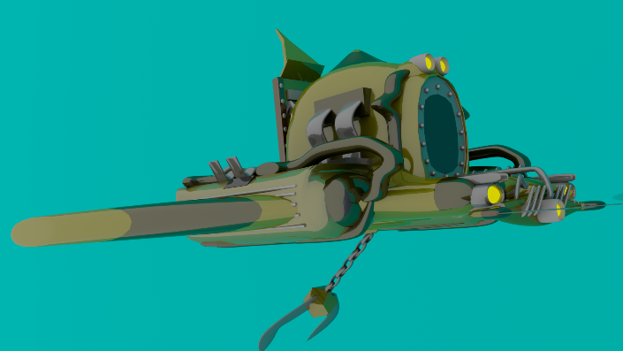

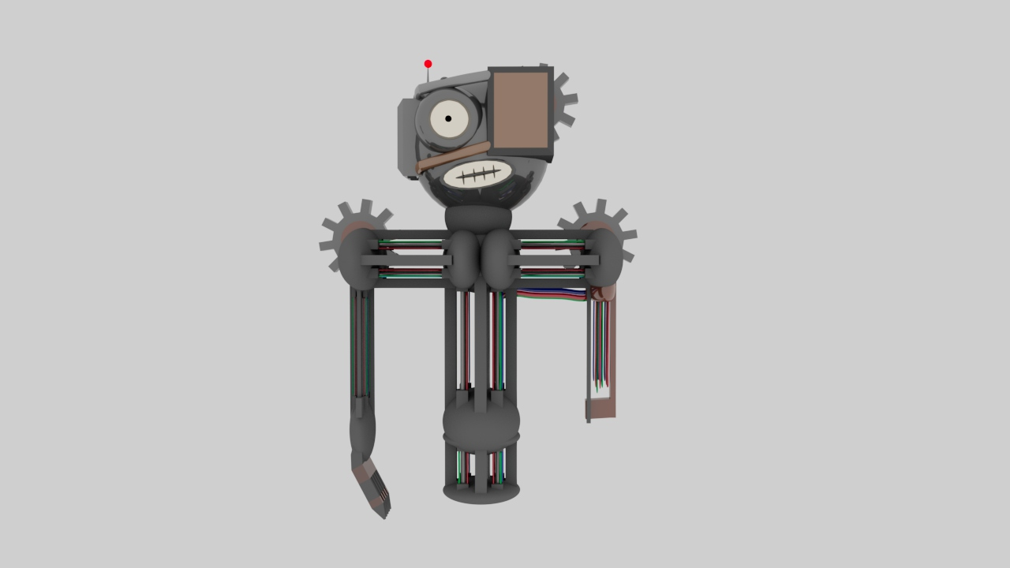

Conclusion/ Evaluation
In conclusion this project has opened my eyes to how much goes into the simplest of productions, from the basic sketches and then to the research to creating the animation itself and then how to capture what I want and putting it in to a video format, visible to all. This project has taught me how important all parts of the production is to make sure the final project is the best it can be.
I have learnt a lot from doing this project and have learnt many new skills from learning techniques for programs to learning ways to improve not only my designs but also my story telling.

Further Work
I hope in future to hack another go at this sort of theme, a sci-fi comedy but this time with the new skills I have learnt from this project to see if I can make it even better with more experience under my belt.

Bibliography
Anon., 2018. 3D Animation: MAYA or Blender. 3D Animation: MAYA or Blender, p. 1.
Jordan, L., 2012. Adobe Premiere Pro Power Tips. New York: Routledge.
King, R., 2019. 3D Animation for the Raw Beginner Using Autodesk Maya 2e. New York: Chapman and Hall/CRC.
Kolb, T., 2004. Focal Easy Guide to Premiere Pro. New York: Routledge.
O'Hailey, T., 2018. Rig it Right! Maya Animation Rigging Concepts, 2nd edition. New York: Routledge.
Watkins, A., 2012. Getting Started in 3D with Maya. New York: Routledge.

Appendices

MAYA - https://www.autodesk.co.uk/
Adobe Premiere Pro - https://www.adobe.com/uk/products/premiere.html
Playlist Of Help Videos - https://www.youtube.com/playlist?list=PLDkBE2u7ABeCf0tCmL4HmoW1F8Qv6q0w_

