ACADEMIC AND EMPLOYABILITY SKILLS
Wahidur Rahman
Student ID
1908557
Executive summary
This report has aims to evaluate a critical analysis over the topic of academic and employability skill and the importance of employability skills. Thus this assignment has effectively evaluated the importance of employability skills. In the current market there are various requirements which led the employability skills in to changes. Mover various changes are enhancing in the segment of employability skills. In the current market employability skills becomes a decisive factor as while recruiting an individual. The judgment of employability skills will be a decisive factor for their selection. Moreover this report has highlighted the main cause of cause of such changes and how these changes are affecting the importance of current employability skills. Thus it may be concluded this report has successfully highlighted the importance of employability skills.
Table of contents

Introduction 4
Importance of employability skills 4
How the employability skill has changed in the last 5 years 6
Rationale 8
6 employability skills that are the same as a decade ago 9
Cause of this change 10
Justification against the importance of employability skills 11
Employability skills that an employee should possess in current employment 12
Conclusions 14
Reference list 15
Appendices 17
Appendix 1: The Changing Trend of Employment Criteria 17
Appendix 2: Rate of Temporary Employment in Various Countries 18
Appendix 3: Employbility Rate in UK 19

Introduction
The labor market is intensely competitive and the employees are looking for a flexible person who possesses the ability to adapt to the current trend of work in different environments which matters employability skills. In the current market employability skills becomes a decisive factor as while recruiting an individual. The judgment of employability skills will be a decisive factor for their selection. There are some certain segments where these skills are judged as the paramount to judge the employees. Moreover, the trend of the criteria of these skills is getting changed with time as per requirements. The changes and the root behind these changes are going to be developed in this report.

Importance of employability skills
Employability skills is a transferable skill that needed by an individual in order to make them employable. It also includes a number of skills like communication, adaptability, collaboration and more. These skills hold a very important place in the segment of any organization as the efficiency of employees leads an organization towards success. There are various importances which are involved with the skills of employability such as:
Remaining competitive
The employability skills masquerade as an indicator of performance for the employees. As the employability skills serve as cognitive factors which indicate the efficiency of an individual. Thus the future potentially could be judged by the help of the skilled efficiency (Suleman, 2016). Even these skills also help to stay competitive with the market trend. The efficiency of an individual to learn will be remaining till long thus the ability to learn new things will be unchanged.
Achieving goals
In the competitive segment, every company is looking for efficient employees as capable and efficient employees are the strength of an organization. Thus it will increase the scopes to get a good position in an organization increasing the overall prefer ability. Thus it will help an individual to get the objective along with an employee who is enriched with good employability skills to achieve the company’s desired goals.
Engaging with various experiences
The employability is concerned with various skills which lead an individual to experience a lot about the workplace culture or the competitive market (Graban, 2018). Thus these skills will help to get various kinds of experiences like the communication skills will help to gain the knowledge that how to reduce the conflicts.
Increasing ability of adaptation
The ability of adaptation developed in the current competitive market will be easy for employee survival. Even every company in the competitive market segment is looking for employees who hold the skill of adaptation. An individual with the essence of adaptability will help an organization to adapt to the current trend to get a stable position in the market abode.
Improvement of attribute
An employee who is highly profound in these skills will lead an organization towards success as fast as possible. Thus it is one of the most important segments for the employability. The attribute of an organization could be changed by the approach of an employee towards an organization (Suleman, 2016). Thus the success of an organization potentially depends on the attribute of an employee’s skills.
Therefore from the above discussion, the importance of employability skills and the potential advantages of these skills also have been effectively discussed in this report. Most significantly it is important to enhance success in an organization.

Figure 1: Importance of Employability Skills
(Source: influenced by Graban, 2018)

How the employability skill has changed in the last 5 years
The employability skills are getting changed with the duration of time as the previous generation has a very simple remedy to get success. Moreover, in the current market, the way of achieving success got changed. Previously the corporate sectors used to choose a profession acquired fundamental knowledge and they believed that slowly the employees will gain knowledge by working in the field. However, in the current market, the corporate sectors used to choose those employees who are also ready very knowledgeable about the field.
In the last five decades, the market of labor has constantly changing whereby the industrial segment is restructuring significantly. There are some trends which have been broadly changed with the current trend of employability and the changes are going to be developed in the segment below,
Self-employment, in the UK, the rate of self-employment has been increased even it becomes one of the most current trends in the segment of employability.
Part-time working, in many organizations along with the trend of recruiting full-time employees, is getting changed (Graban, 2018). The changing trend of shifting can be observed in a broader way in the current corporate levels. Many institutes offer employees to work in part-time basis jobs. Moreover, organizations are adopting this trend in order to increase productivity and generate more profitability.
Contractors, the scope of getting employment direct is now becoming narrow because of enhancement of third parties by the name of consultants. Many firms are getting connected with consultants in order to gain a better option to choose employees. This particular thing leads every many employees to shirt their own business of self-employed contract.
Temporary employment, the scopes of find stability in a position in particular employees is also changed. Moreover, since 2009 the rate of recruiting employees as casual decreases the opportunity to get stability in one position (ilo.org, 2019). Even the increasing rate of employees provides the firms with an opportunity to choose the best employee among the vast area of criteria.
Flextime time arrangement, previously employees generally works for a particular duration of timing for any organization. Moreover, nowadays firms are implemented for various duration times in order to create double productivity along with multiplication of overall productivity.
Reduction of full-time employment, if a particular firm involved with an employee for the long term then the opportunity to get the best opportunity will degenerate. As the market trend is changing thus the skill requirements in an employee is also getting changed.

Figure 2: How the employability skill has changed in the last 5 years
(Source: influenced by ilo.org, 2019)

Rationale
The changing trend of employability has been broadly discussed in the previous section of this report. Moreover, there are various causes which led these changes like, the global workplace is constantly changing causing requirement of skills in an employee is also getting changed (pewsocialtrends.org, 2019). The rising mobility also led to this change, along with industrial recruitment which facilitates these kinds of changes in employability skills. Moreover, the employability skill has featured as a crucial item in the development agenda of multiple countries.

6 employability skills that are the same as a decade ago
There are some features of employability which are the same as a decade ago due to the following reasons,
Critical thinking
Critical thinking is one of the most required abilities which are a crucial ability. In any organization, there could occur multiple complex situations and to deal with those issues the employees should possess the ability to think critically. Moreover, it is beneficial for the corporate sectors along with for an individual (employment-studies.co.uk, 2019). With the help of this skill, any employee could easily overcome any kinds of conflict. Moreover from the last past 5 years, the employees the value of this skill dominates similarly.
Creativity is very necessary for an employee as it will increase the potentialities of an organization (ilo.org, 2019). Moreover, a creative employee could enhance success in the field very quickly. This skill will also help to make the workplace more innovative and advanced thus the trend of creativity is similar from the past 5 years.
Problem solving skills
This skill is a very common skill while working in any workplace as there may occur multiple upside downs. With the help of this ability, the internal problems could be prevented. Thus this skill in employees is predominating and does not change in a broader way.
Communication skill
It helps to build a strong bond between employees and employers even the bonding with the stakeholder also become stronger (pewsocialtrends.org, 2019). Thus this skill is one of the predominated skills in employability.
Time management skills
Managing time is important to increase the efficiency of both employee and company. By managing time an employee could meet the goal in a more swift way. Moreover, in the current market, competitiveness is increasing majorly and for this reason having the ability to manage time is essential (pewsocialtrends.org, 2019). Thus the value of this skill remains similar in last 5 past years of employability skills.
Organizing skills
It is another important skill which remains the same as in any organization there is the crucial importance of organizing. Organizing is a very important part of any organization as an employee with this skill will help an organization to schedule the entire programming and functions.

Figure 4: 6 employability skills that are the same as a decade ago
(Source: influenced by pewsocialtrends.org, 2019)

Cause of this change
Economic, social and environmental factors lead the UK towards globalization and the globalization enhances the increment of corporate sectors. Thus these enormous increments of businesses lead employment thus the trend of employability skills also get changed (Tan, 2016). The changing rate in the labor market demand also helps to assemble the change in the field of employment. Previously the threats in the corporate sector were much simpler but currently, their competitiveness gets increased incredibly.
The public sector also gets reformed in order to improve productivity and generate more profitability. Moreover, the changes have been brought by the pressure from global competitors and the growing need to be responsive to stakeholders. Moreover, the value of higher education also degenerating as other skills like communication skills or collaboration skills are appearing as the most needed ability. The continuous changes in the structure of commerce industry also helps to get change the tread of employability. The seducement of cost production also leads to this change in employability skills. Nowadays the corporate sectors are wishing to hire those employees who possess high adaptability skills in order to increase the efficiency of an organization.
Moreover, the exclusive rate of availability of employees enhances unemployment which also creates competition in recruitment. To get balanced with the current trend employability skills the corporate sectors are willing to hire employees with high problem solving skills. Previously the work segment of corporations was quite different and the HRMs believe that employees will learn while doing the job for the company (Tan, 2016). However, nowadays the HRM hires only those employees who possess high knowledge about the fields. Thus it may be concluded that the trend of employability skills are changing in accordance with the globalization.

Justification against the importance of employability skills
The current market threats of the competitive segment led the employability skills to be changed. Moreover, the change similarly holds their importance for the success of an organization. Moreover it has to be considered that the importance of employability skills is similarly important for the success of any business.
The skills of employability are plays the role of core and trait needs in every jobs and business. Even as employees are the main foundation of any company thus the skills matters a lot in the development of a firm (employment-studies.co.uk, 2019). Moreover, the soft skills of an employee also matter as it helps to attract the outsiders to get involved with the business of the company. Only the core of the employability skills has been changed but the overall importance has a similar importance. In the current market of the workplace, there are several places where some skills are present regardless of the mode of working. Moreover, some of these skills are mandatory to work in such a competitive market. Thus though changed but the employability skills hold the name importance in the current corporate segment.

Employability skills that an employee should possess in current employment
As the industry has been trying to get new approaches in business and the circumstances are also leads changes in the segment of business employability thus the current employees need some changes in their employability skills. The employability skills which are crucially important for the business are going to be developed in the section below,
Complex problem solving skills
The skill of the future which is involved with finding the process of creative solution is one of the important skills to get a scope in the competitive market (employment-studies.co.uk, 2019). The solution of the problem could be actually done by the automation process even in the current global workplace are people believed in the computing method of solving process. The employability skill with complex problem solving skills is very important.
Virtual collaboration
Advancement in technology allowed people to work together through remote virtual teams. Moreover, in the future, this process will be adopted by the maximum corporate as it is the most advanced process to access communication with the team. Even the employees also should hold this skill as it is the advance process of communication development with the team members.
Critical thinking
The global segment is getting changed in a broader way and here also arises multiple complexities thus to deal with these issues the employees should hold the capacity to think logically and critically.
Social intelligence
The marketplace also has been changed broadly and get involved with multiple advanced technologies. Thus one of the important skills which are needed to survive in the corporate abode is the ability to access advanced technologies. The compilation of human intelligence with advanced technology is a deadly combination which will help an organization to achieve success very quickly.
New media literacy
In today’s market definition in computer literacy is obsolete and the ability to operate the computers and office-related applications is also a required skill in any employee. Thus it may be observed as one of the most effective skills for employability.
Apart from this, there are some common skills are also necessary for employment such as good communication skills, User experience with the mindset, problem solving skills, time management skills, organizing skills, advanced skills in technology and many more.

Figure 3: Employability Skills Possessed by Employee
(Source: influenced by employment-studies.co.uk, 2019)

Conclusions
This report aims to evaluate a critical analysis of academic and employability skills. In the current segment of the global market, the employability skills have changed enormously and this change generally enhances some changing trends in employment. The changes of the employability skills have been critically evaluated in this assignment. Moreover, the changes and the cause behind these changes have been evaluated in this report. Moreover, the current employability skills also have been developed in this report. The factors which have led these changes are also has been effectively devalued in this report. Thus it may be concluded that this assignment has been effective evaluates the critical analysis of the academic employability skills.

Reference list
Collet, C., Hine, D. and Du Plessis, K., 2015. Employability skills: perspectives from a knowledge-intensive industry. Education+ Training, 57(5), pp.532-559.
edge.co.uk (2019) employment of final report, available at: http://www.edge.co.uk/sites/default/files/documents/joint_dialogue_-_final_report_2.pdf [accessed on 23rd October, 2019]
employment-studies.co.uk/(2019) employability system, available at: https://www.employment-studies.co.uk/system/files/resources/files/361.pdf [accessed on 23rd October, 2019]
Graban, M., 2018. Lean hospitals: improving quality, patient safety, and employee engagement. Productivity Press.
https://www.pewsocialtrends.org/2016/10/06/1-changes-in-the-american-workplace/ [accessed on 23rd October, 2019]
ilo.org (2019) trend of employability skills, available at: https://www.ilo.org/public/english/standards/relm/ilc/ilc95/pdf/rep-i-c.pdf [accessed on 23rd October, 2019]
pewsocialtrends.org (2019) Changes in the American workplace, available at:
Sankar, G. and Rajan, R.T., 2016. Learning English for Employability. Arts Social Sci J, 7(189), p.2.
stpauls.br (2019) employability skills in current market, available at: http://textbook.stpauls.br/human_resources_student/page_19.htm [accessed on 23rd October, 2019]
Suleman, F., 2016. Employability skills of higher education graduates: Little consensus on a much-discussed subject. Procedia-Social and Behavioral Sciences, 228, pp.169-174.
Tan, K.L., Rahman, N.A.A. and Lim, C.K., 2018, September. Systematic review in the landscape of data mining and predictive analysis on employability. In AIP Conference Proceedings (Vol. 2016, No. 1, p. 020142). AIP Publishing.
Tan, L.M., 2016. Employability skills required of accountants.
uian, K.L., Rahman, N.A.A. and Lim, C.K., 2018, September. Systematic review in the landscape of data mining and predictive analysis on employability. In AIP Conference Proceedings (Vol. 2016, No. 1, p. 020142). AIP Publishing.
Yusof, N. and Jamaluddin, Z., 2017. Graduate employability and preparedness: A case study of University of Malaysia Perlis (UNIMAP), Malaysia. Geografia-Malaysian Journal of Society and Space, 11(11).

Appendices

Appendix 1: The Changing Trend of Employment Criteria
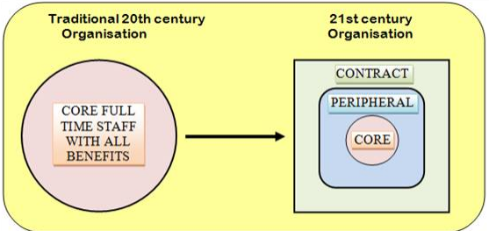
(Source: Graban, 2018)

Appendix 2: Rate of Temporary Employment in Various Countries
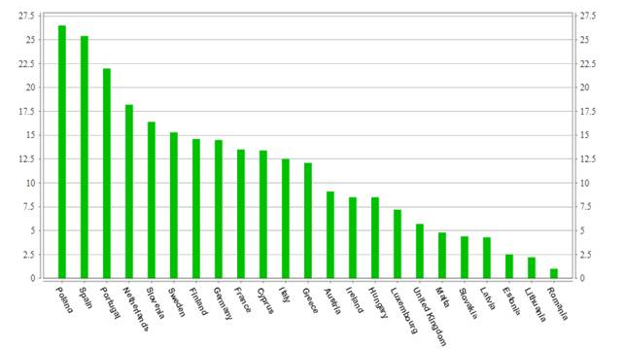

(Source: uian, et al. 2018)

Appendix 3: Employbility Rate in UK
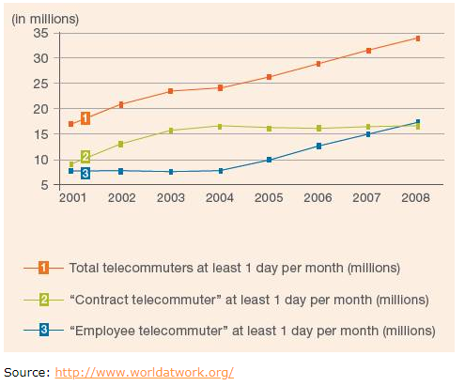
(Source: uian, et al. 2018)

