Academic and Employability skills

Module Code: BMSK4001
Student Name: Ana-Maria Paveliuc
Student ID: 1711207
Lecturer: Peter Allen

Table of Contents
Introduction 2
Development of academic and employability skills 2
Academic writing 2
Research Methods 5
Academic referencing techniques 6
Skill gaps and ways to improve the skills 6
Conclusion 7
References 8

Introduction
According to Overtoom (2015) both academic skills and employability skills are essential for every graduate student. Academic skills help us to achieve success in the school, college and university level. On the other hand, employability skills help a person to get the desired job and perform job-related tasks efficiently. This module allows a student to learn the skills required in a workplace. In this module, I learn about academic writing, research methods and different techniques of academic referencing. This report will show how these learning has helped me to develop my academic skills and employability skills. It will also show some areas where further skills development is possible.

Development of academic and employability skills
Academic skills are the skills that a student should possess in order to learn new things and achieve academic success. Academic skills include reading skill, writing skill, listen to skill, understanding skill, IT-based skill etc. All these skills help me to learn more efficiently. On the other hand, employability skills are the skills that help a person to become suitable for a job. Employability skills include communication skill, presentation skill, human management skill, skill to work in a team, problem-solving skill, analytical skill, planning and organising skill, IT-based skill etc. This module has helped me to develop these skills as the module teaches the skills for the workplace. Academic writing, academic referencing techniques and research methods are the grounds that have been covered in the module. How the learning of these topics has helped me to develop my academic and employability skills are discusses below.

Academic writing
When an employer searches new employees, the employer wants to know how much the potential employee is efficient in academic writing. In the business world, different types of writing are compulsory in the form of reports, essays, reflective papers etc. (Bailey, 2018). Academic writing has played a large part in the development of my academic skills. Writing at the academic level helped me to enrich my subject-specific knowledge. It also helped me to enrich my general vocabulary knowledge. These two together helped me to go for any reasoned argument and discuss subject matters descriptively. It is essential to have the subject-specific knowledge to go for any type of argument or academic discussion. Academic writing helped me to know about a wide range of topics. Academic writings makes a student more knowledgeable. In this module, different skill related academic writing has been assigned to me. It helped me to know about different types of skills and develop those (Philpot et al., 2013). These academic writings helped to develop my intellectual and critical thinking. I have learned to think critically while I was preparing these academic writings.Different types of cases related to academic writing have helped me to develop my critical thinking ability.
Academic writings also helped me to develop my employability skills. Use of appropriate language in the workplace is essential. Academic writing helped me to learn to choose the right word in different circumstances. It helps an employee to communicate quickly, clearly and effectively with different parties related to a company. My communication skill has been developed a lot because of academic writing. Because of such writing, my command over the language has been increased. Effective communication is essential to business organisations as they need to negotiate with different parties on a regular basis (Worth, 2013). It mostly develops the written communication skill. Academic writing also helped me to develop my problem-solving skill. I improve a lot on this skill, even at my workplace, I resolve problem in another matter then I did before and I am more calm and confident, when something happen.
All these academic writings have developed my IT skills. IT skills mean proficiency in information and technology system. Such a skill is a must for every company. When an employer selects an employee, he focuses a lot on the IT skill of the employee. The basic IT skills required for an employee is the proficiency in the use of Microsoft Word, Microsoft PowerPoint Presentation, Microsoft Excel and other business-related applications. The reports submitted to the college had to be in word file format. So, as a student, I had to do all my academic writing in Microsoft Word. It helped me to know how to use the application and with further guidelines form the teacher, I have learnt the use of the application in detail. This skill is required in both academy and company.
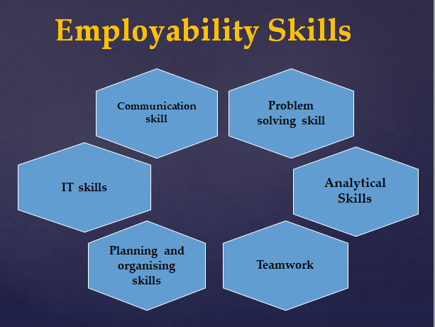
Figure-1: Employability Skills
Source: (Hind and Moss, 2011)
My planning and organising skills also have been developed by academic writing. While writing the academic reports and essays, I used to plan what to do first and what to do next. For the academic writing, I also needed to organize the different types of materials like study materials, draft papers, computer etc. (Hind and Moss, 2011). All these helped in the development of my planning and organising skill. Another skill that has been developed through academic writing is the teamwork. Teamwork is a skill that is needed in academically as well as professionally.
Though my skills have been developed, there are lots of areas where I can develop my skills.

Research Methods
Research is an essential part of both academies and the companies. Educational institutions research to establish new theories and companies research to develop product and services and to know about different trends. Both of my academic and employability skill have been developed through the learning of research methods in this module. My analytical skill has been developed through this learning. Researches include lots of analysis of data and information. Some of the data and information is qualitative and some are quantitative. Different measures of these data require a range of analysis which allowed me to develop my analytical skills. Many other skills have also been developed which are discussed below.
There are three types of research methods; observational method, case study method and survey method. Observational method is a method in which the behaviour of human, animal or any other factor is observed closely. The observation can be done in the society or in the laboratories. This method helped me to improve my observation skill. It allowed me to observe things better. Observation skill is important in organisations as the employees may need to learn their task through observation. In the case study method, it involves an in-depth study of an individual and a group of individuals (McNeill and Chapman, 2012). Lots of hypothesis and prediction are involved in this method. It helps an individual to make a correct prediction. In business organisations, employees need to understand the situation through case study and they should also find the best solution by following the case study.
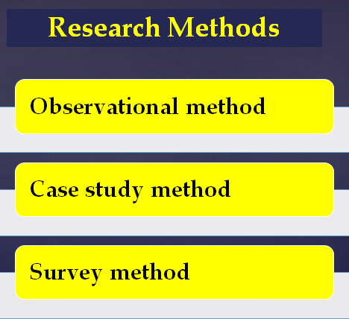
Figure-2: Research Methods
Source: (Cohen, Manion and Morrison, 2015)
The third method of research is survey method. This is the most common type of research method. In this method, a range of participants answers the questions prepared by the surveyor. The surveyor prepares the questionnaire in a way that will lead to an expected conclusion. The answers given by the participants are considered as data. After collecting the data through the survey, the surveyor interprets the data to come to a valid conclusion. It helped to develop my interpreting skills as I have learned to interpret the data collected.

Academic referencing techniques
Referencing and citation in the academic reports and essays have allowed me to learn about different types of academic referencing. The most common type of referencing styles are the Harvard methods (Rahman, 2016). In the UK colleges, Harvard referencing system is mostly used. A student writes lots of academic reports per semester. Students write these reports after reading books, articles, websites, newspaper etc. The students must refer the source from which he or she has collected the information of data. If the students do not cite the source, it will be considered as plagiarism. Plagiarism is taking of someone else’s works or ideas and passing them off as one’s own. It is a serious offence for any kind of writing. It is mostly related to ethics. Learning of the techniques of academic referencing has developed my ethical skill. In the business reports and articles, it is also essential to use proper citation of the sources. Such referencing will increase acceptability of the writings. Proper citation will also improve the ethics of the employees.

Skill gaps and ways to improve the skills
In spite of developing lots of skills, there are still some skills that need to be developed. One of those skills is an entrepreneurial skill. It is the skill through which a person can start a new business. Entrepreneurial skill is a mixture of risk-taking ability, opportunity seeking, predictability etc. This skill can be developed through learning and practice. I can only develop this skill through learning. My strengths is communication which I improve during my class aswell, participating to the class lesson , form groups with other students. My weakness is still confidence and I have a hard time with this, even in the class and at my work place.

Conclusion
Academic skills, as well as employability skills, are must for a graduate student. This module has helped me to develop these skills. Through academic writings, I can develop knowledge related skills, communication skills, analytical skills, problem-solving skill; IT-based skills, teamwork skill and planning and organising skill (Miller, Biggart and Newton, 2013). Through the learning of research methods, I can develop the analytical skill, observational skill and interpreting skill.
This module helped me a lot in my daily basis, at my work place and at my essays, because I discover a lot of new things what I did not know. It helped me to understand how I supposed to manage my time in order to achieve more.

References
Bailey, S. (2018) Academic writing, New York, NY: Routledge.
Cohen, L., Manion, L. and Morrison, K. (2015) Research methods in education
Hind, D. and Moss, S. (2011) Employability skills, Houghton le Spring: Business Education Publ.
McNeill, P. and Chapman, S. (2012) Research methods London: Routledge.
Miller, L., Biggart, A. and Newton, B. (2013) Basic and employability skills. International Journal of Training and Development, 17(3), pp.173-175.
Overtoom, C. (2015) Employability skills Columbus, OH: ERIC Clearinghouse on Adult, Career, and Vocational Education, Center on Education and Training for Employment, College of Education, the Ohio State University.
Philpot, S., Curnick, L., Soars, L. and Soars, J. (2013). Academic skills. Oxford: Oxford University Press.
Pierce, S. and Mills, E. (2012). Planning. London: Iliffe.
Rahman, M. (2016). Referencing – an Academic Obligation. Delta Medical College Journal, 4(2), p.52.
Worth, R. (2013). Communication skills. New York: Ferguson.

