  - 

Internet of Things
Smart Cities Applications

  - University of Wales Trinity Saint David’s
School of applied computing
  - Nicholas Jones, P149676
  - Smart & connected 2, ACDA 6005
  - Lecturer: Dr Mabrouka Abuhmida & Dr John Rees
Date: 13th December 2019

Abstract
Traffic congestion in cities and towns are a safety concern for the public, part of this congestion is related to drivers driving around looking for available parking spaces, An Internet of Things solution has been proposed to minimise this.
A central server gathers data from parking spots and makes it available to drivers through applications on smart devices and web browsers. Vehicle detection technologies have been discussed with ultrasonic being the choice for this system, three wireless communication technologies have been analysed to determine which would be best for this application. Security is a concern today both physical and electronical, basic security measures have been mentioned.
Packet tracer simulation has been used to aid with visualisation of data flow coming from sensors and collected by a central IoT server, a cell network has been configured to allow cell users to access this data which shows if there is available parking in certain streets, IP addressing has been configured to allow data to pass through the network with network devices used to simulate various gateways in the system.

Contents
Abstract i
Figures ii
1 Introduction 1
1.1 Problem 1
1.2 Solution 1
2 Sensors 1
2.1 Inductive Loops 2
2.1.1 Inductive loop conclusion 2
2.2 Ultrasonic 2
2.2.1 Ultrasonic conclusion 3
2.3 Optical 3
2.3.1 Optical conclusion 4
2.4 Sensors conclusion 4
3 Proposed application & design 5
3.1 Mesh networks 5
3.2 Mesh networks conclusion 7
3.3 ZigBee or Thread 7
4 Security 8
5 Simulation summary 9
5.1 Functional block diagram 9
5.2 Packet Tracer 9
6 Conclusion & further work 14
7 References 15

Figures
Figure 1 Diagram of inductive loop [4] 2
Figure 2 Typical ultrasonic sensor unit [7] 3
Figure 3 Optical array used for object detection [9] 3
Figure 4 Optical detection unit [11] 4
Figure 5 Digi-key wireless comparison table [16] 6
Figure 6 ZigBee protocol stack [20] 7
Figure 7 Thread protocol stack [20] 8
Figure 8 Functional block diagram 9
Figure 9 Packet Tracer Logical, root level 10
Figure 10 High street cluster 10
Figure 11 End user desktop view 11
Figure 12 End user login 11
Figure 13 IoT monitor view 1 12
Figure 14 High street, active spaces 13
Figure 15 IoT monitor view 2 13

Introduction
Inner city traffic congestion contributes to several problems, these can include increased environmental pollution, extensive delays to daily commuters and safety concerns amongst other users of public highways such as pedestrians and cyclists. According to “INRIX Global Traffic Scorecard” data collected in 2018 from six major U.K cities shows the last mile travelled averaged to 10 MPH, and 7 cities in the U.K experienced over 140 hours per year of delays, the report goes on to say in London alone this yearly delay costs drivers £1,680 [1].
one contribution to inner city traffic congestion is related to drivers constantly driving around in circles looking for a suitable parking space [2], this clearly adds to environmental pollution and unneeded stress is exerted on the driver and other road users, this is a big safety concern as a driver would be focusing less on manoeuvring their vehicle safely amongst highway users and more on looking for an available parking space.

Problem
Public safety concerns due to high-density inner-city traffic congestion caused by drivers looking for available parking.

Solution
Interconnected smart traffic congestion management system involving the use of real time data collected from sensors to identify areas of available parking within a city and making this data available to road users.
The collection of data will be from sensors at dedicated roadside parking spots and from dedicated car parks such as multi-storey and single level services, dedicated car parks do have systems in place to show road users of parking availability these are usually displayed at the entrance by use of an electronic sign, the focus of this solution will primarily be on roadside parking but will reference a way to integrate current car park systems within the bigger solution.

Sensors
Sensors needed for this problem involve detecting the presence of a vehicle, “motion29.com” [3] provide a range of sensors for detecting vehicles, these can include inductive loops, ultrasound, microwave and optical, their target market appears to be aimed more at access control where by a gate or bollard would be triggered when a vehicle or a person is within detection range but the technologies used can be applied to the problem being discussed with in this report.

Inductive Loops
Inductive loops are a loop of wire embedded within the surface of the target detection area [3] this involves cutting up the surface which could be tarmac, concrete, gravel, etc. Reading their installation guide [4] they recommend a minimum loop size of 0.8 metres. Figure 1 below shows a diagram of a loop.
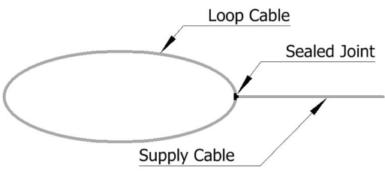
Figure 1 Diagram of inductive loop [4]
For the loop to work an electronic unit is connected to it, this device measures the inductance within the loop, when a vehicle or other large metal object is within range the inductance changes and thus the electronic unit triggers an event [3].

Inductive loop conclusion
This method of vehicle detection is common [3], but it does involve intensive work to install, this would not be practical or cost effective for the problem being solved as cutting up miles of road surface would add more traffic congestion, delays and increased safety concerns. Inductive loop applications are better suited for one off area’s such as driveways, barrier control to car parks, traffic lights, etc.

Ultrasonic
Ultrasonic can be used to detect the presence of an object [5], these work by emitting a pulse of sound outside of the humans hearing frequency range and measuring the time it takes to receive the reflection, this time is then used to determine the distance to the detected object [6, pp. 391, 392]. Figure 2 shows what a typical ultrasonic sensor can look like.
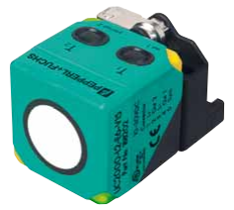
Figure 2 Typical ultrasonic sensor unit [7]
The unit in Figure 2 is a product from “Pepperl-Fuchs.com” [8], they can be used in various applications were detection of an object is needed including vehicles, typical areas for vehicle detection can be access control for gates, barriers, bollards and in carparks monitoring for parked vehicles [7].

Ultrasonic conclusion
Ultrasonic can be a good technology to use for the problem being solved providing it is configure appropriately, the reason for this is other non-vehicular objects can also be detected, for example if a person happens to stop within detection range it could trigger and suggest the space is occupied.

Optical
Optical sensors rely on light being transmitted and then received by a light detector, this light can travel either by air or fibre optic cable [6, p. 383] if the transmitted light is broken then the light detector would change state thus indicating the presence of an object [6, p. 385]. Figure 3 shows a representation of an optical array.
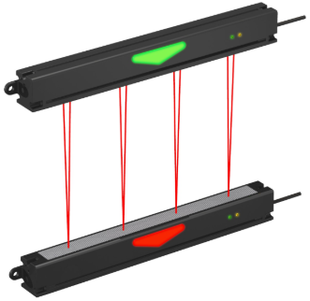
Figure 3 Optical array used for object detection [9]
Figure 3 shows a form of optical array that could be used for vehicle detection, this type of setup can be used at toll booths where different sized vehicles need to be detected [10], other sensors available may just have the one light for detection for when object size is not of concern, Figure 4 below shows an optical sensor used for gate access control.
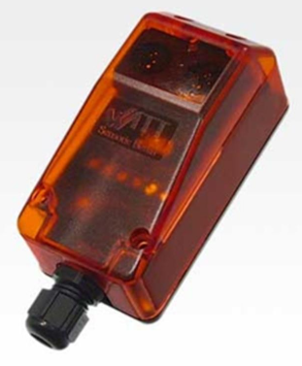
Figure 4 Optical detection unit [11]
The product seen in Figure 4 incorporates a light source and a light detector, this unit relies on a reflective surface to reflect the light back [11] if this light is broken the unit then triggers an event.

Optical conclusion
Providing the system is not faulty optical is a good reliable method of detection, when used as an array various sized objects can be detected and therefore distinguishing between a vehicle and a person can be done with great accuracy, the problem with this type of detection is it’s more suited for specific areas such as toll booths, drive ways, barrier controlled entrance / exits and trying to implement it into various types of parking spots would not be practicable.

Sensors conclusion
Three commonly used vehicle detection technologies have been analysed, these were inductive, ultrasonic and optical, what has been discussed are from specific applications i.e. mainly access control, but the implementation of vehicle detected and event triggering is needed for this problem and the technologies discussed could be adjusted and configured for other application use.
Inductive sensors are good for vehicle detection as it relies on large metal objects for activation, this ensures human presence and other non-metallic objects would not trigger events, the issue is to detect a vehicle the size of the sensor (loop) needs to be substantial and furthermore it needs to be embedded within in the surface of the target area.
Optical can be a reliable method for vehicle detection but implementing it into the application needed for this problem may not be practical as it relies on a light beam being broken thus having multiple arrays of light and reflectors covering each parking space is not feasible and possibly it would not be cost effective.
Ultrasonic can be a reliable detection method, they are extremely configurable in a sense that detection range and detection angle can be adjusted to suit detection area also the sensor itself is small thus being able to build a compact unit.

Proposed application & design
The proposed design will include fitting ultrasonic nodes (sensor nodes) in parking spaces, these will be surface mounted and positioned in the centre of each space, the detection area will be vertical, detection range will be up to 1m, detection angle will be narrow to minimise false alerts, each sensor node would be battery powered and fixed / screwed to the floor, this makes them extremely portable and installation time can be minimised to a few minutes, integrated solar panels and low powered components will be used to aid with battery longevity. The housing will be rugged enough to support the weight of anything that may pass on top of it.
Each sensor node would need a way to communicate its data to a central server, as they have no cables this data will need to be transmitted wirelessly, knowing these nodes need to be low power and they will be obstructed by parked vehicles then transmission range is expected to be small, to overcome this each node will connect to a mesh network [12] this then allows them to communicate with each other and route data to a central node, for this application there will be multiple central nodes, where each maybe assigned to a certain area such a street or block, these can be placed where there is a source of power, the purpose would be to collect data from the ultrasonic nodes and push it to a central server via 4G network, the central server would process it and make it available to users via a web browser or other application.

Mesh networks
Bluetooth low energy (BLE), Thread and ZigBee have protocols in place to create a mesh network [13], Silicon labs conducted performance tests on each of these technologies when configured as a mesh network, results are summarised below [14]:
- In small networks, with small payloads the three technologies performed the same.
- When there is an increase in payload and throughput, Bluetooth performed less than the other two.
- As size of their networks grows so does latency, with Bluetooth showing the biggest increase.
- Relay optimisation can be used with Bluetooth for better performance.
- Having short messages is better for Bluetooth mesh network.
- When selecting IoT devices, power consumption should be considered.
Digi-key electronics [15] have written an article “Comparing Low Power Wireless Technologies” where they compare several RF- based technologies including Bluetooth, Thread and ZigBee, this 3 part article discusses the different protocols used, how each one operates and different types of network topologies, part of their conclusion as to which technology to use suggests this is down the requirements of the application to which is being designed [16]. The article does provide the comparison table seen in Figure 5 to aid with decision.
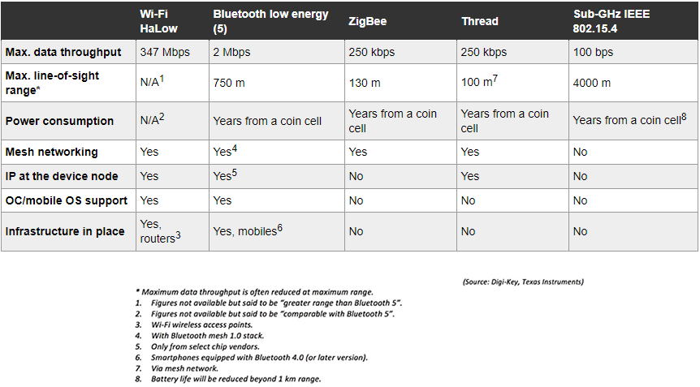
Figure 5 Digi-key wireless comparison table [16]
Figure 5 shows a screen shot of the comparison table provided by Digi-key electronics, out of the three technologies discussed in this chapter it suggests that Bluetooth would be the better choice due to data throughput and transmission range, the Silicon labs report suggested Bluetooth performed worse, what is not known is the version of Bluetooth used when Silicon labs conducted their tests as the table in Figure 5 shows BLE version 5, the Digi-key article [17] suggests data rates are theoretical and subject to a number of variables like environmental conditions and configuration set ups of each system, the Silicon labs test environment was conducted in an office style building with hallways, offices and open areas.

Mesh networks conclusion
For the problem in this report the solution only needs small amount of data from each sensor and as each sensor node will be within metres of each other data throughput speed would be at its maximum. The three discussed communication technologies would be viable wireless communication technologies for this application, Bluetooth will be eliminated here as it is the most used technology found in millions of end user devices thus being congested. Thread and ZigBee performance appear to be similar suggesting either technology could be used.

ZigBee or Thread
ZigBee and Thread are similar to each other, both technologies are built for low powered IoT applications [18] [19], Figure 6 and Figure 7 shows the protocol stack for each.
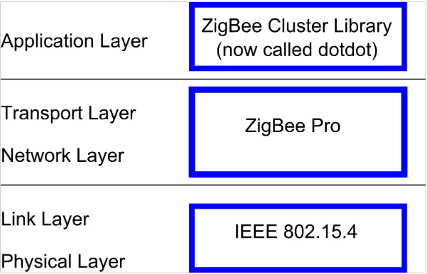
Figure 6 ZigBee protocol stack [20]
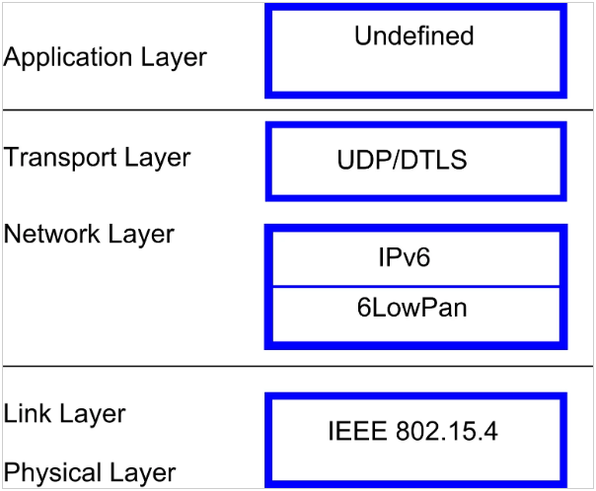
Figure 7 Thread protocol stack [20]
The protocol stacks seen in Figure 6 and Figure 7 shows both technologies use the same physical layer protocol, Thread has adopted IPv6 for their network layer whereas ZigBee has their own protocols for this along with their own at application layer, Threads application layer is undefined.
Literature review of both Thread and ZigBee suggests both technologies would work well for this application, if costings were required for this report then possibly the choice would come down to this.

Security
Security is an issue today electronically and physical, for this application physical would mainly be theft at ground level with the sensors being fixed to the road, other systems involved will have some form of physical security such as locked hard to reach cabinets or secure buildings with security personnel.
This application relies on wireless technology to operate making it an easy target for a cyber-attack, the data collected may not be a national security issue but if a person were to access the system they could create some form of chaos such as feeding false sensor data back to the central server, an easy entry point for an attacker could be at the sensor modules.

Simulation summary
Packet tracer is used to visualise and simulate data flow from sensors at ground level through a number of hops and made available to the end user, due to limitations in the software and complexity of some configuration’s assumptions have been made and are explained where necessary.

Functional block diagram
A functional block diagram of data flow has been created; this is shown in Figure 8.
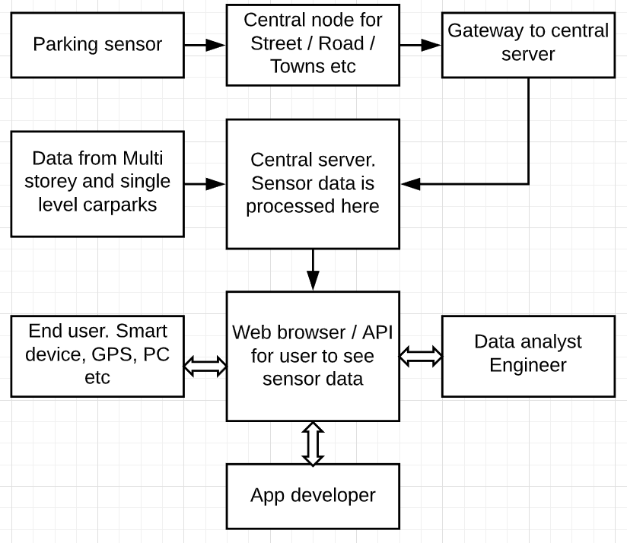
Figure 8 Functional block diagram
Figure 8 shows data from the “parking sensor” passes through a central node placed at the edge of an area such as a road, this data passes through a gateway to the central server, once it has been processed it is made available to end users, App developers, data analyst, etc, it also shows that the central server is responsible for processing data that is received from other car park facilities such as multi storey and single level.

Packet Tracer
Figure 9 shows the root level logical view within Packet tracer.
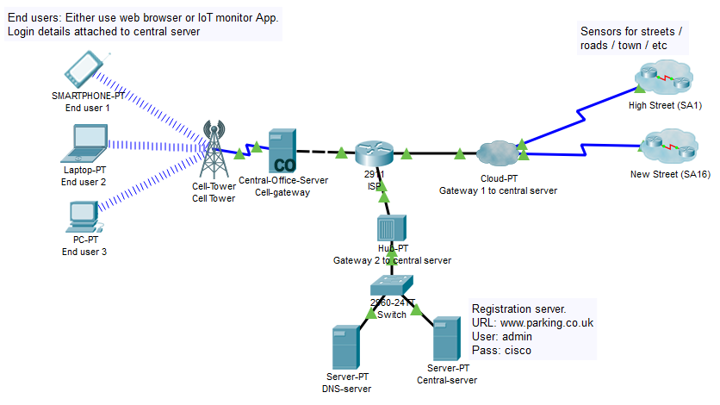
Figure 9 Packet Tracer Logical, root level
In Figure 9 the clusters to the right hand side represent different areas where sensors and central nodes are located these are linked to a number of gateways to enable the data to reach the central server, at the left of Figure 9 is a link showing users connecting to a cell tower which allows access to the central server seen at the bottom, a DNS server has been set up as well allowing a web address to be inputted instead of an IP address. Figure 10 shows the contents of the clusters.
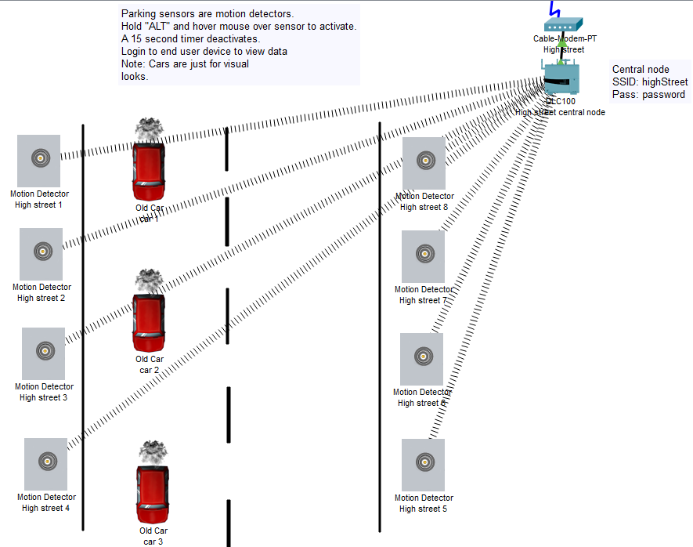
Figure 10 High street cluster
The clusters have the same components within them and operate in the exact same way Figure 10 shows the contents of the High street cluster, the grey nodes lining the road are individual sensors placed at each parking space, these are connected wirelessly to the central node which then passes the data through a number of gateways to the central server, the cars in the road are used as a visual aid and serve no purpose in this simulation. Figure 11 shows an end user “desktop” screen.
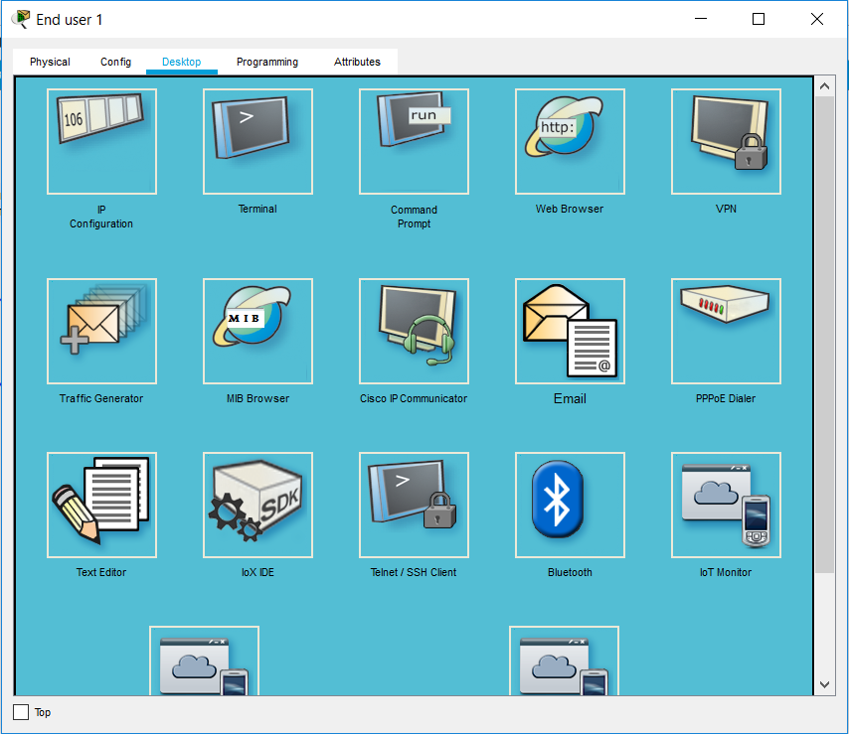
Figure 11 End user desktop view
To access the data as an end user the “web browser” or “IoT monitor” apps can be used, Figure 12 shows the login screen presented when “IoT monitor” is used.
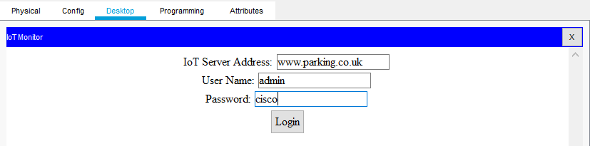
Figure 12 End user login
The DNS server in the simulation has been configured to resolve the Ip address of the central server to a domain name, looking at Figure 12 this is www.parking.co.uk a username and password has also been inputted. Figure 13 shows the user has logged in successfully.
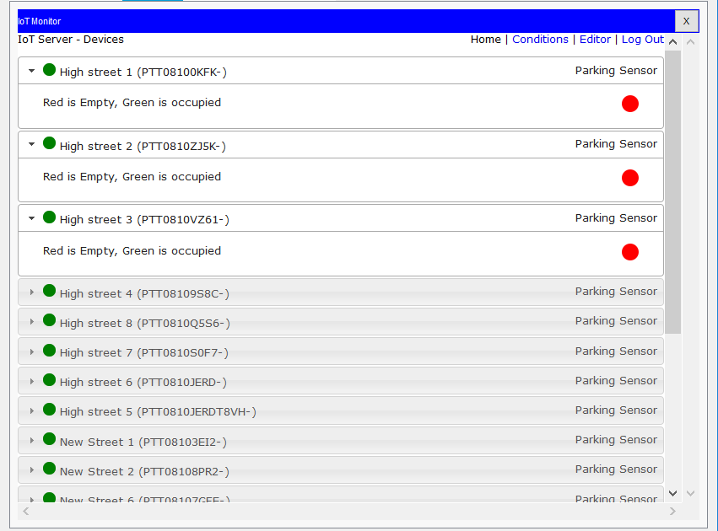
Figure 13 IoT monitor view 1
Figure 13 shows the data available from the central server, the sensor nodes have been named with respect to their cluster name and location, the green icon to the left shows the sensor is online, clicking the drop down arrow shows the state of each sensor where red is not active hence the space is available. To activate a sensor the “Alt” key needs to be pressed whilst hovering the mouse over one, for simulation purpose these have been programmed to deactivate after 15 seconds. Figure 14 shows space 1,2,6 & 7 have been activated.
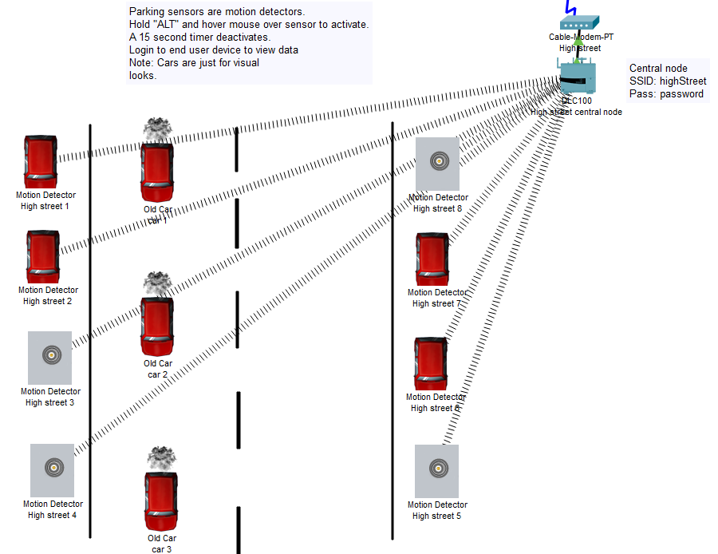
Figure 14 High street, active spaces
The sensors used in Packet tracer are “motion detectors” their icon properties have been changed hence a car shows when activated. Figure 15 shows sensor 1 & 2 have been activated and sensor 3 is available, the view is the same for all sensors.
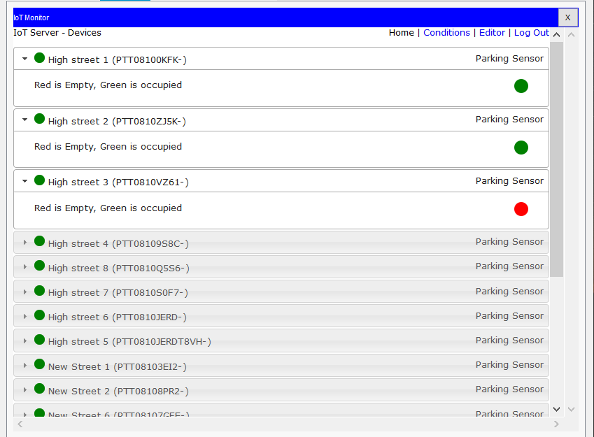
Figure 15 IoT monitor view 2
In Figure 15 when a space is occupied the icon to the right of the sensor turns green, this reverts back to red when the space is available, for simulation purposes the sensor automatically deactivates after 15 seconds and the car changes back to the sensor icon.

Conclusion & further work
The proposed system documented in this report is a starting point for trying to manage traffic congestion in a smart way, a simple sensor has been used to indicate if a parking space is occupied and the data is available on a central server, the sensor used and it’s configuration may not be ideal due to a number of reasons:
- Debris: The sensors have been positioned to sense vertically, with that comes an issue where dirt or other debris can reside on top rendering it in effective. Design of the sensor could be as such that this could be avoided also regular cleaning maintenance could be used such as road sweepers.
- Detection accuracy: Ultrasonic can detect any object that is capable of reflecting sound waves, this also includes persons, if a sensor is triggered there is no mechanism to confirm if it is a parked vehicle. Other systems could be integrated such as CCTV with image recognition software to establish what object has triggered a sensor.
The wireless technologies that have been discussed is a small selection of available wireless communications, 5G is the latest mobile wireless technology currently being employed in towns and cities, it has been designed to aid with smart connected cities. Utilising this new communication could provide faster speeds, higher data throughput and possibly less hardware, further research would be needed to establish this.
Packet Tracer does have its limitations when wanting to use exact technologies such as ZigBee or Thread, but it does house a lot of useful features for IoT integration and having the ability to use programming languages such as java and Python to control various items is a positive, given more time more experience could be gained with usage of Packet Tracer and all of its features where it may be possible to create a more realistic virtual environment for the solution proposed by building and programming the relevant sensors and gateways discussed in this report.

References
[1] ‘INRIX_2018_Global_Traffic_Scorecard_Report__final_.pdf’. .
[2] ‘Smart Cities: Solving Urban Problems Using Technology’, 19-Jul-2017. [Online]. Available: https://www.youtube.com/watch?v=nnyRZotnPSU. [Accessed: 29-Oct-2019].
[3] ‘LED Traffic Lights | Vehicle Sensing | Vehicle Access Control’. [Online]. Available: https://www.motion29.com/products/vehicledtectionandcontrol/default.htm. [Accessed: 30-Oct-2019].
[4] ‘Motion 29 :: Pre-Assemblied Loops for Simple and Quick Installation’. [Online]. Available: https://www.motion29.com/products/controlandsensing/vehicleloopdetectors/preassembl edloops/default.htm. [Accessed: 30-Oct-2019].
[5] ‘Ultrasonic Sensors | Banner’, Banner Engineering. [Online]. Available: https://www.bannerengineering.com/th/en/products/sensors/ultrasonic-sensors.html. [Accessed: 30-Oct-2019].
[6] A. S. Morris and R. Langari, Measurement and instrumentation: theory and application, Second edition. Amsterdam ; Boston: Elsevier, AP, 2016.
[7] ‘Ultrasonic Sensors for Parking Garages and Car Parks’. [Online]. Available: https://www.pepperl-fuchs.com/global/en/24814.htm. [Accessed: 30-Oct-2019].
[8] ‘Pepperl+Fuchs International. Industrial Sensors, Factory, Process Automation, Intrinsic Safety’. [Online]. Available: https://www.pepperl- fuchs.com/great_britain/en/index.htm?countrysiteid=-1#. [Accessed: 30-Oct-2019].
[9] ‘PVL Series Parts Verification Array | Banner’, Banner Engineering. [Online]. Available: https://www.bannerengineering.com/th/en/products/sensors/slot-sensors-and-part- sensing-arrays/parts-verification-array-pvl-series.html. [Accessed: 30-Oct-2019].
[10] ‘5 Considerations for Choosing a Light Grid for Vehicle Separation at Toll Booths’, SICK USA BLOG, 19-Jul-2016. [Online]. Available: https://sickusablog.com/5-considerations-choosing- light-grid-vehicle-separation-toll-booths/. [Accessed: 30-Oct-2019].
[11] ‘PE Sensor | Vehicle/Person Detection’. [Online]. Available: https://www.motion29.com/products/controlandsensing/photoelectricsensors/default.htm. [Accessed: 30-Oct-2019].
[12] ‘What is a Mesh Network? -- Definition from WhatIs.com’, IoT Agenda. [Online]. Available: https://internetofthingsagenda.techtarget.com/definition/mesh-network-topology-mesh- network. [Accessed: 30-Oct-2019].
[13] ‘Bluetooth, Thread, Zigbee Mesh Compared’, EETimes. [Online]. Available: https://www.eetimes.com/author.asp?section_id=36&doc_id=1333265. [Accessed: 30-Oct-2019].
[14] ‘Bluetooth Mesh, Thread, and Zigbee Network Performance Benchmarking - Silicon Labs’. [Online]. Available: https://www.silabs.com/products/wireless/learning-center/mesh-performance. [Accessed: 30-Oct-2019].
[15] ‘DigiKey Electronics United Kingdom | Free Delivery On Orders Over £33.00’. [Online]. Available: https://www.digikey.co.uk/. [Accessed: 01-Nov-2019].
[16] ‘Comparing Low Power Wireless Technologies (Part 3) | DigiKey’. [Online]. Available: https://www.digikey.co.uk/en/articles/techzone/2017/dec/comparing-low-power-wireless-technologies-part-3. [Accessed: 01-Nov-2019].
[17] ‘Comparing Low-Power Wireless Technologies (Part 1) | DigiKey’. [Online]. Available: https://www.digikey.co.uk/en/articles/techzone/2017/oct/comparing-low-power-wireless-technologies. [Accessed: 01-Nov-2019].
[18] ‘Zigbee 3.0’, Zigbee Alliance, 03-Jan-2018. .
[19] ‘Built for IOT Home’. [Online]. Available: https://www.threadgroup.org/BUILT-FOR-IOT/Home. [Accessed: 04-Dec-2019].
[20] ‘A Battle of IoT Protocols: ZigBee vs Thread - News’. [Online]. Available: https://www.allaboutcircuits.com/news/a-battle-of-iot-protocols-zigbee-vs-thread/. [Accessed: 04-Dec-2019].

