STUDENT NAME: DRE STEELE
STUDENT NUMBER: 2332005
MODULE TITLE: MANAGING PROJECTS IN THE ORGANISATION
MODULE CODE: BMSW5009_SWAN
LECTURER NAME: GIULIA CHIFARI



TABLE OF CONTENTS

BLOG 1- Project Introduction & Team Roles 3
BLOG 2 – Project Initiation & Planning 4
BLOG 3 – Stakeholder Analysis & Communication 5
BLOG 4 – Planning Tools WBS & Gantt Chart 6
TEAM DELIVERY ST THOMAS CHURCH 7
BLOG 5 - Risk, Self-Evaluation & Development 8
SELF-DEVELOPMENT PLAN 8
REFERENCE LIST 9

BLOG 1- Project Introduction & Team Roles

Week one marked the start of our project as our team of five came together, selected a team leader, and allocated supporting roles. This provided early structure and allowed us to apply Belbin’s Team Role Theory.
After completing the Belbin questionnaire, I identified Team Worker as my preferred role. This meant I naturally contributed through collaboration, communication, and supporting positive team relationships. These qualities helped create a cooperative working environment during the initial stages of the project.
During our first brainstorming session, we generated two project ideas: a litter-picking event with Amazon as a potential sponsor and a food donation initiative supporting St Thomas Church. These ideas later formed the basis of our Work Breakdown Structure (WBS), allowing us to visualise the tasks involved in each option.
Although Belbin’s model helped us understand our behavioural preferences, I recognised its limitations. Batenburg, van Walbeek and van der Maur (2013) argue that a balanced mix of Belbin roles alone does not guarantee effective team performance. Our experience reflected this, as communication, adaptability, and cooperation were more important than role classifications in determining how successfully we worked together.
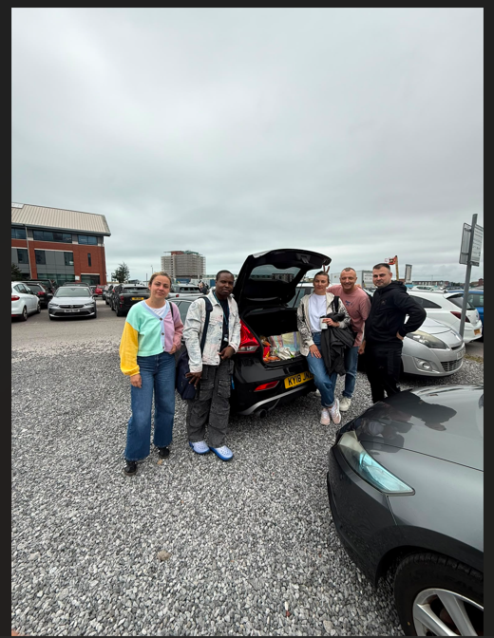

BLOG 2 – Project Initiation & Planning

In week two, our team moved from brainstorming to project initiation by defining aims, objectives, and deliverables. Using the SMART framework, we evaluated our two project ideas and found the litter-picking event initially appeared more feasible due to its clear objectives, measurable outcomes, and achievable logistics.
We developed a Work Breakdown Structure (WBS) to compare the tasks across projects. This helped us identify workload requirements, stakeholder involvement, and overall feasibility. We also considered the Iron Triangle of time, cost, and quality. The litter-picking event appeared easier to deliver because it required limited funding and had a straightforward timeline.
Alongside traditional planning methods, we adopted an Agile mindset, which encourages flexibility and adaptation when circumstances change (Dong et al., 2024). This proved valuable when considering potential uncertainties such as stakeholder availability and response times.
As a Team Worker, I encouraged participation and helped maintain clarity around responsibilities. Overall, the use of SMART objectives, Agile thinking, and the WBS provided a stronger foundation for decision-making and project planning.

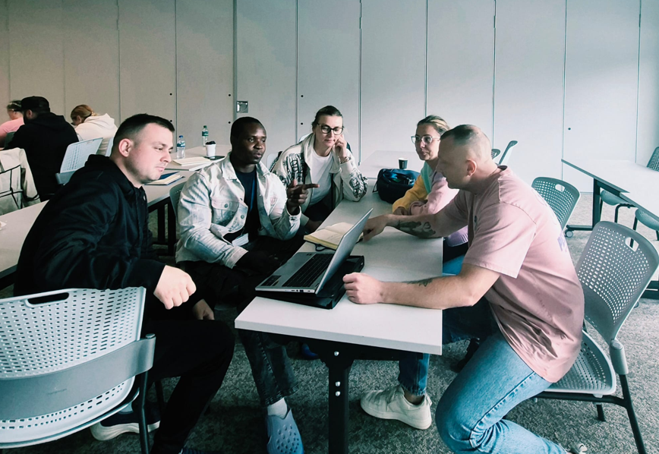

BLOG 3 – Stakeholder Analysis & Communication

Week three presented one of the most challenging points in the project. After contacting Amazon to support our planned litter-picking event, we learned they could not participate due to existing commitments. As Amazon had been identified as a key stakeholder, its withdrawal highlighted the importance of understanding stakeholders and their influence (McGrath & Whitty, 2017; Littau, Jujagiri & Adlbrecht, 2010). It also demonstrated how quickly project feasibility can shift, reinforcing the relevance of the Iron Triangle, where changes in one constraint inevitably affect the others (Pollack, Helm & Adler, 2018).
We explored an alternative wellbeing and mindfulness session, as I was responsible for communication. My attempts to contact a local practitioner via email, Facebook, and WhatsApp were unsuccessful. This revealed the limitations of stakeholder availability and emphasised the need for effective communication management (Manuputty & Nursin, 2023).
To support communication planning, I created a Power–Interest Grid to map stakeholder influence and engagement. St Thomas Church and Tesco fell into the High Power – High Interest quadrant, requiring close collaboration. Amazon moved into High Power – Low Interest once they withdrew. Community donors and team members were placed in Low Power – High Interest, while the local practitioner sat in Low Power – Low Interest. This mapping helped us prioritise communication and tailor our approach.
I suggested a simple communication plan email for external stakeholders, WhatsApp for internal updates, weekly team meetings for coordination, and Facebook for community engagement. With clearer direction, we revisited our WBS and recognised that the food-donation project offered more achievable tasks. St Thomas Church’s positive response allowed the project to regain momentum and move forward.
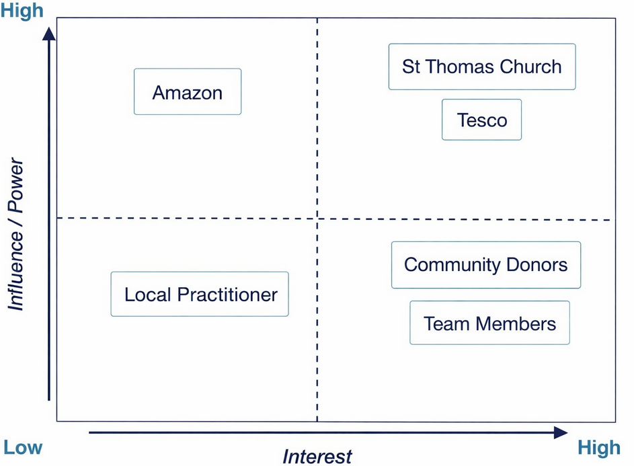

BLOG 4 – Planning Tools WBS & Gantt Chart

By week four, our team regained momentum after a member secured a 10% Tesco employee discount, helping to increase our donation target. As the project progressed, we recognised the need for stronger planning and introduced two key tools: a Work Breakdown Structure (WBS) and a Gantt chart.
The WBS helped break the project into manageable phases, including planning, stakeholder engagement, donation collection, delivery, and closure. This clarified the project scope and enabled the allocation of responsibilities among team members.
The Gantt chart complemented the WBS by mapping tasks across 1–18 June. My tasks included creating the Facebook page (1–7 June), supporting the collection of donations from Tesco Delivery for St Thomas Church, scheduled for 17 June, and a review on 18 June. The chart helped us prioritise activities and monitor progress.
Both tools were valuable, though we occasionally had to adjust timing estimates and update the WBS as new tasks emerged. Despite these challenges, the tools strengthened coordination and kept the project on track.
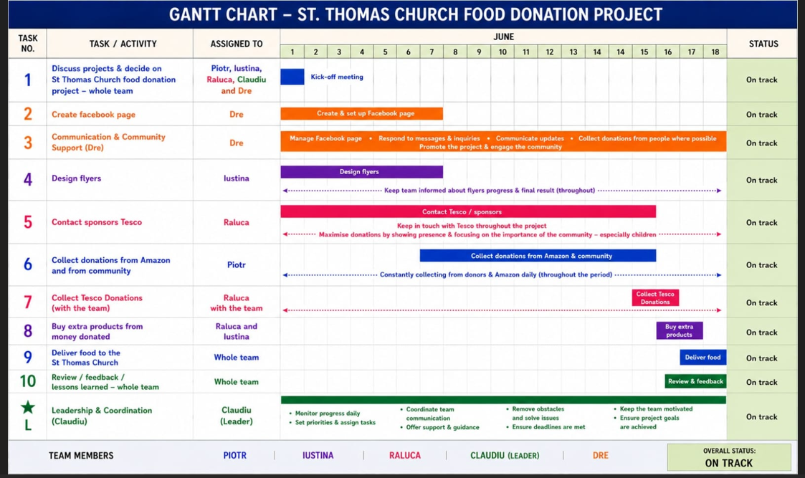

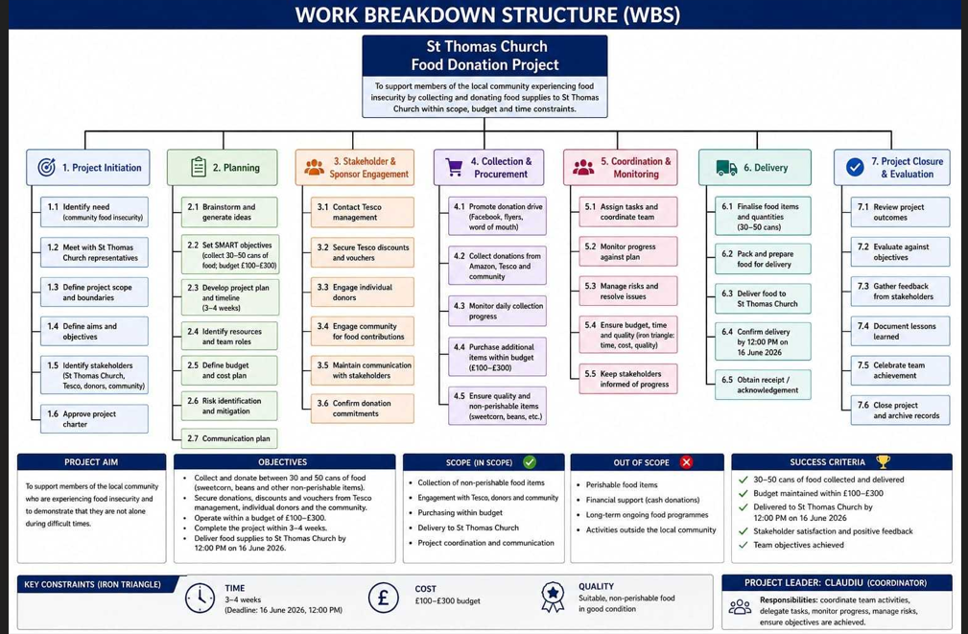

TEAM DELIVERY ST THOMAS CHURCH

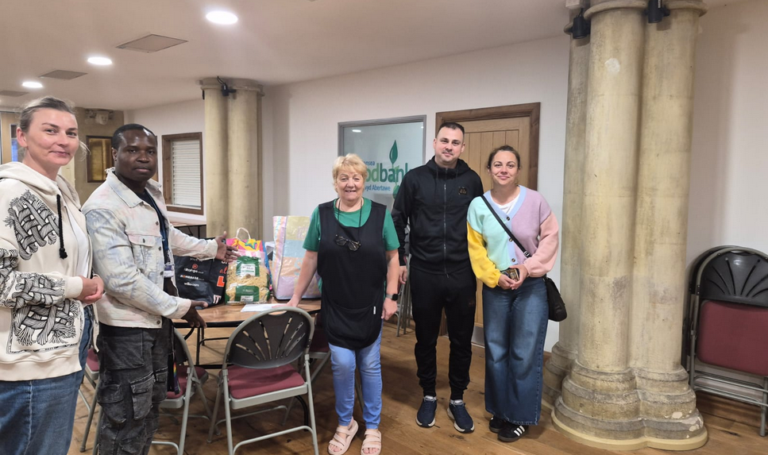

BLOG 5 - Risk, Self-Evaluation & Development

Week five marked a key point of reflection as our project ended. Looking back from team initiation to final delivery, I was able to assess my own abilities and performance as a Team Worker. Throughout the project, I learned to work within constraints and to manage, mitigate, and overcome challenges, particularly when a key stakeholder withdrew, which threatened our project. This experience highlighted the importance of risk awareness and reinforced the essential role of contingency plans in project management. Carvalho and Rabechini Junior (2015) argue that effective risk management depends not only on technical tools but also on soft skills such as communication, collaboration, and stakeholder engagement. I realised that while I contributed positively to team unity, I relied heavily on others to take the lead during moments of uncertainty, revealing a weakness in my confidence when facing unexpected risks. Moving forward, I aim to strengthen my decision-making skills, take more initiative in high-pressure situations, and adopt a more proactive approach to stakeholder communication. These improvements will help me become a more balanced and effective contributor in future projects.

SELF-DEVELOPMENT PLAN
To improve my project management capability, I identified two development goals. Strengthen decision-making confidence by taking initiative in uncertain situations. Improve stakeholder communication by leading more external interactions in future projects.
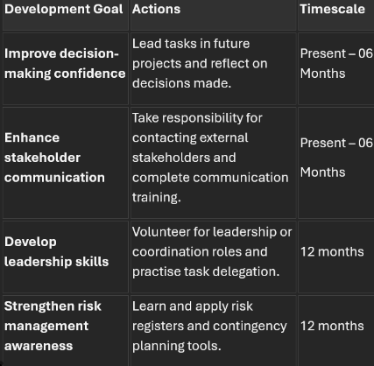

REFERENCE LIST

Batenburg, R., van Walbeek, W. and in der Maur, W. (2013) “Belbin role diversity and team performance: is there a relationship?” The Journal of Management Development, 32(8), pp. 901–913. Available at: https://doi.org/10.1108/JMD-08-2011-0098.

Carvalho, M.M. de and Rabechini Junior, R. (2015) “Impact of risk management on project performance: the importance of soft skills,” International Journal of Production Research, 53(2), pp. 321–340. Available at: https://doi.org/10.1080/00207543.2014.919423.
Charles Doyle (2016) “GANTT chart,” A Dictionary of Marketing. 4th ed. Oxford University Press.
Dong, H. et al. (2024) “What is Agile Project Management? Developing a New Definition Following a Systematic Literature Review,” Project Management Journal, 55(6), pp. 668–688. Available at: https://doi.org/10.1177/87569728241254095.
Littau, P., Jujagiri, N.J. and Adlbrecht, G. (2010) “25 years of stakeholder theory in project management literature (1984-2009),” Project management journal, 41(4), pp. 17–29. Available at: https://doi.org/10.1002/pmj.20195.

Manuputty, N.A. and Nursin, A. (2023) “The Effect of Project Communications Management on Project Time Performance,” Applied Research on Civil Engineering and Environment, 4(1), pp. 9–21. Available at: https://doi.org/10.32722/arcee.v4i01.4798.

McGrath, S.K. and Whitty, S.J. (2017) “Stakeholder defined,” International Journal of Managing Projects in Business, 10(4), pp. 721–748. Available at: https://doi.org/10.1108/IJMPB-12-2016-0097.

Pollack, J., Helm, J. and Adler, D. (2018) “What is the Iron Triangle, and how has it changed?” International Journal of Managing Projects in Business, 11(2), pp. 527–547. Available at:https://doi.org/10.1108/IJMPB-09-2017-0107.

Zecheru, V. and Olaru, B.G. (2016) “Work Breakdown Structure (WBS) in Project Management” Revista de Management Comparat International, 17(1), pp. 61–69.

