
The impact of entrepreneurial characteristics on firm performance: Uncovering the characteristics of strategic entrepreneurship on the performance of Bangladeshi SMEs''

ENTREPRENEURIAL PERSPECTIVES
Part 3
Student ID: 1804704
Programme: DBA-June19

Abstract
The research is done to show the relationship between the characteristics of the entrepreneur with the performance of the SMEs in Bangladesh. As SME is one of the vital source of employment in this developing country, it arranges almost 80% of the total employment of the country with the contribution of 32% of total GDP and that’s why the characteristics of the entrepreneur are tested with the performance of the SMEs of this country. In this deductive research, the hypothesis was made to show the gender, age, innovativeness, labour handling, economic and political environment prediction, technological compliance and legal structure and size of the SME business’s impact on the performance of SMEs and the research has shown a positive correlation with the independent variables with the performance of the business except for the innovation, labour handling, and political and economic situation production. The research provided some recommendations to make sure that these independent factors are improved to make sure that the business can compete in the global market with more innovative product and more efficient employees in this global era.

Table of Contents
1. Introduction 1
1.1 Background of the Research 1
1.2 Research Rationale 1
1.3 Research Title 1
1.4 Research Aim 2
1.5 Research Objectives 2
1.6 Research Questions 2
1.7 Structure of the Dissertation 2
2. Literature Review 3
2.1 Entrepreneurial characteristics and SMEs’ performance 3
2.2 Critical evaluation 4
3. Research Methodology 5
3.1 Philosophy 5
3.2 Approach 5
3.3 Method 5
3.4 Techniques 5
3.5 Data Collection and Sources 6
3.6 Analytical Techniques and Tools 6
3.7 Sampling Size and Technique 6
3.8 Hypothesis 6
3.9 Ethical Considerations 7
3.10 Research Limitations 7
4. Result Analysis and Findings 8
4.1 Demographic Information of the respondents 8
4.2 Analysis and Findings 9
4.3 Descriptive Statistics 9
4.4 Correlation analysis 11
4.5 Regression analysis 12
4.6 Coefficients analysis 13
4.7 Findings 14
5. Conclusion 16
6. Recommendations 17
7. Reference 18
8. Appendix 21
8.1 Analysis and Findings 21

Figure list
Figure 1 Demographic Information of the respondents 8
Figure 2 Descriptive Statistics 9
Figure 3 Correlation analysis 11
Figure 4 Regression analysis 12

Introduction

Background of the Research
SME businesses are the main source of both the production and employment of a developing country like Bangladesh. Being a small and medium-sized business it doesn’t get a management structure like big organisation as the big organisations hire skilled management to make sure that the organisation gets the best decision and production by the management (Van Ness and Seifert, 2015). But in case of SME businesses, the entrepreneur needs to take the act of the owner and the manager to make sure that the strategy is proper to compete with the giant-sized business and that’s why the characteristics of the entrepreneur has a great impact on the business as he is the business as the business this business doesn’t have different entity like large businesses. So the success factor of business solely depends on the entrepreneur's characteristics to remain persistent in achieving the goal of survival and growth of the business in a developing country like Bangladesh (Sarkaria, 2017).

Research Rationale
As a developing country, Bangladesh doesn’t have a lot of business with huge capital, the better half of the overall economy depends on the SMEs’ of this country. The lack of financial resources has reduced the number of development in capital intensive business and that’s why SMEs’ are liable for creating employment for almost 80% of the industrial employment and the contains 30% of the overall GDP of this country (G. and U., 2018). By almost 79,754 SME establishments it continues to flow of production and employment in this country because of the firm management of the entrepreneur though they face many barriers as they don’t easily get any financial backup for their business. Researching this topic will enable the researcher with the entrepreneurial characteristics to determine firms' performance (Basilico, et al 2016).

Research Title
The impact of entrepreneurial characteristics on firm performance: Uncovering the characteristics of strategic entrepreneurship on the performance of Bangladeshi SMEs''

Research Aim
This research aims to show the impact of the entrepreneurs’ characteristics on firms’ performance.

Research Objectives
The objectives of the research are given below:
- To show the impact of entrepreneurial characteristics on firms' performance.
- To evaluate performance criteria.
- To know the strategic entrepreneurship on the performance of Bangladesh SMEs.

Research Questions
- What are the entrepreneurial characteristics?
- What are the performance criteria?
- How the characteristics affect the performance?
- How these entrepreneurial characteristics create an impact on a country like Bangladesh?
- What should be done to increase performance?

Structure of the Dissertation
In the first section, the introduction is discussed to show what the research topic is and why research should be done and in second section writings by the various writers is shown to provide a clear picture of the scenario. In the third part, the methodology to do the report has been shown and in the fourth section, the findings of the research are shown and in the last section, the conclusion and recommendation are given about the research.

Literature Review

Entrepreneurial characteristics and SMEs’ performance
The issue of entrepreneurial characteristics’ effect on the firm performance has divided the philosophers as it is a hard task to say this characteristic is the main reason of getting success by this particular entrepreneur and that’s why this characteristic are the determinants of the success as there are some common characteristics that are somehow same in every organization (Endi Sarwoko, 2017). Getting success by using particular characteristics may not work in another business and success in one business may not be defined as a success in another business that’s why it is a vague concept to determine the success of a business (Blanchard, 2017). The main reason behind the success of these SMEs is the innovativeness of these firms as the large business is more capital intensive that makes them somehow invincible in the economic condition and those have economies of scale that create very much pressure for these businesses. That’s why the small and medium businessman of Bangladesh remains very much innovative about their product to tackle the high competition of the large firms and that’s why the large firm complete their task by making outsourcing work by this business by becoming their customer (Hadi, 2017). This innovation is one of the major reasons why these firms survive in this competition as their selling power is too small compared to the large firms. But this has a huge risk of losing the investment as the innovative products are very much risky and uncertain as it is not proven to the customers (Arief et al., 2016). That’s why some SMEs fell short of capital by losing their asset by introducing innovative product it is hindering the high innovation rate in this country through the country like the UK has a very high innovation rate by the SMEs and those businesses remain successful in the recessionary period when every business collapsed (Silver, et al 2016). Many writers focused on one learning capability by the entrepreneur as the entrepreneur will need to learn from his experience and by any other means. Those who can learn from the experience and another incident can get success more quickly. Size plays a vital role along with the legal structure. Becoming a company with a moderate capital base reduces the risk of the business compared to the small SME businesses (Siems, et al 2018). Political and economic prediction and legal structure of the business has been inforced by several writers in their writings.

Critical evaluation
According to Abdin, (2018), every individual is different in terms of inherent characteristics as there is a very low chance of getting some identical businessmen if they aren’t closely related (Karim and Gide, 2019). The characteristic used to get success in one kind of business may not provide success in another kind of SME business and that’s why it is the vital question to determine the success factor of the SME firm by checking the characteristics of the entrepreneur (Islam, 2016). Bangladesh is a country full with SMEs as there are almost 80000 SME business in which 90% are small business and rest of the part is medium business and Small and medium enterprise jointly has more than 80% of total SME business in this country and as a result the success rate is high in case of small business than the large business (Ahmed and Chowdhury, 2018). This innovation is one of the major reasons why these firms survive in this competition as their selling power is too small compared to the large firms. But this has a huge risk of losing the investment as the innovative products are very much risky and uncertain as it is not proven to the customers (Akther and Afroz, 2018). That’s why some SMEs fell short of capital by losing their asset by introducing innovative product it is hindering the high innovation rate in this country through the country like the UK has a very high innovation rate by the SMEs and those businesses remain successful in the recessionary period when every business collapsed (Hoque, et al 2016). Learning can be of two types; one from success and others from failure and those who can’t take learning from their fault can’t be a good entrepreneur and that’s why it’s a big reason for determining performance. Increasing size by changing legal form increases the success rate as for the previous survey on the success rate of the SME business (Shariful Alam et al 2016).

Research Methodology

Philosophy
The positivism approach is used in this research as it is deemed appropriate in this topic as it is done to develop a specific outcome of the relation between the performances of SMEs by the characteristics of entrepreneurial characteristics of Bangladesh (Bhandari, 2014). Interpretivism will not be used here as it has assumed that humans will participate in the outcome generation of the process.

Approach
The deductive research will be used here as it will be used to attain a specific task of attaining the impact of entrepreneurial characteristics on the performance of SMEs in Bangladesh. The researcher uses a deductive approach as it is used to get a specific solution of a problem as it uses the top to bottom reasoning to gather the solution (Buri, 2016). The inductive approach won’t be used here as it is not done to get a new outcome.

Method
Quantitative research will be used here to get a specific outcome as it is used to get a specific outcome and that’s why qualitative won’t be working here properly as survey sampling will be used here to get the solution to the problem (GOODWIN and GOODWIN, 2015). A quantitative approach is easy to compute the result in this case as qualitative research will be hard to do in this research and will be more cost and time-consuming.

Techniques
The survey will be used to collect the numeric data from the respondent in this research and that’s why the Likert research technique will be used by providing five choices of responding to the question. The survey technique will be used to collect data about the research (Richard, 2017). Likert data is the scale that gives the chance to select one answer from five options named agreed, strongly agreed, neutral, disagreed and strongly disagreed to give the feedback on a statement made by the researcher.

Data Collection and Sources
The primary data source will be used to collect the data for the research and that’s why the data will be collected through using Likert based questionnaire. The numeric data will be collected to make the research as it will be more helpful and cost-efficient than the qualitative research. Qualitative data won’t be working here and secondary source won’t be giving any reliable result as there may be some irrelevant theories and suggestion made by some person and that’s why the data will be collected through using Likert scale to collect the data

Analytical Techniques and Tools
To analyse the collected data, Excel and SPSS will be used and both regression and descriptive analysis will be used to analyse and formulate the collected data (Miltos, 2019). The regression analysis will analyse the coefficient of the collected data and it will be presented by using graphical support by using tabular analysis to determine the dependents variables by the action taken by independent variables. The use of Excel and SPSS will make sure that the analysis is correct in all sense as these will give some relevant answers and a huge analytical scope to do the research.

Sampling Size and Technique
As the sample size is unknown, it is expected that there will be almost 30 respondent those are SME businessman in the survey that will be tested by using the Cochran method (Powell, 2017). The sample will be chosen by a random sampling model to reduce bias and increase the reliability of the research. From them 15 respondents is male and 15 is female to from random age to make sure that the analysis is free from possible biases.

Hypothesis
The gender, age, innovativeness, labour handling, economic and political environment prediction, technological compliance and legal structure and size of the SME business have an impact on the performance of SMEs in Bangladesh.

Ethical Considerations
The data collection and storage and application will be done through maintaining the ethical standard of the work and it will be made sure that the respondent is aware of the use of the data and their data won’t be misused by the researcher. The data will be only used for educational purposes, nothing else.

Research Limitations
As there was a limited time to conduct the research and the data collection is a little bit tough as everyone isn’t cooperating as they think their data will be misused by the researcher and that’s why there is some limitation of the research and time frame and cost of the research is the limitation here.

Result Analysis and Findings

Demographic Information of the respondents
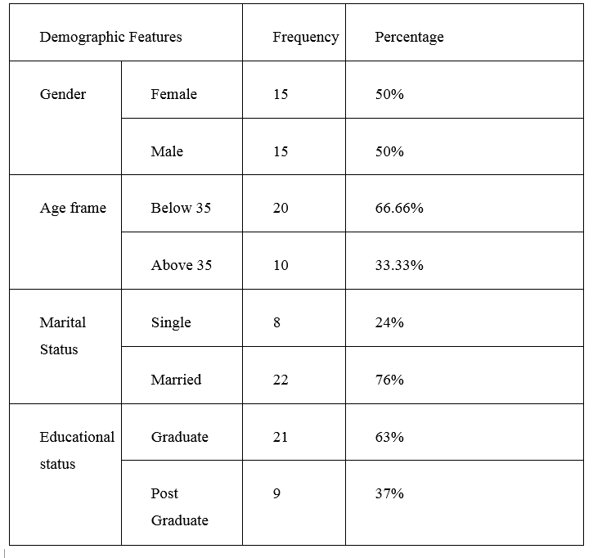
Figure: 1Demographic Information of the respondents
30 participants were selected from those 15 were male and 15 were female to make sure that the biases reduced to the maximum. The participants were selected from random age and educational background to make sure that the research is free from all kinds of biases and the result is a reliable one as depending only one population will be reducing the efficiency and reliability of the research.

Analysis and Findings

Descriptive Statistics
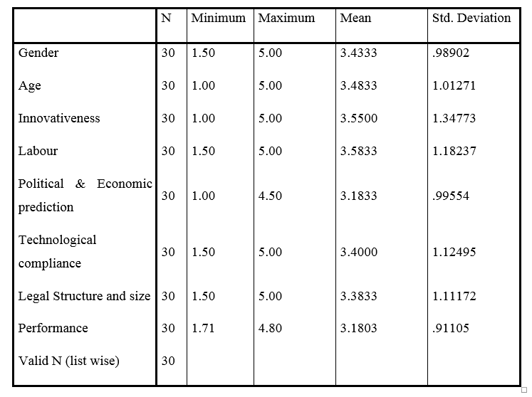
Figure: 2 Descriptive Statistics
While researching with the 30 participants with 15 male and 15 female SME entrepreneurs, it has been found that the mean of Gender is 3.4333 and the standard deviation is .98902 which is a good sign as it doesn’t have many deviations. The age of the entrepreneur has shown a mean of 3.4833 and the standard deviation is 1.01271. There is a fluctuating result about the innovativeness of the result as the mean here is only 3.5500 and the standard deviation is 1.34773. In the case of labour handling, the result shows a mean of 3.5833 and the SD here is 1.18237 and in the case of right Political & Economic prediction the mean is 3.1833 and the SD is .99554. Technological adoption shows a mean of 3.4000 and SD of 1.12495 and legal structure and size of the business showed a mean of 3.3833 and SD of 1.11172 that is an expected result for the research with less deviation from the prediction. The dependent variable, performance of the SMEs shows a mean of 3.1803 and a standard deviation of .91105 that has proven that the hypothesis is showing the right way.
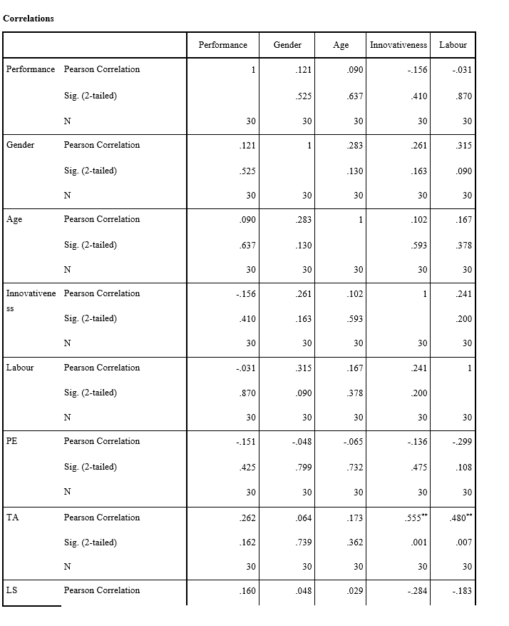
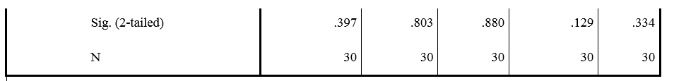
Figure: 3 Correlation analysis
**. Correlation is significant at the 0.01 level (2-tailed).

Correlation analysis
Correlation analysis is done to see the relation between the elements of the research variables. It tests the relationship between the dependent and independent variables of the research. In this research, the independent variables are gender, age, innovativeness, Labour handling, Political & Economic prediction, Technological compliance and Legal Structure and size with the only dependent variable performance of the SME businesses of Bangladesh. The correlation will show whether these independent variables have any kind of relationship with the dependent variable, the performance of SMEs in Bangladesh.
In the correlation model, the correlation between the performance and the gender of the entrepreneur shows a positive correlation as the correlation here is .121 in case of gender and the performance shows 1 and in case of age, the correlation is .090 that is a positive correlation between performance and age of the entrepreneurs. Innovativeness has shown a negative correlation with the performance as it shows -.156 correlation with the performance. Labour handling also shows a negative correlation with the performance with -.031 correlation and in case of political and economic prediction has shown a negative relation with the performance with having -.151 correlation. Technological compliance has shown a positive relationship as the success depends on the technology handling with a result of .262 and in case of legal structure and size of the business, the result is also positive as it shows .160 correlation with the business performance.

Regression analysis
Linear regression analysis is done to test the hypothesis at the beginning of the research. Here the depended variables are tested with the independent variables to show the relationship between the variables. 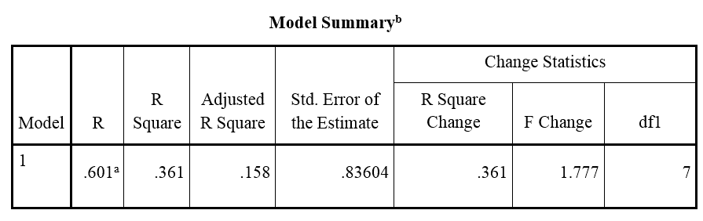
Figure 4 Regression analysis
In this regression analysis model, the regression model shows that 60.01% result of the variables and it is the correlation between the independent and dependent variables. The adjusted r square is .158 that is quite moderate. That means the independent variables of the study will create an impact of .158 to the performance of the SME businesses. The adjusted r square is quite moderate and it will be considered to have a very assertive impact on the model summary used here.

Coefficients analysis
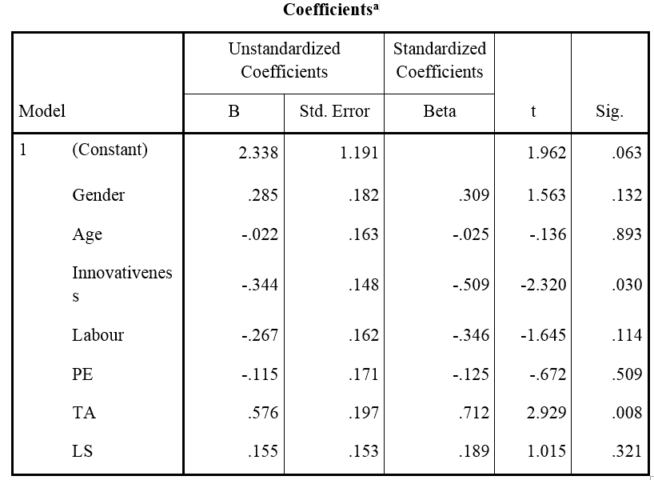
a. Dependent Variable: Performance
From the coefficient, it is seen that the Unstandardized Coefficients in the case of gender are .285 and the age shows a negative coefficient as it shows -.022 and the innovativeness also shows a negative coefficient of -.344 and the labour handling shows a negative coefficient of -.267. The political and economic prediction shows a negative coefficient as it shows -.115 and the technology compliance shows a positive coefficient as it shows .576 and the legal structure and size of the business shows a positive coefficient of .155. The dependent variable, the performance shows a positive correlation that is 2.338 and the standard deviation is moderate and that’s why it shows a relevant result in the case of coefficient analysis.

Findings
The finding and analysing the collected numeric data were made to show the impact of personal characteristics of the entrepreneur on the performance of the SMEs’ of Bangladesh as it was the study outcome (Jabbar, 2019). The performance is the dependent variable and the characteristics of the entrepreneur are the independent variable here in this research. The SMEs are doing quite great in this country as it has made employment for more than 80% industrial employee of the country and from 2016-18 it has created employment for more than 20 lakh employees per year as for the number of both men and women are increasingly becoming interested in entrepreneurship and as educated persons are joining this sector to make it more efficient than before (Hossain, 2019). The innovativeness of the entrepreneurs are helping them to survive and grow in this highly competitive market with large business firms and the innovativeness of this SME businesses are helping them to ensure economies of scale and scope, but in case of this research, the innovation showed a negative relation with the performance of the SMEs in Bangladesh due to instability in the market (Ali and Qun, 2019). As the government is nurturing the SME sector, the SMEs are getting high preferences from the banks in case of taking a loan. But the loan amount is very low and 5 to 20 lakhs isn’t sufficient enough for them to run the business and 5% interest rate is too high for them and they are proving themselves efficient though they are facing financial crisis as funding is very tough for them (Hossain, 2017). The main interesting factor of this country is the low-cost labour force and the entrepreneur is making proper use of them as they are training them properly to get the highest production along with the low cost of the labour force, but as the employees aren’t well trained, the labour handling shows a negative regression and correlation result in case of this research (Sultana, 2017). This country is full of natural resources along with huge human capital, it is helping the entrepreneur to capitalize on this chance and get the maximum result out of it. Technological advancement is helping the innovation but most of the time it is harming them as they aren’t that much capital intensive and political and economic instability is harmful to them though they have remained successful after all this year where all kind of business faced the bad side of external force and that’s why the sector is flourishing, technology has shown a positive result in every test in this research that proves that there is a positive relationship between the performance with it (Jalil, et al 2017). The financial crisis of this sector has been mentioned by several writers in their journal as they mentioned the financial crisis of this sector as 5 lakh to 20 lakh loan isn’t enough to run the business with 5% interest rate and the women entrepreneur aren’t getting as much as they are supposed to get as only 4,157 crores from the 11,192 crores as SME loans so far and only 10% women entrepreneur will be found throughout the country and that’s why the political and economic factor has shown a negative result with this study (Begum and Abdin, 2015). The legal structure and size of the business have shown a positive relationship as it was proven by several writers that only 10% of the SME business failed with large size. The SMEs should increase the size of the business in order to make that they survive in the competition as it is recommended by many writers and the result shows a positive correlation between the size and performance of the business, companies get extra facilities while having an individual entity like a person and that’s why the correlation shows a positive result.

Conclusion
The SME sector of Bangladesh is booming as the population of this country is facing the transition face where people between 15 to 49 are approximately 60% of its total population and as a result, the need for SME business is increasing and as a result of increasing demand for employment and growth of the economy. The SMEs are employing almost 80% of the total industrial employment and more than 31% of the GDP is provided by this sector. This SME sector is flourishing as because of some talented businessman those are continuously working for the betterment of the business and that’s why they should continuously focus on the innovation as the worlds’ SMEs are doing great by continuously innovating the business methods and products. As some writers said, the entrepreneurs are born entrepreneur and that’s why the entrepreneurship needs some basic characteristics that make the businessman different from others and that’s why the more an entrepreneurial characteristic a person has, the more he can get success and 30 respondent SME entrepreneur has shown their interest and those have provided some characteristics that make the business performance a success in this country. Those are lacking business structure and possible financial structure, they are flourishing by their entrepreneurial performance. This study aimed to show the relationship between the characteristics and the performance of the SMEs in Bangladesh and the entrepreneurial characteristics are provided by the respondent of the research that has shown the relation between the entrepreneurial characteristics and business performance of Bangladesh.

Recommendations
Though the performance of the SMEs is very satisfying in this country despite it doesn’t get proper treatment from the government and other sources because of a lack of financial and legislative power, it is flourishing for firm characteristics of the entrepreneur to stay competitive in this era. The SMEs should be increasing the technological involvement in their business it is the main success factor in this competitive era and that’s why the business of this country can’t compete in the global market though they are doing their best in the local market. That’s why technological involvement should be increased to get maximum market coverage.
Another problem for SMEs is the financing problem as they aren’t innovating properly to remain competitive in the competition and that’s why the innovation should be increased to make the SMEs more competitive and induce the chance of employment in the country as it is arranging 80% of the total employment of the country.
The human resource is the main source of competitive advantage for the SMEs in Bangladesh and that’s why they are working well by capitalizing the human resource to increase their profit, but they aren’t getting to fulfil their expectations as the labour force aren’t highly developed and that’s why it is a precondition for the entrepreneur to make sure that the employees are trained properly to reduce the wastage and increase the profit and success of the business.
Young educated persons should join the SME business to make sure that it doesn’t show a negative coefficient in the future time as it needs the more educated person to enter and make sure they succeed in the competition. The education has shown a positive correlation with the performance of the SMEs and that’s why the educated persons should be motivated to join the SMEs to make sure that the SME sector remains competitive with the large firms.
They just need to capture some local supplier and foreign supplier of cheap materials to make sure that the cost of purchasing can harm their business and the supplier are hampering their activities by increasing monopolistic approach and that’s why they should work in a team to reduce the bargaining power of the suppliers to make sure that they can reduce the cost of production to minimum.

Reference
Abdin, J. (2018). Role of SME clusters in Bangladesh economy. Arts & Humanities Open Access Journal, 2(3).
Ahmed, K. and Chowdhury, T. (2018). Performance Evaluation of SMEs of Bangladesh. International Journal of Business and Management, 4(7).
Akther, R. and Afroz, F. (2018). Determinants of Access to Finance for Women-Owned SMEs in Bank Loans in Bangladesh. Al-Barkaat Journal of Finance & Management, 10(1), p.34.
Ali, M. and Qun, W. (2019). STRATEGIC MANAGEMENT PRACTICES AND PERFORMANCE OF THE SME S IN BANGLADESH. International Journal of Advanced Research, 7(1), pp.69-78.
Arief, M., Thoyib, A., Sudiro, A. and Rohman, F. (2016). The Effect of Entrepreneurial Orientation on the Firm Performance through Strategic Flexibility: A Study on the SMEs Cluster in BD. Journal of Management Research, 5(3).
Begum, A. and Abdin, M. (2015). Employment Generation and Poverty Alleviation through SME Cluster Development in Bangladesh. SSRN Electronic Journal.
Bhandari, S. (2014). Legitimacy, Authority, and Validity of Law: An Integrated Approach to Legal Positivism and the Methodology of Welfare-Grundnorm. SSRN Electronic Journal.
Blanchard, K. (2017). Entrepreneurial Characteristics in SMEs: A Rural, Remote Rural, and Urban Perspective of Lincolnshire Businesses. Strategic Change, 22(3-4), pp.191-201.
Buri, R. (2016). Deductive and Inductive Instrumentation. Western Journal of Nursing Research, 3(3), pp.45-48.
Basilico, E., Mantovani, G. and Mestroni, M. (2016). Corporate Governance, Performance and Firm Characteristics of Productive Chain Networks in Entrepreneurial SMEs in South Asia. SSRN Electronic Journal.
Endi Sarwoko, E. (2017). Entrepreneurial Characteristics and Competency as Determinants of Business Performance in SMEs. IOSR Journal of Business and Management, 7(3), pp.31-38.
G., M. and U., A. (2018). Strategic Planning and Performance of Bangladeshi SMEs: The Moderating Role of Entrepreneurial Characteristics. Journal of Economics and Behavioral Studies, 9(6), p.98.
GOODWIN, L. and GOODWIN, W. (2015). Qualitative Vs. Quantitative Research or Qualitative and Quantitative Research?. Nursing Research, 33(6), pp.378-384.
Hadi, A. (2017). Entrepreneurial Orientation and Financial Performance of SMES:. Journal of Management and Training for Industries, 4(1), pp.25-41.
Hoque, M., Sultana, N. and Thalil, T. (2016). Credit rationing’s determinants of Small and Medium Enterprises (SMEs) in Chittagong, Bangladesh. Journal of Global Entrepreneurship Research, 6(1).
Hossain, F. (2017). Prospects and Threats of Women Entrepreneur in SME Sectors in Urban Area Bangladesh- A Study on Sylhet City. IOSR Journal of Business and Management, 19(01), pp.08-13.
Hossain, M. (2019). Comparative Analysis of SME Policy: The Takeaway for Bangladesh. European Journal of Business and Management.
Islam, N. (2016). Factors Determining the Success of SMEs in Bangladesh. SSRN Electronic Journal.
Jabbar, A. (2019). SME Financing and Entrepreneurship Development in Bangladesh: An Impact Analysis. European Journal of Business and Management.
Jalil, M., Roksana, F. and Alam, M. (2017). Management Development for Women Entrepreneurs in the SME Sector of Bangladesh. IOSR Journal of Business and Management, 16(1), pp.81-87.
Karim, S. and Gide, E. (2019). The challenges and opportunities of E-banking adoption for SMEs in Bangladesh. Global Journal of Information Technology: Emerging Technologies, 9(1), pp.1-11.
Miltos (2019). Implementation and Effective Utilization of Analytical Tools and Techniques in Knowledge Management. International Journal of Recent Technology and Engineering, 8(2), pp.6469-6482.
Powell, M. (2017). The Economic Efficiency of Sampling Size: The Case of Beef Trim Revisited. Risk Analysis, 33(3), pp.385-396.
Richard (2017). LIKERT: An APPLESOFT program for the construction, administration, and scoring of Likert scales. Behavior Research Methods & Instrumentation, 15(1), pp.97-98.
Sarkaria (2017). Impact of Industry Type and Firm Characteristics on Firm-level Financial Performance— Evidence from Bangladeshi Industry. The Journal of Entrepreneurship, 8(1), pp.25-44.
Shariful Alam, M., Rajib, S. and Arefin, M. (2016). Critical Success Factors of Re-Engineering in the Production Process: SMEs Sector of Bangladesh. Applied Mechanics and Materials, 44-47, pp.804-808.
Siems, F., Kraus, S. and Pollok, P. (2018). Entrepreneurial pricing: characteristics and implications of pricing in SMEs and start-ups. International Journal of Entrepreneurship and Small Business, 16(4), p.436.
Silver, L., Johanson, M. and Berggren, B. (2016). Entrepreneurial orientation, control aversion and performance in SMEs: the contribution of equity investors. Problems and Perspectives in Management, 14(3), pp.55-64.
Sultana, A. (2017). Promoting Women’s Entrepreneurship through SME: Growth and Development in the context of Bangladesh. IOSR Journal of Business and Management, 4(1), pp.18-29.
Van Ness, R. and Seifert, C. (2015). A Theoretical Analysis of the Role of Characteristics in Entrepreneurial Propensity. Strategic Entrepreneurship Journal, 10(1), pp.89-96.

Appendix
Questionnaire
Demographic Features |  | Frequency | Percentage
Gender | Female | 20 | 40%
Gender | Male | 30 | 60%
Age frame | Below 35 | 22 | 44%
Age frame | Above 35 | 28 | 56%
Marital Status | Single | 17 | 34%
Marital Status | Married | 33 | 66%
Educational status | Graduate | 37 | 74%
Educational status | Post Graduate | 13 | 26%

Analysis and Findings
Variables | Questions | Strongly agreed | Agreed | Neutral | Disagreed | Strongly disagreed
Gender of the entrepreneur | Being a woman is creating a hurdle in doing the business
Gender of the entrepreneur | The discrepancies are reducing due to the government laws to facilitate the small and medium business
Educational background | Being educated is helping the entrepreneur to do the business more properly
Educational background | Educational soundness is not a vital factor in doing SME businesses in Bangladesh
Innovativeness | Being innovative is a must to ensure the survival and growth of the business by competing with large firms
Innovativeness | It is not possible to remain in the business era without being innovative and compete with the large giant
Labour efficiency | Managing the employees properly is a key to attain success in the market
Labour efficiency | Getting high skilled employees at the lowest possible cost is the key to success in this competitive business era with large business firms
Awareness about the political and economic environment | Being cautious about the political and economic environment is the key here as it is very much unstable
Awareness about the political and economic environment | Technological factor is one the vital force that is needed to be taken care of properly
Technological Advancement | Being aware of technological change and being a change maker is the key here
Technological Advancement | It is okay to get success with a small and medium-sized business
Legal form and Size of the business | It is okay to get success with a small and medium-sized business
Legal form and Size of the business | Being a company and moderate-sized is helpful to get success in this market

Variables | Questions | Strongly agreed | Agreed | Neutral | Disagreed | Strongly disagreed
Gender of the entrepreneur | Gender has a impact on the performance of the business
Educational background | Education has an influence on the performance of the business
Innovativeness | Innovation is the most important factor in business performance
Labour efficiency | Labour handling is one of the major influencer of the success of the business
Political and economic factor awareness | Reactiveness to political and economic factor is the key
Technological Advancement | Being proactive to technological change is one the vital success factor of SMEs
Legal form and Size of the business | Large sized SMEs get more success than the smaller one

