Research In Practice ADAD5004.
Independent Project Proposal by Emily Jones

Student Name: Emily Jones
Student Number: 2200404
Module: ADAD5004 Research in Practice
BA Course: Design Craft
Tutor: Julia Lockheart
Word count: 2503
Three keywords: Biomorphism, Ceramic, Feminism.

The content of this writing delves into three keywords, supported with images and artist, with the objective to form a better understanding and provoke curiosity stimulating a pathway for exploration of a series of questions. Through a synthesis of knowledge, analysis and theory this essay aims to contextualise the key principles of the following keywords, Biomorphism, Ceramic and Feminism. Drawing from scholarly sources like Nochlin, Napikoski and Berger, I will demonstrate a practical application of concepts, linking theoretical frameworks to real-world examples such as artworks by Jean Arp and Henry Moore and more.
Keyword 1: Biomorphism
Biomorphism is a design methodology shaped by the inspiration of patterns, forms and textures found naturally occurring in nature and biological organisms. For instance, artists may emulate rhythmic patterns formed within plants as a foundation design concept to manipulate the creation of architecture, sculptures, paintings etc (Morgan, 2018). “Biomorph” was invented by English anthropologist Alfred Cort Haddon in 1895 and then applied to modernism by English critic Geoffrey Grigson in 1934, before being adopted by Alfred Barr in his 1936 publication of modernist movements ‘Cubism and Abstract Art’ (Higgie, 2021). During the aftermath of World War I, numerous European artists grew an interest in psychology and physical sciences, drawing inspiration from both the hidden symbols from the subconscious and the observable internal structures and organisms constituting the human body (Seiferle, 2019). The term Biomorphism evolved from roots of Dada and surrealism, creating a spontaneous expressionism art approach. The fluid method of artistic creation aligns with semiotics, enhancing the emotional, expressive, and evocative aspect of an artifact. Distinguishing biomorphic art pieces is as simple as recognising an organic shape, form or patten. Biomorphic art could also be better understood through the lens of semiotics, the study of signs and symbols and their meanings. In Ferdinand de Saussure’s research, the signifier represents the physical form of the sign, such as the visual elements of biomorphic art, such as curves, textures and patters resembling natural forms. The signified represents the conceptual or abstract meanings associated with the forms, such as ideas or growth, vitality or harmony with nature (Sørensen & Thellefsen, 2022). Although biomorphic art diverges from traditional artistic methodologies by exaggerating abstraction, the recognisable response to signifiers within the work communicates the signified emotions associated with biophilia.
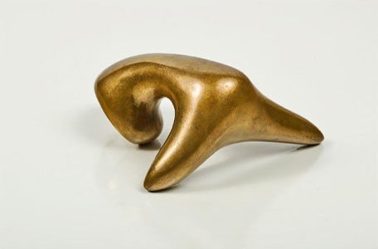
Figure 1, Jean Arp, Homme Vu Par Une Flur (Man seen by a flower) 1958.
For example, biomorphic work might include allusions to the human body, like figure 3 by Jean Arp. ‘Man seen by flower’ is emblematic of biomorphic art, the exaggeration of human form compels the viewer to view this piece semiotically seeing the signifier as an organic shape while the signified is the human body (Harris , 2018).
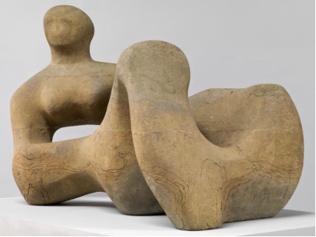
Figure 2, Recumbent Figure, Henry Moore, 1938.
Building upon the principles of Biomorphism, Henry Moore was a pivotal figure in 20th century sculpture known for his contributions to modern art, infusing his works with a profound sense of organic form and human connection. Moore’s artistic evolution spanned both World Wars drawing from diverse influences, from primitive art to surrealism leading to a development of his own distinct aesthetic. Through materials such as bronze and stone, Moore crafted sculptures that evoke a sense of humanity and interconnectedness with nature. Figure 4 depicts one of Moore’s sculptural forms which not only acknowledges biology but also invites various interpretations. Geoffrey Grigson in his 1943 monograph titled ‘Henry Moore’, described the curves in Moore’s work as ‘may be related to a breast, or a pear, or a bone, or a hill, … but they might also relate to the curves of a human embryo, to an ovary … or to a single celled primitive organism.’ (Juler, 2015). This suggests that Biomorphism in art introduces a feeling of familiarity into the artwork, triggering emotions of connection, particularly in today's world where nature is under threat.

Keyword 2: Ceramic
Ceramic encompasses a diverse and ancient art form that has evolved over millennia. It is a solid compound formed by the application of heat, typically in a kiln, as defined by Kingery “the art and science of making and using solid articles” (Barsoum, 2019). Ceramics hold fascination, stemming from the natural presence of clay in subterranean layers. This clay results from the gradual disintegration of granite and gneiss rocks, constituting approximately 81% of the Earth's crust (Rawson, 1984). While ceramics are most frequently associated with pottery, sculptures, tableware, and tiles, they have a wide range of applications. Engineered ceramic materials are utilized in different industries, including aerospace, electronics, automotive, and medical fields, owing to their distinctive qualities such as strong heat resistance, electrical insulation, corrosion resistance, and mechanical strength (Ceramics industry worldwide, 2018). Yet, the scope of ceramics extends far beyond mere function; ceramic can be said to be a base of artistic expression and exploration. The composition, decoration, shape and manufacturing methods of pottery, in the context of archaeological recovery, can offer opportunities to explore numerous areas, including cultural shifts, colonization effects, individual identities, social and economic statuses, evolving culinary consumption habits, trade patterns, and technological advancements and industrialization (Hicks & Beaudry, 2008). Pottery can be an indicator of how ancient people interacted with the environment and each other. The embellishment on ceramic vessels tells us about the beliefs and lifestyles of their era.
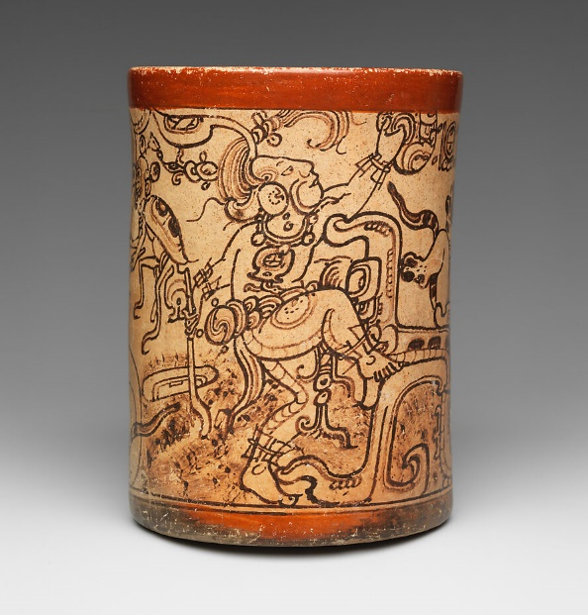
Figure 3, Vessel with a Mythological Scene. The Metropolitan Museum of Art, May 2023.
For example, figure one shows a cylindrical drinking cup that was expertly fashioned by the Metropolitan Master, a renowned Maya vase painter, containing one of the deity portraits from the classic Maya corpus. This ceramic vessel features complex embellishments that offer a captivating glimpse into history. The artwork depicts the young rain deity, Chahk, in fine detail, set against a rich tapestry of mythological tales and symbolic themes. Every element has a purpose, from the elaborate necklace with extruded eyeballs and hieroglyphs to the legs with their scale patterns that suggest images of aquatic life (Doyle, 2016). The vessel also shows the appearance of otherworldly entities like the death god and the baby jaguar. Historians can learn stories about societal standards, religious rites, and cultural beliefs by closely examining these ceramic embellishments. This illustrates the significance of ceramic art as a preservative medium for ancient beliefs and activities.
Not only does ceramic art serve at reflecting the aesthetics, beliefs, and traditions of diverse societies over the years, but it’s also a versatile medium for creative expression. We can appreciate ceramics not only through archaeology but also through the lens of semiotics. Semiotics in ceramic art explores the complex interaction of visual, tactile, and symbolic elements, revealing the depth of meaning within each artifact. Through analysis of motifs, patterns, techniques, and materials, semiotics reveals how ceramics convey cultural, social, and personal stories, elevating these simple vessels to vehicles of artistic expression and communication. Aristotle was the first to propose the connection between core and form in art, with form serving as the principal element and content as the helping factor. He contended that form, while not flawless enough to depict absolute reality, serves as the foundation of reality (Chandler, 2022). In ceramic art, the content signifies the meaning given to a piece, such as moulding a clay into diverse natural forms like a body or organic items to elicit specific emotions and feelings. Clay, glaze, and other materials are employed to transform these signified into tangible forms. Clay, glaze, raw materials, and kilns are some of the physical materials employed, but the product made from these elements is the focus. Signs of a ceramic artwork include both physical forms and the decorative narration (Şişman, 2006).

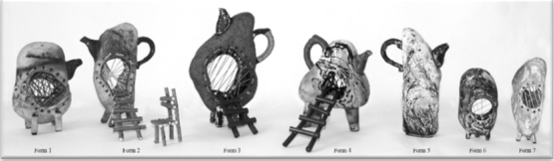
Figure 4, The village of stone teapot, Gaia international Art biennial, 2017.
In the exploration of ceramic art through the lens of semiotics, Figure 2 exhibits work of an unknown artist but exemplifies how clay manipulation elevates a conventional teapot into a central art piece with ample perceptions. Despite its stone-like appearance, the modified teapot conveys the signified concept of modernism. This is highlighted by the spout and hollow forms, which accentuates the solitude prevalent in current individualistic lifestyles, perhaps echoing societal trends towards modern technology and the diminished use of traditional utensils such as the teapot. Building on previous discussion into ceramics from an archaeological perspective, the incorporation of hollow teapots paired with stairs, when viewed through the prism of semiotics, may symbolize modern concerns regarding social hierarchy and the fragility of status, evoking imagery of ascent and descent into emptiness (Serinsu, 2017). Both figures demonstrate the intriguing potential of ceramic, whether through expressive abstract forms or the preservation of ancient knowledge and materials.
Keyword 3 – Feminism
Feminist theory in art looks at how politics, gender and art are all intertwined from a feminist standpoint. With an emphasis on the experiences, visibility and representation of females. It critiques art and power dynamics concerning gender inequality, the objectification of women’s bodies and the marginalisation of female artists (Napikoski, 2019).
The first Feminist challenge was imposed in 1971 with a publication by Linda Nochlin, “Why Have There Been No Great Women Artists?”. An essay examining how societal norms, cultural attitudes and individual experiences related to gender, sexuality and social status influence the development of artistic talent. This was followed by another publication by Nochlin in 1972 entitled “Eroticism and the Image of Women in Nine-Teeth-Century Art” which highlighted sexism with the rapid mutation of the perception of women due to the male dominated art world’s representation of female sexuality and identity (Broude, 2018). Nochlin’s book states that eroticism in art is deeply ingrained and predominantly focused on the male gaze and pleasure. The book highlights that in the 19th century a large proportion of art was centred around men’s desires and that there was a total dismission of art aimed for women’s erotic desires. The lack of art revolving the male body for women’s pleasure isn’t due to deliberate male bias in the arts, but due to the societal norms and relationships between men and women (Nochlin, 1988). Relating to the first book that questions why there has been no greatly recognised female artists, one could infer that men were profoundly recognised for their art as they catered for other men’s pleasures, as said by Nochlin, imagery has always been created about women for men’s pleasure, by men.
To gain insight into the disparity in gendered social presence, one may turn to Chapter 3 of John Berger’s ‘ways of seeing’. Berger states that ‘a man’s presence is dependent upon the promise of power which he embodies’ and shows ‘what he is capable of doing to you or for you’, emphasising the male’s external power. Whereas the woman’s presence is expressive of ‘her own attitude of herself and defines what can and cannot be done to her’. This highlights the way that women are raised to constantly monitor and evaluate themselves. Another quote of Berger, ‘To be born a woman has been to be born, within an allotted and confined space, into the keeping of men’ expressing that to be a woman means restriction to a limited role dictated by men. Berger also refers to women as a ‘physical emanation’ and that a woman must continually watch herself as her being is to be perceived, creating an energy to men that is comparable to something palpable such as warmth or scent. This can be condensed to: Men do, Women appear (Berger, 2008). This relates to Nochlin’s first book, where the central focus is on how male artists primarily depict women’s presence from the perspective of the male gaze. In current day the female body is constantly showcased. In the book of ‘The Female Body as Spectacle in Nineteenth- and Twentieth-Century Western Art’, Cronje discussed the eroticism and over sexualisation of the female body in art, stating that the exchange of gaze reveals power dynamics, particularly sexual differences. Looking is seeking knowledge and pleasure yet also serves power, manipulation, and desire. This along with the idea that the presence of a man is the perceiver while the woman is the perceived, reinforces the idea that woman are subjects to the male gaze leading to objectification and eroticization (Cronje, 2001).
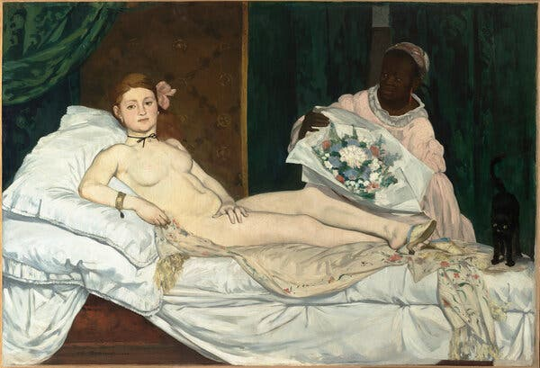
Figure 5, Édouard Manet’s painting “Olympia”, 1863.
Eduard Manet’s painting “Olympia” was one of the “most controversial” paintings from the Nineteenth Century. This painting was the subject to scrutiny and outrage during it’s time. The image clearly depicts a nude female figure glaring at the viewer. This female was made to portray a prostitute which far strayed the usual nude images of mythological women. She is relaxed with only her hand covering her genital area, ironically drawing more attention to it (Plessis, 2023). The woman in "Olympia", who is suspected to be a prostitute, is shown in a passive, reclining pose, emphasising her availability and objectification. She is shown as a desirable item, existing purely for the viewer's enjoyment. This placement perpetuates the recently addressed power relations, with the lady being subject to the viewer's gaze (Lipton, 2023). However, this piece was also considered to be the beginning of Modernism and interpreted as challenging traditional depictions of female sensuality rather than oversexualizing women. In comparison to other paintings such as “The Birth of Venus" by Sandro Botticelli, Manet depicted the female form in its correct anatomy deviating from the usual idealised female sensuality. The painting can also be interpreted with a new from of female identity as Olympia’ s gaze contrasts to the usual as she is looking unabashedly at the viewer in a way in which suggests that she has the power and control over her sexuality (Moore, 1989).

After a critical analysis of each keyword, I can explore the interconnectedness of each which spark inspiration for further questioning. I am mostly drawn to the connection of Biomorphism and feminism leading me to questions such as, “How artists use Biomorphism to challenge traditional notions of form and representation, blurring the lines between the natural and the artificial” stemming from the work of Manet which challenged visual feminine beauty by considering the natural essence of the human form. Another way to approach this topic would be “In what ways does biomorphic art offer alternative perspectives on femininity that diverge from mainstream narratives and representations?” or “How do artists navigate the balance between celebrating femininity and critiquing societal expectations of women in their work?”. All these questions are open to sub questions which can delve deep into different ideas and theories surrounding the very interesting topic of the portrayal of women, not only in art but as a society. These questions allow not only analysis of what recurring themes or motifs are present in artworks that suggest either celebration or critique of femininity but also audience reaction to the characterization of gender. In conclusion, my research question for my individual project will focus on examining the portrayal of women across art history, encompassing aspects such as visual representation, the lived experiences of artists, and broader theories concerning gender dynamics and power structures.

Bibliography
Barsoum, M.W. (2019) Fundamentals of Ceramics. Boca Raton, FL: CRC Press, Taylor & Francis Group
Berger, J. (2008) Ways of seeing. London: Penguin.
Broude, N. (2018) Feminism and art history: Questioning the litany. Routledge.
Chandler, D. (2022) Semiotics: The basics. Abingdon, Oxon: Routledge, Taylor & Francis Group.
Cronje, K. (2001) The female body as spectacle in nineteenth- and twentieth-century western art. Stellenbosch : Stellenbosch University.
Doyle, J. (2016) Unrolling the ceramic canvases of maya painters, The Metropolitan Museum of Art. Available at: https://www.metmuseum.org/articles/unrolling-maya-ceramic-canvases (Accessed: 27 March 2024).
Du Plessis, A. (2023) ‘Olympia’ manet - an analysis of Edouard Manet’s Olympia Painting, Art in Context. Available at: https://artincontext.org/olympia-manet/ (Accessed: 14 May 2024).
Harris , G. (2018) Jean Arp, Frieze. Available at: https://www.frieze.com/article/jean-arp (Accessed: 28 March 2024).
Hicks, D. and Beaudry, M.C. (2008) The Cambridge Companion to Historical Archaeology. Cambridge: Cambridge University Press.
Higgie, J. (2021) The Tate etc.. guide to... Biomorphism – Tate etc, Tate. Available at: https://www.tate.org.uk/tate-etc/issue-52-summer-2021/guide-biomorphism-jennifer-higgie (Accessed: 28 March 2024).
Juler, E. (2015) Life forms: Henry Moore, morphology and biologism in the interwar years, Tate. Available at: https://www.tate.org.uk/art/research-publications/henry-moore/edward-juler-life-forms-henry-moore-morphology-and-biologism-in-the-interwar-years-r1151314 (Accessed: 28 March 2024). .
Lipton, E. (2023) Manet: A radicalized female imagery, Artforum. Available at: https://www.artforum.com/features/manet-a-radicalized-female-imagery-209702/ (Accessed: 15 May 2024).
Moore, L. (1989) ‘Sexual agency in Manet’s Olympia’, Textual Practice, 3(2), pp. 222–233. doi: 10.1080/09502368908582060.
Morgan, A.L. (no date) ‘Biomorphism’, The Oxford Dictionary of American Art and Artists.
Napikoski, L. (2019) How the feminist movement and women’s experience changed the Art World, ThoughtCo. Available at: https://www.thoughtco.com/the-feminist-movement-in-art-3528959 (Accessed: 08 April 2024).
Nochlin, L. (1988) Women, art, and power: And other essays. Boulder, CO: Westview Press.
Rawson, P. (1984) Ceramics. Philadelphia: University of Pennsylvania Press.
Serinsu, B.A. (2017) Transition of natural forms into ceramics and the evaluation of a group of ceramic works from the semiotical perspective, Academia.edu. Available at: https://www.academia.edu/81660860/Transition_of_natural_forms_into_ceramics_and_the_evaluation_of_a_group_of_ceramic_works_from_the_semiotical_perspective (Accessed: 27 March 2024).
Sørensen, B. and Thellefsen, T. (2022) Ferdinand de Saussure in Contemporary Semiotics. Language and Semiotic Studies, Vol. 8 (Issue 1), pp. 1-5. https://doi.org/10.1515/lass-2022-080101
Şişman, A. (2006). Sanat ve Sanat Kavramlarına Giriş. İstanbul: Literatür Yayınları.
No Name, Ceramics industry worldwide (2023) Statista. Available at: https://www.statista.com/topics/8686/ceramics-industry-worldwide/ (Accessed: 27 March 2024).
Figures –
Figure 1, Jean (Hans) Arp (no date) Homme vu par une fleur (Man Seen by a Flower) | Buffalo AKG Art Museum. Available at: https://buffaloakg.org/artworks/1979217-homme-vu-par-une-fleur-man-seen-flower (Accessed: 28 March 2024).
Figure 2 -Erswell, A. (2022) Sculpture & the human form: The role of Henry Moore’s recumbent figure in Ferris Buller’s day off, Norman Rea Gallery. Available at: https://www.normanrea.com/blog/sculpture-and-the-human-form-the-role-of-henry-moores-recumbent-figure-in-ferris-bullers-day-off (Accessed: 28 March 2024).
Figure 3, The Metropolitan Museum of Art, The Michael C. Rockefeller Memorial Collection (May 2023) Vessel with a Mythological Scene. Accessed at Lives of the gods: Divinity in maya art (no date). Available at: https://kimbellart.org/maya-gods (Accessed: 25 March 2024).
Figure 4, Serinsu, B.A. (2017) Transition of natural forms into ceramics and the evaluation of a group of ceramic works from the semiotical perspective, Academia.edu. Available at: https://www.academia.edu/81660860/Transition_of_natural_forms_into_ceramics_and_the_evaluation_of_a_group_of_ceramic_works_from_the_semiotical_perspective (Accessed: 27 March 2024).
Figure 5, Lipton, E. (2023) Manet: A radicalized female imagery, Artforum. Available at: https://www.artforum.com/features/manet-a-radicalized-female-imagery-209702/ (Accessed: 15 May 2024).

