

Program Name: Certificate in Higher Education: Health and Social Care
Assignment Title: Problem Solving and Decision Making
Module Code: BMSW4004
Lecturer Name: Dr Anupan Mazumdar
Submitted By:
Student Name: Joseph Bangura
Student ID: 1818368

Date of Submission: 07/01/20

Contents
Introduction 1
Defining The problem: Skill gaps and performance issue in the health and social care and its scopes and impacts 2
Literature review of problem: Skill and proficiency problems in the social and health care industry 4
Personal experience 5
Decision-making technique to evaluate the problem 6
Identifying the cause of the problems with fishbone analysis 8
Evaluation of the solutions 11
Implementing the solution 12
Communicating to the stakeholders 15
Conclusion 16
References 17

Introduction
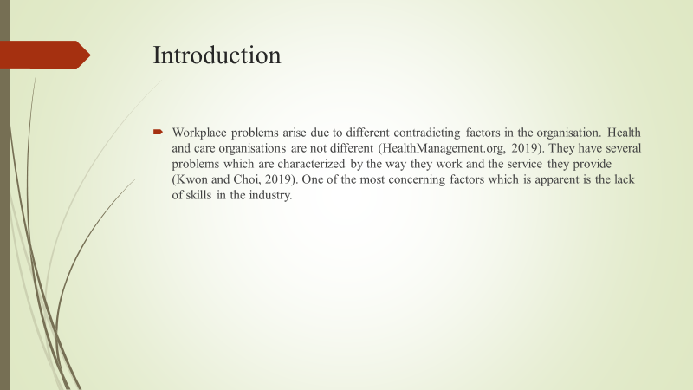
Workplace problems arise due to different contradicting factors in the organisation. Health and care organisations are not different (HealthManagement.org, 2019). They have several problems which are characterized by the way they work and the service they provide (Kwon and Choi, 2019). One of the most concerning factors which is apparent is the lack of skills in the industry.

Defining The problem: Skill gaps and performance issue in the health and social care and its scopes and impacts
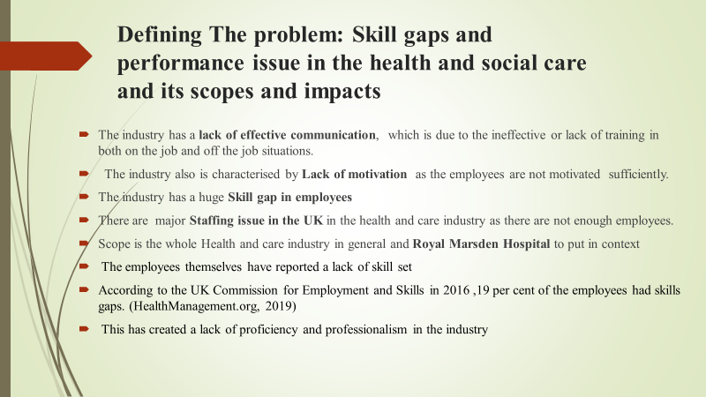
The health and social care industry in the UK is a sector which has several problems due to the immense size and scope of the industry. Over the past years, the industry has faced problems like lesser effective communication, lack of empathy in the employees and lack of motivation by the supervisors or managers (HealthManagement.org, 2019). But one of the most noticeable ones is the skill gap of the employees. This has raised a concerning statistics in the sector. This issue is complemented by the staffing issue in the UK in its healthcare industry. Both the social care and the e health care industry is supposed to be based on communication but they are at fault of not having effective communicative skills.
For the purpose of this report, Royal Marsden Hospital is chosen as an example.
Scopes and impact of the problem
Health industry and the social care industry has faced serious complaints from consumers for lack of employee efficiency in the sector (Investopedia, 2019). The employees themselves have reported a lack of skillset in their workforce which affects how a healthcare industry organisation works. According to the UK Commission for Employment and Skills in 2016 19 per cent of the employees had skills gaps in the industry (HealthManagement.org, 2019). This has created a lack of proficiency and professionalism in the industry. The scope of the problem is the whole health care industry in general and the Royal Marsden Hospital specifically to put in context.

Literature review of problem: Skill and proficiency problems in the social and health care industry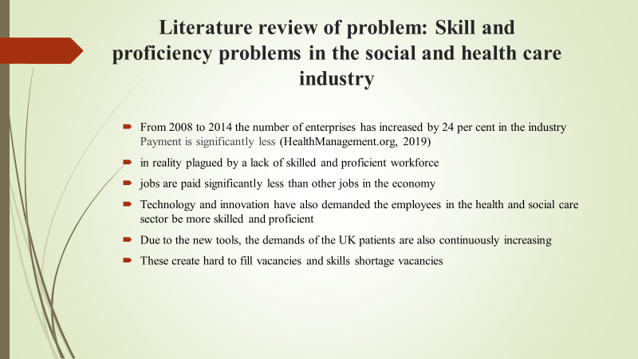
Reports suggested that the health and social care sector has seen a large increase in health enterprises. From 2008 to 2014 the number of enterprises has increased by 24 per cent in the industry (HealthManagement.org, 2019). Although this seems like an improvement for the industry it is in reality plagued by a lack of skilled and proficient workforce. Although the sector is indeed the largest sector in the UK economy, this lack of skills is hampering the whole industry and the UK economy as well. But over time the health industry has seen a lot of 30-44 years employees in the workforce instead of the young workforce in the organisation (Investopedia, 2019). Again, the health and social care jobs are paid significantly less than other jobs in the economy. The industry is also changed by many factors which affect the required skills and proficiency of the employees. One of the most important factors is the changing average ages of service takers. Technology and innovation have also demanded the employees in the health and social care sector be more skilled and proficient and can integrate their work with technology (Kwon and Choi, 2019). Due to the new tools, the demands of the UK patients are also continuously increasing. With the lack of a young workforce, the healthcare industry is facing problems regarding workspace as they do not retain the information or training, they are given. This creates hard to fill vacancies and skills shortage vacancies. Royal Marsden Hospital is also experiencing lack of skill set and communication.

Personal experience
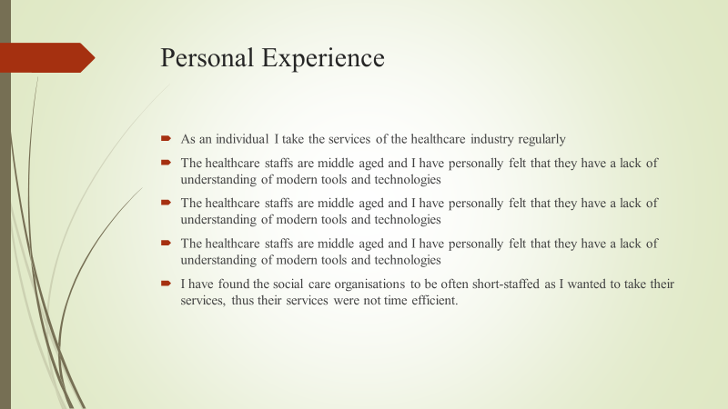
The literature review on the healthcare industry is much more relevant at a personal level. As an individual, I take the services of the healthcare industry regularly and have faced much of the problems first hand. The primary scene at healthcare or social organisation in the lack of young staffs. The healthcare staffs are middle-aged and I have personally felt that they have a lack of understanding of modern tools and technologies. The healthcare staffs are middle-aged and I have personally felt that they have a lack of understanding of modern tools and technologies. Each year with new campaigns the healthcare staffs are middle-aged and I have personally felt that they have a lack of understanding of modern tools and technologies. I have found the social care organisations to be often short-staffed as I wanted to take their services, so their services take a longer time.

Decision-making technique to evaluate the problem
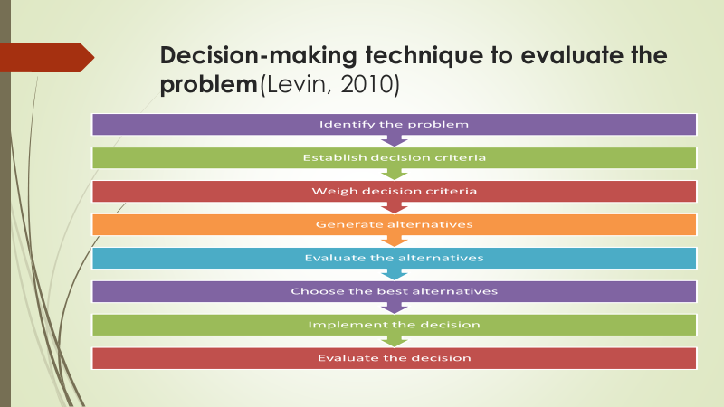
There are various decision-making techniques and models with which any organisation and follow. Different decision-making process helps an organisational. Differing models are used for different purposes in the organisation (Levin, 2010). There are various decision-making techniques available to modern businesses. Intuitive decision-making technique, rational decision-making technique, creative decision-making process and as such. In this presentation, the rational decision-making technique will be used to understand and choose a possible solution to the problem. This decision-making technique is also called the classical decision-making technique as it is used long since. The technique is made of 8 steps which identify the problem, establish the criteria under which the problems will be judged, weigh the problem under the criteria, generate and evaluate the alternatives.
In the primary step of the report the problem is identified (Morgon, 2016). To decide on the possible solution to this problem some criteria should be recognized. Primarily as there is a lack of skills noticed in the industry, the possible solution should then increase the lack of skills. But there are secondary criteria to fulfil like the solution should promote good communication with the different stakeholders.
If the decision of employee retention is taken then the employee exiting in the organisation or the industry will be working for a longer period of time and they would not leave the organisation if not some major problems have occurred. But employee retention also makes a lack of young employees in the organisation, rather the employee will be focusing on their work based on their current skill level without any upgrade.
On the other hand, if the decision is taken to train the employees, then it should also consider the present skill level of the organisation (Shaw, 2010). Providing training to an employee gives the employee a sense of belonging in the organisation. This way they will work harder to achieve the organisational goals and objectives. Training would mean the employee problem is analysed and evaluating them to create a goal that conforms to the organisational goal.
Finally, if the decision is taken to choose young employees rather than the older employees, it would imply that the organisation now has inexperienced workers with knowledge and training. The inexperienced organisation in the health industry will also suffer substantially because of their inexperience and in turn, lack of knowledge of how to deal with a different situation.
According to the three possible solutions the employee training is the most effective. Because the experienced and older generation of workers are the only one who is experimenting on the workforce (Vaderlind, Guy and Larson, 2002). But understand there is a gap in the use of technology and training and decision-making. So, if the employee is trained properly then this training can make them work better in the organisation.
So, training employees in the organisation will finally bid better than the employee retention, and younger generation selection. But all of these can be worked in complementary to one another. With the different training programs on communication, empathy, the employee will understand the skill gap they have and work to improve them.

Identifying the cause of the problems with fishbone analysis
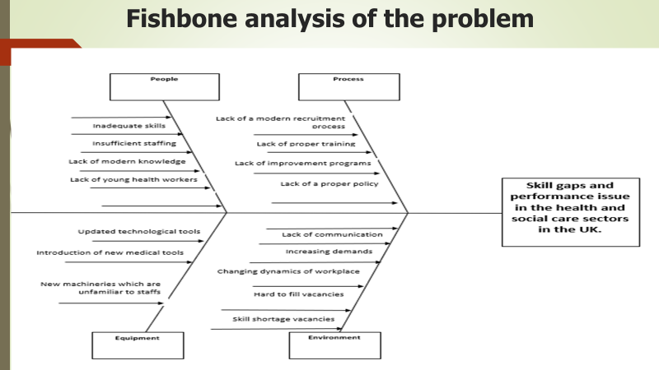
A fishbone diagram or a fishbone analysis is also known as a cause and effect diagram. Possible causes of a problem can be understood through the fishbone analysis (Asq.org, 2019). To understand the cause of the skill gaps and performance issues in the healthcare sector of the UK the fishbone analysis can be done. The personnel-related problems for this problem are inadequate skillsets of healthcare workers. Also, the sector does not have enough staffs to meet healthcare needs. The existing workers are also not updated with the latest medical knowledge and are middle-aged. Lack of young staffs in the healthcare industry is also another reason for inefficient staffs as middle-aged staffs are not as productive as young staffs. One of the equipment related causes for this problem is that the medical industry is constantly being updated with new tools and technologies which improve the efficiency of the medical industry. But unfortunately, the staffs are not properly acquainted with these tools and are thus inefficient. Different processes like recruitment and training processes are also the reason for inefficient workers. The healthcare industry lacks proper training and improvement processes for training and improving their staffs with the latest tools and technologies that are being implemented in the industry. the industry also lacks a proper policy to improve their staffs. Finally, the external and internal environment of the industry has different factors to cause this problem. The industry has a lack of communication between the staffs and the hospital managers. Again, the demands for the healthcare industry is increasing day by day. With the lack of staff required, meeting these demands are becoming hard. Thus, hard to fill vacancies and skill shortage vacancies are emerging from this situation. All of these factors trigger the skill gaps and performance issues in the health and social care sectors.

Proposed Solutions
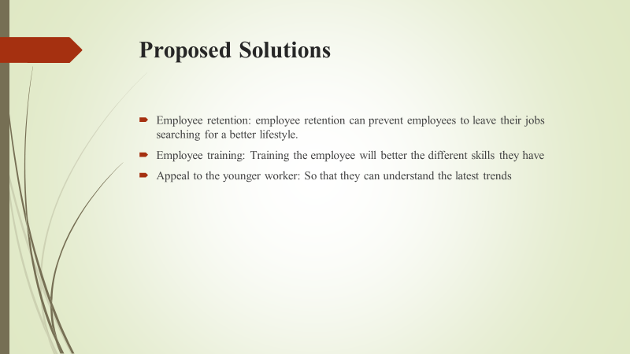
For the above problem, some possible solutions can be outlined, these solutions may include:
- Employee retention: employee retention can prevent employees to leave their jobs searching for a better lifestyle. With different employee retention tools, the organisation can improve their workforce as the employees do not want to quit and become assets for the development of the organisation. Thus, these assets will have good skills in the organisation.
- Employee training: Another possible solution for this problem is the training of employees in the relevant sector and also in skill development like communication skills technique, presentation technique. This will make them better at what they do.
- Appeal to the younger worker: This is another possible solution to increase the skill level in the industry. As there are older workers in the industry, they become experienced but they do not have the efficiency. Thus, appealing to the younger workers in the industry as they recruit employees can improve the general skill level of the organisations.

Evaluation of the solutions
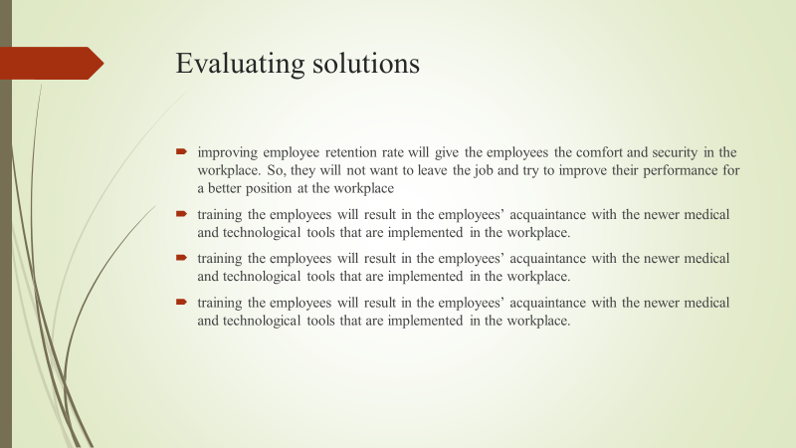
The proposed solutions can be effective for the healthcare industry to improve its employee performance issues and skill gaps. Such as improving employee retention rate will give the employees the comfort and security in the workplace. So, they will not want to leave the job and try to improve their performance for a better position in the workplace. Again, properly training the employees will result in the employees’ acquaintance with the newer medical and technological tools that are implemented in the workplace. Proper training the employees will result in the employees’ acquaintance with the newer medical and technological tools that are implemented in the workplace. Finally, the training the employees will result in the employees’ acquaintance with the newer medical and technological tools that are implemented in the workplace.

Implementing the solution
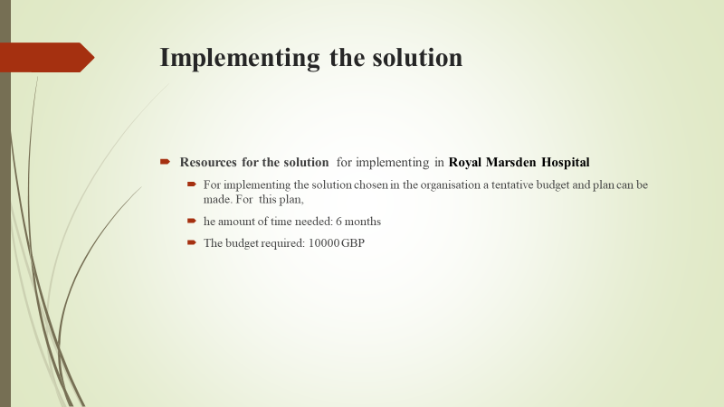
To implement a solution like training employees to have a better skillset will require planning by the health and social care industry. To create an action plan, the organisation needs to understand the scope of the plan. Training employees can mean training them in different skill-developing programmes. For this solution, the employees are to be trained to become efficient in operation. To do this the plan action creator should focus on the different skills that the employees lack. Primarily with the new plan, the employees should be trained to be better at what they do. Then the focus should move on to the older generation of training who work only with their methods of work and they should be focusing on the training. For Royal Marsden Hospital the employees are lesser skilled in communication and specialised skills in the organisation.

Resources required to complete the action
To ensure that training is provided for the health and care industry the training program resources should be calculated. For training the employees in the sector in different skill-developing like developing communication, technological, and specialised health and care skills the industry needs to provide time and motivation for this training. 70 per cent of employers in the UK provide training to their employees (Shaw, 2010). These can be of both on the job and off the job training and would require different amounts of resources necessary. But in recent times the training is not necessary for the industry as the industry organisations do not have proper funds to train their employees effectively (Shaw, 2010). They also need time to send their employees in training. But this is also not possible for the lack of employees. So, health and care industry organisations should focus on managing funds and preparing a budget for the programs in increasing skills. For Royal Marsden Hospital the training program on communication should be completed in a 6-month training program and a specialised trainee program for another 6 months improving the employee in their respective field of work. Again, the budget should be fixed at 10000 GBP for the two pieces of training.
Identify possible things to go wrong
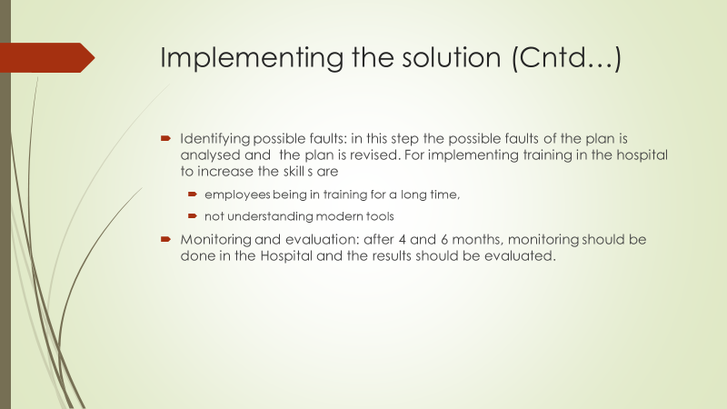
For this program, it is necessary to understand that while sending employees to skill-building programs, the timing is important (Morgon, 2016). For a 6month training on the job is not problematic, but having an employee for 6 months in the training in the off-the-job training programs. Again, while training the older generations, it must be maintained that they understand the basics of the technological aspects of the organisations. Technology is an important sector to be trained in and not all employees can understand many elements of modern technology in health care organisations. So, the employees might not get proper knowledge of the technological tools without the training.
Review Monitoring Plan and Evaluation.
To monitor and evaluate the whole training programs, the program should observe the impact evaluation (Investopedia, 2019). Impact evaluation is the understanding of the impact of the training program in the industry. With communication skill training, the employees in the industry will be better at communicating with different consumers. The training program should be reviewed during the program and after the program in a definite interval to understand how much the industry change in this time period. There should be also surveys and case studies to understand the scope of the changes in the industry. There should be a formal status report, financial report, informal reports and presentations to understand the full extent in the industry (Kwon and Choi, 2019). By the end of the program, after a particular interval, the program should be evaluated as to find the understanding of if the program were successful or not based on if the objectives were achieved or not. For a 6-month training program, the trainer should assess the implication of the training program after 4 and 6 months to inspect the model and efficiency in communication in the Royal Marsden Hospital.

Communicating to the stakeholders
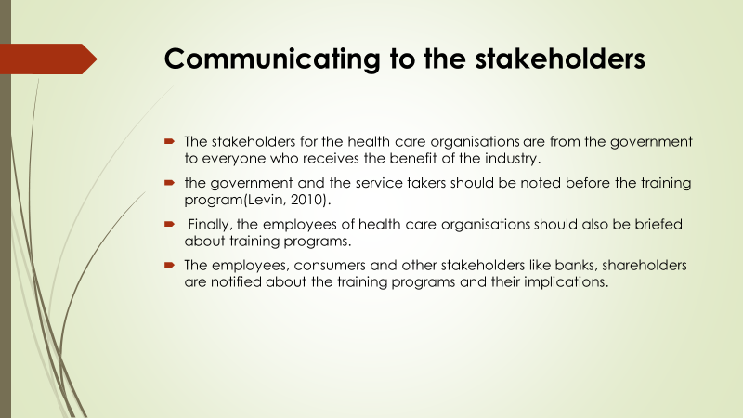
The stakeholders for the health care organisations are from the government to everyone who receives the benefit of the industry. Thus, the government and the service takers should be noted before the training program (Levin, 2010). Finally, the employees of health care organisations should also be briefed about training programs. The employees, consumers and other stakeholders like banks, shareholders are notified about the training programs and their implications.

Conclusion
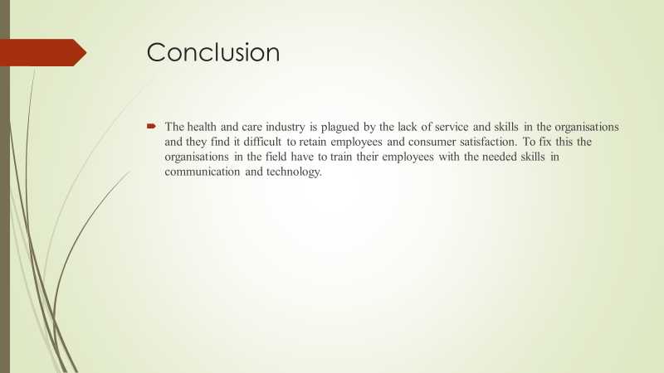
The health and care industry is plagued by the lack of service and skills in the organisations and they find it difficult to retain employees and consumer satisfaction. To fix this the organisations in the field have to train their employees with the needed skills in communication and technology.

References
- Adair, J. (2019). DECISION MAKING AND PROBLEM-SOLVING : break through barriers and banish uncertainty at work.
- Asq.org. (2019). What is a Fishbone Diagram? Ishikawa Cause & Effect Diagram | ASQ. [online] Available at: https://asq.org/quality-resources/fishbone.
- Baggott, R. (2004). Health and health care in Britain. Basingstoke ; New York, N.Y.: Palgrave Macmillan.
- Butterfield, J. (2017). Problem solving and decision making. Boston, Massachusetts: Cengage Learning.
- Caroselli, M. (2011). The critical thinking tool kit : spark your team’s creativity with 35 problem solving activities. New York: Amacom Books.
- Conn, C. and Mclean, R. (2019). Bulletproof problem solving. Hoboken, New Jersey: John Wiley & Sons, Inc.
- Deloitte. (2019). 2019 Global health care sector outlook | Deloitte. [online] Available at: https://www2.deloitte.com/global/en/pages/life-sciences-and-healthcare/articles/global-health-care-sector-outlook.html.
- Haugen, D.M. and Musser, S. (2012). Health care. Farmington Hills, Mi: Greenhaven Press.
- Healthcare Uk, Great Britain. Department Of Health, Great Britain. National Health Service and Uk Trade & Investment (2013). NHS hospitals : working in partnership. Great Britain: Uk Trade & Investment.
- HealthManagement.org (2019). Facts & Figures: The UK Healthcare System. [online] HealthManagement. Available at: https://healthmanagement.org/c/it/issuearticle/facts-figures-the-uk-healthcare-system.
- Investopedia. (2019). Healthcare Sector. [online] Available at: https://www.investopedia.com/terms/h/health_care_sector.asp.
- Kwon, S. and Choi, I. (2019). Exploring Administrative Professionals’ Problem-solving Experiences in Their Workplace: Focusing on Problem Types and Problem-solving Process. JOURNAL OF SECRETARIAL STUDIES, 28(3), pp.31–56.
- Levin, A.C. (2010). Solving the Right Problem: A Strategic Approach to Designing Today’s Workplace. Design Management Review, 18(2), pp.44–52.
- Morgon, P.A. (2016). Sustainable development for the healthcare industry. Springer International Pu.
- Shaw, G.M. (2010). The healthcare debate. Santa Barbara, Calif.: Greenwood.
- Vaderlind, P., Guy, R.K. and Larson, L.C. (2002). The inquisitive problem solver. Washington, Dc: Mathematical Association Of America.
APPENDIX.
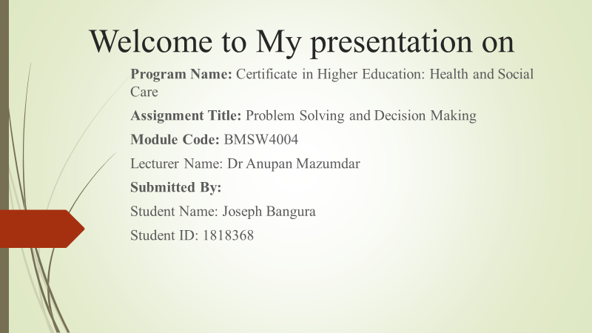 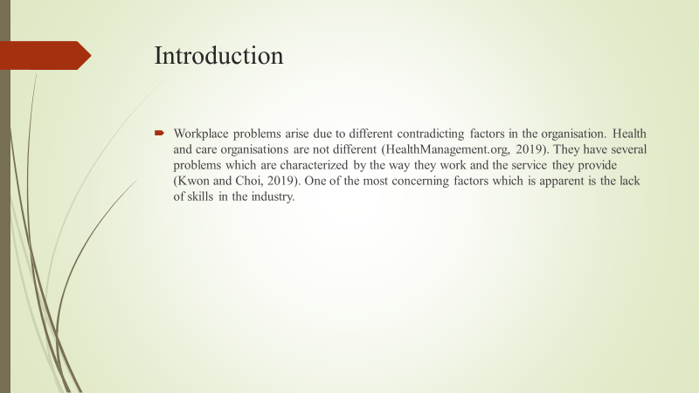 Workplace problems arise due to different contradicting factors in the organisation. Health and care organisations are not different (HealthManagement.org, 2019). They have several problems which are characterized by the way they work and the service they provide (Kwon and Choi, 2019). One of the most concerning factors which is apparent is the lack of skills in the industry.
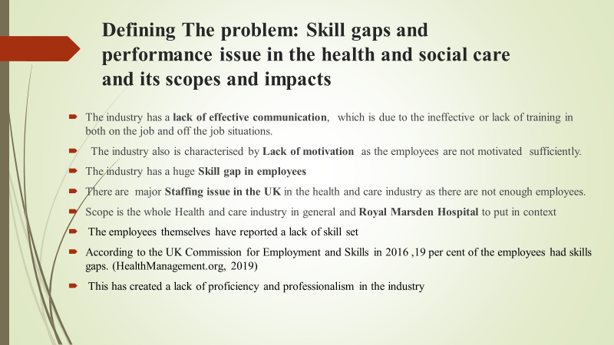 The health and social care industry in the UK are a sector which has several problems due to the immense size and scope of the industry. Over the past years, the industry has faced problems like lesser effective communication, lack of empathy in the employees and lack of motivation by the supervisors or managers (HealthManagement.org, 2019). But one of the most noticeable ones is the skill gap of the employees. This has raised a concerning statistics in the sector. This issue is complemented by the staffing issue in the UK in its healthcare industry. Both the social care and the e health care industry is supposed to be based on communication but they are at fault of not having effective communicative skills.
For the purpose of this report, Royal Marsden Hospital is chosen as an example.
Scopes and impact of the problem
Health industry and the social care industry has faced serious complaints from consumers for lack of employee efficiency in the sector(Investopedia, 2019). The employees themselves have reported a lack of skillset in their workforce which affects how a healthcare industry organisation works. According to the UK Commission for Employment and Skills in 2016 19 per cent of the employees had skills gaps in the industry(HealthManagement.org, 2019). This has created a lack of proficiency and professionalism in the industry. The scope of the problem is the whole health care industry in general and the Royal Marsden Hospital specifically to put in context.
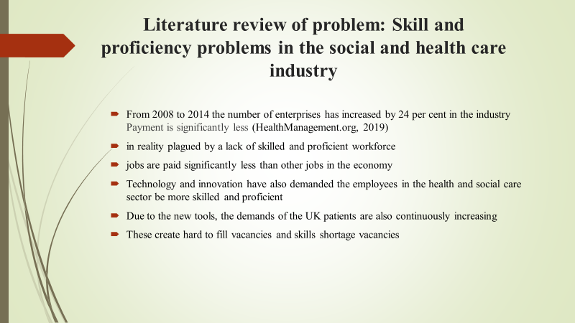 Skill and proficiency problems in the social and health care industry
Reports suggested that the health and social care sector has seen a large increase in health enterprises. From 2008 to 2014 the number of enterprises has increased by 24 per cent in the industry(HealthManagement.org, 2019). Although this seems like an improvement for the industry it is in reality plagued by a lack of skilled and proficient workforce. Although the sector is indeed the largest sector in the UK economy, this lack of skills is hampering the whole industry and the UK economy as well. But over time the health industry has seen a lot of 30-44 years employees in the workforce instead of the young workforce in the organisation (Investopedia, 2019). Again, the health and social care jobs are paid significantly less than other jobs in the economy. The industry is also changed by many factors which affect the required skills and proficiency of the employees. One of the most important factors is the changing average ages of service takers. Technology and innovation have also demanded the employees in the health and social care sector be more skilled and proficient and can integrate their work with technology(Kwon and Choi, 2019). Due to the new tools, the demands of the UK patients are also continuously increasing. With the lack of a young workforce, the healthcare industry is facing problems regarding workspace as they do not retain the information or training, they are given. This creates hard to fill vacancies and skills shortage vacancies. Royal Marsden Hospital is also experiencing lack of skill set and communication.
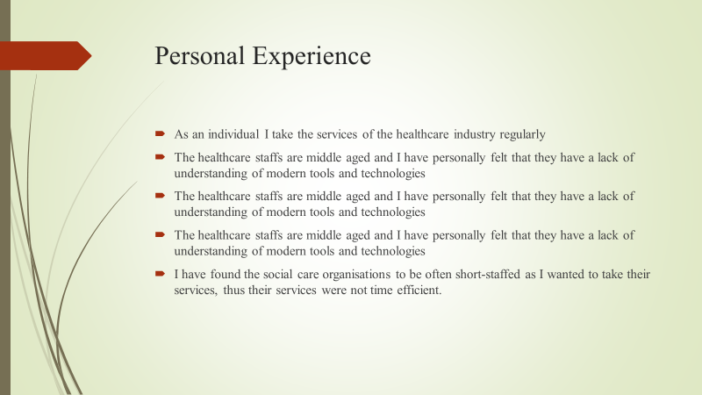 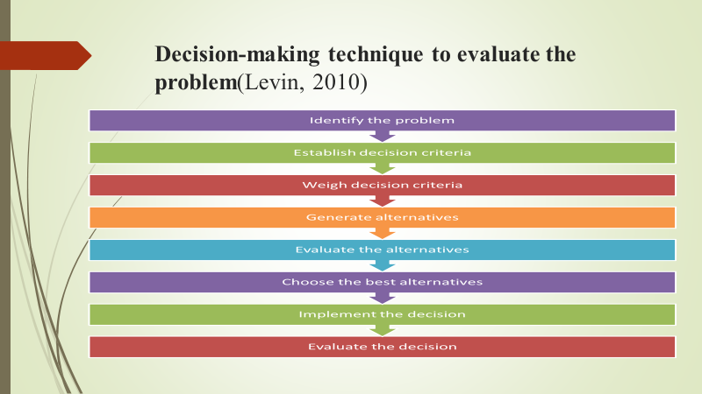 Decision-making technique to evaluate the problem
There are various decision-making techniques and models with which any organisation and follow. Different decision-making process helps an organisational. Differing models are used for different purposes in the organisation (Levin, 2010). There are various decision-making techniques available to modern businesses. Intuitive decision-making technique, rational decision-making technique, creative decision-making process and as such. In this presentation, the rational decision-making technique will be used to understand and choose a possible solution to the problem. This decision-making technique is also called the classical decision-making technique as it is used long since. The technique is made of 8 steps which identify the problem, establish the criteria under which the problems will be judged, weigh the problem under the criteria, generate and evaluate the alternatives.
In the primary step of the report the problem is identified (Morgon, 2016). To decide on the possible solution to this problem some criteria should be recognized. Primarily as there is a lack of skills noticed in the industry, the possible solution should then increase the lack of skills. But there are secondary criteria to fulfil like the solution should promote good communication with the different stakeholders.
If the decision of employee retention is taken then the employee exiting in the organisation or the industry will be working for a longer period of time and they would not leave the organisation if not some major problems have occurred. But employee retention also makes a lack of young employees in the organisation, rather the employee will be focusing on their work based on their current skill level without any upgrade.
On the other hand, if the decision is taken to train the employees, then it should also consider the present skill level of the organisation(Shaw, 2010). providing training to an employee gives the employee a sense of belonging in the organisation. This way they will work harder to achieve the organisational goals and objectives. Training would mean the employee problem is analysed and evaluating them to create a goal that conforms to the organisational goal.
Finally, if the decision is taken to choose young employees rather than the older employees, it would imply that the organisation now has inexperienced workers with knowledge and training. The inexperienced organisation in the health industry will also suffer substantially because of their inexperience and in turn, lack of knowledge of how to deal with a different situation.
According to the three possible solutions the employee training is the most effective. Because the experienced and older generation of workers are the only one who is experimenting on the workforce(Vaderlind, Guy and Larson, 2002). But understand there is a gap in the use of technology and training and decision-making. So, if the employee is trained properly then this training can make them work better in the organisation.
So, training employees in the organisation will finally bid better than the employee retention, and younger generation selection. But all of these can be worked in complementary to one another. With the different training programs on communication, empathy, the employee will understand the skill gap they have and work to improve them.
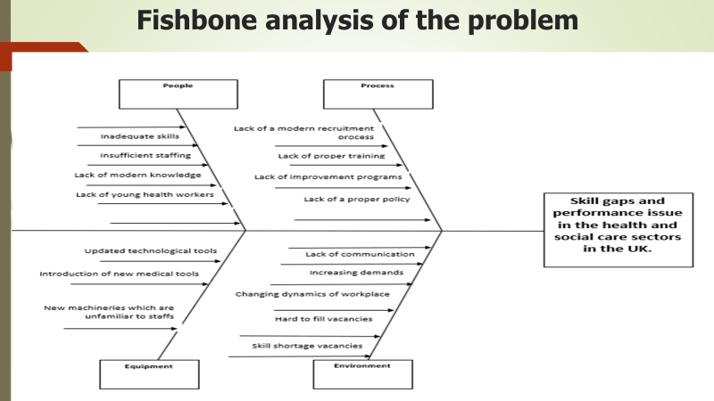 A fishbone diagram or a fishbone analysis is also known as a cause and effect diagram. Possible causes of a problem can be understood through the fishbone analysis (Asq.org, 2019). To understand the cause of the skill gaps and performance issues in the healthcare sector of the UK the fishbone analysis can be done. The personnel-related problems for this problem are inadequate skillsets of healthcare workers. Also, the sector does not have enough staffs to meet healthcare needs. The existing workers are also not updated with the latest medical knowledge and are middle-aged. Lack of young staffs in the healthcare industry is also another reason for inefficient staffs as middle-aged staffs are not as productive as young staffs. One of the equipment related causes for this problem is that the medical industry is constantly being updated with new tools and technologies which improve the efficiency of the medical industry. But unfortunately, the staffs are not properly acquainted with these tools and are thus inefficient. Different processes like recruitment and training processes are also the reason for inefficient workers. The healthcare industry lacks proper training and improvement processes for training and improving their staffs with the latest tools and technologies that are being implemented in the industry. the industry also lacks a proper policy to improve their staffs. Finally, the external and internal environment of the industry has different factors to cause this problem. The industry has a lack of communication between the staffs and the hospital managers. Again, the demands for the healthcare industry is increasing day by day. With the lack of staff required, meeting these demands are becoming hard. Thus, hard to fill vacancies and skill shortage vacancies are emerging from this situation. All of these factors trigger the skill gaps and performance issues in the health and social care sectors.
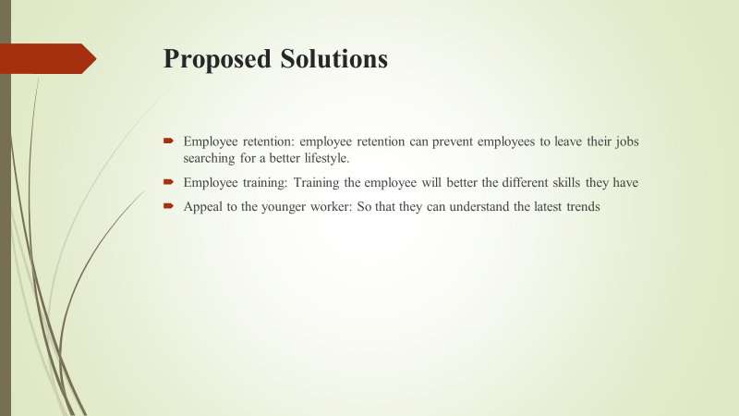 Solutions for the problems
For the above problem, some possible solutions can be outlined, these solutions may include:
Employee retention: employee retention can prevent employees to leave their jobs searching for a better lifestyle. With different employee retention tools, the organisation can improve their workforce as the employees do not want to quit and become assets for the development of the organisation. Thus, these assets will have good skills in the organisation.
Employee training: Another possible solution for this problem is the training of employees in the relevant sector and also in skill development like communication skills technique, presentation technique. This will make them better at what they do.
Appeal to the younger worker: This is another possible solution to increase the skill level in the industry. As there are older workers in the industry, they become experienced but they do not have the efficiency. Thus, appealing to the younger workers in the industry as they recruit employees can improve the general skill level of the organisations.
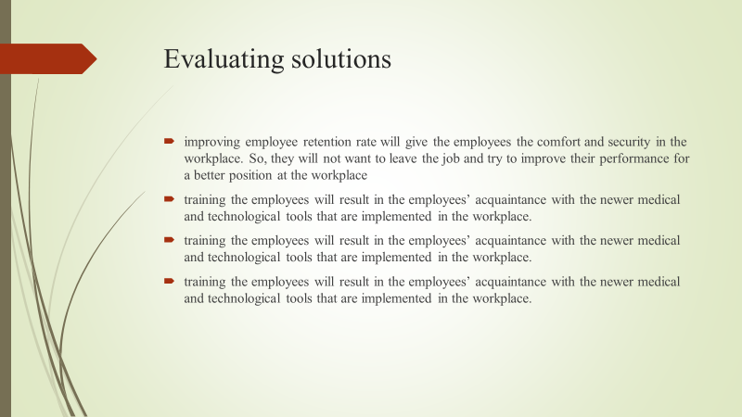 The proposed solutions can be effective for the healthcare industry to improve its employee performance issues and skill gaps. Such as improving employee retention rate will give the employees the comfort and security in the workplace. So, they will not want to leave the job and try to improve their performance for a better position in the workplace. Again, properly training the employees will result in the employees’ acquaintance with the newer medical and technological tools that are implemented in the workplace. Proper training the employees will result in the employees’ acquaintance with the newer medical and technological tools that are implemented in the workplace. Finally, the training the employees will result in the employees’ acquaintance with the newer medical and technological tools that are implemented in the workplace.
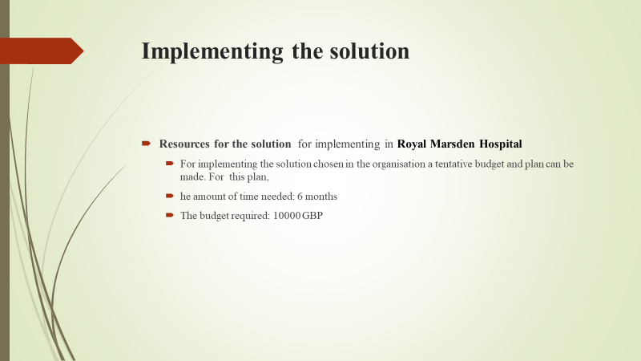 Implementing the solution
To implement a solution like training employees to have a better skillset will require planning by the health and social care industry. To create an action plan, the organisation needs to understand the scope of the plan. Training employees can mean training them in different skill-developing programmes. For this solution, the employees are to be trained to become efficient in operation. To do this the plan action creator should focus on the different skills that the employees lack. Primarily with the new plan, the employees should be trained to be better at what they do. Then the focus should move on to the older generation of training who work only with their methods of work and they should be focusing on the training. For Royal Marsden Hospital the employees are lesser skilled in communication and specialised skills in the organisation.
Resources required to complete the action
To ensure that training is provided for the health and care industry the training program resources should be calculated. For training the employees in the sector in different skill-developing like developing communication, technological, and specialised health and care skills the industry needs to provide time and motivation for this training. 70 per cent of employers in the UK provide training to their employees(Shaw, 2010). These can be of both on the job and off the job training and would require different amounts of resources necessary. But in recent times the training is not necessary for the industry as the industry organisations do not have proper funds to train their employees effectively(Shaw, 2010). They also need time to send their employees in training. But this is also not possible for the lack of employees. So, health and care industry organisations should focus on managing funds and preparing a budget for the programs in increasing skills. For Royal Marsden Hospital the training program on communication should be completed in a 6-month training program and a specialised trainee program for another 6 months improving the employee in their respective field of work. Again, the budget should be fixed at 10000 GBP for the two pieces of training.
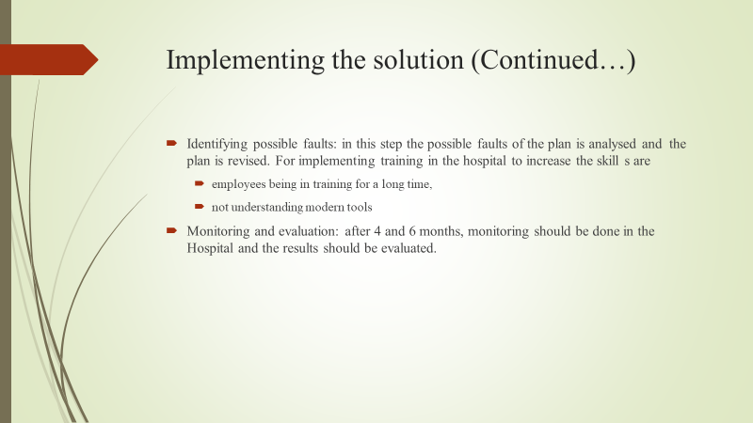 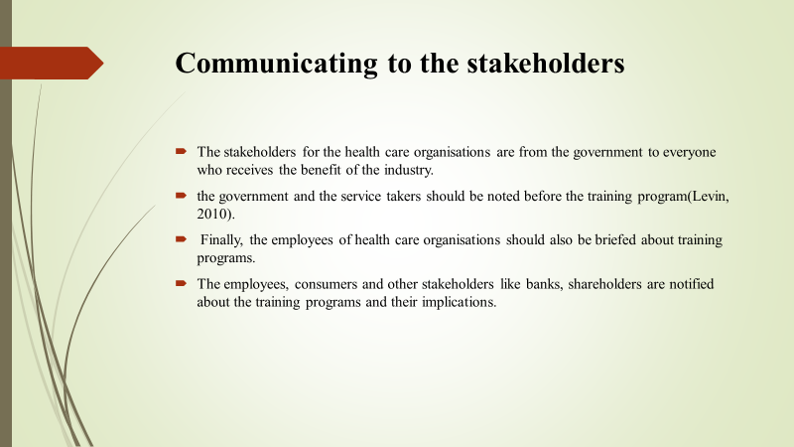 Communicating to the stakeholders
The stakeholders for the health care organisations are from the government to everyone who receives the benefit of the industry. Thus, the government and the service takers should be noted before the training program(Levin, 2010). Finally, the employees of health care organisations should also be briefed about training programs. The employees, consumers and other stakeholders like banks, shareholders are notified about the training programs and their implications.
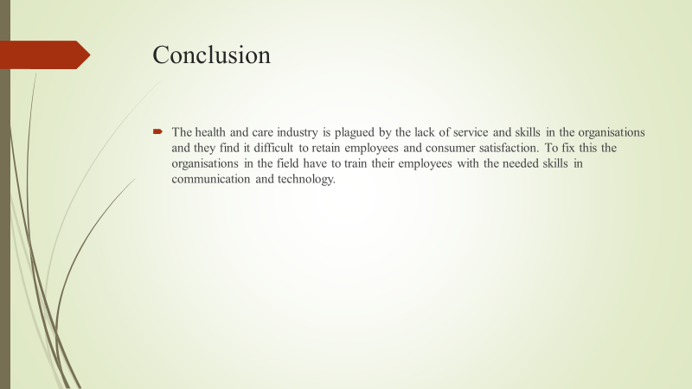 The health and care industry is plagued by the lack of service and skills in the organisations and they find it difficult to retain employees and consumer satisfaction. To fix this the organisations in the field have to train their employees with the needed skills in communication and technology.


