

THE IMPACT OF CLOUD ACCOUNTING SYSTEMS ON FINANCIAL ACCURACY AND OPERATIONAL EFFICIENCY IN SMEs

A dissertation submitted in partial fulfilment of the requirements for the degree of
BA (Hons) Leadership and Management Skills in the Workplace

Elena Popova
Student ID: 2241238
Module: Independent Project
Module Code: LCLM6005
University of Wales Trinity Saint David

Abstract
This study looks at how cloud-based accounting systems affect small and medium-sized businesses' (SMEs) operational effectiveness and financial accuracy. Cloud accounting has become a viable remedy for the shortcomings of conventional accounting systems due to the growing uptake of digital technologies, especially in terms of enhancing data efficiency, accuracy, and accessibility.
The study uses a mixed-methods approach, combining qualitative information from semi-structured interviews with quantitative data gathered from a survey of 22 SME participants. The study investigates the degree of cloud accounting adoption, its impact on operational procedures and financial accuracy, and the difficulties involved in its implementation.
The results show that by lowering human error and boosting the dependability of financial reporting, cloud accounting systems greatly increase financial accuracy. Additionally, the findings show that by automating repetitive accounting tasks and providing real-time access to financial data, cloud accounting enhances operational efficiency. The study does, however, also point out obstacles like the need for staff training, initial implementation challenges, and technical problems that could impair system performance.
The study comes to the overall conclusion that cloud-based accounting systems provide SMEs with significant advantages, especially in terms of improving financial management and facilitating well-informed decision-making. Cloud accounting systems are a useful tool for contemporary business environments because, despite certain implementation challenges, their benefits exceed their drawbacks.

Table of Contents
Abstract 2
List of Figures 4
Chapter 1 – Introduction 5
1.1 Background and Context 5
1.2 Rationale and Research Gap 7
1.3 Research Aim, Objectives, and Research Questions 8
Research Aim 8
Research Objectives 8
Research Questions 9
1.4 Structure of the Dissertation 9
Chapter 2 – Literature Review 10
2.1 SME Accounting Challenges Before Cloud Adoption 10
2.2 Cloud-Based Accounting Adoption Among SMEs 11
2.3 Impact of Digital Accounting Systems on Financial Accuracy 12
2.4 Impact of Digital Accounting Systems on Operational Efficiency 14
2.5 Challenges and Barriers to Cloud-Based Accounting Adoption 15
2.6 Summary of Literature and Research Gap 17
Chapter 3 – Research Methodology 18
3.1 Research Philosophy 18
3.2 Research Approach 19
3.3 Research Design 20
3.4 Sampling Strategy and Participants 21
3.5 Data Collection Methods 22
Survey Method 22
Semi-Structured Interviews 23
3.6 Data Analysis Methods 23
Quantitative Data Analysis 23
Qualitative Data Analysis 24
Integration of Findings 24
3.7 Ethical Considerations 25
Chapter 4 – Findings 25
4.1 Introduction 25
4.2 Survey Results. 26
Participant Demographics 26
Cloud Accounting Usage 27
Financial Accuracy 28
Operational Efficiency 29
Challenges in Implementing Cloud Accounting Systems 30
Impact on Financial Management and Decision-Making 30
4.3 Interview Findings 31
Perceived Benefits of Cloud Accounting 31
Challenges and Implementation Issues 32
Impact on Financial Management and Decision-Making 32
Chapter 5: Discussion 33
5.1 Introduction 33
5.2 Impact of Cloud Accounting on Financial Accuracy 33
5.3 Impact of Cloud Accounting on Operational Efficiency 33
5.4 Implementation Challenges of Cloud Accounting Systems 34
5.5 Impact on Financial Management and Decision-Making 34
5.6 Summary of Key Findings 34
Chapter 6: Conclusion and Recommendations 35
6.1 Introduction 35
6.2 Summary of Key Findings 35
6.3 Recommendations 36
6.4 Limitations of the Study 36
6.5 Suggestions for Future Research 36
Reference: 37
Appendices 41
Appendix A – Interview Questions 41
Appendix B – Survey Questionnaire 41

List of Figures
Figure 4.1 Role of Survey Participants ................................................................................. 25
Figure 4.2 Organisation Size of Survey Participants ........................................................... .26
Figure 4.3 Duration of Cloud Accounting Usage .................................................................. 26
Figure 4.4 Cloud Accounting Software Used by SMEs .........................................................27
Figure 4.5 Frequency of Cloud Accounting System Usage ...................................................27
Figure 4.6 Impact of Cloud Accounting on Financial Accuracy .............................................28
Figure 4.7 Impact of Cloud Accounting on Operational Efficiency …………………………….29
Figure 4.8 Challenges Associated with Cloud Accounting Implementation ...........................29
Figure 4.9 Impact of Cloud Accounting on Financial Management and Decision-Making ... 30

Chapter 1 – Introduction

Background and Context
More than 90% of all businesses worldwide are small and medium-sized enterprises (SMEs), which are the backbone of the global economy and significantly contribute to economic growth and job creation (Beck and Demirgüç-Kunt, 2006; Ayyagari et al., 2011). SMEs still struggle to accurately and effectively manage financial data, despite their economic significance. Maintaining long-term business performance, supporting managerial decision-making, and guaranteeing regulatory compliance all depend on effective accounting systems. Nonetheless, a lot of SMEs continue to use antiquated desktop accounting software, spreadsheets, or manual bookkeeping as part of their traditional accounting methods.
These traditional accounting techniques are often linked to delays in financial reporting and a high risk of human error. Inconsistencies, errors, and duplication of financial records are frequently caused by manual data entry and disjointed accounting procedures, which can compromise the accuracy of financial statements (Mujalli et al., 2024). Inaccurate financial data may restrict access to outside funding, have a detrimental impact on managerial decision-making, and subject SMEs to fines from the government. Even small accounting mistakes can have major operational and financial repercussions for small businesses with little financial cushioning.
In SME accounting practices, inefficiency is still a major concern in addition to accuracy-related problems. When carried out manually or with non-integrated systems, routine accounting tasks like bank reconciliation, payroll processing, and monthly financial reporting frequently take a long time. According to Nguyen Phu et al. (2025), administrative accounting duties often take up a significant amount of employee time in SMEs, which raises operating expenses and takes resources away from strategic business operations. Consequently, managers may have to make decisions based on out-of-date or insufficient data since financial information may not be generated promptly.
For SMEs utilising conventional accounting systems, accessibility and flexibility pose additional difficulties. Real-time and remote access is restricted by financial data kept on local servers or in physical records, which is becoming more problematic in contemporary business environments marked by mobility and digitalisation. Lack of access to current financial data can impair organisational agility, delay reactions to market developments, and make it more difficult to manage cash flow effectively.
Additionally, many SMEs are limited in their ability to invest in advanced accounting technologies due to financial and human resource constraints. SMEs frequently lack the financial resources and technical know-how necessary to hire specialised IT staff or maintain complex on-premises accounting systems, claim Al-Sharafi et al. (2023). These limitations sustain issues with accuracy, efficiency, and accessibility by reinforcing the ongoing use of ineffective accounting techniques.
Cloud-based accounting systems (CBAS) have surfaced as a viable remedy for SMEs in response to these persistent issues. Compared to traditional accounting systems, cloud accounting platforms provide features like automated data processing, real-time financial reporting, remote accessibility, and lower upfront costs. As a result, CBAS are being marketed as instruments that can improve operational effectiveness and financial accuracy while resolving the resource constraints that SMEs frequently encounter.

Rationale and Research Gap
Interest in cloud-based accounting systems (CBAS) as a potential remedy for the persistent financial management issues small and medium-sized businesses (SMEs) face has increased because of the growing digitisation of business operations. According to existing research, SMEs' capacity to generate precise, timely, and easily accessible financial information—which is essential for efficient decision-making and regulatory compliance—is frequently hampered by traditional accounting practices (Soudani, 2012; Lutfi et al., 2022). Because of their capacity to automate accounting procedures, minimise manual intervention, and offer real-time financial reporting, cloud accounting platforms have consequently drawn attention.
An increasing amount of scholarly research has looked at the variables affecting SMEs' adoption of cloud accounting systems. To investigate how organisational capabilities, technological readiness, and external pressures influence adoption decisions, studies commonly use frameworks like the Technology–Organisation–Environment (TOE) model (Nguyen et al., 2015; Putri et al., 2025). Furthermore, according to recent studies, the COVID-19 pandemic and other events may have sped up the digital transformation of accounting procedures, enticing SMEs to investigate cloud-based solutions to facilitate remote work and business continuity (Feghali et al., 2022; Saad et al., 2022).
Although studies that focus on adoption are well-established, there isn't much empirical research that systematically assesses the results of adopting cloud accounting, especially when it comes to operational efficiency and financial accuracy. Although there is little quantitative data to support the assumption that cloud-based systems automatically enhance accounting performance, many studies currently in existence make this assumption (Lutfi et al., 2022; Putri et al., 2025). Furthermore, rather than using primary data gathered directly from SME practitioners, a few studies rely on secondary data or theoretical presumptions.
Additionally, there are conflicting results in the literature about how effective cloud accounting systems are. Researchers point out that obstacles like poor user training, data migration problems, cybersecurity issues, and organisational resistance to change may limit the practical benefits of CBAS, even though automation and real-time data processing are anticipated to lower errors and increase efficiency (Feghali et al., 2022; Saad et al., 2022). This implies that the effects of cloud accounting on SMEs might be more nuanced than vendor-driven narratives typically depict.
The absence of integrated mixed-methods research is another significant gap in the literature. While qualitative insights into managerial experiences and contextual challenges are still understudied, quantitative studies frequently use surveys to measure perceived benefits (Nguyen Phu et al., 2025). Research that integrates quantitative metrics of accuracy and efficiency with qualitative understandings of how and why these results transpire in SME contexts is therefore necessary.
This study uses a mixed-methods approach to fill in these gaps, gathering primary data from accounting professionals and SME managers through semi-structured interviews and surveys. The study intends to add empirical evidence of the useful effects of cloud-based accounting systems to the body of literature by emphasising financial accuracy and operational efficiency as quantifiable outcomes rather than just adoption drivers. For SME decision-makers, accounting software providers, and legislators looking to facilitate successful digital transformation in the SME sector, the findings should provide insightful information.

Research Aim, Objectives, and Research Questions
Although small and medium-sized businesses' (SMEs) accounting practices have changed due to the quick adoption of digital technologies, it is still unclear how much cloud-based accounting systems increase operational efficiency and financial accuracy. Fewer studies empirically evaluate the results experienced by SMEs following implementation, even though existing studies regularly examine the factors that influence adoption. To fill this gap, this dissertation uses primary data to assess how cloud-based accounting systems affect SME financial management in the real world.

Research Aim
This study's objective is to evaluate how cloud-based accounting systems affect small and medium-sized businesses' (SMEs') operational effectiveness and financial accuracy in various international contexts.

Research Objectives
The following goals serve as the study's compass to accomplish this goal:
- To investigate the type and degree of SMEs' adoption of cloud-based accounting systems.
- To assess how cloud-based accounting systems affect financial accuracy, including the dependability of financial reporting and the reduction of errors.
- To evaluate how cloud-based accounting systems affect operational effectiveness, paying special attention to reporting speed, cost effectiveness, and time savings.
- To determine the main obstacles and difficulties SMEs face when utilising and putting into practice cloud-based accounting systems.

Research Questions
The following research questions are addressed in the study in accordance with the goals and objectives of the research:
- RQ1: How much do SMEs use cloud-based accounting systems?
- RQ2: What impact do cloud-based accounting systems have on the dependability and correctness of financial reporting and data in SMEs?
- RQ3: How do cloud-based accounting solutions affect SMEs' operational effectiveness?
- RQ4: What obstacles and difficulties do SMEs encounter when putting cloud-based accounting systems into place and utilising them?
When taken as a whole, these research questions offer a precise and organised framework for examining how well cloud-based accounting systems handle the accounting difficulties faced by SMEs. They also serve as a guide for the choice of research techniques, tools for gathering data, and analytical strategies used in this investigation.

Structure of the Dissertation
From the introduction of the research problem to the presentation of findings and conclusions, the dissertation's six chapters offer a logical flow.
The research is introduced in Chapter 1 by providing an overview of the study's background and context. It justifies the need to investigate cloud-based accounting systems and highlights the main difficulties SMEs have when handling financial data. The research aim, objectives, and research questions are also presented in this chapter.
The literature on SME accounting practices, cloud-based accounting system adoption, financial accuracy, and operational efficiency is critically reviewed in Chapter 2. It assesses earlier research, pinpoints important themes, and draws attention to gaps in the body of knowledge that this study seeks to fill.
The research methodology used in the study is described in Chapter 3. It describes the research philosophy, approach, and design in addition to the sampling plan, data analysis methods, data collection strategies, and ethical issues related to the use of primary data.
The study's conclusions, derived from both quantitative survey and qualitative interview data, are presented in Chapter 4. Key patterns and trends are descriptively analysed, and the results are presented in an organised fashion with figures and charts to support them.
The results are discussed in Chapter 5 considering the research questions and body of existing literature. It examines how the results relate to or deviate from earlier research, as well as the implications for SMEs, accounting procedures, and theory.
The dissertation is finally concluded in Chapter 6, which summarises the main conclusions, outlines the study's contributions, acknowledges its limitations, and offers suggestions for further research and real-world application.

Chapter 2 – Literature Review

2.1 SME Accounting Challenges Before Cloud Adoption
Small and medium-sized businesses (SMEs) primarily used traditional accounting systems to handle their financial operations before cloud-based accounting technologies became popular. Spreadsheets, manual bookkeeping, or simple stand-alone accounting software with restricted integration features were frequently included in these systems. Despite being sufficient for basic record-keeping, the literature continuously emphasises how these systems cannot meet the expanding managerial and informational requirements of SMEs in increasingly cutthroat business environments (Holmes and Nicholls, 1988).
The poor quality of accounting information is one of the biggest problems with traditional SME accounting procedures. Holmes and Nicholls (1988) contend that because small businesses frequently rely on manual processes and lack formal accounting structures, they frequently produce financial information that is inconsistent, erroneous, or incomplete. SME owners and managers' capacity to assess company performance, predict cash flows, and make well-informed strategic decisions is hampered by subpar accounting data. The fact that owners or non-specialist employees with little accounting experience usually handle accounting duties in SMEs makes this issue worse.
The problem of financial reporting accuracy is closely related to information quality. According to Mitchell, Reid, and Smith (2000), manual accounting systems raise the risk of poor internal controls, delayed reconciliations, and data entry errors. Stakeholder confidence may be damaged by inaccurate records leading to misstated financial reports, which can also make it more difficult to comply with legal and tax reporting obligations. Untrustworthy financial statements can also make SMEs less credible to banks and investors when they are looking for outside funding.
Inefficiency in accounting procedures is another enduring issue that has been noted in the literature. According to Jarvis et al. (2000), manual invoice processing, payroll computations, and bank reconciliations are just a few examples of the time-consuming and repetitive administrative duties that are frequently required by traditional accounting systems. SMEs are disproportionately affected by these inefficiencies because they usually have fewer human resources. Consequently, managers become less focused on growth-oriented and strategic tasks when they spend too much time on routine accounting tasks.
One of the main drawbacks of pre-cloud accounting systems, according to the literature, is the limited availability of timely financial information. Critical financial data is delayed by traditional systems, which typically generate financial reports periodically rather than instantly (Ismail and King, 2007). The capacity of SMEs to effectively manage working capital, react swiftly to operational problems, and adjust to shifting market conditions is hampered by delayed reporting. This lack of timely insight can put SMEs at a competitive disadvantage in fast-paced business environments.
Furthermore, organisational and structural limitations prevent SMEs from developing efficient accounting systems. According to D'Amboise and Gasse (1980), small businesses frequently lack standardised processes, formal management structures, and specialised accounting staff. These limitations restrict the use of sophisticated financial management strategies and lower the level of sophistication in accounting procedures. As a result, many SMEs depend on oversimplified accounting systems that put compliance ahead of the strategic use of information.
According to the literature, SMEs frequently faced issues with inadequate information quality, financial inaccuracies, inefficiencies, delayed reporting, and organisational constraints prior to the adoption of cloud-based accounting systems. Examining whether contemporary cloud-based accounting systems can overcome the drawbacks of conventional accounting methods and enhance financial accuracy and operational efficiency in SME contexts is made possible by these long-standing concerns.

2.2 Cloud-Based Accounting Adoption Among SMEs
Small and medium-sized businesses' (SMEs') adoption of cloud-based accounting systems (CBAS) is a result of a larger trend in business operations toward cloud computing and digital transformation. By removing the need for on-premises infrastructure and facilitating real-time data processing, cloud accounting enables SMEs to access accounting software online. According to earlier studies on the adoption of cloud computing, SMEs are beginning to see cloud-based solutions as strategic instruments for enhancing cost effectiveness, scalability, and flexibility (Marston et al., 2011).
A substantial body of research looks at cloud accounting adoption from the perspectives of theories of innovation and technology adoption. According to Rogers' (2003) Diffusion of Innovations theory, perceived relative advantage, compatibility, trialability, complexity, and observability all have an impact on adoption. According to Low et al. (2011), SMEs are more likely to embrace CBAS for cloud accounting when they see definite benefits over conventional systems, like lower maintenance costs and better system accessibility. Adoption decisions are further supported by ease of implementation and compatibility with current business processes.
The significance of cost and scalability factors in promoting adoption is also highlighted by research. Cloud computing, according to Armbrust et al. (2010), lowers capital expenditure by moving IT expenses from upfront investment to pay-as-you-go pricing models. This economic model is especially appealing to SMEs that are struggling financially. Cloud-based accounting systems lower the risk of overinvesting in IT infrastructure by allowing businesses to scale system usage in accordance with business growth (Senyo et al., 2018).
Another important factor that has been found to influence adoption is organisational readiness. According to studies, SMEs are more likely to successfully implement cloud-based solutions if they have greater levels of managerial support, IT expertise, and digital literacy (Thong, 1999). On the other hand, SMEs without in-house technical know-how might put off adoption because they are unsure about how to implement and maintain the system. Therefore, owner-managers' perspectives on technology have a significant impact on how adoption results turn out.
The adoption of cloud accounting is also influenced by institutional and environmental factors. While regulatory expectations regarding financial transparency and reporting accuracy create additional incentives for system modernisation, competitive intensity encourages SMEs to adopt digital technologies to improve efficiency and responsiveness (Zhu and Kraemer, 2005). In certain situations, government programs that encourage digitalisation have also sped up the adoption of cloud-based systems by SMEs through financial incentives or training assistance.
The literature indicates that there may be obstacles to SMEs' adoption of cloud-based accounting, notwithstanding the apparent benefits. Adoption is still hampered by worries about privacy, data security, and reliance on internet connectivity (Garrison et al., 2012). The inability of SMEs to integrate cloud accounting systems with legacy apps may also hinder adoption or decrease system efficacy.
According to the research that is currently available, SMEs' adoption of cloud-based accounting is influenced by a few factors, including organisational preparedness, technological advantages, financial concerns, and environmental demands. Although adoption rates have been gradually rising as cloud technologies have advanced, regional and industry-specific variance still exists. Analysing the ensuing effects of cloud-based accounting systems on operational effectiveness and financial accuracy requires a solid understanding of these adoption drivers.

2.3 Impact of Digital Accounting Systems on Financial Accuracy
Since it supports trustworthy financial reporting, regulatory compliance, and managerial decision-making, financial accuracy is a basic prerequisite for efficient accounting systems. Due to their limited financial buffers and resource constraints, small and medium-sized businesses (SMEs) are especially vulnerable to the negative effects of accounting errors, making financial accuracy crucial. According to earlier studies in the literature on accounting information systems (AIS), the accuracy and dependability of financial data are significantly influenced by the quality and design of accounting systems.
The limited capacity of traditional accounting systems to guarantee high levels of information accuracy has often been criticised. Manual data entry and disjointed accounting procedures, according to Romney and Steinbart (2018), raise the possibility of mistakes, inconsistencies, and problems with data integrity. These risks are increased in SMEs since non-specialist employees frequently handle accounting duties. Inaccurate financial statements, poorly informed decisions, and a decline in trust among external stakeholders can all result from poor financial accuracy.
One important factor influencing system efficacy is information quality, according to the literature on information systems success. According to DeLone and McLean (2003), the success of a system is largely dependent on the timeliness, accuracy, and completeness of the information. When used in accounting contexts, top-notch accounting systems should produce reliable and consistent financial data to meet internal and external reporting needs. Compared to manual systems, digital accounting systems have been demonstrated to improve information quality by standardising accounting procedures and automating transaction processing (Nicolaou, 2000).
The link between enhanced financial accuracy and digital accounting systems is further supported by empirical research. According to Grande et al., (2011), SMEs that use integrated accounting information systems report more accurately and with greater reliability than those that do not. Repetitive manual input is decreased by automation, and system controls improve uniformity among accounting records. Stronger internal control environments and more trustworthy financial statements are two benefits of these enhancements.
Improving accuracy also heavily relies on system integration. According to Hunton et al., (2004), integrated accounting systems guarantee that financial data is recorded consistently across various processes, which lowers reconciliation discrepancies. Digital systems facilitate increased accuracy in financial reporting and transaction recording by reducing manual intervention and data redundancy. For SMEs, which frequently have trouble with reconciliation and error detection in conventional accounting settings, this is especially pertinent.
The literature does warn, though, that increased financial accuracy is not a given with technology alone. Ismail and King (2007) emphasise that proper system alignment with user capabilities and organisational needs is essential to system effectiveness. The accuracy advantages of digital accounting systems may be compromised by inadequate training, improper system configuration, or reluctance to use the system. This implies that even when cutting-edge technologies are used, organisational and human factors continue to play a crucial role in determining accuracy outcomes.
According to the research that is currently available, digital accounting systems have the potential to greatly increase financial accuracy through strengthening system controls, lowering manual errors, and improving information quality. However, user proficiency, organisational alignment, and efficient system implementation determine how much of these advantages are realised in SMEs. These observations offer a crucial theoretical framework for investigating whether cloud-based accounting systems in modern SME environments result in quantifiable increases in financial accuracy.

2.4 Impact of Digital Accounting Systems on Operational Efficiency
The ability of an organization to produce results with the least amount of time, labour, and money required is known as operational efficiency. Because small and medium-sized businesses (SMEs) have limited financial and human resources, efficiency improvements are especially crucial. Ineffective accounting procedures can raise operating expenses and take managers' focus away from strategic initiatives. By simplifying procedures and enhancing workflow integration, digital accounting systems can significantly increase operational efficiency, according to the literature on information systems and organisational performance.
The automation of repetitive tasks is one of the most often mentioned efficiency advantages of digital accounting systems. According to Davenport (1998), information technology makes process redesign possible by cutting down on pointless manual tasks and shortening process cycle times. Automating processes like data entry, payroll, invoicing, and reconciliation speeds up financial processing and lessens administrative burden in accounting contexts. This automation frees up limited employees for higher-value tasks rather than tedious administrative labour for SMEs.
The relationship between digital systems and increased productivity is supported by empirical research in information systems. Information technology investments are linked to higher organisational productivity and efficiency, as shown by Brynjolfsson and Hitt (2000). In addition to automation, better coordination and quicker information flows also contribute to these productivity increases. Digital platforms facilitate faster access to financial data when used with accounting systems, which facilitates quicker reporting and decision-making.
By decreasing fragmentation across business processes, system integration further improves operational efficiency. According to Melville et al., (2004), integrated information systems enhance organisational performance by enabling smooth data exchange between functional domains. Integration between accounting systems and other operational systems, like inventory management or sales, minimises reconciliation delays and eliminates duplication of effort in accounting environments. Such integration streamlines processes and cuts down on the amount of time needed for SMEs to finish accounting cycles.
Cost effectiveness is another important result of adopting digital systems that is highlighted in the literature. Information technology can reduce operating costs by increasing process efficiency and decreasing labour intensity, according to Banker, Bardhan, and Chang (2006). Digital accounting systems lessen the need for manual processing and outside accounting assistance for repetitive tasks, which could result in lower administrative costs. For SMEs looking to stay competitive in price-sensitive markets, these cost savings are especially pertinent.
Digital accounting systems not only save money and time, but they also increase managerial effectiveness by giving managers prompt access to financial data. According to Mithas et al. (2012), information systems increase the efficacy of decision-making by enhancing the usability and availability of information. SME managers can monitor performance in real time, respond to operational issues more quickly, and allocate resources more efficiently when they have faster access to accurate financial data.
Nonetheless, the literature also points out that organisational alignment and successful system implementation are prerequisites for efficiency gains. Digital accounting systems may not produce the anticipated efficiency gains in the absence of proper training, process redesign, and managerial support (Davenport, 1998). For SMEs to fully reap the benefits of efficiency, technology adoption must be synchronised with organisational procedures.
Overall, previous studies show that by automating accounting tasks, enhancing system integration, cutting costs, and facilitating quicker decision-making, digital accounting systems can greatly increase operational efficiency. These efficiency gains offer a solid theoretical foundation for investigating whether cloud-based accounting systems benefit SMEs in quantifiable ways.

2.5 Challenges and Barriers to Cloud-Based Accounting Adoption
Even though small and medium-sized businesses (SMEs) are becoming more interested in cloud-based accounting systems (CBAS), the literature continuously points out a few difficulties and impediments that may prevent adoption and efficient use. Although cloud accounting has the potential to improve accessibility, automation, and cost effectiveness, these benefits are frequently accompanied by organisational, technological, and environmental issues that SMEs need to carefully manage.
Data security and privacy are two of the most mentioned obstacles to the adoption of cloud-based systems. SMEs frequently voice concerns about keeping private financial data on external servers run by outside vendors. Perceived risks of data breaches, unauthorised access, and loss of data control can drastically lower organisational trust in cloud solutions, claim Pearson and Benameur (2010). Uncertainty about data protection measures can be a major barrier to adoption for SMEs without internal cybersecurity knowledge.
Concerns about data sovereignty and regulatory compliance are closely tied to security issues. SMEs that operate in multiple jurisdictions might be unsure of which legal frameworks apply and where their data is stored. According to Kshetri (2010), SMEs may be deterred from implementing cloud-based systems by ambiguous regulatory frameworks and disparate data protection laws, especially when accounting and financial data are at stake. This intricacy raises the risk of noncompliance and could make businesses prefer locally hosted, conventional accounting systems.
Limited technological readiness has been identified in the literature as another significant barrier. SMEs frequently lack the internal IT know-how, dependable internet access, and technical infrastructure needed to successfully deploy and maintain cloud-based accounting systems (Oliveira and Martins, 2011). SMEs may encounter implementation challenges, system outages, or subpar system performance if they are not sufficiently prepared for digitalisation. These issues can lower perceived utility and satisfaction.
Adoption outcomes are also significantly influenced by organisational and human factors. A frequent problem is user resistance to change, especially when staff members are used to conventional accounting procedures. According to Venkatesh and Davis (2000), low user confidence and perceived complexity can hinder the adoption of new technologies. Staff members may not be able to fully utilise cloud accounting features due to inadequate user training, which would limit the anticipated benefits in SMEs, where training resources are frequently scarce.
Even though cloud accounting is thought to be less expensive than traditional systems, cost-related worries are still a significant obstacle. Although cloud-based solutions save money up front, they can result in long-term financial obligations due to ongoing subscription fees, implementation costs, and training expenses (Marston et al., 2011). Adoption may be delayed or prevented for cost-sensitive SMEs due to uncertainty regarding return on investment.
Lastly, it has been determined that system dependability and vendor dependency are obstacles to adoption. Concerns regarding system outages, service availability, and long-term vendor viability are raised by reliance on outside service providers. According to Armbrust et al. (2010), relying too much on cloud providers can raise operational risk in the event of service interruptions, especially for accounting systems that facilitate important financial operations.
According to the literature, SMEs encounter a few obstacles pertaining to security, regulations, technological readiness, organisational considerations, cost, and vendor dependence, even though cloud-based accounting systems have a lot of potential advantages. Comprehending these obstacles is crucial for placing adoption decisions in context and assessing the viability of deploying cloud accounting systems to enhance operational effectiveness and financial accuracy in SME settings.

2.6 Summary of Literature and Research Gap
A review of the scholarly literature on accounting procedures in SMEs, cloud-based accounting system adoption, and their possible effects on operational effectiveness and financial accuracy has been conducted in this chapter. Examining traditional SME accounting procedures before cloud adoption, the review first identified enduring issues like low-quality data, financial errors, inefficiencies, delayed reporting, and a lack of organisational resources. These difficulties have long limited SMEs' capacity to produce trustworthy financial data and facilitate wise decision-making.
The adoption of cloud-based accounting by SMEs was then examined in the literature, which showed that a mix of organisational, technological, and environmental factors affect adoption choices. According to earlier research, the main factors influencing adoption are perceived utility, cost effectiveness, scalability, managerial support, and competitive pressure. Significant obstacles that can impede adoption and efficient system use were also noted by the review, including vendor dependency, user resistance, regulatory uncertainty, data security concerns, and a lack of technological readiness.
The effects of digital accounting systems on operational effectiveness and financial accuracy were the main topics of the following sections. Digital accounting systems can improve financial accuracy by strengthening system controls, lowering manual errors, and improving information quality, according to research in accounting information systems and information systems literature. Digital systems can enhance operational efficiency through automation, system integration, cost reduction, and quicker decision-making, according to research on information technology and organisational performance. However, the literature constantly emphasises that these advantages depend on organisational alignment, user competency, and successful implementation.
Even with the depth of current research, there are still a few significant gaps. First, there is little empirical data on whether cloud-based accounting systems result in quantifiable gains in operational efficiency and financial accuracy because most of the literature concentrates on adoption factors rather than post-adoption outcomes. Second, comparatively few studies use mixed methods designs that capture both quantifiable outcomes and contextual user experiences; instead, most studies rely on either purely quantitative or qualitative approaches. Third, there is a dearth of primary data obtained directly from accounting professionals and SME managers in a variety of settings.
To fill these gaps, this study uses primary data and a mixed-methods approach to investigate how cloud-based accounting systems affect SMEs' operational efficiency and financial accuracy. The study aims to add unique empirical insights to the body of literature by focusing on practical outcomes rather than adoption factors. It also hopes to have significant implications for policymakers, technology providers, and SME decision-makers.

Chapter 3 – Research Methodology

3.1 Research Philosophy
The fundamental ideas and presumptions regarding the creation, interpretation, and validation of knowledge in a research study are referred to as research philosophy. The research design, data collection strategies, and analytical approaches used are all influenced by these presumptions (Saunders et al., 2009). Therefore, choosing a suitable research philosophy is crucial to guaranteeing alignment between the goals of the study and the chosen methodology. A pragmatist research philosophy is used in this investigation.
The foundation of pragmatics is the belief that rather than adhering to a particular philosophical tradition, research should concentrate on solving real-world problems. Pragmatists contend that the best way to understand knowledge is to see how it can be applied and used in practical situations (Morgan, 2007). Depending on the nature of the research problem, pragmatism permits researchers to draw on a variety of philosophical presuppositions rather than solely adhering to positivist or interpretivist paradigms (Bryman, 2016).
For this study, which aims to evaluate the effect of cloud-based accounting systems on financial accuracy and operational efficiency in small and medium-sized enterprises (SMEs), the adoption of a pragmatist philosophy is especially suitable. Both objective components—like error reduction, reporting accuracy, and efficiency gains—and subjective components—like user experiences, perceptions, and difficulties—are included in these ideas. Both quantitative and qualitative methods of inquiry can be accommodated by pragmatics, which enables the researcher to obtain a more thorough understanding of the phenomenon being studied (Creswell and Creswell, 2017).
Additionally, mixed-methods research is closely linked to pragmatism, which is consistent with this study's design. Pragmatism, according to Tashakkori and Teddlie (2010), offers a solid philosophical basis for integrating quantitative and qualitative approaches into a single study framework. The study can investigate quantifiable results and contextual factors affecting the efficacy of cloud-based accounting systems by combining survey data with insights from semi-structured interviews.
Lastly, the research findings' practical relevance is increased by the pragmatist philosophy. In addition to adding to the body of knowledge, this study seeks to produce insights that will be useful to policymakers, accounting professionals, and SME managers. Pragmatism guarantees that research stays rooted in business practice rather than theoretical philosophical debate by emphasising practical results and real-world applicability.
In conclusion, this study has a flexible and strong foundation thanks to the adoption of a pragmatist research philosophy. It is in line with the study's goal of generating useful and actionable insights into the use of cloud-based accounting systems in SMEs, supports the use of mixed methods, and accepts various types of data.

3.2 Research Approach
The research methodology clarifies the relationship between theory and empirical data in a study and establishes whether research moves from theory to data, from data to theory, or iteratively combines the two. The three methods that are most frequently discussed in business and management research are abductive, inductive, and deductive (Saunders, Lewis, and Thornhill, 2009). A mixed deductive and inductive approach is used considering the study's goals and mixed-methods design.
In a deductive approach, research questions or expectations are derived from preexisting theory, and data is then gathered to empirically investigate these claims. Deduction is evident in the way the research aim, objectives, and research questions were developed based on earlier research on accounting information systems, cloud-based accounting, financial accuracy, and operational efficiency. The development of the quantitative survey instrument was guided by the theoretical and empirical research that suggests digital accounting systems may improve accounting outcomes in SMEs (Creswell and Creswell, 2017; Saunders et al., 2009).

However, relying exclusively on deduction may limit the ability to capture contextual and experiential insights, particularly in applied organisational research. The study also uses semi-structured interviews to add an inductive component to overcome this limitation. A deeper comprehension of the experiences and viewpoints of participants is made possible by an inductive approach, which permits patterns and themes to arise directly from the data (Bryman, 2016). Interviews with accounting experts and SME managers in this study enable the investigation of cloud-based accounting systems' practical applications, implementation difficulties, and perceived effects on accuracy and efficiency.
The pragmatist research philosophy used in this study is consistent with the combination of deductive and inductive reasoning. Morgan (2007) contends that when dealing with challenging real-world issues, pragmatism promotes methodological flexibility and the integration of various reasoning techniques. Similarly, by allowing theory to guide inquiry while remaining receptive to fresh empirical insights, Blaikie (2010) observes that integrating theory-driven and data-driven reasoning improves the explanatory power of applied research.
Moreover, an abductive logic is reflected in the combination of deductive and inductive elements, whereby researchers iteratively switch between theory and data to improve comprehension (Dubois and Gadde, 2002). By enabling new qualitative insights to supplement and contextualise quantitative findings, this iterative process increases the research's robustness.
In conclusion, this study can draw from pre-existing theoretical underpinnings while still being responsive to empirical insights obtained from primary data thanks to the use of a combined deductive and inductive research approach. This strategy fits in nicely with mixed-methods research and advances the goal of the study, which is to provide findings about the effects of cloud-based accounting systems on SMEs that are both theoretically sound and practically applicable.

3.3 Research Design
According to Saunders, Lewis, and Thornhill (2009), research design is the overarching approach that successfully addresses the research questions by integrating the various elements of a study in a logical and cohesive way. It offers a structure for gathering, measuring, and analysing data, assisting the researcher in accomplishing the goals of the study. This study uses a mixed-methods research design in accordance with the research goal and philosophical position.
The methodical integration of quantitative and qualitative research techniques within a single study is known as a mixed-methods design. Mixed-methods research, according to Creswell and Plano Clark (2018), allows researchers to minimise the drawbacks of both quantitative and qualitative approaches while utilising their strengths. While qualitative methods offer deeper insights into participants' experiences and contextual factors, quantitative methods enable the analysis of patterns and relationships across a larger sample.
The sequential explanatory mixed-methods design used in this study places quantitative data collection and analysis ahead of qualitative data collection. This design is especially appropriate when qualitative findings are used to clarify or expand on quantitative results, as Creswell (2014) explains. In this study, survey data is first gathered to evaluate how cloud-based accounting systems affect SMEs' operational effectiveness and financial accuracy. Semi-structured interviews are then carried out to investigate difficulties and experiences that cannot be adequately captured by surveys alone, as well as to obtain deeper insights into the causes of the observed patterns.
The applied nature of the study further supports the decision to use a sequential explanatory design. While qualitative data offer contextual explanations that improve interpretation and understanding, quantitative findings offer a broad overview of trends and relationships (Bryman, 2016). By using a variety of data sources, this method also promotes triangulation, which strengthens the validity and reliability of the study's conclusions.
Additionally, the study's pragmatist research philosophy is consistent with the mixed-methods design. Pragmatism places a strong emphasis on methodological adaptability and choosing research techniques according to how well they can solve the research problem (Morgan, 2007). The study can produce both context-specific understanding and generalisable insights by combining quantitative and qualitative methods.
In conclusion, using a sequential explanatory mixed-methods research design offers a logical and practical way to approach the research questions. It makes it possible for the study to blend depth and breadth, improves the reliability of the results, and facilitates the development of useful insights into how cloud-based accounting systems affect SMEs.

3.4 Sampling Strategy and Participants
According to Saunders et al., (2009), sampling is the process of choosing a subset of people or organisations from a larger population to gather pertinent data for the study. Non-probability purposive sampling was used because the study's focus was on small and medium-sized businesses (SMEs) that use cloud-based accounting systems.
The researcher can choose participants using purposeful sampling according to traits pertinent to the study's goals (Bryman, 2016). Participants in this study were selected based on their familiarity with the deployment or use of cloud-based accounting systems and their direct experience with accounting procedures in SMEs. This methodology guarantees that the information gathered is significant and in line with the study's objective, which is to investigate how cloud-based accounting systems affect operational effectiveness and financial accuracy.
SME managers, accountants, and financial personnel who use or supervise accounting systems within their companies make up the study's target population. Since they have direct control over financial management procedures, these people are regarded as suitable respondents since they can offer knowledgeable opinions on system utilisation, perceived advantages, and operational difficulties.
SME managers, accountants, and financial personnel who use or supervise accounting systems within their companies make up the study's target population. Since they have direct control over financial management procedures, these people are regarded as suitable respondents since they can offer knowledgeable opinions on system utilisation, perceived advantages, and operational difficulties.
This gave the researcher a deeper understanding of the participants' experiences and provided contextual information about how cloud-based accounting systems affect operational effectiveness and financial accuracy in real-world scenarios.
Purposive sampling supports the study's goal of obtaining pertinent, experience-based data from people who have firsthand knowledge of SME accounting practices and is consistent with mixed-methods research (Creswell and Plano Clark, 2018). This sampling strategy makes it possible to gather rich and pertinent data that bolster analytical insights, even though it does not strive for statistical generalisation.
In conclusion, the study is guaranteed to include knowledgeable viewpoints from those who are directly involved in SME accounting procedures thanks to the purposive sampling technique. This strengthens the findings' applicability and legitimacy and validates the study's emphasis on useful results related to cloud-based accounting systems.

3.5 Data Collection Methods
Methods for collecting data are those that are employed to obtain the information needed to address the research questions (Saunders, Lewis, and Thornhill, 2009). Both quantitative and qualitative data collection techniques were used in this study in accordance with the mixed-methods research design. Information was gathered from people employed by small and medium-sized businesses (SMEs) via semi-structured interviews and a structured survey.
By enabling the researcher to record both quantifiable results and contextual experiences, the utilisation of multiple data collection methods improves the findings' depth and credibility (Creswell and Plano Clark, 2018). In this study, user experiences, difficulties, and perceptions were qualitatively understood through interviews, while the survey yielded quantitative insights into the degree to which cloud-based accounting systems impact financial accuracy and operational efficiency.

Survey Method
Quantitative data from SME managers, accountants, and financial personnel involved in accounting procedures within their companies were gathered using the survey method. In business research, surveys are frequently used to collect data from a sizable number of participants in an organised and effective way (Bryman, 2016).
The survey included closed-ended enquiries intended to gauge:
- The extent of use of cloud-based accounting software
- Improvements in perceived financial accuracy
- Gains in perceived operational efficiency
- Difficulties encountered when implementing the system
To guarantee accessibility and convenience for respondents, the survey was disseminated electronically through online platforms. According to Saunders et al. (2009), online surveys are especially useful for SME research because they reduce time and geographic constraints by enabling respondents to complete questionnaires at their own convenience.

Semi-Structured Interviews
A smaller group of participants chosen from survey respondents participated in semi-structured interviews to supplement the quantitative findings. While retaining flexibility in questioning, semi-structured interviews enable in-depth examination of participants' viewpoints (Kvale and Brinkmann, 2009).
The purpose of the interviews was to investigate:
- Experiences of participants with cloud-based accounting programs
- Impact on perceived financial accuracy
- Impacts on operational effectiveness
- Implementation-related difficulties
- Organisational elements affecting the efficacy of the system
Participants were able to expound on their experiences and offer insights that were not possible to obtain from structured survey questions alone thanks to this method.
The study gains both breadth and depth of information by integrating survey data with insights from interviews. While interviews offer contextual understanding of how cloud-based accounting systems affect financial processes in practice, the survey captures broad trends across SMEs.

3.6 Data Analysis Methods
Examining, organising, and interpreting gathered data to address research questions is known as data analysis (Saunders, Lewis, and Thornhill, 2009). Both quantitative and qualitative data analysis techniques were used in accordance with the mixed-methods research design used in this study.

Quantitative Data Analysis
Descriptive statistical methods were used to analyse the quantitative data gathered from the survey. In business research, descriptive statistics are frequently used to meaningfully summarise and present data (Bryman, 2016).
The analysis's focus was:
- Finding trends in the use of cloud-based accounting
- Assessing perceived advancements in financial precision
- Assessing improvements in operational efficiency
- Evaluating the difficulties faced by SMEs
Responses were interpreted using statistical summaries like averages, frequency distributions, and percentages. These methods supported the assessment of how cloud-based accounting systems affect SME financial practices by enabling the discovery of patterns and connections within the data.

Qualitative Data Analysis
Thematic analysis was used to examine the qualitative information gleaned from semi-structured interviews. To find patterns and themes in qualitative data, thematic analysis is frequently employed (Braun and Clarke, 2006).
The analysis was conducted using a methodical approach:
- Transcribing interview responses
- Familiarisation with the data
- Coding significant statements
- Identifying recurring themes
- Interpreting patterns related to:
- Financial accuracy
- Operational efficiency
- Implementation challenges
By using this method, the researcher was able to record the opinions and experiences of participants about using cloud-based accounting systems.

Integration of Findings
Findings from both quantitative and qualitative analysis were combined during interpretation to increase the study's validity. This made it possible for qualitative insights to validate and explain quantitative trends (Creswell and Plano Clark, 2018).
For example:
- Interview narratives elucidating the impact of automation on routine accounting tasks were used to further explore survey results indicating increased efficiency.
By offering quantifiable proof and contextual knowledge, this integration enhances the research's credibility.
This study guarantees a thorough investigation of the effects of cloud-based accounting systems on SMEs by fusing descriptive statistical analysis with thematic qualitative analysis. This dual approach facilitates the investigation of real-world experiences as well as the identification of broad trends.

3.7 Ethical Considerations
For research involving human subjects to be carried out responsibly and with respect, ethical considerations are crucial. Throughout the entire data collection and analysis process, this study complied with accepted ethical standards.
All participants were fully informed about the research's purpose prior to their voluntary participation in the study. An information sheet outlining the study's purpose, the intended use of the data, and the participants' rights was given out. This made it possible for participants to decide whether to participate.
Prior to taking part in the survey and interviews, informed consent was acquired. Prior to filling out the questionnaire or participating in interviews, participants had to affirm their agreement. According to Saunders, Lewis, and Thornhill (2009), this is consistent with ethical research practices that prioritise openness and participant autonomy.
Confidentiality and anonymity were upheld throughout the study to safeguard participant privacy. The interview responses were anonymised during transcription and analysis, and no personal information was gathered during the survey. This prevented the research findings from identifying the participants or their organisations (Bryman, 2016).
All information gathered was kept safe to avoid unwanted access and used only for academic purposes. Data protection principles were followed when handling interview recordings and transcripts. Additionally, participants were made aware of their freedom to leave the study at any time and without giving a reason.
Furthermore, this study complied with the university's ethical guidelines and upheld the values of responsibility, integrity, and respect in research involving human subjects (Israel and Hay, 2006).
In conclusion, by guaranteeing informed consent, confidentiality, voluntary participation, and safe data handling, the study was carried out ethically. These precautions contribute to participant safety and strengthen the validity of the study's conclusions.

Chapter 4 – Findings

4.1 Introduction
The results of the primary data gathered from the survey and semi-structured interviews are presented in this chapter. This chapter's goal is to provide the findings pertaining to the study's goals regarding how cloud-based accounting systems affect small and medium-sized businesses' (SMEs) operational effectiveness and financial accuracy.
Participants in SMEs provided a total of 22 survey responses. Additionally, five semi-structured interviews with people employed in financial positions by companies that use cloud-based accounting systems were carried out.
There are two primary sections that present the results. The quantitative survey results are presented in the first section, and the qualitative information gleaned from interviews is presented in the second. Charts and tables are used to present the results in a descriptive manner, and then the observed patterns are briefly explained.

4.2 Survey Results.

Participant Demographics
The survey collected responses from individuals working in various financial and managerial roles within SMEs.
The results show that respondents represented different professional roles, including managers, accountants, owners, finance staff, and other organisational roles.

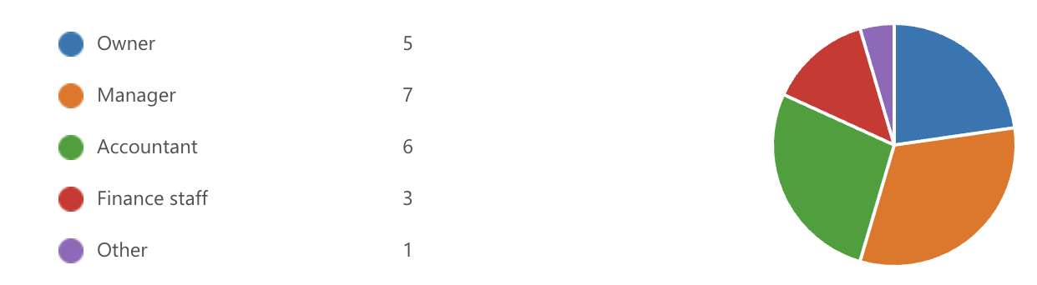
Figure 4.1: Role of Survey Participants
Source: Survey Data (2026)
The findings show that the highest percentage of respondents were managers (31.8%), followed by accountants (27.3%), owners (22.7%), and finance personnel (13.6%). This implies that most participants are directly involved in accounting or financial decision-making within their organisations.
The size of the organisations included in the study was also investigated by the survey.
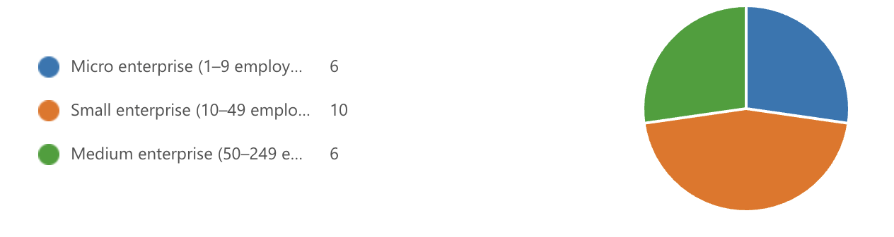
Figure 4.2: Organisation Size of Survey Participants
Source: Survey Data (2026)

With ten respondents, most respondents represented small businesses, as shown in Figure 4.2. With six responders apiece, micro and medium-sized businesses were equally represented. This distribution shows that cloud accounting systems are utilised by a variety of SME categories, indicating their applicability to businesses of all sizes.

Cloud Accounting Usage
The length of time that businesses have been utilising cloud-based accounting systems was another aspect of the survey. Knowing how long a system is used can help determine how much experience an organization has with cloud accounting technologies.
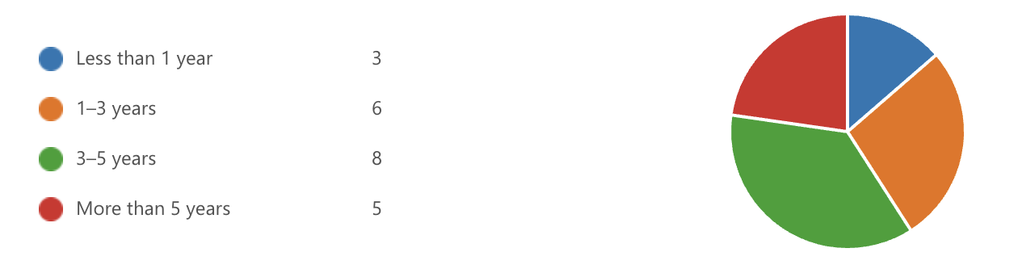
Figure 4.3: Duration of Cloud Accounting Usage
Source: Survey Data (2026)

Most respondents reported using cloud accounting systems for three to five years (8 respondents), as shown in Figure 4.3. Five respondents said their companies had been using cloud accounting for more than five years, while six said their companies had been using it for one to three years. Just three respondents said their companies had been using cloud accounting for less than a year. These results imply that a large number of SMEs in the sample have been using cloud accounting systems for a few years.
Additionally, the survey investigated the cloud accounting software platforms that SMEs use. Understanding which technologies are widely used in practice is made easier by identifying the most popular systems.
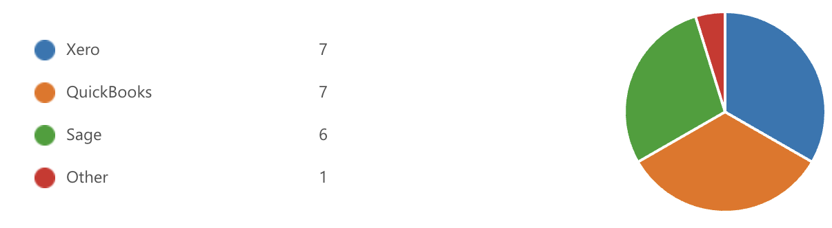
Figure 4.4: Cloud Accounting Software Used by SMEs
Source: Survey Data (2026)

Xero and QuickBooks were the most popular cloud accounting programs among respondents, with seven users each, as shown in Figure 4.4. Six respondents said they used Sage, and only one said they used another accounting platform. These results imply that the SME market is dominated by several significant cloud accounting providers, with Xero and QuickBooks being especially well-liked among the study's participating organisations.
The survey also looked at how often businesses use cloud accounting systems.
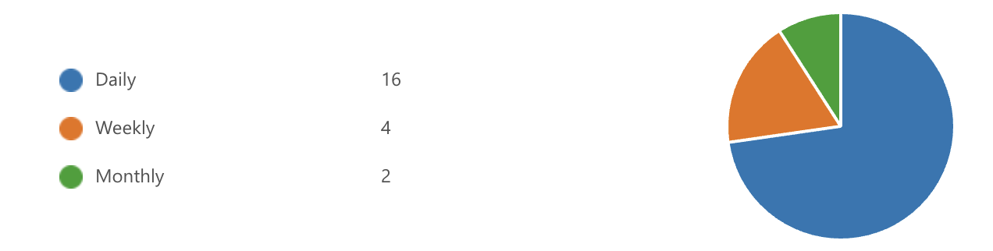
Figure 4.5: Frequency of Cloud Accounting System Usage
Source: Survey Data (2026)

As illustrated in Figure 4.5, most respondents reported using cloud accounting systems daily, with 16 respondents selecting this option. Four respondents indicated that they use cloud accounting systems weekly, while only two respondents reported using them monthly. These findings suggest that cloud accounting systems play an important role in the day-to-day financial operations of SMEs and are frequently used to manage financial data and accounting processes.

Financial Accuracy
A few statements intended to assess how cloud accounting systems affect SMEs' financial accuracy were included in the survey. Participants were asked to rate how much they agreed with statements about reconciliation procedures, accounting errors, and the accuracy of financial reporting.
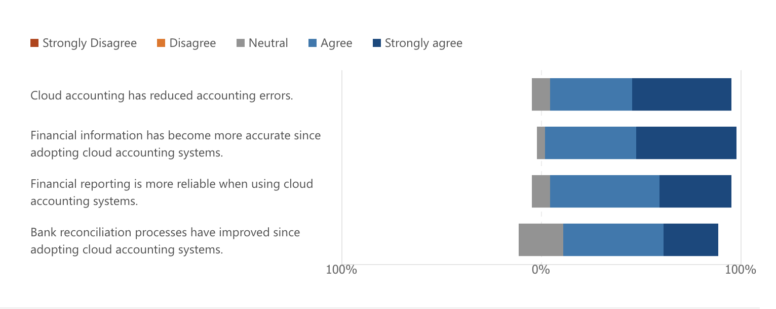
Figure 4.6: Impact of Cloud Accounting on Financial Accuracy
Source: Survey Data (2026)

Most respondents had favourable opinions about how cloud accounting affected financial accuracy, as shown in Figure 4.6. Many participants agreed or strongly agreed that cloud accounting systems increase the accuracy of financial data and decrease accounting errors. In a similar vein, respondents said that using cloud accounting systems increases the reliability of financial reporting. Furthermore, a lot of participants concurred that automation and real-time data synchronisation have improved bank reconciliation procedures. These findings imply that cloud accounting systems greatly enhance SMEs' financial accuracy.

Operational Efficiency
The survey looked at how cloud accounting systems affected SMEs' operational efficiency in addition to financial accuracy. A few statements about workflow efficiency, automation, report generation, and management-financial staff collaboration were given to participants to assess.
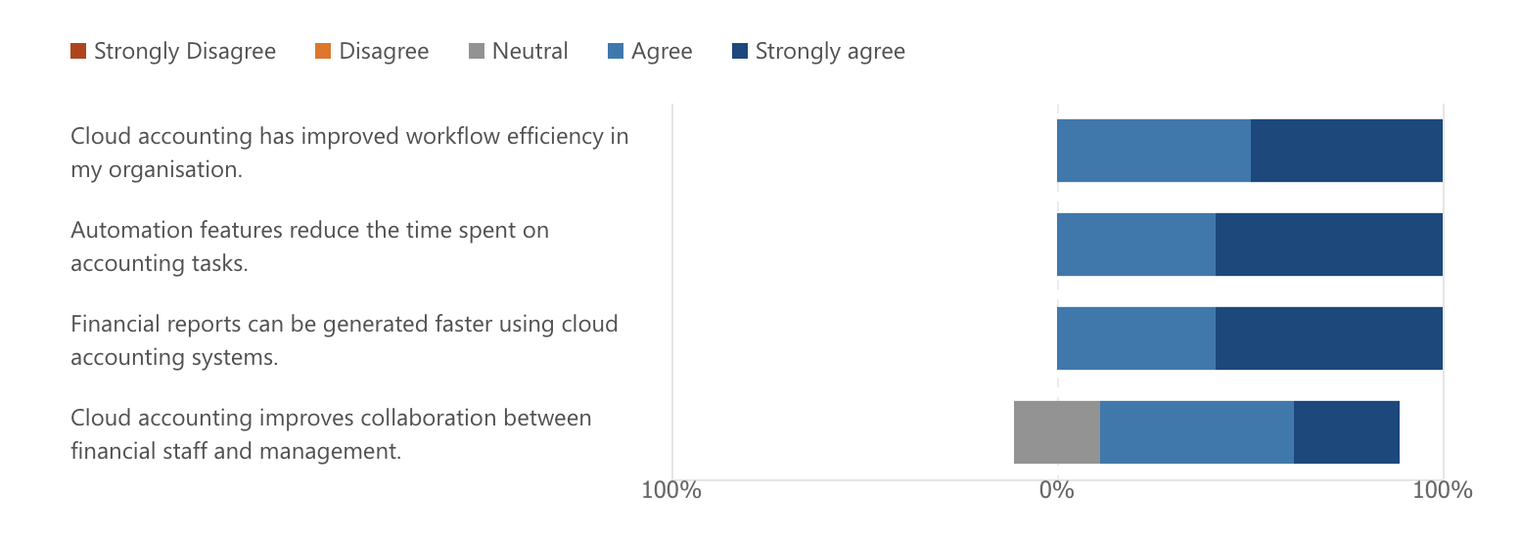
Figure 4.7: Impact of Cloud Accounting on Operational Efficiency
Source: Survey Data (2026)

Most respondents agreed or strongly agreed that cloud accounting systems increase operational efficiency, as Figure 4.7 illustrates. Participants reported that automation features shorten the time needed to finish accounting tasks and that cloud accounting has increased workflow efficiency within their organisations. Additionally, many respondents concurred that using cloud accounting systems can speed up the generation of financial reports. Because financial information can be accessed and shared in real time, the results also imply that cloud accounting enhances management and financial staff collaboration. All things considered, these results show that cloud accounting systems greatly enhance SMEs' operational effectiveness.

Challenges in Implementing Cloud Accounting Systems
In addition to examining the benefits of cloud accounting systems, the survey also explored potential challenges associated with their implementation and use. Participants were asked to evaluate statements related to system implementation difficulties, staff training requirements, and technical issues affecting system performance.
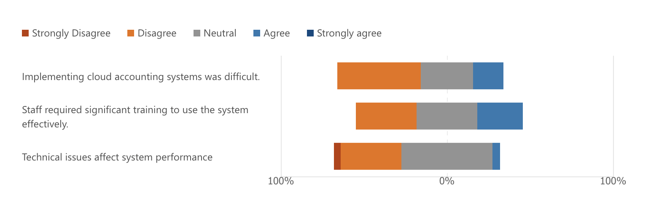
Figure 4.8: Challenges Associated with Cloud Accounting Implementation
Source: Survey Data (2026)

Respondents mentioned several difficulties with the deployment and use of cloud accounting systems, as seen in Figure 4.8. Some participants reported that it was initially challenging to implement cloud accounting systems, indicating that organisations may encounter transitional difficulties when implementing new technologies. Furthermore, many respondents concurred that employees needed training to use cloud accounting systems efficiently. Some participants also mentioned technical problems that affected system performance, but these issues were less significant than the perceived advantages mentioned in previous sections. Overall, the findings imply that even though cloud accounting systems have many benefits, businesses may still run into some implementation issues.

Impact on Financial Management and Decision-Making
The survey's last section looked at how cloud accounting systems affect SMEs' managerial and financial decision-making. Participants were asked to assess claims about enhanced financial management procedures and how cloud accounting helps make better business decisions.
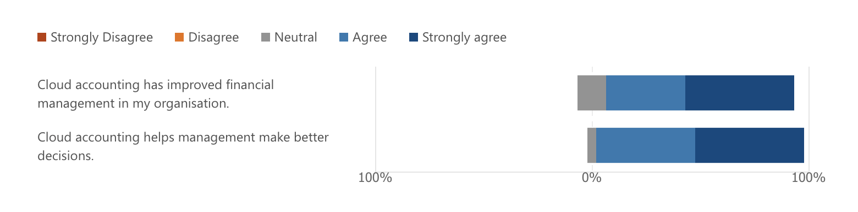
Figure 4.9: Impact of Cloud Accounting on Financial Management and Decision-Making
Source: Survey Data (2026)

Most respondents agreed or strongly agreed that cloud accounting systems have improved financial management within their organisations, as shown in Figure 4.9. Additionally, a lot of participants mentioned that cloud accounting aids in management's ability to make better financial decisions. These results imply that managers can obtain more accurate financial information, which facilitates better informed decision-making processes, thanks to the availability of real-time financial data and automated reporting features.

4.3 Interview Findings
To learn more about how cloud accounting systems are used in SMEs, an interview with an accounting professional was done in addition to the survey data. Qualitative information about the perceived advantages, implementation difficulties, and overall effects of cloud accounting on financial management and decision-making was obtained from the interview. The quantitative results from the survey are complemented and supported by the interview findings.

Perceived Benefits of Cloud Accounting
The interviewee mentioned several advantages of cloud accounting systems for small and medium-sized businesses. The enhancement of real-time reporting and financial data accessibility was one of the biggest benefits noted. The participant claims that cloud accounting systems make it possible to access financial data from any location with internet connectivity, making it easier for managers and accountants to keep an eye on financial performance.
Additionally, the participant emphasised how cloud accounting systems decrease human error and increase accuracy. Errors that frequently arise with conventional accounting techniques are reduced by automation features like real-time data synchronisation, transaction matching, and automatic bank feeds. These results corroborate the survey's earlier findings, which showed that most participants thought cloud accounting systems increased financial accuracy and decreased accounting errors.
The ability to produce financial reports more rapidly was another advantage that was brought up during the interview. The participant clarified that cloud accounting systems enable companies to generate management reports and financial statements nearly instantly, facilitating quicker decision-making. This is consistent with the survey results showing that cloud accounting facilitates quicker financial reporting and increases workflow efficiency.

Challenges and Implementation Issues
The interviewee acknowledged that organisations may encounter certain difficulties during the implementation process, despite the numerous benefits of cloud accounting systems. The initial shift from traditional accounting systems to cloud-based platforms was one of the main challenges mentioned. The participant clarified that workers might need some time to get used to new procedures and systems.
The need for training was also mentioned as a possible difficulty. To effectively use cloud accounting software, staff members who are not familiar with it may need more training. This conclusion is consistent with the survey's findings, which showed that staff training was required for the system to be implemented successfully.
The participant also noted that certain organisations might encounter technical problems, like internet connectivity issues or system updates that momentarily impair system performance. The participant did point out that the long-term advantages of adopting cloud accounting outweigh these problems, which are typically manageable.

Impact on Financial Management and Decision-Making
Additionally, the interview shed light on how cloud accounting systems affect managerial decision-making and financial management procedures. The participant claims that cloud accounting systems give managers access to current financial data, which enhances their capacity to track company performance and make wise choices.
The participant clarified that managers can promptly spot possible financial problems and take appropriate corrective action when they have real-time access to financial data. This enhances organisational budgeting and financial planning procedures. Additionally, because financial data can be instantly shared via cloud accounting systems, managers can work more efficiently with accountants and financial personnel.
These observations corroborate the survey results previously reported, which showed that a significant percentage of participants agreed that cloud accounting systems enhance financial management and assist managers in making better decisions. Overall, the results of the interviews support the quantitative findings and show that cloud accounting systems can greatly improve SMEs' financial management procedures.

Chapter 5: Discussion

5.1 Introduction
In this chapter, the results from Chapter 4 are discussed and contrasted with the body of literature that was reviewed in Chapter 2. The impact of cloud accounting systems on operational effectiveness, financial decision-making, and financial accuracy in small and medium-sized businesses (SMEs) is the main topic of discussion. To ascertain whether the results confirm or refute earlier research, the survey and interview results are examined considering prior research.

5.2 Impact of Cloud Accounting on Financial Accuracy
The study's conclusions imply that cloud accounting systems improve SMEs' financial accuracy. Cloud accounting systems lower accounting errors and increase the accuracy of financial data, according to most survey participants. Additionally, participants reported that using cloud-based accounting systems makes bank reconciliation procedures simpler and more precise.
These results corroborate earlier studies that indicate cloud accounting technologies enhance the accuracy of financial records and decrease human data entry errors (Dimitriu & Matei, 2014). Senyo et al. (2018) contended that cloud-based systems enhance the dependability of accounting data by enabling the automatic and real-time updating of financial data.
The results of the interviews also verified that automation features like transaction matching and automatic bank feeds help to lower accounting errors. This implies that by reducing human error and raising the general calibre of financial data, cloud accounting systems improve financial accuracy.

5.3 Impact of Cloud Accounting on Operational Efficiency
Cloud accounting systems increase SMEs' operational efficiency, which is another important finding of this study. According to the survey's findings, many participants think that cloud accounting systems increase workflow effectiveness, shorten the time needed to finish accounting tasks, and speed up the generation of financial reports.
These findings are in line with those of Alshamaila et al. (2013), who discovered that by automating repetitive tasks, cloud computing technologies can greatly increase organisational efficiency. In a similar vein, Marston et al. (2011) found that cloud-based technologies enable businesses to streamline operations and access data remotely.
Additionally, the interviewee clarified that cloud accounting systems facilitate access to financial data from various locations, which enhances management and financial staff cooperation. This bolsters the claim that real-time data sharing and communication made possible by cloud accounting systems improve organisational efficiency.

5.4 Implementation Challenges of Cloud Accounting Systems
Despite the numerous advantages of cloud accounting systems, the results of this study also highlight a few implementation-related difficulties. According to survey respondents, some businesses have trouble implementing cloud accounting systems at first. One of the biggest issues was staff training, since it might take some time for workers to become proficient with new systems.
These results are in line with earlier studies that indicate organisations may face difficulties when implementing new technology, especially when switching from traditional to digital platforms (Oliveira et al., 2014). Technical problems that occasionally impair system performance were also mentioned by a few respondents.
Nevertheless, the general opinion of cloud accounting systems remained favourable despite these difficulties. Most respondents thought that cloud accounting systems' advantages outweighed their initial implementation challenges.

5.5 Impact on Financial Management and Decision-Making
The results of this study also show that cloud accounting systems help SMEs make better financial decisions and manage their finances. According to survey participants, cloud accounting systems assist managers in improving overall financial management procedures and making better financial decisions.
These results corroborate the findings of Warren et al. (2015), who contended that managers can more successfully monitor company performance thanks to real-time financial data provided by digital accounting technologies. Organisations can spot possible financial issues and react swiftly to shifting business conditions when they have access to current financial data.
This conclusion is further supported by the results of the interviews. The participant clarified that managers can instantly access financial data through cloud accounting systems, which enhances budgeting and financial planning procedures. As a result, organisations can use accurate financial data to make better decisions.

5.6 Summary of Key Findings
Overall, the results of this study show that cloud accounting systems offer SMEs several significant advantages. The findings show that cloud accounting systems facilitate better financial decision-making, increase operational effectiveness, and improve financial accuracy. The benefits of cloud accounting systems seem to outweigh any implementation challenges, such as the need for staff training and sporadic technical problems.
The study's findings confirm that cloud-based technologies are becoming increasingly significant in contemporary financial management and are generally in line with earlier research on the adoption of cloud accounting.

Chapter 6: Conclusion and Recommendations

6.1 Introduction
This chapter summarises the study's main conclusions and discusses how they might affect small and medium-sized businesses (SMEs). In addition, the chapter highlights the study's limitations, offers suggestions for future research, and makes recommendations based on the findings. This study looked at how cloud accounting systems affected SMEs' operational effectiveness and financial accuracy.

6.2 Summary of Key Findings
The results of this study show that cloud accounting systems offer SMEs substantial advantages in terms of operational effectiveness, financial decision-making, and financial accuracy. The survey's findings showed that many participants think cloud accounting systems lower accounting errors and increase the accuracy of financial data. The accuracy of financial records is increased by automated features like bank feeds, transaction matching, and real-time updates.
The findings also imply that cloud accounting systems improve an organization's operational effectiveness. Cloud accounting, according to many respondents, increases workflow efficiency, decreases the amount of time spent on accounting tasks, and speeds up the generation of financial reports. Organisations can more efficiently allocate resources and streamline accounting procedures thanks to these advancements.
Additionally, the study discovered that cloud accounting systems facilitate improved decision-making and financial management. Managers can monitor company performance more successfully and make well-informed decisions based on precise financial data when they have access to real-time financial data.
But the study also noted some obstacles to the adoption of cloud accounting. According to some respondents, staff training requirements and technical difficulties can make the initial implementation of cloud accounting systems challenging. Despite these obstacles, cloud accounting systems were generally viewed favourably, with most participants concurring that the advantages outweigh the drawbacks.
By emphasising the value of real-time financial information, better management-financial staff collaboration, and enhanced efficiency in financial reporting procedures, the interview findings corroborated the survey results.

6.3 Recommendations
Several suggestions for SMEs thinking about implementing cloud accounting systems can be made considering the research's conclusions.
To guarantee that staff members can utilise cloud accounting systems efficiently, companies should first fund suitable training initiatives. Giving employees enough training can lessen implementation challenges and increase system utilisation.
Second, to choose a system that best meets their organisational needs, SMEs should carefully consider various cloud accounting platforms. When choosing cloud accounting software, factors like system functionality, integration capabilities, security features, and cost should be considered.
Third, to safeguard financial data kept in cloud-based systems, organisations should make sure that the proper cybersecurity measures are put in place. For businesses implementing cloud technologies, data security and privacy continue to be major concerns.
Finally, to enhance financial monitoring and strategic decision-making, managers should utilise the real-time reporting features offered by cloud accounting systems.

6.4 Limitations of the Study
Notwithstanding the insightful information this study offers, several limitations should be noted. The survey's comparatively small sample size is one of the study's limitations. A larger sample size might offer a more thorough understanding of cloud accounting adoption among SMEs, even though the survey responses offered insightful information.
The study's reliance on participants' self-reported perceptions is another drawback. Respondents' responses may be influenced by their varying degrees of experience with cloud accounting systems. Furthermore, the study only included a small number of interviews, which might limit the breadth of qualitative insights gleaned.
Additionally, because the study's primary focus was on SMEs, its conclusions might not apply to larger organisations with more intricate accounting systems.

6.5 Suggestions for Future Research
This study could be expanded upon in future research by looking at cloud accounting adoption in a wider range of industries and organisations. Researchers could learn more about how cloud accounting systems affect organisational effectiveness and financial performance with a larger dataset.
The long-term impacts of cloud accounting adoption on company expansion and financial management procedures may also be the subject of future research. Future studies could also examine how new technologies like automation and artificial intelligence can improve cloud accounting systems.
Lastly, research comparing cloud-based accounting solutions with traditional accounting systems may shed more light on the benefits and possible drawbacks of cloud accounting technologies.

By offering empirical data on the real-world effects of cloud accounting systems on SMEs, particularly about operational effectiveness and financial accuracy, this study adds to the body of existing literature.

Reference:

Al-Sharafi, M.A., Iranmanesh, M., Al-Emran, M., Alzahrani, A.I., Herzallah, F. and Jamil, N., 2023. Determinants of cloud computing integration and its impact on sustainable performance in SMEs: An empirical investigation using the SEM-ANN approach. Heliyon, 9(5).

Alshamaila, Y., Papagiannidis, S. and Li, F., 2013. Cloud computing adoption by SMEs in the north east of England: A multi‐perspective framework. Journal of enterprise information management, 26(3), pp.250-275.

Armbrust, M., Fox, A., Griffith, R., Joseph, A.D., Katz, R., Konwinski, A., Lee, G., Patterson, D., Rabkin, A., Stoica, I. and Zaharia, M., 2010. A view of cloud computing. Communications of the ACM, 53(4), pp.50-58.

Ayyagari, M., Demirgüç-Kunt, A. and Maksimovic, V., 2011. Small vs. young firms across the world: contribution to employment, job creation, and growth. World Bank policy research working paper, (5631).

Banker, R.D., Bardhan, I.R., Chang, H. and Lin, S., 2006. Plant information systems, manufacturing capabilities, and plant performance. MIS quarterly, pp.315-337.

Beck, T. and Demirguc-Kunt, A., 2006. Small and medium-size enterprises: Access to finance as a growth constraint. Journal of Banking & finance, 30(11), pp.2931-2943.

Blaikie, N. and Priest, J., 2017. Social research: Paradigms in action. John Wiley & Sons.

Bryman, A., 2016. Social research methods. Oxford university press.

Brynjolfsson, E. and Hitt, L.M., 2000. Beyond computation: Information technology, organizational transformation and business performance. Journal of Economic perspectives, 14(4), pp.23-48.

Creswell, J., 2003. Research design: Qualitative, quantitative and mixed methods. Sage Publications..
Creswell, J.W. and Clark, V.P., 2007. Mixed methods research. Thousand Oaks, CA.

Creswell, J.W. and Creswell, J.D., 2017. Research design: Qualitative, quantitative, and mixed methods approaches. Sage publications.

D’Amboise, G. and Gasse, Y., 1980. Performance in small firms and the utilization of formal management techniques. In Proceeding of the joint national meeting tims/orsa, washington.
Davenport, T.H., 1998. Putting the enterprise into the enterprise system. Harvard business review, 76(4), pp.121-131.

DeLone, W.H. and McLean, E.R., 2003. The DeLone and McLean model of information systems success: a ten-year update. Journal of management information systems, 19(4), pp.9-30.

Dimitriu, O. and Matei, M., 2014. A new paradigm for accounting through cloud computing. Procedia economics and finance, 15, pp.840-846.

Dubois, A. and Gadde, L.E., 2002. Systematic combining: an abductive approach to case research. Journal of business research, 55(7), pp.553-560.

Feghali, K., Matta, J. and Moussa, S., 2022. Digital transformation of accounting practices and behavior during COVID-19: MENA evidence. Accounting and Management Information Systems, 21(2), pp.236-269.
Garrison, G., Kim, S. and Wakefield, R.L., 2012. Success factors for deploying cloud computing. Communications of the ACM, 55(9), pp.62-68.

Grande-Urquia, E., Perez-Estébanez, R. and Munoz-Colomina, C., 2011. The impact of accounting information systems (AIS) on performance measures. The International Journal of Digital Accounting Research, 11, pp.25-43.

Holmes, S. and Nicholls, D., 1988. An analysis of the use of accounting information by Australian small business. Journal of small business management, 26(2), p.57.

Hunton, J.E., Wright, A.M. and Wright, S., 2004. Are financial auditors overconfident in their ability to assess risks associated with enterprise resource planning systems?(Retracted). Journal of Information Systems, 18(2), pp.7-28.

Israel, M. and Hay, I., 2006. Research ethics for social scientists. Sage.

Jarvis, R., Curran, J., Kitching, J. and Lightfoot, G., 2000. The use of quantitative and qualitative criteria in the measurement of performance in small firms. Journal of small business and enterprise development, 7(2), pp.123-134.

King, M., 2007. Factors influencing the alignment of accounting information systems in small and medium sized Malaysian manufacturing firms.

Kshetri, N., 2010. Cloud computing in developing economies. Computer, 43(10), pp.47-55.
Kvale, S. and Brinkmann, S., 2009. Interviews: Learning the craft of qualitative research interviewing. sage.

Low, C., Chen, Y. and Wu, M., 2011. Understanding the determinants of cloud computing adoption. Industrial management & data systems, 111(7), pp.1006-1023.

Lutfi, A., Alkelani, S.N., Al-Khasawneh, M.A., Alshira’h, A.F., Alshirah, M.H., Almaiah, M.A., Alrawad, M., Alsyouf, A., Saad, M. and Ibrahim, N., 2022. Influence of digital accounting system usage on SMEs performance: The moderating effect of COVID-19. Sustainability, 14(22), p.15048.

Marston, S., Li, Z., Bandyopadhyay, S., Zhang, J. and Ghalsasi, A., 2011. Cloud computing—The business perspective. Decision support systems, 51(1), pp.176-189.

Melville, N., Kraemer, K. and Gurbaxani, V., 2004. Information technology and organizational performance: An integrative model of IT business value. MIS quarterly, pp.283-322.

Mitchell, F., Reid, G.C. and Smith, J., 2000. Information system development in the small firm: The use of management accounting. Chartered Institute of Management Accountants.
Mithas, S., Ramasubbu, N. and Sambamurthy, V., 2011. How information management capability influences firm performance. MIS quarterly, pp.237-256.

Morgan, D.L., 2007. Paradigms lost and pragmatism regained: Methodological implications of combining qualitative and quantitative methods. Journal of mixed methods research, 1(1), pp.48-76.

Mujalli, A., Wani, M.J.G., Almgrashi, A., Khormi, T. and Qahtani, M., 2024. Investigating the factors affecting the adoption of cloud accounting in Saudi Arabia's small and medium-sized enterprises (SMEs). Journal of Open Innovation: Technology, Market, and Complexity, 10(2), p.100314.
Nguyen Phu, G., Hoang Thi, T. and Tran Nguyen Bich, H., 2025. The impact of cloud computing technology on cloud accounting adoption and financial management of businesses. Humanities and Social Sciences Communications, 12(1), pp.1-14.

Nicolaou, A.I., 2000. A contingency model of perceived effectiveness in accounting information systems: Organizational coordination and control effects. International journal of accounting information systems, 1(2), pp.91-105.

Oliveira, T. and Martins, M.F., 2011. Literature review of information technology adoption models at firm level. Electronic journal of information systems evaluation, 14(1), pp.pp110-121.

Oliveira, T., Thomas, M. and Espadanal, M., 2014. Assessing the determinants of cloud computing adoption: An analysis of the manufacturing and services sectors. Information & management, 51(5), pp.497-510.

Pearson, S. and Benameur, A., 2010, November. Privacy, security and trust issues arising from cloud computing. In 2010 IEEE Second International Conference on Cloud Computing Technology and Science (pp. 693-702). IEEE.

Putri, E., Bandi, B., Widarjo, W. and Arifin, T., 2025. The value of cloud accounting for MSMEs: a Technology-Organization-Environment (TOE) framework perspective. Cogent Business & Management, 12(1), p.2494712.

Rogers, E., 2003. Diffusion of Innovations 5th.

Saad, M., Lutfi, A., Almaiah, M.A., Alshira’h, A.F., Alshirah, M.H., Alqudah, H., Alkhassawneh, A.L., Alsyouf, A., Alrawad, M. and Abdelmaksoud, O., 2022. Assessing the intention to adopt cloud accounting during COVID-19. Electronics, 11(24), p.4092.

Saunders, M., Lewis, P. and Thornhill, A., 2009. Research methods for business students. Pearson education.

Senyo, P.K., Addae, E. and Boateng, R., 2018. Cloud computing research: A review of research themes, frameworks, methods and future research directions. International Journal of Information Management, 38(1), pp.128-139.

Soudani, S.N., 2012. The usefulness of an accounting information system for effective organizational performance. International Journal of economics and Finance, 4(5), pp.136-145.

Tashakkori, A. and Teddlie, C., 1998. Mixed methodology: Combining qualitative and quantitative approaches (Vol. 46). sage.

Thong, J.Y., 1999. An integrated model of information systems adoption in small businesses. Journal of management information systems, 15(4), pp.187-214.

Venkatesh, V. and Davis, F.D., 2000. A theoretical extension of the technology acceptance model: Four longitudinal field studies. Management science, 46(2), pp.186-204.

Warren, J.D., Moffitt, K.C. and Byrnes, P., 2015. How big data will change accounting. Accounting horizons, 29(2), pp.397-407.

Zhu, K. and Kraemer, K.L., 2005. Post-adoption variations in usage and value of e-business by organizations: cross-country evidence from the retail industry. Information systems research, 16(1), pp.61-84.

Appendices

Appendix A – Interview Questions
The following semi-structured interview questions were used to collect qualitative data regarding the use of cloud accounting systems in SMEs.
1: What is your role in the organisation?
2: How long have you been using cloud accounting systems?
3: In your experience, how has cloud accounting affected financial accuracy?
4: Have you noticed any reduction in accounting errors since adoption?
5: How has cloud accounting influenced efficiency in financial processes?
6: Has it reduced time spent on accounting tasks?
7: What challenges did your organisation face when implementing cloud accounting?
8: Were there any training or technical issues?
9: What benefits do you think cloud accounting provides to SMEs?
10: Would you recommend cloud accounting systems to other SMEs? Why?

Appendix B – Survey Questionnaire
The survey questionnaire was designed to examine the impact of cloud accounting systems on financial accuracy and operational efficiency in SMEs.
Section A – Background
1: What is your role in the organisation?
- Owner
- Manager
- Accountant
- Finance staff
- Other
2: What size is your organisation?
- Micro (1–9 employees)
- Small (10–49 employees)
- Medium (50–249 employees)
3: How long has your organisation used cloud-based accounting systems?
- Less than 1 year
- 1–3 years
- 3–5 years
- More than 5 years
Section B – Cloud Accounting Usage
4: Which cloud accounting software does your organisation use?
- Xero
- QuickBooks
- Sage
- Other
5: How frequently do you use the cloud accounting system?
- Daily
- Weekly
- Monthly
Section C – Financial Accuracy (Likert scale: Strongly Disagree → Strongly Agree)
6: Cloud accounting has reduced accounting errors.
7: Financial information has become more accurate since adopting cloud accounting.
8: Financial reporting is more reliable using cloud accounting systems.
9: Bank reconciliation processes have improved since adopting cloud accounting.
Section D – Operational Efficiency
10: Cloud accounting has improved workflow efficiency.
11: Automation features reduce time spent on accounting tasks.
12: Financial reports can be generated faster using cloud accounting systems.
13: Cloud accounting improves collaboration within the organisation.
Section E – Challenges
14: Implementing cloud accounting systems was difficult.
15: Staff required significant training to use the system effectively.
16: Technical issues affect system performance.
Section F – Overall Impact
17: Cloud accounting has improved financial management in my organisation.
18: Cloud accounting helps management make better decisions.

