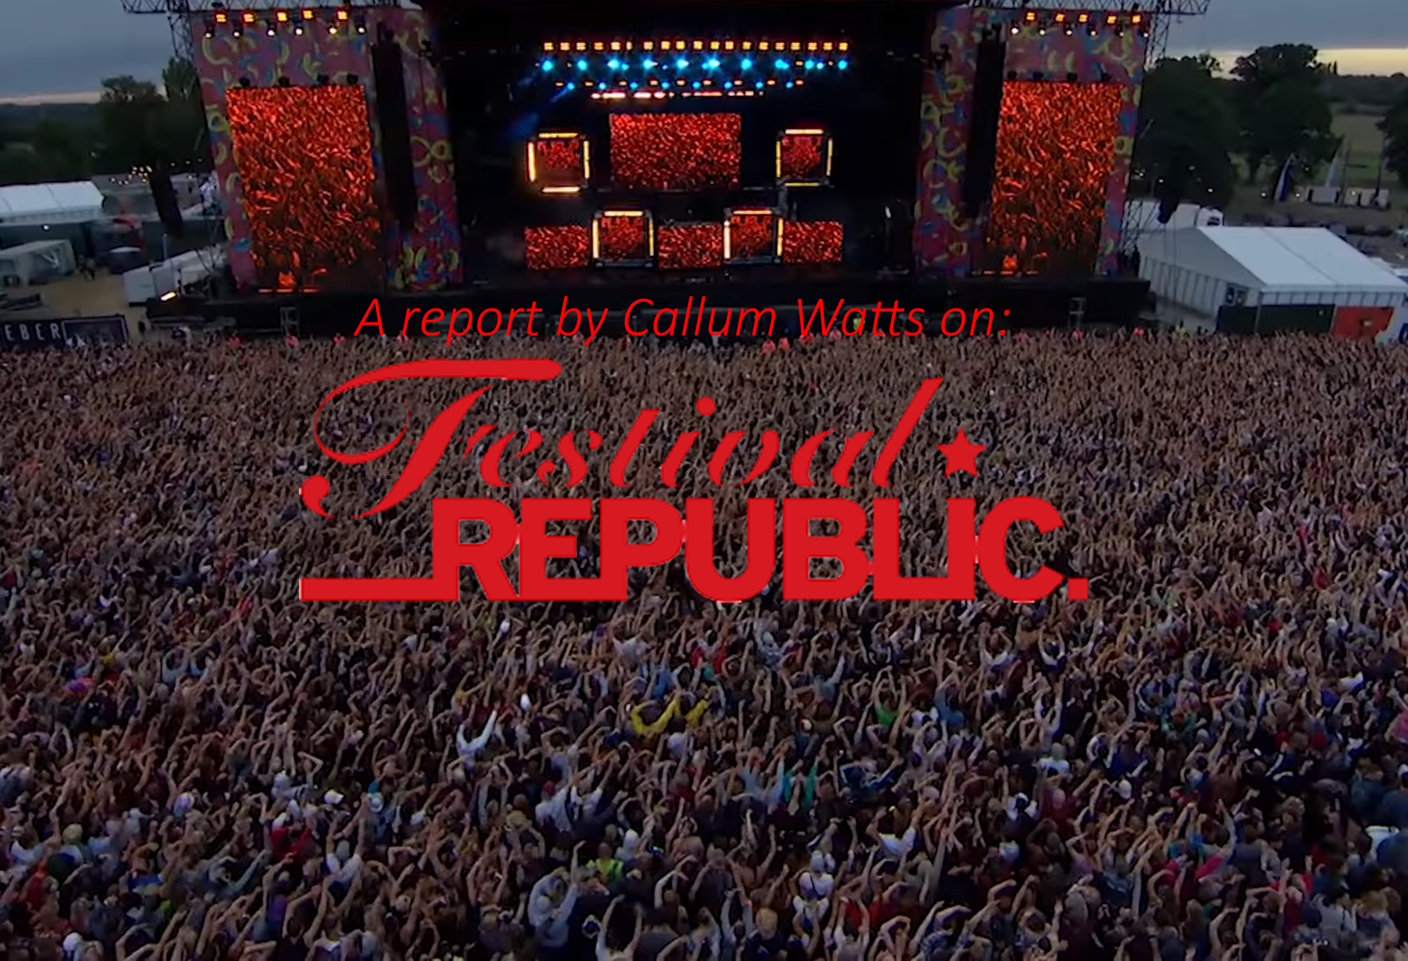

- COMPANY BACKGROUND
- PRODUCTS AND CONSUMER BASE(S)
- MAJOR COMPETITORS
- PRICING STRATEGY
- MARKET CHARACTERISTICS
- MACROENVRIONMENT
- COMPANY FINANCING (SHORT AND LONG TERM)
- RECENT FINANCIAL AND INVESTMENT ACTIVITY
- ALTERNATE FUNDING SOURCES
- CONCLUSIVE REPORT
- APPENDICIES
- BIBLIOGRAPHY
- COMPANY BACKGROUND
Festival Republic was technically founded in 2007, however the first iteration of the company was created in 1982 by Irish music promoter Vince Power, originally christened Mean Fiddler. In 2005 Power and the rest of the Mean Fiddler shareholders accepted a takeover offer from Clear Channel Entertainment (USA) and Gaiety Investments (IRE). It was reported that this takeover bid valued Mean Fiddler at “£37.9m” and would “see the firm’s founder Vince Power pocket around £13m for his 35% stake” (BBC, 2005). In 2007, the relatively newly owned Mean Fiddler, “sold off its name to become Festival Republic” (VirtualFestivals, 2007). Since the rebranding to Festival Republic, the company has overseen huge growth in the UK live music sector. Their portfolio including, Reading & Leeds, Wireless, Latitude, Electric Picnic, Community, Lollapalooza Berlin and Download has grown exponentially since the disassociation from Mean Fiddler, and Festival Republic are well and truly the market leaders in the UK music festival industry.
Since 2010, the company has grown exponentially financially, mainly based around the continuing support and growth for their festivals, however behind the scenes, there has been major restructuring within Festival Republic. In 2012, Festival Republic ended their partnership with the iconic Glastonbury Festival. Festival Republic joined forces with Glastonbury in 2002, and this signalled the ending of a 10-year stake in the festival. Despite the termination of the working agreement, the companies own, directly owned festivals have seen sell out years, larger acts and a vastly increased presence in the UK’s live music scene.
Alongside the restructuring behind the scenes, in August 2018, the director of Live Nation UK Paul Latham “announced his retirement after more than three decades in the live music industry” (Smirke, 2018). Latham was appointed a director of Festival Republic in 2005, coinciding with the sale to Clear Channel and Gaiety, and retired after serving Festival Republic for 13 years.
In 2015, Festival Republic acquired a 25.05% stake in the companies FRHUG Festival GmbH & Co. KG (GER) and FRHUG Verwaltungs-GmbH, (GER) this acquisition was the purchasing of a stake in Lollapalooza Berlin. Asides from this, Festival Republic as an entity doesn’t particularly engage with acquisitions, however its parent company is Live Nation Entertainment (USA) who are notorious for their hostile takeover practises.
This acquisition coincided with the first outing for Lollapalooza Berlin as they joined into partnership for this festival only with the original Lollapalooza’s promoters “Perry Farrell, William Morris Endeavor (WME) and C3 Presents” alongside “Melt! Booking” (Waddell, 2014) to become Lollapalooza’s fourth international expansion outside the US. Having been hosted at the iconic Templehof Airport, the inaugural 2015 launch saw a successful first outing for the joint endeavour. The success of the festival, alongside the emergence of Berlin as a cultural hotspot in the latter stages of the last decade, have resulted in the festival becoming a yearly event. Lollapalooza Berlin and will undoubtably be a mainstay of the European festival calendar for years to come. Alongside entering the international market in 2015, Festival Republic also launched the Community festival in 2017. The one-day, Finsbury Park, festival saw widespread success with a heavy attendance in the North London summer sunshine, as well as success in 2018. Again, this festival is quickly becoming a part of the London summer social sphere, and Festival Republic manage to capture a wide audience base due to their expertise in booking.
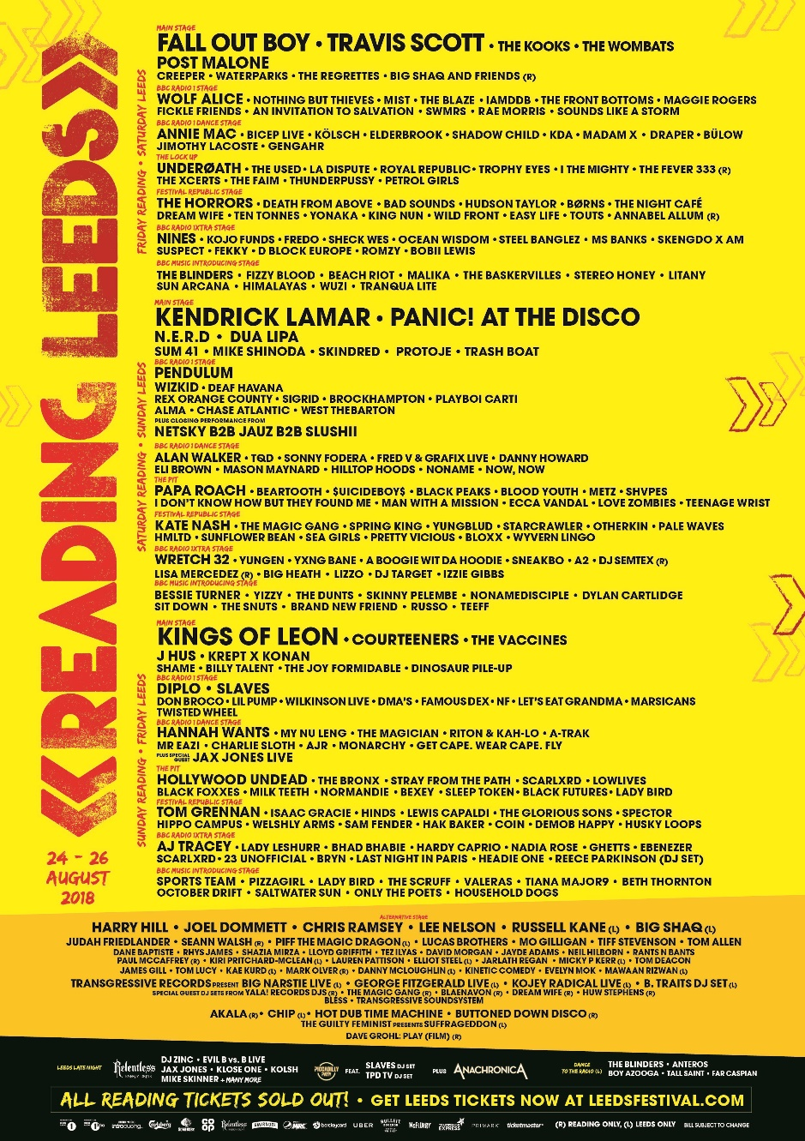
- PRODUCTS AND CONSUMER BASE(S)
Being music promoters, and festival promoters, you must cater to very, very wide audiences. This is something the team at Festival Republic have long succeeded in doing. From their main festivals, like Reading and Leeds, to their more niche focused festivals like Download, they often manage to cater to wide variety of musical cultures and festivals each and every year. Taking Reading and Leeds as a prime example, as you can see in 2018 their line-up has a delicate balance of household names, as well as niche acts to attract the widest possible customer base to the weekend. The sheer variety across their flagship festivals, even in the headline acts. From rap and grime acts like Kendrick Lamar and Krept & Konan to heavier Rock/Metal acts like Skindred and Beartooth, the widespread appeal of their booking manages to retain not only their core market of popular music fans; but draws in others who may have been more interested in other Festival Republic outlets like Download and bring them towards their main showcase for the year.
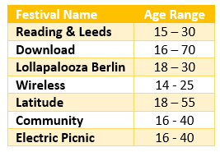
As previously mentioned, Festival Republic across its board has a wide consumer base, however mainly appeals to the same demographic. As attendances for these events can reach up to 90,000 at their main festivals, securing a dedicated demographic for these festivals can be extremely difficult, if not impossible. The table below, provides a rough estimate based on my knowledge of the UK festival scene and the demographic of those appealed to and attending the events.
However, these age ranges cannot always be taken as absolute fact. As has been reported in the news across various festival seasons, there is often older attendees, mostly at niche music festivals where the niche audience is more stable and not as fickle as a popular music fanbase. These audiences are also impacted by varying factors such as the acts performing, availability of disabled/easy access, weather, type of festival (dance/metal/pop etc.), status of festivals and more.
(Festival Republic, 2018)
- MAJOR COMPETITORS
Festival Republic does have a few competitors in the UK festival scene, however for the purpose of this report I will be excluding any UK companies also owned, or part owned, by the parent company Live Nation Entertainment as true, major competitors.
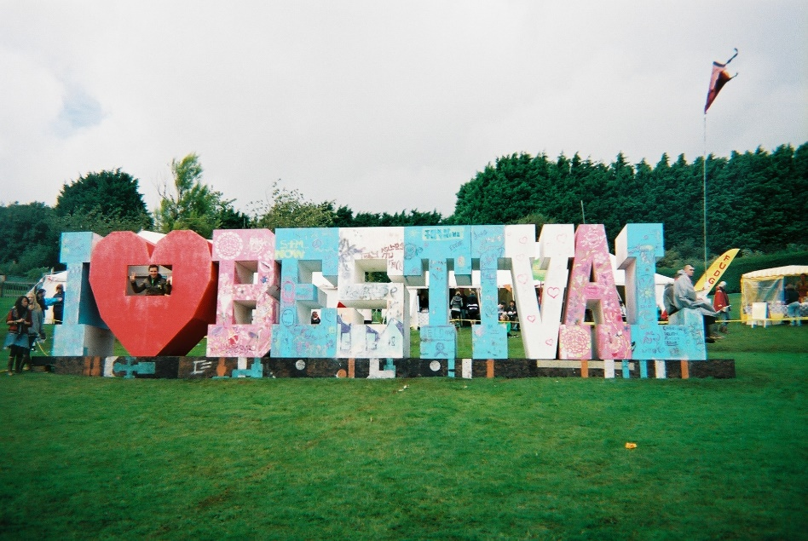
Bestival
In 2018 one of their last remaining true competitors, Bestival, filed for administration.
Bestival was formed by music promoter and DJ Rob da Bank [sic] as a continuation of his successful ‘Sunday Best’ club nights, hosted at South London’s Tearoom des Artistes. Using his connections with artists like Fatboy Slim, Basement Jaxx he founded a festival hosted on Robin Hill, Isle of Wight, christened Bestival. Bestival pitch themselves as a family friendly, socially and environmentally conscious festival and even have dedicated family friendly campsites and sections dedicated to children. Many fingers are pointed at the rise of Boomtown festival to the lack of income for the festival, however many point also at Rob da Bank [sic] for booking line ups that were slightly out of touch with the average festival consumer and seeking to repeat past festival bills that were successful in their own right.
Bestival as quite publicly reported in their administration papers, and through varying news outlets, were unable to pay creditors this last fiscal year. It is stated in their administration papers they owe music acts such as London Grammar “£175,000” and Plan B “£105,000” (Bestival Ltd., 2018), this eventually led to a takeover by Live Nation Entertainment. This in contrast with a seeming surge in the live music industry reiterated the point to the rest of the industry, that nothing can be taken for granted.
(Gomez, 2011)

Boomtown
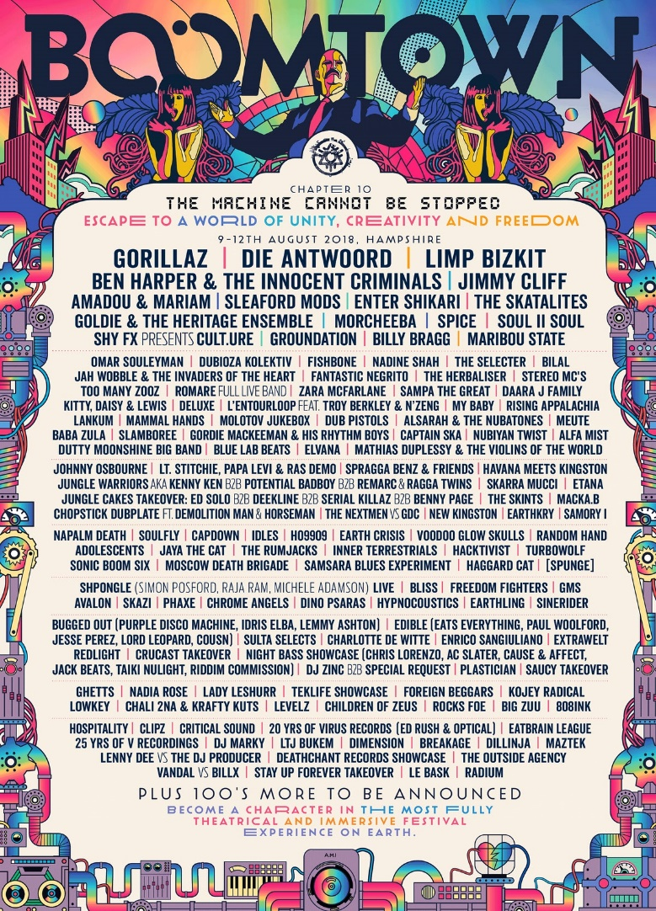
Despite the collapse and purchase of Bestival there is not particularly many competitors drawing possible consumers away from Festival Republic’s and Live Nation Entertainment’s UK events.
Boomtown Fair (owned and operated by Boomtown Festival UK Ltd.) is one of the few remaining. Boomtown, a niche festival is focused mainly towards electronic, rock and reggae music. The festival has managed to draw a regular, and ever-growing, crowd since its inception in 2009. As one of the major independent festivals left in the UK scene, Boomtown has to remain a competitor in the truest sense. Although they operate within a niche and operate their festival in a different way to other UK festivals, they have seen a continuing increase in support and reputation since the beginning of this decade. Somewhat interestingly, the festival organisers choose to brand each outing of the fair as ‘chapters’ instead of the traditional years. For example, the 2018 outing of the festival was named “The Machine Cannot Be Stopped” and featured headliners Gorillaz, Die Antwoord and Limp Bizkit. This disassociation from the normal methodology alongside the festival’s naming scheme including anti-establishment themes (such as “The Revolution Starts Now” and “Declaration of Democracy”) tends to separate Boomtown from more humdrum, mundane festivals. I believe this motive to separate from the wider UK festival industry that allows them to have the staying power as a true independent competitor.
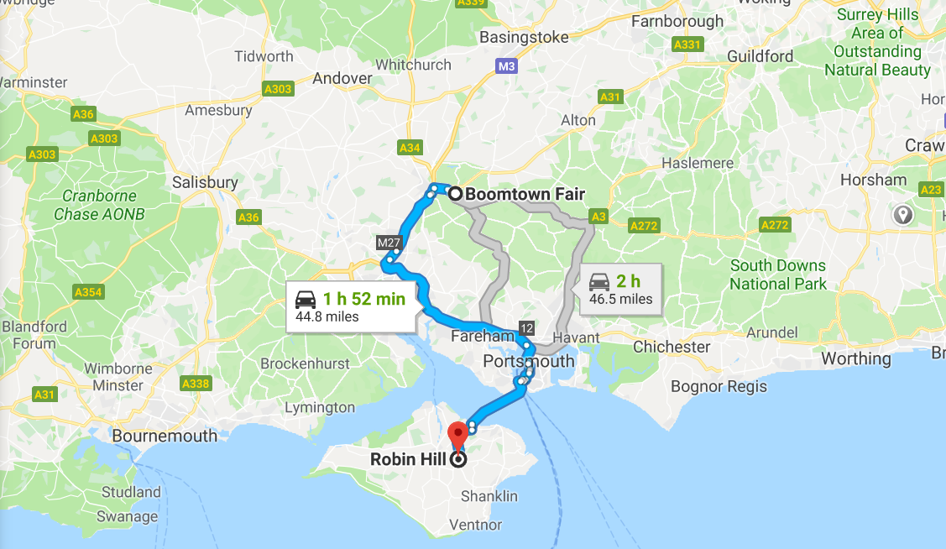
As previously mentioned, Boomtown is seen as one of the factors impacting the collapse of Bestival. When you compare the two festivals locations geographically, it becomes more apparent why the case can be made.
As the two are only separated by less than 50 miles, and they both operate in a less densely populated region of the Southern English coast, the fickle popular music audience may see staying on the mainland of the UK as a benefit, especially when the line up can be more appealing and the festival itself isn’t ‘just another festival.’
(Boomtown Festival Ltd., 2018)
(Boomtown to Robin Hill, 2018)
Global Entertainment
Global Entertainment was formed in 2007 by Ashley Tabor. Since it’s inception it has grown to become the largest commercial radio company in Europe. Their website boasts to visitors that they “entered the festivals business only two years ago, (and) are now the second largest festival operator in the UK” (Radio, n.d.), and as such it is only befitting that they are seen as the biggest competitor to Festival Republic.
Global’s radio portfolio includes stations such as Capital, Heart, Smooth and LBC to name a few. Alongside this Global’s festival portfolio is vast and impressive. From their own radio stations offshoot events such as Capital’s Jingle Bell Ball, they also own and operate; Standon Calling, Hideout (Croatia), YNot? Victorious, Field Day, Festival No. 6, Truck, Rewind, South West Four, Boardmasters, Snowbombing (Austria & Canada), Kendal Calling, and Lost Village (Radio, n.d.) (Hanley, 2017).
This impressive and diversified portfolio does bode for grim reading for anyone associated with Festival Republic namely as Global have managed to acquire controlling stakes in award winning small and medium sized festivals like Kendal Calling, Truck and YNot? Although these festivals are much smaller in attendance and reputation than the behemoth events that Festival Republic own and operate, and some not even on a level plain with Boomtown, with many it would only take one exceptional year to bring these unique festivals into the limelight. Particularly as they operate in catchments that Festival Republic don’t hit such as Central London with South West Four and Field Day, Cumbria with Kendal Calling and, of course, the international shows in Austria, Canada and Croatia.
Despite all this promise, as you can in Fig. 1, Global as an enterprise did not make a profit in 2016 or 2017. This could be down to a multitude of factors. Firstly, in 2017 “£114,383.383 of loans were converted to 114,383,383 ordinary £1 shares” (Global Media & Entertainment Ltd., 2017) which of course will impact their financial data for the year. Secondly, with the rise in popularity of streaming services like Spotify, video sharing platforms like YouTube and the continued torrenting and illegal downloading of music, less people listen to the radio compared to previous years and/or decades. The lower listenership, means less advertisers focus on this platform, and the business would undoubtably suffer as a result of advertisers pulling campaigns from their services. Despite all of this, Global with their intangible assets, sheer reach ability and foothold in the radio industry (whether this is a positive or a negative remains to be seen) they are certainly turning into a huge rival for Festival Republic.
Fig. 1
- PRICING STRATEGY
Across the various festivals Festival Republic usually deploy three entry points. Fig. 2 includes pricing points from all of Festival Republic’s events, both for their base weekend camping tickets and their cheapest day tickets.
Festival  (All prices sourced from festival websites POS) | 3-day Weekend Camping  Ticket Price | Booking Fee | Day Ticket Price  (cheapest if applicable) | Booking Fee | Total Cost  (Weekend where applicable)
Reading | £205.00 | £16.50 | £69.50 | £7.00 | £221.50
Leeds | £205.00 | £16.50 | £69.50 | £7.00 | £221.50
Download | £210.00 | £16.80 | Approx. £85.00 | £0.00 | £226.80
Lollapalooza | €169.00 | €0.00 | - | - | €169.00
Wireless | £175.00 | £15.00 | £57.50 | £7.20 | £190.00
Latitude | £197.50 | £15.80 | £0.00 | £0.00 | £213.30
Community | £0.00 | £0.00 | £40.00 | £5.25 | £45.25
Electric Picnic | €205.00 | Est. €15.00 | N/A | N/A | Est. €220.00
Firstly, the weekend tickets, usually the most common and traditional form. These tickets can either be bought with a slight discount if the attendees do not wish to camp at the site, however as most will travel the length and breadth of the country to attend a festival, this is a very rare occurrence with most festival attendees. As such they will sell weekend camping tickets, which will allow access to the festival and campsites for anywhere between 3-5 days, depending on the festival.
Throughout the years they have adapted and capitalised on the camping market. At most festivals they offer quiet camping. Which, allegedly, will remove any noisemakers from this campsite, however in a festival of 90,000 people as an example, the sheer logistics of this mean there is a strong likelihood that some troublemakers will disturb the quiet campers at some point. Despite these the tickets for these campsites do sell out fast, and at a slight mark up too. They also offer eco-camping for those who are concerned about their ecological footprint. However, this service does not come at a premium, but pre-registration is essential.
Secondly, they offer day tickets. This allows for consumers to attend one day of a festival in order to see a set of acts that they may have more preference seeing than being in the full immersive weekend experience. (For one day festivals like Community, this is the only method of entry as they do not offer camping or have a full weekend festival as of 2018.) These also prove popular, but are often the last to sell out, if at all, a few days/weeks before the festival. Nevertheless, offering this option to their customers is a clever move by Festival Republic and ensures another income stream is available for them during festival season.
Fig. 2
Interestingly though, every ticket does come with a booking fee. These vary in price depending on the ticket type purchased, but can increase prices by 7.34% in some instances. It does lead to wonder how much of this is necessary, and how much is actually a slight ‘commission’.
- MARKET CHARACTERISTICS
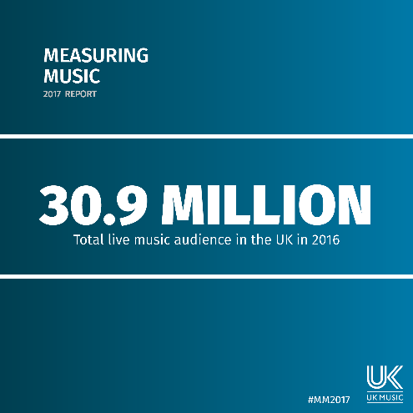
As Festival Republic operates within the live music market, the market is susceptible to variable characteristics. As they operate in the wider music industry it is no surprise, as is the case with the recording music industry that they operate within an oligopoly. As there are only 3 to 4 main competitors (including AEG Presents) to Festival Republic, as the market leader they do hold the ability to set the course for the UK live music sector.
(UK Music, 2017)
Firstly, and perhaps most prominent, is the sheer market size. Demonstrated, on the right, by figures taken from UK Music’s Measuring Music 2017 report. The total live music audience exceeded 30 million in 2016. The sheer size and appetite from the UK market for festivals, is a key aspect of this market, and one which allows for high pricing points. As the supply is lower than the demand for tickets and the ability to attend most festivals, alongside the aforementioned figures for acts such as London Grammar (£175,000) and Plan B (£105,000) taken from Bestival’s administration papers, the cost to attend festivals is large. Alongside these initial cost outlays is the booking fees, which need recouping, but the live music market does carry an exceptional ability to be able to upsell and back-end sell.
As briefly covered in Section 4 (Pricing Points) Festival Republic does make use of upselling with quiet camp sites. In line with the rest of the market Festival Republic allows for add-ons to the base ticket, with some as simple as a shower pass, allowing for shorter queuing for the shower facilities, to premium or early entry for the higher paying customers. This is not anything out of the ordinary for the live music sector. Premium tickets in premium viewing locations have long been a factor in live entertainment as a whole. Box seats at a theatre compared to stalls is a prime example. The live sector has also started to make use of meet-and-greets, in particular with Top 40, major label artists. Often, consumers will pay an extra £20 on top of their ticket to meet their icon. A further continuation of the upselling ability of the live sector is the bundling aspect. Sometimes, it can work out cheaper as a consumer to buy an album in a ticket bundle, with a t-shirt and a concert admission ticket, than buying the album and ticket separately.
Uniqueness is what has kept the live music relatively stable during the digital and piracy age. Although the ability to download a live sound or video of the acts in the arena, it is presently impossible to pirate the experience of physically being there for the show. This ‘atmosphere effect’ allows the UK live music industry to operate continuously, with no sign of slowing to a halt. Despite this the music consuming public, particularly festival goers, are notoriously fickle. They rely more on reputation and what their friends and peers are attending, rather than their own preference. This could see a shift in the live sector, perhaps away from Festival Republic’s capitalistic events and into more independent, ‘cooler’ anti-establishment events such as Boomtown.

- MACROENVRIONMENT
Festivals can be heavily impacted by various factors not in the festival promoters’ hands.
Politically festivals can be ruined before they even begin. As they have to apply for licensing from the local, governing councils, this is often a legal obstacle a festival promoter will have to overcome. Even once the council has granted permission issues and appeals can still impact the festival, as evident by 2018’s Wireless Festival, hosted in Finsbury Park. Of course, holding a festival within a capital city comes with all sorts of restrictions, and Festival Republic were met with complaints by local residents and attendees after the previous outing. Haringey Council responded to the NME stating “Saturday’s event… went well. We are satisfied with the measures Festival Republic have put in place for Wireless” (Trendell, 2018). Of course, the live music industry is not impervious to the political fallout from Brexit either. In fact, it stands be one of the only industries to have suffered a public loss of earnings as a direct result of Brexit. King Crimson, a progressive rock band founded in London in 1968, cancelled their 2018/2019 European tour. Frontman Robert Fripp posted to his blog in 2018 “Currently there is no foreseeable [sic] exit arrangement for the UK, no clear plans for migrant workers, eg [sic] the Brothers Crim and their pals, whether work visas will be necessary for anyone other than our American members. The technicalities and bureaucracy of arranging visa for all eight members of The Beast plus c. twelve support team persons, in each different country, is impracticable” (Fripp, 2018). At present Theresa May has suspended the prospective withdrawal agreement from the EU, leaving even more uncertainty. As the live industry relies on international acts and foreign workers this casts a net of uncertainty over the future for the UK live sector.
Socially, the numbers tell the tale. Over 500,000 attendees will attend Festival Republic’s events on a regular basis, and this mainly is the result of the social impetus and status attending a festival has. In the UK in particular, with Generation Y and Z it is often seen as a rite of passage to attend your first music festival. Of course, with the younger generation too, they want to fit in and be socially accepted. Sometimes attending a festival with a group of people can bond you with those people and then, in turn, they make new friends and connections within their social circles. As previously mentioned, the live experience cannot, at present, be pirated. Interestingly, more music is being listen to than ever before, and as such it is not outside the realms of possibility that the rise in piracy could have been a catalyst for the rise of live. As people listen to new artists and discover new music, they may be more inclined to see the acts live.
Fig. 3
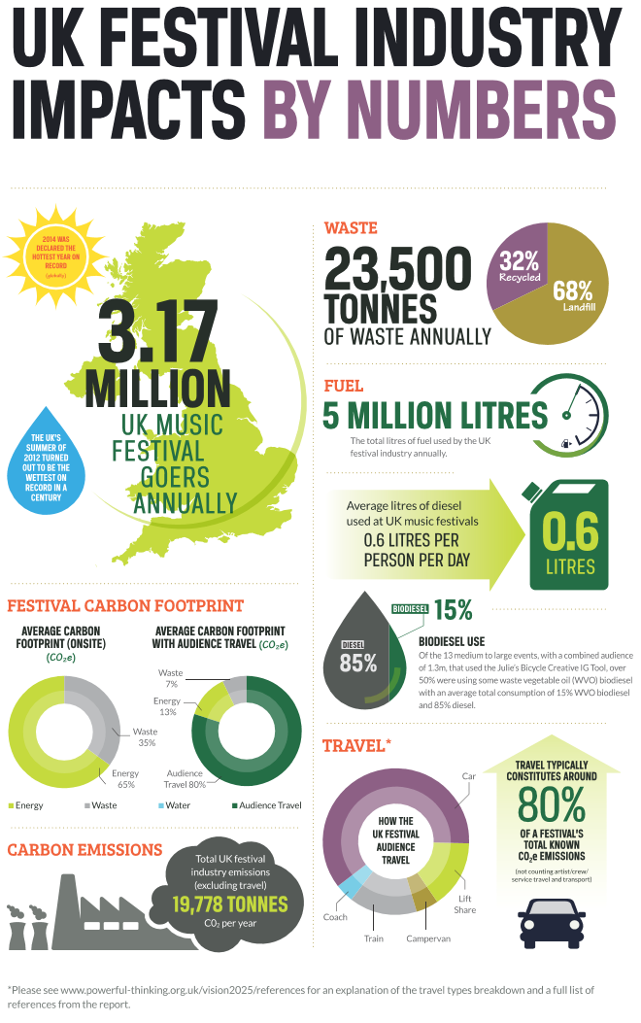
Technologically, the rise of VR partnerships between companies like Live Nation Entertainment and NextVR in 2016 “will let fans around the world experience shows from backstage access to sitting in the front-row to being on-stage during the performance” (Nafarrete, 2016). Interestingly due to the slow rise in VR headset ownership, this has not shot to worldwide usage and prevalence, however this poses an interesting conundrum to the live music industry. It could be possible that fans will not physically attend concerts or festivals anymore, but instead stream the acts they want to see from home. This could follow a model similar to streaming services, where playlisting and selecting singular tracks over listening to a whole LP or album has become the norm, and the same could happen to festivals. Consumers could pick and choose who they want to watch, over 10 festivals from home and not attend a single on in person. That being said, it would be an easy innovation to monetise, but could see the downfall of the traditional festival format, or could provide another income stream if the festival sells out, or the consumer can’t attend for whatever reason.
Legally music festivals have had one traditional issue, and this is the use of illegal substances. As research from TimeOut states “22% of festivalgoers have taken drugs” (Jones, J and Manning, J, 2015). Festival Republic director Melvin Benn stated to the BBC in 2017 “open your eyes. Like it or not drugs are part of society” (McCallum, 2017). However, the legal issues are far from over with regards to drugs. Many, including Benn, are advocates for on site drug testing at festivals. Benn further stated to the BBC “the people that are doing the drugs testing have to have a licence from the Home Office to be in possession of controlled drugs, otherwise they are in possession of illegal drugs” (McCallum, 2017). As the Home Office chooses to pursue the policy of blanket prohibition, MP for Louth and Horncastle Victoria Atkins stated in parliamentary questioning “no illegal drug taking can be assumed to be safe and there is no safe way to take them” (Atkins, 2018). The debate regarding testing continues, with countries like the Netherlands seeing drug testing become widespread, and in instances even mandatory, the issue continues.
Environmentally, the live music industry contributes significantly to climate change. As the infographic to the right from the 2017 “The Show Must Go On” report by industry think tank Powerful Thinking states. However, under the guidance of Powerful Thinking and the merging of companies like Festival Republic, Bestival and other industry leaders, they are taking steps to counterbalance this phenomenally large CO2 footprint. In turn, poor weather can always affect attendance or the ability to even host the festival entirely.
(Powerful Thinking, n.d.)

- COMPANY FINANCING
SHORT TERM
In the short term, Festival Republic seems to be stable. As they are the main business in a top-heavy oligopoly, they are comfortable in their market position and this is reflected in their financial health.
Fig. 4
As would be expected, the financial health of the company rests heavily on attendance for their festivals. As Fig. 4 clearly shows, there is both an uprising trend in attendance and as a result, turnover. On the contrary, this isn’t always the case, as demonstrated by 2015. A mixture of austerity and somewhat poor booking on Festival Republic’s behalf meant they had a slight drop in their income for 2015. This does mean they are at risk in the short-term, should one particular years events not attract a wide enough audience, they could end up losing money and possibly come under scrutiny from Live Nation Entertainment who could deem it necessary to stage a full takeover and remove long standing directors from their roles. Festival Republic essentially runs off a yearly cycle of large expenditure, sales, small expenditure and profit. This is not an ideal scenario to be in as they would have to gamble on the acts selling tickets for the events in order to recoup their money and make a profit. This is usually the case with music promotion though, as acts will often have a busy touring period, and as such a deposit to secure them would be necessary.
Fig. 5
This can make charts (Fig 5) slightly bias as they have to secure these large name acts, who come with large fees, often months ahead of the festival season. And as they account from the 1st January to the 31st December, this can often leave their accounts looking less healthy than is truly the case. This will not be the case exclusively for the musical talent, as lighting technicians, sound technicians and security contractors will also get booked in advance if they operate in the festival season. As such, all of these will require transportation, accommodation which all need to be prepared in advance, requiring further deposits to be made.
The margin between their turnover and their cost of sales is rather fine for a company of Festival Republic’s size. As demonstrated in Fig. 6. As aforementioned, should a poor year’s attendance or weather drastically impact the turnover Festival Republic could see a loss.
Fig. 6

LONG TERM
As Festival Republic state in their 2017 annual accounts “the company has net assets, is profit making and has a positive cash balance. The company’s forecasts project that it will continue to trade profitably and be in a strong liquidity position” (Festival Republic Ltd.,2017). Taking the companies accounts into consideration, alongside the stability provided by having a large parent company such as Live Nation Entertainment as their financial safeguard and/or investors, this is a very reasonable assumption to make.
At present they have no outstanding bank loans, have yet to default on a loan payment when they had them, and have the ability to ask their parent company, who have an annual turnover of $10.337billion (Live Nation Entertainment Inc., 2018) for a cash injection or loan should they need to.
One aspect that does bring cause for concern, is the rising cost of creditors (as seen by the table above), should this continue to rise and rise, Festival Republic could have major long-term financial issues. If these continue to rise and attendance falls, again, this could prove a major issue.
I think it is rather safe to assume that Festival Republic are not at risk, but it is impossible to say they are completely safe either due to the threats that the market presents, and the threats that emerging technologies can present. As they operate within an oligopoly, the rising prices can alienate consumers and can leave some unable to attend their events, which may see a shift to more local, decentralised independent music festivals rising as a result.
If you compare the long-term health of Festival Republic to their main competitor Global Entertainment it is clear to see their financial health is in much better shape than Global’s. Global, although granted has more operating avenues, stated in their 2017 accounts that they had “net liabilities of £374.0m (2016: £445.6m)” (Global Media & Entertainment Ltd., 2017). Although they are new to the festival market, the sheer fact they have hundreds of millions worth of liabilities to pay off, in comparison to none for Festival Republic this leaves them in a much better fiscal position to lead the market for years to come. Not only this, but Festival Republic only focus on one singular method of income, as compared to Global Entertainment being focused across radio, festivals and TV. This allows Festival Republic to hone and focus the company’s strategies to the needs of the festival market.
- RECENT FINANCIAL AND INVESTMENT ACTIVITY
As previously mentioned, Festival Republic doesn’t really invest or have any major financial activity barring the launch of Community and their investment into Lollapalooza Berlin.
This is a safe strategy, as Festival Republic exist within their own market in essence. As they don’t really invest in other companies this does provide minimal risk, but also minimal gains. If they don’t invest further, launch new products or aren’t allowed to invest by Live Nation Entertainment then the company could well be at its maximum growth already.
(Festival Republic Ltd., 2018)
- ALTERNATE FUNDING SOURCES
Should Festival Republic need to source any alternate funding, they could always take the company public. At present, all the shares are held privately. Should they need to raise capital, they could issue new shares and take the company public. Whether they would undergo the foreboding task of a full IPO and risk the company on the open market is up for debate. But if they were to sell privately, then they would be able to find buyers for the shares without too much inconvenience based on their market standing. Again, with Live Nation Entertainment being the parent company however, this is far from a pressing issue, and one that will likely never materialise.

- CONCLUSIVE REPORT
Festival Republic is the market leader in the UK live industry, and continually draws large crowds to their showcases. The financial health is very strong and they face a healthy level of competition, but are still ahead of the rest of the market for now.

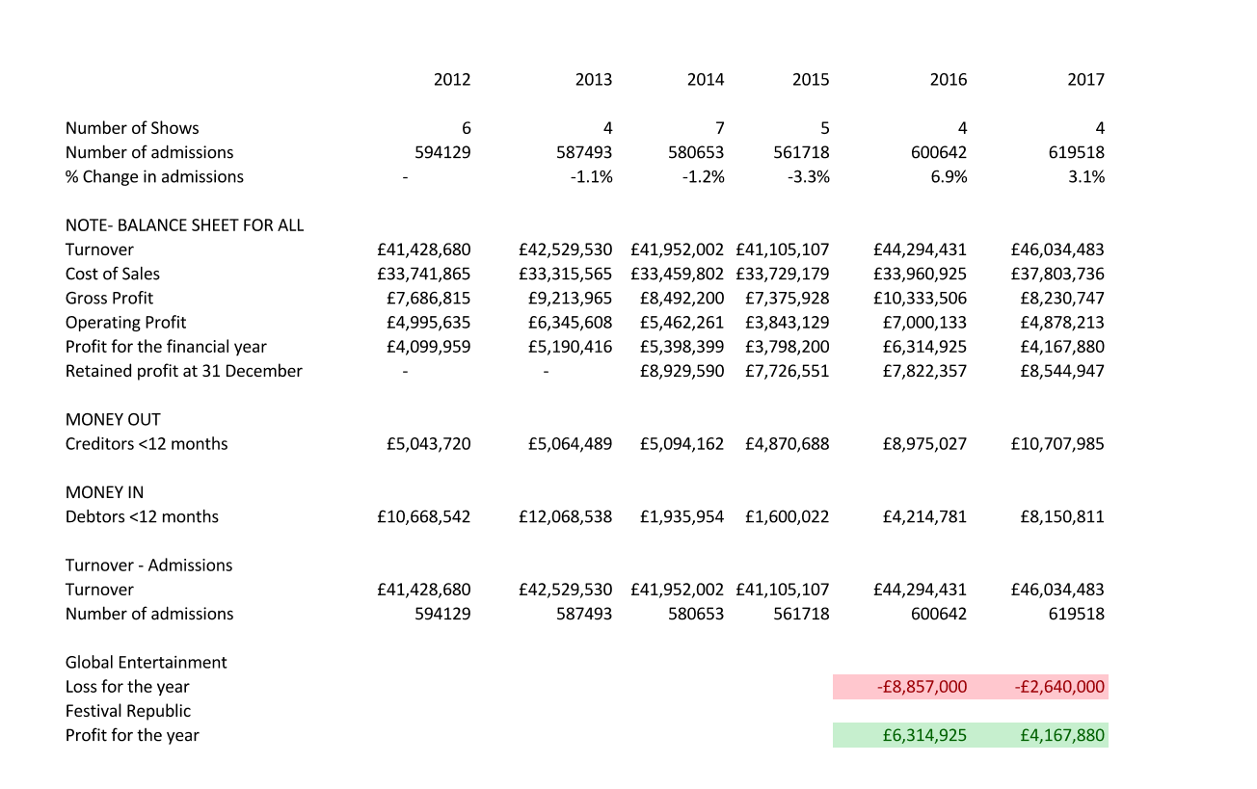
- APPENDICIES
All the data taken for this spreadsheet has come from company annual accounts.
Attendance figures are taken from Festival Republic’s KPI measurements.
The data was then placed into graphs throughout this work in order to cite points made during the main text.

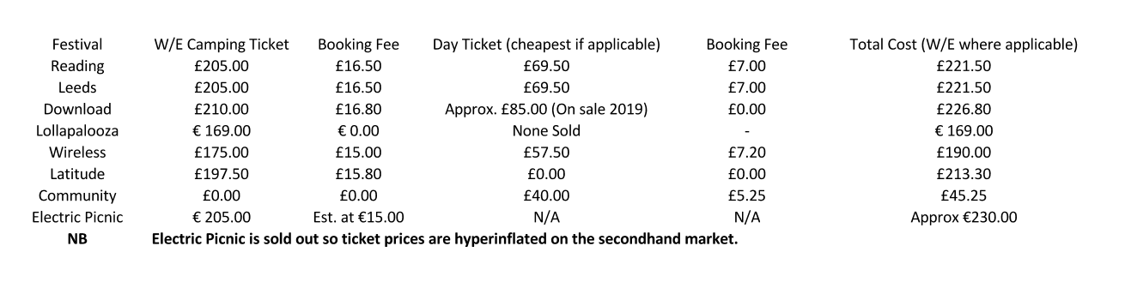
All this data, which can also be seen in Fig 2 was sourced from the festivals point of sale. This is important as second-hand market prices can fluctuate severely. Where was not possible a footnoted and referenced source provides the price. This was not possible with Download 2019’s day tickets. However, a conversation I had with regular Download attendee Mitchell Wood (Blackjack Group and Holdings Ltd.) places last years ticket price at approx. £85, and this is where this estimate was derived from.

- BIBLIOGRAPHY
- Atkins, V. (2018). Drugs: Misuse: 29 Nov 2018: Hansard Written Answers - TheyWorkForYou. [online] TheyWorkForYou. Available at: https://www.theyworkforyou.com/wrans/?id=2018-11-21.194012.h [Accessed 11 Dec. 2018].
- BBC, B. (2005). BBC NEWS | Business | Mean Fiddler accepts takeover bid. [online] News.bbc.co.uk. Available at: http://news.bbc.co.uk/1/hi/business/4426477.stm [Accessed 1 Dec. 2018].
- Bestival Ltd. (2018) Notice of Administrators Proposals. Avaliable at: https://document-api-images-prod.s3.eu-west-1.amazonaws.com/docs/Krzwwt7RuyGvrUCW5wgxdGwcuIG3k6yWxNxgpJUfQuU/application-pdf?X-Amz-Algorithm=AWS4-HMAC-SHA256&X-Amz-Content-Sha256=UNSIGNED-PAYLOAD&X-Amz-Credential=ASIAWRGBDBV3OQ2IMG77%2F20181213%2Feu-west-1%2Fs3%2Faws4_request&X-Amz-Date=20181213T164135Z&X-Amz-Expires=60&X-Amz-Security-Token=FQoGZXIvYXdzEK7%2F%2F%2F%2F%2F%2F%2F%2F%2F%2FwEaDOGfl5uFyRyPMtWTnCK3A0r17%2BcBYl8g%2BfByzA3Au1OOKT17aoZyxqvWSdkEhYxT15OfcH0ZGRXhFEqDKX8ujyTueALadL3HliwY%2Bz63M%2FlR%2BFtsrEhSiiRKgYpmQkYLaY7GtGRzGs703KeVEsRRBoY7oeQByFO0DEfAp8FDzyMBMCoc4RC4nZb%2FG4ex06RgaAjloeV%2FTc%2F%2FHIAVc0oU%2B2sD6BCA7P%2Fj7bwJw3ORmNmrjbx6FxxWLmJheqldhL%2FrpL0Re1J5eT2XrE0HMYgD9Pd0YV6WR0bEUBcVbTo6AGGZxMI0GFLcajcdGA%2F%2BE5PKlve6YcEWMABjkZIwSqf52OR1go4A1jKKLSUQAsXlwWeBQWBcC%2FC0I7ATVtsPBMA%2BB2RrOjyoQz1nER%2FECsfUQzVZC3wv6DFqNU%2BHeubx4ID0F%2B52lz%2FNhBAS5NtGkVwmtz16Bhe4%2FwSwU4hnOxYUCNIvwzp0XrnoULrNiBQJb7gZHgkWG7fyaFp%2Bfqx5H04pl6500veigokCnkg4af7PxgfIwHyEh%2FkYXz7k5C0e4IdRsmgLwgXc0QWP9xVQWLfSCA6gQJ4k8X2J90j8IJoXNLszgs85vKcouZXJ4AU%3D&X-Amz-SignedHeaders=host&X-Amz-Signature=a1511cb6da86b719834940718d7c9de7752b11b277b19660d135f8ce7bf5bbe8 [Accessed 4 Dec. 2018].
- Boomtown Festival Ltd. (2018). Boomtown Festival 2018. [image] Available at: http://playmasters.info/top-trends/11-08-2018/boomtown-2018.html [Accessed 5 Dec. 2018].
- Boomtown Festival to Robin Hill (2018) Available at Google Maps: https://www.google.com/maps/dir/Boomtown+Fair,+Temple+Valley,+Winchester+SO21+1HW/Robin+Hill,+Downend+Road,+Downend,+Newport/@50.8714743,-1.3243962,10.75z/data=!4m15!4m14!1m5!1m1!1s0x487413f62ef08e79:0x2c35a5c6c0eeb003!2m2!1d-1.2461521!2d51.0515495!1m5!1m1!1s0x48746289dc30f93d:0x9d622d5c8b3ba7f4!2m2!1d-1.243359!2d50.686193!3e0!5i1
- Community, T. (2018). Community. [online] Front Gate Tickets. Available at: https://community.frontgatetickets.com/ [Accessed 8 Dec. 2018].
- Download, T. (2018). Tickets - Download Festival. [online] Download Festival. Available at: https://downloadfestival.co.uk/tickets/ [Accessed 8 Dec. 2018].
- Festival Republic (2018). Reading & Leeds Line Up. [image] Available at: https://www.leedsfestival.com/history/leeds-2018 [Accessed 5 Dec. 2018].

- Festival Republic Ltd. (2012) Annual Report 2012. Available at: https://document-api-images-prod.s3.eu-west-1.amazonaws.com/docs/rf7Oi1p02aToCMncl4L04DrHqIvz3EMoVTp-sIhB2rM/application-pdf?X-Amz-Algorithm=AWS4-HMAC-SHA256&X-Amz-Content-Sha256=UNSIGNED-PAYLOAD&X-Amz-Credential=ASIAWRGBDBV3K6OSB5M6%2F20181213%2Feu-west-1%2Fs3%2Faws4_request&X-Amz-Date=20181213T161754Z&X-Amz-Expires=60&X-Amz-Security-Token=FQoGZXIvYXdzELD%2F%2F%2F%2F%2F%2F%2F%2F%2F%2FwEaDMPq2%2FRFIw31qs%2BKnSK3A8zuC7q5V2MTrH%2FCsWt0plv1r8ORCO0Zpjxh2A%2Fb0%2FyCxDiJ1k7wZ9ngAOg%2Be%2FCs9DXrNlOZyV3QSA6lI9lTTLfW318%2Ft8Crd7Phzt0DuBw%2B92HG4077OowYCDiwzAIsJrugUEa77Z4Gd98y3zS7wh0RWdDl8TwXk6gKKuEYUbN5Bxxsho5zVEzbwx7pzYtDh6WVnwzrFU%2F08blq1ihKPDnLnQVvYd%2BWhu6WyQxUCZpesdyCx%2BwDndGRMC3huHvBp6OsF76aZ3SRdU88IppglFtODl0ipWquTb77uJPa6EPRyt88pQ7saImNTtoZia5Exrfbk0vD0H3LpDICTZ%2BP9n9%2BM7yJW66zDEq7iu5%2BZxvYpZgnCjQC3QOflLNsQLs8OfzWVwADfaGEnrAfm9T4qF%2FKXR4yYjkouGYtQUUcoumVVbk%2FcOUv48LrkdyiW33GdBkXd5qEmSPO6X9YFx%2FQiFbAXhsLnGj9WNJVtKJ9h3Nex0shsq8ZowiuhaQsU4NKw7vHGyif6jwPhl56T7gqu0sjs3kjXaHbPLce7P4a45%2Fm7t9cl0lXtS1uMxuXLYu%2Bi0diTgNQ7DQo2N3J4AU%3D&X-Amz-SignedHeaders=host&X-Amz-Signature=93c635409706845b79e97564bcd976981822d97caa1c83d3c4197859bc051899 [Accessed 30 Nov. 2018].
- Festival Republic Ltd. (2013) Annual Report 2013. Available at: https://document-api-images-prod.s3.eu-west-1.amazonaws.com/docs/v-HzVWIPzglkKcy4_2ekXwmGBBFLGfvfgxdczjZx2DY/application-pdf?X-Amz-Algorithm=AWS4-HMAC-SHA256&X-Amz-Content-Sha256=UNSIGNED-PAYLOAD&X-Amz-Credential=ASIAWRGBDBV3OQ2IMG77%2F20181213%2Feu-west-1%2Fs3%2Faws4_request&X-Amz-Date=20181213T161733Z&X-Amz-Expires=60&X-Amz-Security-Token=FQoGZXIvYXdzEK7%2F%2F%2F%2F%2F%2F%2F%2F%2F%2FwEaDOGfl5uFyRyPMtWTnCK3A0r17%2BcBYl8g%2BfByzA3Au1OOKT17aoZyxqvWSdkEhYxT15OfcH0ZGRXhFEqDKX8ujyTueALadL3HliwY%2Bz63M%2FlR%2BFtsrEhSiiRKgYpmQkYLaY7GtGRzGs703KeVEsRRBoY7oeQByFO0DEfAp8FDzyMBMCoc4RC4nZb%2FG4ex06RgaAjloeV%2FTc%2F%2FHIAVc0oU%2B2sD6BCA7P%2Fj7bwJw3ORmNmrjbx6FxxWLmJheqldhL%2FrpL0Re1J5eT2XrE0HMYgD9Pd0YV6WR0bEUBcVbTo6AGGZxMI0GFLcajcdGA%2F%2BE5PKlve6YcEWMABjkZIwSqf52OR1go4A1jKKLSUQAsXlwWeBQWBcC%2FC0I7ATVtsPBMA%2BB2RrOjyoQz1nER%2FECsfUQzVZC3wv6DFqNU%2BHeubx4ID0F%2B52lz%2FNhBAS5NtGkVwmtz16Bhe4%2FwSwU4hnOxYUCNIvwzp0XrnoULrNiBQJb7gZHgkWG7fyaFp%2Bfqx5H04pl6500veigokCnkg4af7PxgfIwHyEh%2FkYXz7k5C0e4IdRsmgLwgXc0QWP9xVQWLfSCA6gQJ4k8X2J90j8IJoXNLszgs85vKcouZXJ4AU%3D&X-Amz-SignedHeaders=host&X-Amz-Signature=a334e204764b44bee3b828e89d1ad9a62c425f9b6f3bae1a5b2903ecac0be271 [Accessed 30 Nov. 2018].

- Festival Republic Ltd. (2014) Annual Report 2014. Available at: https://document-api-images-prod.s3.eu-west-1.amazonaws.com/docs/WCn5NY9Af6bWRTP7TQrSkoTloR7GHKIpcmtuYhGJodw/application-pdf?X-Amz-Algorithm=AWS4-HMAC-SHA256&X-Amz-Content-Sha256=UNSIGNED-PAYLOAD&X-Amz-Credential=ASIAWRGBDBV3OQ2IMG77%2F20181213%2Feu-west-1%2Fs3%2Faws4_request&X-Amz-Date=20181213T161652Z&X-Amz-Expires=60&X-Amz-Security-Token=FQoGZXIvYXdzEK7%2F%2F%2F%2F%2F%2F%2F%2F%2F%2FwEaDOGfl5uFyRyPMtWTnCK3A0r17%2BcBYl8g%2BfByzA3Au1OOKT17aoZyxqvWSdkEhYxT15OfcH0ZGRXhFEqDKX8ujyTueALadL3HliwY%2Bz63M%2FlR%2BFtsrEhSiiRKgYpmQkYLaY7GtGRzGs703KeVEsRRBoY7oeQByFO0DEfAp8FDzyMBMCoc4RC4nZb%2FG4ex06RgaAjloeV%2FTc%2F%2FHIAVc0oU%2B2sD6BCA7P%2Fj7bwJw3ORmNmrjbx6FxxWLmJheqldhL%2FrpL0Re1J5eT2XrE0HMYgD9Pd0YV6WR0bEUBcVbTo6AGGZxMI0GFLcajcdGA%2F%2BE5PKlve6YcEWMABjkZIwSqf52OR1go4A1jKKLSUQAsXlwWeBQWBcC%2FC0I7ATVtsPBMA%2BB2RrOjyoQz1nER%2FECsfUQzVZC3wv6DFqNU%2BHeubx4ID0F%2B52lz%2FNhBAS5NtGkVwmtz16Bhe4%2FwSwU4hnOxYUCNIvwzp0XrnoULrNiBQJb7gZHgkWG7fyaFp%2Bfqx5H04pl6500veigokCnkg4af7PxgfIwHyEh%2FkYXz7k5C0e4IdRsmgLwgXc0QWP9xVQWLfSCA6gQJ4k8X2J90j8IJoXNLszgs85vKcouZXJ4AU%3D&X-Amz-SignedHeaders=host&X-Amz-Signature=e5b823c14cd8dbd8f7cdfd52aa00b253a037e6bc9f02dde42ca78ea9d50afc44 [Accessed 30 Nov. 2018].
- Festival Republic Ltd. (2015) Annual Report 2015. Available at: https://document-api-images-prod.s3.eu-west-1.amazonaws.com/docs/4DGMdeJ76QVo0lg-ZhQKIzdGD_yP_7eZiFdeSsQR5Jg/application-pdf?X-Amz-Algorithm=AWS4-HMAC-SHA256&X-Amz-Content-Sha256=UNSIGNED-PAYLOAD&X-Amz-Credential=ASIAWRGBDBV3AM2BH5VP%2F20181213%2Feu-west-1%2Fs3%2Faws4_request&X-Amz-Date=20181213T161640Z&X-Amz-Expires=60&X-Amz-Security-Token=FQoGZXIvYXdzELH%2F%2F%2F%2F%2F%2F%2F%2F%2F%2FwEaDIQx6c5N7Ek5SNvr1iK3A7Ulc3Bk%2FzeDjn47881bKc0NW2Ko276OT7OMut9AsGYkb54coo0jcJioJS71jj9IWumOnH7hS7VFJtBEs0xF5IG5dyL2C8d4clKO3k5eYo5%2FsQI7alPIMa%2FDTwVz2G8KPBnrjaUyhAvqVFCYbysku0vL24gvf9zWG0%2BWgZIfHb2MxrPNd%2BgnqRQGwXqhVPj%2FjRYU%2FNhuwJwRA8CJktxu3tQpoKPELFj888ATgFSifxRfrUzw4sg4smg9qYIqruNx0K2y0Nla%2BsEUUCke6D6egp22rdDeZZrgLKGBBLDG1Kekv91TlEDzkcaiPkPXJnZ89crk6gaiCiJtod0mNPN1YKYgJvaxLIMQKgOERt8FWX3CuB5sTU1jXLlVXqQX56YPkBveu0qaRDuGT0KL7vIB4XHkljymZUhbZFLik7STxOSwW3gIMziqoVkSwq8Y3fxQV44Tw%2FN%2F1ZAKgi7yiAKCgGkZcIplB0BjK2Lij5p7CvOUCOkOaeECCVDPrKjhS2XfVgZYR7DgKm6S%2B29%2BYw1M%2Ff7phQcYhGbUjG5gwPT8BdJ4u%2Bxq3g7fdTmdPvSUcmzxCqJQuDCODGwolvfJ4AU%3D&X-Amz-SignedHeaders=host&X-Amz-Signature=0512f55f60438ad5680c225fcd7fda0c5f4371a8c6a9c137b638bed6bf49f8c2 [Accessed 30 Nov. 2018].

- Festival Republic Ltd. (2016) Annual Report 2016. Available at: https://document-api-images-prod.s3.eu-west-1.amazonaws.com/docs/BtrVQ25hs0eK_rDS_9HBnNGgjMYwJJbb8hFq-81qkIk/application-pdf?X-Amz-Algorithm=AWS4-HMAC-SHA256&X-Amz-Content-Sha256=UNSIGNED-PAYLOAD&X-Amz-Credential=ASIAWRGBDBV3AM2BH5VP%2F20181213%2Feu-west-1%2Fs3%2Faws4_request&X-Amz-Date=20181213T161458Z&X-Amz-Expires=60&X-Amz-Security-Token=FQoGZXIvYXdzELH%2F%2F%2F%2F%2F%2F%2F%2F%2F%2FwEaDIQx6c5N7Ek5SNvr1iK3A7Ulc3Bk%2FzeDjn47881bKc0NW2Ko276OT7OMut9AsGYkb54coo0jcJioJS71jj9IWumOnH7hS7VFJtBEs0xF5IG5dyL2C8d4clKO3k5eYo5%2FsQI7alPIMa%2FDTwVz2G8KPBnrjaUyhAvqVFCYbysku0vL24gvf9zWG0%2BWgZIfHb2MxrPNd%2BgnqRQGwXqhVPj%2FjRYU%2FNhuwJwRA8CJktxu3tQpoKPELFj888ATgFSifxRfrUzw4sg4smg9qYIqruNx0K2y0Nla%2BsEUUCke6D6egp22rdDeZZrgLKGBBLDG1Kekv91TlEDzkcaiPkPXJnZ89crk6gaiCiJtod0mNPN1YKYgJvaxLIMQKgOERt8FWX3CuB5sTU1jXLlVXqQX56YPkBveu0qaRDuGT0KL7vIB4XHkljymZUhbZFLik7STxOSwW3gIMziqoVkSwq8Y3fxQV44Tw%2FN%2F1ZAKgi7yiAKCgGkZcIplB0BjK2Lij5p7CvOUCOkOaeECCVDPrKjhS2XfVgZYR7DgKm6S%2B29%2BYw1M%2Ff7phQcYhGbUjG5gwPT8BdJ4u%2Bxq3g7fdTmdPvSUcmzxCqJQuDCODGwolvfJ4AU%3D&X-Amz-SignedHeaders=host&X-Amz-Signature=d507ca75460e1549639b08fd96784787d260ef9a2e232fa3318b201834012497 [Accessed 30 Nov. 2018].
- Festival Republic Ltd. (2017) Annual Report 2017. Available at: https://document-api-images-prod.s3.eu-west-1.amazonaws.com/docs/ZB2VO-Gu7lFVre0d2XSl59OJqgqufWbEeWH7CxxgJN4/application-pdf?X-Amz-Algorithm=AWS4-HMAC-SHA256&X-Amz-Content-Sha256=UNSIGNED-PAYLOAD&X-Amz-Credential=ASIAWRGBDBV3K3RXEDOM%2F20181213%2Feu-west-1%2Fs3%2Faws4_request&X-Amz-Date=20181213T161439Z&X-Amz-Expires=60&X-Amz-Security-Token=FQoGZXIvYXdzEKz%2F%2F%2F%2F%2F%2F%2F%2F%2F%2FwEaDKEoLoPsGkvd7I4PLCK3Aw7hcwz3Rytty5ufdcm4c6N0aysfMrHK3VuHZ4%2Fx4O1qEjEhd8Ww0Rrb3TmDqjQlNVyUsQ9hELan3YZCjnp1XzjeceIylpXSZ2AZDb%2F%2FaHwOD%2F7sAHzvcyyCt7tselaPFYYhJO27se%2F2b8%2Fxip8W9GVWzwgImgUw%2BXHPRjWcGYGDxKgH5y7wGKZ2bK1qP9dghG0RE694jXs9qZt%2Bx64IyFUpytks8W7RSK2F%2Fy8BZq14y0QiO%2BPa8xjhZ1YLUVRLxHHbz1yEHnTws3mZ%2FFY0ITpbxbNGK3zsWDmmiaAqh3k34Vs8IxMgmuZzLvJSRfw1xLta1IqAePe78SuzPmlMbO3JJ%2FpgvJ6J8ElF3Sv%2BZaplK4a9eoo%2B4A7orD65%2B88fwFAaBmRaRbRELmNK35QMfOgW3xB1BYdlbfCmoyqBOJTtqXV0xa4s0cvOGYY%2Fud1aiOBuGg4GZhRmLGcQUY4VX4FoWXAZIL0r3xAQs8v0gMGEKyeIGl%2BMzSiQDv9FPX8VMYSYdPIdiEuKwJb8x966wMDCdX2eNBW13cKV8Gywf9aIqDee6kpq%2BFtx3yCuyUu0orn3czHO7Z4osd3I4AU%3D&X-Amz-SignedHeaders=host&X-Amz-Signature=c089e74519d5d7a3aab6519869d71c089ecb1e097e98031e51fe4e29cbf54751 [Accessed 30 Nov. 2018].
- Fripp, R. (2018). Breakfasting Trough, Hotel Acceptable, Krakow.. [online] DGM Live. Available at: https://www.dgmlive.com/diaries/Robert%20Fripp/rfdiary-june-16-2018 [Accessed 10 Dec. 2018].

- Global Media & Entertainment Ltd. (2017) Annual Report 2017. Available at: https://document-api-images-prod.s3.eu-west-1.amazonaws.com/docs/yqcOGQgz7S_cLrrfQgFUIJUFzr6Yt9AJ6zdLCjU3wuI/application-pdf?X-Amz-Algorithm=AWS4-HMAC-SHA256&X-Amz-Content-Sha256=UNSIGNED-PAYLOAD&X-Amz-Credential=ASIAWRGBDBV3K6OSB5M6%2F20181213%2Feu-west-1%2Fs3%2Faws4_request&X-Amz-Date=20181213T164431Z&X-Amz-Expires=60&X-Amz-Security-Token=FQoGZXIvYXdzELD%2F%2F%2F%2F%2F%2F%2F%2F%2F%2FwEaDMPq2%2FRFIw31qs%2BKnSK3A8zuC7q5V2MTrH%2FCsWt0plv1r8ORCO0Zpjxh2A%2Fb0%2FyCxDiJ1k7wZ9ngAOg%2Be%2FCs9DXrNlOZyV3QSA6lI9lTTLfW318%2Ft8Crd7Phzt0DuBw%2B92HG4077OowYCDiwzAIsJrugUEa77Z4Gd98y3zS7wh0RWdDl8TwXk6gKKuEYUbN5Bxxsho5zVEzbwx7pzYtDh6WVnwzrFU%2F08blq1ihKPDnLnQVvYd%2BWhu6WyQxUCZpesdyCx%2BwDndGRMC3huHvBp6OsF76aZ3SRdU88IppglFtODl0ipWquTb77uJPa6EPRyt88pQ7saImNTtoZia5Exrfbk0vD0H3LpDICTZ%2BP9n9%2BM7yJW66zDEq7iu5%2BZxvYpZgnCjQC3QOflLNsQLs8OfzWVwADfaGEnrAfm9T4qF%2FKXR4yYjkouGYtQUUcoumVVbk%2FcOUv48LrkdyiW33GdBkXd5qEmSPO6X9YFx%2FQiFbAXhsLnGj9WNJVtKJ9h3Nex0shsq8ZowiuhaQsU4NKw7vHGyif6jwPhl56T7gqu0sjs3kjXaHbPLce7P4a45%2Fm7t9cl0lXtS1uMxuXLYu%2Bi0diTgNQ7DQo2N3J4AU%3D&X-Amz-SignedHeaders=host&X-Amz-Signature=2aa0288f25b976dab86f9535014391d8e2ec92f64554831d74d78c18d3fa01c8 [Accessed 4 Dec. 2018]
- Gomez, C. (2011). Bestival 2011. [image] Available at: https://theartsdesk.com/node/4544/view [Accessed 5 Dec. 2018].
- Hand, J. (2018). Full lowdown on Electric Picnic 2019 tickets going on sale and payment plans. [online] The Irish Sun. Available at: https://www.thesun.ie/tvandshowbiz/music/3084032/electric-picnic-2019-tickets-price-payment-plans/ [Accessed 8 Dec. 2018].
- Hanley, J. (2017). In the festival market, consolidation has become the name of the game. [online] Musicweek.com. Available at: http://www.musicweek.com/live/read/in-the-festival-market-consolidation-has-become-the-name-of-the-game/067902 [Accessed 5 Dec. 2018].
- Jones, J. and Manning, J. (2015). Go figure: an infographic guide to UK music festivals. [online] Time Out London. Available at: https://www.timeout.com/london/music-festivals/go-figure-an-infographic-guide-to-uk-music-festivals [Accessed 10 Dec. 2018].
- Latitude, T. (2018). 2019 Tickets. [online] Latitude Festival. Available at: https://www.latitudefestival.com/tickets [Accessed 8 Dec. 2018].
- Leeds, T. (2018). Leeds Festival. [online] Front Gate Tickets. Available at: https://leeds-festival.frontgatetickets.com/ [Accessed 8 Dec. 2018].
- Live Nation Entertainment Inc. (2018) Securities and Exchanges Commission- Form 10-K. Available at: https://www.sec.gov/Archives/edgar/data/1335258/000133525818000023/lyv-20171231x10k.htm#s1B14649FFD90EFDA5FEAB4D2AE1156F3
- Lollapalooza, B. (n.d.). Tickets. [online] Lollapalooza Berlin. Available at: https://www.lollapaloozade.com/tickets/ [Accessed 8 Dec. 2018].
- McCallum, S. (2017). UK festival boss Melvin Benn waiting for drug-testing licence for Reading and Leeds. [online] Bbc.co.uk. Available at: http://www.bbc.co.uk/newsbeat/article/40476661/uk-festival-boss-melvin-benn-waiting-for-drug-testing-licence-for-reading-and-leeds [Accessed 10 Dec. 2018].
- Nafarrete, J. (2018). Will You Watch Live Concerts in Virtual Reality? - VRScout. [online] VRScout. Available at: https://vrscout.com/news/live-concerts-virtual-reality/ [Accessed 10 Dec. 2018].
- Powerful Thinking (n.d.). The Show Must Go On. [online] London: Powerful Thinking. Available at: http://www.powerful-thinking.org.uk/site/wp-content/uploads/The-Show-Must-Go-On-Report.pdf [Accessed 28 Nov. 2018].
- Radio, G. (n.d.). Festivals | Global. [online] Global.com. Available at: https://www.global.com/festivals/ [Accessed 3 Dec. 2018].
- Reading, T. (2018). Reading Festival. [online] Front Gate Tickets. Available at: https://reading-festival.frontgatetickets.com/ [Accessed 8 Dec. 2018].
- Smirke, R. (2018). Live Nation UK President/COO Paul Latham Announces Retirement. [online] Billboard. Available at: https://www.billboard.com/articles/business/8470647/live-nation-uk-president-coo-paul-latham-retiring [Accessed 1 Dec. 2018].
- Trendell, A. (2018). Haringey Council respond to Finsbury Park gig complaints ahead of Wireless Festival - NME. [online] NME. Available at: https://www.nme.com/festivals/wireless-festival/haringey-council-respond-finsbury-park-gig-complaints-ahead-wireless-festival-2349236 [Accessed 10 Dec. 2018].
- UK Music (2017). Measuring Music 2017. Measuring Music. [online] London: UK Music. Available at: https://www.ukmusic.org/assets/general/Measuring_Music_2017_Final.pdf [Accessed 8 Dec. 2018].
- VirtualFestivals, W. (2007). Mean Fiddler becomes Festival Republic - ..selling off name and venues in rebrand. [online] Web.archive.org. Available at: https://web.archive.org/web/20071224142634/http://www.virtualfestivals.com/latest/news/3960 [Accessed 1 Dec. 2018].
- Waddell, R. (2014). Lollapalooza Heading to Berlin in 2015. [online] Billboard. Available at: https://www.billboard.com/articles/columns/music-festivals/6304575/lollapalooza-heading-to-berlin-in-2015 [Accessed 1 Dec. 2018].
- Wireless, T. (2018). Tickets | Wireless Festival. [online] Wireless Festival. Available at: https://www.wirelessfestival.co.uk/tickets [Accessed 8 Dec. 2018].

On sale in 2019. Estimate based on last year’s price.
Sold out, as such exact figures cannot be obtained due to resale mark up. However, second-hand source (Hand, 2018) quotes the price at €205.

