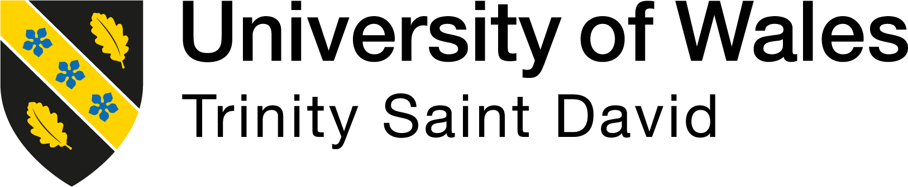

Introducing the Modern Workplace
LCBB4003
Reflection Report

Student Name: Dan Joita
StudentID:2124449
Lecturer: Aparna Venkatesan

Introduction
Teamwork entails collaboration among individuals toward a common objectivity. By doing this, members of a group overcome each other's flaws and accomplish a task that would not have been achievable on their own (Okrepilov, 2021). Working in a group is a great learning experience for addressing urgent assigned tasks especially for students in higher learning, it helps students understand their strengths and shortcomings as well as developing their interpersonal skills. This reflection will be able to discuss my experience in a group of four and with the task that I was assigned in the group. I will use the Kolbe’s reflective model to discuss my experiences in the group. This approach is based on a comprehensive study, analysis, and evaluation of our personal experience over the course of three stages. The fresh experiences will serve as the foundation for a new cycle after this procedure has been completed (Brown, 2015).
Experience
Our group was formed of 4 people where each team member was assigned tasks according to their areas of interest and strengths. Each member of the group was supposed to come up with three to four slides of the work that was allocated. The total number of slides that was required from our group was not less than sixteen slides for three to four minutes presentation in class. Our group was able to come up with eighteen slides as for that case. I was assigned to research on the Task and Skills of Managers. This task was so comfortable to me, and I was able to discuss it well coming up with four slides. I discussed why it necessary for Manager to have diverse skills and qualities that makes different from others. I was able also to discuss why the skills are essential to manage the operational effectiveness process at Amazon. Some of the skills that I discussed in the task include interpersonal skills for manager that are essential to them in diverse activities and management process with each other. I was also able to discuss the importance of the skill such as communication skills and motivation skills are helpful to maintain proper collaboration with others and the employees. I discussed also how the skills reduces the barriers and improve overall performance of the Amazon. Additionally, I was able to discuss the importance of decision making and problem solving for the manager since they are helpful to enhance the strategic controlling process.
I found it to be such a wonderful and life changing experience to be in a group. Although it was not my first time being in a group setting and handling assignments, I was excited to improve creating slides using the PowerPoint presentation. For me team working is really important in improving and naturing some skills such time management and communication skills as I developed.
Reflective observation
During our group work I was able to make a lot of observation from it. I learnt on the importance of teamwork in the university set up. With the team working, students are able to develop a lot of key life skills. During our group working, I was able to develop skills such as the research skills from the task that I was given. Additionally, I developed communication skills, as it was a routine in the group, every person was given a chance to present his or her finding for the final combination of the task to make it a full presentation. One student did not answer to our calls and messages for the meetings and did not communicate to the group leader that. This delayed us a bit, but we were able to manage and compile the report. At one point while I was giving out my findings, one of the group members, corrected me on and with that I learnt and observed how to give out a constructive criticism and feedback without annoying anyone in the group.
Abstract conceptualisation
I was able to grasp the value of maintaining track of time as well as having effective communication skills while working in a team. With the time management techniques that we utilized we were able to complete our task and submit it in the right time given (Cirillo, 2018). My experience in groups has taught me how crucial it is, since better communication leads to better time management (Brewer et al., 2016). I learned the value of teamwork once we successfully completed our assignment, and I now fully understand its importance.
From my group working and during the presentation, I noticed that I have to improve on my presentation skills and communication skills. There was a point also during our schedule meetings in the group that I delayed, and I need to improve more on my time management skills so that I can be able to manage my time well and thus it will help me in my future career and in my academic activities.
Active experimentation
I acquired skills and knowledge from the group working. With the skills that I developed such as the communication skills, I will be able to use this skill in both my academic life and even during my professional life. I will be able to present myself well during meetings and even seminars. Another skill that I developed is time management and research skills. These skills will be able to help me in handling research work, task and assignments in school and even in my future employment. I use time management techniques and theories such as the Pomodoro Technique to be able to improve on my time management.

References
‌ Cirillo, F., 2018. The Pomodoro technique: The life-changing time-management system. Random House.
Brewer, E.C. and Holmes, T.L., 2016. Better communication= better teams: A communication exercise to improve team performance. IEEE Transactions on Professional Communication, 59(3), pp.288-298.
Brown, N. (2015). Reflective Model according to Kolb. [online] Dr Nicole Brown. Available at: https://www.nicole-brown.co.uk/reflective-model-according-to-kolb/.
Okrepilov, E. (2021). What is teamwork: definition, meaning. [online] Weje.io blog. Available at: https://weje.io/blog/what-is-teamwork.

