Assignment 1 of the Digital Entrepreneurship Module:

Part B: Supporting report on an analysis of the organisation

Module code: BMMB7002D

Student ID number: 1906345

Date: 18th of June 2021
Total number of pages: 17

Executive Summary
Stanley Black & Decker is a global manufacturer of power tools that successfully grew revenue and profit in the past. As an innovative industry leader, Stanley Black & Decker strives for digital excellence and is ready to face the challenges imposed by digital disruption. This report analyses the situation of the organisation and chances to intensify its e-business.
After a brief introduction in Section 1, this report presents in Section 2 the main findings of the analysis conducted primarily along Porter’s Value Chain and an extra emphasis on digital marketing. This section is then rounded up by compiling the key strengths and weaknesses. In Section 3, conclusions are drawn and in Section 4 recommendations given. The Appendix A provides the business model canvas comprising external but also internal aspects.
It is recommended to push digital transformation further across all departments and for all activities. Digitalisation enabling integration of all processes is key, in particular for operations where manufacturing can be made more efficient by digital technologies. Sales have to be strengthened by a clear digital marketing strategy, striving to eliminate deficiencies of the website and online shopping possibilities. The introduction of AI can also bring activities like services and human resource management up to speed.
Digital disruption is not easy and does not come for free. It requires substantial investments in technologies, software as well as hardware, but also in the employees to enhance their digital skills and motivation. However, in the long run digital disruption is unavoidable and the best way to make the business fit for the future and to grow the margin.
Table of content

1 Introduction 4

2 Analysis and main findings 5
2.1 Porter’s value chain 5
2.2 Extra: digital marketing 8
2.3 Roundup: strengths and weaknesses 10

3 Conclusions 12

4 Recommendations 13

References 18

Appendix A: Business Canvas 20

Introduction
With around 15 Billion USD revenue, Stanley Black & Decker is one of the big enterprises in the US operating globally with a diversified product portfolio. The current pandemic has accelerated the endeavour towards business digitalisation (Figure 1). This holds particularly for the strategic business unit (SBU) manufacturing power tools used in the construction industry and by Do-It-Yourself (DIY) customers. Typically, the products are sourced or manufactured in China and then sold primarily in the US.



Figure 1: Imaging of Stanley Black & Decker’s digital entrepreneurship (Lemgruber, 2020)

In the following, a systematic analysis of the SBU is presented using Porter’s value chain. The current digital marketing situation is considered, and the strengths and weaknesses are evaluated against the market conditions. The findings are then concluded and used to develop recommendations for encountering challenges and seizing chances of digital disruptions.

Analysis and main findings

Porter’s value chain
The presented analysis is conducted along Porter’s Value Chain (PVC) (Figure 2), looking inside the organisation where 5 primary and 4 supporting activities aim for margin maximisation. The value proposition of the considered SBU is to develop best-in-class power tools and deliver them reliably to the customer as part of a system sell. The business model canvas can be found in Appendix A.

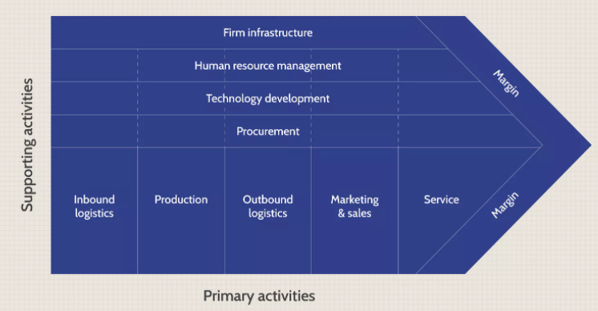
Figure 2: Porter’s value chain analysis (Bajpai and Jiang, 2020)

Primary activities
Inbound logistics
Supply chain management for finished goods as well as for materials feeding manufacturing plants uses digital tools but also requires manual co-ordinating. The demand planning is tricky as this business is very unsteady and influenced by quickly changing conditions including economic (e.g. Covid19 triggered DIY boom) and political (e.g. unclear tariff policies).

Operations
Operation management is also a mix of manual and digital activities involving several departments and many processes. The flow of raw material is sometimes organized ad-hoc due to the volatile nature of the business. There are pilot projects for smart manufacturing using 3D printing equipment and IoT technology.

Outbound logistics
Most of the sales are executed via distributors. Information flow with these is critical to fulfil orders. To keep the inventory level low, excess & obsolete stock is tightly managed and to some degree automated. Packaging is still mostly done manually; however, some investments have recently been made in automated packing stations.

Marketing and sales
E-commerce is increasingly dominating the sales, either indirectly via the distributors (evolving from brick&mortar to click&mortar shops), or more directly by using Amazon as fulfiller. Marketing is very important to support selling-in to the distributor and selling-out to the end-user. Today marketing is mostly digital and so important as a subject on its own that it is investigated further in the following section of this report.

Service
Service is important to build and maintain relationship with customers. After years of understaffed customer service, more service personnel are now hired. However, this department still lacks digitalised processes and digital tools.

Supporting activities
Infrastructure
The organisation’s infrastructure is very diverse. Some of it, like the legal department, is characterized by traditional work style, others like quality control are developing towards digital work flows, while accounting has already been completely digitised and moved to India. Public relation activities are increasingly focusing on social media.

Technological development
While the power tools are technically state-of-the-art engaging all kind of modern and digital solutions, the processes and skills did not keep pace with the technological development despite some efforts to develop 4.0 manufacturing capacities.

Human resources management
Human resources management (HRM) is largely focused on personnel management with a low degree of digitalisation. This applies to all areas including hiring, training, intra-organisational collaboration, engaging and compensating schemes for employees.

Procurement
Procurement activities have been professionalised over past years bur the processes are far away from being automated. Purchasing systems differ per region, thus hampering the harmonisation of systems and integration in SAP.

Extra: digital marketing
Marketing is of outstanding importance for the organisation particularly when it is financially driven. Technological leadership alone does not sell innovative tools successfully (Tidd and Bessant, 2014). – For this analysis, three models are used, namely 7P, SOSTAC, and 6C. The main findings are given in three tables (Figure 3, Figure 4, and Figure 5).

The 7P model is a strategy tool to review the marketing mix and define key issues affecting the marketing of products. Originally limited to 4 Ps, it was developed already as early as 1960 (McCarthy, 1960) but was later extended to 7 Ps (Booms and Bitner, 1981).

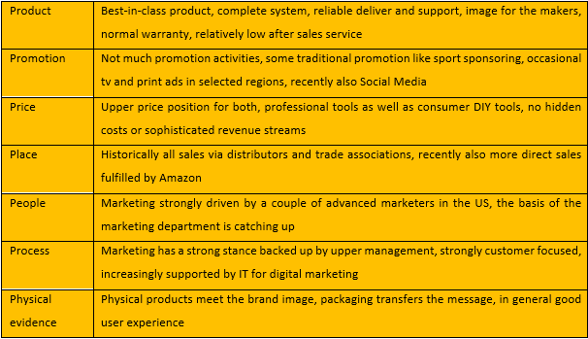
Figure 3: Tabulated 7P marketing mix analysis for the considered organisation

Next, SOSTAC is a marketing model developed in the 1990s (Smith, 1998) as a tool for planning marketing activities or campaigns. It is particularly helpful to develop a digital marketing strategy.

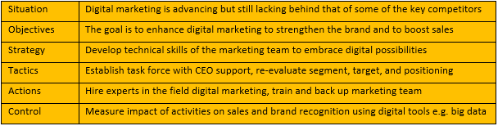
Figure 4: Tabulated SOSTAC analysis for the considered organisation

The third model, 6C (Chaffey, 2015), is a digital marketing model aiming at the customer motivation in a consumer world which by now is vastly online based. It helps to define the Online Value Proposition (OVP).

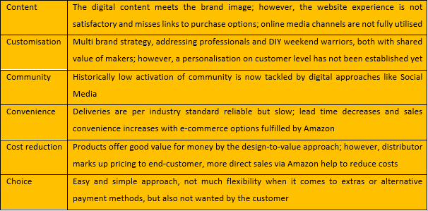
Figure 5: Tabulated 6C analysis for the considered organisation

Roundup: strengths and weaknesses
The above analysis reveals a couple of strengths and weaknesses:
Strengths
The organisation is big and profitable, there is enough funding available for making a change and disrupt. The brands are strong, the organisation is dynamic, its employees are ready for digital transformation.
Inspired employees are the primary source for innovation, predominantly architectural innovation (Henderson and Clark, 1990) which can be as simple as an optimized packaging or something more disruptive like patented battery motors.
Marketing experiences within the organisation a strong support; digital marketing gets some traction. As a key part of the digital strategy, social media with influencers increasingly engages suppliers, employees, and customers (Shaw, 2018).
There are several initiatives to employ advanced digital technologies in manufacturing like IoT and Manufacturing 4.0 (Tate, 2019). Moreover, the increasing importance of e-commerce is understood as a chance to take out margin diluting distributors.

Weaknesses
Some of the above-mentioned strengths are limited in their extent. There are flagship projects for complete digitalisation, e.g. Manufacturing 4.0, but these have not been widely introduced yet.
Many processes are not fully digitalised and integrated; critical technological skills required for digital disruptions are missing across all departments, thus hampering digital entrepreneurship (Elia et al., 2020).
The HRM struggles to provide the talents needed, while the service department cannot meet customer’s expectations. Fulfilment by Amazon (FBA) helps to expedite deliveries and to improve margins but does not fully utilize opportunities for e-business (Seattle, 2019).
One of the biggest weakness is the sub-standard website with no direct sales options or even links to distributors or Amazon. This results in a bad online shopping experience and jeopardises digital marketing activities (Neufeld and Roghanizad, 2018).

Conclusions
Aspects of digital entrepreneurship of the considered SBU have been analysed. The organisation has realized the need for digital transformation and intends to become a disruptive force among global diversified industries (Anon, 2019). The foundation is there but it is still some way to go.
The analysis has shown how digitalisation is affecting all activities, primary and supporting. By this, PVC and the Virtual Value Chain (VVC) go in parallel (Liu and Wu, 2010). Digitalised processes and information flow between departments are critical to increase value throughout the organisation (Schilling, 2008). There are deficiencies particularly in operations.
Digital marketing at the core of the organisation’s entrepreneurship is advancing but requires more reinforcement to transform the value proposition of the business model (Appendix A) and create a distinctive OVP (Chaffey and Ellis-Chadwick, 2016). It is important to not get stuck in doing digital things without really leveraging digital technologies (Wei et al., 2019).

Recommendations
The digitalisation has to be advanced along the value chain. It is recommended to run a full-scale system analysis to identify the most critical activities and to define processes to digitalise and manage. The goal is to the functional enhancement of individual activities between the various departments.
Operations require more digital technologies for a 4.0 manufacturing with integrated processes. This is the chance to bring manufacturing back to the US (Shih, 2020) to avoid tariffs and improve margins. The notoriously volatile forecasting could be improved by demand planning based on AI mining real time data.
The biggest shortfall for marketing and sales is the outdated website and the missing possibility for an easy online shopping. A clear digital marketing is needed also to sharpen the OVP of the business. For this, a RACE analysis (Chaffey, 2010) is recommended, which scope is briefly sketched in Figure 6.

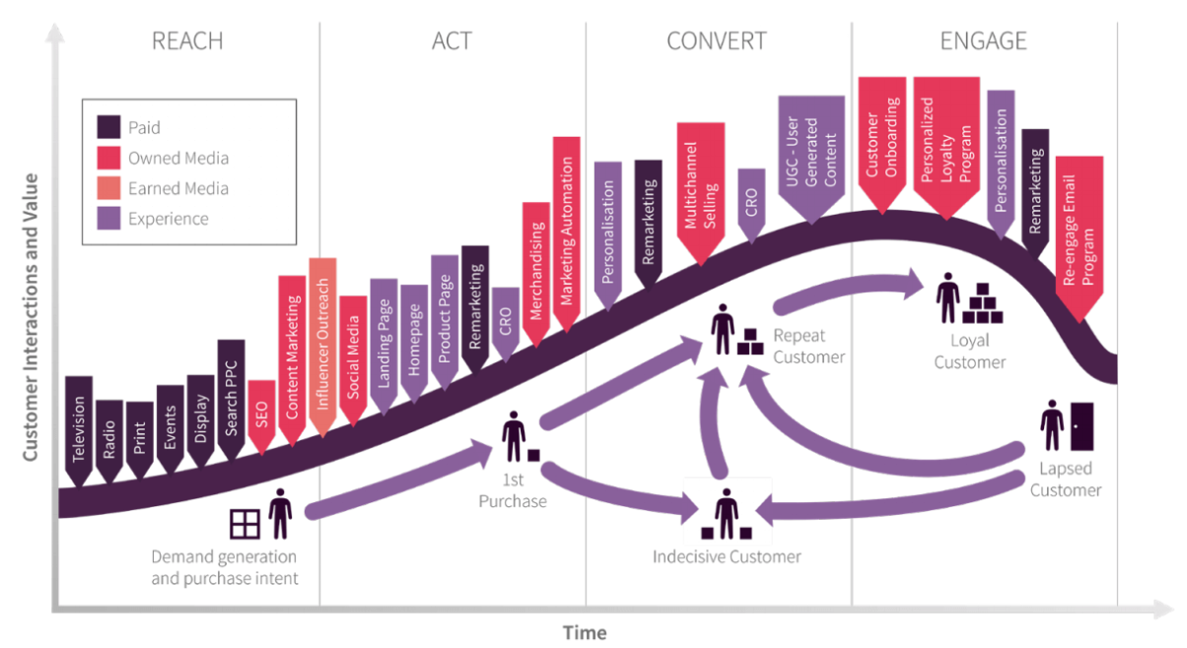
Figure 6: Chart illustrating RACE analysis (Chaffey, 2021)
For the digitalisation program, technical expertise is required in all departments. HRM is responsible to develop the necessary skills of employees and to hire experts like data analyst. HRM must professionalise recruiting e.g. by employing AI chatbot, a technology that can also help the service department to get up to speed.
Resources are limited, and there is resistance against transformation. Digital disruption is difficult but also incumbent organisation can succeed (Bradley and O’Toole, 2016). The wins will not materialise quickly, however, in the long run organisations that embrace digital disruption benefit financially (Figure 7), a strong argument for an organisation focused on growth and shareholder value.

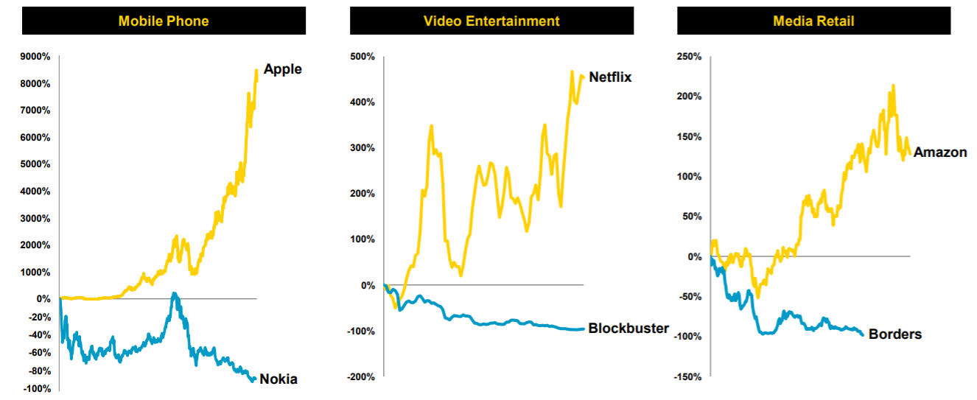
Figure 7: Development of shares for three different industries, companies successfully embracing digital disruption (yellow lines) versus others (blue lines) (Sohovich, 2015)

References
Anon (2019) ‘How we innovate in a digital environment’, [Online]. Available at https://www.stanleyblackanddecker.com/who-we-are/how-we-innovate (Accessed 30 May 2021).
Bajpai, P. and Jiang, S. (2020) ‘Analyzing Porter’s value chain’, [Online]. Available at https://www.investopedia.com/articles/investing/103114/starbucks-example-value-chain-model.asp (Accessed 6 March 2021).
Booms, B. and Bitner, M. (1981) ‘Marketing strategies and organizational structures for service firms’, American Marketing Association, Chicago.
Bradley, C. and O’Toole, C. (2016) ‘An incumbent’s guide to digital disruption’, McKinsey Quarterly, 52(3), 76-85.
Chaffey, D. (2010) ‘Introducing RACE: A practical framework to improve your digital marketing’, SmartInsights [Online]. Available at https://www.smartinsights.com/digital-marketing-strategy/race-a-practical-framework-to-improve-your-digital-marketing/ (Accessed 20 May 2021).
Chaffey, D. (2015) ‘Digital business and e-commerce management, 6th ediiton’, Pearson Education.
Chaffey, D. (2021) ‘SOSTAC marketing planning model guide and the RACE Framework’, [Online]. Available at https://www.smartinsights.com/digital-marketing-strategy/sostac-model/ (Accessed 6 March 2021).
Chaffey, D. and Ellis-Chadwick, F. (2016) ‘Digital marketing’, Pearson.
Elia, G., Margherita, A. and Passiante, G. (2020) ‘Digital entrepreneurship ecosystem: How digital technologies and collective intelligence are reshaping the entrepreneurial process’, Elsevier Inc, Technological forecasting & social change, 2020-01, Vol.150, p.119791.
Henderson, R. and Clark, K. (1990) ‘Architectural innovation: The reconfiguration of existing product technologies and the failure of established firms’, Administrative Science Quarterly, 1 March 1990, 35(1), 9-30.
Lemgruber, B. (2020) ‘Stanley Black & Decker’s path to digitalization’, VTEX digital insider blog [Online]. Available at https://vtex.com/en/blog/strategy/digital-insider/stanley-black-decker-digital-insider/ (Accessed 30 May 2021).
Liu, L. and Wu, J.-N. (2010) ‘Virtual value chain and competitive advantages in the context of e-commerce. 2010 IEEE 17Th International Conference on Industrial Engineering and Engineering Management, 2010-10, p.1467-1472’,.
McCarthy (1960) ‘Basic marketing. A managerial approach’, Richard D. Irwin, Inc., Homewood.
Neufeld, D. and Roghanizad, M. (2018) ‘Research: How customers decide whether to buy from your website’, Harvard Business Review, January 2018 Issue.
Schilling, M. (2008) ‘Strategic management of technological innovation’, McGraw-Hill.
Seattle, W. (2019) ‘Amazon’s empire rests on its low-key approach to AI’, The Economist, April 13th edition.
Shaw, A. (2018) ‘How Social Media can move your business forward’, Forbes [Online]. Available at https://www.forbes.com/sites/forbescommunicationscouncil/2018/05/11/how-social-media-can-move-your-business-forward/#60e29b6b4cf2 (Accessed 29 May 2020).
Shih, W. (2020) ‘Bringing manufacturing back to the U.S. is easier said than done’, Harvard Business Review, April 2020 Issue.
Smith, P. (1998) ‘Marketing communications: An integrated approach’, Kogan Page Publishers, 2nd Ed.
Sohovich, J. (2015) ‘Investor day: Digital excellence’, [Online]. Available at https://ir.stanleyblackanddecker.com/static-files/e698c67f-7273-4733-baaf-e170b8cf82f3.
Tate, P. (2019) ‘Scaling an manufactory 4.0 culture’, Journal of the Manufacturing Leadership Council [Online]. Available at https://www.manufacturingleadershipcouncil.com/2019/08/01/scaling-an-m4-0-culture/ (Accessed 6 February 2021).
Tidd, J. and Bessant, J. (2014) ‘Strategic innovation management’, Wiley.
Wei, J., Sanborn, S. and Slaughter, A. (2019) ‘Digital innovation’, Deloitte Insights [Online]. Available at https://www2.deloitte.com/us/en/insights/industry/power-and-utilities/digital-transformation-utility-of-the-future.html (Accessed 6 January 2021).

Appendix A: Business Canvas
This shot is taken from Part A of the Assignment 1.


