

Postgraduate/Distance Learning
Assignment coversheet & feedback form

THIS SHEET MUST BE THE FIRST PAGE OF THE ASSIGNMENT YOU ARE SUBMITTING (DO NOT SEND AS A SEPARATE FILE)

For completion by the student:
Student Name: Steven Burr

Student University UWTSD Email: 2206586@student.uwtsd.ac.uk
Module code: HPCA7028  Module title: Sacred Skies | Student ID number: 2206586 |  |  | Educational support needs:  Yes/No
Assignment title: Essay 1 - Exploring the Cultural Significance of a Lunar Myth

Assignment due date: 30th March 2023
This assignment is for the 1st 2nd 3rd 4th 5th 6th module of the degree
I confirm that this is my original work and that I have adhered to the University policy on plagiarism.
Signed ……………………………………………………………
Email submission: if you are submitting this form via email, please tick this box x
(as a substitute for your signature) to confirm that you agree to the above declaration.
Assignment Mark
1st Marker’s Provisional mark
2nd Marker’s/Moderator’s provisional mark
External Examiner’s mark (if relevant)
Final Mark

NB. All marks are provisional until confirmed by the Final Examination Board.

ALL COMMENTS ARE ON THE PDF OF YOUR PAPER IN TURNITIN

For completion by Marker 1:
Comments:

Marker’s signature: |  |  | Date:
For completion by Marker 2/Moderator:

Comments:

Marker’s Signature: |  | Date:
External Examiner’s comments (if relevant)

External Examiner’s Signature: |  | Date:

University of Wales Trinity Saint David
Institute of Humanities and Education

Sacred Skies
HPCA7028
Exploring the Cultural Significance of a Lunar Myth
(Word Count: 3097)

Submitted by
Steven Burr
2206586
2206586@student.uwtsd.ac.uk

Submitted to Professors:
Dr. Bernadette Brady
Dr Darrelyn Gunzburg
Dr Nick Campion

Date of Submission
March 30th, 2023

Introduction

This essay will explore and critically examine the cultural significance of a lunar myth. Specifically, this document will delve into the nursery rhyme Hey Diddle-Diddle as originally presented in Mother Goose’s Melody of 1760. The lunar myth in this instance is the verse which includes a cow jumping over the moon. One may say this is incredulous, nonsense a mere fantasy or myth, but does this statement have an underlying truth? What impact has this rhyme had on Western culture over the centuries?

To reveal these answers, I have divided this document into the following:

- Culture, myth, and the moon,
- The rhyme Hey Diddle-Diddle,
- Impact on culture, and
- Conclusions.

It should be noted, this examination of a myth is through the lens of a person raised
within Western culture and immersed in nursey rhymes as a child. As such, I should be considered an insider with all the accompanying biases and prejudices of this culture as it pertains to nursery rhymes.

Culture, Myth, and the Moon

As defined by the Encyclopedia Britannica, ‘culture: behaviour peculiar to Homo sapiens together with material objects used as an integral part of this behaviour. Thus, culture includes language, ideas, beliefs, customs, codes, institutions, tools, techniques, works of art, rituals, and ceremonies, among other elements.’ The origins of the word culture according to the Online Etymology Dictionary, ‘is from Latin cultura "a cultivating, agriculture," figuratively "care, culture, an honoring," from past participle stem of colere "to tend, guard; to till, cultivate." An early anthropologist Edward Burnett Taylor (1832 to 1917) defined culture as:

‘Culture, or civilization, taken in its wide ethnographic sense, is that complex whole which includes knowledge, belief, art morals, law, custom, and any other capabilities and habits acquired by man as a member of society.’

Raymond Williams (1921 to 1988), a cultural theorist, outlined three definitions for the word culture:

- The independent and abstract noun which describes a general process of intellectual, spiritual, and aesthetic development,

- The independent noun, whether used generally or specifically, which indicates a particular way of life, whether of a people, a period, a group, or humanity in general, from Herder and Klem.

- The independent and abstract noun which describes the works and practices of intellectual and especially artistic activity.

The English literary theorist Terry Eagleton provided more depth to the concept of culture when he wrote:

‘If the word ‘culture’ traces a momentous historical transition, it also encodes a number of key philosophical issues. Within this single term, questions of freedom and determinism, agency, and endurance, change and identity, the given and the created, come dimly into focus.’

The word culture has a variety of meanings and depth to it. It is defined as a way of life humans nurture and foster to allow us collectively to survive. For the purpose of this document, Raymond Williams definition will be utilized.

As a follow on to culture, the word myth must also be defined if we are to look at a cultural significance of a myth. To start of with, Robert L. Fowler in his paper Mythos and Logos (2011) refers back to Plato’s concept:

‘As myth itself, it conforms to Plato’s much -quoted definition at Rep. 2.337a: there are two kinds of logoi, one false and one true; myths are the false kind, generally speaking, though there is some truth in them.’

`The philosopher Mircea Eliade (1907 to 1986) defines myth as follows:

‘The myth relates a sacred history, that is, a primordial event that took place at the beginning of time, ab initio.’ and ‘The myth then, is the history of what took place in ab origine. Once told, that is, revealed, the myth becomes the apodictic truth; it establishes a truth that is absolute.’

For the French philosopher Levy-Bruhl (1857 to 1939), ‘Myths and legends are true stories, but their “truth” has characteristics which distinguish it from that of the events of everyday life.’ and he felt, ‘Despite appearances, then, they must have some objective foundation.’ These three definitions of myth loosely describe myth as a traditional story with a truth at its center. It is with this understanding of myth that this document is orientated to.

The moon whether seen night or day attracts our attention. For example, Robert Frost (1874-1963), the American poet aptly describes the moon as a celestial timekeeper:

‘But not to call me back or say good-bye.
And further still at an unearthly height,
One luminary clock against the sky
Proclaimed the time was neither wrong nor right.
I have been one acquainted with the night.’

The moon our closest celestial neighbour is solid rock, with a diameter of 3,476 km, orbiting earth from a mere 384,000 km away. It lights the darkness through reflected sunlight providing the ancients with almost nightly illumination and a natural clock. As Liz Green describes it, ‘a visible heavenly phenomenon’. For Bernard Brummer, ‘Both myth and history bear witness to the overwhelming sensations inspired by the beauty of the full moon’. The full moon is indeed a sight to behold, see Figure 1. It is understandable therefore, that the moon in the time before artificial illumination, was such a powerful symbol and aid to culture.
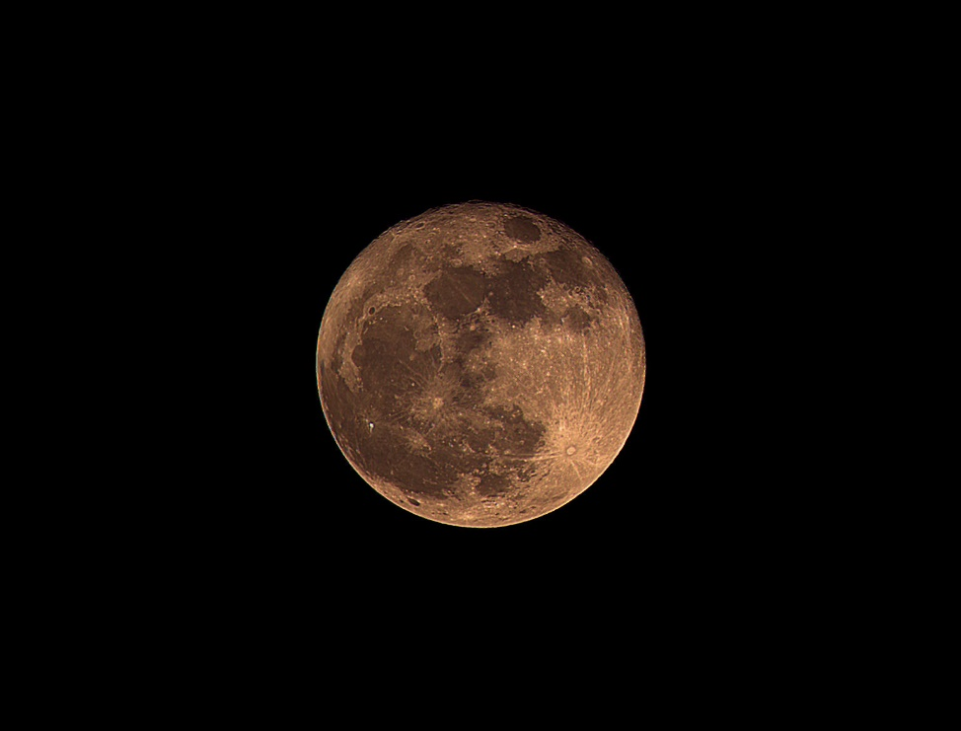
Figure 1. Full Moon, 14 June 2022, South Marysburgh, Prince Edward County, Photo: Steven Burr

Hey Diddle-Diddle

Nursery rhymes are a staple of our early childhood. I can still remember some to this day that my mother, and grandmother recited to me as a child. These rhymes were the same ones they heard from their parents, and so on through the ages. As Dennis Butts describes it,

‘Nursery rhymes, often in the form of short songs, have often been used by parents, perhaps at bedtime, to amuse or soothe their children. The seem to have come from all kinds of sources, such as adult folk songs, counting games, and even political squibs, and were widely known throughout Europe.’

The nursery rhyme Hey Diddle-Diddle as we understand it today can be traced back to Mrs. Goose’s edition of 1793, with indications the rhyme originates much earlier, as in medieval times. The rhyme as we know it is as follows:

‘Heh, diddle, diddle,
the cat and the fiddle,
The cow jumped over the moon;
The little dog laughed to see such a sport,
And the dish ran away with the spoon.’

O.F. Sigworth and W.C. Helmbold in their 1950 paper on Hey Diddle-Diddle described it as follows:

‘In this superb example of mediaeval lyricism, we catch at one glimpse the full sweep of the social struggle which attended the progressive crumbling of the Feudal System: the unknown author presents us with a deeply felt, highly subjective picture of the vain strivings of the oppressed common people.’

Sigworth and Helmbold’s take on the rhyme specifically in reference to the cow jumping over the moon and its meaning, ‘The cow jumped over the moon: the peasant strives for equality with the Lord of the manor.’ If this is true, the rhyme represents a reflection of the culture itself and a truth at its core. John Ker in his book “An Essay on the Archeology of Popular Phrases, Nursery Rhymes”, previously echoed the same understanding that of a labouring peasant in his assessment of Hey Diddle-Diddle.

Further indication this rhyme dates back to the medieval times is reflected in Malcolm Jones’s essay ‘The Cat in the Badge. In it he wrote,

‘In the English tradition too, there seems to be a particular association between the cat and the fiddle, as most familiarly in the nursery-rhyme, Hey diddle-diddle, the Cat and the Fiddle. As early as 1361 an English document mentions a tenement (probably an inn) named le Catfithele,26 and in medieval Amiens there was similarly a house called le Cat qui vielle in the Rue des Orfèvres.’

There are also some distractors from the labouring peasant line of thought, namely Iona Opie who describes the rhyme as ‘the best-known nonsense verse.’ She indicated previous attempts to link this rhyme with Hathor worship, various constellations (Tauris, Canis minor etc.), and the flight from the Nile have been proven false. As she sees it, Hey Diddle-Diddle has no underlying truth; it is mere babble. However, if this rhyme is mere babble, why is it still around?

The long levity of this rhyme surely attests to the value that the western society has placed on it. This is demonstrated by the fact my parents recited this rhyme to me and, I did the same to my children. This rhyme is therefore not fading into obscurity and has become a staple of our children’s early education.

Impact

Raymond Williams provided us with three definitions of culture, as follows:

  - a general process of intellectual, spiritual, and aesthetic development,
  - a particular way of life, and
  - the works and practices of intellectual and especially artistic activity.

Using these definitions, we will look at how this rhyme has impacted culture in the arts. In Marjory Willison’s short story ‘Hey Diddle-Diddle,’ she refers to the rhyme in both title and text. For example, she wrote, ‘Monstrous! Incredible! This must have been precisely how the Moon and felt when the cow jumped over!’ This example clearly demonstrates the continued use and symbolic meaning of a cow jumping over the moon. Hey Diddle-Diddle has therefore impacted the literary realm beyond the rhyme.

In addition, books are still being printed with the rhyme Hey Diddle-Diddle incorporated in it, see Figure 2. This continued publication clearly demonstrates it is still a very popular nursery rhyme for children. As well, it demonstrates the rhyme has been integrated into the culture over time.

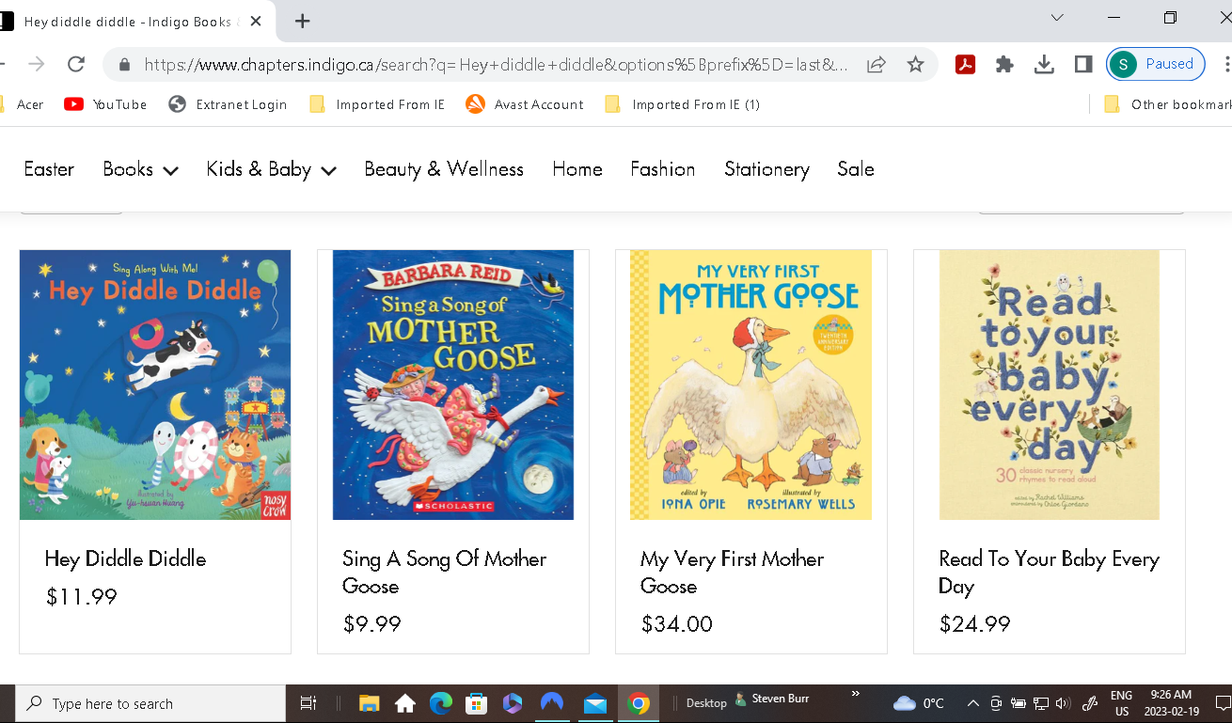

Figure 2. Indigo/Chapters – Books with Hey Diddle-Diddle [online],18 February 2023, Screenshot: Steven Burr

The impact of this rhyme is further demonstrated in the graphic arts. One example would be nursery rhyme books which are often filled with images. For example, Figure 3 demonstrates an illustration for Hey Diddle-Diddle. These images are expressly designed to attract and hold children’s attention.
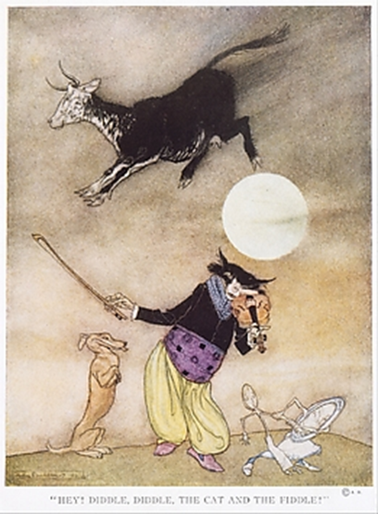
Figure 3. Arthur Rackham (1867-1939), Mother Goose. The old Nursery Rhymes, 1913, Illustrations: photo mechanical colour process and lithography. Image: The Met.
The rhyme Hey Diddled-Diddle has also been felt in music. In the book ‘Anthology of Rap’, the author quotes the American rapper, songwriter, and actor Kool Moe Dee’s lyric,

‘Hey, diddle-diddle on the fiddle, ’cause the cat is in the middle Will he rhyme, or will he riddle, does he want a tender vittle? Have a lot, maybe a little, long as he can feel his middle’

The rhyme Hey Diddle-Diddle is therefore still impacting music to this day as demonstrated above. In addition, if one wishes to search for music associated with this rhyme, you will find a variety of music sheets with 22 available online from Digital Scores, see Figure 4.

.

Figure 4. Digital Scores available 22 total - Hey Diddle-Diddle Music Sheets [online], 18 February 2023, Screenshot: Steven Burr

The impact of nursery rhymes on intellectual development on young members of a culture is immense. As Stanley Zehm in his paper ‘Promoting Language Growth through Nursery Rhymes’ found, nursery rhymes helped him achieve the following objectives:

1. Link the study of language and literature more closely.

2. Provide an opportunity for lively production of oral and written language.

3. Provide a context for genuine vocabulary building.
4. Promote the meaningful use of the dictionary and thesaurus.

Nursery rhymes are an essential feature of human development within a given culture. Zehm also found that by using nursery rhymes, ‘some of my students read myths very closely to discover mythic elements they could incorporate into their own "modern myths." This further demonstrates the importance of myth and rhyme within a culture to develop its citizens.

In our local education system, rhymes are integrated within the early education realm. See Figure 5 and 6, a Kindergarten Diploma with Hey Diddle-Diddle prominently displayed. This falls in line with Raymond Williams definition of culture including intellectual development and activity.

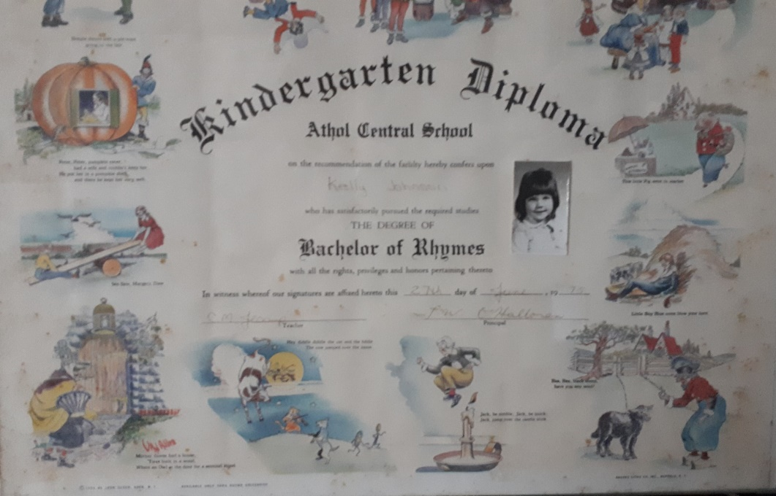

Figure 5. Bachelor of Rhymes, 15 February 2023, colour print, 20.32 cm x 27.94 cm, South Marysburgh PEC, Photo: Steven Burr

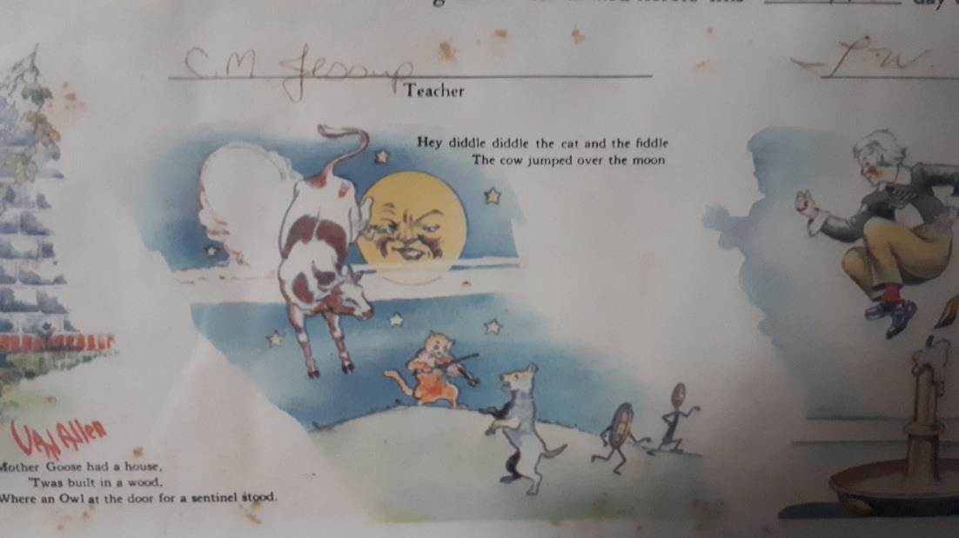

Figure 6. Bachelor of Rhymes close-up, 15 February 2023, South Marysburgh PEC, Photo: Steven Burr

The nursery rhyme Hey Diddle-Diddle has also spawned poetry, one example being Martine Bellen’s ‘Hey Diddle, Diddle as follows:

‘And the cat jumped over the Milk Moon,
the Spoon Moon, the Sleepy Mean Moon.
Not the Flying Fish Moon. Or the Tiger Shark Moon.
Moon of the Terrible. Moon of the Raccoon.’

As well, Hey Diddle-Diddle has been preformed live onstage. An example being, Hey Diddle-Diddle: A Christmas spectacular. Puppetry is another art form that this rhyme appears in. It can therefore be said, the nursery rhyme Hey Diddle-Diddle is engrained in all parts of our Western culture, in our intellectual, aesthetic, and artistic development and practices as defined by Raymond Williams.

Conclusion

This essay delved into the cultural significance of a lunar myth that of the nursery rhyme Hey Diddle-Diddle with the myth of a cow jumping over the moon. To begin this journey; culture, myth, and the moon were first examined. For the purpose of this document, Raymond Williams (1921 to 1988) definition of culture was utilized in this examination. He defined it as follows: a process of intellectual, spiritual, and aesthetic development, a particular way of life, and practices of intellectual and artistic activity.

A myth was loosely described as a traditional story with a truth at its center. The rhyme Hey Diddle-Diddle therefore can be defined as a myth; a traditional story dating from medieval times with its truth being reflected in the meaning of ‘the cow jumped over the moon’ which represented the peasant striving for equality with the Lord of the manor. As demonstrated, society is still incorporating Hey Diddle-Diddle within the Western culture in intellectual and artistic activity.

The moon, our closest celestial neighbour provides the basis for myth, light and a natural clock. It overwhelms and inspires us as it did to our ancestors. It is no wonder moon myths to this day still connect with humanity.

As a society, we are no longer the peasant striving for equality with the Lord of the manor. However, our way of life has not changed very much. Today, many in our society are still striving for equality. The Lord of the manor may have gone, but he’s only been replaced by another Lord, one of corporate greed. Raymond Williams definition of culture as a way of life certainly pertains to this rhyme.

. The impact of this rhyme crosses all areas of culture as defined by the cultural theorist Raymond Williams. It has a significant and positive influence on the culture through education, art, music, and literature making society a better place. Why do I say positive impact? If it wasn’t, the rhyme/myth would have died out long ago and not still be incorporated into those elements of culture we hold so dearly today.

Bibliography

Bellen, Martine. “Hey Diddle, Diddle.” Conjunctions, no. 58 (2012): 36–36.
http://www.jstor.org/stable/24517131.

Brunner, Bernd. “Gazing at the Moon.” In Moon: A Brief History, Yale University
Press, (2010), 1-23 http://www.jstor.org/stable/j.ctt1npsfb.4

Butts, Dennis, and Peter Hunt. “Why Were There No Nursery Rhymes before 1744?: Tom
Thumb’s Pretty Song Book, Vol. II.” In Why Was Billy Bunter Never Really Expelled?: And Another Twenty-Five Mysteries of Children’s Literature, 12–17. The Lutterworth Press, 2019. https://doi.org/10.2307/j.ctv10vm12h.7.

Eagleton, Terry, The Idea of Culture (Oxford: Blackwell, 2000)

Eliade, Mircea, The Sacred and Profane: The Nature of Religion (New York: Houghton
Mifflin Harcourt Publishing, 2021)

Fowler, Robert L., ‘Mythos and Logos’, The Journal of Hellenic Studies, 131 (2011), 45–66

Frost, Robert, Acquainted with the Night [online]. Poetry Foundation, 2004 [cited 17
February 2023]. Available from:
https://www.poetryfoundation.org/poems/47548/acquainted-with-the-night

Gates, Henry Louis, Chuck D, and Common. “Treacherous Three.” In The Anthology of Rap,
edited by Adam Bradley and Andrew Dubois (Yale University Press, 2010), pp 106–12.. http://www.jstor.org/stable/j.ctt1nq45c.19

Greene, Liz, ‘Signs, Signatures and Symbols: The Languages of heaven’, in Astrologies:
Plurality and Diversity in the History of Astrology, ed. by Nicholas Campion and Liz Greene (Ceredigion: Sophia Centre Press, 2011)

Harper, Douglas, Culture (N.) [online]. Online Etymology Dictionary, 2023, [cited 11
February 2023]. Available from: https://www.etymonline.com/word/culture

Hey Diddle-Diddle: A Christmas Spectacular [online]. Northern Stage, 2022 [cited 17
February 2023], Available from: https://northernstage.co.uk/whats-on/hey-diddle-diddle/

Hewins, C.M., The History of Children’s Books [online]. The Atlantic, 1888 [cited 17
February 2023]. Available from:
https://www.theatlantic.com/magazine/archive/1888/01/the-history-of-childrens-books/306098/
Indigo Search Page [online]. Indigo, 2023 [cited 17 February 2023]. Available from:
https://www.chapters.indigo.ca/search?q=hey%20diddle%20diddle&type=product,page&options[prefix]=last

Jones, Malcolm. “The Cat in the Badge – the Iconography of Late Medieval Bicaudal and
Other Felines….” In Beyond Pilgrim Souvenirs and Secular Badges: Essays in Honour of Brian Spencer, edited by Sarah Blick, 151–69. Oxbow Books, 2007. http://www.jstor.org/stable/j.ctt1cd0px1.17.

Ker, John Belledon, An Essay on the Archeology of Popular Phrases, Nursery Rhymes,
(London: Langmon, Rees, Orme, Brow, Green and Coupland, 1837)

Mother Goose’s Melody (London: John Newbery, 1760), Reproduced in Facsimile
(Worcester, Mass: Isaiah Thomas, 1785)

North, Gerald, Observing the Moon (New York: Cambridge University Press, 2007)

Opie, Iona, and Peter Opie, The Oxford Dictionary of Nursery Rhymes (Oxford: Oxford
University Press, 1977)

Sigworth, O. F., and W. C. Helmbold, ‘Hey Diddle-Diddle: A Newly Revised Edition,
With Notes, Commentary and Appendix’, The Classical Journal (Classical Association of the Middle West and South), 45.4 (1950), 183–85

Tylor, Edward Burnett, Primitive Culture, 3 Vols, (New York: Harper Torchbooks 1958)
[London: Murray 1871], Vol 1, ‘The Origins of Culture’,

White, Leslie. A.. "Culture." Encyclopedia Britannica, August 5, 2022.
https://www.britannica.com/topic/culture.

Willison, Marjory. "Hey, Diddle Diddle! (A Story)." Queen's Quarterly, 1936, 146,
https://www.proquest.com/magazines/hey-diddle-story/docview/1296879932/se-2.

Williams, Raymond, Keywords: a Vocabulary of Culture and Society, New edition, second
edition. (New York, NY: Oxford University Press, 2015)

Mother Goose’s Melody (London: John Newbery, 1760), Reproduced in Facsimile (Worcester, Mass: Isaiah Thomas, 1785), p. n46.
Leslie A. White, "culture." Encyclopedia Britannica, August 5, 2022. https://www.britannica.com/topic/culture
Douglas Harper, Culture (N.) [online]. Online Etymology Dictionary, 2023, [cited 11 February 2023]. Available from: https://www.etymonline.com/word/culture
Edward Burnett Tylor, Primitive Culture, 3 Vols, New York: Harper Torchbooks 1958 [London: Murray 1871], Vol 1, ‘The Origins of Culture’, p. 1
Raymond Williams, Keywords: A Vocabulary of Culture and Society, New edition, second edition. (New York, NY: Oxford University Press, 2015), p. 46
Terry Eagleton, The Idea of Culture (Oxford: Blackwell, 2000), p. 7
Robert L. Fowler, ‘Mythos and Logos’, The Journal of Hellenic Studies, 131 (2011), 45–66, (p. 49).
Mircea Eliade, The Sacred and Profane: The Nature of Religion, p. 95
Lucien Levy-Bruhl, The notebooks on primitive mentality trans. Peter Riviére (San Francisco: Harper & Row Publishers, 1975), p. 63.
Robert Frost, Acquainted with the Night [online]. Poetry Foundation, 2004 [cited 17 February 2023]. Available from: https://www.poetryfoundation.org/poems/47548/acquainted-with-the-night
North, Gerald, Observing the Moon (New York: Cambridge University Press, 2007), p. 2.
Liz Greene, Signs, Signatures and Symbols: The Languages of heaven, in Astrologies: Plurality and Diversity in the History of Astrology, ed by Nicholas Campion and Liz Greene (Ceredigion: Sophia Centre Press, 2011), p. 27.
Bernd, Brunner. ‘Gazing at the Moon’, Moon: A Brief History. (New Haven: Yale University Press, 2010). http://www.jstor.org/stable/j.ctt1npsfb. pp. 1-23, (p. 6).
Dennis Butts, and Peter Hunt. “Why Were There No Nursery Rhymes before 1744?: Tom Thumb’s Pretty Song Book, Vol. II.” In Why Was Billy Bunter Never Really Expelled?: And Another Twenty-Five Mysteries of Children’s Literature, 12–17. (The Lutterworth Press, 2019), p. 12.
O.F. Sigworth, and W. C. Helmbold, ‘Hey Diddle-Diddle: A Newly Revised Edition, with Notes, Commentary and Appendix’, The Classical Journal (Classical Association of the Middle West and South), 45.4 (1950), 183–85, (p. 183).
Mother Goose’s Nursery Rhymes A Collection of Alphabets, Rhymes, Tales, and Jingles (Project Gutenberg), p. 175.
O.F. Sigworth, and W. C. Helmbold, ‘Hey Diddle-Diddle: A Newly Revised Edition, with Notes, Commentary and Appendix’, The Classical Journal (Classical Association of the Middle West and South), 45.4 (1950), 183–85, (p. 183).
Sigworth, O. F., and W. C. Helmbold, pp. 183-185, (p. 183).
John Belledon Ker, An Essay on the Archeology of Popular Phrases, Nursery Rhymes, (London: Langmon, Rees, Orme, Brown, Green and Coupland, 1837). P. 252.
Malcolm Jones, “The Cat in the Badge – the Iconography of Late Medieval Bicaudal and Other Felines….” In Beyond Pilgrim Souvenirs and Secular Badges: Essays in Honour of Brian Spencer, edited by Sarah Blick (Oxbow Books, 2007), 151–69 (p. 162).
Iona Opie, and Peter Opie, Oxford Dictionary of Rhymes, (Oxford; Oxford University Press, 1977), p. 203.
Williams, p. 46
Marjory Willison, "Hey, Diddle Diddle! (A Story)." Queen's Quarterly, 1936, 146, https://www.proquest.com/magazines/hey-diddle-story/docview/1296879932/se-2
Henry Gates, and Chuck D, and Common. “TREACHEROUS THREE.” In The Anthology of Rap, edited by Adam Bradley and Andrew Dubois (Yale University Press, 2010), pp 106–112, p. 109.
Stanley Zehm, “Promoting Language Growth Through Nursery Rhymes.” Elementary English 52, no. 1 (1975), 141–42, (p. 142).
Zehm, 141-142, (p. 142).
Martine Bellen, “Hey Diddle, Diddle.” Conjunctions, no. 58 (2012), p. 36–36.
Hey Diddle-Diddle: A Christmas Spectacular [online]. Northern Stage, 2022 [cited 17 February 2023], Available from: https://northernstage.co.uk/whats-on/hey-diddle-diddle/
Hey Diddle-Diddle [online]. Stephen Joseph Theatre, [cited 18 February 2023]. Available from: https://sjt.uk.com/events/hey-diddle-diddle

