CHANGE & STABILITY MANAGEMENT
ORGANISATIONAL CHANGE CASE STUDY: NETFLIX
Word count: 3,529

Guo Haotian

Executive Summary
This study has been evaluated the change management strategy of Netflix Inc highlighting the reason of change and the major driving factors behind change. Resistance to change can be considered as a common issue within all organisations including Netflix. This report has addressed issues related to resistance to change factor such as lack of understanding about the need of change and others. It has been identified the strategy which can help Netflix to fight with those challenges related to resistance is to form a style of transparent and clear communication which can help them to improve their performance and successfully implement changes. The theoretical underpinning to evaluate the change has become effective to provide useful knowledge on change and stability management of any organisation.

Table of Contents
Introduction and background 4
Introduction 4
Background 4
Specific change by Netflix and reason for change 5
Key change management models and Application of change models considering incremental or large scale change programme 7
Lewin’s change Model 7
7s framework of change management 8
Adkar’s Model of Change Management 9
Driving factors of change 10
Strategies for dealing with resistance factors to the change 13
Implementation and effectiveness of change strategies 16
Conclusion 18
Reference List 19

Introduction and background

Introduction
Change and stability management in any organisation exist side-by-side and the major principles of change management includes understanding change, planning change, implementing and communicating change (Rosenbaum et al. 2018). This study has been investigated about the change management strategy of Netflix Inc. specific change by the organisation, reason of change, major change management model and their implementation have been analysed. Evaluating the key driving factors of change such as competition, digitalisation, power, culture, leadership along with the resistance factors of change have been evaluated in this study. Analysing specific change and evaluating the factors behind change, the effectiveness has been described providing suitable suggestions to implement change plans in the organisation.

Background
Netflix Inc is the video-rental and the media-streaming company that was founded in 1997 and it’s headquarter is located in California (Netflix Inc, 2023). The company also creates original programming. The subscription-based video streaming service allows the audience to watch movies and TV shows on internet-connected devices. The company uses consumer-centric and data-driven marketing strategies that work in this digital age.
Total revenue of this video streaming platform has amounted to about 31.6 dollars and net income is about 4.49 billion US dollar with total 12,800 employees worldwide (Stoll, 2023). The success of the company is dependent on the constant optimisation and analysis in order to market the business online. From its beginning in the form of a DVD-by-mail service provider, the company has emerged as the most subscribed video streaming platform worldwide. The company is the market leader finding potential with technology and it has found the transition first (Stoll, 2022). Since this great transition of the company, total revenue has grown to over 26 billion from 1.36 billion just within 13 years. The subscription number has followed a significant trend, although this market leader has suffered a great loss in recent times.

Specific change by Netflix and reason for change
Netflix’s Product strategy 2022
Throughout the last decade, the approach of the company was very consistent (Jayatilleke and Lai, 2018). The company aims to provide a greater consumer experience emphasising on personalised merchandising and compelling experience. The company delivered a number of movies and TV shows with maximised investment to make original content. The company focused on creating optimal balance between value and price. The punch line of the change of Netflix change strategy exhibits the company has needed to completely change the strategy. However for re-accelerating the growth of the business the company has been accelerated three core tactics-
- New ad-based monthly plan
- Paid sharing of account
- The capability to transfer those sub-profiles to the paid accounts
The product vision of the company outlines several step-function innovations that have propelled the company forward in the last two decades. The product vision of the company includes lead streaming, worldwide expansion, and creating original content (Mak, 2022).
Reason of change
Two millions new subscribers was forecasted to be added by the company in the first quarter of 2022, however the company lost about 200000 members (Mak, 2022). The reason behind the change strategy by Netflix is to hold the competitive position in the market. The major reason behind this new product strategy by the company consists of increasing competition in the market, creation of original content, international expansion, innovation technology and monetisation strategies.
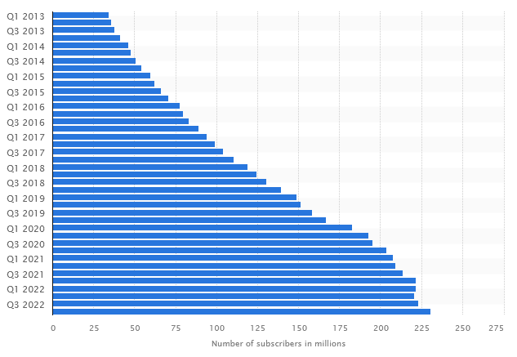
Figure 1: Numbers of paid subscribers of Netflix worldwide (2013-2022)
(Source: Stoll, 2023)
In the year 2022 an increase of eight million subscribers can be noted than the previous year. Behind the great fall of the subscription number is the subscription sharing and the key reason of this new product strategy by the company is to increase the total profit and hold the consistency in the market. Apart from that as the important priority, the company emphasises on the monetization process, so the company may invest into the incremental profits providing original contempt to its audience.
Behind the decree in the numbers of subscribers are-
- Slower adoption rate than expected rate
- Widespread sharing of accounts
- Macro factors consist of Russia-Ukraine war impact (decision of 700k Russian subscriber cancellation, continued crisis posed by Covid-19 pandemic and the worldwide recession and inflation.

Key change management models and Application of change models considering incremental or large scale change programme

Lewin’s change Model
Lewin’s change management model includes three stages: unfreezing, changing and freezing that helps business to understand the change process and manage the changes. The first stage of this model consists of the preparation stage for the change that refers to understanding the need of change, finding reason and making sense of the immediate requirement for motivating people to accept that change (Cone and Unni, 2020). The second stage of this model is involved with the change implementation. It includes changing processes, systems, structures and particular behaviour. According to Hussain et al. (2018), the second stage is the most critical stage as it asks people to include new ways to do particular things. The third stage of the model states to make particular change as the permanent part to denote long-term growth of the organisation. This stage of the change management ensures sustainable change of organisation. Netflix in the freezing stage has understood the requirement of change in the organisation. The organisation aims to lead streaming and worldwide expansion providing great experience to the consumers. The decree in the numbers of consumers evidently might be difficult to continue the growth of the business effectively. Having knowledge about the consumer demand and the requirement to expand the business worldwide, the company has been taken the decision to include new product strategy 2022.
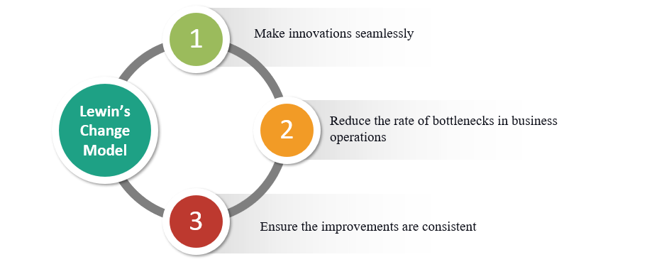
Figure 2: Lewin’s change management model
(Source: Rosenbaum et al. 2018)
The change strategy is highly focused on the monetization process, engagement and the monetisation. To drive the numbers of subscribers the company has been provided a new ad-based plan and paid accounting sharing along with the ability to transfer those sub profiles onto the paid accounts. Testing the optimal balance between value and price of the product

7s framework of change management
The 7s framework of change management includes seven elements to accelerate change that are strategy, structure, system, shared value, skill, staff and style (Gechkova and Kaleeva, 2020). In order to implement change effectively in the organisation all of these important elements are required to be integrated and aligned change has a cascading impact on others and for implementing and planning change all of these elements must be considered effectively.
For accelerating the change in business, the company has been combined three major elements that are-
Strategy: The Company has planned delightful experiences for the customers that are hard to copy. The margin-enhancing way to fulfil the consumer satisfaction and increase the value of business the strategic choice to prioritise the original content is highly important in the change strategy by Netflix.
Structure: The structure of the business has been transformed in the last thirteen years rapidly. In order to deal with the wide account sharing and prevent the decrease in the consumers of consumers the decision of the company is highly impactful (Sokol et al. 2020). The structure of change is important to deal with the changing demand of the consumers and respond to extensive competition in the current marketplace.
Consumer science: Testing for exposing effective planning in real to manage consumer whim and to manage high competitiveness in the market the strategic choice by the company is efficient.
The change decision taken by Netflix would be positively impactful to increase the profitability rate of the company. In the Covid-19 period a surge in growth scale can be noted, however after the pandemic period this change would bring a greater profit in business of Netflix making a balance between the value of business and the consumer expectations.

Adkar’s Model of Change Management
Adkar’s change management model consists of five elements that are awareness, desire, knowledge, ability and reinforcement (Ali et al. 2021). Awareness refers to the need for change. The desire to participate in it is required. Knowledge and ability to manage the change is required and lastly, reinforcement for sustaining change is required to the long-term change management strategy of any organisation.
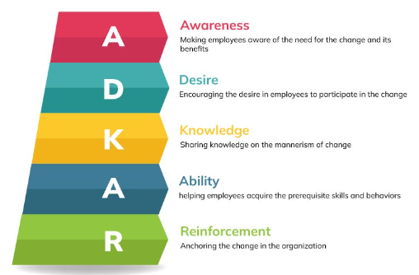
Figure 3: Adkar’s change management Model
(Source: Houben et al. 2020)
Netflix has increased its ability to prepare an environment in the organisation that can embrace change, make suitable experiments and create values that may serve in the change process. Focusing on the decreased profit and subscription number the company has accepted the need to change. Providing knowledge in the organisation about the requirement of change the change management procedure has been reinforced.

Driving factors of change
Organisations are required to be able to include multiple market conditions and fulfil the needs of the consumers. If any organisation cannot be flexible to change, it may lose the competitive advantage. The managers must identify the existing issues and challenges of business before taking strategic decisions for consistent growth of business. Effective change management is necessary to implement the change in an effective way. Anticipating the change the managers of any organisation is required to understand the key driving factors behind the change. According to Zhou et al. (2018), the driving factors behind change and stability management can be two types- external factors and internal factors such as leadership, culture, digitalisation, competition. The general external forces in the change strategy in business are social, demographic, Cultural, economic, political and technological and the business environment are competition, industry ambience and the existing demand of the consumers in the market (Malek et al. 2019). On the other side, the internal forces behind the change management includes low performance, new vision and mission of the business, specific leadership style of the company and the organisational conflict.
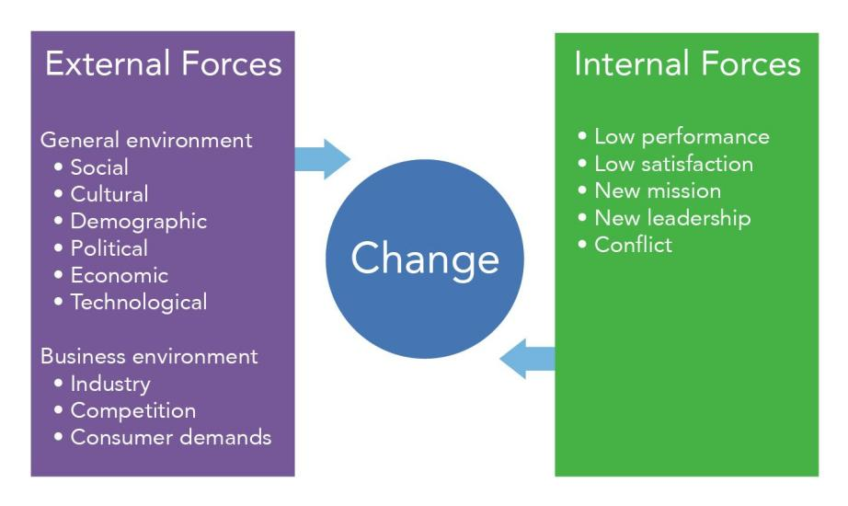
Figure 4: Internal and external factors of change
(Source: Zhou et al. 2018)
The change of the organisation refers to the transformation or peculiar adjustment to new functions of the business. As per given opinion of Hussain et al. (2018), organisations should adjust the little changes, however focusing on the long term impact on business finds t enhance the productivity by responding specific norms and regulations, including similar things or improving the productivity of business. In order to respond to larger external forces such as technology, consumer demand or competition larger response is needed in business.
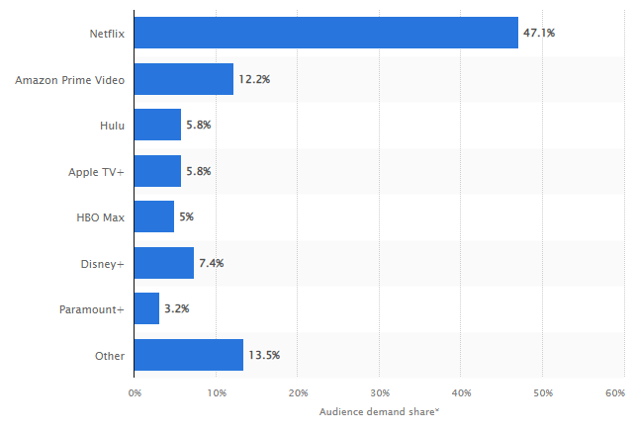
Figure 5: Most popular in-demand video streaming services globally 2021
(Source: Stoll, 2022)
Above figure clearly states that Netflix holds about 57.1% of the total demand, followed by Amazon Prime (12.2%), Hulu, Apple TV and more. The existing competition in the market is one of the greatest factors behind the change strategy of Netflix. Behind the change management strategy by Netflix it is the existing competition in the market, digitalisation and the market leadership. In order to hold consistency in its growth the new product strategy the company is immensely important. In order to manage the profitability of the company and accelerate change in the video streaming business the contribution of this new strategy is highly effective.
Market leadership: In recent years the video streaming industry is emerging more crowded with new several entrants such as Apple TV, HBO, Disney and more. For holding the leadership in the market the company is focusing on creating original content.
Innovation and technology: In order to differentiate the product from the existing rivals in the market the force of innovation and technology is a major factor behind the change strategy by Netflix. According to Sundaram et al. (2020), the reliance on technology to send ahead of the market competition this strategy is effective for the company.
International expansion: In order to find more growth opportunities the international expansion in recent years is a notable step by the company.

Strategies for dealing with resistance factors to the change
Netflix has always been a company which has gone through significant changes over the years from DVD rentals to a leading streaming platform with original content. Despite this massive success within the company there are some factors which have contributed to the change resistance within the company. Growing competition from other streaming services such as Amazon Prime, Hulu, and others have forced Netflix to adapt to changes and improve performance of the business. Resistance to change can be considered as a common issue within organisations which basically arises in time of implementing changes such as organisational restructuring and others. There are also other change factors such as changes in leadership, introducing advanced technology and others.
Resistance for changes can come in various forms such as lack of engagement, active opposition, passive resistance and others. In order to successfully implement change management it is important to consider these factors which contribute to the overall resistance. Fear of the unknown can be considered as one of the common causes for resistance to change (Wan et al. 2020). Changes can create a sense of anxiety and uncertainty in case people feel they do not have enough information about the change. They can also be feared in case they are not sure about the way it can impact their role. Organisations need to have a clear communication about the change and the importance of implementing those changes which can address the fear of unknown factors (Schulz-Knappe et al. 2019). Apart from that, the benefit of the change and the way it can be implemented also need to be communicated. Some of the strategies for resolving the issue is to provide regular updates, holding team meetings, taking feedback and inputs from all the people within the organisation.
Implementing training and development programs can also be helpful for resolving these resistances. Another problem which can arise is a sense of loss of control. Netflix is known for its decentralised structure where employees are responsible for making decisions and taking risks (Vaia et al. 2022). Thus, it can cause resistance to change as people can also feel that changes can reduce their autonomy and their ability to make decisions, and their influence to work with the team. In order to implement these strategies it is important to involve all employees in the process of change. This can also involve employees in the change management process and help them to understand the way changes can be implemented.
The strategies of revolving the factor such as loss of control can also include forming a cross-functional team to work on the change. Apart from that, providing opportunities for input and empowering employees to take ownership of the change is also important which can resolve the problem related to resistance to change. Training and development programs can also be helpful as employees can have an opportunity to gain new skills and obtain the support they require for implementing the changes (Chanana, 2021). Inconvenience is another factor which can also contribute to the resistance for change within employees. The pace of change in Netflix can also create a resistance to change. Changes within the organisations will require people to change their way of working or to learn new skills which can cause inconvenience. In order to address the issue related to pace and inconvenience, organisations need to provide resources and support to help them in adapting to the changes.
Strategies for addressing issues related to inconvenience also include mentoring, coaching and training the employees in order to help them to acquire new skills and approaches which can provide tools and resources which can make the transition to change easier. Rewards and recognition programs for the employees that have successfully adopted the changes can also be helpful for achieving the transition. Lack of trust can also be considered as a factor which can contribute to the resistance to change (Kho et al. 2020). People within Netflix can be sceptical about the change in case they are not aware about the motive behind the changes. In order to address this factor, organisations need to build credibility and trust within organisations. Implementing a form of clear and transparent communication about the changes along with the requirement for changes need to be done for addressing the issue related to lack of trust (Yue et al. 2019). Involving trusted leaders of the organisation for implementing the changes can provide a sense of stability and continuity which can also address this challenge.
In this given context, Netflix is also known for having a unique and high performance culture which is focused on innovation and experimentation (Mier and Kohli, 2021). This can also work as a resistance to change factor for the company. In order to address this challenge, Netflix needs to encourage employees to embrace change and take risks. The company can also take steps for training and development programs for helping employees and providing them with resources for embracing the changes and improving overall performance. Netflix can also address the resistance to change through creating a consistent approach to change management across organisations. This also involves creating a structured process for implementing changes with providing employees a clear set of roles and responsibilities. Apart from that, another strategy for addressing resistance to change is to provide consistent and clear leadership. Netflix also needs to ensure that the leaders are consistent in giving the message to the co-workers about changes. Moreover, these are some of the strategies which can help Netflix to address and resolve issues related to change management.

Implementation and effectiveness of change strategies
The nature of various organisational change management programs undertaken on the basis of certain change management models and frameworks are often found to be complex and involve various strategies for planning, implementation and evaluation. The task of assessing that a certain adopted program of change management has been completed requires identification and evaluation of certain indicators (Wan et al. 2020). Some of the indicators that are significant for assessing that a certain change management program has come to end have been elaborated through the following lines.
Achievement of objectives
The most significant and first indicator for assessing that the change management process has reached completion point, is evaluation of the fulfilment of aims and objectives. The goals and objectives of the program need to be assessed and the extent of their fulfilment need to be analysed. This requires a clear definition of the goals and objectives of the study at the initial phases. Regular monitoring of progress is essential for evaluation of the degree to which aims and objectives of the program have been achieved (Errida and Lotfi, 2021). If the objectives have been met, this can be regarded as a strong indicator of completion of the change management process.
Employee engagement
Employee engagement is influential for achieving success in terms of realising any change management program effectively. Employees need to be involved within the process of planning and implementation of various activities within the spectrum of change management (Abbasnejad et al. 2021). Feedback from employees needs to be sought throughout the execution of various procedures. The observation that the majority of the employees are engaged and supportive of the changes, it can be held as an indicator that the program has been executed successfully.
Resistance management
Resistance to change is existent in any organisation. Management of resistance is crucial. An effective change management program needs to incorporate plans to address resistance. When it is observed that plans to manage resistance to change have been executed effectively, it can be regarded as an indicator of successful completion of the change management process.
Evaluation
The aspect of evaluation is the final phase involved within the wider aspect of organisational change management. It is of utmost necessity to evaluate the success of change management programs objectively on part of the respective organisation (Mbatha, 2022). The business organisation in discussion, Netflix, needs to conduct a thorough evaluation process with respect to the adopted change management program. The evaluation process adopted for determining the success rate of the change management program for Netflix needs to incorporate metrics for measuring the overall impact of the change program on the stakeholders as well as on the organisation. Effective implementation of the paid sharing of accounts plan, successful rendering of the capability to transfer sub profiles to paid account as well as accurate incorporation of the new ad-based monthly plans can be regarded as valid and reliable indicators of the success achieved by implementing the discussed program of organisational change for enhanced business stability as well as profitability.

Conclusion
This current report has focused on Netflix and also determined the importance of change which is forced by growing competition. Key change management models such as Kurt Lewin's change management model, ADKAR model, and McKinsey & Company’s 7-S framework have been used in this study for aligning the changes within importance. The strategies for utilising the models have also been elaborated in this report. The driver factors for change in Netflix such as competition, Market leadership and others have also been elaborated in this study. It has also been derived that there are also other factors such as organisational culture, pace of change and more which has worked as a resistance to change factor for Netflix. A set of recommendations have also been given which can help Netflix to deal with those factors and implement changes appropriately.

Reference List
Abbasnejad, B., Nepal, M.P., Ahankoob, A., Nasirian, A. and Drogemuller, R., 2021. Building Information Modelling (BIM) adoption and implementation enablers in AEC firms: a systematic literature review. Architectural Engineering and design management, 17(5-6), pp.411-433.
Ali, M.A., Zafar, U., Mahmood, A. and Nazim, M., 2021. The power of ADKAR change model in innovative technology acceptance under the moderating effect of culture and open innovation. LogForum, 17(4).
Chanana, N., 2021. Employee engagement practices during COVID‐19 lockdown. Journal of public affairs, 21(4), p.e2508.
Cone, C. and Unni, E., 2020. Achieving consensus using a modified Delphi Technique embedded in Lewin's change management model designed to improve faculty satisfaction in a pharmacy school. Research in Social and Administrative Pharmacy, 16(12), pp.1711-1717.
Errida, A. and Lotfi, B., 2021. The determinants of organizational change management success: Literature review and case study. International Journal of Engineering Business Management, 13, p.18479790211016273.
Gechkova, T. and Kaleeva, T., 2020. The mckinsey 7s model in the airport system protection. KNOWLEDGE-International Journal, 42(5), pp.843-848.
Houben, M.A.M., Caekebeke, N., van den Hoogen, A., Ringenier, M., Tobias, T.J., Jonquiere, F.J., Sleeckx, N., Velkers, F.C., Stegeman, J.A., Dewulf, J. and Postma, M., 2020. The ADKAR® change management model for farmer profiling with regard to antimicrobial stewardship in livestock production. Vlaams Diergeneeskundig Tijdschrift, 89(6).
Hussain, S.T., Lei, S., Akram, T., Haider, M.J., Hussain, S.H. and Ali, M., 2018. Kurt Lewin's change model: A critical review of the role of leadership and employee involvement in organizational change. Journal of Innovation & Knowledge, 3(3), pp.123-127.
Jayatilleke, S. and Lai, R., 2018. A systematic review of requirements change management. Information and Software Technology, 93, pp.163-185.
Kho, J., Gillespie, N. and Martin-Khan, M., 2020. A systematic scoping review of change management practices used for telemedicine service implementations. BMC health services research, 20, pp.1-16.
Mak, A,. 2022. How should Netflix's product strategy change, given its recent earnings chaos? By Former VP of Product at Netflix.in. Available at: https://www.linkedin.com/pulse/how-should-netflixs-product-strategy-change-given-its-mak-?trk=pulse-article[Accessed on 10th February, 2023]
Malek, L., Umberger, W. and Goddard, E., 2019. Is anti-consumption driving meat consumption changes in Australia?. British Food Journal, 121(1), pp.123-138.
Mbatha, L.L., 2022. Stakeholder perceptions of leadership and organisational change management in two community education and training colleges in South Africa (Doctoral dissertation).
Mier, J. and Kohli, A.K., 2021. Netflix: reinvention across multiple time periods, reflections and directions for future research. AMS Review, 11, pp.194-205.
Netflix Inc, 2023. About Us. Available at: https://about.netflix.com/en [Accessed on 10th February, 2023]
Rosenbaum, D., More, E. and Steane, P., 2018. Planned organisational change management: Forward to the past? An exploratory literature review. Journal of Organizational Change Management, 31(2), pp.286-303.
Rosenbaum, D., More, E. and Steane, P., 2018. Planned organisational change management: Forward to the past? An exploratory literature review. Journal of Organizational Change Management, 31(2), pp.286-303.
Schulz-Knappe, C., Koch, T. and Beckert, J., 2019. The importance of communicating change: Identifying predictors for support and resistance toward organizational change processes. Corporate Communications: An International Journal, 24(4), pp.670-685.
Sokol, R., Schuman-Olivier, Z., Batalden, M., Sullivan, L. and Shaughnessy, A.F., 2020. A change management case study for safe opioid prescribing and opioid use disorder treatment. The Journal of the American Board of Family Medicine, 33(1), pp.129-137.
Stoll, J., 2023. Most in-demand video streaming services worldwide 2021, by share of demand. Statista. Available at: https://www.statista.com/statistics/1035628/most-in-demand-streaming-services-global-share/ [Accessed on 10th February, 2023]
Stoll, J., 2023. Netflix - statistics & facts . Statista. Available at: https://www.statista.com/topics/842/netflix/#topicOverview [Accessed on 10th February, 2023]
Stoll, J., 2023. Netflix's annual revenue 2002-2022. Statista. Available at: https://www.statista.com/statistics/272545/annual-revenue-of-netflix/[Accessed on 10th February, 2023]
Stoll, J., 2023. Quarterly Netflix subscribers count worldwide 2013-2022. Statista. Available at: https://www.statista.com/statistics/250934/quarterly-number-of-netflix-streaming-subscribers-worldwide/[Accessed on 10th February, 2023]
Sundaram, R., Ziade, D. and Quinn, D., 2020. Drivers of change: an examination of factors that prompt managers to enforce changes in business. International Journal of Management, 11(5).
Vaia, G., Arkhipova, D. and DeLone, W., 2022. Digital governance mechanisms and principles that enable agile responses in dynamic competitive environments. European Journal of Information Systems, 31(6), pp.662-680.
Wan, J., Saade, R. and Wang, L., 2020. Deriving significant factors for managing change in UN. Journal of Organizational Change Management, 33(1), pp.114-126.
Yue, C.A., Men, L.R. and Ferguson, M.A., 2019. Bridging transformational leadership, transparent communication, and employee openness to change: The mediating role of trust. Public relations review, 45(3), p.101779.
Zhou, X., Huang, G., Wang, X. and Cheng, G., 2018. Future changes in precipitation extremes over Canada: Driving factors and inherent mechanism. Journal of Geophysical Research: Atmospheres, 123(11), pp.5783-5803.

