Calum Case (1901766)
[Email address]
information engineering
(ACCB4013)

Contents
Top Process (Context Diagram) 2
Entity Relationship Diagram (ERD) 3
Data Flow Diagram (DFD) – Level 0 4
Data Flow Diagram (DFD) – Level 1 5

Top Process (Context Diagram)
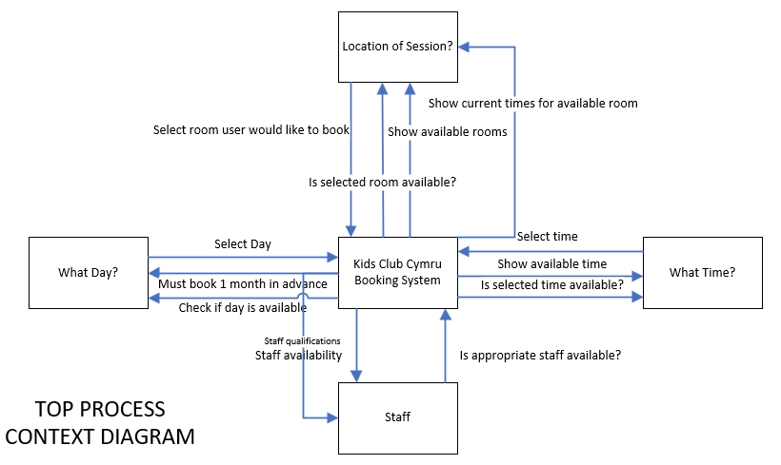
Below is the top process context diagram that has been created.

Entity Relationship Diagram (ERD)
Below is the entity relationship diagram that has been created.
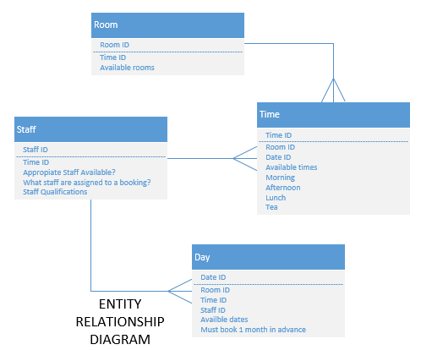

Data Flow Diagram (DFD) – Level 0
Below is the data flow diagram (level 0) that has been created.
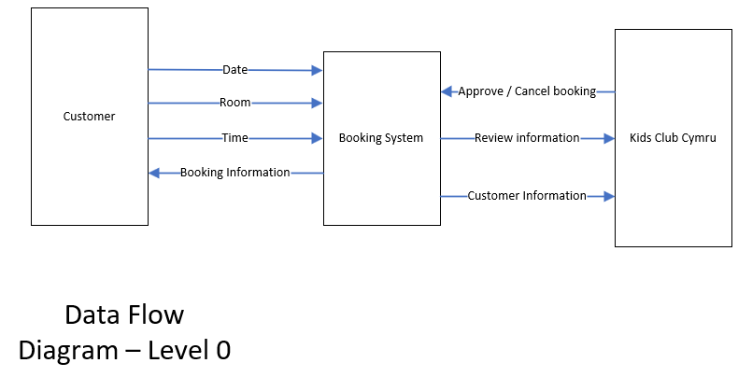

Data Flow Diagram (DFD) – Level 1
Below is the data flow diagram (level 1) that has been created.


