Name: Syed Maksum Zabid (ID: 2245066)
Module title: Financial Management for the Hotel Industry
Module Code: BMIH5007
Course Teacher: Tristan Hawkins & Kathryn Roberts

AI ACKNOWLEDGEMENT:

I confirm that I have not used any AI tools in the research and creation of this assignment. I confirm that I have not presented any AI generated materials as my own work. I confirm I have copies of my drafts, notes, and other resources I used, which I may be asked to provide in evidence.

Table of Contents
Executive Summary 4
Revenue Statement 4
Cash Flow and Solvency 5
Operating and Net Income: 6
Labor Expenses: 7
Overheads on Operations: 7
Debt and Equity Situation in the Long-Term 8
Financial Summary: 8
Internal Analysis Using SWOT 9
Strengths 9
Weakness 9
Opportunities: 10
Threats: 10
Theories Applied for City Hotel 10
Recovery Program 12
Phase 1 (0–6 months): Cost Control 12
Phase 2 (6-12 months): Diversification and Revenue Growth 12
Phase 3 (12–24 months): Financial Restructuring 12
Phase 4, 24-36 months: Sustainability and Growth 12
Risk Mitigation Through Strategy 12
Avoidance: 12
Cost Control: 13
Risk Transfer: 13
Retention: 13
Risk Assessment 13
Conclusion 14
Recommendations 14
References 14

Executive Summary
The report illustrates that the City Hotel is an established hotel that offers restaurant, bar functions, and event managing services. However, recent operational and financial challenges have been encountered in terms of revenue, occupancy rate, and the satisfaction level of clients. This report makes an exhaustive financial review, identifies key risks, and gives strategic recommendations for a turnaround. The report will consider The City Hotel's factors for recovery using Max Weber's organisation theory and an in-depth SWOT analysis to provide a phased recovery plan with a focus on profitability improvement, cost reduction, and better market positioning.

Revenue Statement
The analyses show that the City Hotel has encountered tremendous revenue declines during the past three years. Its income fell to £2,325,440 in 2023 from £5,248,290 in 2021, and that reflects a staggering 56% decline. This reduction is mostly caused by various factors, such as the fall in tourism, inflation, increased operational costs, and consumer behaviour change over time. For example, employee costs remained a substantial burden, reaching £1,770,700 in 2022 before decreasing slightly to £1,233,160 in 2023 (Adeyeri, 2024). Despite attempts to manage expenses, external costs, including utilities and maintenance, still reached £1,071,030 in 2023. Reduced global and domestic travelling due to a wake-up call from economic uncertainty and a shift in spending behaviour in the post-pandemic period results in direct impacts on occupancy. Increasing customers' demand for budget accommodations also challenges mid-range hotels, in this case, The City Hotel, further and tremendously raising its challenge, which reflects occupancy and guests' expenditure per stay per annum.
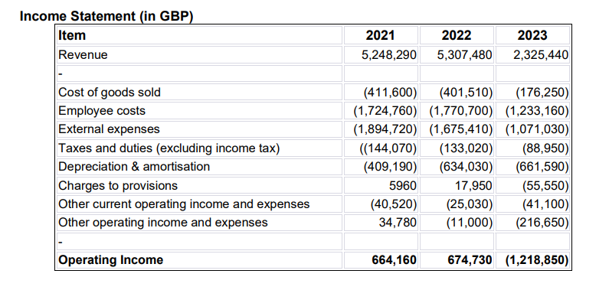

Cash Flow and Solvency
The analysis states that a positive cash flow is crucial to establishing liquidity and ensures that a business can survive when it meets its short-term finance obligations. The cash reserve that The City Hotel presents has been proven to have drastically decreased from £740,590 in 2021 to £295,510 in 2023. This level of cash reserve depletion signifies liquidity constraints limiting the ability to service immediate expenses invest in improving operations or handle unexpected costs (Boubaker et al., 2024). This decline is further compounded by a decrease in trade receivables, thus constraining cash flow. Liquidity affects the smooth running of operations and the timely payment of all vendors, employees, and other creditors, which can also damage supplier relationships and make borrowing more expensive.
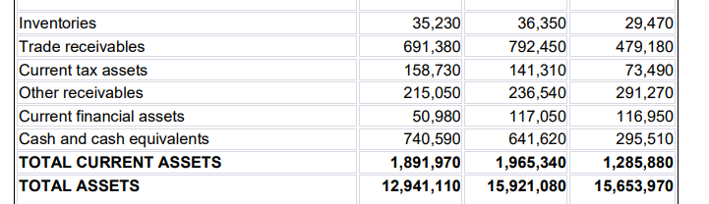

Operating and Net Income:
The analyses highlight that the operating income analysis clearly shows how bad The City Hotel's financial position is. The report states that an operating income of £664,160 for the year 2021. Thus, it reported a positive operational performance. However, for 2023, this has shifted yet again to a loss of £1,218,850. Such a drastic change within such a short period demands urgent strategic intervention. The existing business model cannot have sufficient income-generating abilities considering the current operating costs over their revenues (Samira et al., 2024). This scenario generates quite serious concerns about hotel operations sustainability and indicates that the necessary adjustments are pretty significant to consolidate profits.
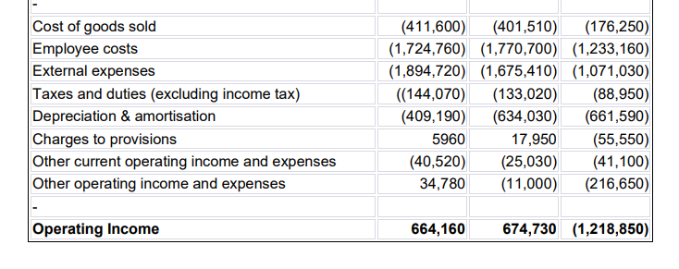

Labor Expenses:
The analyses show that labour remains one of the biggest cost items, and labour expenses have decreased from the previous year. Labour costs decreased from £1,770,700 in 2022 to £1,233,160 in 2023. This decrease would be an indication that the hotel has reduced payroll expenses due to layoffs and reduction of working hours or at a staffing structure level. However, labour cost control without the loss of service quality is challenging in the hospitality industry since customer satisfaction is directly linked to interaction with staff. Hence, The City Hotel needs to strike an optimum balance between labour cost efficiency and service quality to sustain its competitive advantage (Ahmad et al., 2024).
Overheads on Operations:
The analyses illustrate that the direct and indirect external overheads of the hotel to run the business, like utilities, maintenance, and others, have also decreased. This number has come down from £1,894,720 in 2021 to £1,071,030 in 2023. All these cuts have been a result of the overhead cuts that have been made by the hotel to avoid the outcome of the fallen revenue. Yet, the fall has been deeper than what overhead cuts alone can handle to put the profitability in balance again. There is a need to further optimise costs, particularly in non-essential categories, to avoid further erosion of the hotel's financial stability. Efficient resource management, energy-saving measures, and improvement in maintenance processes can yield economies without impacting the customers' experience (Chowdhury, 2024).
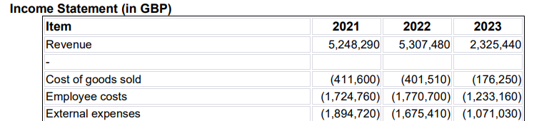

Debt and Equity Situation in the Long-Term
The study shows that Long-term liabilities increased from £8,113,710 in 2021 to £8,290,570 in 2023. The dependency on debt in addition to a decline in equity, as well, reduces the debt-to-equity ratio, hence raising uncertainty about the long-term financial strength of the hotel. A more substantial level of debt bears down harder on cash flow due to the regular interest and principal payments thereby reducing financial flexibility required in the event of challenges such as market shocks. In addition, high debt yet with no corresponding matching assets or income translates to an imbalance in finances thus leaving the hotel vulnerable to fluctuations in interest rates or eventualities that economically downsize (He et al., 2024). A high debt-to-equity ratio may also discourage potential investors or partners, due to an association of it with involvement in risk that would be attached to them in case they decide to invest.
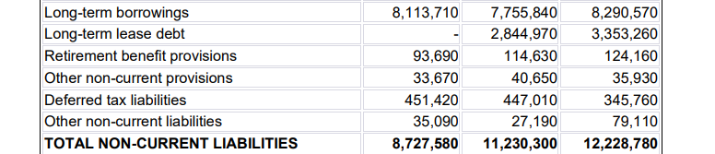

Financial Summary:
The analyses show that the financial management of City Hotel was pretty weak because it suffered from falling revenues, increasing debt, and lower cost savings in addressing those losses. It leaves it with a very huge labour and operational overhead cost even after a string of attempts to reduce the costs. Added to this are problems of liquidity constraint and an unfavourable debt-to-equity ratio; it points to a number that calls for immediate corrective action to arrest the situation from further erosion. If no strategic changes are put into practice, then City Hotel is threatened to suffer recurring losses and even be insolvent.
The study further shows that The City Hotel needs to improve the generation of revenue with diversified services, new customer segments, and targeted marketing to overcome these. Besides, further cost optimisation concerning labour and overhead is required. A phased recovery strategy, focusing first on expense control, revenue building, and debt management, works toward stabilising financial health and rebuilding profitability for The City Hotel (Alamry, 2021).

Internal Analysis Using SWOT

Strengths
The analyses show that the City Hotel has created a reputation that is trusted by its old customers as well as clients engaged with events. It is situated in an urban area and can attract people who will be tourists, business travellers, or even locals. The hotel also has a team of professional and knowledgeable employees with industry knowledge and skills to serve customers to quality satisfaction.

Weakness
The study highlights that the hotel has high operating costs, especially in terms of labour and utilities, which reduces its profitability. Low customer satisfaction, which may be brought about by inconsistent services or archaic facilities, further weakens its ability to attract and retain guests. The hotel also has minimal marketing efforts, thus reducing its exposure in the competitive market while missing growth through targeted campaigns (Limidy et al., 2023).

Opportunities:
The analyses show that with growing local tourism, there is potential for attracting more guests, including through advertising to local and regional tourists. Linkages with nearby businesses, including local restaurants or tour operators, can expand the service options created and provide better experiences for the guests.

Threats:
The study states that the threat is the shifting of focus towards social media and other online sources that can bring negative effects to the business. Unfavourable comments or customer dissatisfaction if responded to in a wrong way will reduce the perceived credibility of potential clients. Due to the high level of competition, much importance should be attached to it. Preservation and building reputation on the internet management is important in sustaining the image and bookings (Santos-Arteaga et al., 2020).

Theories Applied for City Hotel
The study performed this theory, also referred to as Bureaucratic Theory, emphasises that the rules and regulation-based approach should be for management and operations in organisations. He stated that all affairs concerning an organisation should be covered by rules. There is an ideal way of doing something and nothing else. Tasks must be specialised, rules simple and impersonal relations are needed in running such an organisational structure for efficiency and consistency. Applying Weber's principles to The City Hotel may give a framework towards better management and will help solve the various problems that are being experienced today in terms of operation and finance (Sayin, 2019).
The analyses show that defining clear hierarchies in the organisational structures of the hotel might help outline the specific roles and duties, therefore defining the tasks and encouraging accountability. Its well-defined managerial and employee roles may allow the hotel to standardise decisions and let each department, like the front desk, housekeeping, restaurant, etc., execute their jobs according to their defined tasks. Such a structure can bring about quality service and operation, both of which are fundamental for a hospitality business which is currently experiencing financial issues (Muramalla et al., 2019).
The study also shows that formalised rules and procedures as emphasised by Weber would ensure consistency in service delivery at The City Hotel. A clear SOP in guest interaction, maintenance tasks, and cost management will ensure that members of staff carry out similar activities. Consistency helps in increasing customer satisfaction, which is crucial for returning customers and enhancing reputation.
Finally, impersonal relations in Weber's context, where the course of action is determined by rationality and not favouritism, lead to a more just workplace. The analyses show that the hotel can inspire the staff and other workers to effectively work within their duties through merit-based decisions and clear rules. This will help to have a stable efficient operation. Therefore, The City Hotel can establish and attain a sustainable turnaround strategy through the addition of Weber's principles to generate structure, consistency, and performance (Mucharreira et al., 2019).

Recovery Program

Phase 1 (0–6 months): Cost Control
- The report adds to cut back on non-core services cost.
- Introducing promotions focused on attracting the local market and increasing occupancy levels

Phase 2 (6-12 months): Diversification and Revenue Growth
- Establishing co-working facilities, wellness services, and flexible meeting areas for diversification of revenues.
- Providing quality services to boost customer satisfaction.

Phase 3 (12–24 months): Financial Restructuring
- Negotiating with creditors to settle debt restructurings and increase cash flows.
- Developing price elasticities through dynamic pricing to get the optimal room rate based on real-time demand.

Phase 4, 24-36 months: Sustainability and Growth
- The analyses show that partnering with local businesses for further consistent revenue streams can be helpful.
- Investing in sustainability appealing to the eco-conscious customer base

Risk Mitigation Through Strategy
Avoidance: The analyses further state that the off-peak package can help the hotel increase the number of persons occupying during the low seasons, thus expanding revenue production throughout the year and minimising the risk of cash flow gaps. Targeted discounts, flexible check-in options, and value-added packages can attract more guests during low-demand periods.
Cost Control: The report highlights that The exercise should have tight control on non-core areas, such as administrative expenditure and other costs of non-core supplies. Controlling unnecessary inventory will enhance resource allocation by making sure that whatever exists is used effectively, thereby reducing operational costs without loss of service quality. This is an important determinant for overcoming high overheads and the maintenance of profitability (Akash et al., 2024).
Risk Transfer: The analyses show that the acquiring of cancellation insurance will protect the hotel from financial losses in case of last-minute changes or unforeseen cancellations. The safety net then shields the hotel from fully felt strain through ready money which will see to whether commitments are met even when events are disrupted (Samira et al., 2024).
Retention: The hotel must retain experienced employees at the cost of its service quality. Flexibility in staffing is critical, which may include part-time and outsourcing arrangements, to balance its interests in controlling labour costs so it can stay competitive in customer satisfaction without optimising labour costs.

Risk Assessment
- The report outlines Market and Economic Risk: The turnover in the economy, inflation, and discretionary spending have hurt the hotel's competitiveness in the market.
- Operational Risks: Labor shortage and high energy prices pose a more harmful effect on the staffing level and continued quality service standards.
- Low returns generation and high debt servicing skills risk posing financial risks associated with long-term sustainability (Bouteraa et al., 2023).

Conclusion
The analyses finally conclude that the current position of the City Hotel exemplifies the need for an organised recovery plan with cost control and risk mitigation, as well as revenue diversification. Thus, with the adoption of Weber's organisational principles and staged approach, the operations of the hotel can be stabilised, while placing it competitively in the market. If these recommendations are well implemented, The City Hotel can increase profitability, regain customer trust, and build a sustainable model for long-term success.

Recommendations
- Strict framework for cost management along with labour and operational costs.
- Diversification of services to open up new segments in the market (Chowdhury, 2024).
- Debt management through negotiation with creditors and enhancement of liquidity

References
Adeyeri, T.B. (2024) 'Enhancing Financial Analysis Through Artificial Intelligence'. A Comprehensive Review Journal of Science & Technology. pp. 102-120. Available at: <https://www.thesciencebrigade.com/jst/article/view/167> [Accessed: 12 Nov 2024].
Ahmad, M., Kuldasheva, Z., Ismailova, N., Balbaa, M.E., Akramova, N. and Ain, N.U. (2024) 'Effect of the Supply-Side factors on inflation in South Asia: An analysis of oil price, technology, and labor market dynamics'. Research in Globalization. p. 100210. Available at: <https://www.sciencedirect.com/science/article/pii/S2590051X24000194> [Accessed: 7 Nov 2024].
Akash, Tanvir, R., Jafrin, R. and Ashraful (2024) 'Evaluating financial risk management in corporation financial security systems'. World Journal of Advanced Research and Reviews 23. pp. 2203-2213. Available at: <https://wjarr.co.in/wjarr-2024-2206> [Accessed: 10 Nov 2024].
Alamry, S.J.M. (2021) Financial Ratios Analysis [Online] Available at: <https://www.researchgate.net/publication/330872853_Chapter8_Financial_Ratios_Analys> (Accessed: 04 November 2024).
Boubaker, Sabri and Thanh, N. (2024) 'Handbook on Data Envelopment Analysis in Business, Finance, and Sustainability'. Recent Trends and Developments. Available at: <https://books.google.com.pk/books?hl=en&lr=&id=apMhEQAAQBAJ&oi=fnd&pg=PR5&dq=Handbook+on+Data+Envelopment+Analysis+in+Business,+Finance,+and+Sustainability&ots=uaVuXBDQ1M&sig=tqjdeD57a5mVQPa7dau4LOkKvyU&redir_esc=y#v=onepage&q=Handbook%20on%20Data%20Envel> (Accessed: 03 November 2024).
Bouteraa, Elhachemi, T., Mohammed, El Hafedh, A., Sadok, A., Suddin, L., Rudy, A., Lim, M.F. and Brahim, C. (2023) 'International Joint Ventures’ Knowledge Acquisition: Critical Literature Review'. Sustainability. Available at: <https://www.mdpi.com/2071-1050/15/8/6364> (Accessed: 10 November 2024).

Chowdhury, R.H. (2024) 'The evolution of business operations: unleashing the potential of Artificial Intelligence, Machine Learning, and Blockchain'. World Journal of Advanced Research and Reviews. pp. 2135-2147. Available at: <https://wjarr.co.in/wjarr-2024-1992> (Accessed: 10 November 2024).
He, Y., Qi, R., So, K.K.F. and Li, Y. (2024) 'Which ESG dimensions matter in the hotel industry? Evidence from the cost of debt'. International Journal of Hospitality Management. p. 103866. Available at: <https://www.sciencedirect.com/science/article/abs/pii/S0278431924001786> (Accessed: 06 November 2024).
Limidy, Daniel, S. and Sahlan, T. (2023) 'SWOT Analysis In Strategy Sales Call on Sales and Marketing Department At The Hotel All Seasons Jakarta Thamrin'. AIMS International Journal of Management. pp. 188-199.
Mucharreira, Pedro, R., Marina, G., Nuno, A., Maria, R. and Joaquín, T. (2019) 'The relevance of tourism in financial sustainability of hotels'. European Research on Management and Business Economics. pp. 165-174. Available at: <https://www.sciencedirect.com/science/article/pii/S2444883419301019> (Accessed: 07 November 2024).
Muramalla, R, V.S.S. and Al-Hazza, A.M. (2019) 'Entrepreneurial strategies and factors stimulate the business of tech startups'. International Journal of Financial Research. p. 360. Available at: <https://papers.ssrn.com/sol3/papers.cfm?abstract_id=3506966> (Accessed: 05 November 2024).
Samira, Zein, Yodit, W. and Olajide, S. (2024) 'Comprehensive data security and compliance framework for SMEs'. Magna Scientia Advanced Research and Reviews. pp. 043-055. Available at: <https://magnascientiapub.com/journals/msarr/content/comprehensive-data-security-and-compliance-framework-smes> (Accessed: 7 November 2024).
Santos-Arteaga, F.J., Tavana, M. and Torrecillas, C. (2020) 'Innovation dynamics and financial stability: A European Union perspective'. Technological and Economic Development of Economy. pp. 1366-1398. Available at: <https://journals.vilniustech.lt/index.php/TEDE/article/view/13521> (Accessed: 9 November 2024).
Sayin, K. (2019) 'The Effect of Communication Problems on Productivity in Hotel Operations: A Qualitative Application'. Mednarodno inovativno poslovanje = Journal of Innovative Business and Management. pp. 51–58. Available at: <https://journal.doba.si/ojs/index.php/jimb/article/view/11-2-6> (Accessed: 9 November 2024).

