Using Information in Human Resources

Report Title: An analysis of how to improve the implementation of flexible working within South Wales Bristol and Bath Area Team.

Name: Owen Donovan

CIPD Membership Number:

Date: 28/10/2018

Word count: 2416

I declare that this assignment is my own work and that any information obtained from books and other sources have been appropriately referenced.

Signed Owen Donovan Date 28/10/2018



An analysis of how to improve the implementation of flexible working within South Wales Bristol and Bath Area Team.



South Wales Bristol and Bath ADO



Executive summary

This report sets out to investigate how to improve the implementation of flexible working within South Wales Bristol and Bath Area Team and aims to identify practical solutions to support this.

Research is drawn from secondary quantitative and qualitative sources with key findings highlighting the positive impact in outputs that working from home can create with a 24% increase over a two year period from a controlled study. (Bloom, 2017)

Results highlight an increased need for flexibility is required in working from home and shortfalls in management capability through lack of specific training around flexible working.

Recommendations include a balanced approach to working from home and the design and introduction of a flexible working section in the management induction programme.

Limitations include the lack of previous specific research into flexible working within community banking and the impact this has within this specific sector.

Contents

1. Executive Summary pg 3
2. Introduction pg 5
3. Literature Review pg 6,7
4. Methodology pg 8,9
5. Conclusion pg 9,10
6. Recommendations pg 10
7. References pg 11,12
8. Appendices pg 13,14,15

Introduction

This report will investigate how to improve the implementation of flexible working within South Wales Bristol and Bath Area Team and aims to identify practical solutions to support this. Flexible working is defined as “a way of working that suits an employee’s needs, eg having flexible start and finish times, or working from home” (Gov.uk, n.d.).
Recent legislation commits that “From 30 June 2014 all employees have the right to request flexible working hours after 26 weeks service and employers have a duty to consider a request” (ACAS, 2014) (Unison , 2014). A recent study by Working Families has shown that in the finance and accountancy sector only 17% of professionals work flexibly for at least one day a week below the current UK average (Jenifer Liston Smith, 2016)
Tom Neil a senior guidance writer for ACAS states that as of January 2017 over half of UK companies now have a flexible working policy present within their organisation (The Guardian, 2017).
Over the past 6 years the geographical distance of the furthest branches in the area has grown from 76 miles to 163 miles incorporating 8 additional branches. Although digital capability has improved with the introduction of office 365 the current pattern of an individual’s working day/week has remained the same ensuring arrival at the branch at 9am leaving at 5pm. In a recent survey conducted amongst the 8 Area team members the average daily travel time was between 2-2:30hrs per day based over a working week with average work-life balance satisfaction at 7.11 out of 10.
Figure 1: Internal Area survey representing the average Work life balance Satisfaction of area team, conducted Sept 2018
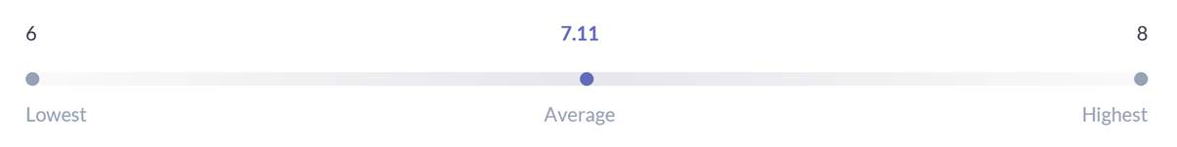
The report is designed to inform the Area Director of South Wales Bristol and Bath of improvements to implementation and the benefits this can bring. The area consists of 155 employees with 8 Area team Partners 7 of which have no fixed base (TSB, 2018).

Literature Review
The literature review sets out to critique existing research, investigating the implementation of flexible working policies and the benefits it can bring to an organisation.
In 2011 the Consultation on Modern Workplaces outlined examples of flexible working in the UK employers should offer their employees dependant on the business needs. They include but are not confined to “flexible working: Part-time, Flexi-time, Compressed hours, Homeworking, Annualised hours Term-time working, Structured time off in lieu, Job-sharing, Varied-hours working or time banking” (Department for business innovation and skills, 2011)

Organisational Benefits and Flexible Working
Over recent years flexible working has been a growing area of interest with an increasing number of organisations introducing flexible working arrangements for their employees, offering them a degree of control over where, when and how much work they do (Kersley et al. , 2005). TSB rated 4th in the Times best big companies to work for in 2018 has an established policy and framework to follow (Times, 2018) (TSB, 2017). For many organisations the incentive to offer flexible working arrangements has been for them to remain competitive within the labour market, helping them to recruit and retain a talented workforce (Croucher and Kelliher, 2005). It is also suggested that the most significant benefit of flexible working is increased employee engagement translating to increased productivity (Thomson, 2008).
Employers are recognising the importance of how employees feel about the organisation they work for and how they identify with the values, objectives and goals of the organisation (Schaufeli and Bakker, 2004). The Chartered Institute for Personnel and Development published a report describing engagement as a "passion for work" and employee engagement as individuals who are positive in the workplace and are prepared to go the extra mile to ensure they carry out their roles to the best of their ability (Truss et al. , 2006). Employee engagement is strong indicator of organisational performance (Trahant, 2007) and is also found relating to job satisfaction, organisational commitment (Schaufeli and Bakker, 2004) and job involvement (Brown, 1996).
Various studies have investigated a “business case” to support the implementation of flexible working. Advantages include improved overhead costs as a result of reduced office space requirements (Thomson, 2008) (Bloom, 2017), improved quality of performance (Dex et al. , 2001) and increased numerical and operational flexibility (Branine, 2003). However there is little evidence to examine the implementation of flexible working within the community banking sector, this paper is in response to that research gap and seeks to identify recommendations to support the evidence.

Potential Pitfalls of Flexible Working
There are several disadvantages of a flexible working arrangements dependant on its nature. Smith and Wedderburn (1998) have highlighted some potentially concerning factors linked to compressed working and the extended shift patterns: problems with communication, fatigue, isolation, impact of employees failing to cope with daily hours and continuity. Dex (2003), suggests that together; lean production and minimised staffing levels can be problematic, especially when combined with sickness and annual leave. Significant negative effects have been suggested when employees are cut off from frequent social interaction, for example, working from home, this may lead to both health and social problems (Lendfers and Nijhuis 1989).
Reasons Why Flexible Working is not always implemented
A businesses existing culture alongside senior leaders and line managers attitudes towards flexible working are significant factors in the breakdown of policy becoming practice in the workplace (CIPD, 2017), (HRMagazine, 2018). This is further supported in qualitative studies conducted by Working Families whereby both mothers and fathers would want to access flexible working options however they feel hostile working cultures and unsupportive managers are the two main barriers in not wanting to take this up (Working Families, 2017). The training received by line managers is often substandard and they are nervous of its implementation for fear of mass requests being received and the negative perceived impact this could have alongside getting it wrong through lack of communication of the organisations policy and process (Unison , 2014) (© Equality and Human Rights Commission, 2009).
Another critical factor in the lack of implementation of flexible working is the lack of awareness from employees of the existence and their rights to request this since the creation of the children and families act 2014 (House of Commons, 2018). There is also the perceived stigma that is still attached to requesting flexible working, with some employees reluctant to make requests due to fear of being overlooked for promotion opportunities, seen as not being as committed to the business as other employees and worried about the risk of losing their job. (House of Commons, 2018)

Methodology

This methodology will explore 3 key sources used to inform the recommendations in the report, including secondary quantitative and qualitative data.
“Quantitative data is the term given to data that can be counted and deals in variables that can be counted, measured, described and compared to other variables”.
“It would be almost impossible to investigate a HR problem without the use of quantitative data” (Anderson, 2008).
“Qualitative data can be broadly categorised as encompassing information in the form of language and words” (Anderson, 2008) and is normally sourced from observations, interviews and focus groups. Both methods are open to bias which can occur throughout the gathering, interpreting and publication process and require regular critiquing to ensure credibility. (Noble, 2018) (Galdas, 2017)
1) Go Ahead, Tell Your Boss You Are Working from Home | Nicholas Bloom | TEDxStanford (Bloom, 2017)
In a recent scientific study conducted by Nicholas Bloom and CTRIP he suggests that flexible working, particularly working from home can have significant benefits for a company, workforce and society as a whole. The study combines both quantitative and qualitative data collection methods over a two-year period sampled from a random control group of employees. The credibility of the work is supported by Nicholas Bloom who is currently a professor at Stanford University having won several prestigious prizes throughout his career and published 23 full papers. He attended UCL, Oxford and Cambridge where he achieved a BA, MPHIL and PHD respectively. CTRIP are Chinas largest travel company worth an estimated $20 Billion on the NASDAC stock market.
Qualitative data provided rationale and insight into reasons why outputs increase when employees have the option of working from home, these reasons include no commuting time leading to the ability to fulfil allocated hours and less distractions enabling maximum focus on required tasks. Limitations of this study may include subjective bias as there is no exploration of reasons why employees chose to return to the office rather than remain at home as well as the companies goal of needing to increase their workforce whilst reducing office space and the costs associated with this.
2) ADO Team Survey October 2018 – Appendix 1
This source uses both quantitative and qualitative data collection methods in a simple electronic survey otherwise known as methodological pluralism (Anderson, 2008). It is relevant in supporting understanding of how the area team currently feel about their work-life balance and ways this can be improved as it was conducted within the last two months. Given the lack of research into the role flexible working can play in Branch community banking directly it is key in understanding the current position within the team. The survey was sent out with direction to complete within a two-week time window with confirmation all submissions would be held in confidence and redacted as appropriate to avoid identification from the feedback. This supports greater accuracy in the quality of information collected however as there are only 7 participants care must be given to conscious bias in the qualitative feedback through concern of being identified.
The survey also set out with the goal of how the Area could work smarter leading the participant to feel they had to give a response with no option to state they were happy with the way we are working at present. Further understanding and insight would be required before this is acted on directly with full team involvement. The author of the survey works in a fixed location supporting the area team minimising potential bias in how the report is put together however it should be noted has no formal training or background in HR and data collection methods.
3) Meeting the changing needs of families, workers and employers in the 21st century. Equality and Human rights commission 2009 (© Equality and Human Rights Commission, 2009)
This report uses both quantitative and qualitative methodology with 4500 online participants taking part allowing for detailed sub sector analysis. The report also consults credible UK bodies including the CBI, CIPD, TUC and USDAW when concluding its recommendations on each topic and focuses in particular on new ways of working with comparisons to other EU countries. The report was commissioned in 2009 within the last 10 years making it relevant to todays working practices. The report provides a balanced viewpoint of recommendations examining what has worked successfully whilst at the same time is also critical of areas of failings from previous initiatives. The commission itself operates independently and was created through the equality act of 2006, it has also received the highest A status by the United Nations as a National Human Rights Institution.

Conclusions

1) Bloom acknowledges through his research that there is still a stigma that exists around working from home with several anecdotes around “working from home is shirking from home” and “working remotely is remotely working” (Bloom, 2017) however his scientific research approach to understand the benefits to remote working go some way to removing this stigma. He demonstrates through his study an initial 13% increase in outputs through a random sample of employees working from home increasing to 24% when rolled out to the whole company. The study found employees have a natural preference of where they work, and choice was key to maximising performance. The most efficient employees were those who worked a balance between the office and at home.
Fig 2 represents results from Nicolas Bloom and CTRIP working from home study.
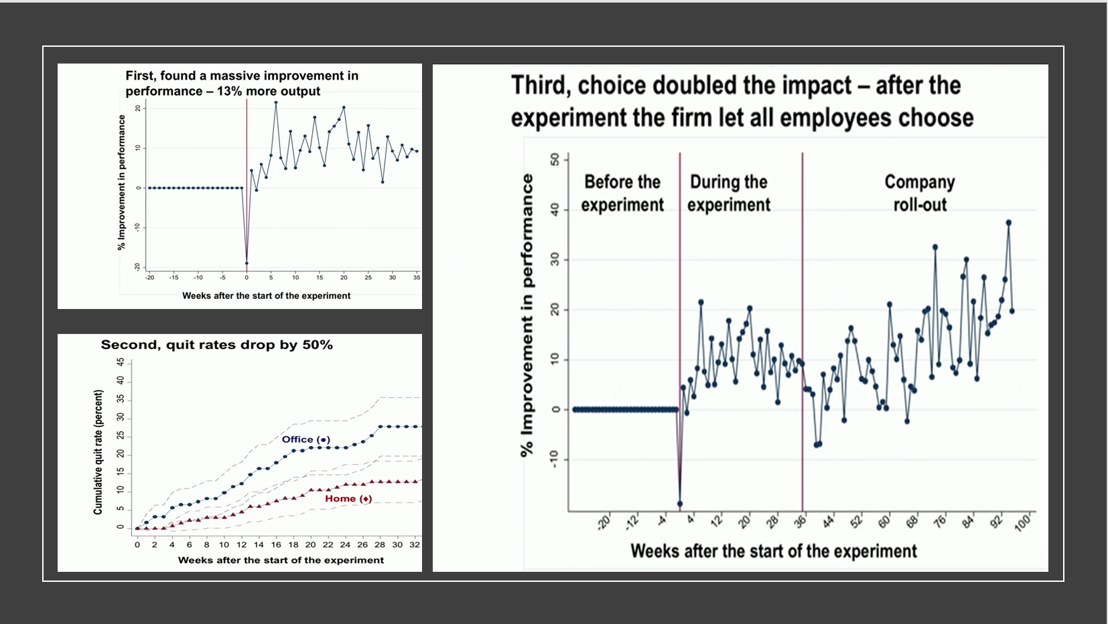

2) The internal survey of all ADO team members demonstrates that 46% of qualitative feedback around working smarter concerns the ability to work flexibly from home to avoid additional commuting time and improve work life balance. The quantitative feedback highlights an overall satisfaction of 7.11/10 for the current work life balance highlighting room for improvement within the team.

3) The report by the Equality and Human rights commission is set out into 5 chapters. Focusing specifically on chapter 4 and new ways of working the report specifies “Our evidence and consultations have highlighted the need for more consistent investment in management training. Over 80 percent of managers responsible for flexible workers have received no training in how to handle alternative working patterns” (© Equality and Human Rights Commission, 2009). This demonstrates the need for further support for line managers in how to approach flexible working and the benefits this can bring alongside mitigating some of the potential pitfalls, which in turn will encourage better conversations and an increase in appropriate working patterns being taken up.

Recommendations

From the research available and the current situation in South Wales Bristol and Bath the following recommendations are formed;

1) Proactively encourage a balanced approach to working from home and being present in branches to improve the work life balance of the team. From direct feedback in the ADO survey commuting time and being present in a branch is seen as the biggest factor to ensure we can work Smarter and improve work life balance. Choice in how this is implemented and frequency will be key and down to individuals preference to improve overall output. This will reduce overall costs through mileage expenses on a monthly basis.

2) TSB has a robust flexible working policy with guidelines to follow in its formal implementation however the current 5 day TSB management induction programme doesn’t include anything to inform managers about flexible working or its practical application. Currently the management induction programme runs over 4.5 days including an early release on the final day. It would be a recommendation of this report to build flexible working material into the programme explaining the process and the options available to allow the appropriate level of support for all employees. We currently partner with Blue Sky an external training company who currently design and deliver training material based on TSB values and policies. The estimated cost for research, design, new material and delivery to the existing training team is £13,600. This will be a one off initial cost as once built can be added into the existing course structure.

References
© Equality and Human Rights Commission, 2009. Meeting the changing needs of families, workers and employers in the 21st century, UK: Equalityand Human rights act.
ACAS, 2014. ACAS. [Online]
Available at: http://www.acas.org.uk/index.aspx?articleid=1616
[Accessed 18 October 2018].
Anderson, V., 2008. Research Methods in Human Resource Management. London: CIPD.
Bloom, N., 2017. Tedtalk Stanfordx You Tube. [Online]
Available at: https://www.youtube.com/watch?v=oiUyyZPIHyY
[Accessed 11 October 2018].
Branine, M. (2003), "Part-time work and job sharing in health care: is the NHS a family-friendly employer?", Journal of Health Organization and Management, Vol. 17 No. 1, pp. 53-68.
Brown, S.P. (1996), "A meta-analysis and review of organizational research on job involvement", Psychological Bulletin, Vol. 120, pp. 235-55.
CIPD, 2017. CIPD Flexible Working. [Online]
Available at: https://www.cipd.co.uk/knowledge/fundamentals/relations/flexible-working/factsheet
[Accessed 18 October 2018].
Croucher, R. and Kelliher, C. (2005), "The right to request flexible working in Britain: the law and organizational realities", European Journal of Comparative Law and Industrial Relations, Vol. 21 No. 3, pp. 503-29.
Department for business inovation and skills, 2011. Consultation on Modern Workplaces, London: UK Government.
Dex, S. (2003), "Flexible (or family friendly) work arrangements in the UK. Are they a good thing?", Centre for Longitudinal Studies, Institute of Education, London University, London and Judge Institute of Management, University of Cambridge
Galdas, P., 2017. Revisiting Bias in Qualitative Research. [Online]
Available at: http://journals.sagepub.com/doi/full/10.1177/1609406917748992
[Accessed 24 October 2018].
Gov.uk, n.d. Flexible Working. [Online]
Available at: https://www.gov.uk/flexible-working
[Accessed 18 10 2018].
House of Commons, 2018. Flexible Working, London UK: BRIEFING PAPER Number 01086, 3 October 2018 .
HRMagazine, 2018. Lessons on flexible working. Working Families’ National Work Life Week Conference 2018, HR Magazine.
Kersley, B., Alpin, C., Forth, J., Bryson, A., Bewley, H., Dix, G. and Oxenbridge, S. (2005), "Inside the workplace: first findings from the 2004 workplace employment relations survey (WERS 2004)", Routledge, London.
Lendfers, M. L. H. G. and Nijhuis, F. J. N. (1989). Flexibilisering van de arbeid en gezondheidseffecten (Health consequences of flexibilisation of work), OSA Report, Working document no. W66, The Hague.
Noble, H., 2018. Issues of validity and reliability in qualitative research. British Medical Journal, 18(2), pp. 1,2.
Schaufeli, W.B. and Bakker, A.B. (2004), "Job demands, job resources, and their relationship with burnout and engagement: a multi-sample study", Journal of Organizational Behavior, Vol. 25 No. 3, pp. 293-315.
Smith, J. L., Bodey, S. & Wilson, J., 2016. Flexible and Family Friendly Working in the Banking and Finance Sector. UK: Hydrogen.
Smith, P.A. and Wedderburn, A.I. (1998), "Flexibility and long shifts", Employee Relations, Vol. 20 No. 5, pp. 483-9.
The Guardian, 2017. Time to embrace flexible working. [Online]
Available at: https://jobs.theguardian.com/article/why-now-s-the-time-to-embrace-flexible-working/
[Accessed 19 October 2018].
Thomson, P. (2008), "The business benefits of flexible working", Strategic HR Review, Vol. 7 No. 2, pp. 17-22.
Times, T., 2018. The Times Best Companies. [Online]
Available at: https://www.b.co.uk/company-profile/?tsb-bank-99893
[Accessed 23 October 2018].
Trahant, B. (2007), "Debunking five myths concerning employee engagement", Public Manager, Vol. 36 No. 1, pp. 53-9.
TSB, 2017. TSB Internal flexible working policy. London: TSB.
TSB, 2018. Monhly People Pack. Brsitol: TSB HR Dept.
Unison , 2014. Flexible Working making it work Guideline. London: Unison.
Working Families, 2017. The Modern Family Index 2017, England: Working Families.

Results ADO Team Survey – October 2018
Question: How do you think we can work smarter as an ADO Team?

Can we work smarter with our hours - why travel during the busiest times to get to branches - go in later or leave earlier?
Support flexible working where applicable to improve work life balance. We spend a lot of time traveling between branches given our geography. Do we always have to be in a branch?

Be more open to flexible working - there is sometimes too much focus on what others think rather than what is right for the business and the individual e.g. working from home, leaving a branch early when you have been on the road since 5am, changing working patterns etc

Consider the 3-week month approach used in Telephony

Set a time to plan as an ADO team - including getting area meetings in the diary to ensure not too many happen in same week. Do we know when the MA meeting is? Do we know when the development programme meetings are?

Review distribution of work to understand who can support and when others have capacity.

The Monday meeting always feels like in a rush and inconvenient to talk about branch visits. Can we agree what we do want to discuss.
Plan time in to plan, balancing where this is done does it have to be a branch?

Rearrange working days to improve travel times where appropriate.

Align discussion topics with our key priorities

Consider do we set time aside for personal development
Look at timings on a Monday to start earlier reducing travel time.
Have a planning meeting to review progress made in 2018 and look at priorities for 2019.

Question: How engaged do you think our area partners currently are?
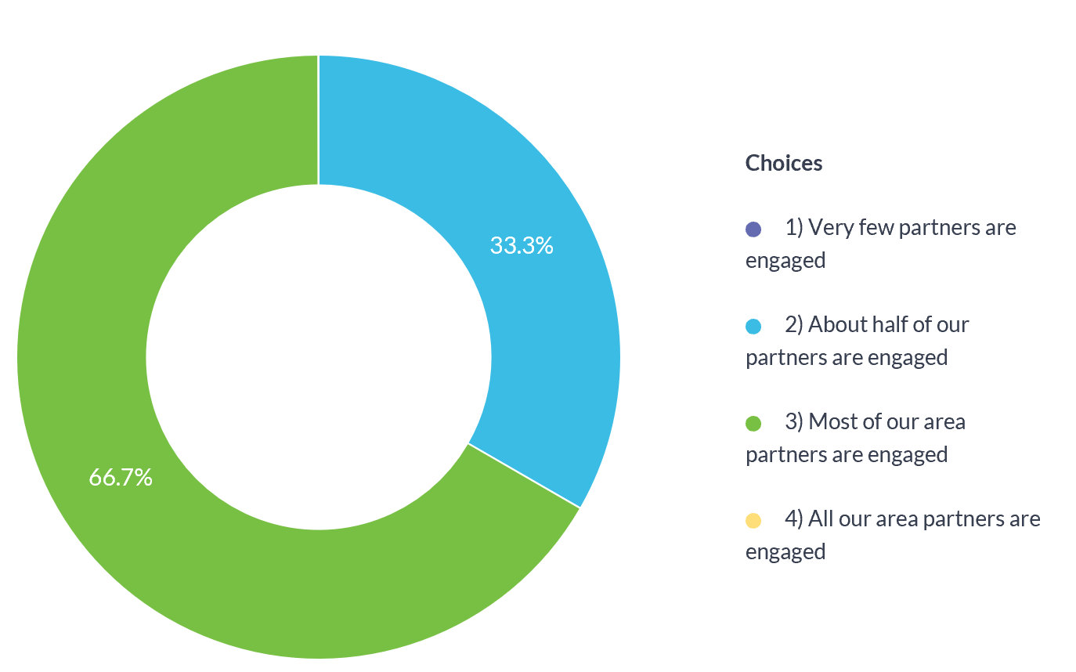

- Question: On a scale of 1 to 10 (1 being poor and 10 excellent) - how would you rate your current work-life balance?

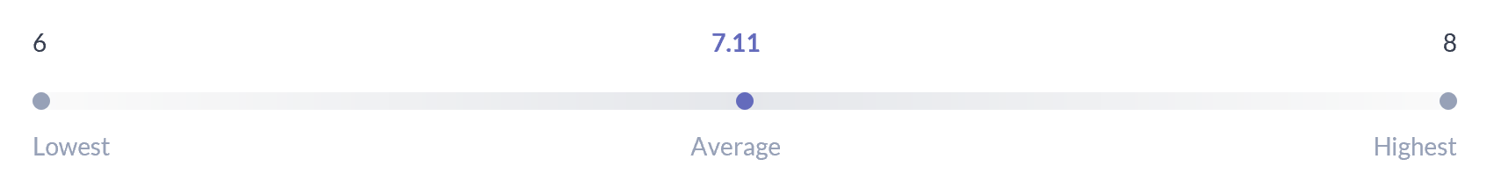

Question: How do you think we can improve communication within the area? (including communications with all area partners, communications with BMs/LMs and communication within the ADO Team)
Promote the use of Yammer further to highlight what is happening in the Area and what is going well. We need to ensure we are regularly promoting good news stories and sending in as an ADO team. Whats App can also have positive news added to it.

Be more consistent and rigorous in testing the understanding of partners whilst attending branches
Think we have a good level
Use of Yammer can be better. Why don't we recognise Partners on Yammer and give updates on what we have done that week and what we have seen.
I am not sure the Wednesday afternoon call is working 100% but not sure it can be perfect.
BM/LM – We give out too many messages at times and perhaps if it is a download of information If we have to communicate something that needs a sign back could we use this type of survey to do that so it makes it easier to track.

Wednesday call works really well for a mid-week catch up to share messages/news - we often rush this on a Monday.
BMs and LMs to be closer to email use and be part of 121/BRM to ensure this is managed more effectively, too many partners do not make time for managing their emails. Development hour weekly allow time to read and update on communications.
We have tried and used many forms of communication but it still isn't hitting the mark with our partners - they are still not accessing and using e-mails, Yammer etc frequently. We've asked for feedback and input on how we can improve communications but it isn't always forthcoming. Could look more at best practice from other areas on how they have increased partner engagement.

When ADO team sending emails to branches - not everyone is copied in and sometimes messages are missed- can we ensure all relevant people are included. Easy enough to delete an email if do not want to keep it.

ADO team - How do we make sure everyone gets the same messages? It can often be by chance at the moment if we catch up with people during the week.
Use of the Area Yammer group - ADO to update what seen on branch visits/workshops - Use the Praise tool
Vary the format we use to keep things fresh - for instance we could have an audio newsletter once a quarter or using show me to share with everyone?
More effective use of the Topical Board and One Note

