
PROGRAMME: MBA - MASTER OF BUSINESS
ADMINISTRATION
MODULE: STRATEGIC MANAGEMENT
MODULE CODE: LCMB7003
ASSIGNMENT TITLE: STRATEGIC MANAGEMENT
REPORT

TASK 2
Name : Samir Siddiqui
Student : 2322090

Table of Contents Introduction ................................................................................................................................ 3
Challenges of arrangements ....................................................................................................... 3
Opportunities of arrangements ................................................................................................... 5
The concept of virtual management is practiced within an organisation Like Amazon ............ 6
Conclusion ................................................................................................................................. 8
References .................................................................................................................................. 9

Introduction
Globalization reflects a tremendous change in making communications in between groups or people through electronic communication system (Ayalew and Ayenew, 2022). This communication is defined as virtual organisation where groups, people and employees work with electronic connection system and connect remotely from different location within a single unit. This specific discussion will focus on the concept of the emergence of “Virtual Organisations” and how the concept of virtual management is practiced within an organisation”. This will critically evaluate the concept of virtual organisation and will also reflect the different practices of Virtual arrangements in a chosen company Amazon.

Challenges of arrangements

Communication barriers
In virtual management, face to ace communication is not done properly which may be the reason of lots of interaction issues, misunderstanding the job roles and responsibilities. Only verbal communication may cause the reason of ineffective virtual communication system which can impact the performance of an organisation. On the other hand, gathering real time feedbacks and providing assurance that accepting accurately through effective understand can be more challenging in this virtual management or practices in a virtual organisation (Bagga et al., 2023). Therefore, it can be said that communication barrier can act as a great challenge in maintaining virtual communication system in an organisation. In this case, using digital technologies and advanced technologies and machines has played an effective role for making workforce active.

Team cohesion and culture
Developing strong and effective interpersonal relationship in between employees or working people in an organisation can not be done properly or effectively due to the virtual communication system. Different types of electronic devices like computers, phones, software and advanced technologies are playing command able role for creating strong connection and establishing strong communication by which organisation can easily improve its business performance and competitive advantages in the global business market (Garro-Abarca et al., 2021). Virtual communication practices only also employees or workers to establish communications through using digital technologies or other communication devices like emails, massages, video calls, chats and telecommunications (Adamovic et al., 2022). These are not enough to develop a strong relationship or warm relationship with different team members. This can be the reason for having difficulties to have high levels of employee engagements and motivate employees to provide best performances towards organisational development or performances.

Performance management
Tracking productivity and track the performance of employee can be more complicated and challenging in this matter. Managers struggle to track performance of employees in their working hours and also face issues to monitor the working times during because of remote work facilities (Chamakiotis et al., 2021). This is the reason for facing difficulties to ensure to fulfil the target by employees during their work periods. Ensuring accountability needs effective virtual setting and clear expectations that is almost impossible through the virtual connection or practices in business system.

Technology dependency
Virtual management is impossible without having strong technological base in an organisation. Virtual management highly relies on machines those are used for establishing strong communication and connection in between employees and group of people of an organisation. sometimes, technical issues like internet interruptions, machine failures, website traffics and many more can e the cause for impacting communication system (Lee, 2021). Therefore, it can be said that technical disruption can impacts the organisational operations. on the other hand, virtual communication can be the reason for impacting security or data privacy because there are lots of data are shared by people through internet. This can be leads the cyber threat issues. Time zones and coordination
Different countries have different times and operation times. Which reflects different time of meetings and schedules. Collaborative working system and coordinating meetings of work across the world and different time zone can lead to the issues of delay in deliver ultimate project or completing tasks within times (Asatiani et al., 2021). On the other hand, choosing suitable times for making communications or interactions with employees become more difficult when team members spread across different time zones and be the reason for impacting real communication and collaboration system. Therefore, it can be said that virtual management has great negative impacts on team collaboration system.

Opportunities of arrangements
Access to global talents
Virtual management open new opportunities for searching global talents through effective recruitments system through online system. Virtual organisations are able to involve global talents from different countries which can be the reason for enhancing innovation and creativity at the same time (Wood et al., 2024). This also helps to access global talents, expertise and skills those are not available locally. This helps to involve different specialists from different regions that are the reason for enhancing the organisational competitiveness. Therefore, it can be said that virtual organisations are capable to access global talents and enhance competitive advantages in global market. From different geographical locations organisations are able to doing operations and developing a strong connectivity with other stakeholders through virtual practices.

Cost savings
Virtual organisations are using advanced technologies and machines which can help organisations to save the cost of operations. This helps to decrease the cost of operations and helps organisations to be more improved and developed in the global business market (Hirudayaraj and Matić, 2021). A virtual organisation is capable to operate remotely without having a fixed location. In this modern age, organisations are capable to establish a strong connections and communication with different channels with lots of digital technologies and electronics (Anthony Jnr and Noel, 2021). This also utilizes spaces and physical resources. Organisations can do operation with more flexibilities and potentiality which enhance the efficiencies and reduce the cost of travelling to different regions with more facilities of work process. Therefore, it can be said that virtual organisation is capable to have more cost saving options for better or future development opportunities.

Increased flexibility
Virtual organisation is capable to improve flexibility in the business system. Remote work is capable to improve work life balance which helps to improve potentiality to improve work satisfactions (Rahimi et al., 2022). This helps to motivate employees by which they can perform effectively and productivity in the work field. Employee retentions also can be more effective and easier at the same time. Virtual management helps to engage changes that are necessary for gaining most positive outcomes towards organisational development. On the other hand, this reduces the human errors which helps to increase productivity of the workplace and flexibility in operations.

Enhanced productivity
Improving focus on different job roles and responsibility can be possible through the help of virtual management system. Employees can think creatively and make workplace more productivity with enhancing workplace flexibility during the remote work facilities (Mavri et al., 2021). Office distraction can be reduced through the help of virtual management system which also helps to improve productivity is the workplace in the business development process. On the other hand, virtual environment is capable to foster innovation in working style which encourages employees by which they can easily improve the operations and reaching organisational objectives through different experimental experiments and work flows.

Sustainability
Virtual operations or management is more effective to reduce environmental impacts. The uses of advanced technologies like AI, computers, electronic communication reduces the uses of transportation system, using harmful elements to complete tasks and many more (Ayalew and Ayenew, 2022). This decreases the level of carbon emission which helps to improve positive elements in environment. On the other hand, virtual organisations are the reason for involving and accessing foreign talents which provide job opportunities to people from different region which isa also helps to develop the society (Anthony Jnr and Noel, 2021). This all are most important to have sustainable performance to organisations operating in global business market.

The concept of virtual management is practiced within an organisation Like Amazon

Global workforce coordination
Virtual organisation has played an effective role for understanding the future of business in the global business market. after facing huge communication gaps and business development issues at the time of Covid-19 pandemic situation through all over the world, organisations are focusing to continue their operations by using remote working system (Newman and Ford, 2021). Amazon is one of the global companies that are recruiting global talents with effective recruitments policies. Amazon has searched for best talents through virtual management system and involve most talented and skilled people from different corners of the world. This multinational company allows diverse culture in the organisation where different people from different cultural background can operate easily and provide best effort for accomplishing tasks that are delivered by Amazon towards development (Rikap, 2023). Therefore, it can be said that Amazon is able to improve its performance through global workforce coordination.

Technology integration
Creating strong reputation ion international market, increasing competitiveness, enhancing brand awareness, improving product performance, developing workplace environment and many more can be possible through virtual practices in this present and advanced age. Amazon has levered different digital tools and technologies to improve collaborations a communication with its employees or work force (Fuchs et al., 2022). Communication system in this multinational company is more effective which is the reason for having effective engagement of employees in the business development system. By including project management performance, video conferencing and real time massaging system, employees are able to make effective communication and maintain effective culture in the workplace. AWS is the Amazon own web service which is also used by its employees to have strong communication and collaboration system that offering reliable and scalable cloud computing services which supports remote work effectively (Wittig and Wittig, 2023).

Performance management
Data driven metrics is one of the best and effective methods that is used by Amazon for making workplace more productive. The Data Driven matric is able to help the Amazon for monitoring or tracking the performance of employees through KPIs (Rikap, 2023). On the other hand, using data analytics Amazon is capable to analyse the progress and development of each and every performance of employees in the working hours. Amazon is also able to review the feedbacks which helps to addressing issues those are faced by employees during their performance or working style.

Team and cultural engagement
Amazon is the reputed organisation which aiming to improve its employee performance by providing effective training to its employees. Newly joined employees through different regions are capable to take opportunities of effective training through the help of virtual training by its expert teams. This helps to understand the needs of development which allows management of Amazon to take effective steps towards development. Amazon has used virtual team building activities by which each and every employee of this multinational organisation is capable to gain opportunities to improve their skills, expertise and development through virtual activities (Ramaswamy and Narayanan, 2022). Therefore, it can be said that Amazon is success to have effective team and engaging diverse culture in business development system.

Security and compliance
Enhancing security and compliance is very much important to reduce the level of risks or security challenges in the business development plan. Multinational ecommerce companies like Amazon are capable to build effective security system through developing digital technological base (Williamson et al., 2022). The uses of cloud computing system is the reason for improving security compliance in the business operations every data and details of employees and customers are highly secured with its strong authentication system by which Amazon is capable to enhance employee satisfactions and customer purchasing experiences at the same time.

Conclusion
The entire discussion of this concept reflects the negative and positive impacts of virtual management and different practices. Virtual organisations are gaining both positive and negative impacts by which global companies are gaining opportunities to analyse the issues and engage effective strategies and changes in the business system which are necessary and important towards organisational development. Amazon is one of the best and reputed multination or global organisations that is practicing virtual management for having most positive outcomes and enhancing the competitive advantages in the global business market. However, in conclude it can be said that appropriate uses of virtual practices may help organisation to have more advanced and positive outcomes and improve its performance and competitive advantages towards more bright future.

References
Adamovic, M., Gahan, P., Olsen, J., Gulyas, A., Shallcross, D. and Mendoza, A., 2022. Exploring the adoption of virtual work: the role of virtual work self-efficacy and virtual work climate. The International Journal of Human Resource Management, 33(17), pp.3492-3525.
Anthony Jnr, B. and Noel, S., 2021. Examining the adoption of emergency remote teaching and virtual learning during and after COVID-19 pandemic. International Journal of Educational Management, 35(6), pp.1136-1150.
Asatiani, A., Hämäläinen, J., Penttinen, E. and Rossi, M., 2021. Constructing continuity across the organisational culture boundary in a highly virtual work environment. Information systems journal, 31(1), pp.62-93.
Ayalew, M. and Ayenew, Z., 2022. Do paradoxical virtual leadership and emotional intelligence have relationships? In particular from technology dependence, geographical dispersion, and human capital tensions. International Journal of Organizational Leadership, 11(1), pp.1-25.
Bagga, S.K., Gera, S. and Haque, S.N., 2023. The mediating role of organizational culture: Transformational leadership and change management in virtual teams. Asia Pacific Management Review, 28(2), pp.120-131.
Chamakiotis, P., Panteli, N. and Davison, R.M., 2021. Reimagining e-leadership for reconfigured virtual teams due to Covid-19. International Journal of Information Management, 60, p.102381.
Fuchs, M., Dannenberg, P. and Wiedemann, C., 2022. Big tech and labour resistance at Amazon. Science as Culture, 31(1), pp.29-43.
Garro-Abarca, V., Palos-Sanchez, P. and Aguayo-Camacho, M., 2021. Virtual teams in times of pandemic: Factors that influence performance. Frontiers in psychology, 12, p.624637.
Hirudayaraj, M. and Matić, J., 2021. Leveraging human resource development practice to enhance organizational creativity: A multilevel conceptual model. Human Resource Development Review, 20(2), pp.172-206.
Lee, M.R., 2021. Leading virtual project teams: Adapting leadership theories and communications techniques to 21st century organizations. Auerbach Publications.
Mavri, A., Ioannou, A. and Loizides, F., 2021. Cross-organisational communities of practice: enhancing creativity and epistemic cognition in higher education. The Internet and Higher Education, 49, p.100792.
Newman, S.A. and Ford, R.C., 2021. Five steps to leading your team in the virtual COVID-19 workplace. Organizational Dynamics, 50(1), p.100802.
Rahimi, S., Khorasani, A., Rezaeizadeh, M. and Waterworth, J., 2022. The virtual human resource development (VHRD) approach: an integrative literature review. European Journal of Training and Development, 46(5/6), pp.484-503.
Ramaswamy, V. and Narayanan, K., 2022. Into the eXperience-verse: the strategic frontier of cloud business innovation and value co-creation. Strategy & Leadership, 50(5), pp.25-31.
Rikap, C., 2023. Same end by different means: Google, Amazon, Microsoft and Facebook's strategies to dominate artificial intelligence. Amazon, Microsoft and Facebook's Strategies to Dominate Artificial Intelligence.
Williamson, B., Gulson, K.N., Perrotta, C. and Witzenberger, K., 2022. Amazon and the new global connective architectures of education governance. Harvard Educational Review, 92(2), pp.231-256.
Wittig, A. and Wittig, M., 2023. Amazon Web Services in Action: An in-depth guide to AWS.
Simon and Schuster.
Wood, J.M., Zeffane, R.M., Fromholtz, M., Wiesner, R., Morrison, R.R., Factor, A. and McKeown, T., 2024. Organisational Behaviour Core Concepts & Applications. John Wiley & Sons.

Appendix

Title
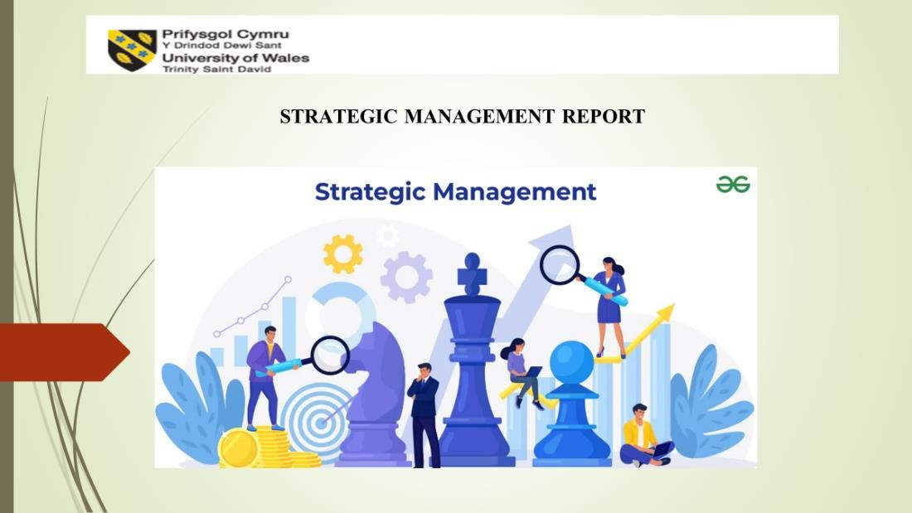

Importance of human capital
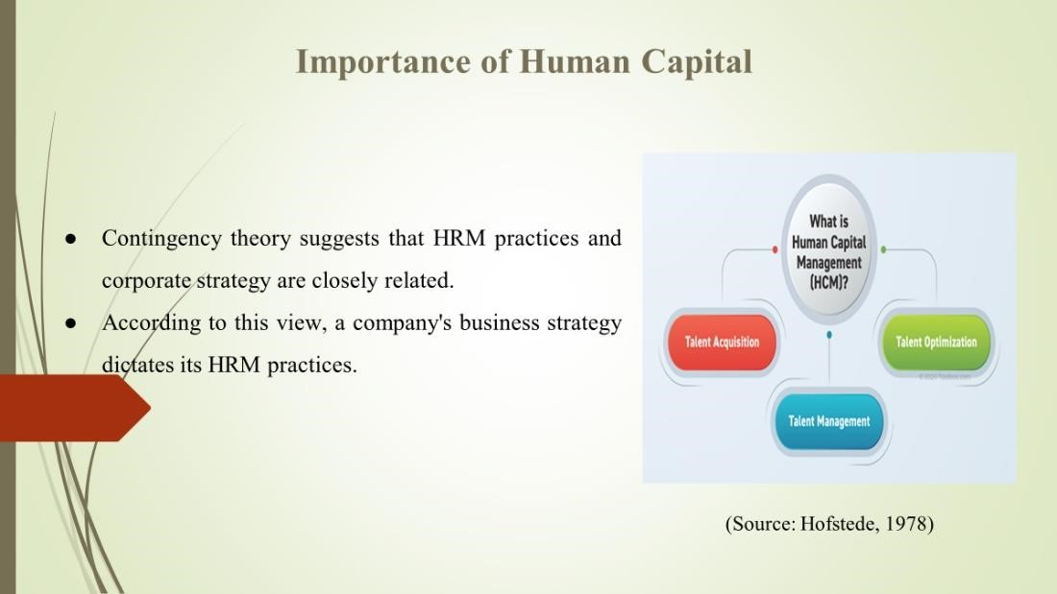
There has been a lot of research done on the connections between HRM strategy and competitive strategy so far. On the other hand, from a control viewpoint, one significantly absent area is the relationship between HRM control and company strategy and the method it affects performance.

HRM system
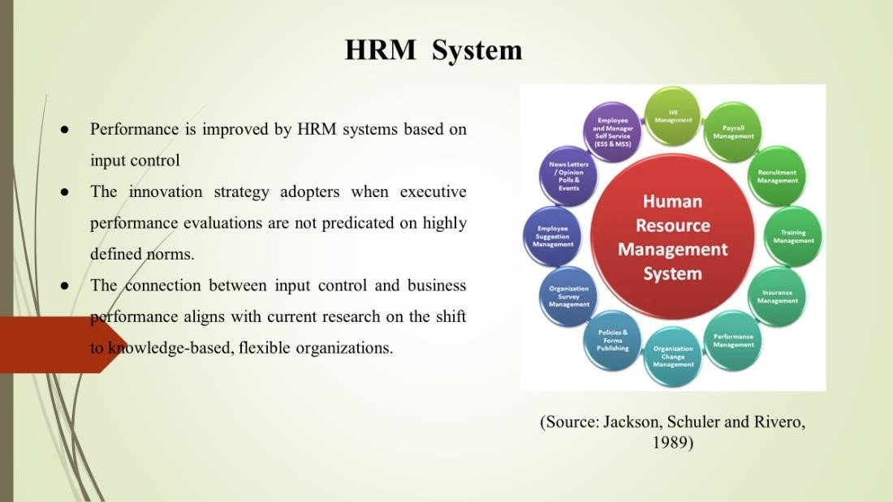

The relationship between input control and innovation-focused corporate strategy increased its beneficial effects. In order to be able to adapt to the quick changes in the market and advances in technology, these organizations want their employees to be creative, collaborative, capable of pursuing long-term goals, ready to take chances, and able to effectively manage ambiguity and uncertainty.

Summary

Introduction
Strong cost-reduction and behaviour strategy worked together to provide the lowest expected value of the dependant variable and the highest performance level. The goals of a business-level strategy are to increase customer value and gain a competitive edge in specific product markets by using critical competencies. As a result, a company's business-level strategy reveals its understanding of the advantages it has over competitors. A company's position in the market in relation to its competitors is taken into consideration by business strategy. Thus, companies in favourable circumstances can have an advantage of competition in the same sector. The attention to formal HRM procedures including hiring, training, performance reviews, and incentives was limited by the control focus. The study integrated specific HRM practices into control systems as opposed to looking at them separately.

Discussion
Input, output, and behaviour control are the three categories of control systems that can be created by combining these HRM methods. When a significant portion of the residual variance in the dependent variable is explained by the set of interaction factors, there is evidence of moderation (Liao, 2005). The estimated value of performance was highest when high behavioural management and high cost-reduction strategy were combined, while the expected value of the dependent variable was lowest when low behaviour control and low cost-reduction approach were combined. Companies that place a high priority on innovation need to be prepared to react quickly to shifts in the market and advances in technology. Workers need to be able to think creatively and strategically, collaborate well with others, focus on long-term objectives, carefully consider the amount and quality of products and services provided, take calculated risks, and handle uncertainty and unpredictability in the workplace (Alsafadi and Altahat, 2021). Executives are not required to describe the precise behavioural sequences that employees must follow in situations when causeand-effect knowledge is lacking to expect behaviours that are in the best interests of the company. Similarly, in the absence of rigid performance criteria, executives can use input control to guarantee that people behave appropriately and independently. According to enough time without having to specify the specific criteria by which they are to be judged.
Companies that employ a quality enhancement strategy must continuously raise the calibre of their output, necessitating regular adjustments to the manufacturing procedure. In order to provide a higher level of quality than other products or services, this method necessitates a high level of personnel engagement. When output control is used, results information is often easily accessible, allowing subordinates to get a lot of operational data and make changes without initially communicating with superiors (Hofstede, 1978 and Ouchi, 1978). A unmarried, highly wanted performance outcome with a crystalline standard as its aim is based on the concept of a unidimensional utility function.
The behaviour control measure of six Likert items assessed the extent to which policies and guidelines are dictated from above, how well subordinates' behaviour is observed and monitored, how performance is evaluated through progress over time, and how often feedback is given. This scale had a coefficient of 0.82. A twelve-item Likert scale assessed output control, gauging how much performance is determined by outcomes, how assessments are predicated on predetermined goals, and how incentives are connected to output. This scale had a coefficient of 0.73 (Liao, 2005). Using a seven-item Likert scale, input control assessed how much importance was given to staffing practices as well as the availability of opportunities for training and growth.
This study examined the connection between business strategy, HRM practices, and overall firm success. The results demonstrate multiple relationships between company performances. While some of these demonstrate the existence of many contingency linkages, others point to a direct relationship between HRM and performance. The notions of behaviour, output, and input control don't seem to conflict with one another, but they do offer a suitable foundation for incorporating HRM as a whole into theories of organization (Collins, 2022). Considering their respective advantages and disadvantages, a mix of the three may enhance the performance of the company as a whole. Therefore, adopting the conclusion that there are effective, comprehensive, or bestpractice approaches to HRM is inaccurate.
A combination with an innovation-focused corporate strategy, yet increased the beneficial effects of input control. The study's findings corroborate these ideas. Performance is positively impacted by HRM systems based on input control, especially for innovation strategy adopters when executive performance evaluations are not predicated on highly defined norms. Employees at these companies need to be creative, collaborative, risk-takers, able to pursue long-term goals, comfortable with ambiguity and uncertainty, and ready to adapt to the rapidly changing market and advances in technology. The connection between input control and business performance aligns with current research on the change to knowledge-based, flexible organizations.
Business strategies discuss how a company compares to its competitors in the market. Therefore, companies in favourable circumstances might have an advantage over rivals in the same industry (Liao, 2005). In terms of business strategy kinds, there were three categories: prospector, analyst, and defender. They divided strategies into three general categories: focus, distinctiveness, and cost leadership. The three categories they chose to categorize corporate strategy were cost-reduction, innovation, and quality enhancement. These labels were marginally different from Porter's. Academics have widely used the method developed by Schuler and Jackson; this study has also used their classification scheme for further examination.

Conclusion
Contingency theory states that for HRM practices to improve organisational performance, particular business strategies must be paired with them. Businesses employing a cost-reduction strategy need to strictly monitor and cut costs, as well as aim for larger economies of scale. Behaviour control, which involves direct supervision, behavioural performance evaluation, standard operating procedures, and feedback among other by establishing a routine for the transformation process, HRM practices encourage predictability. This approach to HRM concentrates on matters like efficiency and dependability by trying to control behaviour. Moreover, a disconnected collection of employment procedures, HRM has developed throughout time.

References
Alsafadi, Y. and Altahat, S., 2021. Human resource management practices and employee performance: the role of job satisfaction. The Journal of Asian Finance, Economics and Business, 8(1), pp.519-529.
Collins, C.J., 2022. Expanding the resource based view model of strategic human resource management. In Strategic Human Resource Management and Organizational Effectiveness (pp. 107-134). Routledge.
Hofstede, G. 1978. "The poverty of management control philosophy", Academy of Management Review, pp. 450-61.
Jackson, S.E, Schuler, R.S. and Rivero, J.C. (1989), "Organizational characteristics as predictors of personnel practices", Personnel Psychology, Vol. 46, pp. 569-92.
Liao, Y.S., 2005. Business strategy and performance: The role of human resource management control. Personnel Review, 34(3), pp.294-309.
Snell, S.A. and Youndt, M.A. (1995), "Human resource management and firm performance: testing a contingency model of executive controls", Journal of Management, Vol. 21 No. 4, pp.
711-37.

Name : Samir Siddiqui
Student : 2322090

Precis
Business strategy and performance: the role of human resource management control by Yao-Sheng Liao is used for this presentation. Business executives understand that the HR department is aligned with corporate objectives that affect financial performance. Organizational effectiveness is determined by the efficient management of human capital. Since the beginning of the SHRM era decades ago, researchers have developed a larger perspective focused on managing the workforce as an entire system. Strategies are merely tools to achieve a goal. It also makes the assumption that companies that closely match their HRM practices to their business strategy outperform those that do not. Contingency theory suggests that HRM practices and corporate strategy are closely related. According to this view, a company's business strategy dictates its HRM practices. There has been a lot of research done on the connections between HRM strategy and competitive strategy so far. On the other hand, from a control viewpoint, one significantly absent area is the relationship between HRM control and company strategy and the method it affects performance.
The focus of SHRM research has shifted to firm-level challenges in people management. It is assumed that the goal of different HRM procedures is to elicit and regulate the attitudes and behaviours of employees. In terms of the role behaviours that are thought to be necessary for various strategies, this theory is rather detailed. It focuses on the kinds of HRM techniques that work well to generate these role behaviours. The behavioural approach assumes that strategies result in HRM practices that elicit employee role behaviours, which affect and lead to a variety of outcomes that are positive for the company.
Behaviour control has a notably favourable impact on performance. A behaviour-control-based HRM control system would improve a company's performance According to agency theory, output control may provide workers greater freedom to use their judgment and be innovative. However, output control makes subordinates assume greater business risk; as a result, they usually choose safe paths of action and focus on short-term goals. It seems that no company in Taiwan competes only based on quality; rather it uses reducing expenses, quality-enhancement, or innovation strategies to improve its competitive status. The study's findings indicate that quality is emphasized by all businesses, suggesting that quality is a common corporate priority. It is not unexpected that companies cannot achieve greater performance with matching HRM orientation.
Performance is improved by HRM systems based on input control. The innovation strategy adopters when executive performance evaluations are not predicated on highly defined norms. The connection between input control and business performance aligns with current research on the shift to knowledge-based, flexible organizations. The relationship between input control and innovation-focused corporate strategy increased its beneficial effects. In order to be able to adapt to the quick changes in the market and advances in technology, these organizations want their employees to be creative, collaborative, capable of pursuing long-term goals, ready to take chances, and able to effectively manage ambiguity and uncertainty.

