BSc (Hons) Health and Social Care

BMHP5015 Changemakers: Building your Personal Brand for Sustainable Employment

Component 1: Online portfolio
Student Name: Cristina Apostol
Student code: 2335890
Lecturer name: Caroline Salami
Table of Contents

Introduction 3
Week 1: 3
Week 2: 6
Week 3: 9
Week 4: 12
Conclusion 15
References 16

Introduction
The professional identity within the healthcare sector is considered as a dynamic construct which requires continuous self-evolution and alignment with industry standards (Weber et al., 2024). This portfolio can serve as a comprehensive record. By documenting a series of proactive activities the following sections demonstrate a reflective approach to develop employability skills for the health and social care sector.

Week 1:
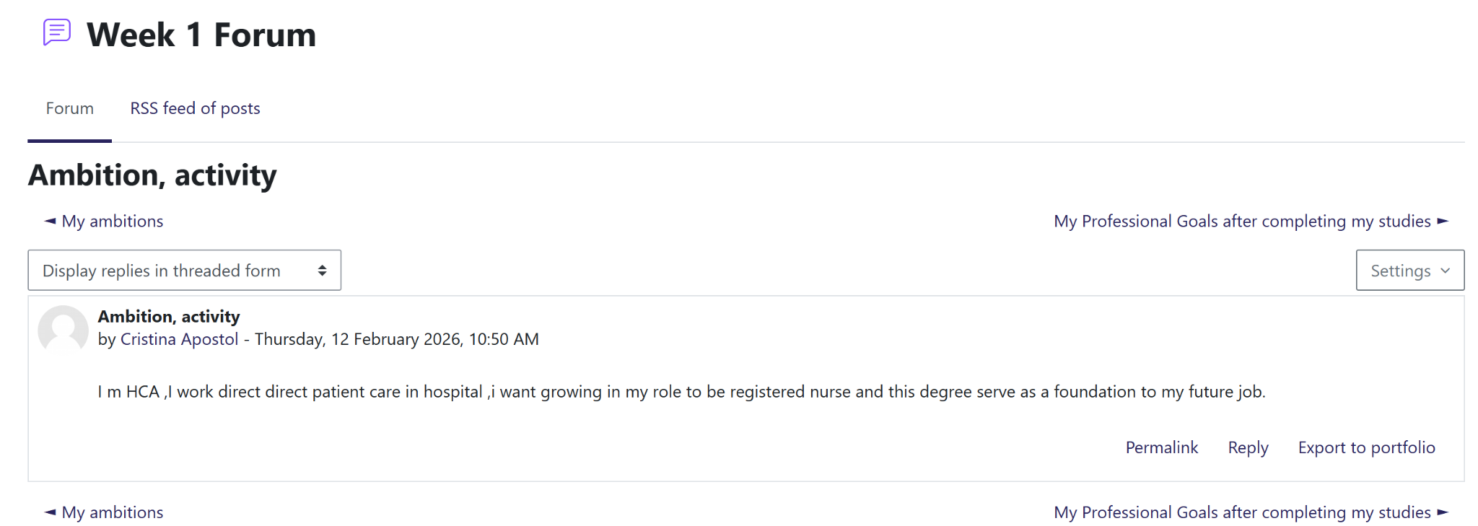
Ambition
The initial forum activity has encouraged me to define my professional ambition within the hospital setting. My current experience as a Health Care Assistant (HCA) providing direct patient care will serve as a practical foundation for future progression. The ambition of transition into the role of a Registered Nurse, this degree is the critical step which is well aligned with the personal employability skills and professional requirements within the nursing field (Nasser, 2024). By reflecting on this goal I can see how my current hands on experience can directly inform the professional identity I am building.
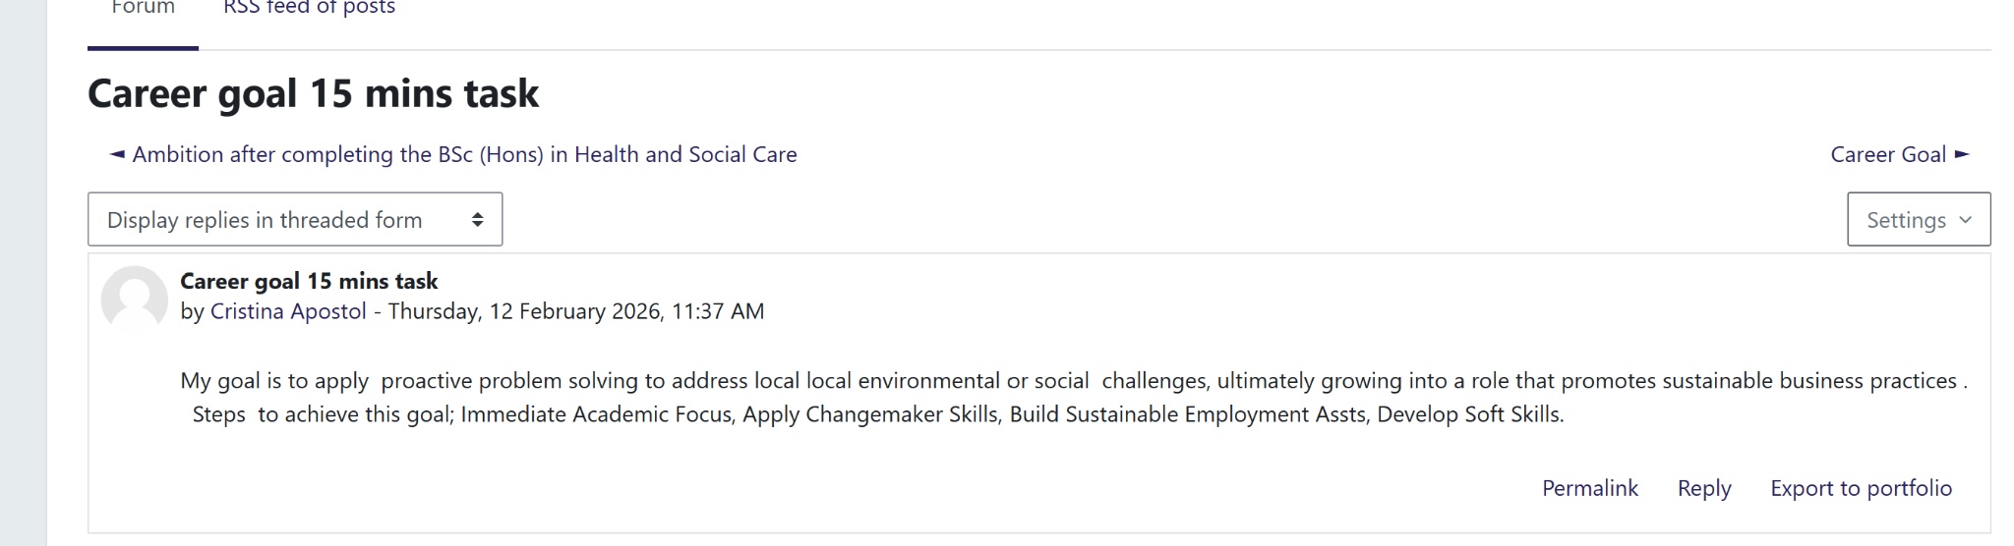
Career goal
The “Career goal 15 minutes task” was focused on understanding the importance of proactive problem solving for addressing the local environment and social changes. Establishing goals that can promote sustainability practice is necessary for modern healthcare practitioners (Mostepaniuk et al., 2023). To achieve this, I have outlined several key steps:
- Step 1: Immediate academic focus
I will provide priority to strengthening the critical undergarments of my career practice.
- Step 2: Applying change makers skills
The aim is to use innovative thinking skills for improving the service delivery for building the trust of the potential stakeholders (Atiku et al., 2023).
- Step 3: Building sustainability employment asset
I am focused on creating a personal brand which remains relevant according to the major principles of the sector.
- Step 4: Developing short skills
Enhancement of communication skills and leadership competencies are essential for exercise in personal responsibility within a professional environment (da Silva et al., 2025).
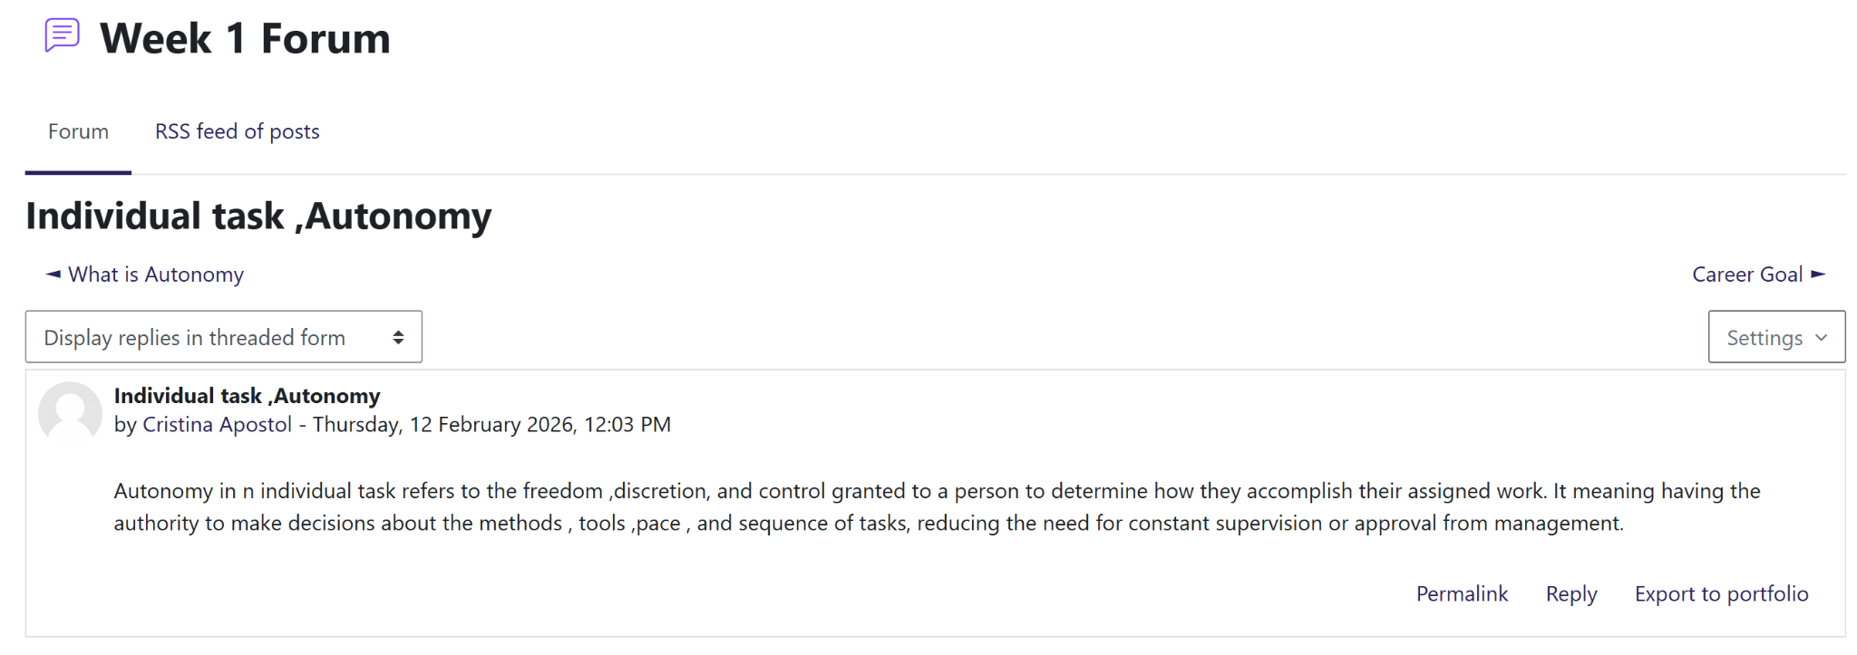
Individual Task, Autonomy
Reflecting on the “Individual Task, Autonomy”, I have explored the potential freedom to manage work. Within the context of the healthcare sector, autonomy highly refers to the authority to make informed decisions about methods and tasks without constant supervision (Mennella et al., 2024). Conversely, I must recognise the limits of my knowledge and how this influences my clinical interpretations. Increasing professional autonomy can lead towards better patient outcomes which provide significant support of evidence-based reasoning rather than just personal opinion (Ominyi et al., 2025).
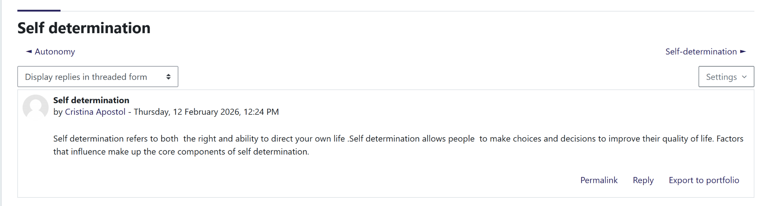
Self determination
The final task of week 1 was associated with self-determination which emphasised the right of individuals to direct their own lives to improve their quality of life (Mumbardó‐Adam et al., 2024). I consider this concept as the central to my professional identity which is particularly associated with patient centred care and empowerment of service uses. Being a practitioner, the job role requires respect for the choices of others while making sound judgements that provide support to their well-being. The factors influencing self- determination are considered as core components of personal brand that are rooted with advocacy and ethical decision making (de Villiers et al., 2025).

Week 2:
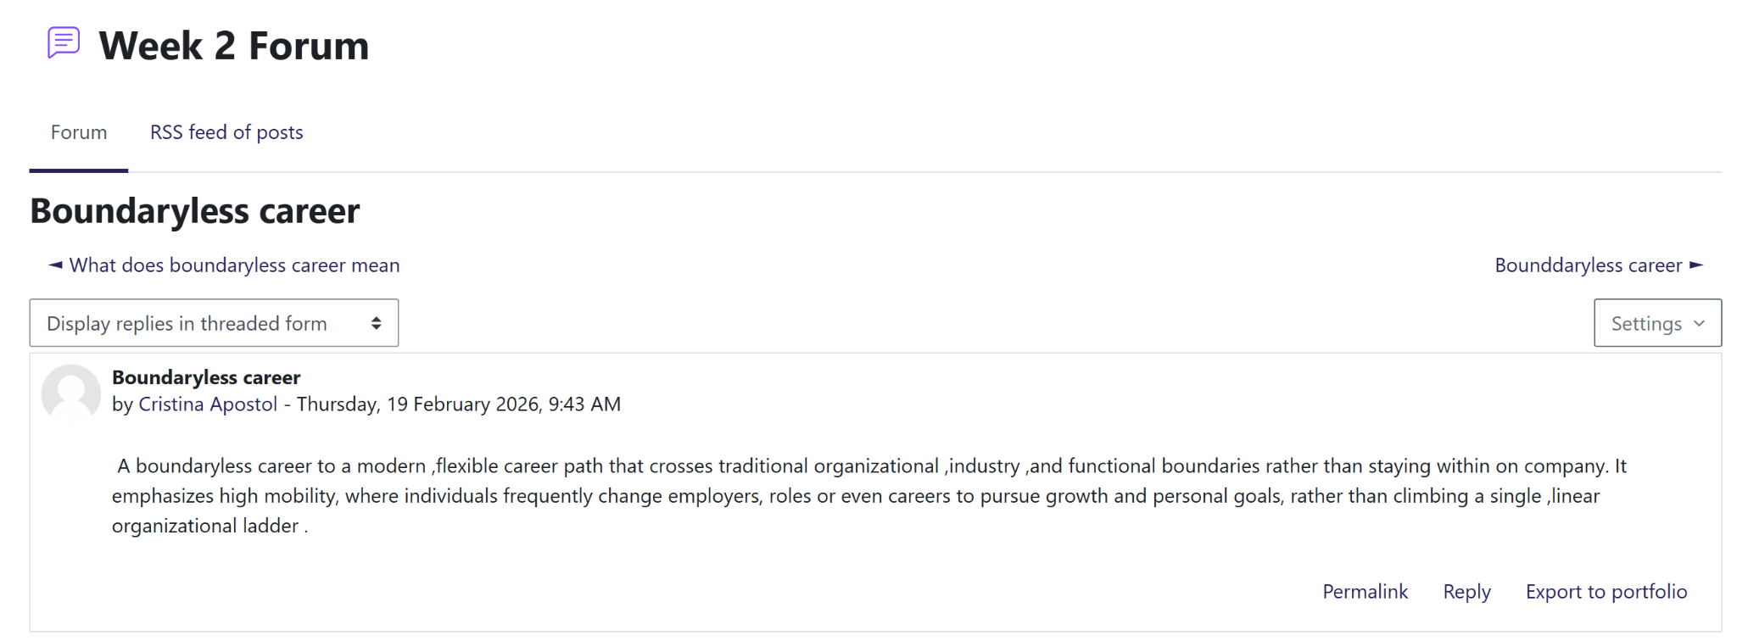
Boundaryless career
The activity of week 2, I explored the concept of boundaryless careers, which represented a modern, flexible path that crosses the traditional organisational industry lines. I have reflected on how this morning has emphasized high mobility where I might frequently change rules for employers to pursue my personal goals and growth rather than climbing a single and linear organisational ladder. In the context of health and social care, the mind-set is increasingly relevant as it provides the benefit of gaining diverse experiences across different clinical settings (Lombardo et al., 2023). Eventually, this contributes to strengthening the personal brand as a versatile practitioner.
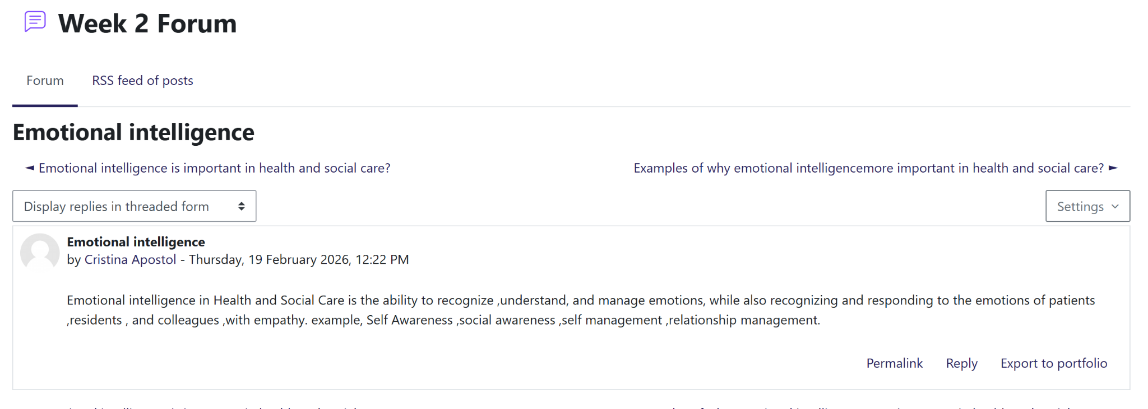
Emotional intelligence
A significant portion of my learning this week was focused on emotional intelligence which I defined as the ability to recognise, understand and manage my own emotions by emphasizing with patients, residents as well as colleagues. I have categorised the core components of emotional intelligence into four key areas:
- Self-awareness which focuses on understanding emotional triggers in high pressure clinical environments (Espiritu et al., 2021).
- Social awareness focuses on recognising the emotional needs of the patients who are under care (Foye et al., 2022).
- Self-management deals with controlling the responses during the challenging shifts (Grabowski et al., 2021).
- Relationship management contributes to building strong and collaborative teams.
Emotional intelligence is not just a soft skill but can be considered as a core competency of a professional practice as it directly influences the quality of therapeutic relationship between care giver and the patient (Metz et al., 2022).
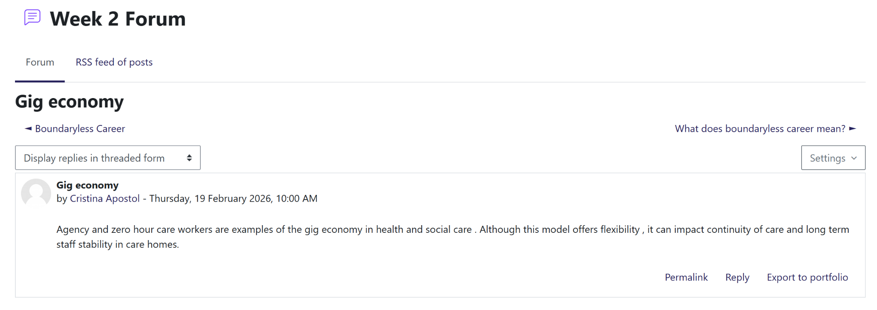
Gig Economy
Following my exploration of career paths, I have analysed the gig economy within the health and social care sector. Agency work and zero hour contracts are prominent examples of gig economy (Inversi et al., 2023). I recognise that these arrangements significantly offer flexibility for workers. However, there is a limitation associated with continuity of care for patient and long term staff stability in homes. This exercise has helped me in realising that I may value flexibility but I should consider the ethical implication of my employment choices. The lesson learned from the exercise is associated with maintaining continuation in quality service delivery and focus into patient wellbeing (Lebea et al., 2024).

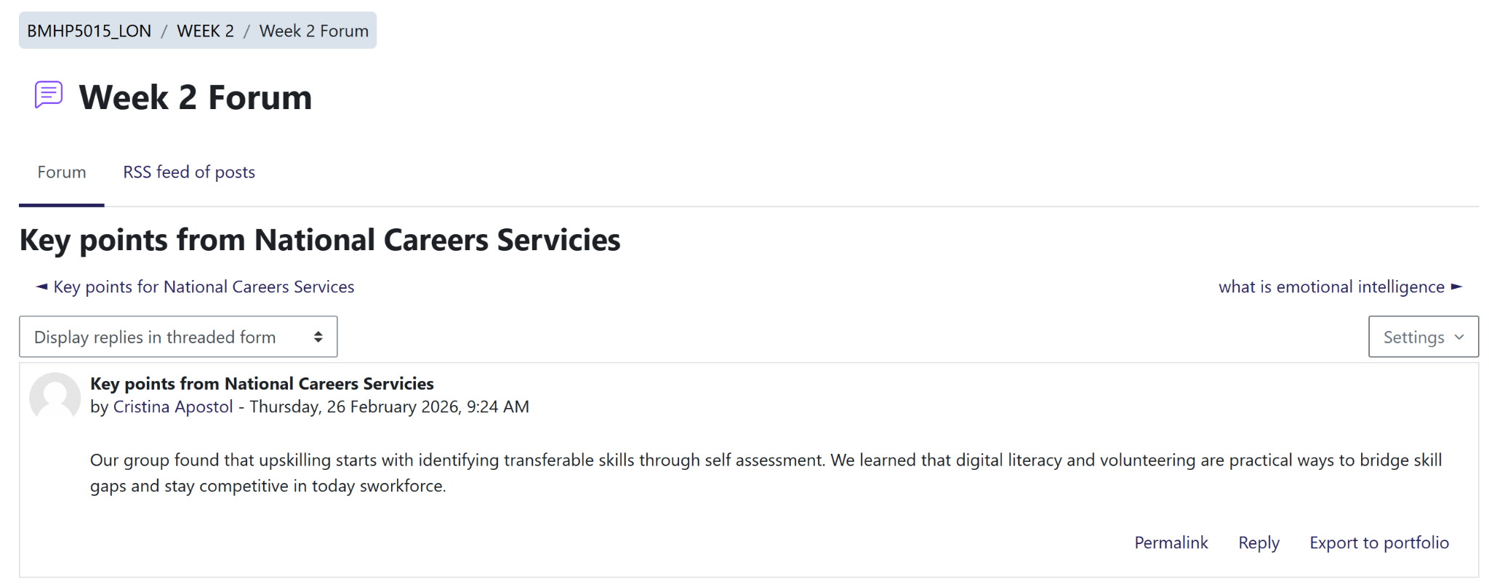
Key points from National Careers Services
Finally, I have engaged with resources from National Career Services for identifying the practical ways to limit my own skill gaps. Through self-assessment, I have learned that up skilling starts with identifying transferable skills. Volunteering and improving digital literacy are two practical ways by which a professional can stay competitive in the workforce of the present era (Zubeyr et al., 2024). The proactive approach significantly ensures that my personal brand remains strong and aligned with the changemaker ethos of the module (Corbelli, 2025).
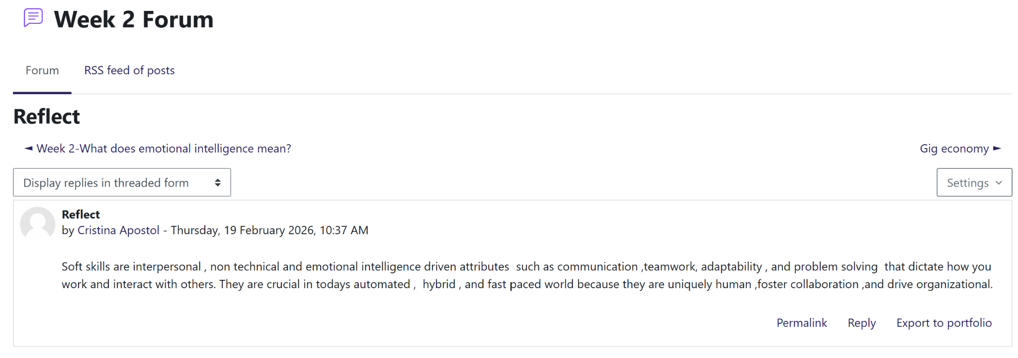
Reflect
My potential engagement with these activities has shifted my perspective on career longevity. Understanding of sustainable employment significantly demands balance between technical proficiency as well as high emotional intelligence (ST and Chandrahasa, 2025). Application of these concepts to my current role as an HCA, I should navigate the complex cities associated with the modern health care market. The reflective procedure is well supported with the requirement regarding critical awareness and thinking in the health and social care field (Čajko Eibicht et al., 2022).

Week 3:
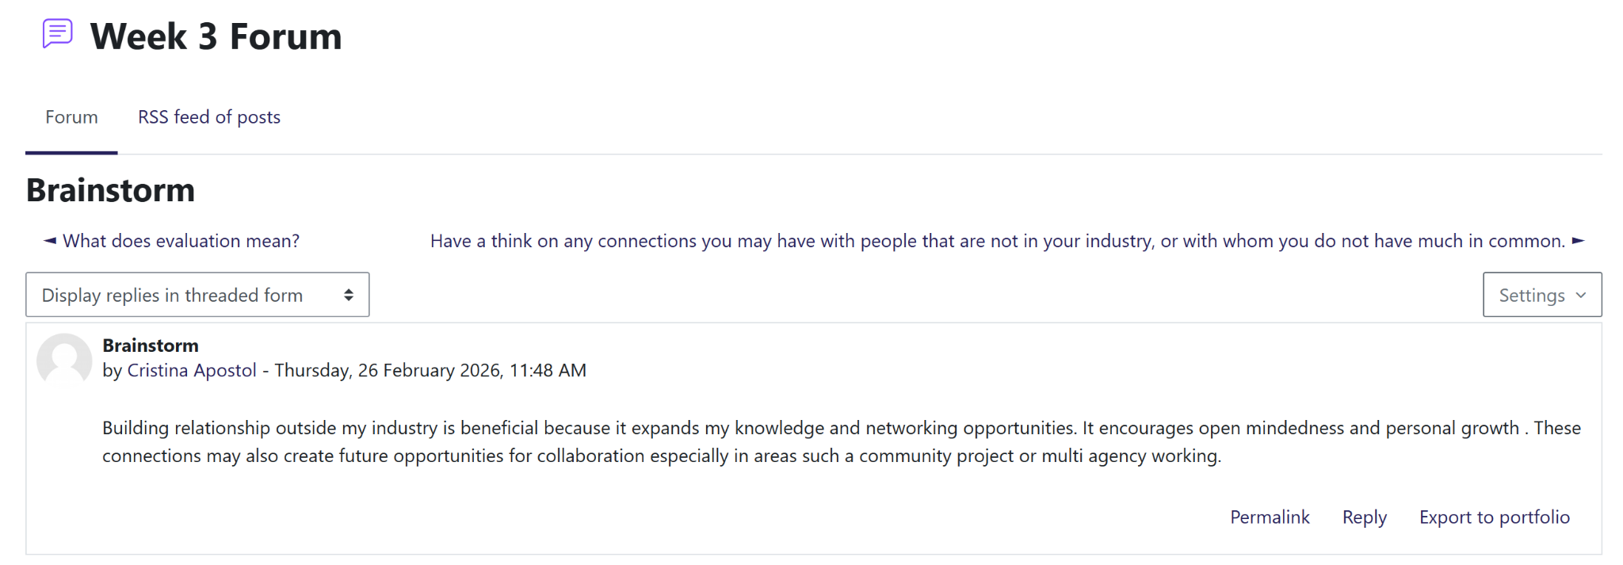
Brainstorm
In this activity, I have effectively utilised brainstorming techniques to map out the core competence of my career growth. Continuing Professional Development (CPD) contributes to intentional and systematic maintenance of the skills and knowledge (Mlambo et al., 2021). This exercise demands visualising how academic learning integrates with clinical practice as an HCA. Identifying my current strengths and areas of improvement, I can ensure that my professional identity remains congruent with evolving requirements of the healthcare sector. Eventually, this will contribute to achieving the long term goal of becoming a Registered Nurse (Lundell Rudberg et al., 2022).
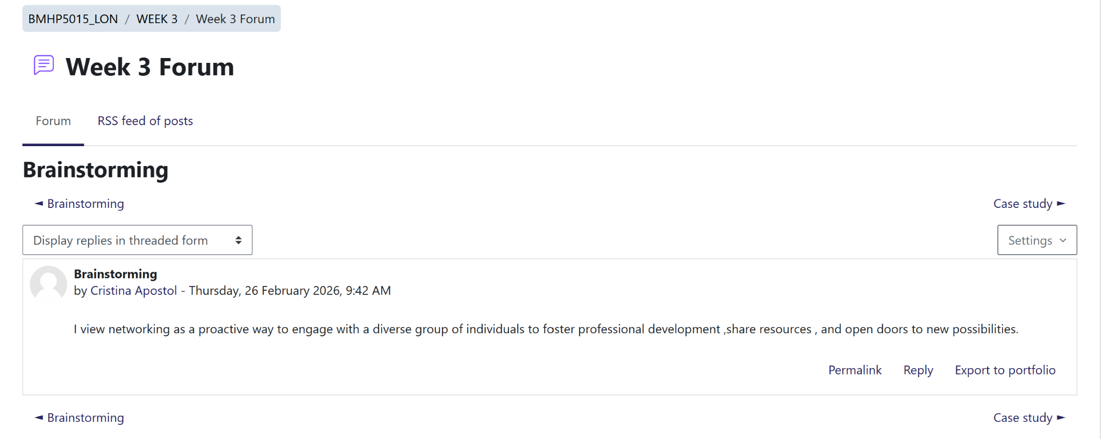
Brainstorming
In this task I have viewed networking as a proactive way to engage with different groups of individuals to promote professional development and share resources. The brainstorming process was focused on some key pillars like self-assessment, skill development, learning goals, networking, feedback as well as reflection (Van Dyck et al. 2024). Healthcare Assistant is not just about clinical tasks, it's about the continuous cycle of seeking feedback and reflecting on my experiences (Davison et al., 2022). This structured approach significantly allows me to align my daily learning with the long term goal of nursing.
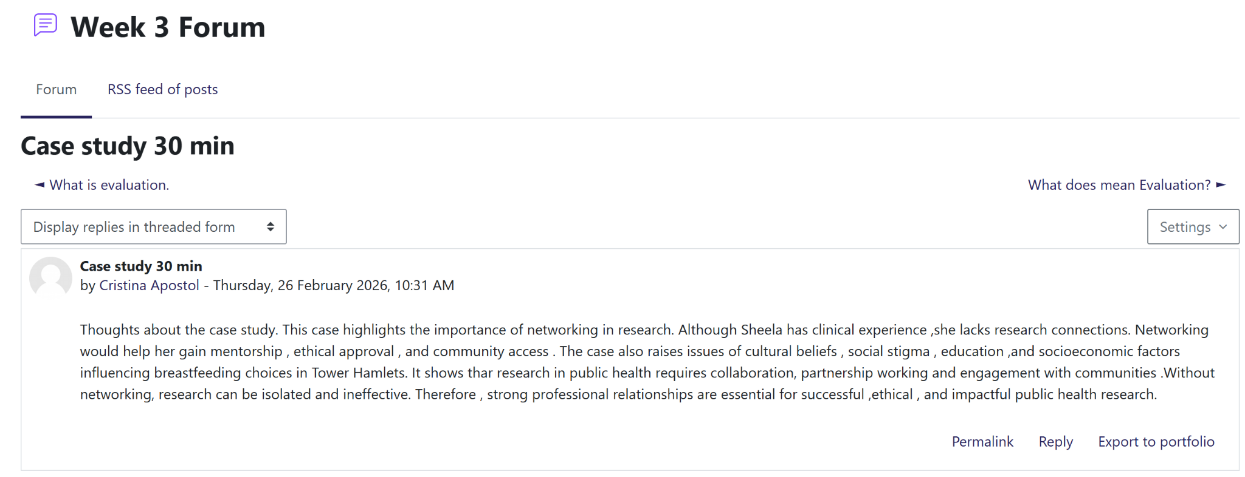
Case study
The Tower Hamlets case study has highlighted that the clinical expertise alone is insufficient for impactful research. The professional identity can be built through strategic networking. Networking is considered as one of the effective practical skills which is essential for navigating complex barriers like social stigma and cultural beliefs (Bhatti and Alzahrani, 2023). Without a collaborative partnership working, this research remains isolated or ineffective. Application to this to our health and social care context, building a personal brand must involve active community engagement as well as mentorship to ensure ethical and impactful practices. This emphasises the transferable skills of exercising personal responsibility with a wider professional network is essential (Hellison et al., 2025).
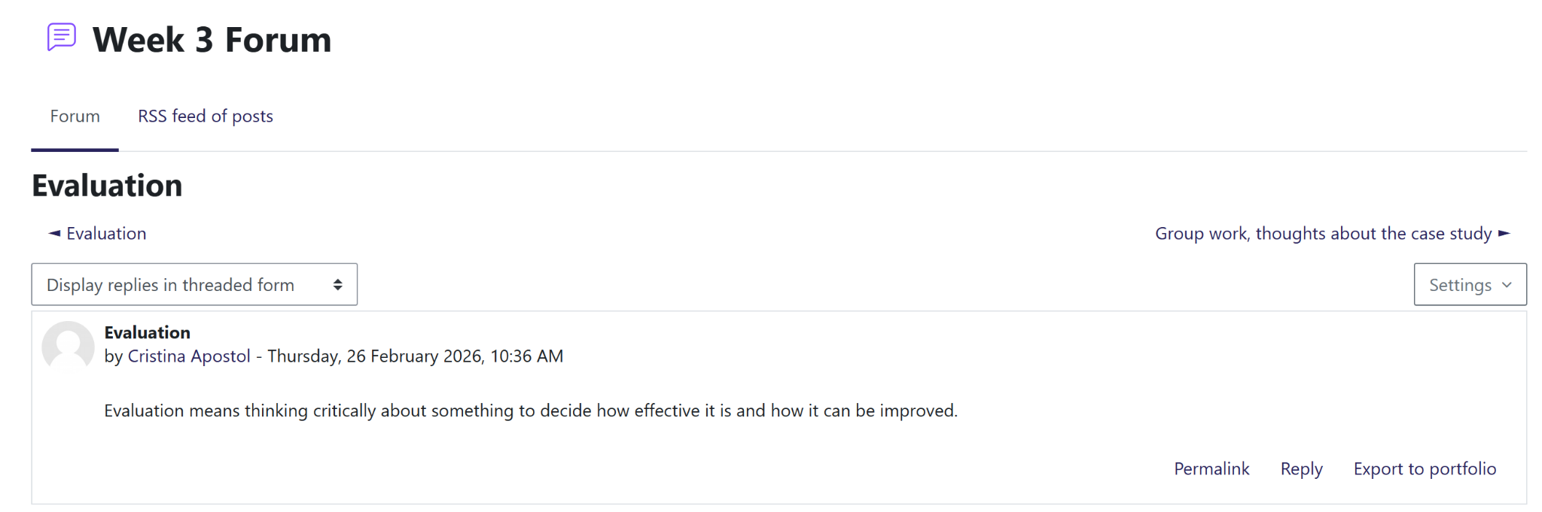
Evaluation
In the context of health and social care, evaluation is one of the essential cognitive skills which involves more than just observation (Dieckmann et al., 2024). This requires critical analysis of the effectiveness of the services to propose solutions for further improvement. Systematic examination of clinical outcomes or community interventions, practitioners demonstrate personal responsibility for improving the quality of service (Komashie et al., 2021). The procedure of logical analytical thinking significantly ensures that the professional practice remains evidence based and contributes to handling complicated patient care.
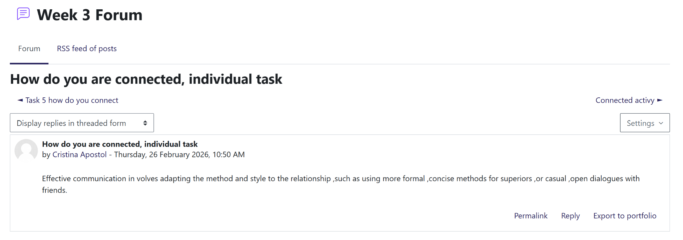
Individual task
This task emphasised that effective communication is considered as one of the essential transferable skills which demands potential ability to tailor information for both specialist and non-specialist audiences (McGreavy et al., 2022). In health and social care, adopting my style is a practical skill which is essential for maintaining a professional boundary. Utilisation of formal and concise methods with superiors ensures that the clarity and effectiveness with open dialogue can improve both empathy and trust from the perspective of service users (Pocobello et al., 2023. This adaptability demonstrates personal responsibility as well as decision making which are key techniques of maintaining discipline in an effective way (Kim et al., 2024). This also ensures that clear understanding of the information across diverse professional and personal relationship contributes to improving trust between service provider and service user.
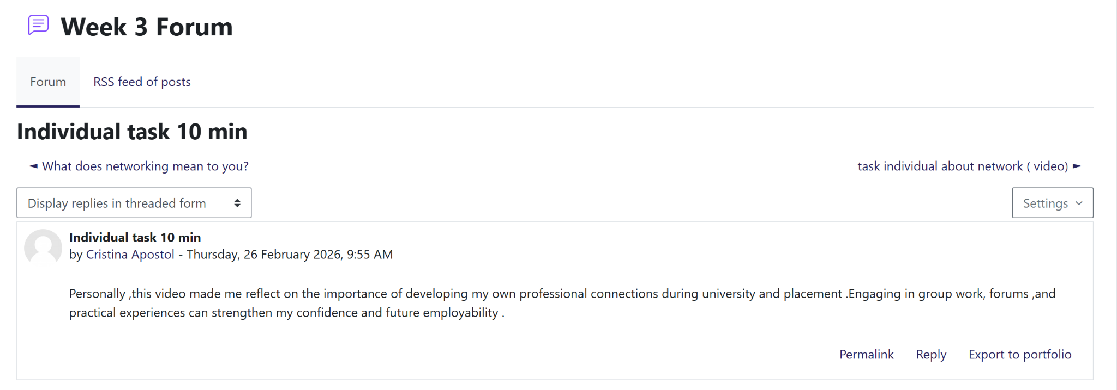
Individual task
Engaging with this video task significantly reinforced that building of personal brand is a proactive process which involves development of professional connections (Medina Garrido, 2025). In the context of the health and social care sector, networking during University and placements is a practical skill which can limit the gap between theory and real world situations (Singh et al., 2024). By participating in the group work and forums, I have acquired new competencies and confidence. This active engagement significantly demonstrates my personnel responsibility for improving my own employability and professional dignity.

Week 4:
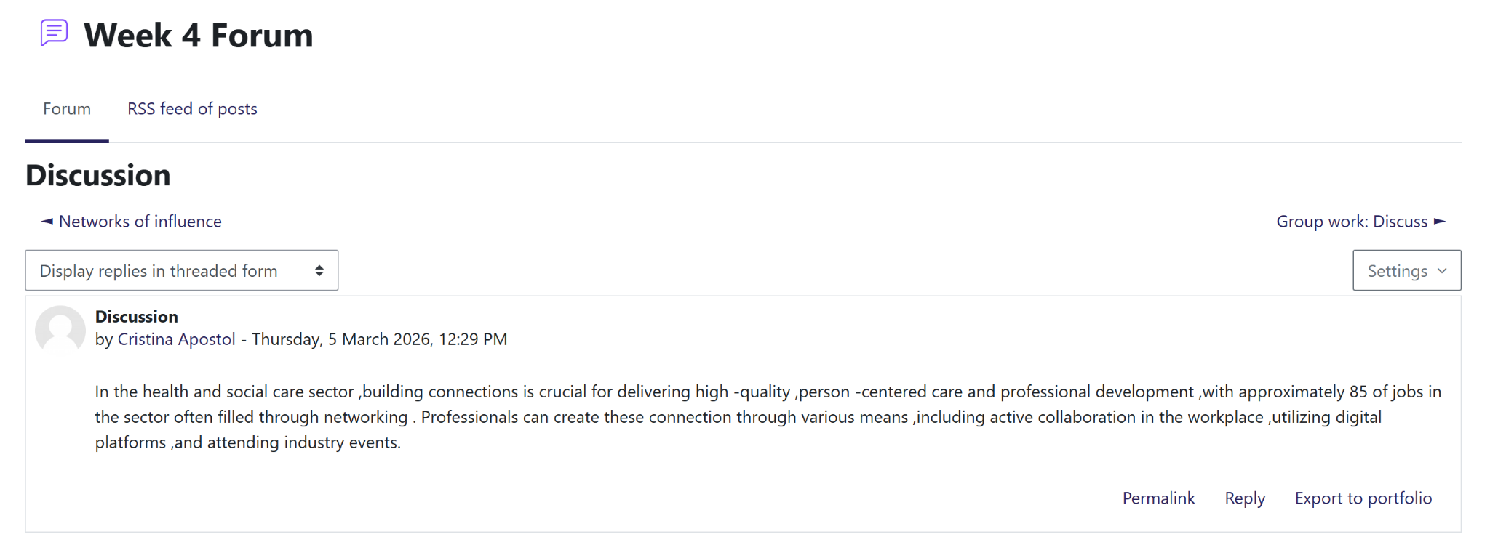
Discussion
The discussion has highlighted that networking is considered as one of the practical skills which is essential for both professional development and providing high quality care delivery (Isabirye et al., 2024). Recognising the worst majority of sector rules which are filled through connection underscores the need for promoting professional identity across digital platforms and industry events (Kronblad and Jensen, 2023). In the context of health and social care, these collaborations are not just about social but about key techniques for building a personal brand that ensure sustainable employment (Kessler et al., 2023).
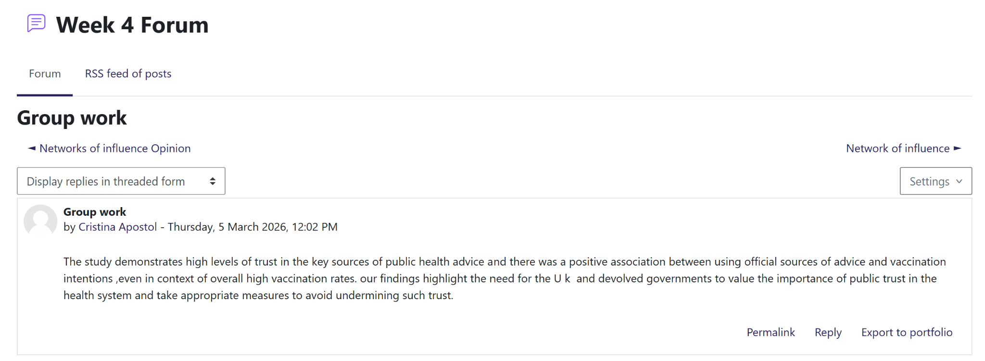
Group work
Participating in the group task has highlighted that integration of a collective critical analysis is also essential for understanding the complex health issues like vaccination hesitancy (Svensson et al., 2025). Our findings have demonstrated that public trust is a well-established concept which directly influences the health outcomes as well as professional practice. Within the HSC context, this critically highlights the personal responsibility of a team to communicate by using credible and reliable information for avoiding undermining system-wide trust (Blom et al., 2025). This collaboration significantly serves as a practical skill which shows how a proactive and reactive approach helps a group and proposes solutions for maintaining an environment of high quality, person-centred care (Lood et al., 2024).
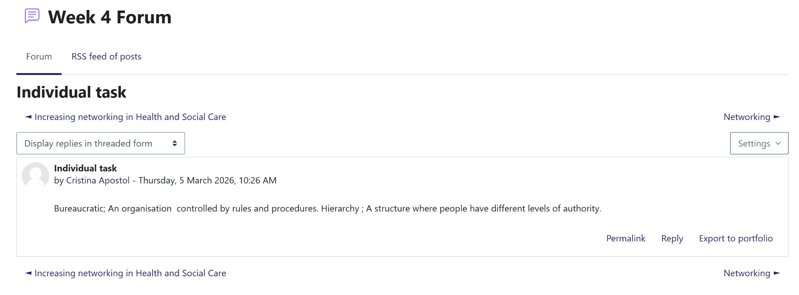
Individual task
Understanding of bureaucratic systems and hierarchy is considered as one sum of the fundamental cognitive skills for navigating the HSC environment (Sutiyoso and Faedlulloh, 2024). The settings associated with authority and rules significantly ensure safety but they can sometimes hinder the practical skills of networking. My reflection demonstrates that hierarchies provide structure and contribute to building connections across different levels which is necessary for providing person centred care. Elevation of communication and collaboration skills can improve both personal responsibility and identity by respecting the existing chain of commands as well as organisation and procedures (Emam and Hans, 2025).
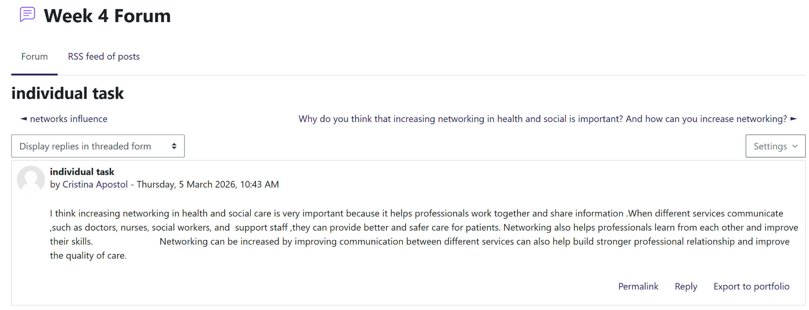
Individual task
This individual task highlights that networking is considered as one of the fundamental practical skills which ensures effective person-centred care through effective multi-disciplinary collaboration (Michielsen et al., 2023). By facilitating communication between diverse professionals including doctors, social workers, nurses, networking acts as a key technique for sharing information (Mokhtari Nouri et al., 2022). This also contributes to reducing the risk of patient safety. This collaborative approach is necessary for professional development and it provides benefits to the practitioners in learning from one another and improving their existing skills (Khasawneh et al., 2023).
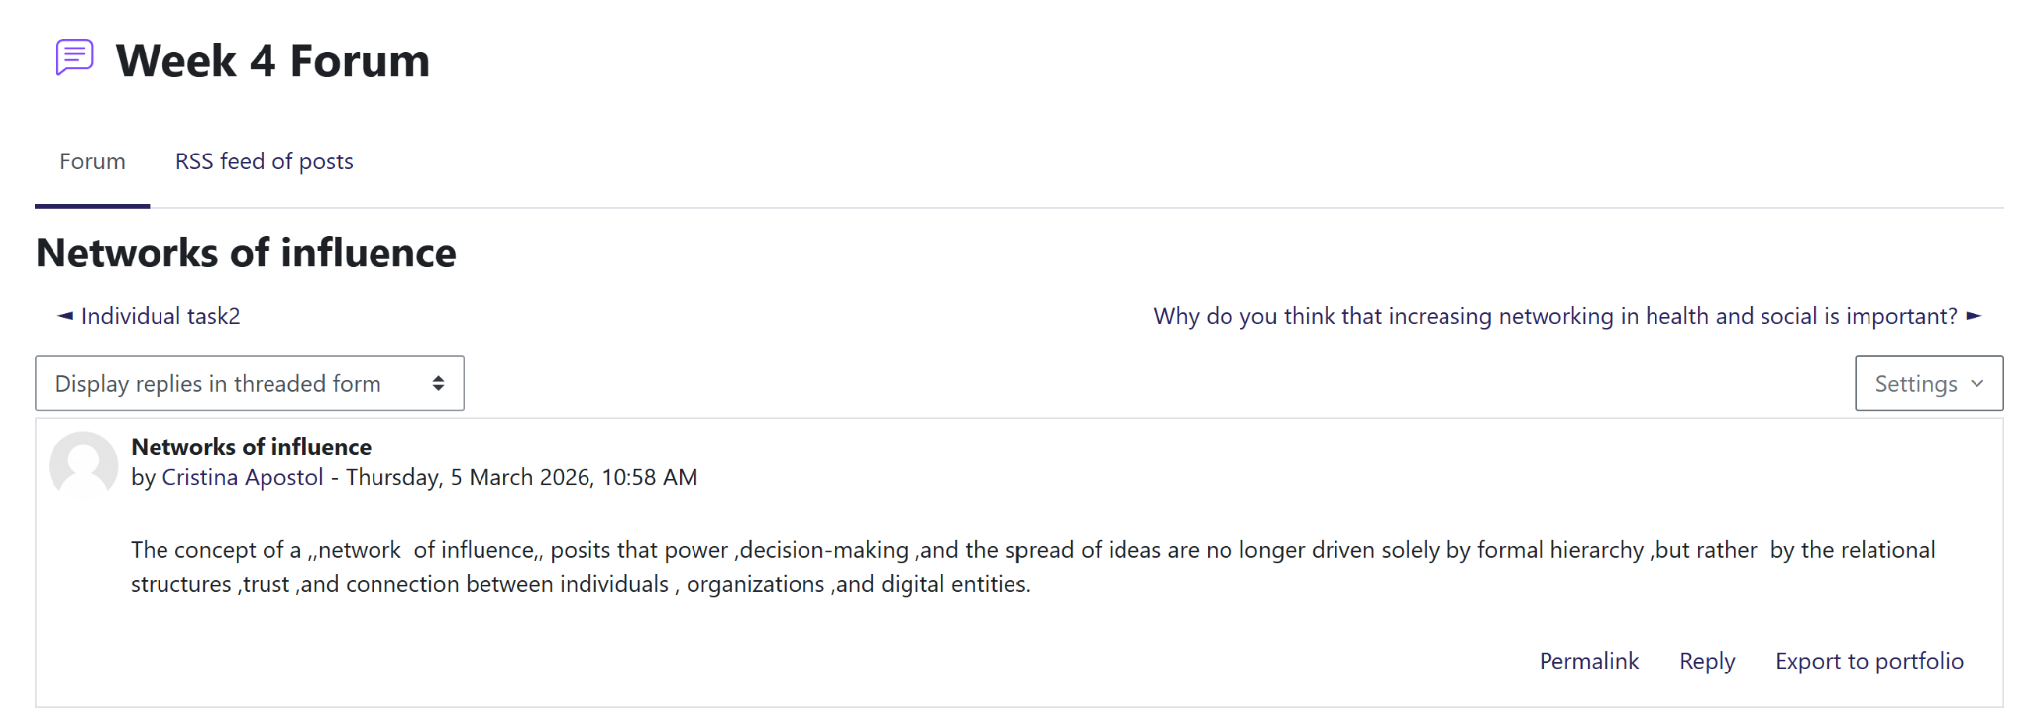
Networks of influence
The concept of network of influence significantly represents the shift from hierarchy to relational power which is essential for cognitive skills to understand the landscape of modern health care (Redhead and Power, 2022). This suggests potential trust and digital connectivity as a key technique for spreading ideas and making decisions. The professional identity and ability of practitioners for promoting personal brand is depending on their capacity of building authentic and trust oriented corrections (Motorina, 2025).

Conclusion
The portfolio has demonstrated a comprehensive proactive and reactive approach for building a personal brand within the health and social care sector. By analysing employability skills I have developed a strong personal identity. My engagement with multi-disciplinary networking and ethical values as highlighted by personal responsibility and decision making ability which is necessary for sustainable employment.

References
Atiku, S.O., Kurana, C.M. and Ganiyu, I.O., 2023. Leadership and service delivery in times of change. Administrative Sciences, 13(5), p.125.
Bhatti, M.A. and Alzahrani, S.A., 2023. Navigating Linguistic Barriers: Exploring the Experiences of Host National Connectedness among Multilingual Individuals. Eurasian Journal of Applied Linguistics, 9(3), pp.96-112.
Blom, J.M., Rivi, V., Tascedda, F. and Pani, L., 2025. Building trust in clinical research: a systems approach to ethical engagement and sustainable outcomes. Frontiers in pharmacology, 16, p.1570899.
Čajko Eibicht, M., Lorenz, W. and Havrdová, Z., 2022. Enhancing reflectivity in social, care and health professionals–Identifying students’ abilities and needs. European Journal of Social Work, 25(4), pp.732-744.
Corbelli, J., 2025. Changemaker: A Modern Playbook for Creating Personal Impact and Transformational Change. John Wiley & Sons.
da Silva, D.P., de Melo, G.N., de Albuquerque, D.B., de Oliveira Caminha, I., Cardoso, G.A., de Melo, J.C.M., do Nascimento Caetano, T.J., de Alencar Arrais, J.F., Rosado, A.F.B. and Martins, P., 2025. Motivational profiles in the context of exercise and health: Leadership aspects and communication skills of personal trainers. Revista iberoamericana de psicología del ejercicio y el deporte, 20(5), pp.557-568.
Davison, E., Semlyen, J. and Lindqvist, S., 2022. “From doing to knowing”: medical students’ experiences of working as Healthcare Assistants. Journal of Interprofessional Care, 36(4), pp.560-566.
de Villiers, J.M., Degenaar, A. and Fourie, L., 2025. Trends in research on strategic communication, strategic integrated communication, personal branding and brand advocacy in the context of higher education. Communicare: Journal for Communication Sciences in Southern Africa, 44(1), pp.36-55.
Dieckmann, P., Bruun, B., Mundt, S., Holgaard, R. and Østergaard, D., 2024. Social and Cognitive Skills (SCOPE)—a generic model for multi-professional work and education in healthcare. Advances in Simulation, 9(1), p.28.
Emam, S.S. and Hans, C., 2025. Breaking the Chain of Command: Rethinking Organisational Structures to Unlock Performance in South Africa’s Mining Sector. Acta Universitatis Danubius. Administratio, 17(1), pp.173-192.
Espiritu, E.W., Busby, P.H.D., Hunt, J.W., Brown, R., Hallmark, B.F., Cochran, K. and Krueger-Brophy, C., 2021. Students’ self-perceptions of self-awareness/self-regulation when experiencing unexpected situations in an interprofessional clinical simulation. Internet Journal of Allied Health Sciences and Practice, 19(1), p.11.
Foye, U., Stuart, R., Trevillion, K., Oram, S., Allen, D., Broeckelmann, E., Jeffreys, S., Jeynes, T., Crawford, M.J., Moran, P. and McNicholas, S., 2022. Clinician views on best practice community care for people with complex emotional needs and how it can be achieved: a qualitative study. BMC psychiatry, 22(1), p.72.
Grabowski, D., Overgaard, M., Meldgaard, J., Johansen, L.B. and Willaing, I., 2021. Disrupted self-management and adaption to new diabetes routines: a qualitative study of how people with diabetes managed their illness during the COVID-19 lockdown. Diabetology, 2(1), pp.1-15.
Hellison, D., Hellison, D.R., Wright, P.M., Martinek, T.J. and Walsh, D.S., 2025. Teaching personal and social responsibility through physical activity. Human Kinetics.
Inversi, C., Dundon, T. and Buckley, L.A., 2023. Work in the gig-economy: The role of the state and non-state actors ceding and seizing regulatory space. Work, Employment and Society, 37(5), pp.1279-1298.
Isabirye, A.K., Moloi, K.C. and Lebelo, R.S., 2024. Enhancing networking skills for professional success: Strategies and tactics. Mitteilungen Klosterneuburg, 74(7), pp.1-35.
Kessler, I., McDermott, A.M., Vermeerbergen, L., Pulignano, V. and Harney, B., 2023. Sustainable work and employment in social care: New challenges, new priorities. Human Resource Management.
Khasawneh, Y.J.A., Alsarayreh, R., Al Ajlouni, A.A., Eyadat, H.M., Ayasrah, M.N. and Khasawneh, M.A.S., 2023. An Examination of Teacher Collaboration in Professional Learning Communities and Collaborative Teaching Practices. Journal of Education and e-Learning Research, 10(3), pp.446-452.
Kim, Y., Park, C., Jeong, H., Chan, Y.S., Xu, X., McDuff, D., Lee, H., Ghassemi, M., Breazeal, C. and Park, H.W., 2024. Mdagents: An adaptive collaboration of llms for medical decision-making. Advances in Neural Information Processing Systems, 37, pp.79410-79452.
Komashie, A., Ward, J., Bashford, T., Dickerson, T., Kaya, G.K., Liu, Y., Kuhn, I., Günay, A., Kohler, K., Boddy, N. and O'Kelly, E., 2021. Systems approach to health service design, delivery and improvement: a systematic review and meta-analysis. BMJ open, 11(1), p.e037667.
Kronblad, C. and Jensen, S.H., 2023. ‘Being a professional is not the same as acting professionally’—How digital technologies have empowered the creation and enactment of a new professional identity in law. Journal of Professions and Organization, 10(2), pp.99-119.
Lebea, M.J., Agumba, J.N. and Adebowale, O.J., 2024. Critical success factors in the maintenance strategies of public healthcare facilities. International Journal of Building Pathology and Adaptation, 42(7), pp.55-75.
Lombardo, L., Ehlers, J. and Lutz, G., 2023, March. Mindset and reflection—How to sustainably improve intra-and interpersonal competences in medical education. In Healthcare (Vol. 11, No. 6, p. 859). MDPI.
Lood, Q., Carlström, E., Klinga, C. and Barenfeld, E., 2024. A collaborative endeavour to integrate leadership and person-centred ethics: a focus group study on experiences from developing and realising an educational programme to support the transition towards person-centred care. BMC Health Services Research, 24(1), p.395.
Lundell Rudberg, S., Westerbotn, M., Sormunen, T., Scheja, M. and Lachmann, H., 2022. Undergraduate nursing students’ experiences of becoming a professional nurse: a longitudinal study. BMC nursing, 21(1), p.219.
McGreavy, B., Haynal, K., Smith-Mayo, J., Reilly-Moman, J., Kinnison, M.T., Ranco, D. and Leslie, H.M., 2022. How does strategic communication shape transdisciplinary collaboration? A focus on definitions, audience, expertise, and ethical praxis. Frontiers in Communication, 7, p.831727.
Medina Garrido, J.A., 2025. Steps to develop your professional personal brand.
Mennella, C., Maniscalco, U., De Pietro, G. and Esposito, M., 2024. Ethical and regulatory challenges of AI technologies in healthcare: A narrative review. Heliyon, 10(4).
Metz, A., Jensen, T., Farley, A., Boaz, A., Bartley, L. and Villodas, M., 2022. Building trusting relationships to support implementation: A proposed theoretical model. Frontiers in health services, 2, p.894599.
Michielsen, L., Bischoff, E.W., Schermer, T. and Laurant, M., 2023. Primary healthcare competencies needed in the management of person-centred integrated care for chronic illness and multimorbidity: Results of a scoping review. BMC primary care, 24(1), p.98.
Mlambo, M., Silén, C. and McGrath, C., 2021. Lifelong learning and nurses’ continuing professional development, a metasynthesis of the literature. BMC nursing, 20(1), p.62.
Mokhtari Nouri, J., Ebadi, A., Rezaiye, M. and Babajani Vafsi, S., 2022. Nursing knowledge-sharing in mobile social networks as a means of professional dynamic interactions: A qualitative content analysis. Interdisciplinary Journal of Virtual Learning in Medical Sciences, 13(1), pp.1-14.
Mostepaniuk, A., Akalin, T. and Parish, M.R., 2023. Practices pursuing the sustainability of a healthcare organization: a systematic review. Sustainability, 15(3), p.2353.
Motorina, A., 2025. The influence of the guide’s personal brand on the formation of trust in author’s excursions in a competitive environment. Актуальні питання економічних наук, (14).
Mumbardó‐Adam, C., Vicente, E. and Balboni, G., 2024. Self‐determination and quality of life of people with intellectual and developmental disabilities: Past, present, and future of close research paths. Journal of Policy and Practice in Intellectual Disabilities, 21(1), p.e12460.
Nasser, S., 2024. Current status, challenges, and future career pathways of diploma-prepared nurses from the stakeholders’ perspective: a qualitative study. BMC nursing, 23(1), p.542.
Ominyi, J., Agom, D.A. and Beryl, N.A., 2025. Nursing Autonomy and Evidence‐Based Practice in Acute Care: Navigating Power and Promoting Collaboration. In Nursing Forum (Vol. 2025, No. 1, p. 9343933). Wiley.
Ominyi, J., Agom, D.A. and Beryl, N.A., 2025. Nursing Autonomy and Evidence‐Based Practice in Acute Care: Navigating Power and Promoting Collaboration. In Nursing Forum (Vol. 2025, No. 1, p. 9343933). Wiley.
Pocobello, R., Camilli, F., Alvarez-Monjaras, M., Bergström, T., von Peter, S., Hopfenbeck, M., Aderhold, V., Pilling, S., Seikkula, J. and El Sehity, T.J., 2023. Open Dialogue services around the world: a scoping survey exploring organizational characteristics in the implementation of the Open Dialogue approach in mental health services. Frontiers in Psychology, 14, p.1241936.
Redhead, D. and Power, E.A., 2022. Social hierarchies and social networks in humans. Philosophical Transactions of the Royal Society B, 377(1845), p.20200440.
Singh, K., Alomari, A.M.A., Sayed, H.M.A., Mannethodi, K., Kunjavara, J., Joy, G.V., Hassan, N., Martinez, E. and Lenjawi, B.A., 2024. Barriers and solutions to the gap between theory and practice in nursing services: a systematic review of qualitative evidence. In Nursing Forum (Vol. 2024, No. 1, p. 7522900). Wiley.
ST, N. and Chandrahasa, R., 2025. Emotional Intelligence and Sustainable Workplaces: A Study on Employee Well-being and Behavioral Outcomes. OIDA International Journal of Sustainable Development, 18(12), pp.301-328.
Sutiyoso, B.U. and Faedlulloh, D., 2024. Navigating social capital development through organisational citizenship behaviour in local government bureaucracy. Cogent Social Sciences, 10(1), p.2386708.
Svensson, A., Nardoni, M., Svalastog, A.L., Vidmar, M., Machado, H., Kopilaš, V., Gajović, S., Martinelli, L. and Todorović, Z., 2025. Vaccine Hesitancy in Public Healthcare During Pandemics: An International Study to Inform Management Learning. Health science reports, 8(8), p.e71190.
Van Dyck, H., Mestdagh, E. and Vaes, K., 2024. Integrating Personal Development, Values, and Self-Reflection in Design Education: A Holistic Approach for Creative Excellence.
Weber, A., Devenish, S. and Lam, L., 2024. Exploring the alignment between paramedicine's professional capabilities and competency frameworks for current and evolving scopes of practice: a literature review. BMC medical Education, 24(1), p.31.
Zubeyr, E., Kunasegaran, M. and Kunjiapu, S., 2024. Embracing youth volunteerism through digital literacy for a sustainable future. International Journal of Academic Research in Business and Social Sciences, 14(4), pp.1406-1415.

