

Master of Business Administration

LCMB7000
Human Resources Management 2

Student Name : Ranul Thotagamuwa
Student ID : 2132228
Submission Date : 09/09/2022

Table of Contents
1 introduction 4
2 Change Management 4
2.1 Outline detailed and appropriate of HR strategies for Change Management 5
2.2 Demonstration of HR Strategies for Change Management that are put on display will help team members feel valued, respected, and like part of our organization. 6
8
3 Compensation 9
3.1 Outline detailed and appropriate of HR strategies for Compensation 9
3.2 Demonstration of HR Strategies for Compensation that are put on display will help team members feel valued, respected, and like part of our organization. 9
3.3 Importance of compensation strategies 10
3.4 Development effective compensation strategies 10
4 Leadership development 13
4.1 Outline detailed and appropriate of HR strategies for Leadership Development 13
4.2 Demonstration of HR Strategies for Leadership Development that are put on display will help team members feel valued, respected, and like part of our organization. 15
4.3 The importance of leadership development 16
5 References 18

list of figures
Figure 1 - Change Management Model 3
Figure 2 - How constant and going changes stretch HR Management 4
Figure 3 - HR Leader's Role in change management 4
Figure 5 - Change Management approach for HR Transformation 5
Figure 6 - Change Management Workflow 6
Figure 7 - A scenario for a successful change management Strategy 6
Figure 8 - Common Comepnsation Issues 8
Figure 9 - Types of Compensation 9
Figure 10 - Compensation and Benefits 10
Figure 11 - Compensation Purposes 11
Figure 12 - Compensation planning 11
Figure 13 - Integrated human resource management process with leadership development 12
Figure 14 - Leadership Development Process Methodology for successful Management 13
Figure 15 - leadership development plan 14
Figure 16 - impact of leadership development 15
Figure 17 - HR Leadership development program 16

introduction
In order to demonstrate a critical awareness of the principles, models, and concepts of current HRM and IHRM theories of an International Technology Company, this report identifies three major areas, including change management, compensation, and leadership development.
This report has been produced in such a way that it describes the specific and useful human resource strategies that a human resource director would develop and implement in the three core HRM fields stated above.

Change Management
No matter how big or little, planning, implementing, and ongoing management of an organizational change are all components of change management. Organizational structures, operational procedures, technology advancements, and corporate strategy are a few of the continuously changing sectors that call for careful preparation. (Todnem, 2005)
Change calls for an effective change management approach, despite the fact that it can be stressful for everyone concerned. Some of the benefits shown below:

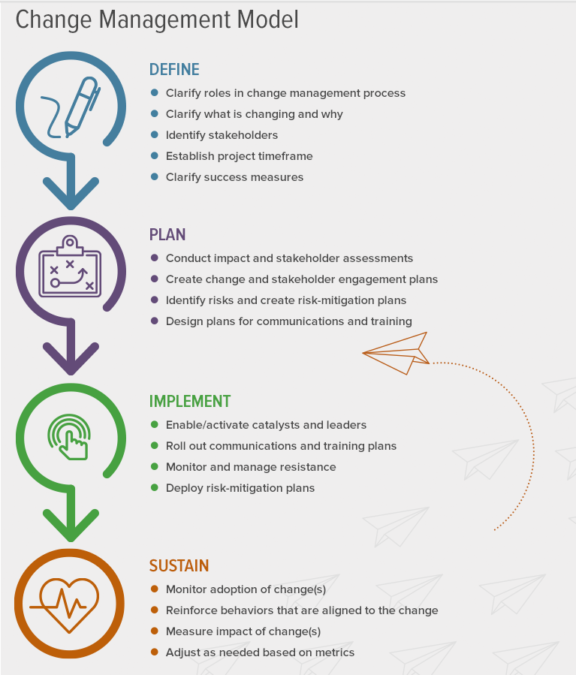
Figure 1 - Change Management Model

Outline detailed and appropriate of HR strategies for Change Management
By ensuring that the change's objectives are realized, they aid in change management. In order to effectively manage change, HR staff members need to be involved at every stage, from strategy to execution. In order to meet their requirements and allay their worries during the shift, HR experts also contribute their understanding of employees. In essence, they act as a conduit for information between management and workers. (Tummers, et al., 2015)
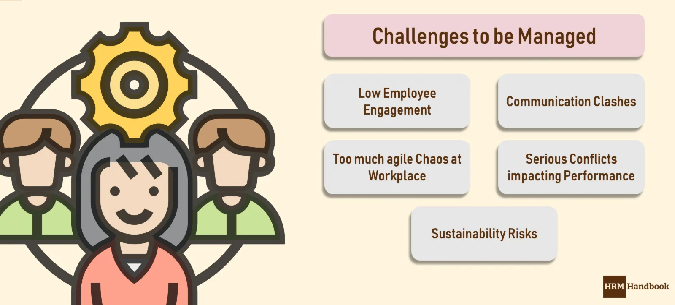

Figure 2 - How constant and going changes stretch HR Management

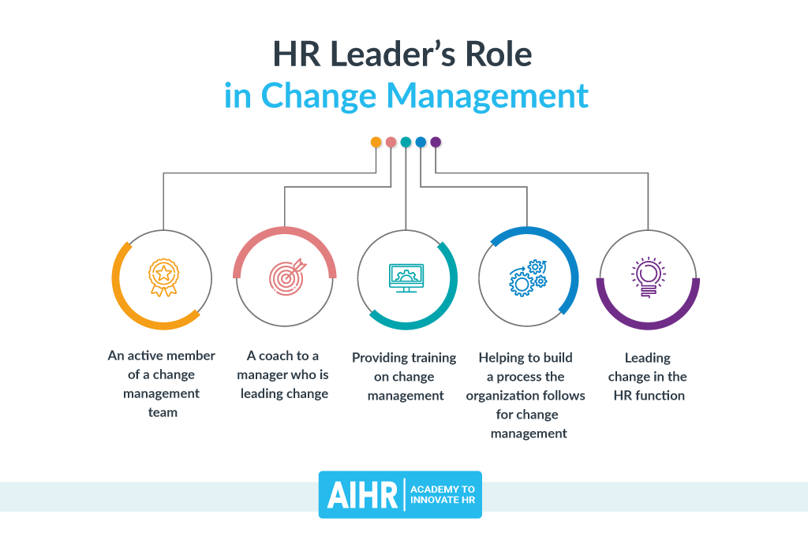
Demonstration of HR Strategies for Change Management that are put on display will help team members feel valued, respected, and like part of our organization.
Figure 3 - HR Leader's Role in change management

The organization's structure
Maps and charts help CEOs and HR specialists understand how many employees are now employed by the organization and what their responsibilities are. With this knowledge at hand, it is simpler to determine how and how much the change will impact the organization at different granularities.
Adapt employee responsibilities
With this phase possible adjustments which includes job position, salaries and talent acquisition will be produced
Report on structural change to managers
HR professionals may better understand how the change will impact employees using the knowledge they've gained from the previous two processes, and they can assemble this data to give to people in charge of organizing and implementing organizational change.
Establish and maintain organizational culture change
Once the shift has begun or has been fully assimilated as the new norm, which can take up to 10 years, HR may assist and encourage such change within the organization in both practical and cultural ways.
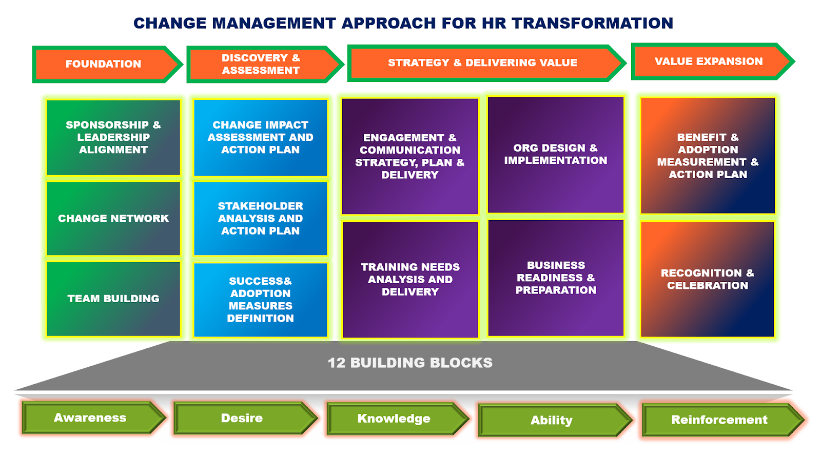
In order to conform procedures and policies to the new vision established by the transformation, HR must revise the relevant documents. ProProfs, Talent LMS, and SAP's Litmos solution are a few examples of learning management systems that offer central hubs for document and training management. (Fugate, 2012)
Figure 5 - Change Management approach for HR Transformation

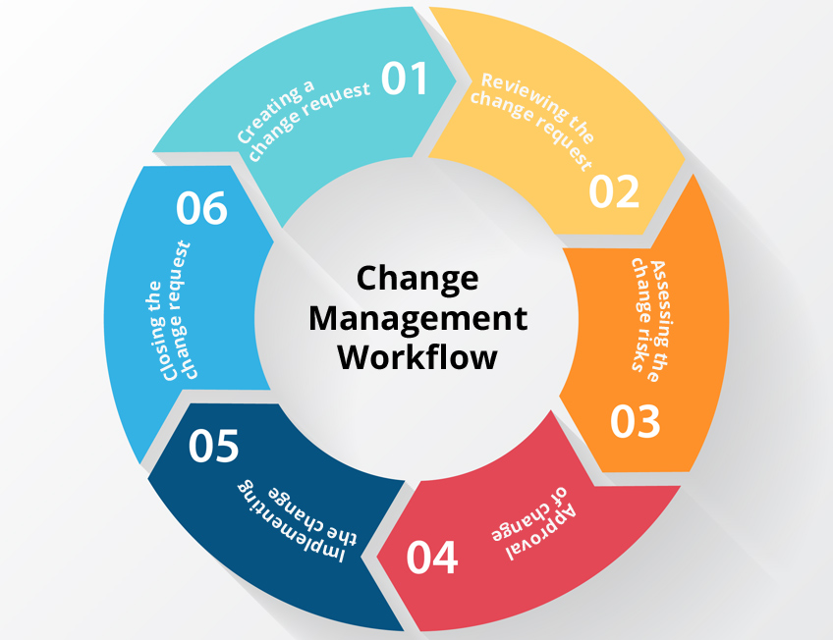
Figure 6 - Change Management Workflow

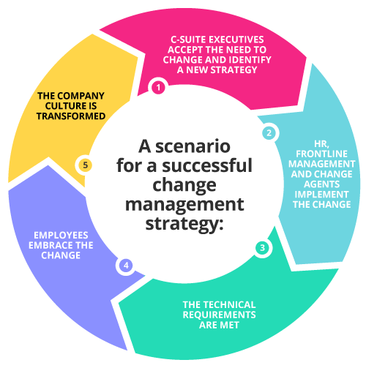

Figure 7 - A scenario for a successful change management Strategy

Compensation
A compensation strategy describes how your business will handle employee compensation and benefits. This covers the company's standing on the labor market, the amount of total funds, the organization's key bonus concepts, the base wage guidelines, and employee perks. The executive management is always the owner of the pay strategy because it has a significant impact on an organization's budget. The plan is shaped with input from the HR and/or Compensation & Benefits staff. (NinaGupta & D.Shaw, 2014)

Outline detailed and appropriate of HR strategies for Compensation
Talent sourcing
Effective recruitment is impossible without an effective pay strategy. You can have great recruiting marketing methods, but in the end, you need to be able to offer entire rewards packages that are both competitive and in line with your internal policies and budgeting if you want to draw in the talent your business needs.
A compensation strategy will also assist you in understanding how to distinguish yourself as the employer of choice among your rivals. In other words, it will support your plan for employer branding.
Talent retention
You can retain the talent you have invested a lot of time and money in hiring if you have a solid remuneration strategy. You can ensure that your staff are happy and motivated enough to be more productive and less inclined to leave the company by using the proper strategy.
Budgeting
You will be better able to determine and monitor pay ranges, wage differentials, and other compensation measures if you have a defined compensation strategy in place. Additionally, it guarantees consistency and openness in choices about compensation and benefits. (Rani, 2014)

Demonstration of HR Strategies for Compensation that are put on display will help team members feel valued, respected, and like part of our organization.
Compensation strategies are blueprints that specify how a company chooses staff salaries and perks. These plans specify the company's compensation goals as well as the pay ranges for different employment roles.It also describes how the business assesses workers to determine compensation. A corporation can get a competitive edge by implementing a successful compensation strategy. Additionally, it may promote employee loyalty. (Indeed Canada Corp, 2021)

Importance of compensation strategies
Strategies for compensation aid in formalizing employee compensation. Here are some typical justifications for creating and implementing a compensation strategy at work: (Simona Iancu, 2020)
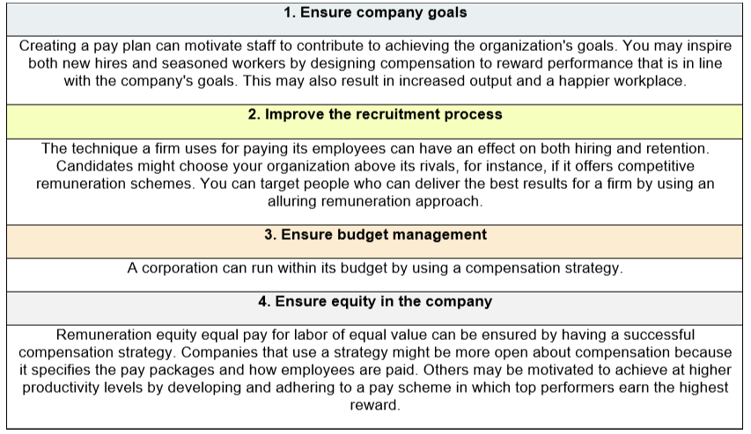
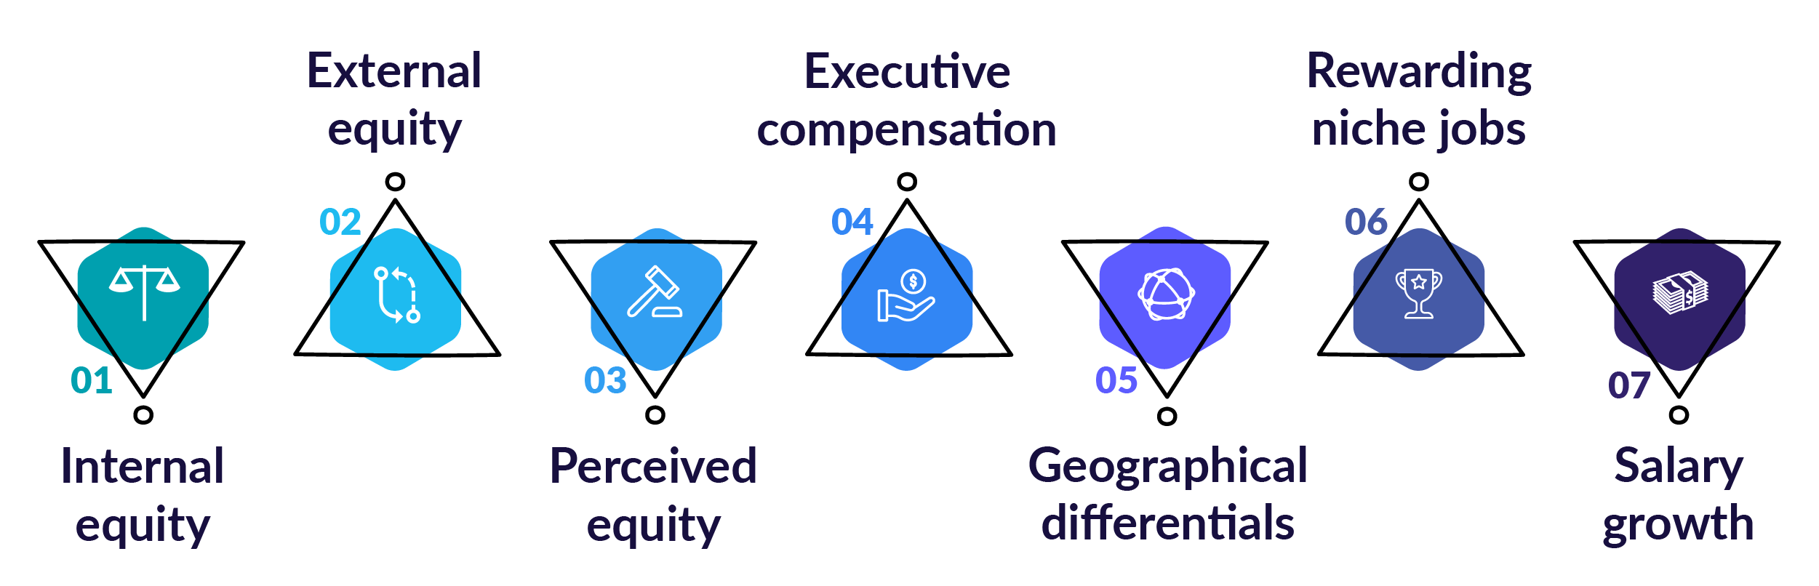
Figure 8 - Common Comepnsation Issues

Development effective compensation strategies
1. Assess the company's goals
Analyze the company's objectives and what it hopes to accomplish with a compensation strategy first. A corporation might need a pay strategy, for instance, to lower staff turnover or draw in qualified recruits.
2. Identify the company's competitive advantage and current strategy
Take note of what makes the business special.
3. Seek employee input
Take employee satisfaction and morale into account when designing a remuneration strategy.
4. Research compensation data and evaluate the talent market
Examine the talent market and the tactics of your rivals.
5. Determine your priority for competition
Consider selecting the company's most crucial requirement since businesses may implement compensation plans to meet a variety of objectives.
6. Select compensation packages
Decide what rewards to give staff next. For instance, you might provide senior staff with retirement packages and new hires with vacation packages.

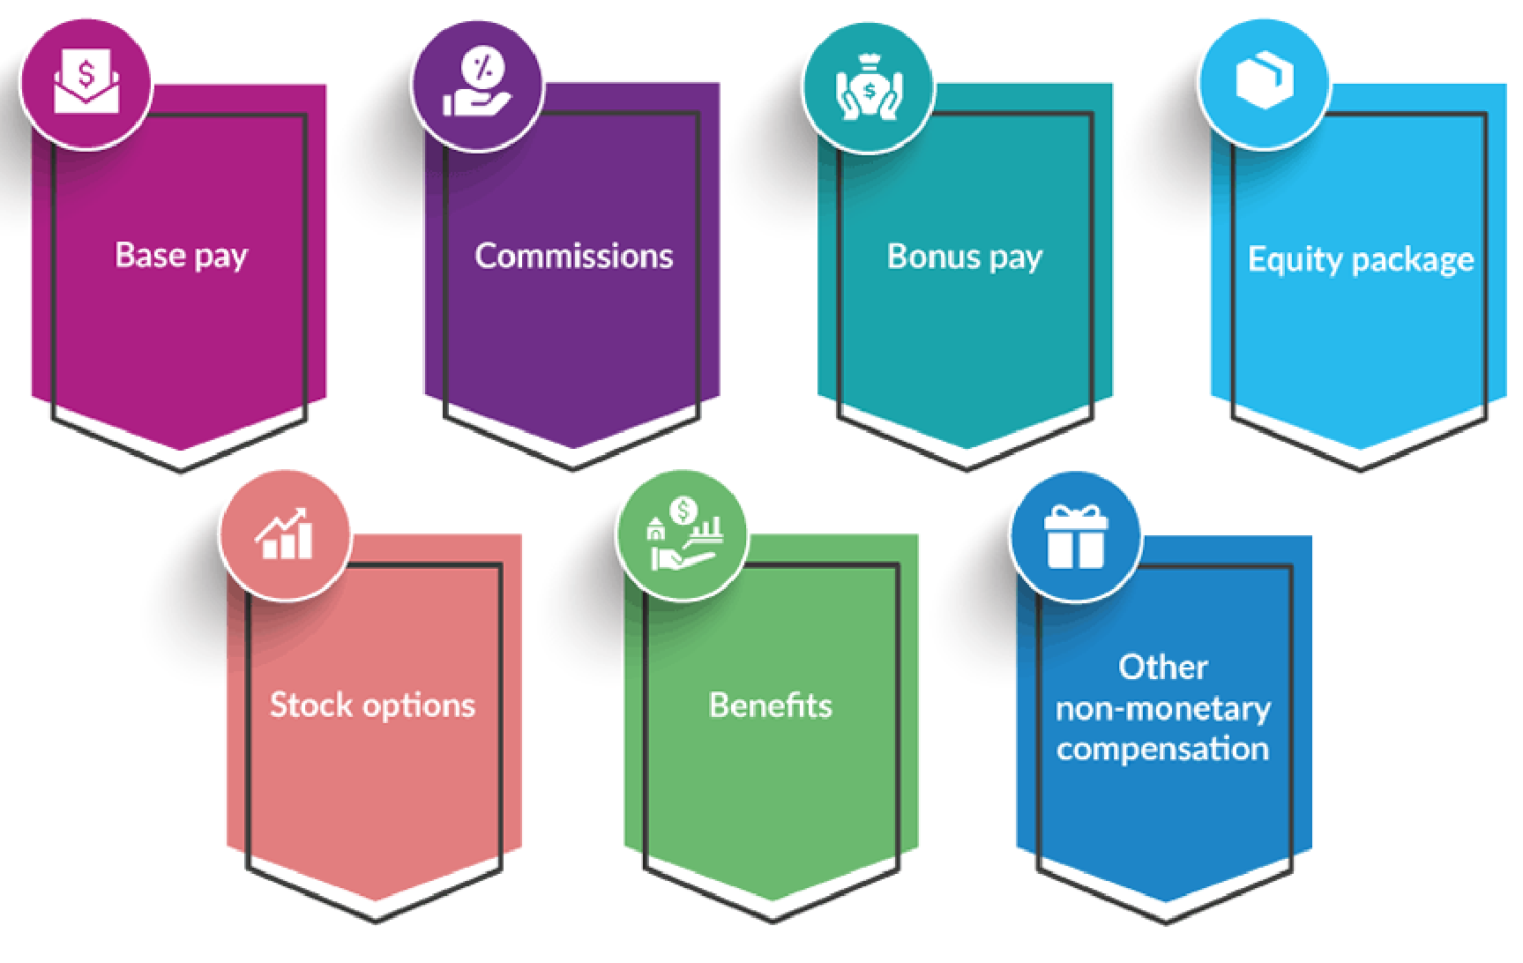

Figure 9 - Types of Compensation

7. Create compensation ranges
Consider developing salary ranges rather than set values after deciding on employee packages.
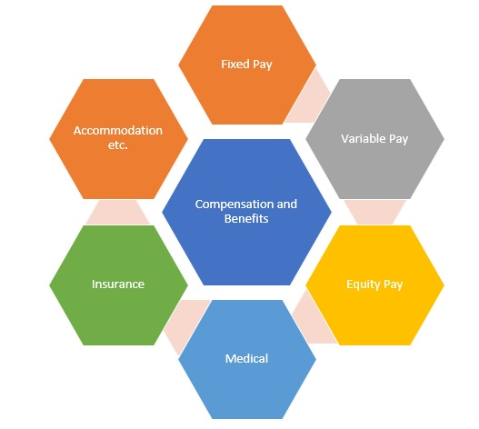
Figure 10 - Compensation and Benefits

8. Check compensation strategy for legal compliance
Make that your compensation approach complies with all applicable federal, provincial, and territory legislation after establishing it.
9. Seek upper management approval
Prepare a report that includes competition strategy, compensation information, and employee feedback for your meeting with higher management.
10. Write the compensation strategy
Write a document outlining the details of the compensation approach after gaining approval.
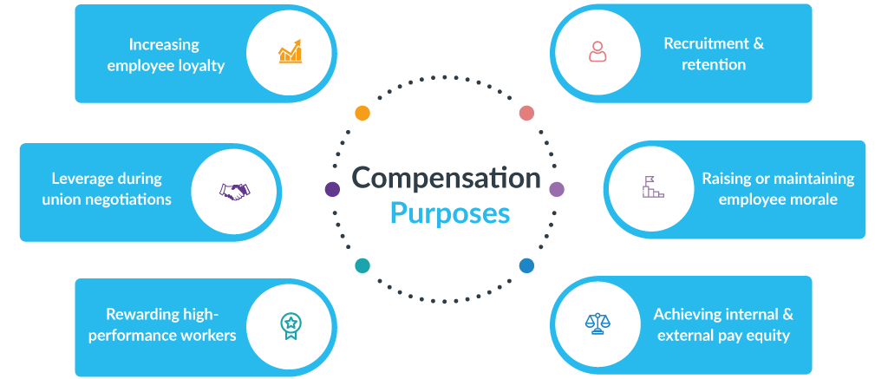
Figure 11 - Compensation Purposes

11. Monitor and review the compensation strategy
Implement the compensation strategy, then monitor the outcomes in relation to the corporate objectives. You can determine the plan's impact by doing this. (Ding, et al., 2006)
Figure 12 - Compensation planning
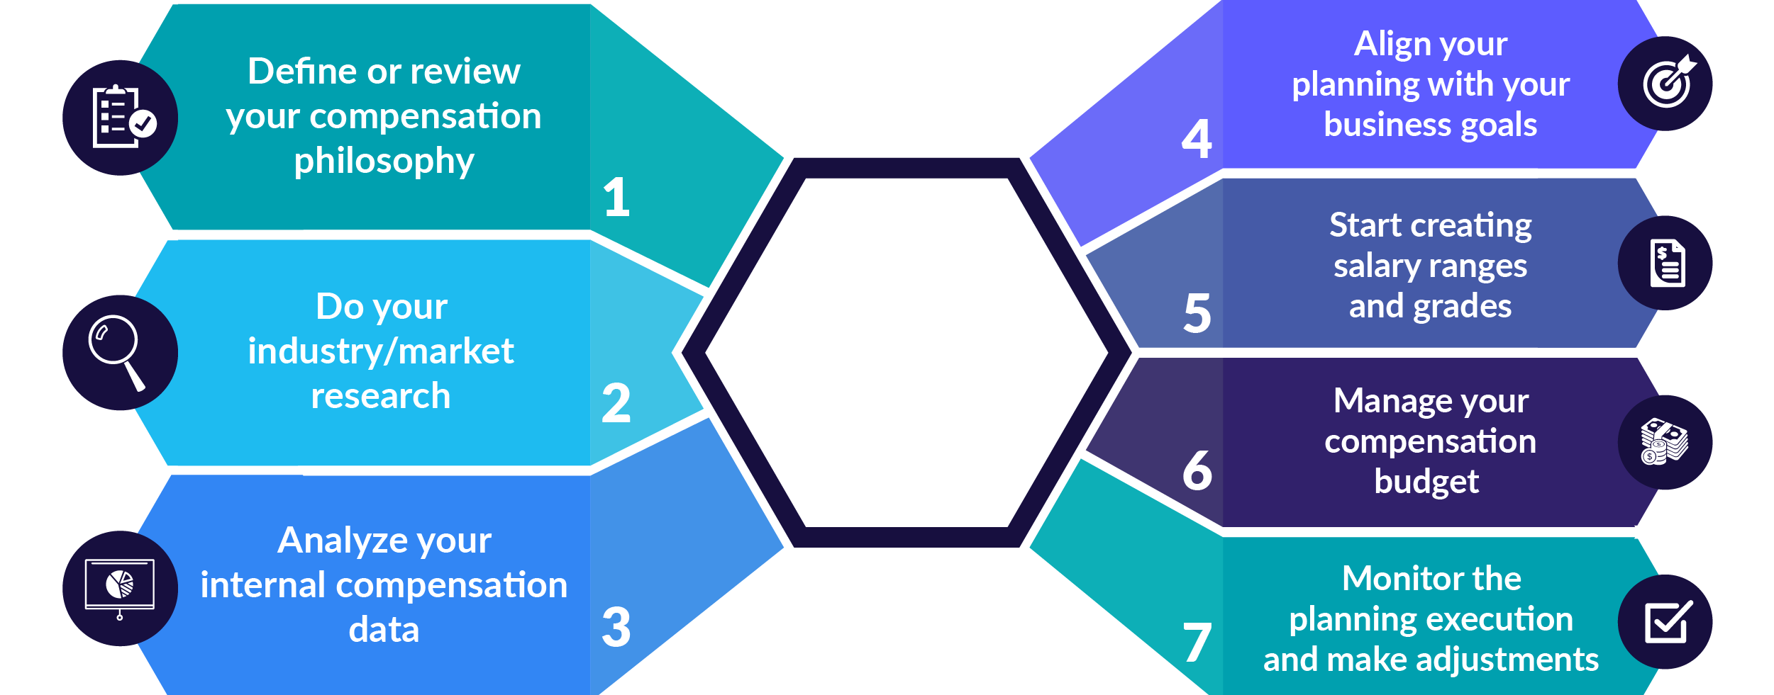

Leadership development
The growth of leaders is intrinsically linked to human resources. By implementing HR Leadership Development programs to teach HR employees important leadership qualities to develop both themselves and others, organizations may openly recognise this connection.
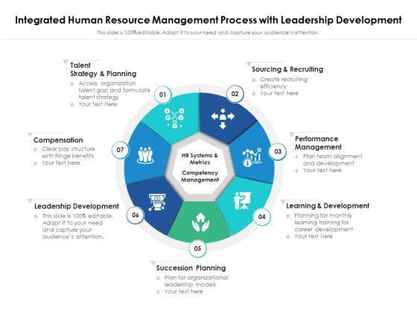
There are two unique facets to developing leaders in human resources. On the one hand, establishing a program for leadership development to ensure strong, viable leadership for the organization is a vital goal for human resources. On the other hand, HR staff members require leadership abilities in order to oversee personnel and provide the resources the company needs to address its business difficulties. (Andries & Sukesh, 2014)
Figure 13 - Integrated human resource management process with leadership development

Outline detailed and appropriate of HR strategies for Leadership Development
The role of HR in creating leaders
Realizing leadership potential and maintaining a program for leadership development may be the most crucial strategic role of HR. This entails taking measures to guarantee that your firm has the appropriate number of skilled leaders to manage workers across the board and that you have a structure and processes in place to provide a consistent, dependable source of leadership talent.
Implementing Training Programs for Leadership Development
Leaders don't just appear out of nowhere. Identification, development, and training of potential leaders are required. In order to create a training program that is integrated into the larger, cyclical process of discovering talent and developing that potential into leadership roles in a sustainable fashion, HR should cooperate with L&D.
Retaining Talent
The cornerstone of effective leadership development is this. You must keep your talent if you want to develop it into leadership ability. HR spearheads measures to make the workplace a desirable place to work, and it provides advantages and incentives that motivate employees to actively explore career prospects within the company in addition to staying with the company.
Using A Team-Based Strategy
HR can provide managers with the resources they need to train and manage their personnel. Building morale and fostering both teamwork and personal initiative are made easier with a clear delineation of roles and duties supported by active communication and an empathic leadership style. As firms vary and grow, and as working habits adjust to new working arrangements, the importance of teamwork is emphasized by the rise in remote working and, as a result, remote management.
pursuing innovative hiring
It could be necessary to hire outside leaders if a firm expands and its business objectives change as a result of external factors. This is simpler if you already have a leadership development program in place and an atmosphere that encourages career advancement, active engagement, and the advantages of teamwork. With these components in place, talent is drawn to your company.
Displaying Emotional Intelligence
The "human" component of human resources is fundamentally emotional intelligence. Understanding, empathizing with, and responding to others is essential, especially when those others are spread across different geographies, have varying histories, and experiences. As essential as how you treat others is how you treat yourself. With emotional intelligence, you become more self-aware, which improves your ability to manage relationships with coworkers.
Employing Organizational Skills
No HR leader can succeed without having a firm grasp of organizational specifics since the scope of HR is so broad and its relationship with a company is so profound. This entails organizing both your own work and other people's work. But encouraging more individuals to self-organize is one of the fundamental components of an organization. Promoting the need for employees to take charge of their own work and growth not only reduces HR's workload but also results in increased independence and self-confidence, which increases productivity as a whole.
Providing Moral Leadership
Typically, HR is both above and below the fray. The perception that HR leaders have among the rest of the organization is greatly influenced by how they present themselves and the leadership style they choose. As a gauge of the environment, they ought to respond creatively to the difficulties experienced by management, staff members, and the entire company. HR executives must conduct themselves in a way that is beyond reproach and morally sound in order to operate as trustworthy middlemen in any resolution. People should be able to approach HR leaders with confidence that they will be treated fairly and can anticipate professional leadership in addition to decisive leadership. (Viitala, et al., 2017)
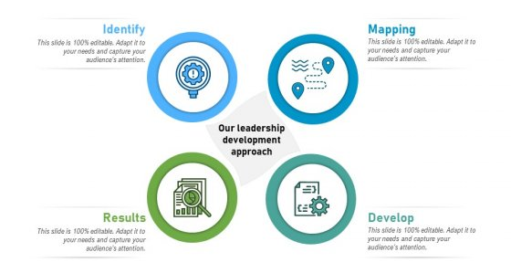

Figure 14 - Leadership Development Process Methodology for successful Management

Demonstration of HR Strategies for Leadership Development that are put on display will help team members feel valued, respected, and like part of our organization.
As a leader, it is crucial that you have a clear understanding of the objectives for the organization and team. Create specific strategies for your team and communicate them to your staff. Include team feedback in your strategic planning meetings by taking it into consideration. This makes you an excellent leader because it's obvious that you value their viewpoint. Additionally, it will provide a platform for novel suggestions that could greatly advance strategic planning.
Determine your advantages and disadvantages, and strive to make the most of each. It is essential to develop your leadership abilities and use them. You can also instruct your team players in these techniques and motivate them to play to their strengths.
Keeping a good attitude in challenging circumstances can help your team develop confidence. A positive quality is optimism, especially when dealing with difficulties and disputes.
A team's success is strongly influenced by its ability to communicate effectively. Improve your communication abilities so you can keep the team's environment open and honest. Additionally, it will inspire the members of your team to generate suggestions for actions that will help you reach your objectives. (Andries & Sukesh, 2014)
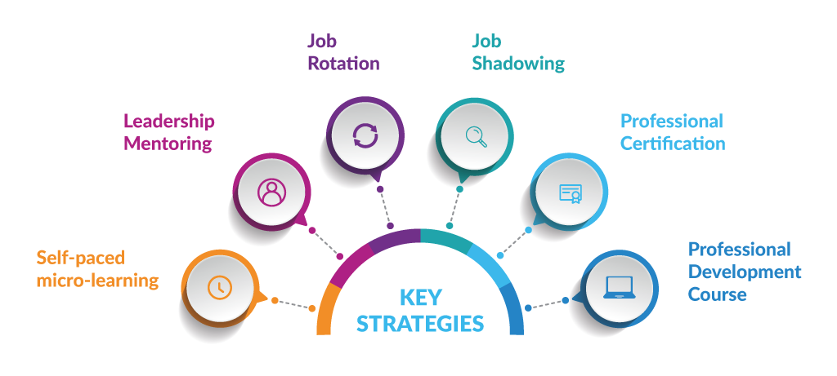
One of the most crucial characteristics of a leader is motivation, whether it comes from within or beyond.
Figure 15 - leadership development plan

The importance of leadership development
Programs for developing leadership have positive benefits on the organization, its dynamics, and its staff. Organizations are increasingly realizing the importance of leaders to the efficient operation of their business.
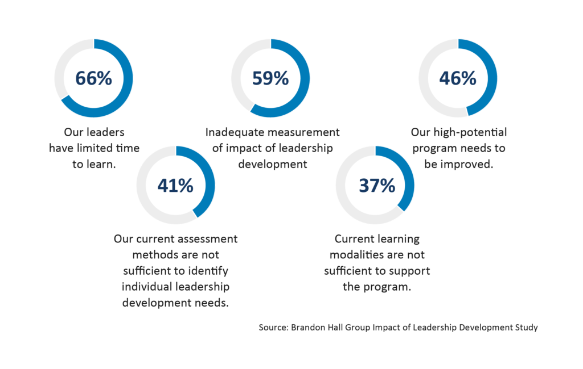
Figure 16 - impact of leadership development
Employer recruitment and retention have benefited from organizations' investments in leadership development.
Leadership development gives leaders the tools they need to boost the output of their teams.
Through leadership development programs, which concentrate on outlining a clear path for individuals who want to assume leadership roles, increased employee engagement can be accomplished.
Future leaders are inspired to develop their leadership abilities by the role models it provides.
In particular when the leadership panel is changing, it guarantees that any leadership gaps are avoided.
An effective leadership development program has a high return on investment. It encourages aspiring managers to take on managerial responsibilities and raises worker productivity. This can also translate into wise commercial choices and tactics.
Programs for leadership development have demonstrated to be significantly effective in enhancing business culture.
It can assist in identifying potential leaders who are able to overcome obstacles in a volatile corporate environment. (Berman, 2015)
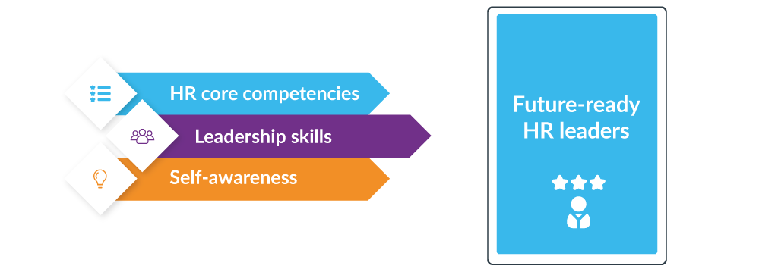
Figure 17 - HR Leadership development program

References
Andries, D. P. & Sukesh, S., 2014. The role of HRM in leadership development, talent retention, knowledge management, and employee engagement.. Auckland, New Zealand, World Business and Economics Research Conference.
Berman, E. M., 2015. HRM in Development: Lessons and Frontiers. Public Administration and Development, 35(2), pp. 113-127.
Ding, D. Z., Akhtar, S. & Ge, G. L., 2006. Organizational differences in managerial compensation and benefits in Chinese firms. The International Journal of Human Resource Management, 17(4).
Fugate, M., 2012. The Impact of Leadership, Management, and HRM on Employee Reactions to Organizational Change. Research in Personnel and Human Resources Management.
Indeed Canada Corp, 2021. What Are Compensation Strategies and Why Are They Important?, Toronto, Canada : Indeed Editorial Team.
NinaGupta & D.Shaw, J., 2014. Employee compensation: The neglected area of HRM research. Human Resource Management Review, 24(1), pp. 1-4.
Rani, S., 2014. Green HRM: Practices and Strategic Implementation in the Organizations. International Journal on Recent and Innovation Trends in Computing and Communication, 2(11).
Simona Iancu, 2020. Compensation Strategy and Culture: 3 Steps to Create Alignment. [En ligne]
Available at: https://www.aihr.com/blog/compensation-strategy/#:~:text=A%20compensation%20strategy%20outlines%20your,base%20salary%2C%20and%20employee%20benefits.
[Accès le 31 July 2022].
Todnem, R., 2005. Organisational change management: A critical review. Journal of Change Management , pp. 369-380.
Tummers, L., Kruyen, P. M., Vijverberg, D. M. & Voesenek, T. J., 2015. Connecting HRM and change management: the importance of proactivity and vitality. Journal of Organizational Change Management.
Tummers, L., Kruyen, P., Vijverberg, D. & Voesenek, T., 2013. Connecting HRM and Change Management: How HR Practices Can Stimulate Change Readiness. Edinburgh, Public Administration, Technology and Innovation.
Viitala, R., Kultalahti, S. & Kangas, H., 2017. Does strategic leadership development feature in managers’ responses to future HRM challenges?. Leadership & Organization Development Journal.

