Digital Transformation in Hospitality and Tourism
Student number:2124124
Student name:Oana Manta

Introduction
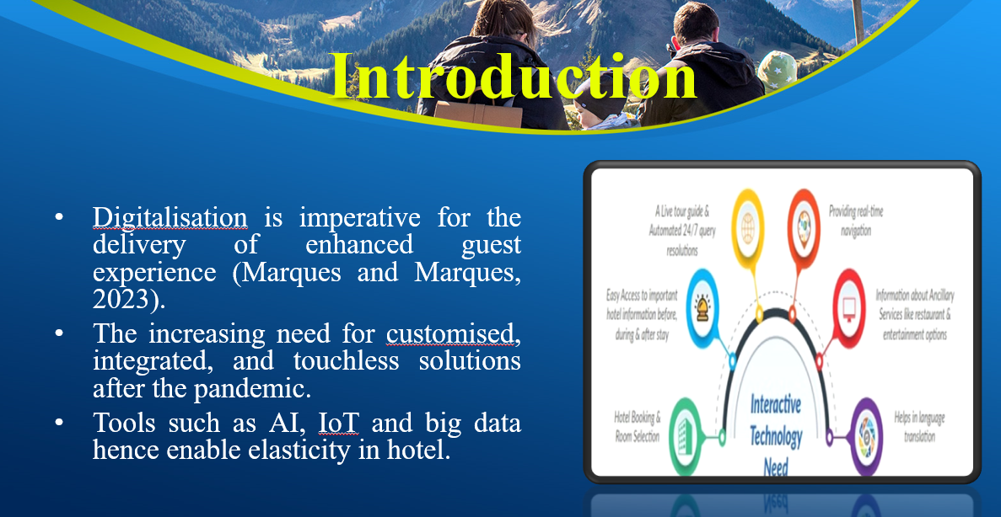Speaker notes
Adaptation of digital technologies has become essential for the hotel and the hospitality industry that provides approaches for improving guests’ satisfaction, managing the firm’s functioning, and ensuring its sustained viability. Technological advancement that has overtime created consumer awareness of personalized services and integrated solutions borne by the COVID 19 health crisis creates both a challenge and an opportunity to the industry. AI, IoT and big data, for example, have become indispensable solutions for generating effective change that creates flexible frameworks for operating in today’s milieu.

Importance for Hospitality and Tourism
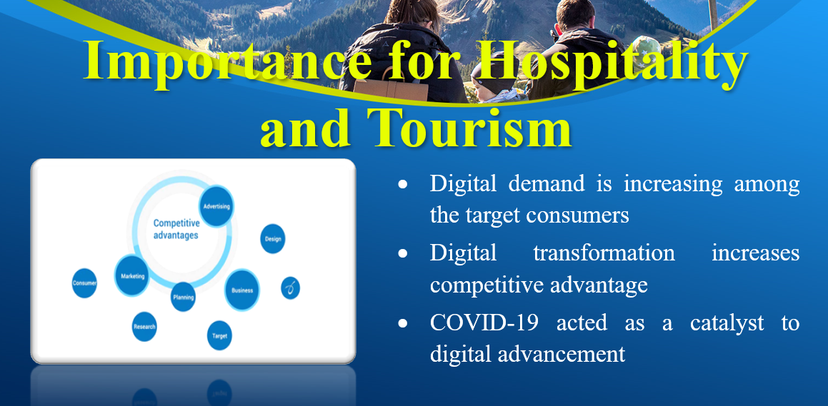Speaker Notes:
Digital transformation fulfils the growing customer needs for digitalisation as consumers expect easy and customised services. It provides competitive advantage since it can automate work processes and offer better services to its clients. The analysis highlighted that the pandemic influenced the decision to go digital as customers needed less physical interaction.

Industry Background
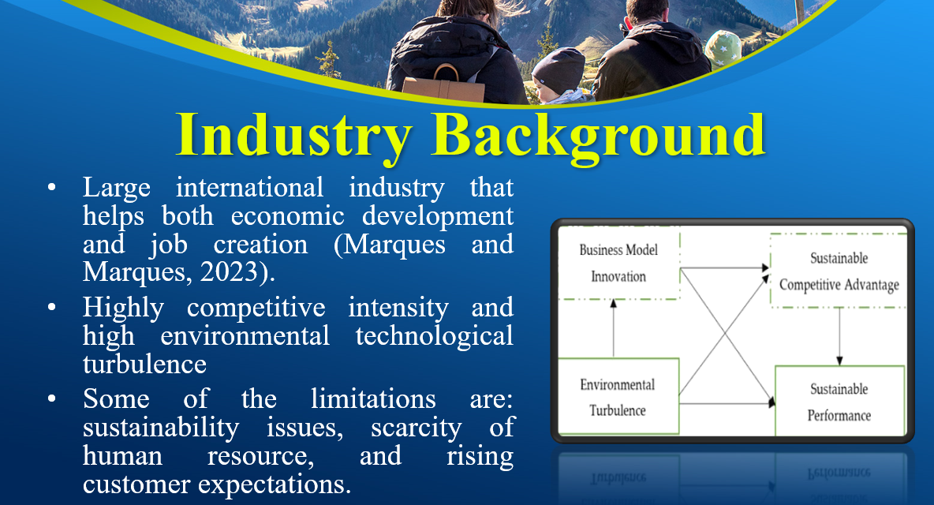Speaker Notes:
Hospitality and tourism industry is one of the biggest world industry providers and job creators. It covers everything from providing lodging to providing leisure, to customers and clients in the global market. The sector has tremendous competition and is influenced by changes in the angles of technology that include online booking and uses of data to create unique services.

Literature Review
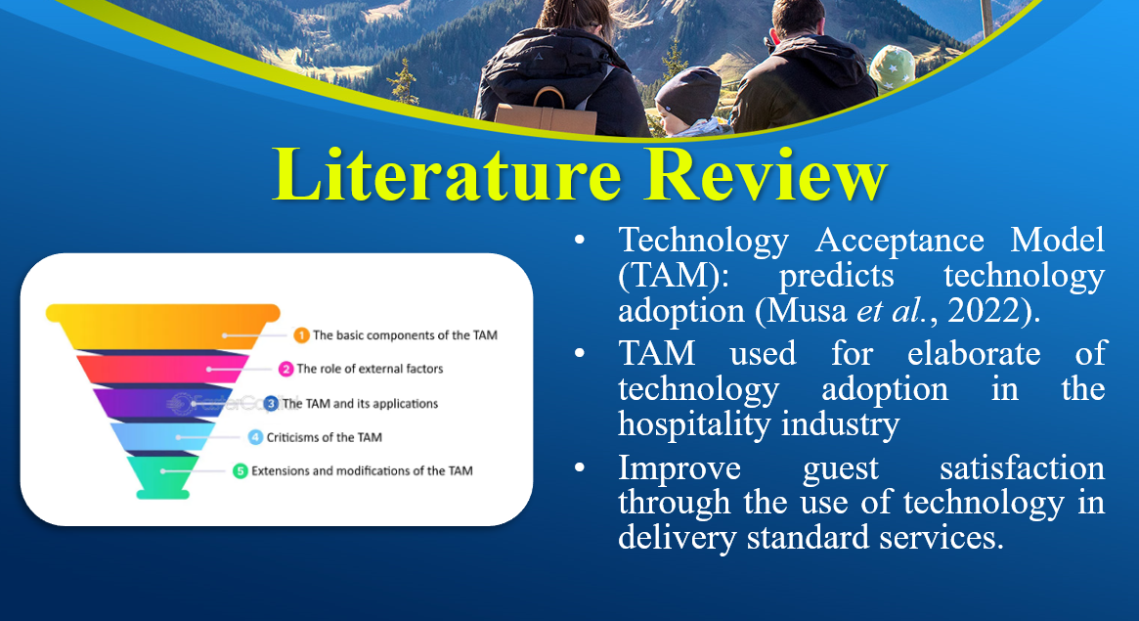Speaker Notes:
Technology Acceptance Model (TAM) is used commonly to study how a user adopts a particular technology which depends on perceived usefulness (PU) and perceived ease of use (PEOU). In hospitality, TAM makes it easier to forecast customers’ acceptance of the use of such digital technologies as the mobile application and artificial intelligence services that improve the efficiency of a smooth and individual approach to guests.

PESTEL Analysis
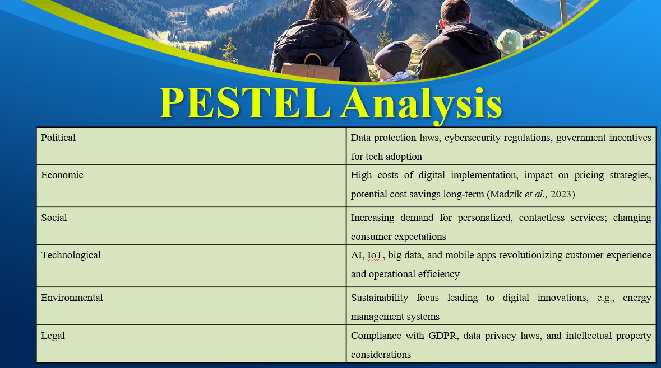Speaker notes
The analysis in terms of PESTEL provides information concerning the external factors affecting digital transformation in hospitality. In the political context, DP laws influence how organisations handle the identity information of their customers. From an economics point of view, digital enhancements are expensive in the short run but economical in the long run. Concerning an economic perspective, social trends give focus on the need to have personalized services. In terms of technology the notions such as AI and IoT improve guests’ experiences. Environmentally, sustainability programs are aided by energy-efficient technology while legally, hotels have the issue of data privacy.

Industry Responses to Digital Transformation
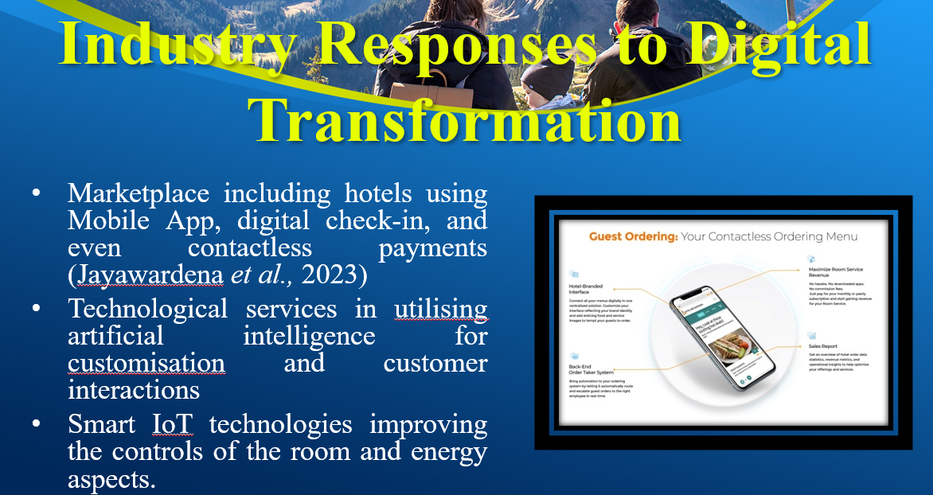Speaker Notes:
Through adoption of digital transformation, hospitality industry has adopted different technologies to enhance guest’s experience and business operations. Many hotels including Marriott and Hilton have gone further to enable their customers check in with their mobile phones, transact with their rooms through the App and have their needs attended to by robots or virtual assistants. IoT mainly includes room automation and energy savings whereas big data is beneficial for modifying the marketing techniques.

Strength and limitation
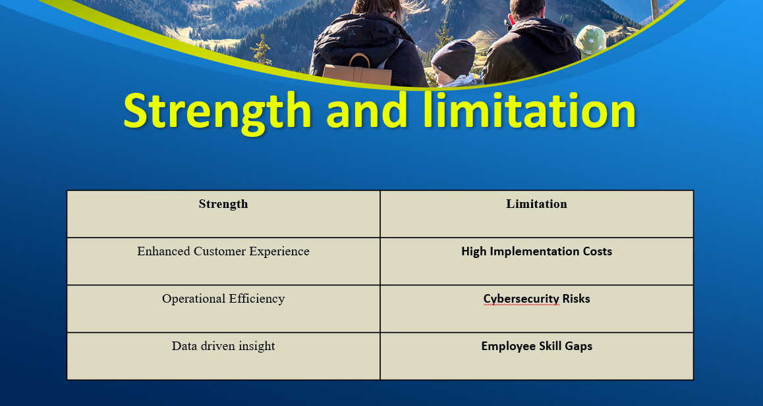Speaker notes
Digital transformation in the hospitality industry presents significant strengths such as customer experience, operational value, and customer experience which can advance service tenderness and sustainability. Nevertheless, it is crucial to pay for it, especially for the small and medium businesses while its use entails cyber security factors, and there is a need for constant training for the employees. However, attention should be paid to their protection to meet the requirements of customers, thus the need for moderation.

Recommendation for evaluating Future Policy Options
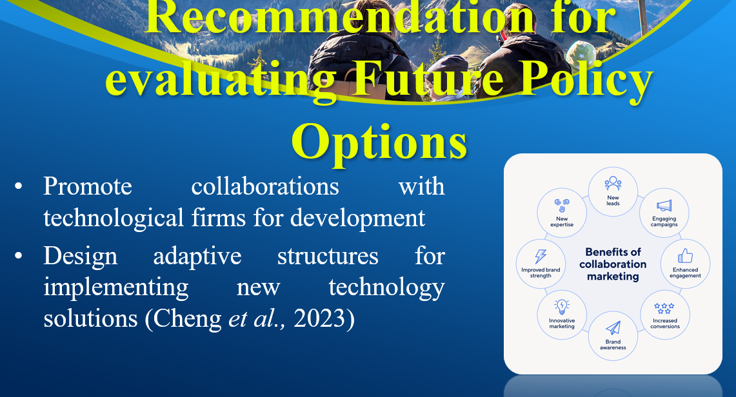Speaker Notes:
It’s recommended that future policies concerning hospitality should address issues of data privacy and security in order to protect the data of guests. Organisations’ training will educate its employees on how to go about the technological tools, thus improving services delivery.

Management Options for Digital Transformation
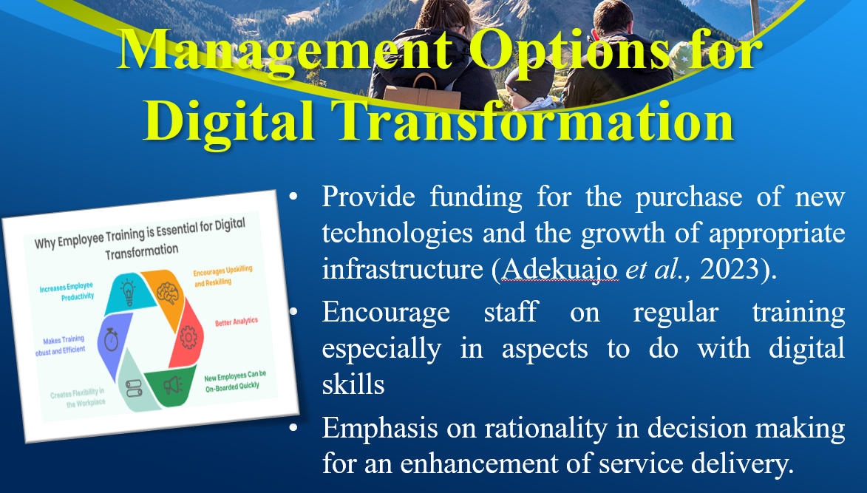Speaker Notes:
The best management strategies for implementing digital technology in hospitality are resource funds for implementing the IoT and AI and investing in infrastructure. Updating digital skills incrementally becomes crucial if one has to deliver good digital service. Stressing more on operational controls enables the managers to personalize service delivery by focusing the one guest preferences, and firm specific touch points such as guest’s mobile applications increases customer interactions.

Conclusion
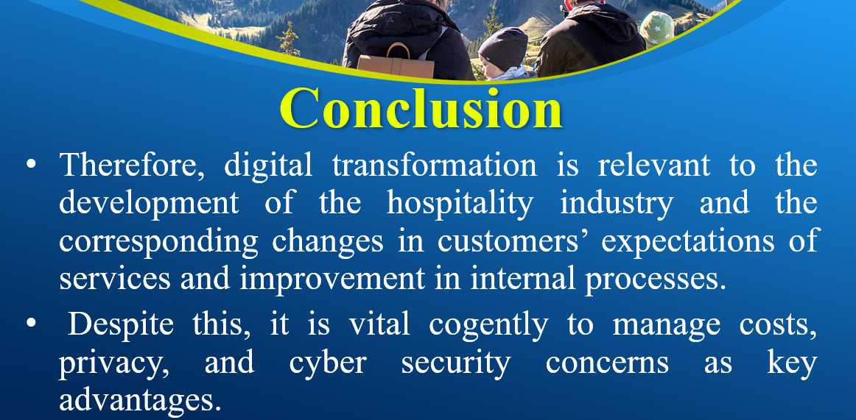Speaker Notes:
Presently, a strategic investment in working capital and training will consequently produce sustainable competitive growth in what is becoming an increasingly competitive market.

References
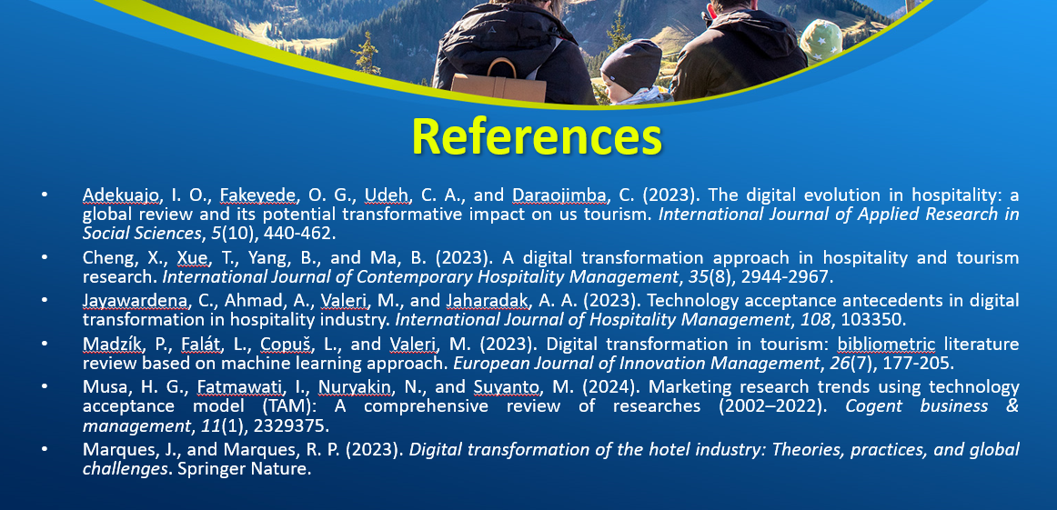
Adekuajo, I. O., Fakeyede, O. G., Udeh, C. A., and Daraojimba, C. (2023). The digital evolution in hospitality: a global review and its potential transformative impact on us tourism. International Journal of Applied Research in Social Sciences, 5(10), 440-462.
Cheng, X., Xue, T., Yang, B., and Ma, B. (2023). A digital transformation approach in hospitality and tourism research. International Journal of Contemporary Hospitality Management, 35(8), 2944-2967.
Jayawardena, C., Ahmad, A., Valeri, M., and Jaharadak, A. A. (2023). Technology acceptance antecedents in digital transformation in hospitality industry. International Journal of Hospitality Management, 108, 103350.
Madzík, P., Falát, L., Copuš, L., and Valeri, M. (2023). Digital transformation in tourism: bibliometric literature review based on machine learning approach. European Journal of Innovation Management, 26(7), 177-205.
Marques, J., and Marques, R. P. (2023). Digital transformation of the hotel industry: Theories, practices, and global challenges. Springer Nature.
Musa, H. G., Fatmawati, I., Nuryakin, N., and Suyanto, M. (2024). Marketing research trends using technology acceptance model (TAM): A comprehensive review of researches (2002–2022). Cogent business & management, 11(1), 2329375.

