Marketing Fundamentals Analysis and Evaluation
Module: Marketing Fundamentals

Student Name: Atanas Antonov
Student ID: 2011641
Module Code: LCBB4004

Table of Contents
Introduction 3
Discussion 4
Conclusion 11
References 13

Introduction
A strategic marketing approach is a crucial aspect of business expansion. In recent times almost all companies maintain the quality of their products and services. So the right marketing is the only way to eliminate the competition from the existing market. Marketing is a type of Communication Bridge that helps to connect the customers and the company. So the relationship with customers depends on the strength of this bridge. Building relationships with customers is more important than producing a product without analysing the market well. Marketing helps to build relationships with stakeholders of the company, and the right relationship helps to increase the engagement of the stakeholders in the company. So these rotate as a cyclic order. This essay is going to cover up all of these factors with a critical analysis.

Discussion
The role of marketing in creating value for customers
Marketing is the only way to reach potential customers directly or indirectly. So the organisation pressurises the marketing and sales department to be strong and move strategically. Marketing helps an organisation to explain their products or services to the people. With the help of marketing, an organisation can attract customers to it. This way, an organisation increases sales (memobookfredf - Download Principles of Marketing 16th Edition Ebook PDF, 2021).
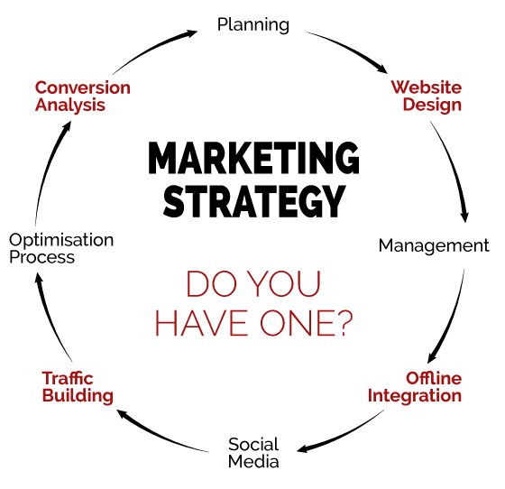
Fig 1:- Marketing strategy
Sources - (Islaini and Nayan, 2020)
In recent times, people are getting over traditional marketing practices and adopting new techniques. Nowadays, the marketing and sales department uses marketing strategies to create and increase values. This strategic marketing is based on marketing theories, and these theories are based upon the process and stage of marketing. This process and stage of marketing can be different from company to company. But still, the roles of the process and stage are the same for all types of organisation. These roles are marketing environment, research of marketing and marketing mix. The stage and processes of marketing consist of four elements too. These elements are marketing control, marketing mix, marketing analysis and marketing implementation (Islaini and Nayan, 2020).
The marketing environment is one of the crucial factors of an organisation to start marketing planning or marketing analysis. Before a company starts marketing planning, it should observe the internal and external marketing environments. The entire strategy should be dependent on these environments. These environments influence the potential customers of the company. The external and internal environments are divided into six parts. These parts are economic, political, social, technical and legal. Each of these parts consists of some components. These components are the actual internal and external environments that influence marketing planning (Mothersbaugh, Hawkin and Kleiser, 2019).
An organisation should have to research a particular geographical area before making a marketing plan for the product. The data can help the organisation know about the people's habits, purchasing power, demands, availability of other resources and so on. Political factors are considered as external factors of the organisation. The components of the political environment are political stability, political orientation, types of government and the corruption level. An organisation should start marketing analysis by considering these components of political factors. If the political condition is not stable in a country or state, then that organisation may not create ultimate value for their customer. The economic factor is also considered as an external environment for marketing analysis. The components of the economic factor are inflation, taxation, GDP of the country, the strength of the currencies, the unemployment rate of the country and so on. To build a strategic marketing plan, the organisation must consider these components.
The strength of currency and inflation rate of a country dramatically impacts the total revenue. If the currency's strength is high, the organisation may need less money to purchase raw materials from another country. This will save the expenses of the company. When it sells the product to its origin country, it will get more revenue due to the high currency strength.
The components of social factors are considered as internal environments. The behaviours of employees of an organisation are one of the main components of the social factor. Generally, companies hire employees from the local area to improve the financial growth of the locality. Now, if the locality people are self-motivated, they can provide the best performance for the organisation. With the help of those efficient employees, the organisation may grow rapidly. The opposite may happen too. An organisation may fail due to its deficiency of talented employees.
The components of technical factors are considered an internal environment. These components are the technical skill of the employees, technical health of a company, machine and tool usages of the company and so on. To provide the ultimate value to the customers, only self-motivated employees are not enough. These employees need to show technical competence to the company. A company should focus on acquiring hard skills and soft skills. To make the marketing strategy, both of these skills are required. Technical competence is considered a hard skill. If a company believes in automation, it will have more advanced machines and tools to complete tasks quickly by maintaining quality. This will help companies to scale the business by maintaining customer satisfaction.
The components of legal factors are considered as external environments for a company. The components of the legal factor are employment laws and policies, and competition laws. These are some laws that influence the marketing of a particular company. It means a company can't sell products or services according to its own rules. The company has to obey the government rules first to build a marketing strategy.
After analysing the marketing environment, a company should proceed to the next step. The next step is marketing research. Marketing research helps a company to understand the condition in the existing market. The marketing research helps an organisation know the market demand, sales information, alternative way to do the business, competitive analysis, finding new opportunities, the company's position in the market, acceptance of the new product, existing products conditions and demands, etc.
Finding the new sources of a cheaper supply chain is one of the main opportunities of doing market research. The supply chain takes most of the investment of a company. So the industrial revolution prefers the lean supply chain model for all companies. By applying a lean supply chain, a company can reduce its costs. The company may use this excess amount of money to improve customer services. Customer experience is dependent on the customer service of a company, and the customer experience is directly proportional to customer satisfaction. Improving customer service is equal to creating value for the customers of a company.
Creating value for customer means, to solve customer's problems at any costs. Customers will pay a certain amount of money to the company to buy products or services. Now, if the products or services can't solve customer's problems, customers will go to that company's competitors. So creating value for customers is essential for customer retention too. A company can be sustainable if it successfully retains customers (Kotler, Kartajaya and Hooi, 2017).

Fig 2:- Market threat and opportunity
Sources - (Morgan, et.al., 2019)
By doing market research, a company can get information about the potential market threats too. The market threat is such a thing that can disrupt a particular marketing strategy. Market research can help a company to know about the significant gaps in its marketing strategy. The right marketing strategy should have a plan B. The only plan is not applicable for the marketing industry. This is a trial and error process. So this is mandatory to have a plan B. Plan B will work as a safety net for that company. The ultimate aim of the company is to solve its customers' issues with its products or services. If the company observes that the existing market has a potential threat, it can find its path to solve the problems (Morgan, et.al., 2019).
For example, steel sheets are required to make vehicles. Currently, the price of raw materials (steel sheet) of the vehicle industry is increasing in the whole world. For this cause, the price of vehicles is also growing right now. Due to the high cost of vehicles, a lesser number of people will be able to afford them. Now, this is a market threat for vehicle companies. But Tesla Motors has grabbed the innovation and technologies to solve this problem strategically. They started to make electric vehicles to beat the traditional vehicle market. They began to create environmental awareness among people. Due to awareness, people have begun to shift towards electric vehicles. These electric vehicles are providing more values than traditional vehicles. These are helping to maintain the brand value in front of customers also. Thus, this is how Tesla Motors has faced market threats and has eliminated them strategically (Jing, 2020).
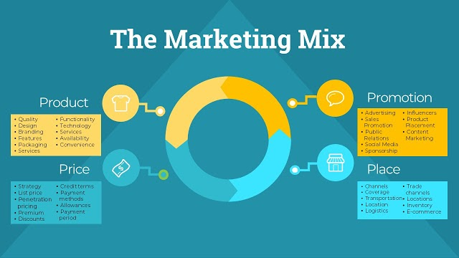
Fig 3:- Marketing mix
Sources - (Mahmoud, 2019)
After analysing the market research, the next step is to apply the marketing mix concept to know whether the current marketing strategy is suitable or not. Marketing mix theory consists of four factors. These are product, price, place and promotion. This is called the 4ps of marketing as well. The role of the marketing mix is to understand and evaluate the pricing strategy, effectiveness of the procedures and systems, advertising strategy, place of the market, customer experience, service innovation and so on (Mahmoud, 2019).
A company should focus on building its product more efficiently to solve a particular problem. Marketing is almost impossible if the product is not valuable enough. A well-constructed marketing strategy may increase sales for a company. Moreover, to retain customers, the quality of the product should be improved. Quality of the product is the first step of marketing. In recent times the quality of the product is not the only parameter to enhance sales. Brand value is now an important parameter that needs to be considered. Nowadays, people want to purchase branded products to maintain their status symbol. If a company's product does not offer brand value, then that product will be considered negligible in the current market (Kotler, 2017).
For example, lots of companies are making electric vehicles right now. But high society will not prefer any other electric vehicle brand except Tesla Motors. This is happening just because of Tesla's marketing strategy and image. Tesla has penetrated the market as a premium brand. So despite the same quality, Tesla Motors is charging more money for a single electric vehicle than other vehicles brands (Handa, 2020).
Pricing strategy is one of the essential strategies of marketing. The company should remember various factors while setting up a price for its products and services (Kumar, 2017). The company should know people have the ability to buy one product in a different price range. So the company will not face the deficiency of customers. But this can happen if the company can't use the pricing strategy well. If the price of a specific product is high, that means that the product is solving a bigger problem in the existing market. For example, the Model S (product of Tesla Motors) cost is approximately $ 73000 in the current market. Now, why does Tesla Motors put this enormous amount of price tag on its vehicle? How are people buying vehicles at such a high rate? This is just because of its brand value. People will feel luxurious if they buy this particular premium car. Tesla has marketed their products as premium products. So they have the authority to demand this amount of price for a single electric vehicle.
The place is another factor in marketing mix theory. A company can't generate sales if it is not able to choose the right place. The right place is very much essential to expand the business. The right location can give the right opportunities for a company. For example, if a restaurant company opens an outlet in a remote area, that outlet may not get customers due to its lack of awareness. The remote area might have inhabitants who cannot afford to eat out regularly. However, if that place is a popular tourist spot, there is a possibility of getting customers. So that restaurant should check the place, analyse their scope of expansion, and then move forward. If that company opens an outlet in a popular urban area, the possibility of getting customers will increase higher than that remote area. This way, a restaurant company can increase its sales by choosing the right place (Sukmanegara, 2020).
Promotion is one of the most important parameters in the marketing mix theory. Promotion is directly linked with the marketing strategy. This strategy is considered as the advertisement of the product. A quality product may not get a single sale if the ad is poor. In recent times, advertising is primarily dependent on online platforms. Social media marketing, digital marketing, email marketing, and SMS marketing are penetrating gradually in the traditional advertisement system. By only advertising, people can know about the products or services. By digital marketing, the companies are targeting their potential customers directly. They are using traditional marketing such as TV or radio ads, billboards, templates, and newspaper ads to build brands and networks. But they are using digital marketing for increasing sales at a time (Kannan, 2017). Email marketing is the most effective way to increase sales. Through this method, the company can send emails directly to customers (Shams, et.al., 2019).
These are some fundamental roles of marketing. Without marketing, a company can't create value for their customers. Currently, various companies create values for their customers through effective marketing strategies. They first analyse the environment, research the market, and apply marketing mix theory to build a sustainable marketing strategy.
Stakeholder engagement and their impact on the marketing activities of an organisation
Stakeholders are the most critical part of a company. Due to efficient and active stakeholders, a company gets an opportunity to expand. If the company wants to generate more revenue annually, it needs to engage its stakeholders through an effective marketing strategy. Marketing is such a weapon that builds a connection between products, the customers, and the company's employees. With the help of effective marketing activity, the engagement of the stakeholders of a company increases (Brown, 2020).
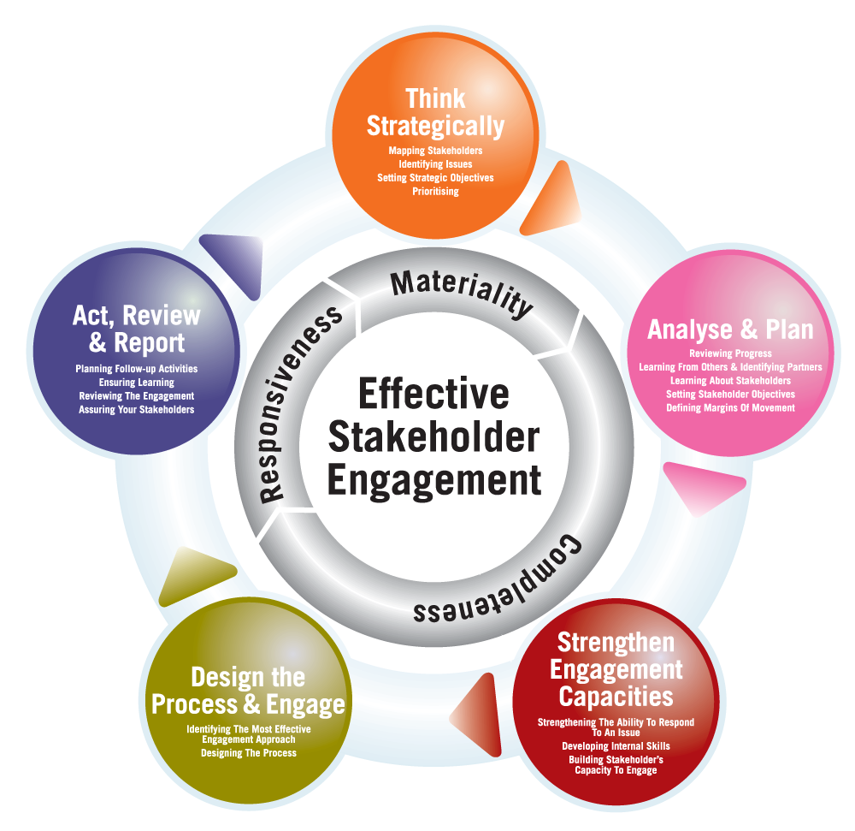
Fig 4:- Stakeholders’ engagement
Sources - (Domegan, et.al., 2019)
All employees, vendors, retailers, customers are considered as the stakeholders of a company. Now, if the stakeholders of the company are active means the company is growing. The marketing strategy helps to align the stakeholder's demand with the production. It means a company produces more products if the demand for the product is more. Now demand for the product will be more if the internal stakeholders are managing the internal procedures well. So these all parameters are interconnected. This type of engagement helps to build a plan for the advertisement. At that time, the company takes more risks to extract profit from the market. Stakeholders engagement helps to improve the marketing activities holistically (Domegan, et.al., 2019).
A marketing project manager is the top post of any company in the marketing and sales department. So anyone can't be there to maintain the job role. The marketing project manager should be effective enough to maintain relationships with internal and external stakeholders of a company. He/she needs to make the company's marketing strategy according to the relationship.
The other departmental managers of a company also maintain the same roles. They make the relationships strong to improve the engagement of different stakeholders. These managers or team leaders apply promotional strategies to employees to engage them. This is only possible with the help of effective communication. Employees get proper recognition with the help of promotional activities, and they become more productive. This helps to maintain a healthy internal organisational culture. If the corporate culture is healthy, then the customers of this company will be satisfied automatically, and the satisfaction of customers helps to improve the marketing strategy of that company.

Conclusion
To improve the rate of sales, marketing is the most important tool. A company can get improvement with a combination of three factors. These factors are products, brand value and marketing strategy. All these three factors are very much crucial for a company's growth and sustainability. Customers of a company observe the values first. The right marketing strategy helps to increase customer value. Stakeholders are equally important with the marketing strategy. Stakeholders' engagement helps to improve the marketing strategy for a company. If the stakeholders are inactive, then the marketing strategy can't bring revenue for the company. This essay has discussed these aspects with examples to understand the concepts better.

References
Brown, D.M., 2020. Internal Marketing: Theories, Perspectives, and Stakeholders. Routledge.
Domegan, C., McHugh, P., Flaherty, T. and Duane, S., 2019. A dynamic stakeholders’ framework in a marketing systems setting. Journal of Macromarketing, 39(2), pp.136-150.
Handa, M.B., 2020 Constant Rise of Tesla Inc.: Strategic Marketing Plan Leading To Company’s Colossal Growth in 2020.
Islaini, M.A.A. and Nayan, S.M., 2020. The Role of Price in the Marketing Mix. Journal of Undergraduate Social Science and Technology, 2(2).
Jing, X.U., 2020. Analysis of the Operation Strategy of Tesla Inc. in China. Frontiers in Economics and Management Research, 1(1), pp.21-25.
Kannan, P.K., 2017. Digital marketing: A framework, review and research agenda. International Journal of Research in Marketing, 34(1), pp.22-45.
Kotler, P., 2017. Philip Kotler: some of my adventures in marketing. Journal of Historical Research in Marketing.
Kotler, P., Kartajaya, H. and Hooi, D.H., 2017. Marketing Tactic For Value Engagement. World Scientific Book Chapters, pp.191-211.
Kumar, R.R., 2017. SERVICE MARKETING: AN OVERVIEW.
Mahmoud, T.O., 2019. Green Marketing: A Marketing Mix concept. International Journal of Electrical, Electronics and Computers, 4(1), pp.20-26.
Morgan, N.A., Whitler, K.A., Feng, H. and Chari, S., 2019. Research in marketing strategy. Journal of the Academy of Marketing Science, 47(1), pp.4-29.
Mothersbaugh, D.L., Hawkin, D.I. and Kleiser, S.B., 2019. Consumer behavior: Building marketing strategy. McGraw-Hill Higher Education.
Shams, S.R., Vrontis, D., Weber, Y., Tsoukatos, E. and Galati, A. eds., 2019. Stakeholder engagement and sustainability. Routledge.
Sites.google.com. 2021. memobookfredf - Download Principles of Marketing 16th Edition Ebook PDF. [online] Available at: <https://sites.google.com/view/memobookfredf/download-principles-of-marketing-16th-edition-ebook-pdf> [Accessed 17 April 2021].
Sukmanegara, R., 2020. Marketing Mix.

