
Managing Enterprise in the 21st Century
Module Assignment Submission
Students Names: | Amir Adibmehr, Alexandra Alan, Crina Razoare, Dwayne McDaid, Rebecca Williams
Students Numbers: | P, 1811559, 1811696, 1811561, 1811604
Module No: | BMSK4006
Module Title: | Managing Enterprise in the 21st Century
Statement of Confirmation of Authenticity
By the act of making this submission, the student declares that this is the work of the student named above. The work has not, in whole or in part, been knowingly presented elsewhere for assessment, or where assessment has been built on a previous assessment, this has been identified. Where materials have been used from other sources it has been properly acknowledged. If this statement is untrue, the student acknowledges that an assessment offence has been committed.
Attention is drawn to the plagiarism and unfair practice policies of both the University and of ILM.
Permission for ILM to use this script
ILM uses learners’ submissions – on an anonymous basis – for assessment standardisation. By submitting, both the centre and the learner agree that ILM may use this script on condition that identifying information is removed. However, if you are unwilling to allow ILM use this script, please refuse by ticking the box: □



Rainbowws

Sky’s the limit
LGBTQ Wedding Service

Rainbowws.com
Contact: 07709282769
Email: info@rainbowws.com

BMSK4006 –Crina Razoare, Amir Adibmehr, Alexandra Allan, Rebecca Williams, Dwayne McDaid

Table of Contents
Executive Summary 3
Business Idea: 4
Markets and Competition 6
Market Overview 6
PEST(LE) Analysis 6
SWOT Analysis 8
Competition 10
Sales and Marketing 12
Marketing Objectives & Product Positioning 12
Marketing & Sales 13
Management 14
Key Personnel 14
Operations 15
Premises and Equipment 15
Financial Forecast 16
Sales 16
Cashflow 17
Profitability 17
Financing 19
Personal profile: 28
I am a punctual and a reliable person who works well under pressure. I am able to work both in a team environment and on my own initiative. I have a friendly disposition and have a good sense of humor. I have been in an administration position for more than 5 years. My goal is to work for a reputable employer in an administration role or human resources. 28
Key skills and Experiences: 28
References 44
Bibliography. 47

Executive Summary
• LGTBQ Wedding Party Planning Service

• Our Target market are LGBTQ couple who are looking for ideas, vendors and suppliers for their wedding party

• We will obtain customers through Targeted Advertising and Wedding Exhibitions

• We have five partners who all mange a certain aspect of the company. Decorations & Flowers, Food & Catering, Music and Entertainment, Customer Relations and Event Co-Ordinator

• We are an out LGBTQ company who are socially conscious. We use recycled materials for our internal operations and donate 10% of profits to LGBTQ charities every year.

• Our start up costs are minimal, our operational costs are low and we plan to make £33,638 in profit in our first year and

• We will be investing our own seed money and looking for a small grant from the Princes trust. Further than that we may only need a small business loan of less than £2,000 to start

Business Idea:

Rainbowws is a LGBTQ specific wedding service.

We are wedding party specific broker who target the LGBTQ community who are looking to get married. We find the best deals for our customers; specializing in arranging flowers, decoration, food and entertainment.

Owners and Managers:

Crina Razoare
Amir Adibmehr
Alexandra Allan
Rebecca Williams
Dwayne McDaid

Business Type:

Partnership – The business will be partnership with equal shares of profits and losses. We understand we have unlimited liability however due to the nature of our business combined with insurance we have very limited liabilities.

Service Details:
From our research we found that wedding want to source their own attire/dress, rings and venue. That is because these are the more personal aspects of the wedding day.

The latter part of most wedding days is the party, where the newlyweds share their day with their closest friends and family. The wedding party is mostly not about pleasing themselves but their guests.

This is where we come in.

We help couples find arrange the decorations/flowers, entertainment and food, for the wedding party.

Through one to one meetings, phone calls and emails we will identify our clients wants and desires. We will scour the market and contact suppliers and service providers on behalf of our customers and find the best price for the customer’s needs.

Weddings are hugely expensive, the saving our customer’s get will mean they can spend more on their dress, rings or even honeymoon.

Furthermore, our service will mean the customer’s save time and effort obtaining the decorations and services they need, whilst getting exactly what they wanted and at the best price.

By being a broker, the customers are not restricted to the suppliers and providers of the location provider or wedding planners.

As we are strictly a service, with no premises so we have minimal overheads. This keeps our running costs low and means we can pass these savings on to our customers.

Future Success:

Due to the nature of the service provide we are not necessarily limited to the LGBTQ community. To make sure we reach our sales target we can expand our services to heterosexual couples with a lot of ease.

We could also expand the amount of services we offer. Upon the original we could also partner with vehicle fleet owners to arrange transport to and from weddings/wedding parties.

Markets and Competition

Market Overview

Since 2012 the proportion of the UK population whom identify as either a lesbian, gay or bisexual has increased from 1.5% to 2%. In 2017 there were an estimated 1.1 million people aged sixteen and over that identified as either a lesbian, gay or bisexual. Office of National Statistics (2019).
7,019, that is the number of same sex marriages that happened within the UK in 2016, out of that figure, 55.1% were females. Office of National Statistics (2019).
Due to these figures we can see a trend, majority of same sex marriages involve females.

PEST(LE) Analysis

Political:
The Same Sex Marriage Act 2013, as discussed by Legislation.gov.uk (2013), enforces our local government to allow and bless same sex marriages. Brexit could be an issue for the same sex marriage scene, this assertion is based on how the economy as a whole may be effected as a whole thus disallowing potential clients to afford our services, a solution to such an issue would be to offer a payment plan suited to the client’s availability and finances.
Economic:
The office of national statistics (2019) publish live statistics in the form of a graph on the unemployment rates within the UK (see appendix one). Unemployment rates are seen to be on a steady decrease, decreasing from 4.2% to 3.8% within the last twelve months.
As stated in the political section of this analysis, brexit leaves the economy is a state of uncertainty. Incomes, taxes, trade market and the value of the pound may be negatively affected and this may leave couples wanting to postpone weddings or plan a wedding on a budget.
Social:
Sociocultural factors must be considered, for example how not all of the UK allow same sex marriages. Scotland and Northern Ireland still forbid a wedding ceremony that involves two people of the same gender. We believe that equality is all about love and we welcome the legislation for same sex marriage in England and Wales. British society’s views around sexuality may have moved forward, but there is still a long way to go to protect LGBTI rights in the UK as lesbian, gay, bisexual, transgender and intersex people are still subject to negative and hurtful stereotypes.
The debate on gay marriage in the UK will continue until Scotland and Northern Ireland allow same sex couples the same rights across the whole of the UK. LinkupUK (2017).
Technological:
Technology today is a beneficial factor to business. Social media is a fantastic way to advertise however one must be aware of the policies relevant to their advertisements when using a social media platform. Storing and sharing of data must be in accordance to local guidelines. When taking a payment it would be easier to use a platform like paypal, this platform has all of the anti-hacking and virus software and insurance already in place.
Technology can be used to provide visual aids of inspiration and ideas when conversing with long distant clients.
Legal:
The Same Sex Marriage Act 2013 was published and discussed by Legislation.gov.uk (2013) it states that legislation to allow same-sex marriage in England and Wales was passed by the Parliament of the United Kingdom in July 2013 and came into force on 13 March 2014, and the first same-sex marriages took place on 29 March 2014. The parts of the law that allow civil partnerships to be converted into marriages, and allow married people to change their legal gender while remaining married, came into force on 10 December 2014.
Environmental:
A customer’s geographical location should be considered when agreeing to a booking. Would we a business be able to attend to and supervise their needs and big day in their location? Is same sex marriages legal in their country? Is there a minority living local to their desired venue that would target such an event? As a business these are the factors we must be aware of in order to successfully advise and plan a same sex marriage.
The weather is an environmental factor to be considered when providing advice, for example, a clients would like an outdoor wedding in the autumn, and it is likely that the weather be detrimental to the client’s attire and the service.

SWOT Analysis

Strengths:
It is lawful to wed two people of the same gender within England and Wales. Same sex marriages are on the rise and the market for wedding planners is booming. It’s common knowledge that planning a wedding is no easy feat. Between finding a venue, coming up with a guest list and orchestrating bridal showers and bachelor parties, couples find themselves managing a lot during the engagement period. Understandably, feelings of anxiety can bubble-up throughout the process. But what's often lost in the conversation about wedding-related stress is the acknowledgement that getting married is a major life transformation. With such monumental change comes a slew of messy emotions we don’t typically associate with the wedding day itself, so why not use a wedding planner? People now acknowledge the stress related to planning a wedding therefore making our services desirable. Hitched (2018).
Weaknesses:
A weakness to our business is stigma. As much as we would like to think that equality for all is now widely accepted it is not, a graph published by The Guardian (2019) shows that hate crimes, including violent attacks on the LGBT community have more than doubled within the last five years. (See appendix two).
Opportunities:
We are entering a new market, this enables us as a business to set the standards for our type of services. We can aim to receive fantastic reviews and become advocates for the LGBT community, promoting same sex marriages and equality for all.
Threats:
Religion could be a treat to our services. Protesters and narrow minded folk whom may not like to a business that supports same sex marriages thrive. Negative reviews and fake reviews may be a threat. It is common knowledge that reviews are public, speaking for myself, when ordering a product or hiring a company the first thing I do is google their negative reviews, having false and negative reviews made public can be damaging to a business’s reputation and financial success.

Competition
Our two main competitors are wedding planners and Location providers.
Wedding planners:
Wedding planners offer some of the same benefits as us. They will help acquire the good and services the customer wants. For most people they are planning their first wedding. This means they have never organized such an event before. Wedding planners have experience and can aid customers in getting the things they want, as well as suggest things the customers may have never thought of. Also, from having experience in the industry they are well connected. They have networked and built up connections reducing the time it takes to source whatever requirements the customers have. They can also keep up with the day to day administration and keep up contact with these vendors so the couple don’t have to.
The drawbacks to wedding planners is that the customer has to relinquish some control. With marriage being one of the biggest life events a person has some people will find it hard to relinquish control of such an important event. There’s a lot of trust to be instilled in someone they normally previously have never known.
Another is that a wedding planner is an additional cost. Marriages already cost on average of around £20k and for customers who want to make sure every penny stretches as far as it can it can lead to customers thinking do they really need one. Especially when there’s a lot of other parts of the day this money could go towards.
Location providers:
Venues are our other competitors. They benefit from already having the customer select them for a part of their day. They also can offer reduced costs for decoration and food as it’s kept in house. It also means there’s one less point of contact for the preparations of the event. Venues normally also offer pre-packaged services meaning customers can save a lot of money by having multiple services provided by the venue freeing up money for the customers or just simply reducing the overall cost.
The drawbacks to venues is that they are limited to what the venue can do. They will normally have a list of services they can offer and no more. They may be able to grant the odd concession however it’s usually held within their remit. This could mean a couple would have to sacrifice certain desires or wants they had envisaged or having to compromise.
What we will do differently:
Our business will take many of the benefits of our competitors and reduce the negatives.
We will help source the items and services the customer wants, saving them the time and effort of doing so – just like a wedding planner. Over our time of sourcing and comparing prices for these items we will build a list of vendors and service providers and create connections. This can help us build relationships and get even better prices for the products we buy. Wedding planners normally charge a fee and then a mark up on items, we will only take the mark up. Our mark up will also be less than those of wedding planners. We are setting ours at 10-15% where other services normally charge nearer 30%
We will also have no pre-packages. As a broker we will have no ties to vendors or services so we have an open market to choose from. This means there’s no limit for us or the customer.

Sales and Marketing

Marketing Objectives & Product Positioning
Our key marketing objective is to identify with our customers. We will also highlight that we are socially conscious and personal with the best price.

Identifying with our customers:

One of the biggest life events for any LGBTQ person is ‘coming out’ or ‘being out’. This is where person who is part of the LGBTQ community openly and publicly states they are so. We hope to identify with our customers by also being open about our preference. We are not just a wedding business that offers our services to the LGBTQ community. We are a company that is a LGBTQ wedding service. We’re out, just like them, and we reckon this will make more people choose us over the usual service providers.

Socially Conscious:

We will advertise to our customers that we are a socially conscious business. Our flyers, leaflets, business cars and exhibition displays will all be sourced from recyclable sources. We also obtained them all from the same company. This reduces our carbon footprint when it comes to delivery. For the business it also reduces delivery costs.

We will also be giving a part of our profits to LGBTQ charities at the end of every year. To help with funding services for those who need it.

Personal and best price:

We will make sure the customer understands our business model. We have no fixed address so we come to them. This means we reduce operating costs by not having to pay for a building and utilities and highlight that this means we can pass that saving on to them. We are also a broker service so we are not tied to any vendors or suppliers. Informing the client this means they can have whatever. Unlike other companies who can only supply them with what their vendors and suppliers can offer.

Marketing & Sales

We will mainly market our company via targeted advertising and wedding exhibition’s. After entering the market we would also hope for word of mouth to help driver further sales.

Targeted Advertising -
We will use targeted advertising on Facebook and Instagram to reach our customers. Both platforms have a range of tools that let you choose who you target. They use website cookies and other personal data to identify potential customers who are looking on getting married, for us. This reduces the time and money we need to spend identifying these people. Furthermore, these companies only charge you if the advertisement link is clicked. This means we will only pay for those who have actively engaged our advertising. One the link is clicked it will bring the customer to our website where there will be an e-form for the customer to fill in. this will give us a lead. According to our research the average cost of a lead is £2-10. We will be spending £600 a month of adverts. Working on the top end, of the average lead cost, this will generate 60 leads a month. We only need to convert 5% of these to meet the sales target in our cashflow.

Wedding Exhibits – People actively looking for services

We will also advertise and weddings shows and exhibitions. These events are attended mostly by people looking for services and ideas for their weddings. There are many of these over the year all over the country so it makes it a very easy form of direct marketing. There is also a major wedding show specifically for the LGBTQ community. The Gay Wedding Show has four exhibitions a year. As we identify as a LGBTQ company we will arrange a stall at this event so we can market our services directly to LGBTQ people who are looking for wedding services

Management

Key Personnel
Crina Razoare – Decorations / Flowers Co-Ordinator

- Organises the flowers and decorations
- Creates displays and colour assortments
- Experienced in sourcing business materials in previous roles
- Keen eye for aesthetics and flower arrangements
- Crina translated means ‘Lily’

Amir Adibmehr – Catering Co-Ordinator
- Sources food and caterers for the wedding
- Takes down any allergies and nutritional requirements
- Manages the expectations of the catering companies
- Worked in the food industry for several years

Alexandra Allan – Event Co-Ordinator
- Manages communication between all managers at Rainboowws
- Logs dates, times and chases vendors
- Organizes transport, booking and meetings
- Has experience in organising vital services for colleagues and customers
- Manages website content and e-form

Rebecca Williams – Customer Relations
- Meet face to face with customers
- Keep customers updated via meetings, skype, calls and emails
- Relays all customer requirements direct to both service related co-ordinator and Event co-ordinator
- 20 years experience in customer service roles with several customer service related qualifications

Dwayne McDaid – Entertainment Co-Ordinator
- Organizes the music and entertainment
- Co-ordinate sound and lighting technicians
- Sources new acts for potential bookings
- 10 years’ experience on the gig circuit with connections both on and behind stage

Operations

Premises and Equipment
Rainbowws has very low operating costs.

There are no premises as the managers will work from home, form the customers home or in public places like coffee shops and restaurants.

Each member will be have a mobile phone that’s on a business contract.
At the beginning each member will use their own personal laptop. However, in month six we will lease laptops to carry out business activities. Leasing laptops reduces the initial outlay and also means that faults with the hardware or software are fixed and handled by the lease company. Accidental damage is also covered under the lease agreement

All mangers will use their own personal internet or tether their mobile devices which are on unlimited data usage plans. £10 a month will be given to each member to go towards their internet costs.
Public transport and personal vehicle will be used to travel. All members will be able to claim for fuel and wear and tear.
We will purchase the domain name rainbowws.com and link it to our website. Web hosting services are very cheap and website builders are more advanced than ever so we will create our own to reduce cost as well.

Financial Forecast

Sales
We estimate a starting customer base of 5% of the wedding market in the Swansea area which would initially equate to 3 weddings a month, steadily increasing by one additional booking for the first 5 months. An overall increase to 6 bookings (10%) a month from month 6 for the duration of the wedding season and gradually decreasing in month 10 & 11 with a marginal increase for winter wonderland wedding style in month 12 (December)
Word of mouth along with the increase in dement for our service over the ‘typical’ wedding period of May to September and the presence of our marketing team attending the summer Gay Pride events.

£6207 would be the outlay for each event, with an initial 10% mark up for profit in the first 3 months of business once we are able to provide perspective customers with previous customer feedback then profit margin can be increased to 15% going forward with a potential to increase further as the standard profit margin on the majority of competitors services in between 15%-25%.

Wages would also be an expenditure that would not be forecast into the cash flow until month 4 when a substantial amount of profit has been made and the company could support the monthly expenditure with a bi annual review period for a maximum of 1.5% pay rise.

Cashflow
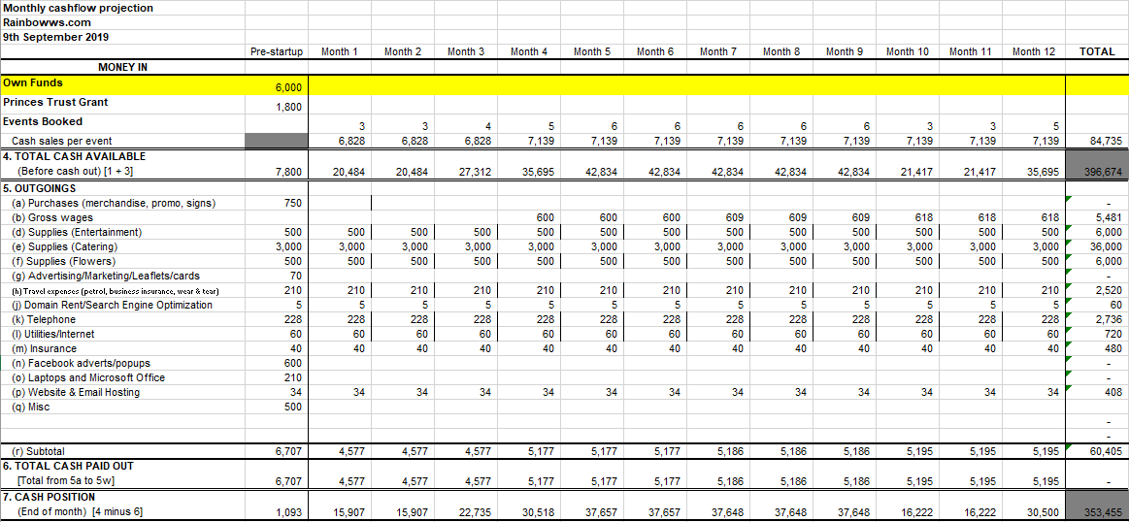

Profitability
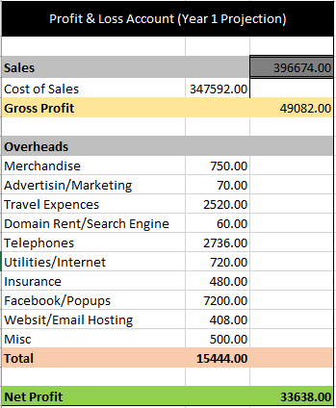

Financing
As our company has very little start up costs all members have agreed they will invest seed money of £1,250 per person. Totalling £6,000 this is more than enough to cover the initial outlay of starting up our business.

Princes Trust are also supporting new businesses with a potential start up grant of £1800. If successful in the application this would be added to our contingency fund for future expansion.

]If we are not successful, due to the low cost of our start up we can either invest more personal money or look at other government grants or bank loans.

Appendix

Operational costs research sums
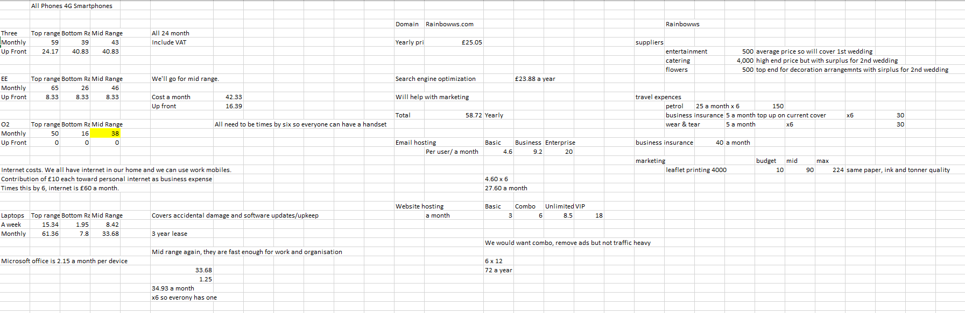
Operational Costs Overview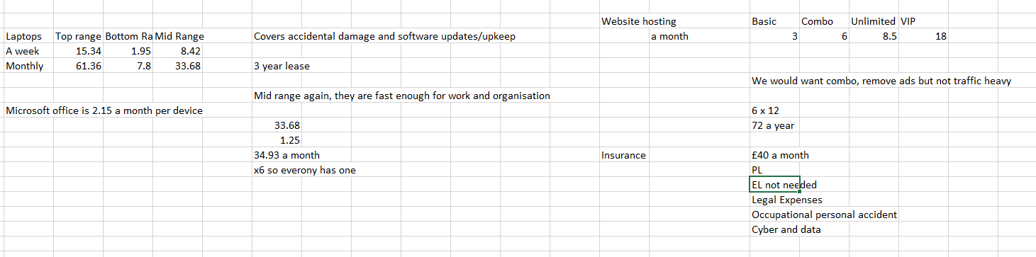

Start-up costs
£750 Merchandise i.e. Promotion Boards, Signs, Banners & Place cards that are all portable and can all be re utilised at each event/location
£200 Deposit (£500 total) for Entertainment (but will be recouped at time of wedding contract from customers initial deposit to secure date)
£1000 Deposit (£3000 total) Catering (but will be recouped at time at time of wedding contract from customers initial deposit to secure date)
£200 Deposit (£500 total) Flowers (but will be recouped at time of wedding contract from customers initial deposit to secure date)
£70 Advertising i.e. Marketing, Leaflet & Business Cards Printing. Eco friendly company, recycled paper and double-sided printing, purchased from same supplier to reduce delivery cost and waiting time
£210 Travel expenses i.e. petrol, business insurance, wear & tear for each director x 6
£5 Domain Rental/Search Engine Optimiser
£228 Telephones
£60 Utilities/Internet x6 – part payment to cover home internet bill
£40 Public Liability Insurance
£600 Facebook adverts/popups to promote the service to a wide range of net surfers
£34 Website & Email Hosting
(£210 for Laptops & Microsoft Office – but this would be non-essential and would use current equipment until enough funds were available and if they needed to be replaced)
Cost with deposits to secure suppliers is £3397 (with purchase of laptops and software £3607)

Total Cost of event with balance in full for suppliers £6207
Rebecca Williams – Curriculum Vitae

Personal Statement

Throughout my career I have demonstrated commitment and reliability to my work and responsibilities. As a leader I continuously review my potential and ability to contribute significantly to the business, a team or a cause. I do not believe 'that one idea fits all' but that each situation, person and business is an individual and that there are many ways to approach for a variety of successful outcomes. I am highly self-motivation to produce the best experience for all customers and continuously develop my skills and abilities at every possible opportunity.
A strong team player who will always forge good relationships, with the ability to work under my own initiative. I am a trustworthy, honest, reliable and approachable individual, striving to deliver an excellence tailored to each customer.
I am not afraid to constructively suggest ideas/alternatives to gain a better experience and product.
I have excellent communication and interpersonal skills with a proven record for building and maintaining strong and effective professional relationships across a network of private sector companies/suppliers.

I have strong organisational skills which have allowed me to give back to my local community by creating a local play schemes, volunteering at the local Beavers & Cubs club and club secretary for a local rugby team.

My experiences and skills have allowed me to continuously develop and drive performance whilst thriving in a continual changing environment.

Work Experience:

Training , Engagement and Communication Lead for an Online Project 2004 – to date:

As the Training facilitator for a new online project I was tasked with producing, packaging and delivering all the new training material to internal departments and external customers ensuring that their needs and requirements were met, whilst working to a tight deadline and within a set budget.
By using online advertising platforms enabled me to successfully promote my project to wide audience with minimal effort and outlay. Visual marketing has for the last decade been rated as the best form of advertising and it clearly proved its worth for my project.
I was able to meet the goals set and exceed them by setting up a centralised data sharing system for UK Government Agencies, also setting up a telephone support team for all end users by training internal staff on the new system and ensuring they were fully proficient in all aspects of each process. This, under my supervision enabled them to problem solve, guide and advise each end user at every stage of their set up and usage. I strived to produce the best packages and become the leading content expert in my field.
As the training lead and system support supervisor I also set the requirements for ongoing project collaboration and customer-based interaction for the advertising and production of private and public sector projects.
Through my actions, continuing update meeting with each customer, sub-contractor and supplier I delivered a successful training package along with ongoing support and built strong working relationships with points of contact from every organisation for future use.
Following the successful roll out I promoted the service to a wider audience which means there are now many Government Agencies that are part of a live online data sharing network.
In that role I made myself a subject matter expert, wrote the operational instructions for the training, set-up and continuing support of end users and trained and supported the team.

Customer Services Advisor 2000 to 2004:

- To answer incoming customer calls and fully resolve the query to ensure customer satisfaction whilst adhering to set targets
- Positively react to change in an ever changing fast paced environment
- To write up referrals and pass to internal departments for additional investigations if needed. I would also follow the requests to ensure a timely/accurate rely ensuring full customer satisfaction and no need for a return customer call. This also expanded my knowledge and drive for excellent customer service.
- To supply support to the E-Mail team if turn-around time for replies wasn’t being met
- To support and mentor new staff, adhering to training requirements and ensuring proficiency levels were met before sign off. I did this by accuracy checking and holding weekly 1-2-1 sessions to assess their learning. It also highlighted any knowledge gaps and confidence issues that I would then address with an appropriate ‘timed’ action plan.
- Supervise a Team of Staff that would monitor telephone calls and identify training/knowledge gaps
- Make informed decisions in line with previous experiences and current guidelines ensuring fairness and consistency
- Set contingencies to ensure continuous learning and resource support staff to support and assist in delivery of training
- Ensure agreed performance targets are met.
- To deputise as a Team Manager when required
- Adhere to Agency data protection policies by ensuring all personal data is locked away and not sharing password/user id’s

Qualifications

- 2017 Key Skills 2 - Leadership
- 2016 NVQ 3 – Customer Care
- 2016 Key Skills 2 – Getting to know your Customer
- 2016 NVQ 3 - Customer Service & Business Delivery
- 2016 NVQ 3 - Quality Delivery
- 2014 Key Skills 2 - Managing Expectations
- 2014 Key Skills 2 - Developing Work Relationships
- 2014 Key Skills 3 - Essential Skills ICT
- 2013 NVQ 2 – Communication, Information and Knowledge
- 2011 NVQ 2 - Business Systems
- 2010 Key Skills 3 - Management
- 2009 Key skills 2 - Public Speaking
- 2007 Princes Trust Druid Stone Plus Programme (Residential Placement with Special Needs Children)
- 2006 NVQ 3 - Handling Conflict
- 2006 Key Skills 3 – Dealing with Difficult Customers
- 2005 NVQ 3 - Customer Management
- 2004 NVQ 2 - Customer Service Orientation
- 2004 NVQ 2 - Problem Solving
- 2004 NVQ 2 - Working Collaboratively
- 2004 NVQ 2 - Self Awareness
- 2003 Key Skills 2 - Communication
- 2003 Key Skills 2 - Customer Relations
- 2000 NVQ 3 - Customer Service

Amir Adibmehr
82 Lon Olchfa, Swansea SA2 8NN
Tel: 07460 676575
Email: a_adibmehr@yahoo.com
Summary
I have many years’ experience in coordinating and planning weddings and other events, working with all kinds of clients and advising them on the best ways to make their dream weddings come true.
I remain calm in stressful situations and can work well alongside other client-appointed individuals and venue staff to make the best of any given situation.

Skills
- Excellent negotiation and coordination skills.
- Clear communicator both verbally and written.
- Extensive communication, cooperation and service skills
- Experience in event logistics and timing
- Ability to remain calm under pressure.
- Experienced in all different kinds of photography.

Work Experience
Volunteer Photographer 2011-present
Since moving to the UK, I have done a fair amount of photography work at community events for our church, and also friends and family.

Freelance Photographer 1993-2011
I have had vast experience as a wedding planner during my photography career, often advising clients about every aspect of the wedding day. During this time, I have worked with hundreds of clients and thousands of individuals, from venue staff to all the different service providers appointed by clients.
I believe my experience in dealing with people of all types and backgrounds and in many different locations makes me specially suited to work with same-sex couples in planning their wedding.

Curriculum Vitae
Dwayne McDaid

Flat 16 The J Shed, Kings Road
Swansea, SA1 8LY
07709282769
dwaynemcdaid@gmail.com

EXPERIENCE

Live Performance Artist – UK
Oct 2007 – Preset

Performing and arranging live entertainment in around Swansea. Also with events in London, Newcastle and Cardiff.

Admiral, Swansea — Customer Care Representative
DEC 2017 – PRESENT

Customer Services for Home and Motor insurance products. Also, part of the department charity team, ‘Innovate’ project and numerous other internal groups.

Eastside Insurance, Swansea — Business Development Manager
DEC 2014 - DEC 2017

Handled my own book of taxi insurance, single and fleet, as well as handling some personal and commercial insurance products

EDUCATION

UWTSD, Swansea — Cert HE & BA Leadership and Management
OCT 2018 - PRESENT

I am currently studying for a Certificate in Higher Education Skills for the Workplace and a BA in Leadership and Management

MISC.

First Aid At Work — St. Johns Ambulance - Valid until Aug 2019

SKILLS

Over 10 years experience of live performing

A built-up connection of industry colleagues and friends

Sound and lighting technical work as well as event organizing

Experience handling multiple clients, record keeping and timing

ABOUT ME

I enjoy running, cycling and fitness with a fondness of obstacle course and endurance races

I also enjoy reading up on current affairs and some fiction.

Regularly attend live music events with a keen interest in new talent.

REFERENCES

Chris Mills - Eastside Insurance, Manager
01792 641 611

Angela Bettany - Safe Foundation Charity, Project Manager
agniebettany@gmail.com

Crina Flavia Razoare
Swansea
Phone: 07466 862 675
e-mail: crinaflavia@yahoo.com

Personal profile:

I am a punctual and a reliable person who works well under pressure. I am able to work both in a team environment and on my own initiative. I have a friendly disposition and have a good sense of humor. I have been in an administration position for more than 5 years. My goal is to work for a reputable employer in an administration role or human resources.

Key skills and Experiences:
Strong communication skills, experience of customer service, excellent team player, initiative, teamwork, flexibility, problem solving, communication skills, planning and organizing, time management, computer skills, money handling experience.
Work Experience:
Decoration / Florist
Rainboww
Prep and arrange flowers for businesses, hotels, weddings and other events, answer telephones and place orders, maintain overall appearance of the department, ensuring proper design and freshness of flowers, delegate tasks to team members and provide timely feedback, oversee design area and inventory, provide consultations and schedule meetings for weddings and other special events

Logistic Administrator – Stock Controller
Pullmaflex UK Limited
July – present
Maintain accurate stock levels and material inventory, ensure the security and stock accuracy of high value items, prepare and control kits in line with BOM requirements and production schedule, provide line-service of parts to the production line and collect any spoilt material and replace, liaise with all departments regarding inventory requests, ensure integrity and accuracy of the stock management system, provide accurate monthly reports showing data and trends, liaise with all departments to offer support and ideas on stock accuracy and how this can be achieved, carry out ad-hoc projects and reasonable requests to develop and improve stock accuracy when required providing support to all departments upon request.

Administrator
TLC The Training & Learning Company
June 2017
Responsible for managing, organizing, and updating relevant data using database applications along with filing data and other routine administrative tasks, responsibility for the introduction of new learners to the systems and on-going maintenance of the files in line with audit compliance, typing and word process various documents and electronic format, log information on calls received and maintain detailed & accurate record, assisting in the administration of external testing processes for Functional Skills and Technical Certificates.

Estates Administrator
Dwr Cymru Welsh Water
March 2017 – May 2017
Entering new documentation into Legend Property Management, updating existing records and updating scanned images, scanning documentation utilising the software scanning package Fortis and uploading and storage of scanned images utilising SAP Document Management System. Provide administrative support to the Estates Services team, including using SAP purchasing system, arranging of meetings, correspondence, filing and general office administration.

Administrator
Nicholsons Accountancy Services Limited Hatfield
September 2015 – November 2016
Dealing with telephone and emails enquires, using a variety of software packages such as Microsoft Word, Excel, Outlook, Access, IRIS, Rapport, invoicing, payroll, ordering and maintaining stationery and equipment, preparing and filing documents (Company Secretarial).

Warehouse Operative
Prime Time Recruitment Hatfield
July 2014 - October 2014
Pick and pack products for customers

Carer
Four Season Healthcare Hemel Hempstead
January 2014 - August 2014
Responsible for personal hygiene, nutrition and social activities, daily care plans and hourly checks.

Domestic cleaner
Aniska Lodge Haywards Heath
June 2013 - December 2013
Responsible for keeping the place clean at the higher standards and a healthy environment for residents.
Work Experience Abroad:
Medical registrar
County Clinical Emergency Hospital Targu Mures
December 2010 - June 2013
Responsibility of patient’s medical records, statistical reports

HR Assistant
County Clinical Emergency Hospital Targu Mures
November 2008 - December 2010
Payroll, calculation and preparation, statistical reports.

Education:
University ‘’Lucian Blaga”, Tirgu Mures, Romania
Economics, Finance, Marketing, Accounting
Certificates: University Degree
October 2005 – June 2008

High School “Gheorghe Sincai”, Tirgu Mures, Romania
Mathematics, physics, English language, history, geography
Certificate: High School Diploma
September 2001 - June 2005

Hobbies, interests: reading, music, travel
References:
Hays Recruiting Experts Worldwide
02920398198

Nicholsons Accountancy Services Limited
01707630880

Prime Time Recruitment
01707228339

Alexandra Care Centre / Four Season HealthCare
01442246775

To Whom It May Concern.
My work ethic and punctuality can be used as a prime example of how much I enjoy my current workload, which I manage well.
I remain recognized within my current workplace as an effective communicator who does not shy away from promotion of her beliefs. I am also recognized as a reliable source of information on relevant legislation and information surrounding technology, including recent advancements.

07939594366 alexandra.allan1992@gmail.com
6 Heol Islwyn, Fforestfach, Swansea, SA5 4NZ.

Personal Profile:
For my entire upbringing and adulthood, I have remained an avid reader. I enjoy attending my local cinema and entertaining my young niece and nephew. A further pastime of mine includes attending plush restaurants, where I may indulge in their fine cuisine, this gives me a good knowledge of popular attractions and destinations locally.
Throughout my career, the skills which I have obtained during experience and throughout the extensive training I have undertaken, I have acquired skills which I deem to be transferable. Such skills include a keen eye for improvement and perfection, problem solving, compassion, communication skills and punctuality. I remain an outgoing person with excellent socialising skills.

Academic Achievements:
English literature - GCSE - 2008 - Olchfa Comprehensive.
English Language – GCSE – 2008 - Olchfa Comprehensive.
Mathematics - GCSE - 2008 - Olchfa Comprehensive.
Access to nursing and higher health professions - Level 2 - 2012/2013 - Gower College Swansea.
Access to nursing and higher health professions - Level 3 - 2013/2014 - Gower College Swansea.
General Nursing - level 4 -2014/2015 - Bournemouth University.
General Nursing - level 5 - 2015/2016 - Swansea University.
Skills within the workplace - HNC Level 4 - 2018/ on-going - Swansea University UWTSD.

Career Summary:
Trinity Nursing Services – 04/2016 to present day.
In this role I provide safe and effective care within various clinical settings. I support services users with acute mental health issues and learning difficulties. I provide a safe area for assessment and treatment to take place, whilst promoting indolence and quality of life. I cover staff shortages within The National Health Service and work to an on-call basis and a booking service.
Enviva Care – 06/2018 to present day.
Within this role, I have provided care for children with complex clinical needs. I have supported the family of a service users and promoted the highest standard of living whilst safeguarding the everyday needs of said service user.
Happy holiday home Cleaning Company – 2012/2014 – Part time role whilst I studied.
Within this role I provided a cleaning service for a holiday home company. I ensured that guests would arrive to a hygienic space and a welcoming sense.
Family Carer – 2010/2012.
During this time, I provided full-time lived-in care for an immediate family member.
Virgin Media – 2008/ 2010.
I worked for Virgin Media as a customer service representative. I attended to the everyday needs of the customer and upheld the reputation of the company. Customer satisfaction was at the heart of my day to day tasks.

Further Training:
Medication administration – 2018.
Management and leadership skills level 3 – 2018.
Safeguarding – 2018.
Administration of rectal diazepam and buccal midazomal – 2018.
Emergency first aid within the workplace level 3 – 2018.
Epilepsy awareness and emergency medication administration – 2018.
Medication awareness and record keeping level 3 – 2018.
Control and restraint – 2017.
PBM – 2017.
Manual handling – 2016.
Violence and aggression – 2016.
Pressure ulcer prevention – 2015.
Effective communication – 2015.
Infinity pump – 2015.
Prevention assessment and management of violence and aggression – 2015.
Study skills – 2014.
Manual handling – 2014.
Violence and aggression – 2014.
Endoscopy – 2014.
Communication skills – 2014.

Additional information:
I hold a full UK driving licence.
I am the owner of a vehicle.
I am a member of the disclosure and barring service update system; my update service ID is: CO324208243. I have no convictions, nor do I have any pending convictions or cautions.
I am currently studying towards a degree, thus disallowing me to be reachable on Tuesdays 1800-2000 and one Saturday a month 1000-1600.

References:
- Trinity Nursing services.
25 Commercial Road
Resolven
Neath
Swansea
SA11 4HF
01639 710498
Generalmanagers@trinitynursingservices.co.uk

- Joyce Morris Williams
19 Brynbach
Tycoed Village
Penllegaer
Swansea
SA4 1RX
07903869968
Jmwilliams1925@gmail.com

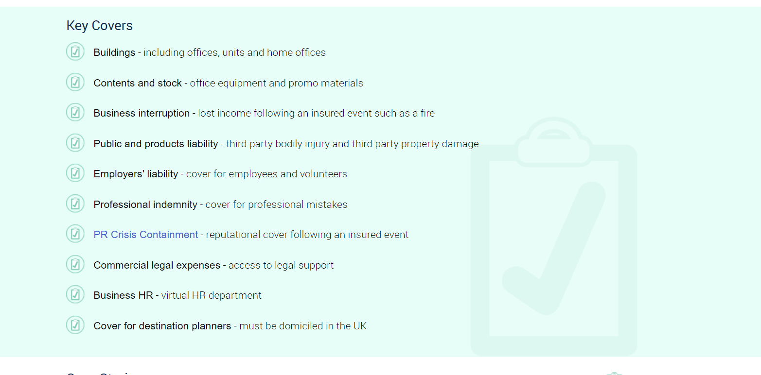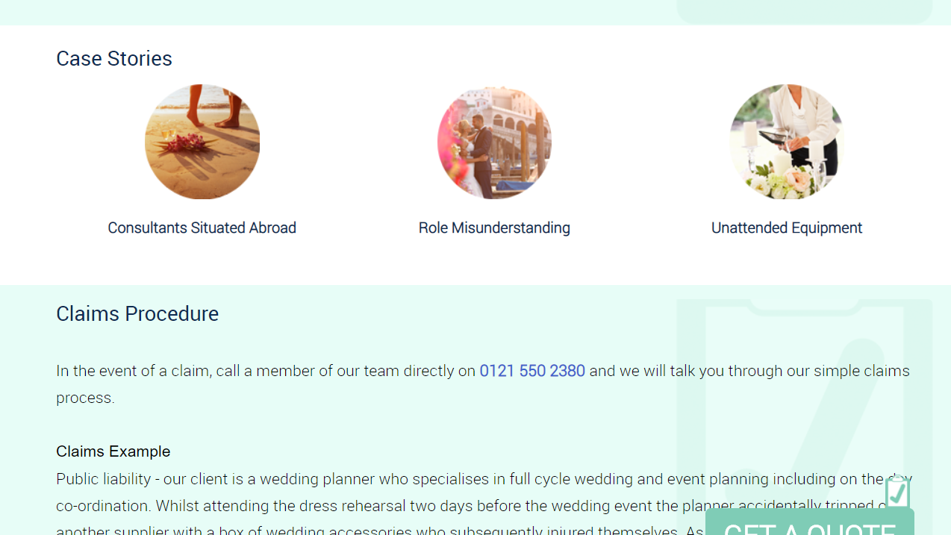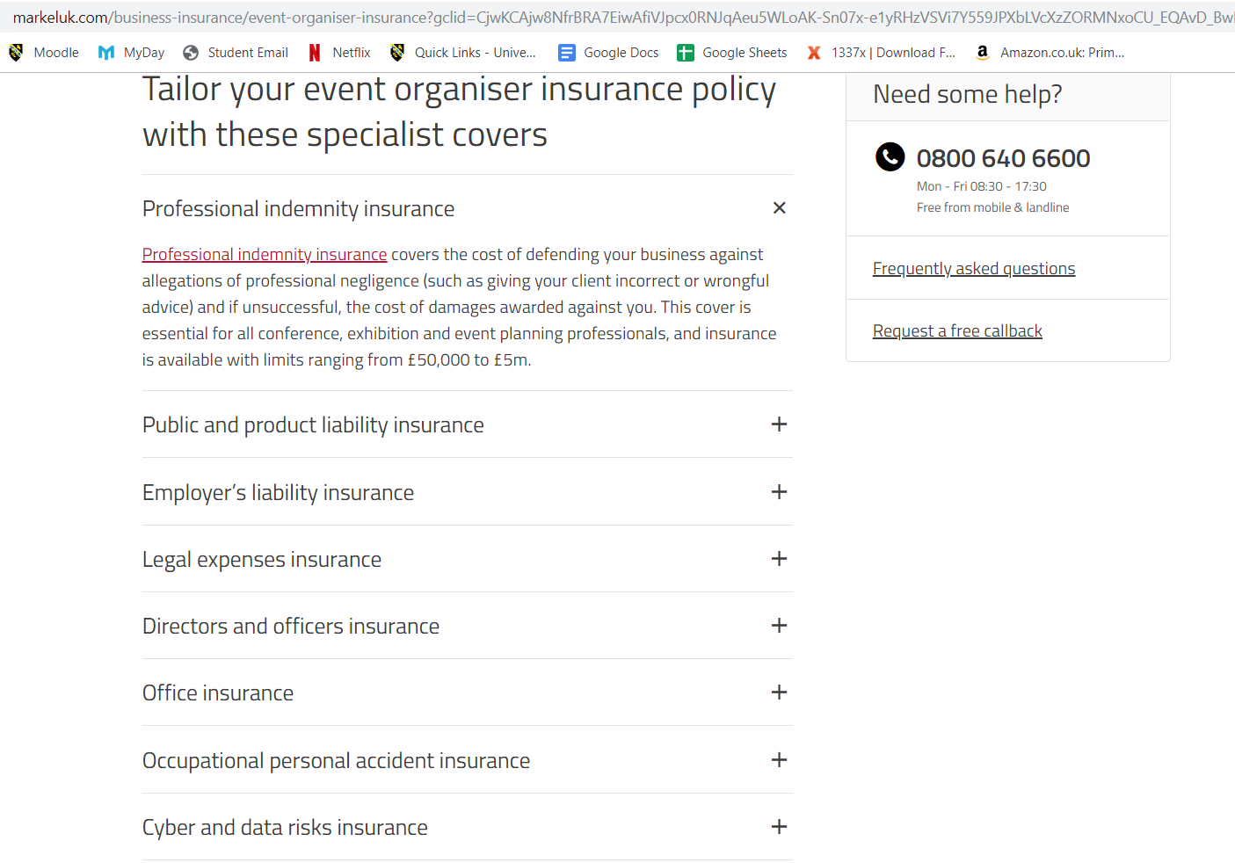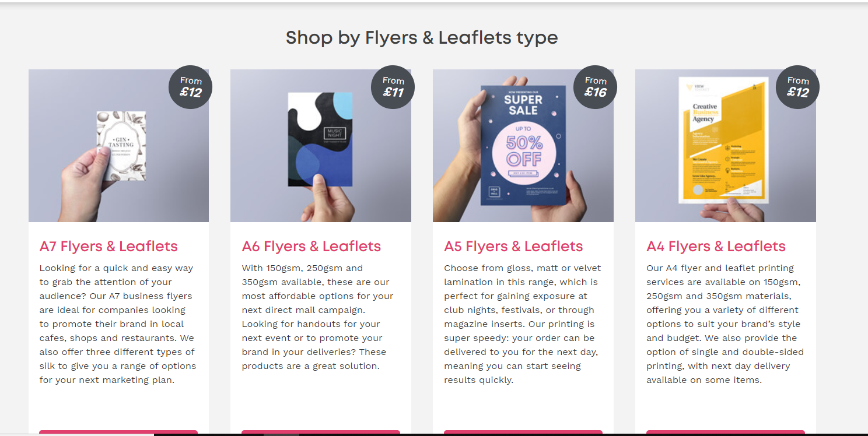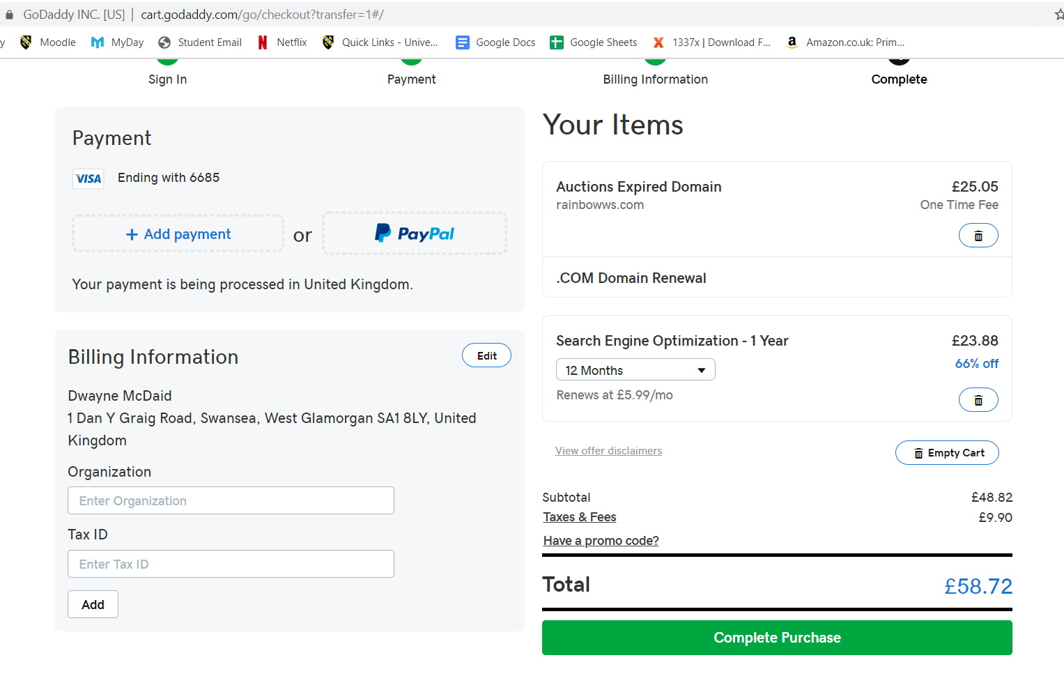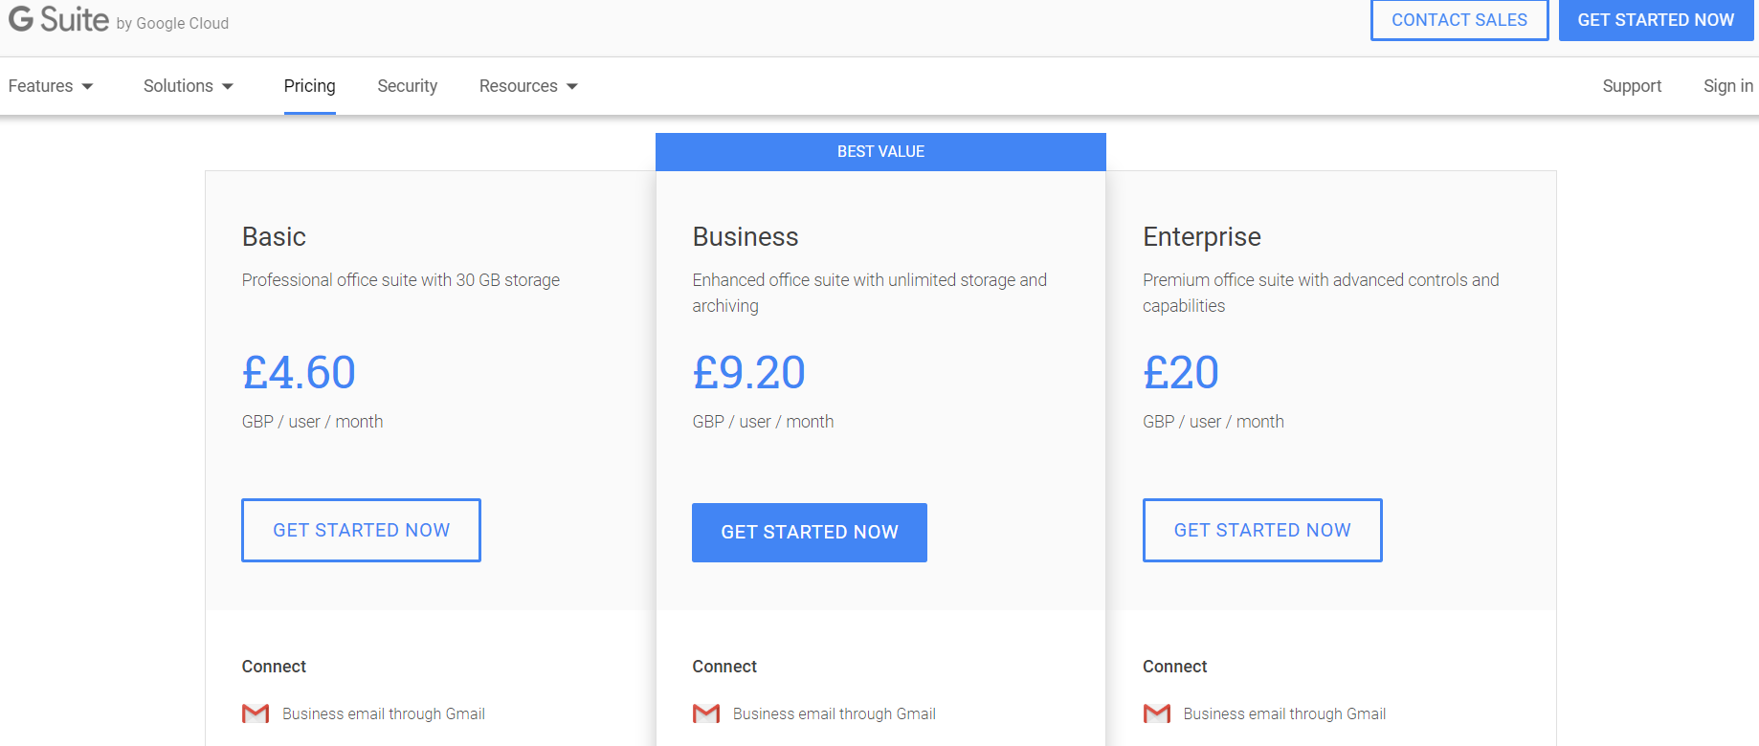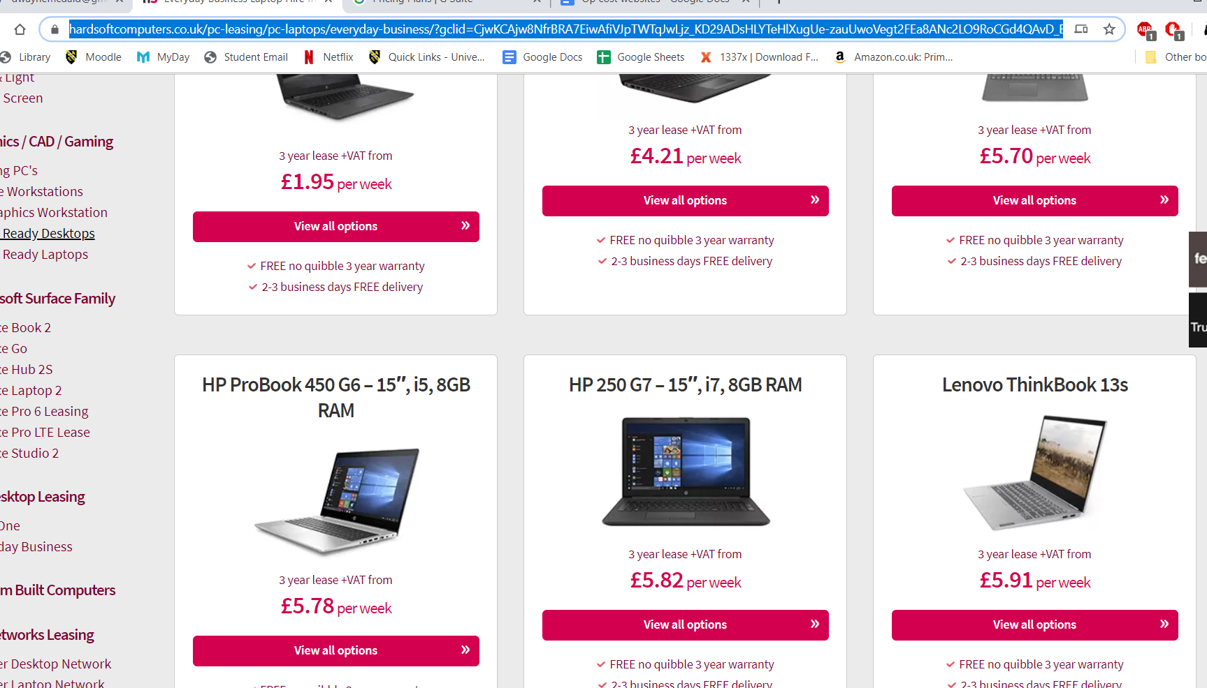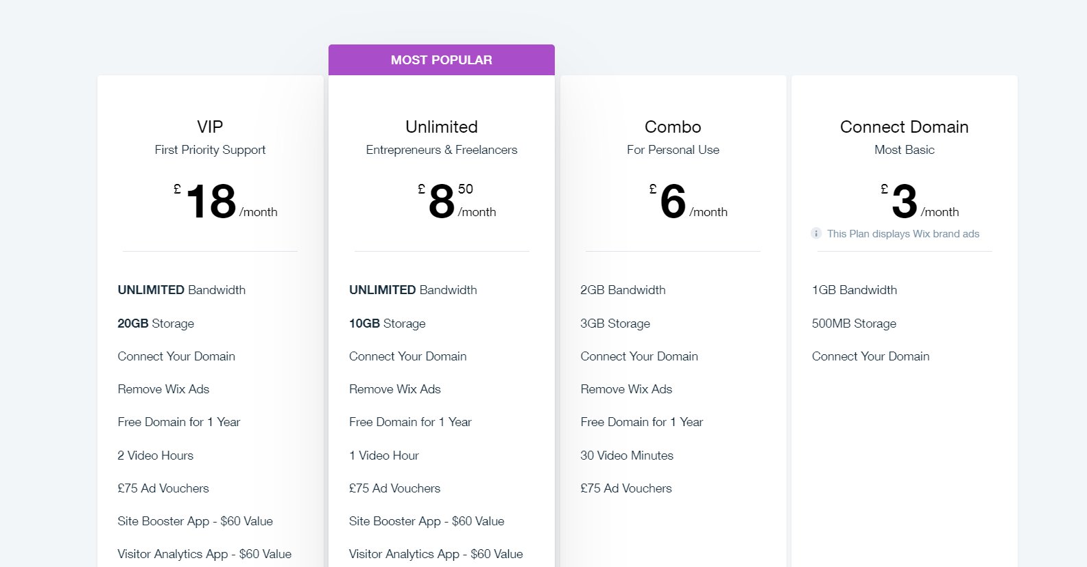

References

Carphone Warehouse, 2019. Business. carphonewarehouse.com, Available from: https://business.carphonewarehouse.com/ [Accessed 20 September 2019].

Citizen Advice, 2019. Sexual orientation and transgender identity hate crime. Citizenadvice.org.uk, Available from: https://www.citizensadvice.org.uk/law-and-courts/discrimination/hate-crime/sexual-orientation-and-transgender-identity-hate-crime/ [Accessed 20 August 2019].

Dryden, S., 2017. A short history of LGBT rights in the UK. British Library, 3 March 2017, Available from: https://www.bl.uk/lgbtq-histories/articles/a-short-history-of-lgbt-rights-in-the-uk [Accessed 28 August 2019].

Direct line, 2019. small business insurance. www.directlineforbusiness.co.uk, Available from: https://www.directlineforbusiness.co.uk/small-business-insurance/office?gclid=Cj0KCQjwn_LrBRD4ARIsAFEQFKsCqUCKT0CRYIBcmXOLdTUL3NAWiJl3ebNKkSmOkf5_IjJfHo1wRoAaAgWvEALw_wcB&gclsrc=aw.ds [Accessed 20 September 2019].

EE, 2019. business mobile phone plans. ee.co.uk, EE. Available from: https://ee.co.uk/business/small/price-plans/?msgtype=&s_cid=ee_ppc_essence_google_generics_ee-c-2037153351-72375128539-kwd-19850786290-&gclid=CjwKCAjw8NfrBRA7EiwAfiVJpYkAs2AAZqFM0kxa-HYcM9iE86PNEtCh_lUwDHZZ3BaTEfuKqxW2LxoCBkoQAvD_BwE&gclsrc=aw.ds [Accessed 20 September 2019].

Facebook, 2019. How ad billing works on facebook. facebook.com, Facebook. Available from: https://www.facebook.com/business/help/716180208457684?helpref=page_content [Accessed 20 September 2019].

Felter, c. and Renwick, D., 2019. Same-Sex Marriage: Global Comparisons. Council on Foreign Relations., 27 June 2019, Available from: https://www.cfr.org/backgrounder/same-sex-marriage-global-comparisons [Accessed 29 August 2019].

G Suite, G suite edition. Google Cloud, Available from: https://gsuite.google.com/intl/en_uk/pricing.html [Accessed 20 September 2019].

GOV.UK, 2019. Get married or form a civil partnership in England or Wales: step by step. www.gov.uk, GOV.UK. Available from: https://www.gov.uk/get-married-in-england-or-wales [Accessed 29 August 2019].

GOV.UK, 2013. Equality Act 2010: guidance Information and guidance on the Equality Act 2010, including age discrimination and public sector Equality Duty. www.gov.uk, GOV.UK. Available from: https://www.gov.uk/guidance/equality-act-2010-guidance#equalities-act-2010-legislation [Accessed 29 August 2019].

GOV.UK, 2015. Equality and Human Rights Commission. www.gov.uk, GOV.UK. Available from: https://www.gov.uk/government/organisations/equality-and-human-rights-commission [Accessed 30 August 2019].

Group Map, 2011. PESTLE analysis. groupmap.com, group map. Available from: https://www.groupmap.com/map-templates/pestle-analysis/ [Accessed 29 August 2019].

Hardsoft, 2018. Microsoft office. hardsoftcomputers.co.uk, Available from: https://www.hardsoftcomputers.co.uk/software/office-microsoft/ [Accessed 20 September 2019].

Hitched, 2018. Wedding Stress Management: How To Reduce Stress While Planning Your Big Day. Hitched.com, 28 August 2019, 1-17.

instaprint, 2019. flyers and leaflets - design online and print. instaprint.co.uk, instaprint. Available from: https://www.instantprint.co.uk/flyers-leaflets?_$ja=tsid:|cid:6482126065|agid:79453058604|tid:kwd-21419440454|crid:381000829129|nw:g|rnd:16415052854879733798|dvc:c|adp:1t1|mt:b|loc:9045394&gclid=CjwKCAjw8NfrBRA7EiwAfiVJpWRZzGf5A30999Mdjg9T_Zd_XD2trM7wOEkqic9Xj4-vEP_MGQd9phoCllYQAvD_BwE [Accessed 20 September 2019].

instaprint, 2019. recycled eco friendly business cards prints. www.instaprint.co.uk, Available from: https://www.instantprint.co.uk/business-cards/recycled?turnaround=Standard&sided=double&rangesizeq=0 [Accessed 20 September 2019].

Indeed, 2019. The millhouse restaurant. www.indeed.co.uk, Available from: https://www.indeed.co.uk/salaries/Wedding-Planner-Salaries-at-The-Millhouse-Restaurant,-England [Accessed 20 September 2019].

Lead Cycle, 2016. how much do facebook ads cost. leadcycle.co.uk, Available from: https://leadcycle.co.uk/much-facebook-ads-cost/ [Accessed 20 September 2019].

Legislation.gov.uk, 2013. Marriage. Same sex couples ACT 2013. Legislation.gov.uk, Legislation.gov.uk. Available from: http://www.legislation.gov.uk/ukpga/2013/30/contents/enacted [Accessed 21 August 2019].

Link up UK, 2017. Great British Community. Sexuality and Marriages. 03 Mar 2017. Available from: http://greatbritishcommunity.org/resources/lgbt/ [Accessed 28 August 2019].

Madeson, D., 2016. SWOT Analysis: A Management Fashion Perspective. International Journal of Business Research, 16(1), 39-56.

Office of National Statistics, 2019. Unemployment rates UK. Office of National Statistics, ONS. Available from: https://www.google.com/search?source=hp&ei=2wBoXc3-GuSe1fAP27G64Ak&q=unemployment+rates+uk&oq=unemployment+rates+uk&gs_l=psy-ab.3..0l4j0i22i30l6.1170.5432..5854...0.0..0.67.989.21......0....1..gws-wiz.......0i10.V-_PoMSIwcw&ved=0ahUKEwiN2NG4w6jkAhVkTxUIHduYDpwQ4dUDCAc&uact=5 [Accessed 29 August 2019].

Office of National Statistics, 2019. Sexual orientation. ONS.gov, Office of National statistics. Available from: https://www.ons.gov.uk/peoplepopulationandcommunity/culturalidenitity/sexuality/bulletins.sexualidentityuk/2017 [Accessed 22 August 2019].

Office of National Statistics, 2019. Marriages in England and Wales. ONS.gov, Office of National statistics. Available from: https://www.ons.gov.uk/peoplepopulationandcommunity/culturalidenitity/sexuality/bulletins.sexualidentityuk/2017 [Accessed 13 August 2019].

Prince's Trust, Support for starting a business. princes-trust.org, The Princes Trust. Available from: https://www.princes-trust.org.uk//help-for-young-people/support-starting-business [Accessed 20 September 2019].

Turn2us, 2019. The prince's trust. turn2us.org, Available from: https://grants-search.turn2us.org.uk/grant/the-princes-trust-15765?iframe=False&postcode=sa57db [Accessed 20 September 2019].

Three Phones, 2019. business like a boss. three.co.uk, 3phones. Available from: http://www.three.co.uk/business-mobiles?id=1550&gclid=CjwKCAjw8NfrBRA7EiwAfiVJpcJZAwiMU1nZs7e8Ck5cTvsyWqZEpCcOQxRg_DqH3BdWB7czjX011BoC_PQQAvD_BwE&gclsrc=aw.ds&aidset=1 [Accessed 20 September 2019].

ukawp, 2018. How much do wedding planners cost?. www.ukawp.com, Available from: https://www.ukawp.com/how-much-do-wedding-planners-cost/ [Accessed 20 September 2019].

Vodafone, 2019. Your business unlimited. vodafone.co.uk, vodafone. Available from: https://www.vodafone.co.uk/business/business-mobile-plans [Accessed 20 September 2019].

Wedding planner book, How much do wedding planners make. theweddingplannerbook.com, Available from: http://www.theweddingplannerbook.com/how-much-do-wedding-planners-make [Accessed 20 September 2019].

Wedding Insurance group, 2019. Wedding and event planner insurance. www.weddinginsurancegroup.co.uk, Available from: https://www.weddinginsurancegroup.co.uk/wedding-and-event-planner-insurance [Accessed 20 September 2019].

WIX, 2017. Wix Premium Plans. wix.com, Available from: https://www.wix.com/upgrade/website#/ [Accessed 20 September 2019].

Zimonjic, P. and Simpson, K., 2019. Scheer gets support from openly gay candidate over same-sex marriage controversy. CBC, 27 August 2019, Available from: https://www.cbc.ca/news/politics/scheer-duncan-abortion-lgbtq2-1.5262053 [Accessed 29 August 2019].

Bibliography.
Citizen Advice, 2019. Sexual orientation and transgender identity hate crime. Citizenadvice.org.uk, Available from: https://www.citizensadvice.org.uk/law-and-courts/discrimination/hate-crime/sexual-orientation-and-transgender-identity-hate-crime/ [Accessed 20 August 2019].
Dryden, S., 2017. A short history of LGBT rights in the UK. British Library, 3 March 2017, Available from: https://www.bl.uk/lgbtq-histories/articles/a-short-history-of-lgbt-rights-in-the-uk [Accessed 28 August 2019].
Felter, c. and Renwick, D., 2019. Same-Sex Marriage: Global Comparisons. Council on Foreign Relations., 27 June 2019, Available from: https://www.cfr.org/backgrounder/same-sex-marriage-global-comparisons [Accessed 29 August 2019].
GOV.UK, 2019. Get married or form a civil partnership in England or Wales: step by step. www.gov.uk, GOV.UK. Available from: https://www.gov.uk/get-married-in-england-or-wales [Accessed 29 August 2019].
GOV.UK, 2013. Equality Act 2010: guidance Information and guidance on the Equality Act 2010, including age discrimination and public sector Equality Duty.. www.gov.uk, GOV.UK. Available from: https://www.gov.uk/guidance/equality-act-2010-guidance#equalities-act-2010-legislation [Accessed 29 August 2019].
GOV.UK, 2015. Equality and Human Rights Commission. www.gov.uk, GOV.UK. Available from: https://www.gov.uk/government/organisations/equality-and-human-rights-commission [Accessed 30 August 2019].
Zimonjic, P. and Simpson, K., 2019. Scheer gets support from openly gay candidate over same-sex marriage controversy. CBC, 27 August 2019, Available from: https://www.cbc.ca/news/politics/scheer-duncan-abortion-lgbtq2-1.5262053 [Accessed 29 August 2019].

