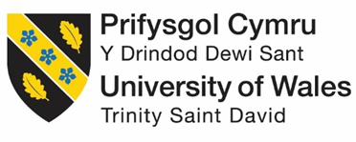

LEVEL 5
MODULE CODE: LCBB5004
ASSESSMENT TYPE: REPORT
ASSESSMENT NUMBER: 1
ASSIGNMENT TITLE: MANAGING PEOPLE
LECTURE’S NAME: MARY MARCH
NUMBER OF STUDENT: 1817472
NAME STUDENT: IULIANA-MARINELA RADU

Task 1: A statement using CIPD Profession Map 3
Task 2: Report 5
Introduction: 5
Resourcing activities of HR: 5
Planning: 5
Recruitment: 7
Selection: 8
Conclusion: 10
References: 11

Figure 1: Subjective appraisal method 6
Figure 2: Unilever's selection process 9

Task 1: A statement using CIPD Profession Map
According to CIPD profession map, an HR professional is a service provider, advisor, consultant and leader (CIPD, 2020). As human resource management is mostly about achieving maximum performance with minimum cost, a human resource (HR) professional requires a series of qualities.
Firstly, in the initial level or, Band 1, an HR professional is expected to satisfy the client by supporting and managing ongoing and urgent needs. In Band 1, technical skills get more priority than behavioural skills (CIPD, 2020). Therefore, the measurement and analysis of providing service are mostly facts and information focused. In this level, an HR professional spends most of the time in acquiring information, organising data and managing the delivery.
In the next level or in Band 2, an HR professional gets out of the narrow focus of information-only service and starts playing the role of an advisor. The issue of advising is usually the ongoing ones or the ones that are likely to occur in the near future. With an equal combination of behavioural and technical skills, an HR professional manages issues, and provide a wide range of solutions and recommendations. Also, the solutions and recommendations are the results of analysis, evaluation and forecasting.
In Band 3, the role of being an advisor takes the next step and become the role consultation. In this level, an HR professional emphasises on the relatively long term issues than the previous levels. In order to do it, the range of analysis gets wider and includes risk management and contingency planning. Moving from the individual level issue, an HR professional now searches for solutions for the whole organisation. An HR professional's behavioural skills take the lead role of being a consultant. On top of that, the sole role of providing solutions and options, an HR professional shows the leadership skill to some extent along with problem-solving skills (Cook, 2019).
In the last level or, Band 4, an HR professional plays the role of a leader, and focus goes mostly in the behavioural skills. As a part of being a leader, an HR professional plays the role of a cooperative colleague and mentor. Now, an HR professional leads a particular professional area develops field related strategies. When an HR professional reaches this level, he/she often takes the responsibility of leading the HR department and formulating strategic decisions. Moreover, an HR professional in this level manages and challenging issues and develops strategies accordingly.
It can be seen that as an HR professional moves up from one level to another, the focus starts shifting from serving an individual to a whole organisation. Also, the focus of activities starts shifting from factual to analytical. It reflects the wide menu of services of an HR professional. These services facilitate the achievement of optimal performance of employees, handles different challenges and brings sustainability in the business operation. On top of that, an HR professional leads the department as well as the organisation to the extent that results in fulfilling a long-term goal (Boxall and Purcell, 2016). All of these concludes the multiple roles and skills of an HR professional.

Task 2: Report

Introduction:
Human resource management is one of the most significant parts of an organisation that is responsible for many important managerial and operative functions. The main goal of human resource management is to maximise the outputs of employees and minimise the costs associated with it (Bailey, Mankin, Kelliher and Garavan, 2018). The HR function of an organisation fulfils some organisational objectives such as the development of organisational hierarchy, ensuring employee satisfaction etc. These objectives play the role of a helping hand to help an organisation attain its goals and long-term vision. When it comes to HR, Unilever is an excellent example. The organisation has a proud history of being the best employer in many countries in a row. The report discusses the organisational activities an HR of a company is fulfilling. It also discusses a multinational company, Unilever's evolving changes in response to changes in the business environment as well as its impact.

Resourcing activities of HR:

Planning:
Planning is the first stage of the recruitment process. In the planning stage, the first organisational objective is to identify the vacancies and required new positions (Boxall and Purcell, 2016). HR is responsible for estimating the required new positions by analysing the vacant positions. Therefore, the first step is to monitor the company's present employee supply. As in, HR is responsible for looking at the number of employees in the organisation, identify their skill level, and compare it with the compensation and incentives they receive. In this way, HR gets an idea about the organisation's strength by analysing pay with performance. In order to manage the future employee requirement of the organisation, the HR first forecast the feasibility of current employees' workhour, pay structure, incentives such as promotion, likely scenarios such as retirements (Newenham-Kahindi, 2016). After forecasting the feasibility, the HR makes strategic plans such as a layoff, furlough, recruitment etc. The next objective of the planning is to create a balance between demand and supply. It is done by conducting a gap analysis which gives birth to critical questions. The job of the HR is to answer these questions with information, data analysis and finally make a decision.
When it comes to human resource management, Unilever comes at top for their sustainable planning and effective implementation. In this 21st century of technology, Unilever has evolved its planning process accordingly. As a part of the analysis of current employees' supply, Unilever uses an automated system that provides data, graph, trend and other statistical analysis of compensations and incentives. In order to assess the skills of employees, Unilever appreciates work quality over work quantity. As the organisation's one of the objectives is to make the employees self-sufficient as in, improvement for the time being in the organisation, it uses subjective appraisal by the manager to assess employee skill. The assessment is done quarterly (Lin and Sanders, 2017).
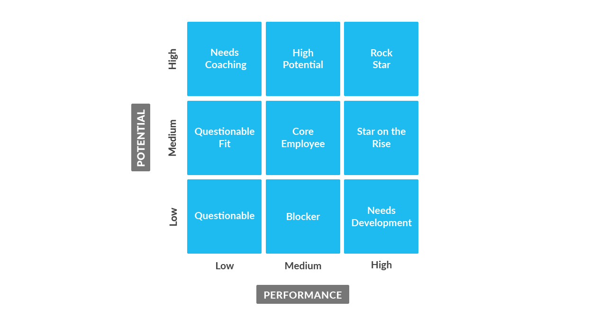
Figure 1: Subjective appraisal method
Source: (Reitsma, 2016)
In this method, employees performance are measured along with their potential using a 9-box grid. The HR uses this grid filled up by the manager to make decisions in planning. For instance, an employee stands in the top right corner as in, high potential with high performance. Such an employee will move up the ladder of hierarchy quickly so that the organisation gets more value from that individual. On the other hand, if an employee is showing high performance; however, the potential is low, he/she is remarked with a need for development. In that case, the organisation arranges training and counselling session to elevate the potential.

Recruitment:
The HR of a company is responsible for recruiting new employees as in, attracting candidates in different ways (Sankar, 2017). Before attracting new candidate, the HR of a company identify the potential pool of candidates. In this process, a company detects the likely places that will reach most of the targeted candidates. For instance, campus recruitment, roadshows, etc. Also, in this digital era, HR is focusing more on online platforms than conventional offline platforms to save time and money. A formal social network like LinkedIn got to the centre of attention of the HRs due to many reasons. However, the main reason is the combination of employers, employees and candidates. The objective of HR is to minimise cost in the recruitment process; however, engage the maximum number of audiences. Therefore, in this process, the HR and marketing team of an organisation works closely. Recruitment remains a crucial function of HR as it is the first step to build the human capital of a company. There are different types of recruitments, such as internal, retained, etc. If an organisation wants to keep a low profile for its recruitment process and save time and money as well, internal recruitment is a suitable option. Internal recruitment is a process where existing employees are given the responsibilities to fill up a vacancy (Boxall and Purcell, 2016). In this process, the company does not need to conduct recruitment planning and invest substantial capital. If the objective of an organisation is to relieve the HR team of a recruitment process and focus more on other parts such as training, compensation etc., retained recruitment is an option. In retained recruitment, a single recruiting firm gets the job to fill a vacancy (Boxall and Purcell, 2016). Usually, a company works with the same recruiting firm for filling future vacancies as well.
Unilever uses a combination of the internal and external recruitment process. The external recruitment process is comprised of advertisements in social media and digital platforms, employee referral, walk-ins etc. The company also grabs the attention of the candidates by sponsoring business competitions and hosting seminars and webinars. By sponsoring business competitions, Unilever not only attracts a pool of candidates but also fast-track the recruitment process of deserving candidates. By hosting seminars, subsidiaries of Unilever in different countries attract local talents. Here, the regional Unilever employees and top-level management officials encourage the targeted pool of candidates by providing information and facts. In webinars, the company attracts the candidate pool on a global level. Here, candidates from different countries can come under one platform, and international leaders of the company lead the session. Here, the candidates get to know about the company's benefits, the field of opportunity and the skills they are looking for. For attracting the fresh graduates, Unilever offers apprenticeships that allow an individual to kick-start the career with training and grooming (Crush, 2020) . The company also offers seasonal placement to attract candidates. For instance, summer industrial placement program. Here, the candidates get the opportunity of learning by working alongside a manager that drives them to apply for the position.

Selection:
In order to make the recruitment process effective, selection plays a vital role. In this step, the HR has to make decisions in each and every step as he/she evaluates a candidate. Unlike recruitment which is a positive process to attract candidates, the selection is a negative process where elimination and rejection take place (Bailey, Mankin, Kelliher and Garavan, 2018). In any organisation, the main objective is to select the best candidates available in the job market. The HR of an organisation plans the selection process in a way to ensure that objective is fulfilled. There are many different ways of selecting a candidate. Interviewing is the most common and widely used approach to select an employee. In an interview, the employer gets the opportunity to evaluate the candidate with a pre-arranged set of questions or an impromptu one. In an interview, an employer does not only test the candidate's required skills and knowledge for the post but also checks the mentality and psychology of the candidate as well. In internships and some entry-level jobs, the HR of a company sometimes select candidates based on their application forms and CVs.
When the objective of an organisation is to keep the organisational culture intact, psychometric testing always takes place in the selection process (Claus, 2017). The test is usually held online where the candidates are given some situations. Their responses and decisions are recorded, and the system produces a report of their traits. The HR evaluates the report by comparing it with their average result of the current employees. In some specific organisations such as marketing firm, news agency etc., public speaking and presentation skill is a must. In such cases, the HR designs a presentation based selection process. Candidates either receive a topic beforehand or give an impromptu presentation to show their communication and presentation skills. If an organisation wants to screen candidates by assessing their numeric, vocabulary and industry-related knowledge, a written examination is commonly used. In many organisations, the written examination is the second phase of selection after the initial screen by assessing application forms and CVs. Different types of the selection process are used by different organisations based on their goals and objectives.
In Unilever, the selection process is a long 8 step process. The initial screening is usually conducted through an interview rather than a conventional screening of CVs and resumes at the beginning.
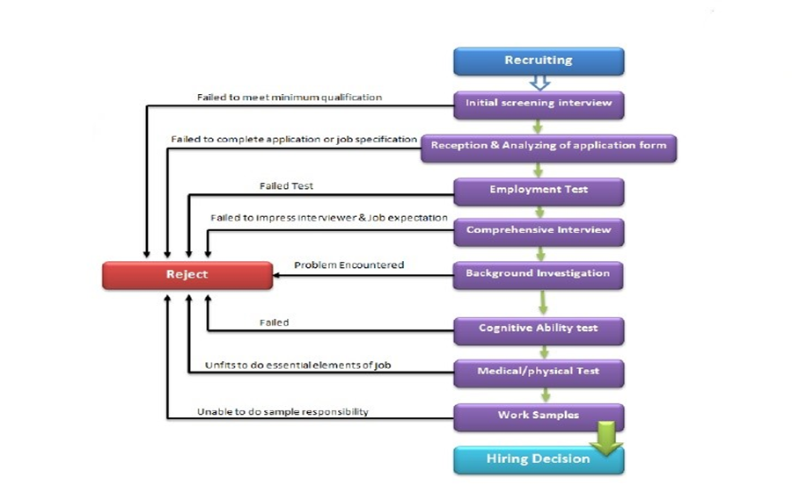
Figure 2: Unilever's selection process
Source: (Varchetta, 2018)
After this step, the organisation analyses the application form of the short-listed candidates. As the application form is comprised of many open-ended questions and basic information, the interviewer gets an idea of the consistency and authenticity based on the previous interview. If a candidate manages to pass this level, he/she is required to sit for an employment test. The employment test is a conventional written test where the candidates answer job-related questions and solve basic numerical and analytical problems. Before moving on to the cognitive ability test, the company runs a background check of the candidates to avoid any unexpected situations. In the cognitive ability test, different psychometric tests are conducted. The medical fitness test tests the fitness required for the essential elements of the job. Lastly, by assessing work samples, HR takes the decision of hiring candidates. This long process of selection has been developed over the years by assessing the job market, candidates, current employees and performance trend. As a part of the evolution of the selection process, Unilever also arranges a competition named Future Leaders League. Through this program, candidates are fast-tracked from the long process selection method. The successful candidates in this program are entitled to a 3-year scheme that prepares themselves to be the business leader of the dynamic changing business environment (Pramod and Bharathi, 2016).

Conclusion:
The human resource management department of an organisation acts as a bridge between the potential candidates, current employees, and ex-employees with the organisation. The HR professionals fulfil the objectives of an organisation for its human capital. Multinational companies like Unilever have evolved their resourcing activities to an extent over the years that has allowed them to become one of the most well-known and top employers across the globe. A balance and harmony in the planning, recruitment and selection process have made the Unilever's resourcing activities impeccable in the industry.

References:
Bailey, C., Mankin, D., Kelliher, C. and Garavan, T., 2018. Strategic Human Resource Management. Oxford: Oxford University Press.
Boxall, P. and Purcell, J., 2016. Strategy And Human Resource Management. London: Macmillan Education.
CIPD, 2020. New Profession Map | CIPD Profession Map. [online] CIPD People Profession. Available at: <https://peopleprofession.cipd.org/profession-map> [Accessed 14 November 2020].
Claus, L., 2017. The role of international human resource in leading a company from a domestic to a global corporate culture. Human Resource Development International, 1(3), pp.309-326.
Cook, M., 2019. Chartered Institute of Personnel and Development (2018) How do People Learn?. Nurse Education Today, 23(8), pp.638-639.
Crush, P., 2020. International Case Study: Unilever's Internal Project Platform. [online] Hrmagazine.co.uk. Available at: <https://www.hrmagazine.co.uk/article-details/international-case-study-unilevers-internal-project-platform> [Accessed 14 November 2020].
Lin, C. and Sanders, K., 2017. HRM and innovation: a multi-level organisational learning perspective. Human Resource Management Journal, 27(2), pp.300-317.
Newenham-Kahindi, A., 2016. Effective People Management In Africa. Houndmills, Basingstoke, Hampshire: Palgrave Macmillan.
Pramod, D. and Bharathi, S., 2016. Social Media Impact on the Recruitment and Selection Process in the Information Technology Industry. International Journal of Human Capital and Information Technology Professionals, 7(2), pp.36-52.
Reitsma, S., 2016. Management development in Unilever. Journal of Management Development, 20(2), pp.131-144.
Sankar, R., 2017. What Makes a Successful Global HR Professional?. NHRD Network Journal, 2(1), pp.18-21.
Varchetta, G., 2018. Competences and Human Resources Empowerment in a Market-Driven Company. The Unilever Case. Symphonya. Emerging Issues in Management, (2).

