Module Name: “Entrepreneurship”
Module Code: “LCMB7004”
Student Name: Nizar Kasamali Charania
Student ID: 2132189

Table of Contents
Introduction 3
Importance 3
Difference between Enterprise and Entrepreneur 4
Most Considerable Models related to Entrepreneurship 4
Theory of Innovation 5
Critical Evaluation 6
Need for Achievement Theory 6
Critical Evaluation 7
Theory of Leadership 7
Critical Evaluation 8
Lessons from Elon Musk and TESLA, Two of History's Greatest Entrepreneurs 8
In connection with Amazon 9
Studying the Impact of Government Regulation on Business Startups and Internal Innovation 9
Analysis and Effects of Regulation 10
Profit and Non-profit Making Organisation 11
Common Diferences 11
Illustrations in Context 12
Conclusion 12
References 13

Introduction
The term "entrepreneurship" is commonly used to describe the process of creating new businesses and introducing novel products and services. The focus is on doing what is necessary to put up enterprises that are profitable within the constraints of the law. This research aims to provide an accurate picture of entrepreneurs and business ownership. Their value to the economy and to any given sector of the nation is incalculable, as are the positive effects on society at large. The point is to take a hard look at the theoretical model and see where it falls short and where more effort needs to be done to bring it together. The primary goal is to develop a grasp of the following entrepreneurship-related theories:
- Conceptual Model of Innovation
- Achieve-Need Theory
- Management theory
- Theoretical physiology
- Speculation in Economic Theory
More than that, we take into account the fact that many people conflate the words "business" and "entrepreneur," which leads to a misunderstanding of why the former is necessary for the latter.

Importance
Entrepreneurship and commerce are the bedrock of every nation's economy. From fostering positive social change to propelling economic progress, the business enterprise is essential. They are a country's most valuable resource, thus it's important to motivate them to make as many positive changes and get as much assistance as possible. The commercial initiative is noteworthy because it has the potential to not only broaden people's understanding of coating concepts, but also the coating industry as a whole. Entrepreneurs and their cutting-edge ideas are a major contributor to the market's expansion. Companies are essential to the functioning of the economy and the flow of money(Azlan et al., 2015). Support for entrepreneurial endeavours yields a unique harvest. Existing connections might stay tethered to existing company components and achieve a salary ceiling. Fresh commercial components and new prosperity are made possible by the possessions, organisations, and developments of currency executives.
Moreover, the models aid us in every manner; even a common man may use their advice to improve himself in many ways and overcome his faults. It's also important to remember that these ideas provide the groundwork we may build upon. The foundation of this is the entrepreneur's ideas. Improved open compensation as advanced cost pay and increased administrative expense is also a result of long hours and superior perks. The community may utilise the money from this settlement to fund human resources and expansion into other promising regions. While this may seem redundant to some current players, the public expert may negotiate with the government to have flood funds used to retrain workers(Baker and Welter, 2018). A successful businessperson has the drive, creativity, and vision necessary to achieve their goals, is resilient in the face of adversity, knows when and how to implement process improvements, and is resilient under pressure. Out of luck, they will require knowledge about how to progress. The apparent truth is that ideas without abilities are useless, and skills without ideas are useless without something to apply them to. All of these parts depend on one another.

Difference between Enterprise and Entrepreneur
Enterprise refers to an endeavour undertaken for economic gain, whereas an entrepreneur is someone who undertakes this endeavour on their own. Entrepreneurship is the action or process of starting and running a company, as well as the associated planning, creativity, skill application, and knowledge acquisition. As a result of their innovative ideas, products, and businesses, entrepreneurs contribute to economic expansion. In the face of sustained competition from businesspeople, established companies evolve into more serious competitors. People in business sometimes draw long straws to open doors to new roles(Berger et al., 2021).

Most Considerable Models related to Entrepreneurship
Entrepreneurship has long been recognised as a key to a flourishing economy. Because of the lack of a theoretical framework to explain what kinds of risks lead to what kinds of rewards, economists have failed to give a factual or analytical interpretation of either the demand for or supply of entrepreneurial activity(Bhide, 2003). As a result, despite the fact that many theories have shed light on the reality of entrepreneurship, they all include flaws and assumptions that invite scrutiny. As a result of the evolution of many schools of thought, several hypotheses about the nature of entrepreneurship have emerged. These are some of the most important theories in the field of entrepreneurship:

Theory of Innovation
Theories of Innovation J.A. Schumpeter lays forth a hypothesis for creating new things. The notion that an entrepreneur is an innovator because he or she presents a novel concept is central to the entrepreneurial narrative. Since this idea involves providing something new to the customer, it touches on certain key components of the company with which he is not yet aware. This hypothesis also accounts for the techniques of manufacturing that have just recently been established or may never have been introduced at all. Making a brand-new industry out of thin air, using nothing but the newly discovered raw resources, is an impressive feat. This idea may also be used to explain how monopolies come to be(Bird, 2019).
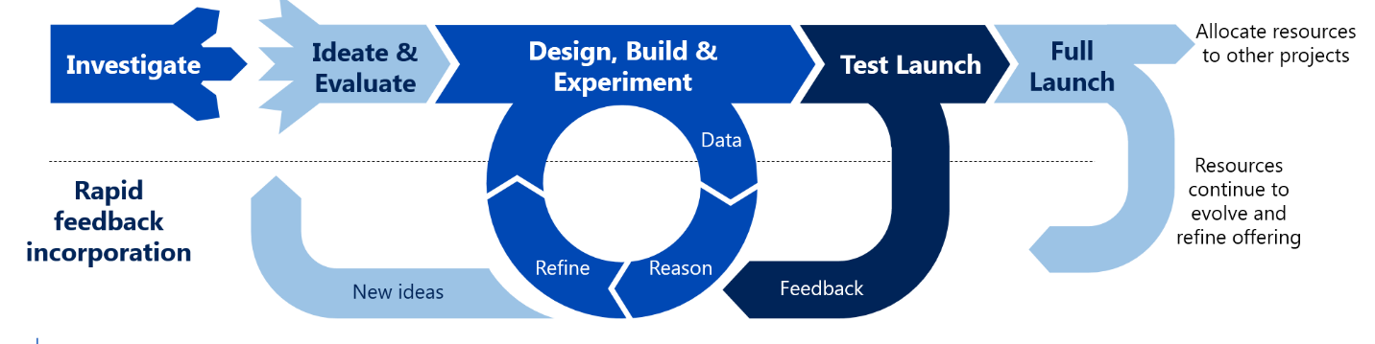
Figure 1 The Improvised Innovation Lifecycle(BOLDUREANU, 2018)
For instance, when autos started playing a significant role in the economy, Ford Motor Company concentrated only on offering low-cost vehicles to consumers, whereas Alfred Sloan prioritised maintaining good relationships with existing customers and seeking out new ways to improve his product.
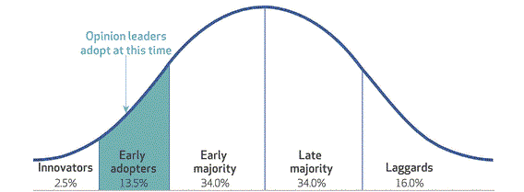
Figure 2 Theory of Innovation(Carter and Jones-Evans, 2006)

Critical Evaluation
The idea of progress lies at the heart of the Schumpeterian theory. He differentiates between pioneers and innovators. As per him, a designer discovers new methods and new materials. As a result, the economic tide turns as a result of ground-breaking progress. Independent producers, advanced-function supervisors, and subordinates all benefit from an entrepreneurial environment.

Need for Achievement Theory
This is what David. C. McClelland stands for; it has to do with economic development, elements that impact human values, and motivations that might lead to exploiting possibilities. The idea behind this philosophy is to achieve success in business without drawing undue attention to oneself. The desire for esteem among the populace is low. He continues by saying that strict requirements produce highly motivated workers(Carter and Jones-Evans, 2006). As an example, in order to take risks that bring about potentially fruitful outcomes, a person who is ready to bring about change and present something new to the market must have accomplished all types of accomplishment in order to be at it full at boring potential.
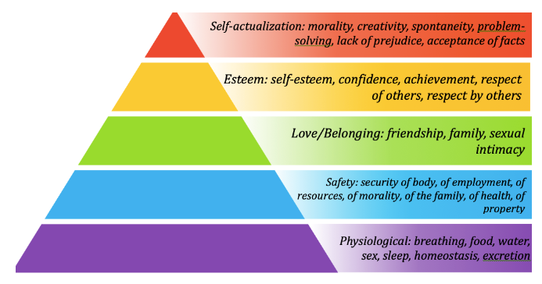
Figure 3 Achievement Theory(Emden, 1998)

Critical Evaluation
There is good reason to doubt the reliability of his idea-generating experiential apparatuses. As a matter of fact, we can see this working in the real world right now. One thing to remember is that it is hard to quantify since it has reinforcing effects.

Theory of Leadership
Hoselitz puts out this view, and he claims that entrepreneurship is the point of executive services and management after the finances have been taken care of. There is more to becoming a successful manufacturer entrepreneur than just a desire for financial gain, and this article explains what those other motivations are(Fayolle, 2018). It elaborates on the three distinct styles of leadership. It has been theorised that leadership is a skill that may be acquired via experience but not by mental calculation. As you move closer to your goal, you'll be more willing to let your teammates in on your progress. A person's capacity for learning is directly correlated to their future leadership potential. Individuals develop as a result of their exposure to and success in overcoming various challenges. A person's ability to see things clearly, both for himself and for others, improves as he gains life experience(Ferreira et al., 2019).
Tesla, one of the most prominent companies in the world, hires managers with leadership qualities or provides them with the training they need to build these talents via experiences and readings.
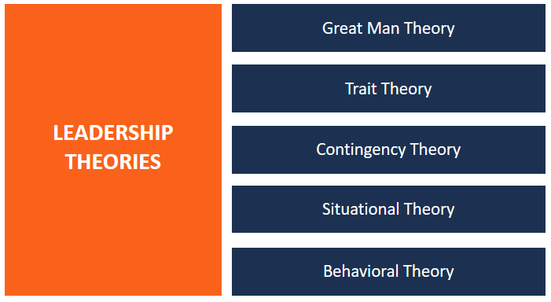
Figure 4 Leadership Theories(Fitz-Koch et al., 2018)

Critical Evaluation
The development of business is indeed more common among males and groups on the margins who value a mysterious culture and social standing and are free from the constraints of ritual. Women are just as capable of becoming agents of change and taking risks as men, so the idea that entrepreneurship is biased toward a certain gender is ridiculous.

Lessons from Elon Musk and TESLA, Two of History's Greatest Entrepreneurs
To Elon, it's not enough to just establish successful firms; he has loftier goals in mind. His goal with SpaceX is to enable everyone on Earth (not just astronauts) to participate in space exploration. When it comes to Tesla, he is dead set on developing brand-new, eco-friendly forms of mobility. Some individuals find inspiration and motivation in the pursuit of a lofty goal. A lofty goal might serve as a source of motivation for you and your team members. Indeed, Elon has taken a different path than others. Tesla deals only with the buying public. Displays at retail malls are used instead of expensive, impersonal dealer showrooms. He is a tireless proponent of open innovation, publishing and otherwise making available all of Tesla's patentable discoveries(Frederick et al., 2018).
Unlike other automakers, it rejects convention in favour of creating a one-of-a-kind, environmentally friendly car, which increases its marketability. Elon Musk has taught us that it is important to build upon one's triumphs, which brings us to our next point. He didn't rest on his laurels after selling his first internet startup. When he initially got rich, he didn't pack up and move to the Caribbean. His early successes caused him to fold his grand goals. Use your early success to propel you towards bigger and riskier endeavours(Imran Nkun, 2020). A continuous cycle of reflection on past actions and future enhancements is essential. That, in my opinion, is the most crucial piece of guidance: to always question oneself and look for ways to improve. In conclusion, if you want to sharpen your mind, you should disregard conventional wisdom in favour of forming your own opinion based on facts and reason(Mehmood et al., 2019).

In connection with Amazon
We can learn a lot from Amazon, a corporation that has clearly perfected the art of business management. Its amazing growth from its 1994 beginning to its current form makes it an invaluable management teaching tool. Amazon's financial statements alone would have made the company a risky investment, but that's irrelevant now that we've considered all the other indicators that point to sustained expansion.

Studying the Impact of Government Regulation on Business Startups and Internal Innovation
The Competition and Markets Authority is in charge of regulating the market in the United Kingdom (CMA). Roughly 90 regulatory bodies operate in the United Kingdom. The government of the United Kingdom recognises the need of protecting workers' rights, preserving the environment, and limiting corporations' ability to abuse their position of power by passing a slew of business rules. We have seen that poorly drafted rules may have unintended negative consequences, despite regulation's central role in helping achieve broad public goals. This leads to a proliferation of regulations that stifle productive innovation and stunt economic development. Individuals, corporations, and the environment are all protected and aided by regulations that are put in place for the greater good of the economy(TERAN-YEPEZ and Guerrero-Mora, 2020). Government uses regulation as a primary tool to further its policy agenda. When compared to direct government service supply, this method uses incentives to persuade citizens and businesses to alter their actions on their own will. Entrepreneurs and intrapreneurs use cunning techniques to introduce new ideas inside organisations, often making little adjustments that have a domino effect. This demonstrates that even very junior corporate visionaries may launch bottom-up socially-driven innovations for the public good. The federal, state, and local governments all have regulations that affect small businesses. Environmental regulations, workplace norms, and advertising regulations are just a few examples of the many areas where governments enforce laws. Government regulations also affect enterprises in many other ways, including their organisational makeup, preferred locations, employee classifications, and many more(Yildiz, 2018). There are several rules that stand out and have a greater impact on business owners and innovators than others.
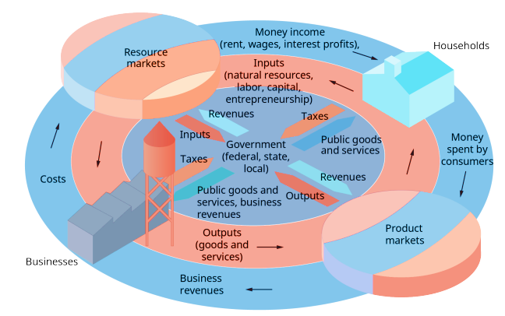
Figure 5 Regulation Chart(Williams et al., 2020)

Analysis and Effects of Regulation
Summarizes the views of those involved with the UK's smallest businesses and their experiences in coping with the overall regulatory load. Learn about 500 small businesses and you'll find that many are struggling to comply with current rules, and that each new legislation or change makes their situation even more precarious. Although British businesses already have a substantial economic impact and have room to expand, they must contend with certain peculiar regulatory issues. The following is from a study published by the government of the United Kingdom, which details the effects on new businesses and corporate innovation.
- Microbusiness operators claim that excessive regulation hampers their ability to expand and pay themselves a living salary(Thompson et al., 2020).
- Some company owners have claimed that they are unable to pay themselves a living wage because of the cost of regulation, while working long hours for little compensation.
- Businesses are frustrated by regulation because "no one is looking out for our interests," in their words. It's also obvious that the sum of the expenses faced by certain company owners makes it difficult to operate at a profit.
- In addition, there is evidence that certain compliance costs are unnecessary or duplicated.
- The company's leadership is sidetracked from pursuing opportunities that might provide more financial gain.

Profit and Non-profit Making Organisation
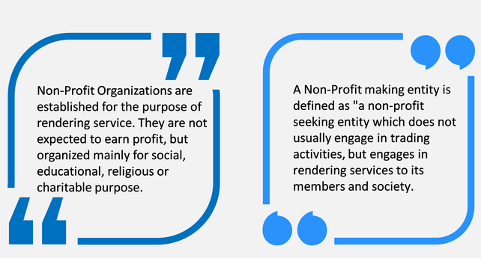
Figure 6 Profit and Non-profit Organisations(Stroe et al., 2018)

Common Diferences
- Non-profit associations, the development of humanity is fundamental, and individual justifications follow immediately. Associations with a primary focus on making money get the ball rolling.
- Membership fees, participation fees, commitment fees, and so on are the main sources of money for non-profit organisations, while the sale of goods and investments is the main source of income for revenue-driven organisations.
- Charitable organisations are exempt from this obligation, while for-profit organisations are.
- Non-profit organisations use budget reports, which include things like revenue statements, salary structures, and expenditure breakdowns. Non-profit organisations, however, keep detailed records of all payments received and made, as well as an accounting report that details all financial transactions(Seckin-Halac, 2021).

Illustrations in Context
Nonprofit organisations are businesses whose primary goal is serving the public good, such as by providing necessities such as housing, human rights, and water to the poor. Companies that supply goods and services to clients and whose primary goal is to produce sales and profit are examples of for-profit enterprises.

Conclusion
The success of a company may be greatly influenced by the mentality of its founders, who provide a description of the company's overall strategy and goals. It might be a major factor in catastrophic failure or unprecedented success. Each theory has unique strengths that set it apart from others. And, of course, they have special constraints that no one else shares. Great businessmen, such as Elon Musk, may teach us a lot about where our focus should be. Making all of the hypotheses consistent and working on them together may help entrepreneurs reduce the likelihood of failure. In addition, the value of profit and non-profit organisations is different in the eyes of every business owner. First and foremost, we need to train ourselves to take into account competing worldviews and to go beyond current constraints. Due to the influence of rules, we have to deliberate about whether to invest in some things or not.

References
Azlan, A., Anwar, R., Zainol, A.S., 2015. A hypothetical methodology of transferring graduates’ knowledge through ceramic art entrepreneurship, in: Proceedings of the International Symposium on Research of Arts, Design and Humanities (ISRADH 2014). Springer, pp. 133–139.
Baker, T., Welter, F., 2018. Contextual entrepreneurship: An interdisciplinary perspective. Foundations and Trends® in Entrepreneurship 14, 357–426.
Berger, E.S., Von Briel, F., Davidsson, P., Kuckertz, A., 2021. Digital or not–The future of entrepreneurship and innovation: Introduction to the special issue. Journal of Business Research.
Bhide, A., 2003. The origin and evolution of new businesses. Oxford University Press.
Bird, B., 2019. Toward a theory of entrepreneurial competency, in: Seminal Ideas for the next Twenty-Five Years of Advances. Emerald Publishing Limited, pp. 115–131.
BOLDUREANU, G., 2018. The Economic and Social Impact of Entrepreneurial Activity. EUFIRE 2018 203.
Carter, S., Jones-Evans, D., 2006. Enterprise and small business: Principles, practice and policy. Pearson Education.
Emden, C., 1998. Conducting a narrative anlysis. Collegian 5, 34–39.
Fayolle, A., 2018. Personal views on the future of entrepreneurship education, in: A Research Agenda for Entrepreneurship Education. Edward Elgar Publishing.
Ferreira, J.J., Fernandes, C.I., Kraus, S., 2019. Entrepreneurship research: mapping intellectual structures and research trends. Review of Managerial Science 13, 181–205.
Fitz-Koch, S., Nordqvist, M., Carter, S., Hunter, E., 2018. Entrepreneurship in the agricultural sector: A literature review and future research opportunities. Entrepreneurship theory and practice 42, 129–166.
Frederick, H., O’Connor, A., Kuratko, D.F., 2018. Entrepreneurship. Cengage AU.
Imran Nkun, U., 2020. Challenges young entrepreneurs face when seeking funding to establish business.
Mehmood, T., Alzoubi, H.M., Ahmed, G., 2019. Schumpeterian entrepreneurship theory: evolution and relevance. Academy of Entrepreneurship Journal 25.
Seckin-Halac, D., 2021. Historical Development of Entrepreneurship in the Literature, in: Engines of Economic Prosperity. Springer, pp. 93–112.
Stroe, S., Wincent, J., Parida, V., 2018. Untangling intense engagement in entrepreneurship: Role overload and obsessive passion in early-stage entrepreneurs. Journal of Business Research 90, 59–66.
TERAN-YEPEZ, E., Guerrero-Mora, A.M., 2020. Teorías de emprendimiento: revisióncrítica de la literatura y sugerencias para futurasinvestigaciones. RevistaEspacios 41.
Thompson, N.A., Verduijn, K., Gartner, W.B., 2020. Entrepreneurship-as-practice: Grounding contemporary theories of practice into entrepreneurship studies. Entrepreneurship & Regional Development.
Williams, A.M., Rodriguez, I., Makkonen, T., 2020. Innovation and smart destinations: Critical insights. Annals of Tourism Research 83, 102930.
Yildiz, K., 2018. The Effect of Career Decisions on Entrepreneurial Intention Levels of University Students Studying Sport Sciences. Journal of Education and Training Studies 6, 13–18.

