Research on detection and recognition methods of Prohibition Traffic Signs based on Deep Learning

Zhihao Xiao
2200466
Research Methods and Professional Development
University of Wales Trinity Saint David
2200466@student.uwtsd.ac.uk

Introduction
With the continuous development of technology, the number of cars has been increasing. Meanwhile, traffic congestion and traffic accidents have gradually increased. Among them, the proportion of traffic accidents caused by driver's operating errors or negligence is increasing. According to the "Global Status Report on Road Safety" [1], traffic problems have become a major cause of accidental deaths worldwide, with nearly 1.25 million people dying in traffic accidents every year. More than 80% of these accidents are caused by human factors such as driver's lack of concentration, fatigue driving, and ignoring traffic sign information. As traffic signs contain important information about traffic regulations, research has shown [2] that timely and accurate communication of traffic sign information to drivers before accidents occur can greatly reduce the occurrence of similar accidents. people are focusing on studying Intelligent Transportation Systems (ITS) [3] to reduce the number of traffic accidents. ITS is an intelligent system that integrates information digitization and communication technology, control operation technology, digital image processing technology, etc., with the main purpose of assisting in the establishment of a more intelligent, efficient, fast, accurate, and convenient transportation management system on the basis of existing traffic construction, which will provide a guarantee of safety and convenience for road driving. As a subsystem of ITS, the Traffic Sign Recognition (TSR) system captures traffic signs in front of the road through a front-end camera of the vehicle and accurately recognizes them through corresponding traffic sign detection algorithms. The TSR system plays a positive role in assisting driving, regulating traffic order, improving vehicle passing efficiency, and reducing the incidence of human-caused traffic accidents.
At present, there has been some progress in the research on detection and recognition of traffic signs, mainly focusing on the detection and recognition of general categories of traffic signs (such as prohibition, direction, warning, etc.) [4]. However, there is relatively little research on the detection and recognition of specific subcategories of signs (such as no passing, no U-turn, speed limit, etc.) within these general categories. Specifically, most current traffic sign detection models lack specific semantic information about the recognized signs and do not express information about subcategories under general categories. If specific subcategories cannot be accurately detected and recognized, vehicles will be unable to obtain effective information about their surrounding road environment, thereby affecting their ability to make autonomous decisions. The specific subcategories of traffic signs are numerous, with significant differences in shape and color, and they involve various scenarios, making their recognition challenging. While some scholars have conducted research on the identification of certain specific subcategories of traffic signs, it is limited to a few and cannot meet the needs of actual traffic scenarios. Therefore, further in-depth research and exploration of accurate detection and recognition algorithms for various subcategories of traffic signs hold significant academic and practical value. The design and standards of traffic signs vary among different countries. There are differences in the colors, shapes, text or symbols included in the signs, their placement and meaning. This means that for research on traffic sign detection and recognition algorithms, adjustments and optimizations need to be made based on the characteristics of different countries' signs to ensure the accuracy and robustness of the algorithms. In Chinese urban roads, prohibition signs account for a large proportion, especially on traffic arteries, highlighting their importance. Accurately recognizing and understanding prohibition signs can effectively improve the operation efficiency and traffic safety level of traffic arteries, and have a positive effect on road traffic management and planning. Therefore, this study focuses on recognizing the 12 most common types of prohibition signs on Chinese roads, aiming to provide effective technical support for Chinese urban road traffic management and planning.
The algorithms for detecting and recognizing traffic signs can be divided into traditional machine learning-based methods and deep learning-based methods. Traditional methods mainly rely on image processing and pattern recognition techniques, including feature extraction, classifier design, and object detection. Feature extraction methods include shape features, color features, and texture features, while classifier design methods include support vector machines, naive Bayes, and decision trees. Object detection methods include sliding window detection and cascade detection. In recent years, with the rapid development of deep learning technology, deep learning-based algorithms for traffic sign recognition and detection have become a research hotspot. These algorithms mainly use convolutional neural networks (CNNs) for end-to-end training, which can automatically learn features from images and have achieved good performance in detection and recognition tasks. Currently, the main deep learning algorithms include Faster R-CNN, YOLO, and SSD. YOLO algorithm, in particular, has multiple advantages. It has a fast detection speed and can meet the real-time requirements of high-demand scenarios. Additionally, YOLO performs detection and recognition simultaneously in one network, allowing it to achieve a better balance between speed and accuracy than other algorithms. Moreover, YOLO's network structure is simple and easy to use, making it more convenient for training and implementation. In summary, considering its excellent performance in speed and accuracy, as well as its simple and easy-to-use network structure, YOLO algorithm is a worthwhile option for traffic sign detection and recognition.
With the popularity of mobile devices, embedded devices, and other edge computing devices, the requirements for computing resources and model size are becoming increasingly high. Therefore, the development of lightweight neural network models has become increasingly important. In the field of object detection, the YOLO series algorithm has been widely recognized as an efficient and accurate detection algorithm since its release. However, its application on devices with limited computing resources, such as mobile devices, still faces challenges. Therefore, designing lightweight YOLO algorithm variants to adapt to different scenarios of computing resources and storage requirements is currently an important research direction. At the same time, this can also improve the feasibility and practicality of object detection algorithms in practical applications. In this article, we focus on deploying improved YOLO models based on the YOLO algorithm on Raspberry Pi. To achieve the deployment of the algorithm on Raspberry Pi, it is necessary to first optimize and compress the trained model to meet the limitations of Raspberry Pi's computing power and storage capacity. Secondly, it is necessary to port the optimized model to Raspberry Pi and perform appropriate hardware configuration and debugging to ensure that the algorithm can run normally on Raspberry Pi. Finally, real-time and accuracy tests of the algorithm need to be carried out to ensure that the algorithm can meet the requirements of practical applications.
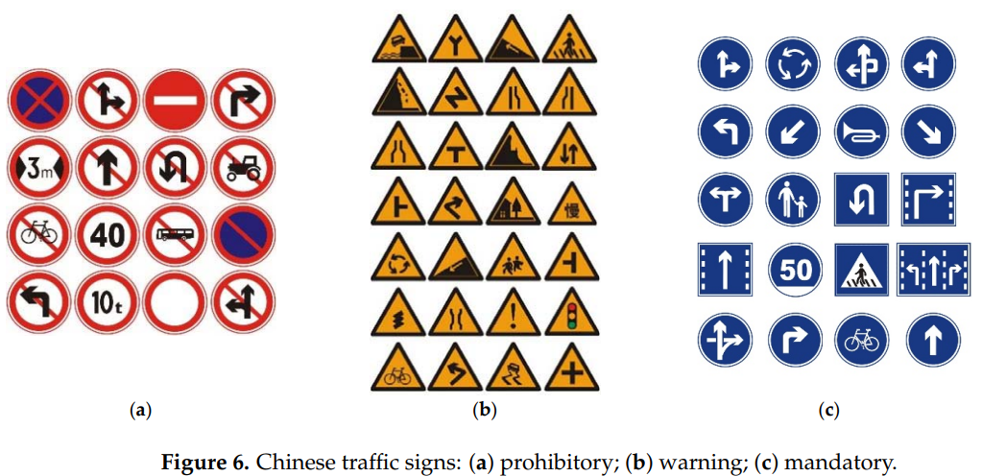
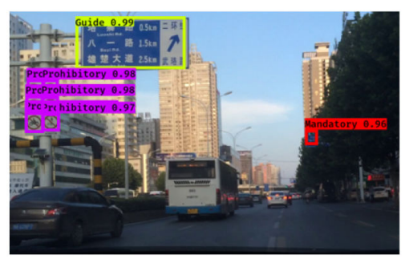
Fig.1. Most of the current traffic sign recognition models recognize the targets as the general category, without expressing the specific semantic information of the subcategories under the general category.
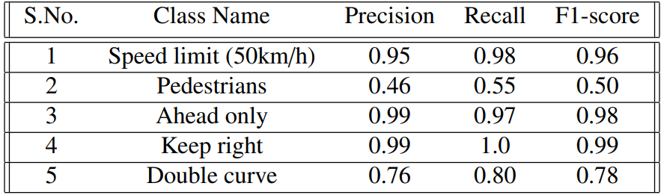
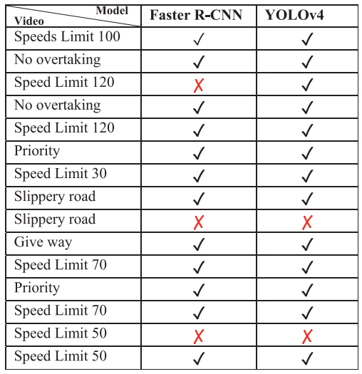Fig.2. Current researches on specific subclasses of traffic sign recognition.( The total number of recognized categories is relatively little and may not include commonly seen traffic signs on the road.)

Fig.3. The twelve types of prohibited signs in China. (From top to bottom and left to right, they are: no turns, no horn, no stopping, no overtaking, no entry, lifting speed limit, speed limit, height limit, weight limit, no left turn, no right turn, and no go straight.)
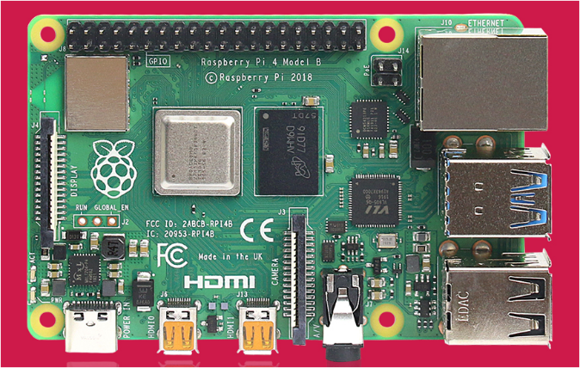
Fig.4. Raspberry Pi 4B model diagram.

Literature Review
Traffic sign detection is the use of computer algorithms to determine whether there are traffic signs in an image and to quickly and accurately locate them. The algorithmic process of traffic sign detection mainly involves inputting a target image, extracting image features in candidate box regions, distinguishing image signs in classifiers, performing non-maximum suppression, and then outputting the target image. Another approach is to directly regress the output target image after feature extraction from the input image. Both domestic and foreign research teams have conducted various types of detection research on traffic signs, constantly improving and innovating, and summarizing many methods and techniques. Massive learning methods have also injected new blood into the development and progress of traffic sign detection and intelligent transportation. The common ways of traffic sign detection algorithms can be summarized as detection based on traditional methods and detection based on deep learning, as shown in Figure 5 The most common detection methods based on traditional models in the past include SIFT, SURF, HOG, DPM, VJ, and other methods. The currently popular traffic sign detection methods based on the deep learning field are mainly one-step detection algorithms such as the YOLO series and SSD algorithm based on regression algorithm, and two-step detection algorithms such as the R-CNN algorithm based on candidate box regions and upgraded series algorithms. Among them, the first step of the two-step detection algorithm is to determine the candidate box domain of the target object, and the second step is to perform accurate positioning and division of the candidate box region.
Fig.5. Traffic sign detection algorithms

Traffic sign detection based on traditional methods
Traditional research methods typically use manual extraction of color and geometric features of traffic signs for detection and classification. This is mainly based on feature extraction and learning to detect the target location in the original image. Yang et al. [5] first transformed the RGB space into the Ohta color space and used the calculation of color-related probabilities to determine the candidate range of target pixels. Kastner et al. [6] used Gaussian difference and Gabor filters to establish a model and detect traffic signs by calculating attention feature maps. Gudigar et al. calculated the global brightness mean and determined the current lighting conditions based on a threshold, then used a red angle space transformation and grayscale enhancement to process the image, and finally segmented the target image according to different thresholds. Farhat et al. also detected target images using three color spaces (RGB, HIS, and HSV) after comparing different lighting conditions, and found that the HSV color space-based method had higher detection accuracy than the other two, effectively improving detection efficiency. Wang et al. detected arbitrary-shaped images mainly by jointly using HOG and SVM to complete the traffic sign detection task. Boumediene et al. [7] detected the specific triangular warning sign by encoding gradients to select corner positions, and transformed the triangle into a detection symmetrical line to complete the detection of the specific warning sign. Zheng et al. [8] first performed white balance processing on the image, then calculated the channel ratio of the color based on RGB, and segmented the image based on the channel ratio. After processing, they detected circles in the image using radial symmetry transformation, and detected various polygonal sign images using the Douglas-Peucker algorithm.
Traditional detection methods mainly rely on color and shape information to detect traffic signs. However, this approach has limited ability to extract information features and can only perform well on feature-rich local images, resulting in significant limitations in detection. Detection is also affected by factors such as lighting, shooting angle, and manual design, making it difficult to achieve satisfactory results. In practical applications, compared with traditional methods, deep learning operations have more complex tasks and higher requirements for computing resources. Nevertheless, deep learning can achieve relatively complex and high-precision tasks, better meeting the needs of people's work and learning.

Traffic Sign Detection Algorithm Based on Deep Learning
In recent years, the continuous innovation and development of deep learning has brought traffic sign detection into a new stage. The main advantage of deep learning is the ability to independently train complex network models, which results in better detection accuracy and efficiency compared to previous algorithms. One-stage detection algorithms are direct detection algorithms that use end-to-end processes, and include the SSD [9] and YOLO [10] algorithms. These algorithms adopt regression methods, dividing the image into several grids and predicting the position and content of objects within each grid. Their characteristics include fast detection speeds, but with some limitations in accuracy. W. Liu [11] et al. proposed SSD, which uses convolution to locate and classify frames, and sets prior frames to improve detection accuracy. R. Joseph [12] et al. proposed the YOLO detection algorithm, which applies the convolutional network to an entire image and divides it into multiple regions. The boundary boxes and categories of each region are predicted. Wu Xiaohui [13] et al. improved the feature pyramid layer for small object detection and achieved good robustness using the Tiny-YOLOv3 model. Liu Mingwang [14] improved the YOLOv3 algorithm for small object detection, which effectively enhances detection performance. Yang Jinsheng et al. [15] proposed a YOLOv3-tiny-based model that is lightweight, and improved multi-scale fusion, which can effectively improve detection accuracy.
Two-stage detection algorithms extract candidate box regions based on feature information, and perform feature extraction and classification operations on the network model using CNN. The representative algorithms are R-CNN[16], and its upgraded versions, including Fast R-CNN[17] and Faster R-CNN[18]. Their advantage lies in improving detection accuracy, but they cannot meet real-time requirements. T.-Y. Lin[19] discovered the feature pyramid network (FPN) based on Faster R-CNN, which has become one of the mainstream network models in many object detection research directions. Karen Simonyan[20] proposed VGG16, a convolutional neural network model with certain performance advantages in the early stage of research. Although its structure seems outdated now, VGG16 has contributed to the research of deep learning convolutional neural networks. Alex Krizhevsky mainly discovered the AlexNet convolutional network architecture. This algorithm uses innovative techniques to obtain Dropout, ReLU activation functions, etc. It has demonstrated through experiments that neural network models are far superior to artificial feature extraction learning methods.
In summary, in the context of small embedded devices, this research focuses on a lightweight and high-precision algorithm for traffic prohibition sign recognition. Among various options, Yolov5 is currently one of the best-performing first-stage object detection algorithms, with Yolov5s being the smallest and most suitable for applications with high real-time requirements. Therefore, this research chooses Yolov5s as the basic model framework and combines with the demand for traffic prohibition sign recognition to study the performance balance among detection accuracy, speed, and model memory usage. Based on this, we aim to develop an embedded traffic prohibition sign recognition system.

Summary of literatures
Through analysis of the above literature, it can be seen that most current traffic sign detection and recognition systems do not have clear definitions for the targets they recognize. They mostly identify targets as "prohibition", "warning", "indication", "directional", etc., without further classification. As a result, the recognition results need to be interpreted again to obtain more specific information that can help intelligent connected vehicles make correct decisions and improve driving safety. However, the process of interpreting the recognition results will increase the overall recognition time of the detection model, which will have a certain impact on the real-time performance of detection and recognition. Secondly, there are currently some models for detecting and recognizing the specific meanings of traffic signs, but the recognized traffic signs have not been well classified. That is, the recognized traffic sign categories are numerous (a model may need to detect forty to fifty traffic sign categories), which will cause low recognition accuracy for certain categories or a small number of specific subcategories recognized. These cannot meet the high-precision detection and recognition of traffic signs in complex driving scenarios.
To address the above issues, we first will establish a dataset containing specific semantic information of traffic signs and choose the 12 specific subcategories of prohibition signs as recognition targets. This is because prohibition signs have the highest proportion among all traffic sign categories in urban and rural roads in China, and many traffic accidents are caused by failure to comply with prohibition signs, such as speeding, overtaking, and U-turns. Therefore, recognizing the specific meanings of prohibition signs provides strong security guarantees for intelligent connected vehicles. Second, by learning the methods used in lightweight and high-precision object detection networks, we will establish a prohibition sign detection model based on the YOLOV5 algorithm that balances real-time performance and high accuracy, and verify the model's detection performance on embedded devices such as Raspberry Pi.

Methods
Firstly, a dataset of Chinese prohibitory traffic signs was established by extracting 5,000 images containing prohibition signs from driving videos recorded by a vehicle's front camera. The dataset was then expanded using data augmentation techniques to include more realistic images of prohibitory traffic signs in various scenarios. Secondly, a traffic sign recognition algorithm called SC-Yolov5s was proposed to address the weak feature extraction capability and low accuracy of the Yolov5s model, which cannot effectively recognize small target traffic signs. The network structure was optimized by introducing coordinated attention mechanisms, Stem block structure, and detection layer scale optimization to improve detection accuracy. To better adapt the algorithm to embedded devices such as Raspberry Pi, a lightweight version of SC-Yolov5s called SC-Yolov5s-lite was proposed by introducing Fire module lightweight convolution structures and reducing the number of Bottleneck residual modules to simplify the parameter volume and improve detection speed, laying the foundation for the next step of Raspberry Pi embedded system integration.
The implementation and experimental verification of the Raspberry Pi embedded intelligent recognition system for traffic prohibition signs were carried out as follows: Firstly, the construction and calibration of the traffic prohibition sign dataset were completed, and the newly designed model was trained and optimized through ablation experiments and performance comparison tests. Then, the Raspberry Pi system environment and deep learning runtime environment were set up, and the trained and optimized traffic prohibition sign recognition model was deployed on the Raspberry Pi embedded platform. Subsequently, an experimental system for traffic prohibition sign recognition on the Raspberry Pi embedded platform was built. Finally, a testing environment was constructed by integrating a camera, Raspberry Pi, and host, and various tests were conducted under multiple scenarios to obtain performance test results and verify the recognition effect of the system.

Establishment of the Dataset
The basic dataset used in this study consists of 5,000 images, which were selected from the Chinese public transportation datasets TT100K and CCTSDB, as well as real-world traffic scene images captured by driving vehicles. To increase the diversity of the dataset in terms of scenes and traffic sign categories, four common data augmentation methods were employed: translation, rotation, brightness adjustment, and noise addition. Firstly, all the images of the prohibited traffic sign samples were subjected to rotation transformations, based on the convolutional neural network's rotational invariance, with rotation angles ranging from -5° to 5°, so as to avoid significant changes in the aspect ratio of the detection boxes. Then, horizontal translation transformation was performed, with a scaling factor ranging from 80% to 110%, in order to prevent the prohibited sign images near the image edges from being shifted out of bounds and to avoid loss of details. Brightness adjustment was applied to enhance the image clarity and brightness, and to better adapt to different lighting conditions in practical applications. Specifically, a brightness adjustment factor alpha was randomly generated in the range of [0.5, 1]. A blank array of the same size as the input image was constructed, and the addWeighted() function in OpenCV was used to perform a weighted sum of the input image and the blank array, where the weight of the input image was alpha and the weight of the blank array was 1-alpha. Finally, the output image with adjusted brightness was obtained. To improve the robustness of the model, a method of adding Gaussian noise was used, with μ = 10 and σ = 1. The three channels of the image RGB were added to the three-dimensional Gaussian noise, and the clamp function was used to handle out-of-bounds values. Some of the images with data augmentation are shown in Figure 6.
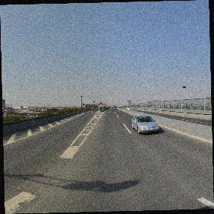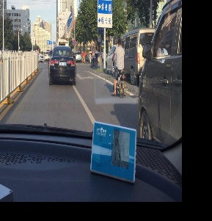
Rotation Translation
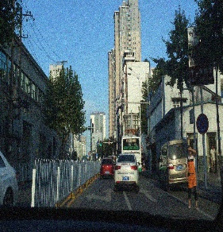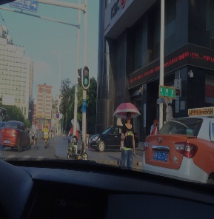
Gaussian Noise Brightness Adjustment
Fig.6. Four data augmentation strategies: rotation, translation, Gaussian noise, and brightness adjustment.

Design of SC-YOLOv5s-Lite Algorithm for Traffic Prohibition Sign Recognition
Considering the application scenario of deploying the algorithm on embedded hardware, Yolov5s, the smallest model in Yolov5 algorithm, was chosen as the basic design framework. Although Yolov5s has achieved remarkable results in the field of object detection, its network feature extraction ability is weak, resulting in missed detections and low accuracy in traffic sign detection. Its network structure introduces a novel attention mechanism, CA, and a Stem block structure to improve detection accuracy, and optimizes the detection layer scale to reduce model memory usage. As the application fields and task requirements of computer vision continue to expand, the overall performance of the network is becoming increasingly important. To improve the network's detection accuracy in complex background situations, the number of layers in the network has been increased from 7 layers in AlexNet to more than 100 layers in ResNet[21], and even up to thousands of layers in DenseNet[22]. However, deepening the network depth has led to problems such as large model storage space and slow detection speed. Model lightweighting has become an important approach to solving this problem. The network structure of SC-Yolov5s-lite reduces the number of Bottleneck residual modules and introduces the Fire module structure to achieve model lightweighting.
- The CA mechanis：The core of the attention mechanism is to make the network focus on the areas it needs to pay more attention to. For example, when browsing an image with a traffic sign, the human eye will focus more on the area where the traffic sign is located, gather more information about the traffic sign, and ignore other information that is not relevant to the traffic sign. In 2017, the SENet [23] network used the attention mechanism in the form of an SE module. However, SE only considers channel information and ignores important positional information. The CBAM [24] attention mechanism obtains positional information by pooling, concatenating, and convolving operations based on the channel information of the feature layer to solve the remaining problems of SE. However, it can only obtain local feature relationships and cannot obtain long-term dependencies. When using attention mechanisms in lightweight networks, it is necessary to consider the additional computational overhead and its impact on network performance. This paper introduces a lightweight and novel Coordinating Attention (CA) mechanism [25].
- Stem Block Model: Yolov5 utilizes the Focus structure as the first layer, mainly to reduce the number of layers, parameter size, and increase inference speed, while having minimal impact on detection accuracy. However, the Focus layer only uses one convolution operation, which cannot extract more scale feature information, resulting in weak feature expression capability. To enhance feature extraction capability, the Stem block is introduced to replace the original Yolov5s network's Focus and the first Conv layer as the first layer of the network input. Robert J. Wang et al. proposed a lightweight object detection model PeleeNet [26] aimed at real-time mobile applications, which designed a more efficient Stem block as the first layer of the network input.
- Optimization of detection layer scale: The Yolov5s network trains images at a unified resolution of 640x640, using three different scales of features for detection, with feature map resolutions of 80x80, 40x40, and 20x20. The best detection results are then obtained through non-maximum suppression. The 80x80 detection layer is responsible for detecting small objects, while the 20x20 detection layer is responsible for detecting larger objects. The images in our self-built traffic sign dataset are mostly at a resolution of 1920x1080, and most of the traffic signs are below 90x90 resolution. A typical traffic sign may be at a resolution of 80x80, accounting for only 10% of the image in a 1920x1080 resolution image. In our dataset, traffic signs are small targets, so we choose to remove the 20x20 detection layer and related network structures. This reduces network parameter size and avoids wasting computational resources, while not affecting the accuracy of traffic sign detection.
- Fire module: Iandola et al. [27] proposed the SqueezeNet network model, which replaces the 3x3 convolutions with 1x1 convolutions and lower channel 3x3 convolutions, effectively reducing the size of the model by decomposing the convolutions into multiple smaller ones. In general, the channel lightweighting idea aims to reduce the number of parameters in the model by reducing the number of input and output channels (M and N) in a 3x3 convolutional layer, which has a parameter count of 3x3xMxN. The SqueezeNet network uses a Fire module structure to reduce the number of parameters in convolutional layers. The Fire module consists of two parts: the Squeeze structure and the Expand structure. The Squeeze layer contains a low-channel 1x1 convolutional layer, which compresses the model's parameters. The Expand layer consists of a group of 1x1 convolutional layers and a group of 3x3 convolutional layers that expand the model. The ReLU function is chosen as the activation function, and the final output is the concatenation of the results of the two convolutional branches.
- Adapting residual modules to different depths: The residual module is a classic structure in CNN, consisting of multiple convolutional layers and a shortcut connection to pass features through skip connections. The Bottleneck residual module in Yolov5s is located in the C3 module, and there is a total of four C3 modules in the Yolov5s backbone network, each with 1, 3, 3, and 1 Bottleneck modules, respectively. Having too many Bottleneck modules can easily result in multiple irrelevant backgrounds being stacked, causing the semantic information of small objects to disappear and increasing the size of the model. Therefore, it is necessary to re-adapt the number of Bottleneck modules.

Experimental environment
The computer used for training our proposed algorithm is equipped with an NVIDIA GEFORCE RTX 3080 graphics card with 10GB of memory, and the software development was done using Python language and the Pytorch deep learning framework with GPU acceleration using CUDA 11.0. The specific software and hardware configurations for the experimental environment are shown in Table 1 and Table 2. For the embedded system, considering factors such as low cost, low power consumption, hardware size, universality, and future development, we chose the latest generation of Raspberry Pi, the Raspberry Pi 4B, as the development platform.
Table.1. experimental software environment
Operating System | Window 10
System Type | 64 bit
GPU | NVIDIA GEFORCE RTX 3080
Graphics Memory | 8G
Programming Language | Python3.8
Complier | Pycharm
Deep Learning Framework | Pytorch1.8.1
GPU Acceleration Tool | CUDA11.0+CUDNN8.0.5

Table.2. experimental hardware environment
SOC | Broadcom BCM2711
CPU | 64 bit
Bluetooth | 5
GPU | 500Mhz VideoCore VI
USB port | USB3.0
Wired network | Gigabit Ethernet
Wireless | (2.4/5GHz)
Power requirements | 3A, 5A
Memory | 4GB DDR4

Model performance evaluation metrics
To evaluate the performance of the traffic sign recognition algorithm, this paper uses parameter count, model memory consumption (in MB), mean Average Precision (mAP), and inference latency (in ms) as evaluation metrics. The parameter count reflects the total number of parameters in the network structure. Model memory consumption represents the amount of storage space occupied by the trained model on the computer. mAP is a commonly used metric in image recognition to reflect the accuracy of object detection algorithms. Inference latency refers to the time required to detect an image, which can effectively reflect the real-time performance of the object detection algorithm.
- Precision is defined as the proportion of true positive samples among all samples predicted as positive. It directly reflects the degree of false positives of the model, and its formula is as follows:
$$P=\frac{TP}{TP+FP} (1)$$
- Recall is defined as the proportion of positive samples that are correctly predicted as positive, among all true positive samples. Recall directly reflects the model's ability to detect positive samples, and its calculation formula is as follows:
$$R=\frac{TP}{TP+FN} (2)$$
- Average Precision (AP) is a metric that combines precision and recall. The P-R curve is plotted by using precision and recall as the x-axis and y-axis, respectively. Since precision and recall are inversely proportional, the area under the P-R curve represents the AP. AP is commonly used to evaluate the detection accuracy performance of algorithms, and it is calculated as follows:
$$AP=\int_{0}^{1}{P\left(R\right)dR} \left(3\right)$$
- In the field of object detection, it is usually not a simple binary classification task. For multi-class tasks, just take the average of the AP values of all categories, which is mAP. The mathematical formula is shown below：
$$mAP=\frac{\sum_{i=1}^{N}{{AP}_{i}}}{N} (4)$$
where C represents the number of categories. TP: True Positive - actual positive sample and predicted positive sample. TN: True Negative - actual negative sample and predicted negative sample. FP: False Positive - actual negative sample but predicted positive sample. FN: False Negative - actual positive sample but predicted negative sample.

Risks
Based on in-depth research and theoretical learning, this project combines the powerful feature detection capabilities and proficiency in complex recognition tasks of deep learning object detection methods with the real-time and small form factor features of embedded devices, with the aim of optimizing the performance of deep learning object detection models in embedded applications. However, this project also faces certain risks. Firstly, the performance of the optimization algorithm may not meet expectations, resulting in ineffective improvements in device performance. Secondly, the process of constructing the recognition dataset may
encounter difficulties, affecting the training results. Finally, unexpected situations such as adverse weather or equipment failures may occur during physical testing, which could affect the accuracy of the test results. To address these risks, this project will strengthen experimental design and control of model optimization to ensure the effectiveness of the algorithm, while fully considering various sources of uncertainty during physical testing to maximize the reliability and effectiveness of the tests.

Timeline
Figure 7 displays a GANTT chart outlining the suggested project timeline.

Fig.7. project timeline

Evaluation and Conclusion
TSR is an important component of intelligent transportation, which can effectively reduce the occurrence of traffic accidents and improve traffic efficiency. It has good application prospects in traffic safety assistance, autonomous driving, and other fields. Currently, most of the research on traffic sign detection and recognition focuses on general categories such as prohibition signs, directional signs, and warning signs. However, for specific subcategories of traffic signs, such as no overtaking, no turning, and speed limit signs, there is relatively little relevant research. In traffic sign detection, detecting prohibition signs is an important subtask, which can improve the autonomy and safety of intelligent vehicles. Nevertheless, due to the variety and diversity of prohibition signs, detecting and recognizing them poses considerable challenges. In addition, in recent years, due to limited computing resources and diverse application needs, the development of lightweight neural network models has received much attention. However, although these models have been successful, they are still not as accurate as some traditional deep convolutional neural network models. Therefore, designing lightweight neural network models that can maintain high accuracy while reducing the size and computational complexity of the model is still a challenging problem. In particular, the intelligent recognition system of traffic signs has gradually become a hot research field. In the intelligent recognition system of traffic signs, the embedded traffic sign intelligent recognition system is a key technology, and its research is of great significance.
Based on in-depth research and theoretical learning, the powerful feature detection capability and proficiency in complex recognition tasks of deep learning object detection methods are combined with the real-time and small size characteristics of embedded devices, gradually exploring the performance optimization issues of memory usage, detection speed, and recognition accuracy of deep learning object detection models in embedded applications. Firstly, a high-precision and lightweight traffic prohibition sign recognition optimization algorithm, SC-Yolov5s-lite, is proposed, and model training and testing environments are separately set up on a PC and a Raspberry Pi, a traffic prohibition sign recognition dataset is constructed, and network structure optimization design and model training are completed. Then, the trained model is deployed on the Raspberry Pi platform to construct a Raspberry Pi embedded real-time traffic sign intelligent recognition system. Finally, a physical testing environment is set up to obtain meaningful testing results and validate the effectiveness of the new algorithm.
In summary, the newly designed algorithm will take into account the comprehensive performance of model size, detection accuracy, and detection speed, making it more suitable for deployment in embedded application environments. It has the advantages of accurate recognition, small size, good applicability, and low cost, providing a scientific design basis for the application of traffic sign recognition in intelligent car-mounted terminals, intelligent traffic roadside units, and other applications, and has a good application prospect. Although the proposed Raspberry Pi embedded traffic sign recognition model algorithm has obtained performance advantages in theory, the actual traffic environment is very complex. Therefore, future research prospects could consider the following aspects:
(1) Considering the influence of various weather conditions on traffic sign recognition, some image preprocessing methods can be introduced to improve the applicability of the model. In addition, future research can expand field testing to improve overall performance.
(2) Raspberry Pi is widely used in the field of the Internet of Things, has good versatility and cost advantages, and future research can focus on intelligent transportation Internet of Things applications. Moreover, when complex tasks require computing power, it can be combined with computing acceleration hardware or other dedicated AI embedded platforms to continue to improve computing performance and real-time performance.
Preliminary results:
Data collection: Currently, 5300 images of traffic prohibition signs have been extracted from videos recorded by driving cars, with a resolution of 1920x1080 and covering various traffic environments. The Labelimg annotation tool was used to label the prohibition class traffic signs in the dataset. Firstly, the traffic sign bounding box was manually drawn, and the position information of the bounding box was stored in the YOLO data format. Secondly, the category information of each bounding box was manually inputted. After labeling, the 5300 images in the base dataset were divided into training and test sets in a 7:3 ratio. Table 3 details the number of labels for each type of traffic sign in the test and training sets of the base dataset.
Table.3. The distribution of each type of sign image in the training and validation sets
 | train sets | test sets | all
Speed limit | 997 | 391 | 1388
High limit | 456 | 211 | 667
Weight limit | 380 | 193 | 573
No left turn | 576 | 247 | 823
No right turn | 342 | 145 | 487
No turns | 432 | 189 | 621
No overtaking | 244 | 91 | 335
No stopping | 685 | 311 | 996
No entry | 355 | 119 | 474
No horn | 203 | 99 | 302
Lifting speed limit | 440 | 203 | 643
No go straight | 269 | 119 | 388
Algorithmic improvements:
In the current improvement of the algorithm, only the detection layer scale and network depth of yolov5s have been optimized, but compared to the original yolov5s algorithm, it achieved good results with a 29% reduction in computational complexity and a reduction of approximately 78% in network parameters. The average detection accuracy of the model also increased by 6%.
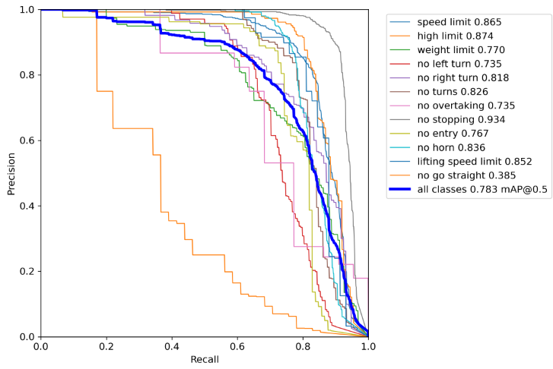
Fig.8. YOLOV5s detection results
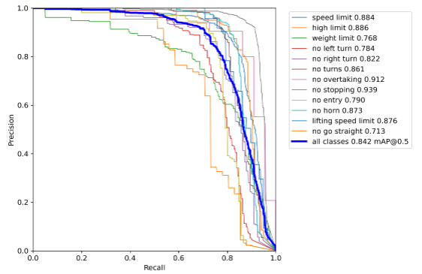
Fig.9. Modified model detection results

References
[1] World Health Organization. Global status report on road safety 2015: supporting a decade of action[M]. World Health Organization, 2015.
[2] Singh S. Critical Reasons for Crashes Investigated in the National Motor Vehicle Crash Causation Survey[J]. Traffic Safety Facts - Crash Stats, 2015.
[3] Zhao Na, Yuan Jiabin, Xu Ha Overview of Intelligent Transportation Systems [J] Computer Science, 2014, 41 (11): 7-11
[4] Du Luyao et al. Improved detection method for traffic signs in real scenes applied in intelligent and connected vehicles[J]. IET Intelligent Transport Systems, 2020, 14(12) : 1555-1564.
[5] Yang Y,Luo H,Xu H,et al.Towards real-time traffic sign detection and classification[J].IEEE Transactions on Intelligent Transportation Systems,2015,17(7):2022-2031.
[6] Kastner R,Michalke T,Burbach T,et al.Attention-based traffic sign recognition with an array of weak classifiers[C].2010 IEEE Intelligent Vehicles Symposium. La Jolla,CA, USA:IEEE Press,2010,333-339.
[7] Boumediene M,Lauffenburger J P,Daniel J,et al.Coupled detection,association andtracking for Traffic Sign Recognition Intelligent Vehicles Symposium[C].2014.
[8]Zheng Z,Zhang H,Wang B,et al.Robust traffic sign recognition and tracking for advanced driver assistance systems[C].2012 15th International IEEE Conference on Intelligent Transportation Systems, Anchorage, AK, USA.IEEE,2012,704-709.
[9]Wu T C,Wang X Q,Cai Y J,et al.Lightweight SSD object detection method based on feature fusion[J].Chinese journal of liquid crystals and displays,2021,36(10).
[10]Redmon J,Divvala S,Girshick R,et al.You Only Look Once:Unified,Real-Time Object Detection[C].Computer Vision&Pattern Recognition.IEEE,2016.
[11]Liu W,Anguelov D,Erhan D,et al.Ssd:Single shot multibox detector [C].European conference on computer vision.Springer,Cham,2016:21-37.
[12]Redmon J,Divvala S,Girshick R,et al.You only look once:Unified,real-time object detection[C].Proceedings of the IEEE conference on computer vision and pattern recognition.2016:779-788.
[13] Wu Xiaohui. Research on Traffic Sign Algorithms Based on Deep Learning [D]. Beijing: Beijing Jianzhu University, 2020
[14] Liu Mingwang. Domestic Traffic Signs and Embedded Implementation Based on YOLOv3 [D]. Haikou: Hainan University, 2020
2019,34(12):1191-1201.
[15] Yang Jinsheng, Yang Yannan, Li Tianjiao. Traffic sign algorithm based on deep separable convolution [J]. LCD and display,
[16]Girshick R，Donahlle J，Darrell T，et al.Rich feature hierarchies for accurate object detection and semantic segmentation[C].CVPr.IEEE,2014.
[17]Girshick R.Fast r-cnn[C].Proceedings of the IEEE international conference on computer vision.2015:1440-1448.
[18]Ren S，He K，Girshick R，et al.Faster R-CNN:Towards Real-Time Object Detection with Region Proposal Networks[J].IEEE Transactions on Pattern Analysis and Machine Intelligence,2017,39(6):1137-1149.
[19]Lin T Y,Goyal P,Girshick R,et al.Focal loss for dense object detection[C].Proceedings of the IEEE international conference on computer vision.2017:2980-2988.
[20]Simonyan K,Zisserman A.Very deep convolutional networks for large-scale image recognition[C].Proceedings of the 3rd International Conference on Learning Representations.San Diego:ICLR,2015.
[21] Xie Yuelei, Deng Hanfang RF fingerprint recognition method based on improved ResNet [J] Telecommunications Technology, 2022, 62 (04): 416-423
[22] HUANG G , LIU Z , LAURENS V , et al. Densely Connected Convolutional Networks[J]. IEEE Computer Society, 2016.
[23] HU J, SHEN L, ALBANIE S, et al. Squeeze-and-Excitation Networks. [J]. IEEE transactions on pattern analysis and machine intelligence, 2019.
[24] ZHU X K, LYU S C, WANG X, et al. TPH-YOLOv5: Improved YOLOv5 Based on Transformer Prediction Head for Object Detection on Drone-captured Scenarios [J]. arXIv: 2108.11539, 2021.
[25] HOU Q B, ZHOU D Q, FENG J S. Coordinate attention for efficient Mobile network design[J]. arXiv: 2103.02907, 2021.
[26] WANG R J, LI X, LING C X. Pelee: A real-time object detection system on mobile devices[J]. In Advances in Neural Information Processing Systems (Neur IPS), 2018: 1963-1972.
[27] Zhou Zhuofeng. Research on Traffic Sign Detection Method Based on Lightweight YOLO [D]. Xi'an: Chang'an University 2021

